WF-18 — Exception Management Workflow
Bellomassi Order-to-Delivery Management Platform
BM-WF-18 · Version 1.0 · Draft — for client review
2026-11-12

Document control
Field | Value
Document title | WF-18 — Exception Management Workflow
Document ID | BM-WF-18
Version | 1.0
Status | Draft — for client review
Category | Business Workflows
Related module(s) | All modules
Document owner | Business Analyst
Prepared by | Project documentation team (AI-assisted draft prepared from source-code analysis)
Reviewed by | Pending — not yet reviewed
Approval | Not approved — awaiting client review (no approval has been given)
Created date | 2026-11-12
Last updated date | 2026-11-12
Status labels used in this document: VERIFIED (confirmed in the current source code or existing documents) · PROTOTYPE (works in the React/LocalStorage prototype with mock or simulated behaviour) · PROPOSED (recommended production design, not built) · PENDING CONFIRMATION (needs a client decision) · NOT IMPLEMENTED · NOT VERIFIED.

Purpose
Specify how exceptions are detected and resolved.

Scope
Workflow WF-18 as implemented in the prototype, with production differences marked.

Definitions
Other terms: see BM-GLO-001 (Project Glossary).

References
- BM-WF-00 (Business Workflow Catalogue)
- BM-SYS-008 (Requirement Traceability Matrix)

Contents

  - Workflow summary

  - Step-by-step process

  - Decision points

  - Approval conditions

  - Rejection conditions

  - System actions

  - User actions

  - Status changes

  - Notifications

  - Exception scenarios

  - Workflow diagram

  - Final outcome

1. Workflow summary
Field | Value
Workflow ID | WF-18
Workflow name | Exception Management Workflow
Business purpose | Specify how exceptions are detected and resolved.
Initiating role | Any role
Trigger | Validation failure or operational exception
Preconditions | —
Final outcome | Exception resolved.
Related requirements | FR-EXC-001, FR-EXC-002, FR-EXC-003, FR-DRA-002, FR-OTP-002
Related test cases | TC-EXC-001, TC-EXC-N01, TC-EXC-002, TC-EXC-N02, TC-EXC-003, TC-DRA-002, TC-DRA-N01, TC-OTP-002, TC-OTP-N01, TC-OTP-N02
Detailed chapter | docs/workflow/ chapter 15

2. Step-by-step process
- Service detects the exception and refuses the action or moves the record to an exception status.
- Named role resolves it (see register in docs/workflow chapter 15).

3. Decision points
Exception type.

4. Approval conditions
Depends on type.

5. Rejection conditions
—

6. System actions
Validation, idempotency, transactions.

7. User actions
Resolver role.

8. Status changes
Exception statuses: RETURNED, REJECTED, DELIVERY_FAILED, PARTIALLY_DELIVERED, RETURNED_TO_HUB, CANCELLED.

9. Notifications
Responsible role notified.

10. Exception scenarios
37 exceptions listed in docs/workflow 15.2.

11. Workflow diagram
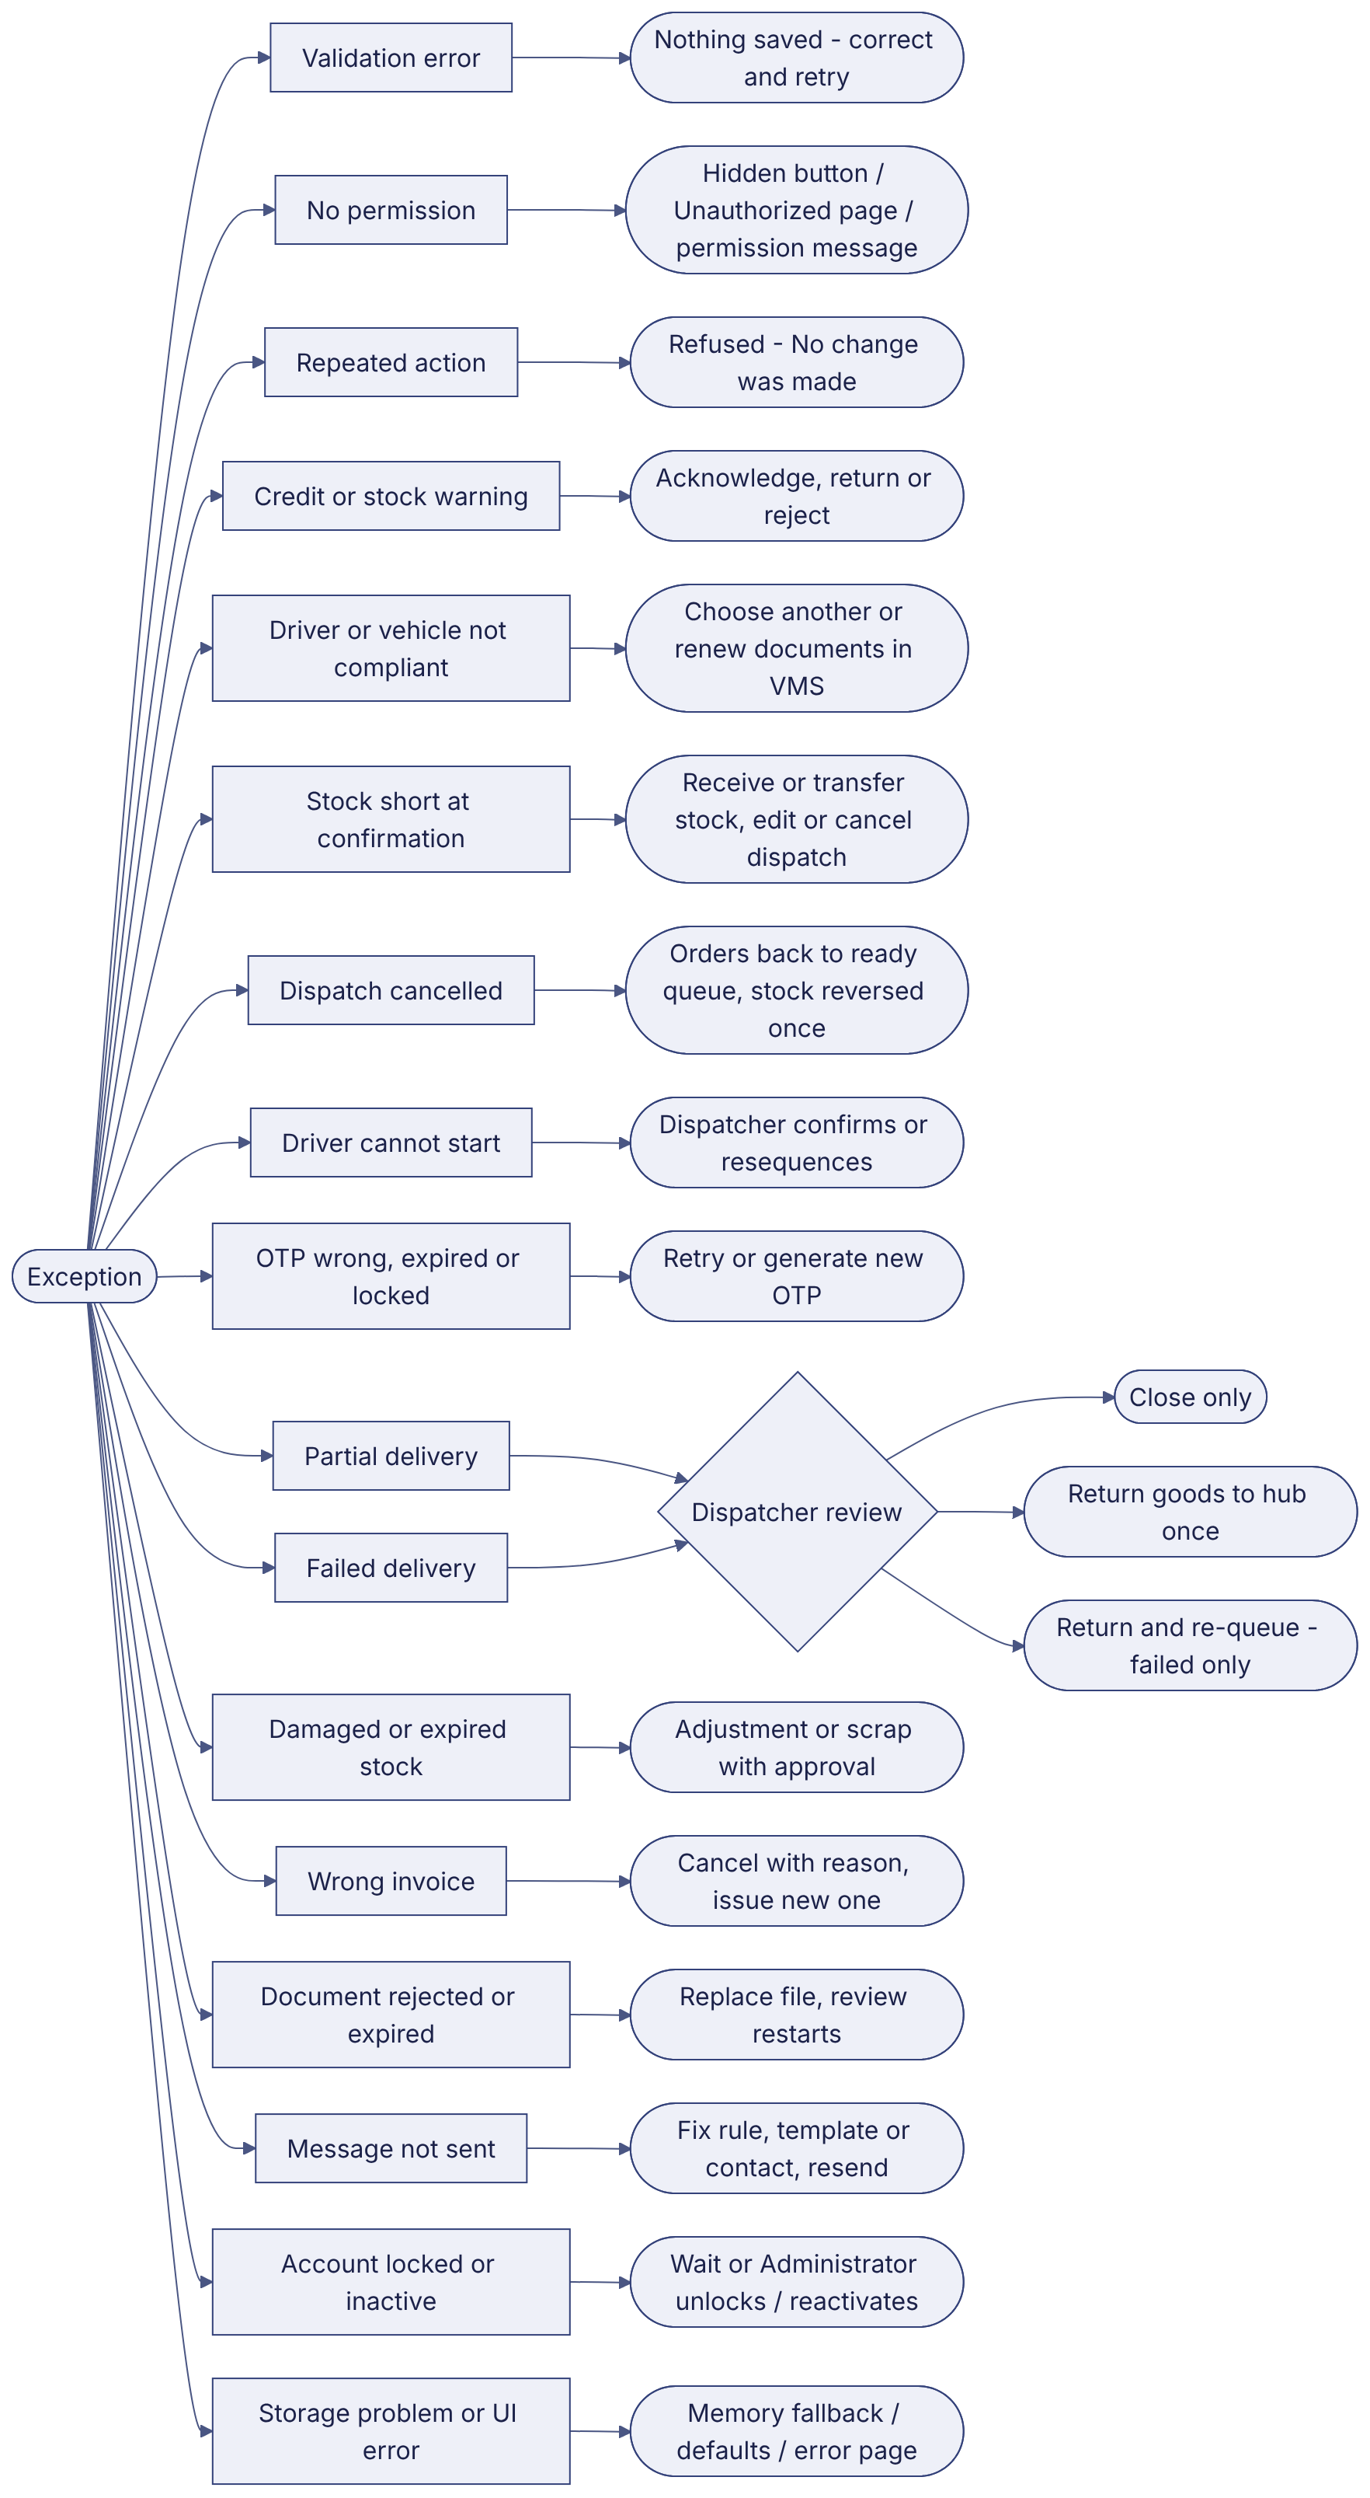
Implementation label: diagrams describe the prototype behaviour (VERIFIED in source code) unless a step is marked PROPOSED / NOT IMPLEMENTED.

12. Final outcome
Exception resolved.

Revision history
Version | Date | Author | Description
1.0 | 2026-11-12 | Documentation team | Initial draft prepared from analysis of the bellomassi-premium-ui source code and existing project documents.

