WF-19 — Rejection Workflow
Bellomassi Order-to-Delivery Management Platform
BM-WF-19 · Version 1.0 · Draft — for client review
2026-11-12

Document control
Field | Value
Document title | WF-19 — Rejection Workflow
Document ID | BM-WF-19
Version | 1.0
Status | Draft — for client review
Category | Business Workflows
Related module(s) | All modules
Document owner | Business Analyst
Prepared by | Project documentation team (AI-assisted draft prepared from source-code analysis)
Reviewed by | Pending — not yet reviewed
Approval | Not approved — awaiting client review (no approval has been given)
Created date | 2026-11-12
Last updated date | 2026-11-12
Status labels used in this document: VERIFIED (confirmed in the current source code or existing documents) · PROTOTYPE (works in the React/LocalStorage prototype with mock or simulated behaviour) · PROPOSED (recommended production design, not built) · PENDING CONFIRMATION (needs a client decision) · NOT IMPLEMENTED · NOT VERIFIED.

Purpose
Specify all rejection paths.

Scope
Workflow WF-19 as implemented in the prototype, with production differences marked.

Definitions
Other terms: see BM-GLO-001 (Project Glossary).

References
- BM-WF-00 (Business Workflow Catalogue)
- BM-SYS-008 (Requirement Traceability Matrix)

Contents

  - Workflow summary

  - Step-by-step process

  - Decision points

  - Approval conditions

  - Rejection conditions

  - System actions

  - User actions

  - Status changes

  - Notifications

  - Exception scenarios

  - Workflow diagram

  - Final outcome

1. Workflow summary
Field | Value
Workflow ID | WF-19
Workflow name | Rejection Workflow
Business purpose | Specify all rejection paths.
Initiating role | Sales Manager / reviewers
Trigger | Order, scrap, replenishment or document rejected
Preconditions | A request awaiting decision.
Final outcome | Requester informed.
Related requirements | FR-APR-005, FR-SCR-003, FR-DOC-003, FR-AI-003
Related test cases | TC-APR-005, TC-APR-N02, TC-SCR-003, TC-SCR-N01, TC-DOC-003, TC-DOC-N01, TC-AI-003
Detailed chapter | docs/workflow/ chapter 07

2. Step-by-step process
- Order: Sales Manager rejects with reason → REJECTED (final).
- Scrap: approver rejects with reason → REJECTED.
- Replenishment: Administrator rejects with reason → REJECTED.
- Document: reviewer rejects with reason → REJECTED; uploader replaces file.

3. Decision points
Reject vs return (orders only).

4. Approval conditions
—

5. Rejection conditions
Reason mandatory in every case.

6. System actions
Decision records; notifications.

7. User actions
Approver.

8. Status changes
→ REJECTED.

9. Notifications
Requester notified / sees reason.

10. Exception scenarios
Missing reason refused.

11. Workflow diagram
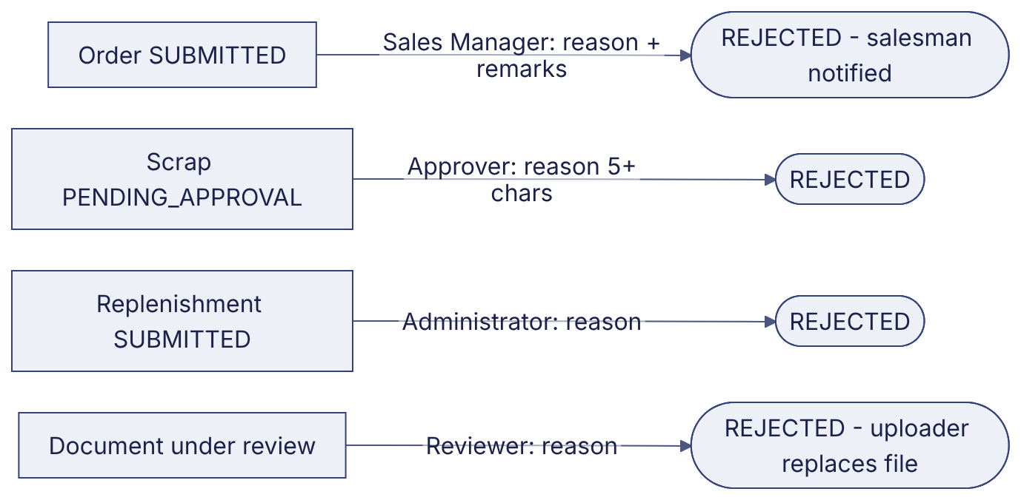
Implementation label: diagrams describe the prototype behaviour (VERIFIED in source code) unless a step is marked PROPOSED / NOT IMPLEMENTED.

12. Final outcome
Requester informed.

Revision history
Version | Date | Author | Description
1.0 | 2026-11-12 | Documentation team | Initial draft prepared from analysis of the bellomassi-premium-ui source code and existing project documents.

