WF-20 — Cancellation Workflow
Bellomassi Order-to-Delivery Management Platform
BM-WF-20 · Version 1.0 · Draft — for client review
2026-11-12

Document control
Field | Value
Document title | WF-20 — Cancellation Workflow
Document ID | BM-WF-20
Version | 1.0
Status | Draft — for client review
Category | Business Workflows
Related module(s) | All modules
Document owner | Business Analyst
Prepared by | Project documentation team (AI-assisted draft prepared from source-code analysis)
Reviewed by | Pending — not yet reviewed
Approval | Not approved — awaiting client review (no approval has been given)
Created date | 2026-11-12
Last updated date | 2026-11-12
Status labels used in this document: VERIFIED (confirmed in the current source code or existing documents) · PROTOTYPE (works in the React/LocalStorage prototype with mock or simulated behaviour) · PROPOSED (recommended production design, not built) · PENDING CONFIRMATION (needs a client decision) · NOT IMPLEMENTED · NOT VERIFIED.

Purpose
Specify cancellation paths and their stock effects.

Scope
Workflow WF-20 as implemented in the prototype, with production differences marked.

Definitions
Other terms: see BM-GLO-001 (Project Glossary).

References
- BM-WF-00 (Business Workflow Catalogue)
- BM-SYS-008 (Requirement Traceability Matrix)

Contents

  - Workflow summary

  - Step-by-step process

  - Decision points

  - Approval conditions

  - Rejection conditions

  - System actions

  - User actions

  - Status changes

  - Notifications

  - Exception scenarios

  - Workflow diagram

  - Final outcome

1. Workflow summary
Field | Value
Workflow ID | WF-20
Workflow name | Cancellation Workflow
Business purpose | Specify cancellation paths and their stock effects.
Initiating role | Dispatcher / Finance / requester
Trigger | Dispatch, invoice, scrap or replenishment must be cancelled
Preconditions | A cancellable record.
Final outcome | Record cancelled cleanly.
Related requirements | FR-DSP-005, FR-INVC-003, FR-SCR-001, FR-ORD-010
Related test cases | TC-DSP-005, TC-DSP-N05, TC-INVC-003, TC-INVC-N03, TC-SCR-001, TC-ORD-010
Detailed chapter | docs/workflow/ chapter 15

2. Step-by-step process
- Dispatch: cancel with reason + remarks before any stop starts; orders back to READY_FOR_DISPATCH; stock reversed once if confirmed.
- Invoice: cancel with reason; new invoice possible.
- Scrap / replenishment: cancel while not completed.
- Order: cancellation after submission NOT IMPLEMENTED (reject with “Customer cancelled”).

3. Decision points
Cancellable state?

4. Approval conditions
—

5. Rejection conditions
—

6. System actions
Reversal movements; timeline.

7. User actions
Owner role.

8. Status changes
→ CANCELLED.

9. Notifications
Driver and Admin on dispatch cancellation.

10. Exception scenarios
Started dispatch cannot be cancelled.

11. Workflow diagram
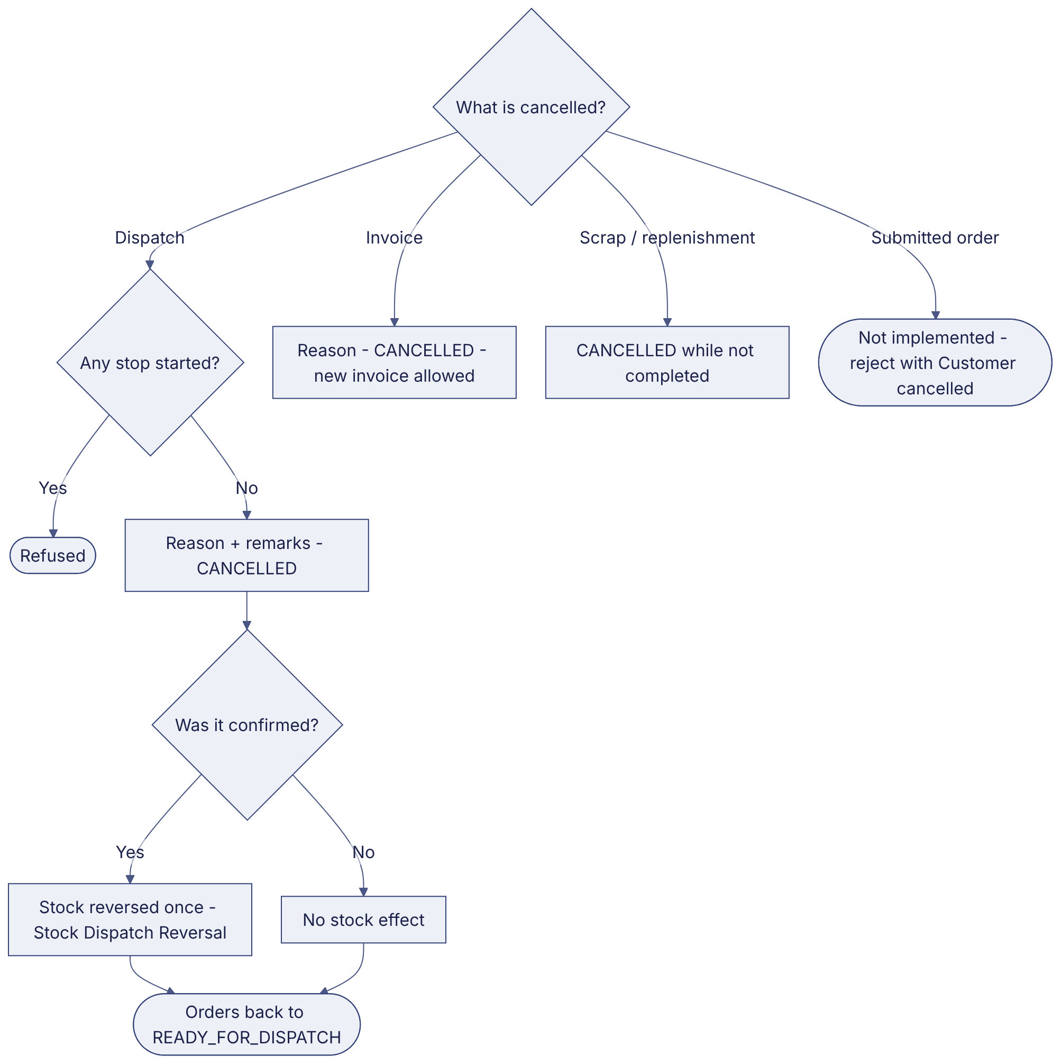
Implementation label: diagrams describe the prototype behaviour (VERIFIED in source code) unless a step is marked PROPOSED / NOT IMPLEMENTED.

12. Final outcome
Record cancelled cleanly.

Revision history
Version | Date | Author | Description
1.0 | 2026-11-12 | Documentation team | Initial draft prepared from analysis of the bellomassi-premium-ui source code and existing project documents.

