WF-22 — Document Upload and Verification Workflow
Bellomassi Order-to-Delivery Management Platform
BM-WF-22 · Version 1.0 · Draft — for client review
2026-11-12

Document control
Field | Value
Document title | WF-22 — Document Upload and Verification Workflow
Document ID | BM-WF-22
Version | 1.0
Status | Draft — for client review
Category | Business Workflows
Related module(s) | All modules
Document owner | Business Analyst
Prepared by | Project documentation team (AI-assisted draft prepared from source-code analysis)
Reviewed by | Pending — not yet reviewed
Approval | Not approved — awaiting client review (no approval has been given)
Created date | 2026-11-12
Last updated date | 2026-11-12
Status labels used in this document: VERIFIED (confirmed in the current source code or existing documents) · PROTOTYPE (works in the React/LocalStorage prototype with mock or simulated behaviour) · PROPOSED (recommended production design, not built) · PENDING CONFIRMATION (needs a client decision) · NOT IMPLEMENTED · NOT VERIFIED.

Purpose
Specify document upload and verification.

Scope
Workflow WF-22 as implemented in the prototype, with production differences marked.

Definitions
Other terms: see BM-GLO-001 (Project Glossary).

References
- BM-WF-00 (Business Workflow Catalogue)
- BM-SYS-008 (Requirement Traceability Matrix)

Contents

  - Workflow summary

  - Step-by-step process

  - Decision points

  - Approval conditions

  - Rejection conditions

  - System actions

  - User actions

  - Status changes

  - Notifications

  - Exception scenarios

  - Workflow diagram

  - Final outcome

1. Workflow summary
Field | Value
Workflow ID | WF-22
Workflow name | Document Upload and Verification Workflow
Business purpose | Specify document upload and verification.
Initiating role | Any uploader
Trigger | Document uploaded
Preconditions | Active document type; user may upload for the record.
Final outcome | Verified document.
Related requirements | FR-DOC-001, FR-DOC-002, FR-DOC-003, FR-DOC-004
Related test cases | TC-DOC-001, TC-DOC-N02, TC-DOC-002, TC-DOC-003, TC-DOC-N01, TC-DOC-004
Detailed chapter | docs/workflow/ chapter 13

2. Step-by-step process
- Upload with type, record, file, fields.
- OCR (if enabled) extracts fields (MOCK in prototype).
- Reviewer corrects fields.
- Verify or reject with reason.
- Uploader replaces file after rejection.

3. Decision points
OCR type? Verify or reject?

4. Approval conditions
Reviewer verifies.

5. Rejection conditions
Reason mandatory.

6. System actions
OCR result kept with originals; expiry derived.

7. User actions
Uploader, reviewer.

8. Status changes
PENDING_OCR → OCR_COMPLETED → PENDING_REVIEW → VERIFIED / REJECTED.

9. Notifications
Expiry events.

10. Exception scenarios
File not stored; provider unavailable.

11. Workflow diagram
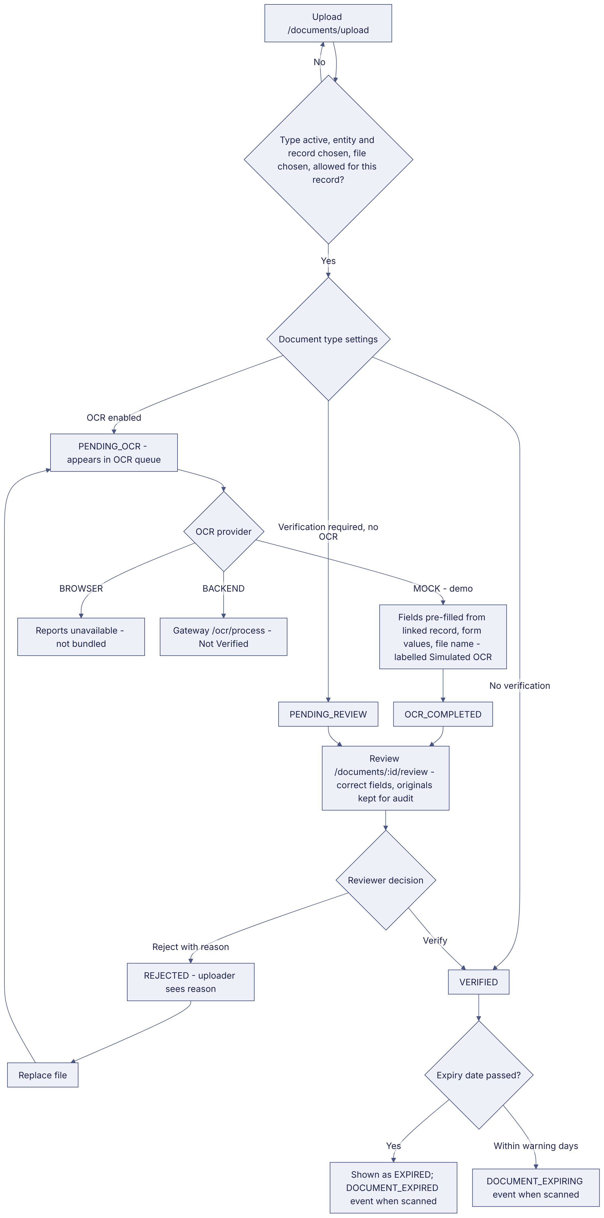
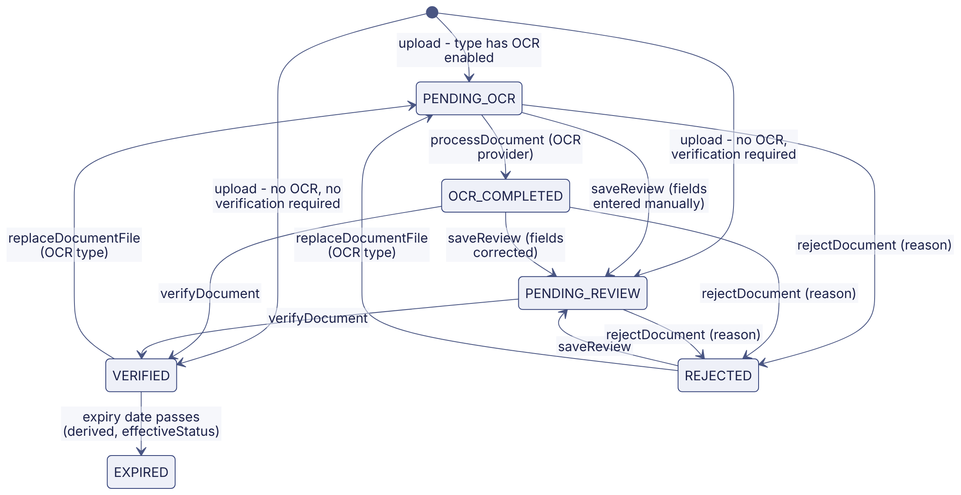
Implementation label: diagrams describe the prototype behaviour (VERIFIED in source code) unless a step is marked PROPOSED / NOT IMPLEMENTED.

12. Final outcome
Verified document.

Revision history
Version | Date | Author | Description
1.0 | 2026-11-12 | Documentation team | Initial draft prepared from analysis of the bellomassi-premium-ui source code and existing project documents.

