WF-24 — Reporting Workflow
Bellomassi Order-to-Delivery Management Platform
BM-WF-24 · Version 1.0 · Draft — for client review
2026-11-12

Document control
Field | Value
Document title | WF-24 — Reporting Workflow
Document ID | BM-WF-24
Version | 1.0
Status | Draft — for client review
Category | Business Workflows
Related module(s) | All modules
Document owner | Business Analyst
Prepared by | Project documentation team (AI-assisted draft prepared from source-code analysis)
Reviewed by | Pending — not yet reviewed
Approval | Not approved — awaiting client review (no approval has been given)
Created date | 2026-11-12
Last updated date | 2026-11-12
Status labels used in this document: VERIFIED (confirmed in the current source code or existing documents) · PROTOTYPE (works in the React/LocalStorage prototype with mock or simulated behaviour) · PROPOSED (recommended production design, not built) · PENDING CONFIRMATION (needs a client decision) · NOT IMPLEMENTED · NOT VERIFIED.

Purpose
Specify dashboards and reports.

Scope
Workflow WF-24 as implemented in the prototype, with production differences marked.

Definitions
Other terms: see BM-GLO-001 (Project Glossary).

References
- BM-WF-00 (Business Workflow Catalogue)
- BM-SYS-008 (Requirement Traceability Matrix)

Contents

  - Workflow summary

  - Step-by-step process

  - Decision points

  - Approval conditions

  - Rejection conditions

  - System actions

  - User actions

  - Status changes

  - Notifications

  - Exception scenarios

  - Workflow diagram

  - Final outcome

1. Workflow summary
Field | Value
Workflow ID | WF-24
Workflow name | Reporting Workflow
Business purpose | Specify dashboards and reports.
Initiating role | Office roles
Trigger | User opens a dashboard or report
Preconditions | Report category permission.
Final outcome | Insight / export.
Related requirements | FR-RPT-001, FR-RPT-002, FR-DASH-002
Related test cases | TC-RPT-001, TC-RPT-002, TC-DASH-002, TC-DASH-N01
Detailed chapter | docs/workflow/ chapter 14

2. Step-by-step process
- Choose period on dashboard; compare.
- Drill down to lists.
- Open Reports Center; search / favourite.
- Run report with filters; export CSV or print.

3. Decision points
Report has source data?

4. Approval conditions
—

5. Rejection conditions
—

6. System actions
reportService.runReport with data scope.

7. User actions
Analysis.

8. Status changes
—

9. Notifications
—

10. Exception scenarios
24 reports state “no source data”.

11. Workflow diagram
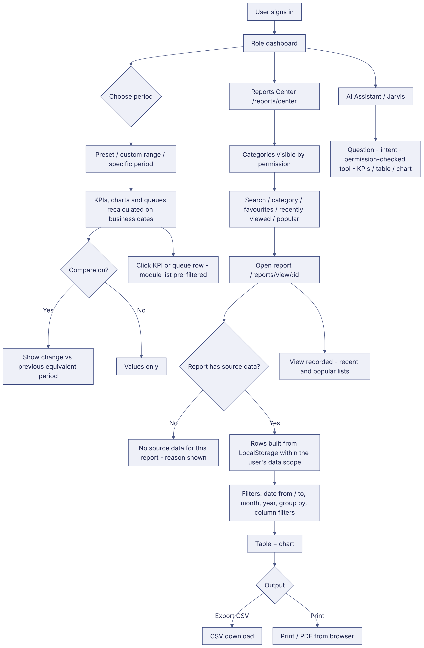
Implementation label: diagrams describe the prototype behaviour (VERIFIED in source code) unless a step is marked PROPOSED / NOT IMPLEMENTED.

12. Final outcome
Insight / export.

Revision history
Version | Date | Author | Description
1.0 | 2026-11-12 | Documentation team | Initial draft prepared from analysis of the bellomassi-premium-ui source code and existing project documents.

