High-Level Design (HLD)
Bellomassi Order-to-Delivery Management Platform
BM-ARC-001 · Version 1.0 · Draft — for client review
2026-11-12

Document control
Field | Value
Document title | High-Level Design (HLD)
Document ID | BM-ARC-001
Version | 1.0
Status | Draft — for client review
Category | System Architecture
Related module(s) | All modules
Document owner | Solution Architect
Prepared by | Project documentation team (AI-assisted draft prepared from source-code analysis)
Reviewed by | Pending — not yet reviewed
Approval | Not approved — awaiting client review (no approval has been given)
Created date | 2026-11-12
Last updated date | 2026-11-12
Status labels used in this document: VERIFIED (confirmed in the current source code or existing documents) · PROTOTYPE (works in the React/LocalStorage prototype with mock or simulated behaviour) · PROPOSED (recommended production design, not built) · PENDING CONFIRMATION (needs a client decision) · NOT IMPLEMENTED · NOT VERIFIED.

Purpose
Describe the architecture of the current prototype (VERIFIED) and the target production architecture (PROPOSED), their components, boundaries, data flows and integration points.

Scope
Frontend, backend target, database, integrations, deployment, security architecture and scalability strategy.

Definitions
Other terms: see BM-GLO-001 (Project Glossary).

References
- Driver App GPS Implementation Guide §6, §10, §11
- docs/INTEGRATION_GATEWAY.md (gateway contract)
- BM-ARC-002 (Low-Level Design (LLD))
- BM-ARC-003 (Architecture Diagrams)
- BM-DAT-002 (Proposed Production Database Design)
- BM-API-001 (API Specification (Overview and Conventions))
- BM-SEC-002 (Security Architecture)
- BM-INF-003 (Infrastructure, Network Architecture and Server Specification)

Contents

  - Architecture summary

  - System architecture — current prototype (VERIFIED)

  - Target production architecture (PROPOSED)

  - Logical architecture

  - Frontend architecture (VERIFIED)

  - Backend target architecture (PROPOSED)

  - Database architecture

  - Integration architecture

  - Deployment architecture — PROPOSED

  - Security architecture

  - Data flow — order to delivery (production)

  - Component responsibilities and system boundaries

  - External dependencies

  - Scalability strategy — PROPOSED

1. Architecture summary
Layer | Prototype — VERIFIED | Production target — PROPOSED
Presentation | React 19 SPA (Vite 8, Tailwind 4, React Router 7), lazy-loaded pages; office, /driver, /customer layouts | Same React web app; React Native Drivers App; customer app (web or native, to confirm)
Application logic | 84 service modules in the browser (src/services) enforce rules and permissions | Django REST Framework services; Celery workers; Django Channels
Data | LocalStorage via storageService (74 keys, version 8, transactions, migrations) | PostgreSQL 16 (+ PostGIS optional), Redis, S3-compatible object storage
Integration | Simulated providers; optional gateway contract (VITE_INTEGRATION_GATEWAY_URL) — NOT VERIFIED | Maps / Routes, SMS / WhatsApp, email, OCR, SAP adapters
Security | Client-side demo authentication and can() checks | JWT / session auth, server-side RBAC, TLS, audit, secrets management
Deployment | Static files | Docker containers, Nginx, CI/CD, monitoring

2. System architecture — current prototype (VERIFIED)
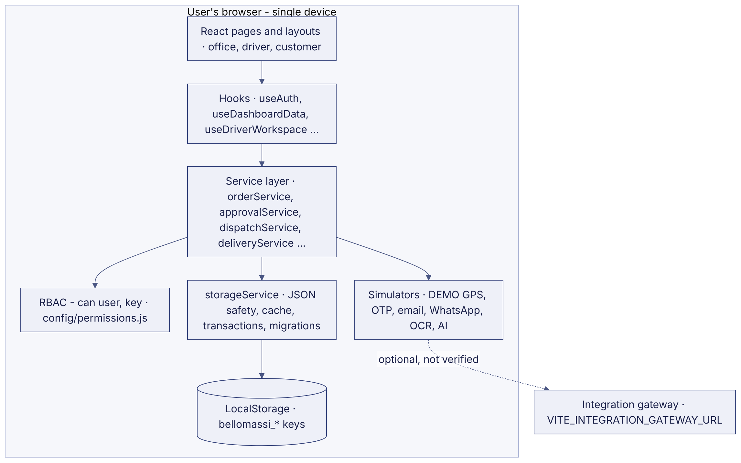

3. Target production architecture (PROPOSED)
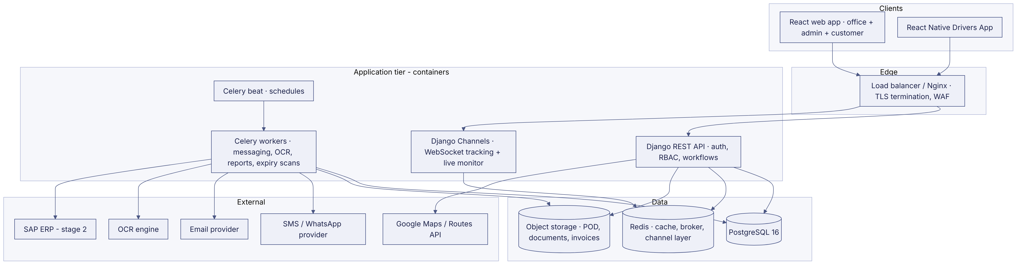

4. Logical architecture
Logical component | Responsibility | Prototype module(s) | Production component
Identity and access | Authentication, sessions, roles, permissions, data scope | authService, rbacService, userService, ProtectedRoute | Django auth + accounts app, DRF permissions
Master data | Customers, products, hubs, zones, drivers, vehicles, suppliers, organisation | customerService, productService, hubService, zoneService, driverService, vehicleService | masterdata app
Sales | Orders, approval, credit, consolidation | orderService, approvalService, consolidationService | orders app
Logistics | Dispatch, assignment, deliveries, OTP, POD, notes, tracking, exceptions | dispatchService, deliveryService, otpService, deliveryNoteService, trackingService | logistics app + Channels consumers
Inventory | Stock, receipts, transfers, adjustments, scrap, replenishment | inventoryService, scrapService, replenishmentService | inventory app
Compliance and documents | VMS, documents, OCR | complianceService, documentService, ocrService | documents app + OCR worker
Finance | Invoices, templates (scope to confirm) | invoiceService, invoiceTemplateService | billing app (optional)
Communication | Notifications, automation, email, WhatsApp, calls | notificationService, automationService, emailService, openWAService, callService | comms app + workers
Analytics | Dashboards, reports, forecasting, AI | dashboardService, reportService, forecastService, aiChatService | analytics app, read replicas
Platform | Settings, audit, storage, numbering | appSettingsService, auditService, storageService | core app

5. Frontend architecture (VERIFIED)
- Single navigation configuration (src/config/navigation.js, 206 entries) drives routes, menus, breadcrumbs, search and route permissions.
- Pages are lazy-loaded; three layouts: AppLayout (office), DriverLayout, CustomerLayout.
- State: React contexts (AuthContext, ThemeContext, DashboardPeriodContext) + storage subscriptions (useSyncExternalStore over storageService.subscribe, cross-tab storage events).
- Rule of the codebase: page → hook → service → storageService; pages never touch storage.
- Details: BM-ARC-002 (Low-Level Design (LLD)).

6. Backend target architecture (PROPOSED)
- Django 5 project with apps: core, accounts, masterdata, orders, logistics, inventory, documents, billing, comms, analytics, integrations.
- DRF viewsets with permission classes mapped 1:1 to the 110 permission keys; object-level scope filters per role.
- Service layer (Python) re-implements the prototype services’ rules; the prototype services are the executable specification (messages and edge cases).
- Transactions with select_for_update on stock rows and order status changes; idempotency keys for state-changing endpoints (approve, confirm, complete, write-off).
- Celery for asynchronous work; Channels for WebSockets; drf-spectacular for OpenAPI.

7. Database architecture
Prototype: LocalStorage keys described in BM-DAT-001 (Current Prototype Data Model (LocalStorage)). Production: PostgreSQL schema with ≈45 tables, audit columns, soft delete, indexes and constraints — BM-DAT-002 (Proposed Production Database Design).

8. Integration architecture
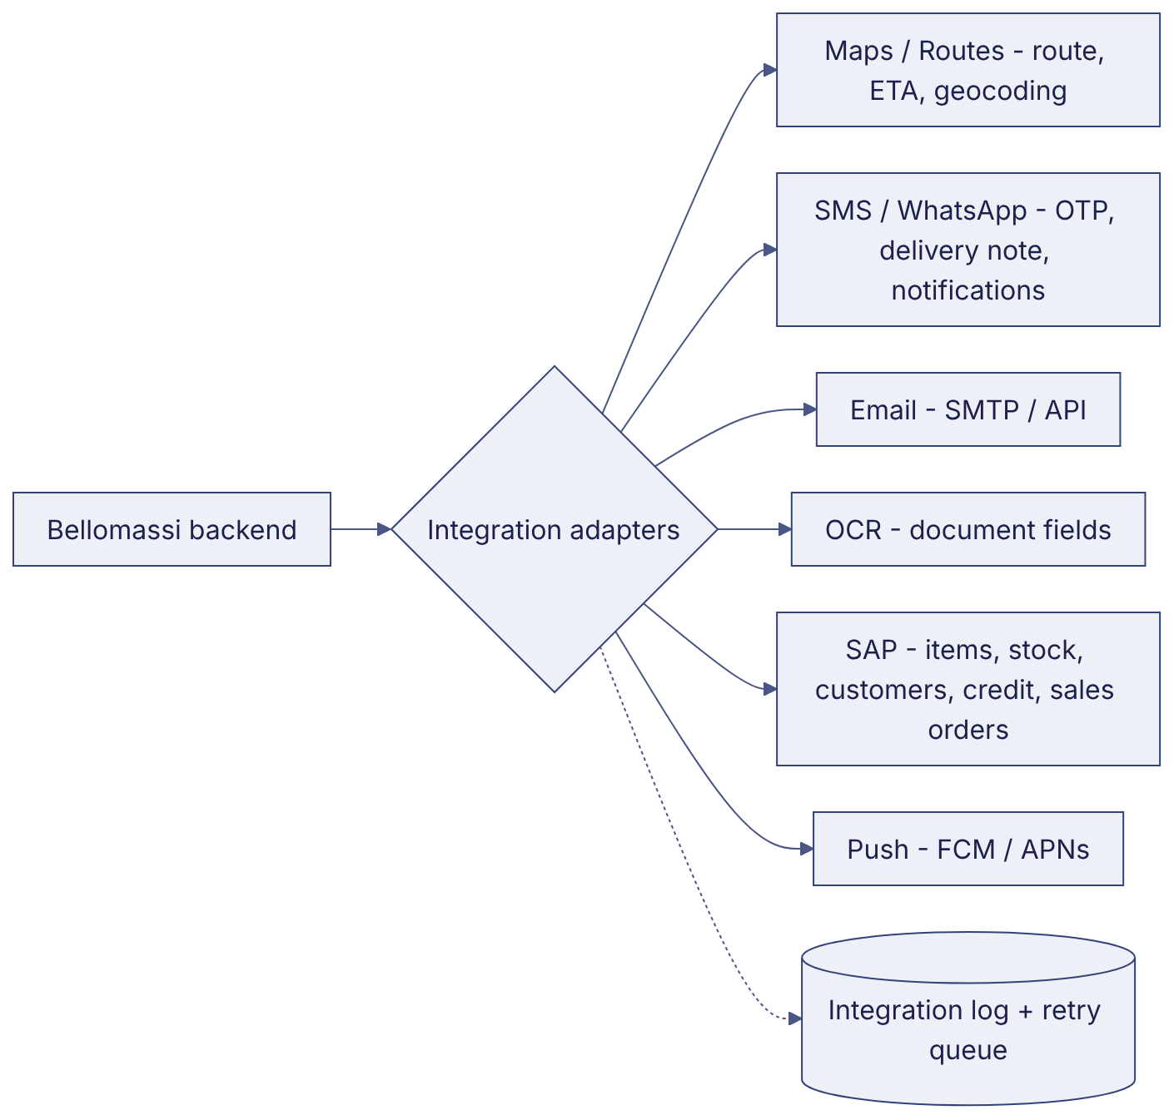
Every adapter is behind an interface with a sandbox / mock implementation (as in the prototype) so that tests never call live providers. Contract details: BM-API-019 (Integration Specification (External Systems)).

9. Deployment architecture — PROPOSED
Containers (API, Channels, workers, beat, Nginx) on a managed container platform or VMs; managed PostgreSQL and Redis; object storage; CDN for the web app; separate test, staging and production environments. See BM-INF-003 (Infrastructure, Network Architecture and Server Specification) and BM-INF-006 (Docker Architecture and Deployment Guide).

10. Security architecture
TLS everywhere; JWT access (15 min) + refresh tokens; Argon2id; MFA for privileged roles; server-side RBAC and object scope; OTP hashing and rate limiting; signed URLs for files; audit log; secrets in a vault; WAF and rate limits. Prototype controls are simulated. See BM-SEC-002 (Security Architecture).

11. Data flow — order to delivery (production)
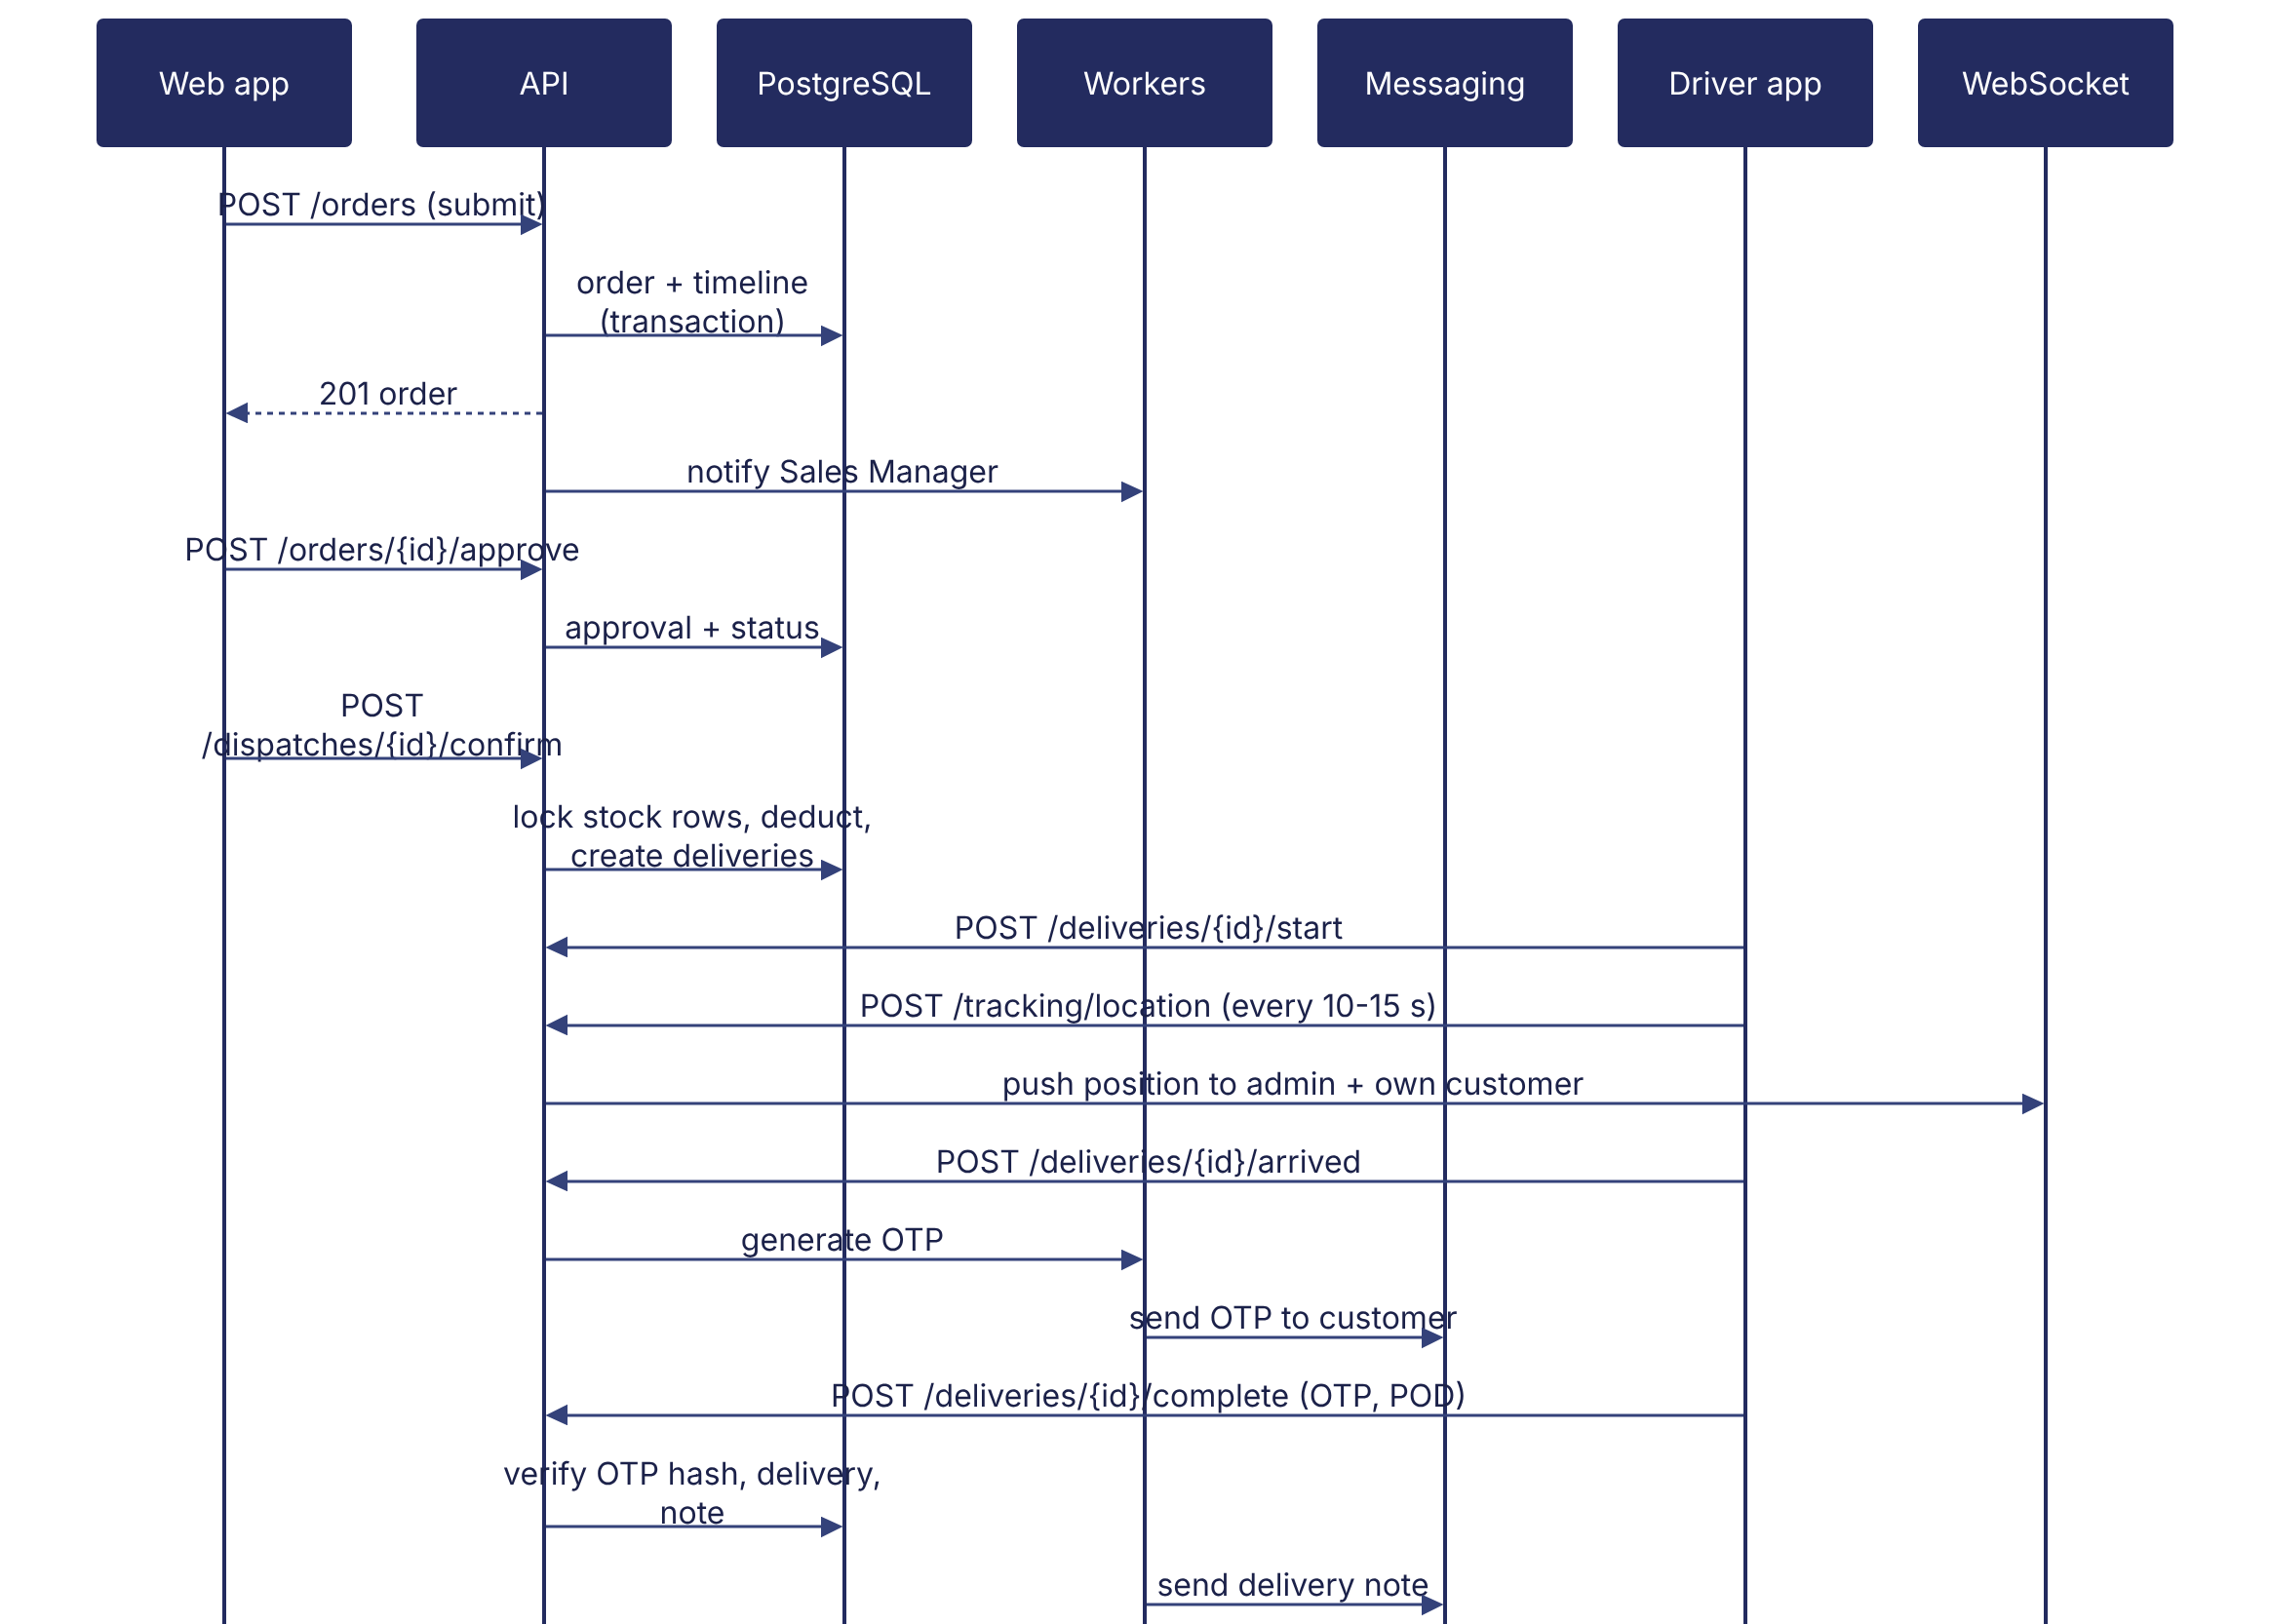

12. Component responsibilities and system boundaries
- Inside the system: all workflows from order capture to delivery note, master data, rules, notifications, reporting, (optionally) invoices and inventory.
- Outside the system: ERP accounting and invoicing (unless confirmed), payment collection, map and messaging infrastructure, SAP master data ownership (stage 2), vehicle hardware.

13. External dependencies
Google Maps Platform / Routes API · SMS / WhatsApp provider · email provider · OCR engine · SAP · app stores · hosting provider. All PENDING CONFIRMATION of account and contract.

14. Scalability strategy — PROPOSED
Stateless API containers scaled horizontally behind the load balancer; Channels scaled with a Redis channel layer; Celery queues separated (messaging, ocr, reports); PostgreSQL vertical scaling + read replica for reports; GPS points written in batches and partitioned by month (or PostGIS / TimescaleDB if volumes require); CDN for static assets. Capacity numbers depend on confirmed volumes (NFR-SCAL-002).

Revision history
Version | Date | Author | Description
1.0 | 2026-11-12 | Documentation team | Initial draft prepared from analysis of the bellomassi-premium-ui source code and existing project documents.

