Low-Level Design (LLD)
Bellomassi Order-to-Delivery Management Platform
BM-ARC-002 · Version 1.0 · Draft — for client review
2026-11-12

Document control
Field | Value
Document title | Low-Level Design (LLD)
Document ID | BM-ARC-002
Version | 1.0
Status | Draft — for client review
Category | System Architecture
Related module(s) | All modules
Document owner | Solution Architect / Lead Developer
Prepared by | Project documentation team (AI-assisted draft prepared from source-code analysis)
Reviewed by | Pending — not yet reviewed
Approval | Not approved — awaiting client review (no approval has been given)
Created date | 2026-11-12
Last updated date | 2026-11-12
Status labels used in this document: VERIFIED (confirmed in the current source code or existing documents) · PROTOTYPE (works in the React/LocalStorage prototype with mock or simulated behaviour) · PROPOSED (recommended production design, not built) · PENDING CONFIRMATION (needs a client decision) · NOT IMPLEMENTED · NOT VERIFIED.

Purpose
Describe the internal design of the prototype code (structure, routing, state, services, validation, errors, storage, integrations) and the corresponding low-level design of the future backend services.

Scope
Source tree src/ of bellomassi-premium-ui (391 files, ≈46,500 lines) and the proposed Django service design.

Definitions
Other terms: see BM-GLO-001 (Project Glossary).

References
- BM-ARC-001 (High-Level Design (HLD))
- BM-ARC-003 (Architecture Diagrams)
- BM-DAT-001 (Current Prototype Data Model (LocalStorage))
- BM-API-001 (API Specification (Overview and Conventions))
- BM-SYS-007 (Business Rules Catalogue)

Contents

  - Source structure — VERIFIED

  - Component structure

  - Routing structure — VERIFIED

  - State management — VERIFIED

  - Service layer design — VERIFIED

  - Validation design

  - Error handling

  - Data storage design — VERIFIED

  - Integration components

  - Detailed workflow logic

  - Future backend service design — PROPOSED

1. Source structure — VERIFIED
Folder | Files | Responsibility
src/config | 15 | Navigation (206 entries), roles, permissions, RBAC catalogue, status metadata (orders, dispatch, documents, invoices, communication, VMS, AI), runtime config
src/services | 84 | Business services, validation, storage, simulators, seed data (services/seed), AI (services/ai) and ML (services/ml)
src/pages | 134 | Screens grouped by module (orders, dispatch, driver, customer, inventory, scrap, vms, documents, invoices, communication, calls, reports, ai, admin, account, auth, errors)
src/components | 121 | Layouts, common UI kit (Button, Card, DataTable, Modal, Input…), dashboard widgets, module components
src/hooks | 19 | Data hooks (useDashboardData, useDriverWorkspace, useCustomerWorkspace, useTableQuery, usePermission…)
src/context | 3 | AuthContext, ThemeContext, DashboardPeriodContext
src/routes | 2 | AppRoutes (generated from navigation), ProtectedRoute
src/utils | 11 | Formatters, periods, dashboard filters, stock helpers, demo geo, invoice snapshot, dispatch stock

2. Component structure
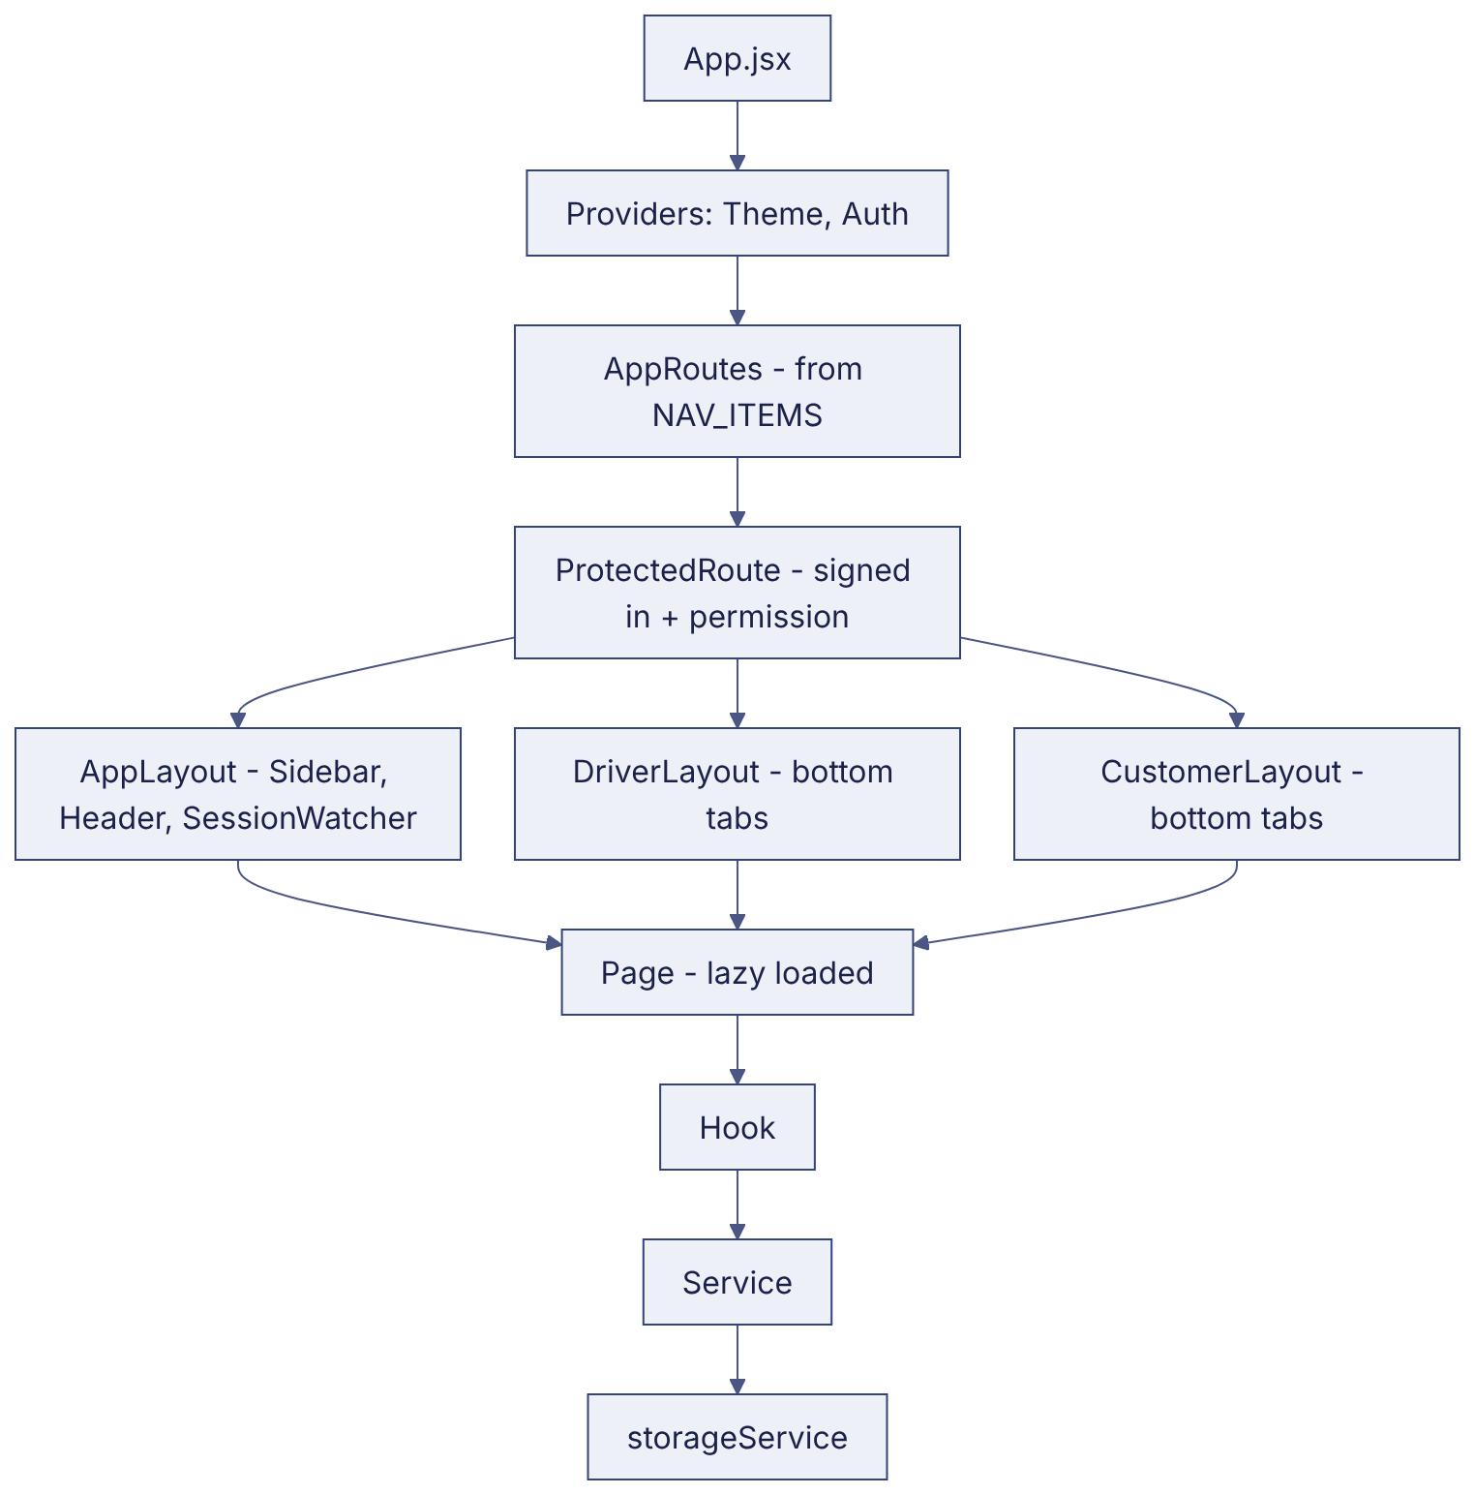

3. Routing structure — VERIFIED
- Every route is an entry in NAV_ITEMS with path, page, permission, hidden, parent, redirectTo, public.
- AppRoutes maps page keys to lazy components; public routes (/login, /driver/login, /customer/login, /forgot-password, /reset-password) use PublicOnlyRoute.
- ProtectedRoute redirects signed-out users to the sign-in page of the right app and shows /unauthorized when the permission is missing; unknown paths render NotFound.
- Landing path per role from the role record (landingPathFor).
- Full screen list: BM-UX-004 (Screen Inventory).

4. State management — VERIFIED
State | Mechanism
Session and user | AuthContext (session in localStorage or sessionStorage)
Theme | ThemeContext (bellomassi_theme)
Dashboard period | DashboardPeriodContext (memory only, per dashboard)
Business data | useStoredValue / useSyncExternalStore over storageService.subscribe; read cache; cross-tab sync through storage events
Forms | useFormState (local state, field errors from service errors)
Tables | useTableQuery (search, filter, sort, pagination in memory)

5. Service layer design — VERIFIED
- Each service owns one area and exports pure-ish functions: getX, validateX, createX, updateX, status transitions (approveOrder, confirmDispatch…).
- Return contract: { ok: true, record } or { ok: false, error, errors } (field map).
- Permission first: if (!can(user, 'orders.approve')) return deny('…').
- State guard second: status must match the expected state, otherwise a “No change was made” message.
- Writes through storage.transaction([...]) so related keys update together.
- Side effects: timeline event, notification (pushNotification), automation event (fireEvent), activity log.
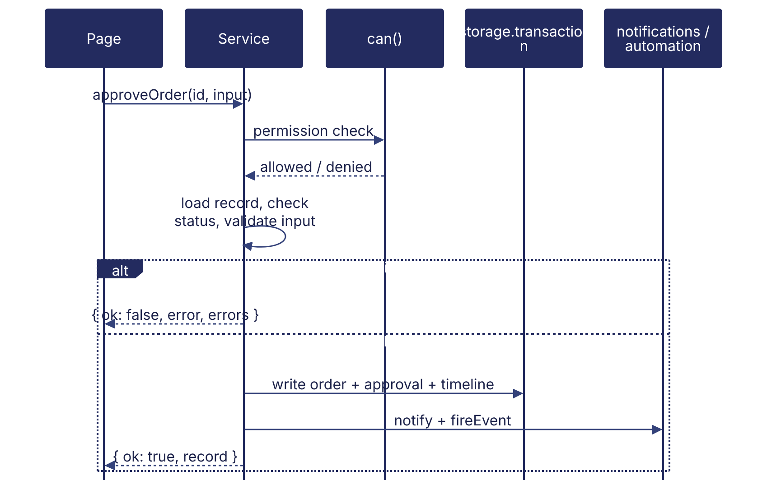

6. Validation design
- Field validation in validateX functions per service (services/validation.js shared helpers: required, email, phone, pincode, PAN, GSTIN, dates, numbers).
- Cross-record rules in the service (stock, credit, sequence, compliance).
- UI shows errors[field] beside the field and error as a toast.
- Production: the same rules in DRF serializers / service layer; the browser keeps its checks for usability only.

7. Error handling
Layer | Prototype | Production (PROPOSED)
Service | Structured { ok:false } results, never throws for business errors | Domain exceptions → HTTP 400 / 403 / 404 / 409 with error codes
Storage | JSON safety; corrupted key falls back to defaults; in-memory fallback when storage blocked; issues listed | DB constraints + transactions; retry on serialization failure
UI | Error boundary page, NotFound, Unauthorized, toasts | Same + API error mapping, offline banner in mobile app
Integrations | Simulated statuses (SENT_DEMO, FAILED_DEMO) | Retry with back-off, dead-letter queue, integration log

8. Data storage design — VERIFIED
storageService is the only module that touches browser storage: key registry (STORAGE_KEYS), versioning (APP_DATA_VERSION 8) and migrations, seed on first load, read cache, change subscription, transactions, export / import with validation, reset to demo data, usage report. Detail: BM-DAT-001 (Current Prototype Data Model (LocalStorage)).

9. Integration components
services/integrationGateway.js calls an optional gateway when VITE_INTEGRATION_GATEWAY_URL is set; otherwise the simulators are used (emailService demo mode, openWAService mock, ocrService MOCK, aiProviderService DEMO, trackingService DEMO GPS, otpService). Gateway mode is NOT VERIFIED.

10. Detailed workflow logic
The exact rules per workflow are documented in BM-SYS-007 (Business Rules Catalogue) and the module FRDs; key algorithms:
Logic | Location | Summary
Approval checks | approvalService.getApprovalChecks | 6 checks with severity block / warn; credit block configurable
Suggested sequence | dispatchService.suggestSequence | Priority rank → pincode → order number
Stock deduction | utils/dispatchStock | Per line, once (stockDeducted), reversal once (stockReversed)
Start rules | deliveryService.startDelivery | Dispatch confirmed / in transit, date reached, next in sequence, single active stop
OTP | otpService | 6 digits, expiry, 5 attempts, invalidation on regenerate
Dispatch closing | deliveryService | COMPLETED if all delivered else PARTIALLY_DELIVERED
Compliance | complianceService | Expiry states and blocking rules
Dashboard filter | utils/dashboardFilter | Per-collection business date

11. Future backend service design — PROPOSED
Django app | Models (main) | Services | API prefix
accounts | User, Role, Permission, RolePermission, UserRole, LoginAttempt | auth, users, rbac | /api/v1/auth, /users, /roles
masterdata | Customer, CustomerLocation, Product, ProductCategory, Hub, Zone, ZonePincode, Supplier, Company | master data CRUD | /customers, /products, /hubs, /zones
orders | Order, OrderItem, OrderApproval, Consolidation, OrderEvent | order, approval, consolidation, credit | /orders
logistics | Driver, Vehicle, Dispatch, DispatchStop, Delivery, DeliveryItem, DeliveryOtp, ProofOfDelivery, DeliveryNote, TrackingSession, LocationPoint | dispatch, assignment, delivery, otp, tracking | /dispatches, /deliveries, /driver, /tracking
inventory | StockItem, StockMovement, StockReceipt, StockTransfer, StockAdjustment, ScrapRequest, ReplenishmentRequest | stock, scrap, replenishment | /inventory, /scrap
documents | DocumentType, Document, OcrResult, ComplianceRule | documents, OCR, compliance | /documents, /vms
billing | InvoiceTemplate, Invoice, InvoiceLine | invoice | /invoices
comms | Notification, MessageTemplate, Message, AutomationRule, CallLog | notify, email, whatsapp/sms, automation | /notifications, /messages
core | Setting, AuditLog, Sequence | settings, audit, numbering | /settings, /audit-logs
API detail: BM-API-001 (API Specification (Overview and Conventions)); tables: BM-DAT-002 (Proposed Production Database Design).

Revision history
Version | Date | Author | Description
1.0 | 2026-11-12 | Documentation team | Initial draft prepared from analysis of the bellomassi-premium-ui source code and existing project documents.

