Architecture Diagrams
Bellomassi Order-to-Delivery Management Platform
BM-ARC-003 · Version 1.0 · Draft — for client review
2026-11-12

Document control
Field | Value
Document title | Architecture Diagrams
Document ID | BM-ARC-003
Version | 1.0
Status | Draft — for client review
Category | System Architecture
Related module(s) | All modules
Document owner | Solution Architect
Prepared by | Project documentation team (AI-assisted draft prepared from source-code analysis)
Reviewed by | Pending — not yet reviewed
Approval | Not approved — awaiting client review (no approval has been given)
Created date | 2026-11-12
Last updated date | 2026-11-12
Status labels used in this document: VERIFIED (confirmed in the current source code or existing documents) · PROTOTYPE (works in the React/LocalStorage prototype with mock or simulated behaviour) · PROPOSED (recommended production design, not built) · PENDING CONFIRMATION (needs a client decision) · NOT IMPLEMENTED · NOT VERIFIED.

Purpose
Collect the architecture diagrams required for design review.

Scope
Context, component, application, logical, order processing, data flow, deployment, network, authentication, integration, driver delivery, customer app and RBAC diagrams.

Definitions
Other terms: see BM-GLO-001 (Project Glossary).

References
- BM-ARC-001 (High-Level Design (HLD))
- BM-ARC-002 (Low-Level Design (LLD))
- BM-DGM-001 (Diagram Catalogue and Visual Documentation)

Contents

  - System context diagram (DGM-19)

  - Component diagram (DGM-20)

  - Application / logical architecture diagram (DGM-01)

  - Order processing architecture (DGM-23)

  - Data flow diagram (DGM-12)

  - Deployment architecture diagram (DGM-13)

  - Network architecture (DGM-14)

  - Authentication flow diagram (DGM-15)

  - Integration architecture diagram (DGM-16)

  - Driver delivery architecture (DGM-21)

  - Customer application architecture (DGM-22)

  - RBAC diagram (DGM-10)

1. System context diagram (DGM-19)
Label: VERIFIED (actors) / PROPOSED (external systems)
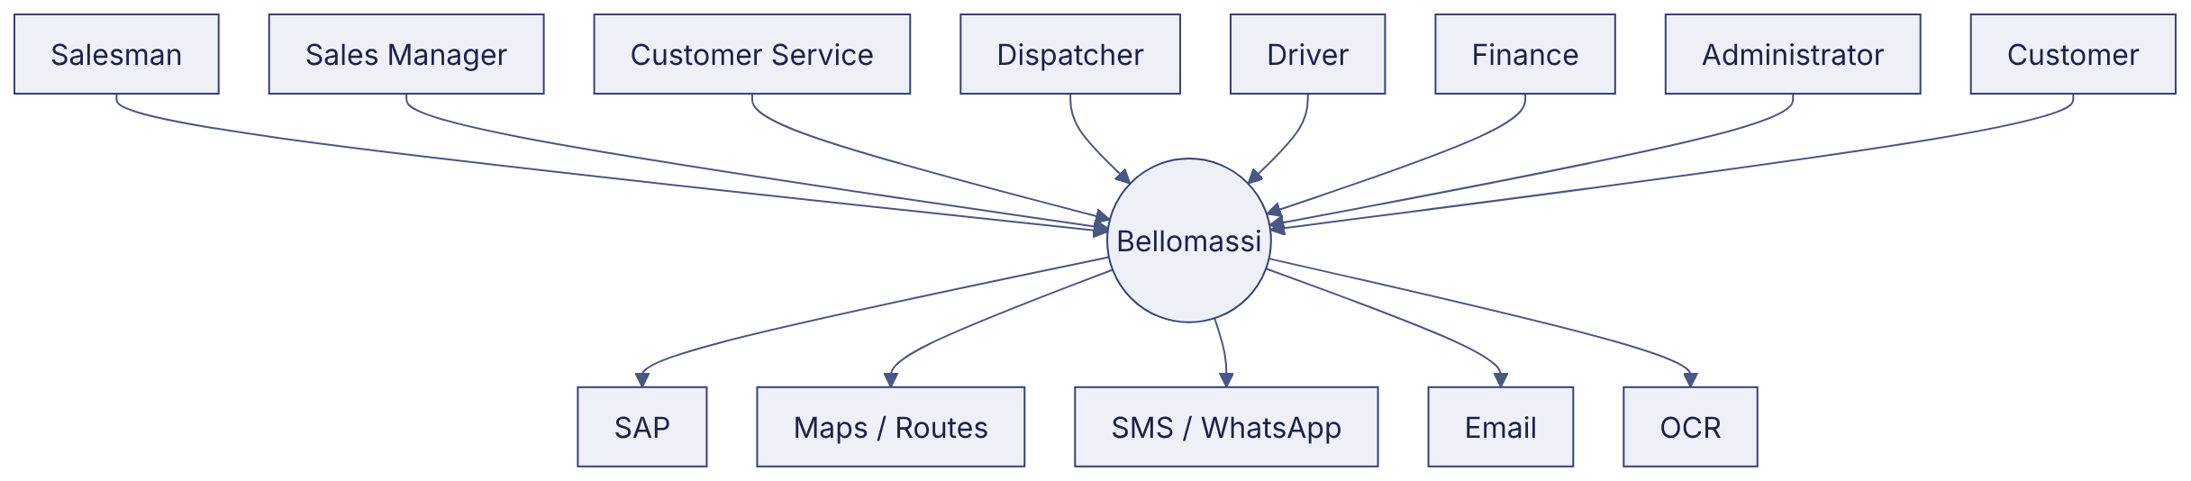

2. Component diagram (DGM-20)
Label: VERIFIED
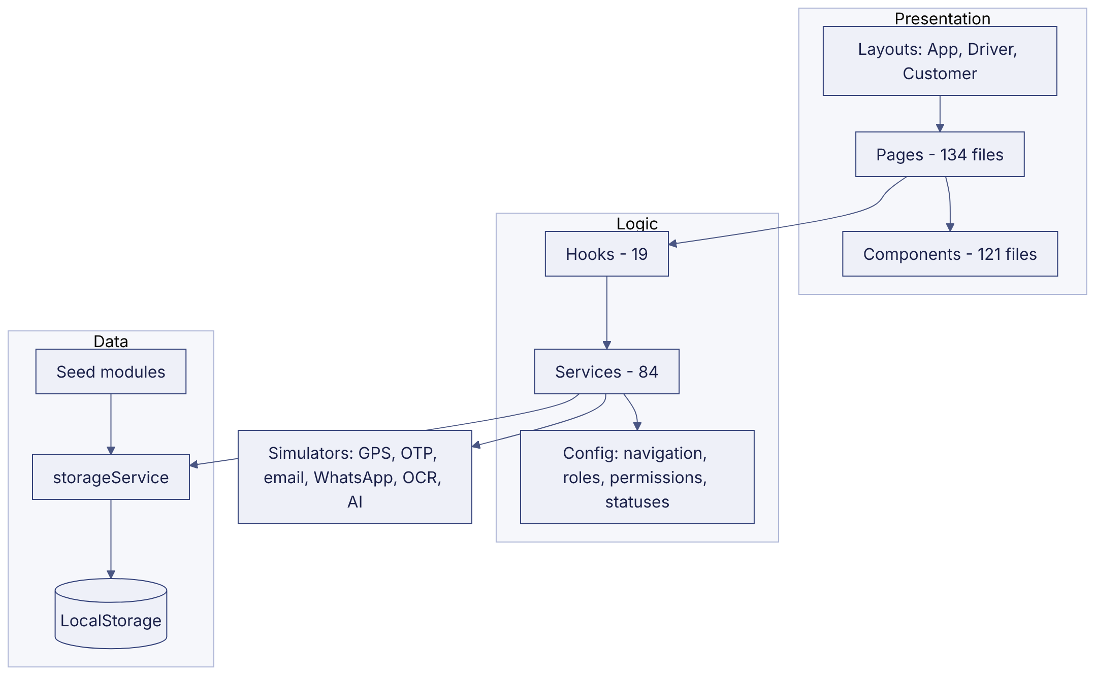

3. Application / logical architecture diagram (DGM-01)
Label: VERIFIED (prototype) / PROPOSED (target)
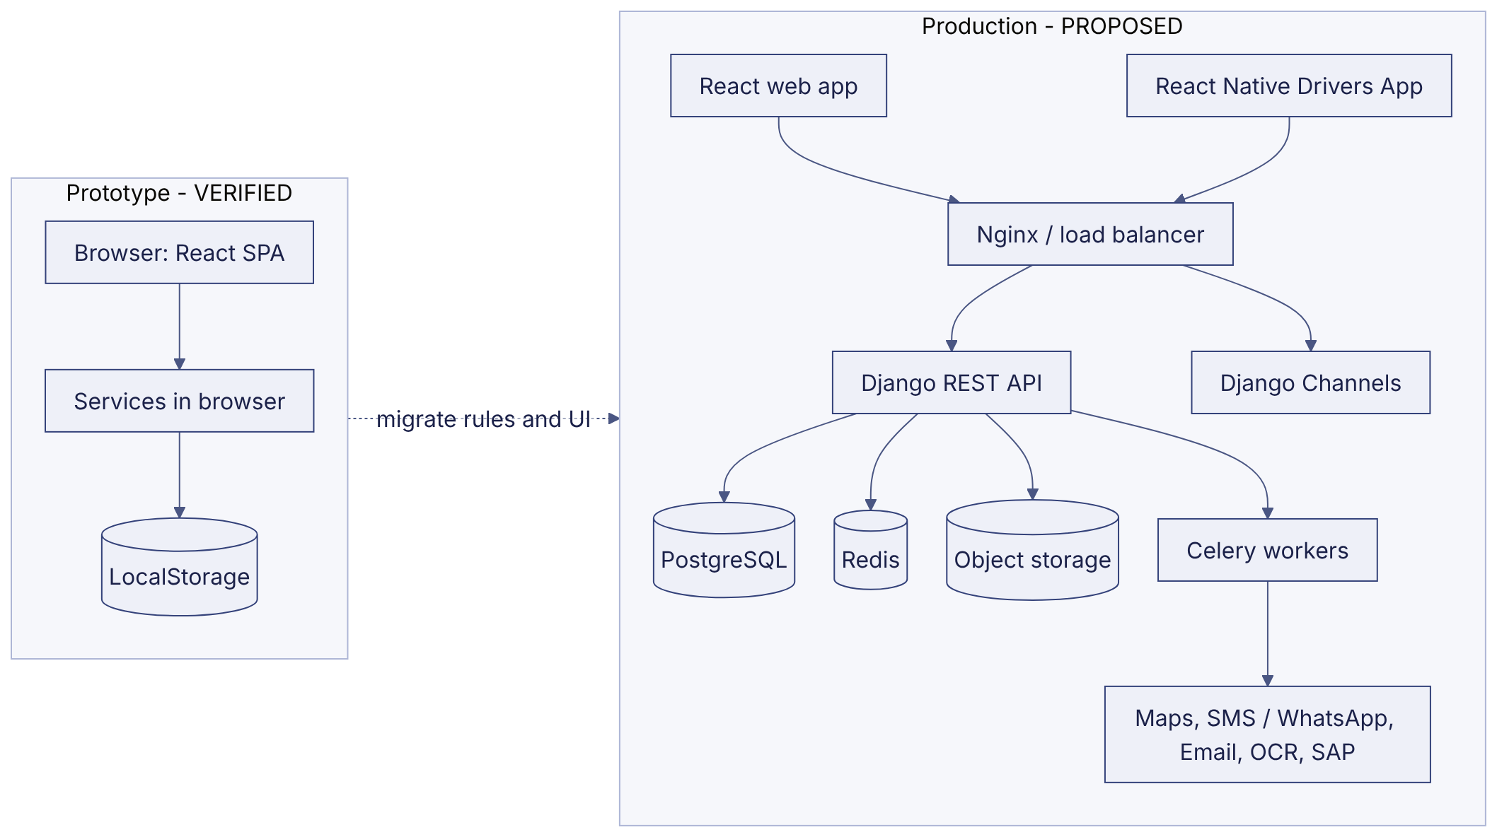

4. Order processing architecture (DGM-23)
Label: VERIFIED (logic) / PROPOSED (server)

5. Data flow diagram (DGM-12)
Label: PROPOSED
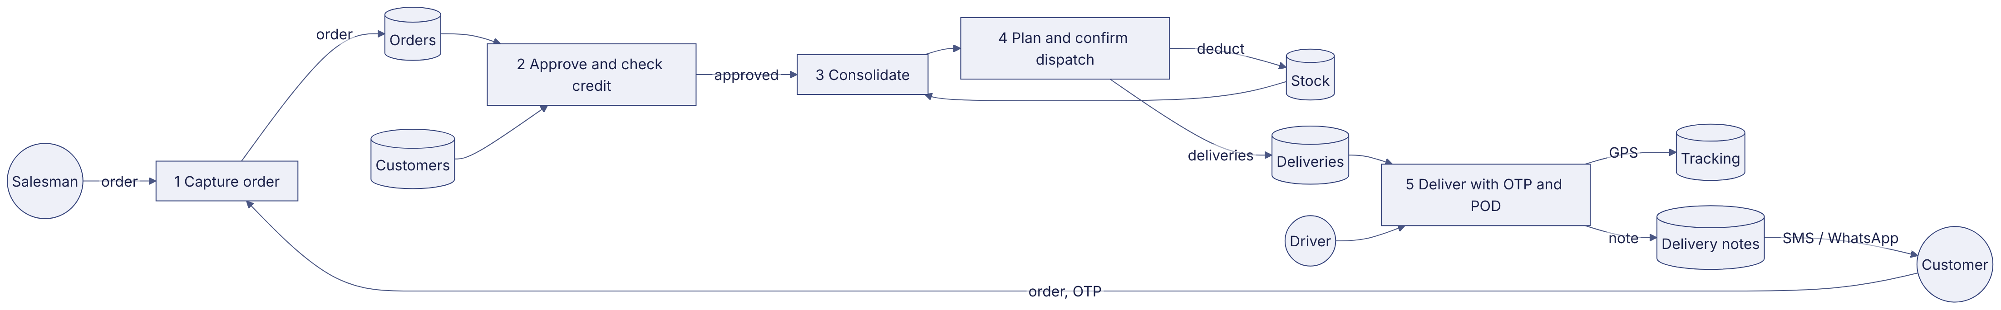

6. Deployment architecture diagram (DGM-13)
Label: PROPOSED
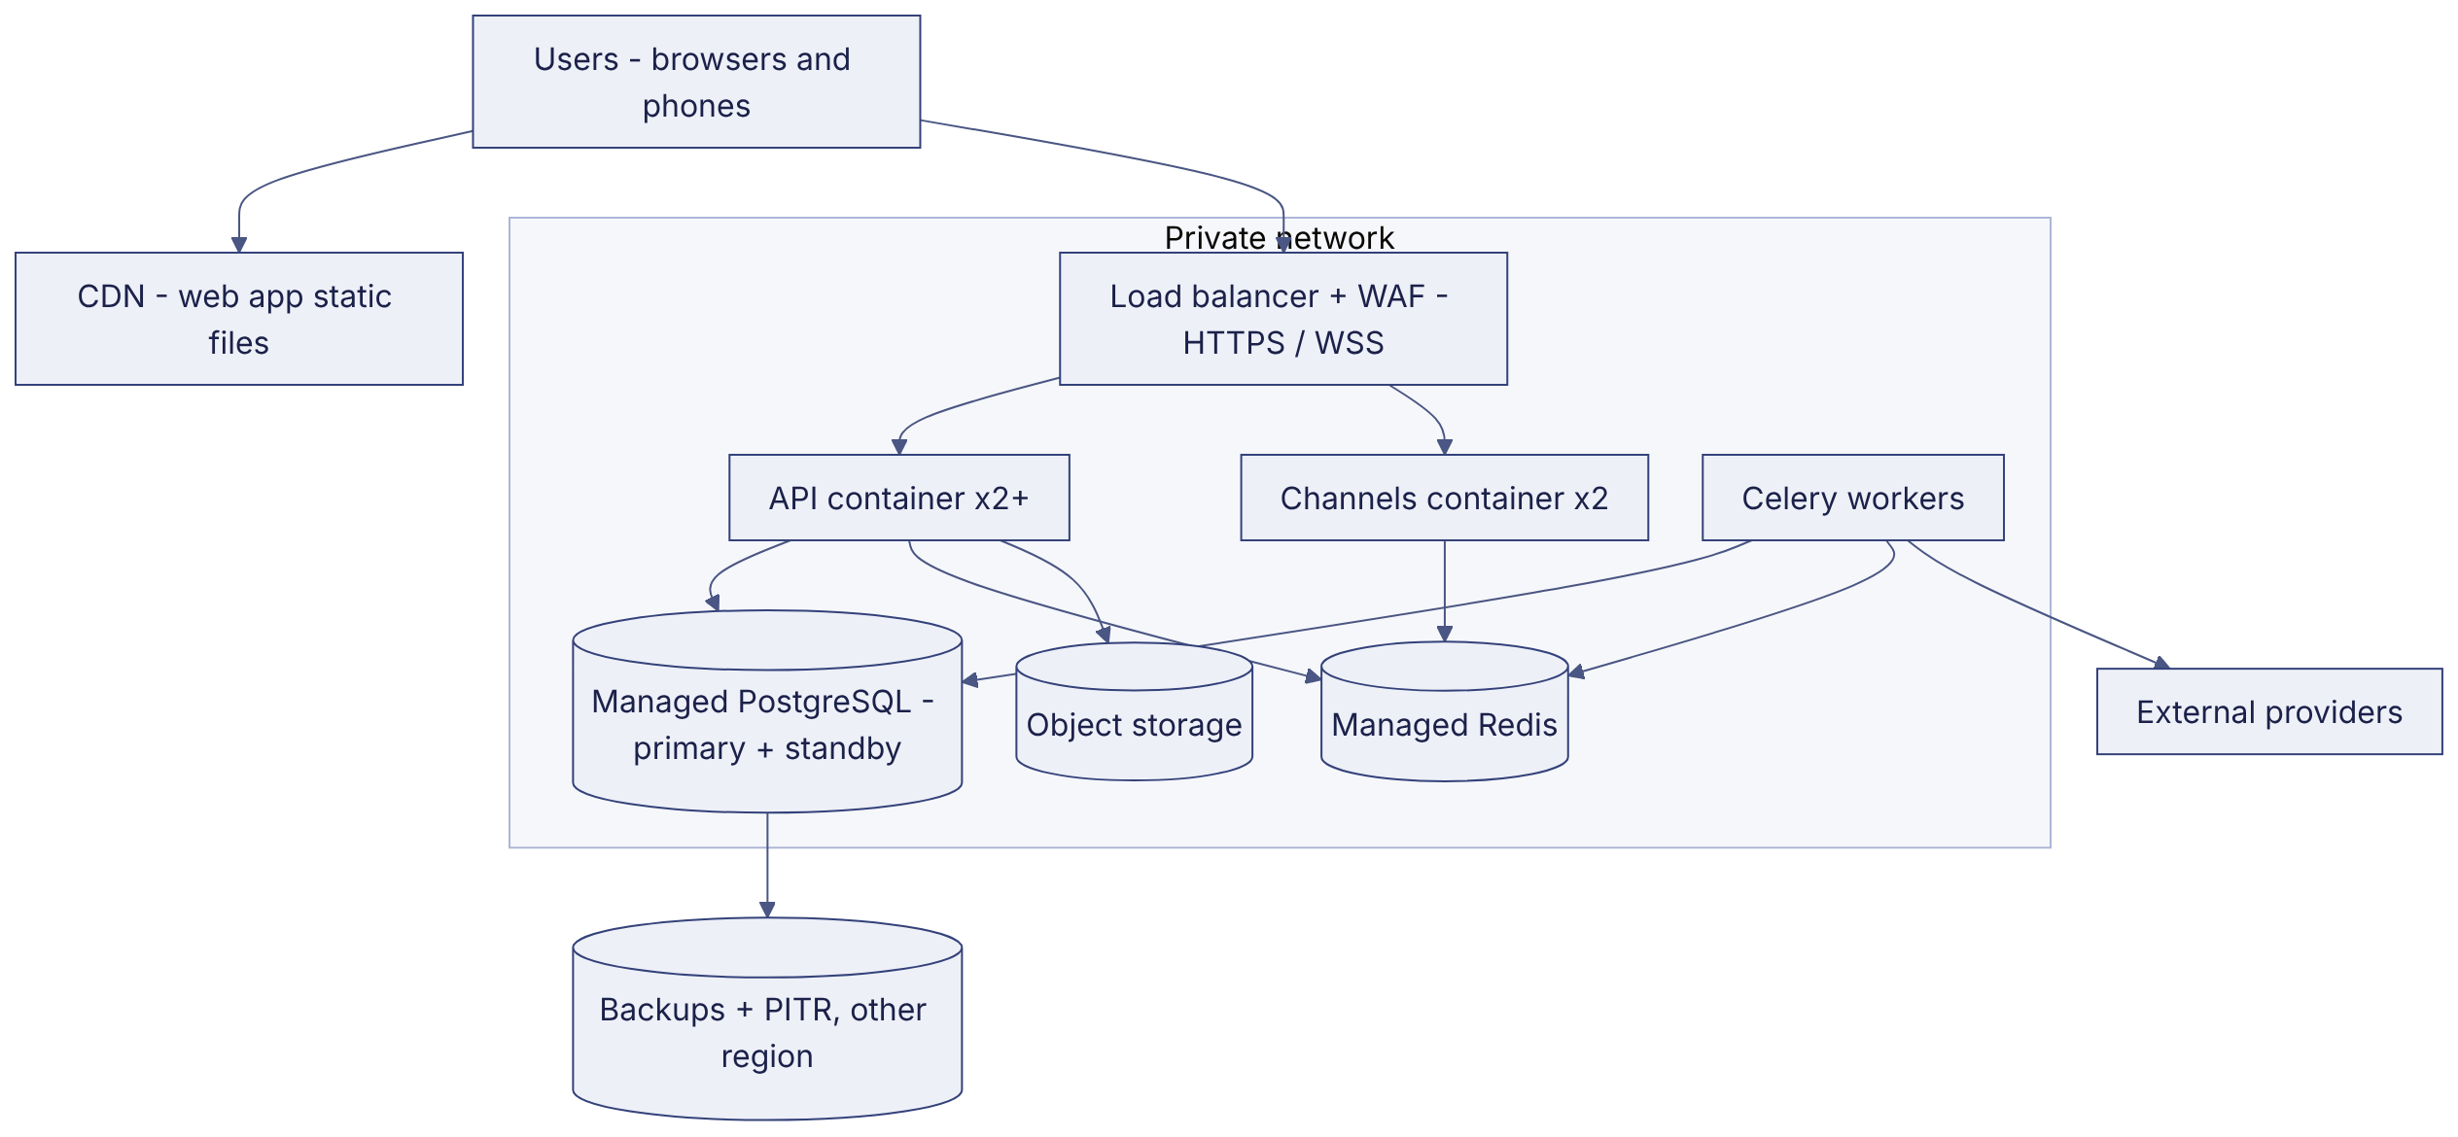

7. Network architecture (DGM-14)
Label: PROPOSED
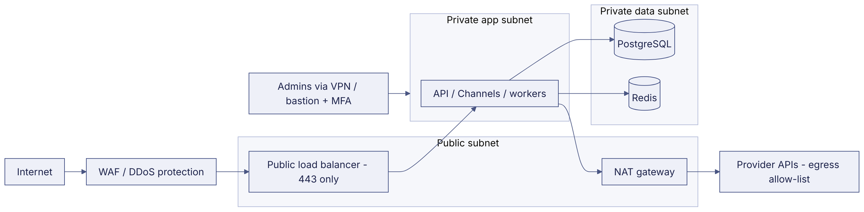

8. Authentication flow diagram (DGM-15)
Label: PROPOSED
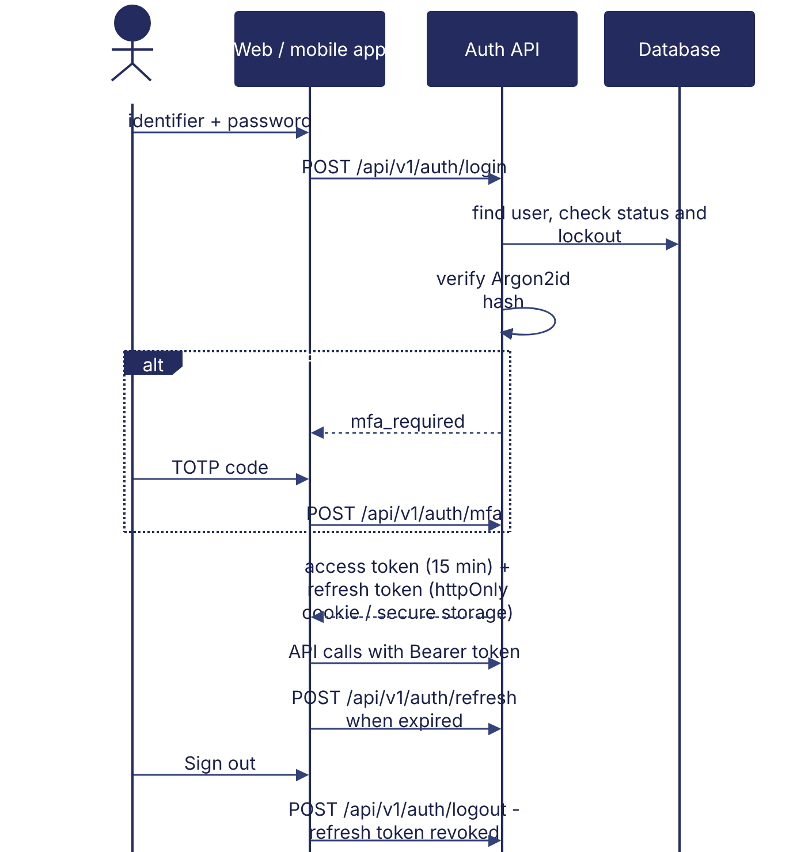

9. Integration architecture diagram (DGM-16)
Label: PROPOSED
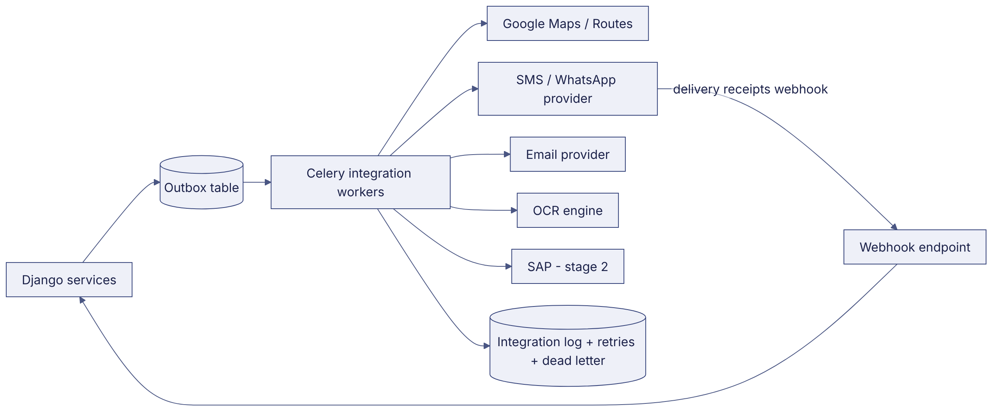

10. Driver delivery architecture (DGM-21)
Label: PROPOSED
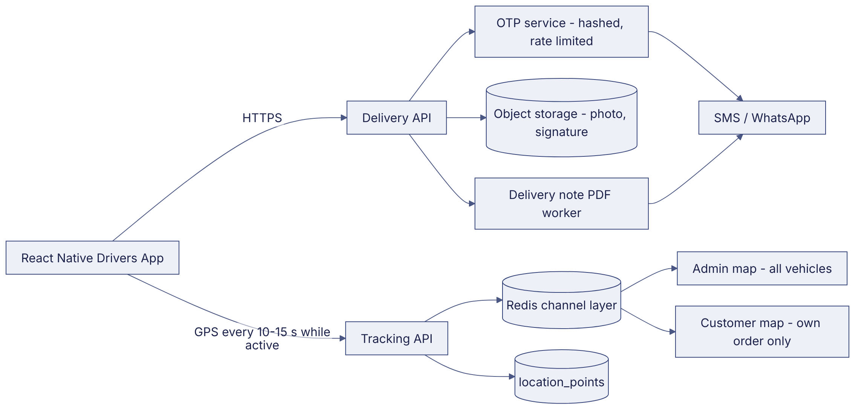

11. Customer application architecture (DGM-22)
Label: VERIFIED (prototype) / PROPOSED (production)
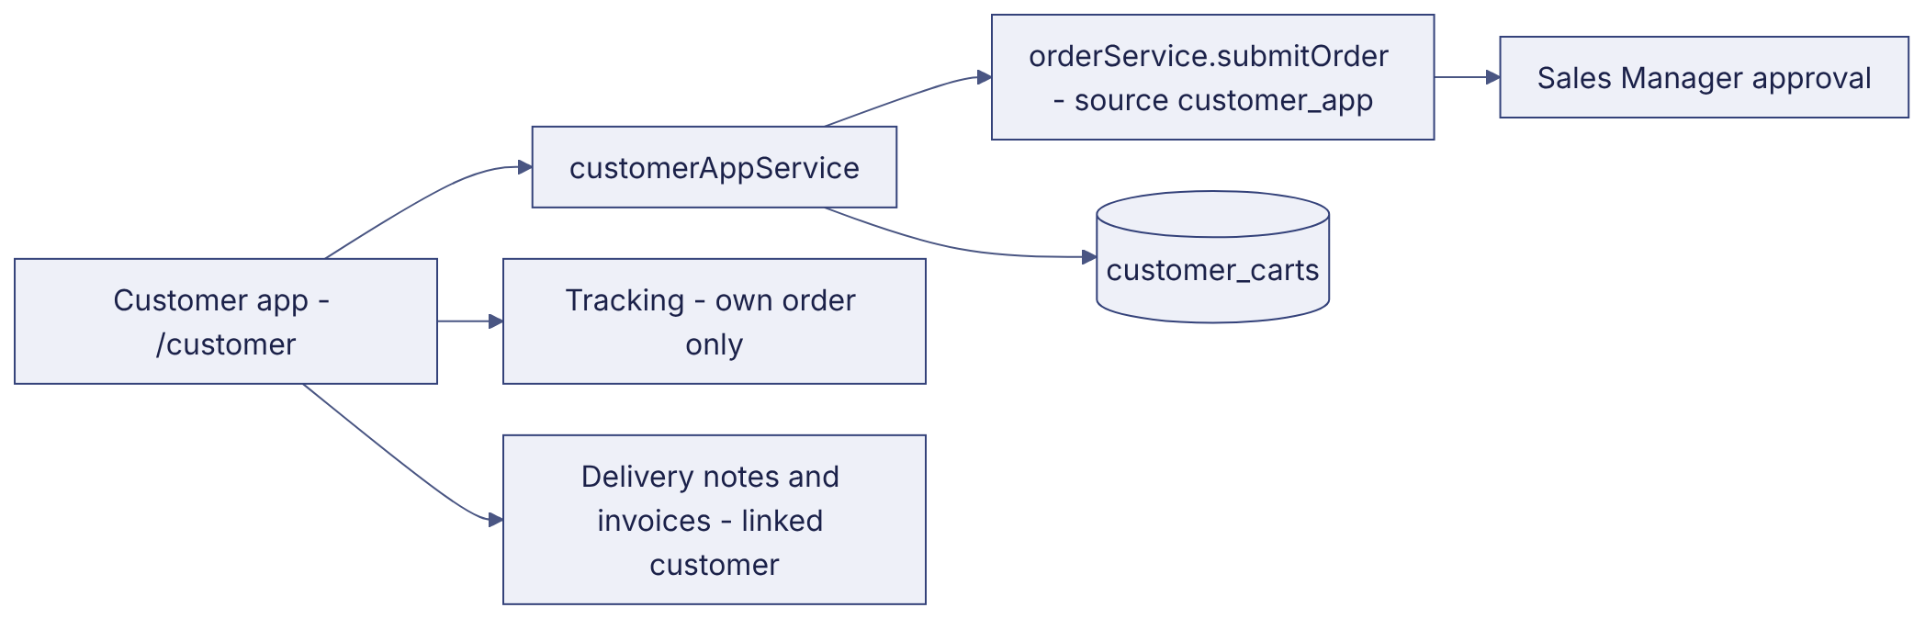

12. RBAC diagram (DGM-10)
Label: VERIFIED (prototype) / PROPOSED (server enforcement)
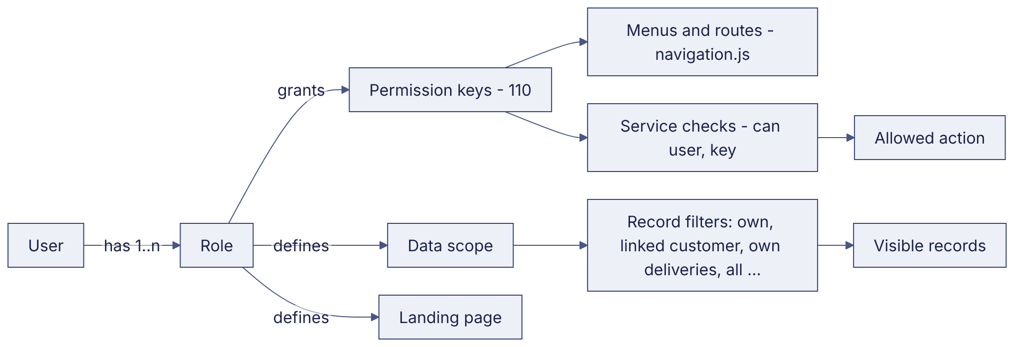

Revision history
Version | Date | Author | Description
1.0 | 2026-11-12 | Documentation team | Initial draft prepared from analysis of the bellomassi-premium-ui source code and existing project documents.

