Proposed Production Database Design
Bellomassi Order-to-Delivery Management Platform
BM-DAT-002 · Version 1.0 · Draft — for client review
2026-11-12

Document control
Field | Value
Document title | Proposed Production Database Design
Document ID | BM-DAT-002
Version | 1.0
Status | Draft — for client review
Category | Database and Data Design
Related module(s) | All modules
Document owner | Solution Architect
Prepared by | Project documentation team (AI-assisted draft prepared from source-code analysis)
Reviewed by | Pending — not yet reviewed
Approval | Not approved — awaiting client review (no approval has been given)
Created date | 2026-11-12
Last updated date | 2026-11-12
Status labels used in this document: VERIFIED (confirmed in the current source code or existing documents) · PROTOTYPE (works in the React/LocalStorage prototype with mock or simulated behaviour) · PROPOSED (recommended production design, not built) · PENDING CONFIRMATION (needs a client decision) · NOT IMPLEMENTED · NOT VERIFIED.

Purpose
Propose the PostgreSQL schema for the Django backend, derived from the prototype data objects. Nothing in this document exists yet — all content is PROPOSED.

Scope
50 tables in 7 domains with columns, keys, constraints, indexes, status, audit and soft-delete rules.

Definitions
Other terms: see BM-GLO-001 (Project Glossary).

References
- BM-DAT-003 (Data Dictionary (Proposed Production Schema))
- BM-DAT-001 (Current Prototype Data Model (LocalStorage))
- BM-DAT-004 (Data Migration Strategy)
- BM-DAT-005 (Data Retention Policy (Draft))
- BM-ARC-002 (Low-Level Design (LLD))
- BM-API-001 (API Specification (Overview and Conventions))

Contents

  - Design principles — PROPOSED

  - Table catalogue
- ER diagram — Identity and access
- ER diagram — Master data
- ER diagram — Orders
- ER diagram — Logistics
- ER diagram — Inventory
- ER diagram — Documents and billing
- ER diagram — Communication and platform
- Column definitions
- Constraints and indexes
- Status fields
- Audit fields and soft delete
- Data retention and migration

1. Design principles — PROPOSED
- PostgreSQL 16, Django ORM migrations; surrogate bigserial keys; business numbers unique.
- Every table has audit columns created_at, created_by_id, updated_at, updated_by_id.
- Master data uses soft delete (is_deleted, deleted_at); transactions are never deleted (cancel / status instead).
- Status columns are varchar with CHECK constraints listing the exact prototype status codes.
- Money numeric(14,2); quantities numeric(12,3); times timestamptz (UTC) displayed in the organisation time zone.
- Optimistic locking (version) on orders, dispatches and stock rows; SELECT … FOR UPDATE in stock and status transitions.
- Files in object storage; only keys stored in the database. OTPs stored hashed.
- GPS points partitioned by month; retention per BM-DAT-005 (Data Retention Policy (Draft)).

2. Table catalogue
Domain | Table | Django app | Prototype source | Description | Columns
Identity and access | users | accounts | bellomassi_demo_users | User accounts for all roles | 22
Identity and access | roles | accounts | bellomassi_roles | System and custom roles | 15
Identity and access | permissions | accounts | bellomassi_permissions | Permission catalogue (110 keys) | 8
Identity and access | role_permissions | accounts | bellomassi_roles.permissions | Permissions granted to a role | 7
Identity and access | user_roles | accounts | bellomassi_demo_users.roles | Roles assigned to a user | 8
Master data | company | core | bellomassi_company | Company profile | 13
Master data | hubs | masterdata | bellomassi_hubs | Fulfilment hubs / warehouses | 19
Master data | zones | masterdata | bellomassi_dispatch_zones | Delivery zones per hub | 11
Master data | zone_postal_codes | masterdata | bellomassi_dispatch_zones.pincodes | Pincodes of a zone | 7
Master data | customers | masterdata | bellomassi_customers | Customer accounts | 25
Master data | customer_locations | masterdata | bellomassi_customers.address* | Delivery locations of a customer | 18
Master data | product_categories | masterdata | bellomassi_products.category | Product categories | 6
Master data | products | masterdata | bellomassi_products | Item catalogue | 23
Master data | suppliers | masterdata | bellomassi_forecast_settings.suppliers | Suppliers | 12
Orders | orders | orders | bellomassi_orders | Sales orders | 32
Orders | order_items | orders | bellomassi_orders.items | Order lines | 13
Orders | order_approvals | orders | bellomassi_approvals | Approval decisions | 14
Orders | consolidations | orders | bellomassi_consolidations | Customer Service verification | 11
Orders | order_events | orders | bellomassi_order_timeline | Order timeline | 12
Logistics | drivers | logistics | bellomassi_drivers | Drivers | 18
Logistics | vehicles | logistics | bellomassi_vehicles | Vehicles | 16
Logistics | dispatches | logistics | bellomassi_dispatches | Vehicle runs | 21
Logistics | dispatch_stops | logistics | bellomassi_dispatches.orderIds/sequence | Orders on a dispatch in sequence | 9
Logistics | deliveries | logistics | bellomassi_deliveries | One delivery per order per dispatch | 24
Logistics | delivery_items | logistics | bellomassi_deliveries.items | Delivered quantities per line | 12
Logistics | delivery_otps | logistics | bellomassi_delivery_otps | Delivery OTPs | 12
Logistics | proofs_of_delivery | logistics | bellomassi_delivery_pod | POD evidence | 10
Logistics | delivery_notes | logistics | bellomassi_delivery_notes | Delivery notes | 11
Logistics | tracking_sessions | logistics | bellomassi_driver_tracking | GPS tracking per delivery | 12
Logistics | location_points | logistics | (not stored in prototype) | GPS points (partitioned by month) | 12
Inventory | stock_items | inventory | bellomassi_inventory | Stock per product per hub | 14
Inventory | stock_movements | inventory | bellomassi_stock_movements | Movement ledger | 13
Inventory | stock_receipts | inventory | bellomassi_stock_receipts | Goods receipts | 12
Inventory | stock_transfers | inventory | bellomassi_stock_transfers | Inter-hub transfers | 12
Inventory | stock_adjustments | inventory | bellomassi_stock_adjustments | Stock adjustments | 12
Inventory | scrap_requests | inventory | bellomassi_scrap_requests | Scrap requests | 18
Inventory | replenishment_requests | inventory | bellomassi_replenishment_drafts | Purchase requests | 12
Documents and billing | document_types | documents | bellomassi_document_types | Document types | 14
Documents and billing | documents | documents | bellomassi_documents | Stored documents | 23
Documents and billing | ocr_results | documents | bellomassi_ocr_results | OCR extraction results | 10
Documents and billing | invoice_templates | billing | bellomassi_invoice_templates | Invoice templates | 12
Documents and billing | invoices | billing | bellomassi_invoices | Customer invoices (scope to confirm) | 16
Communication and platform | notifications | comms | bellomassi_notifications | In-app notifications | 12
Communication and platform | message_templates | comms | bellomassi_email_templates / whatsapp_templates | Email / WhatsApp / SMS templates | 12
Communication and platform | messages | comms | bellomassi_email_history / whatsapp_messages | Outbound messages | 14
Communication and platform | automation_rules | comms | bellomassi_notification_templates | Event rules | 11
Communication and platform | call_logs | comms | bellomassi_call_history | Call history | 17
Communication and platform | settings | core | bellomassi_settings | Application settings | 8
Communication and platform | sequences | core | bellomassi_order_sequence / dispatch_sequence … | Document number sequences | 9
Communication and platform | audit_logs | core | bellomassi_audit_logs | Audit trail (append-only) | 13

ER diagram — Identity and access
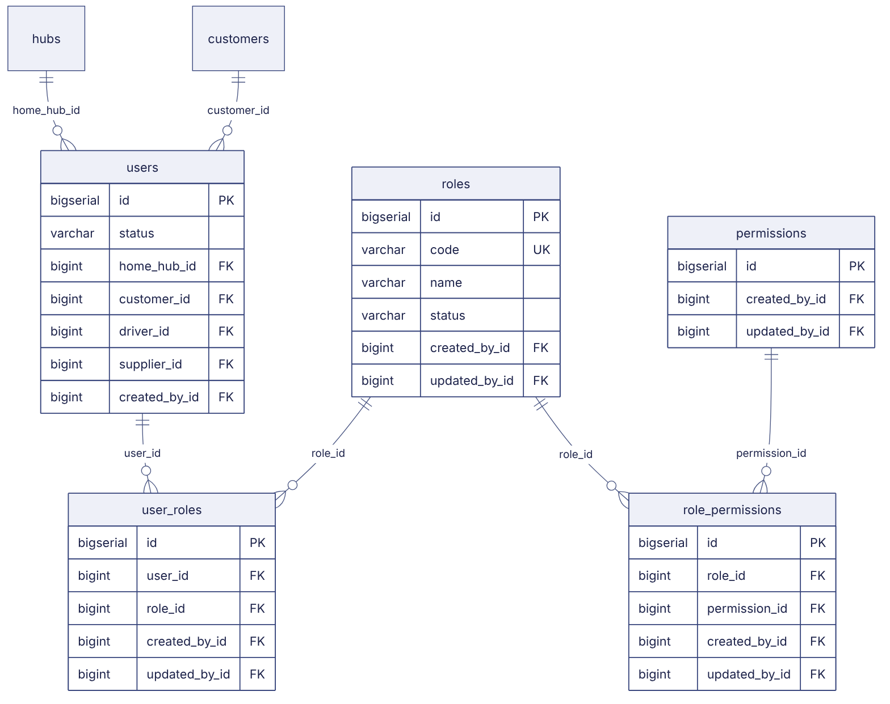

ER diagram — Master data
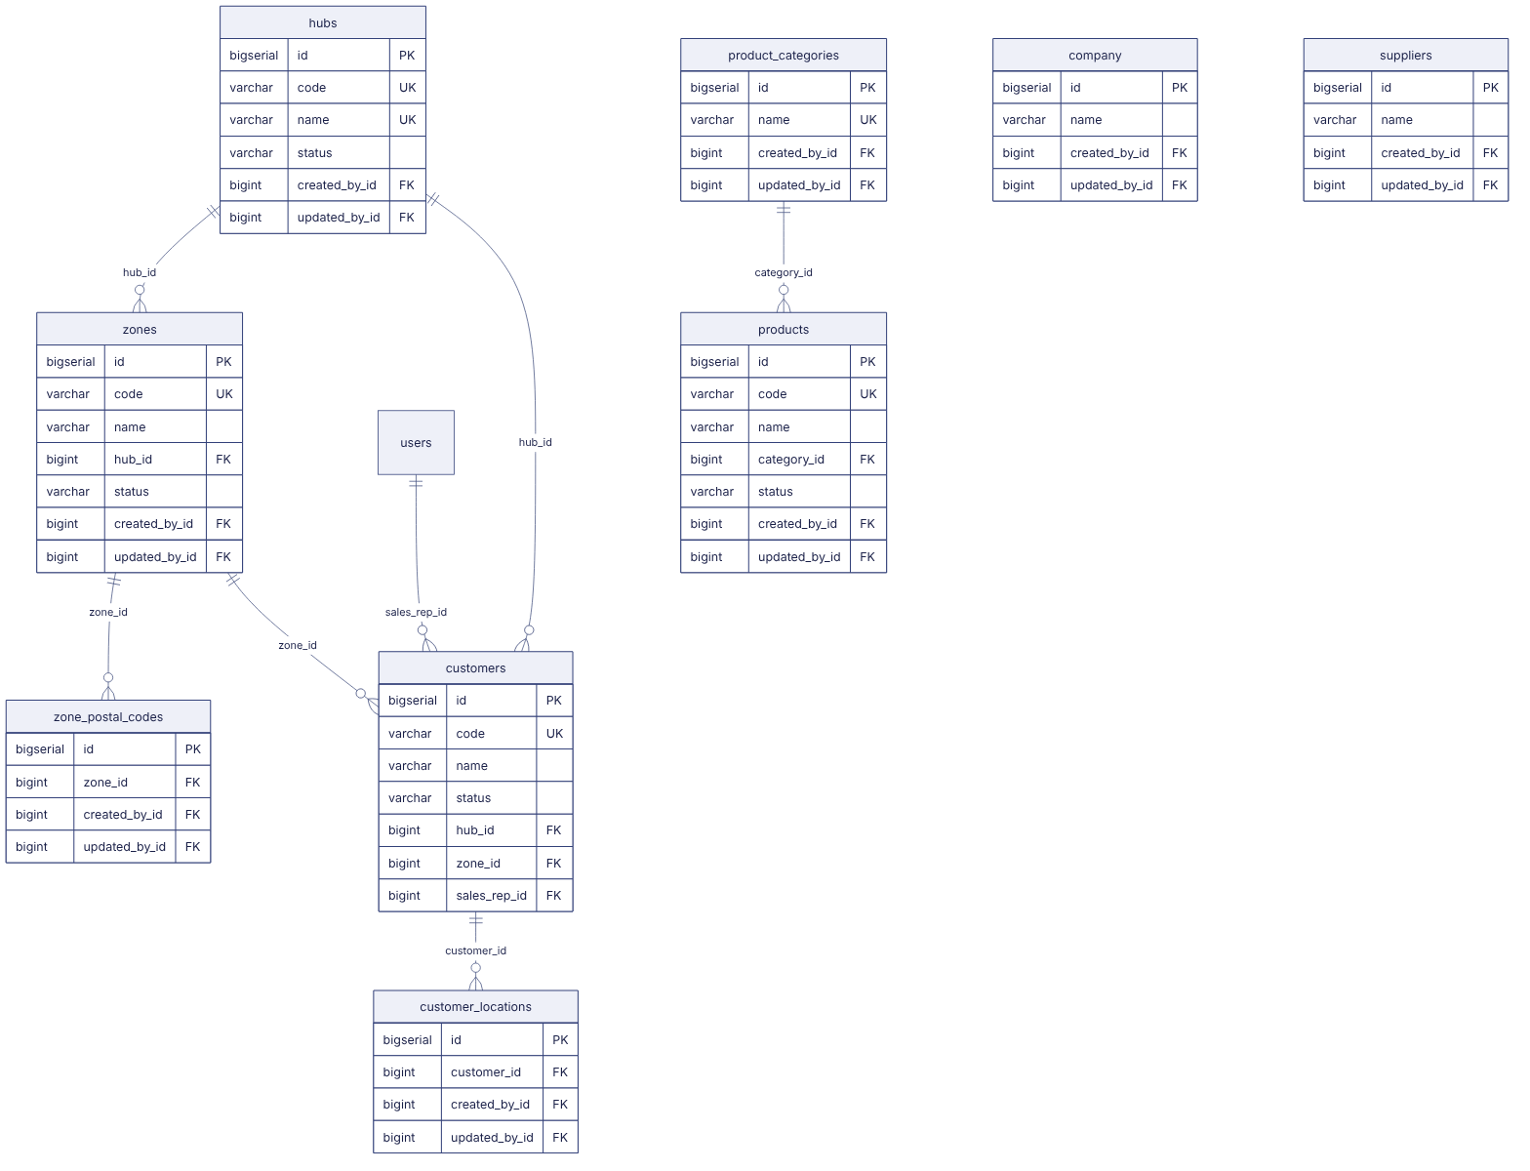

ER diagram — Orders
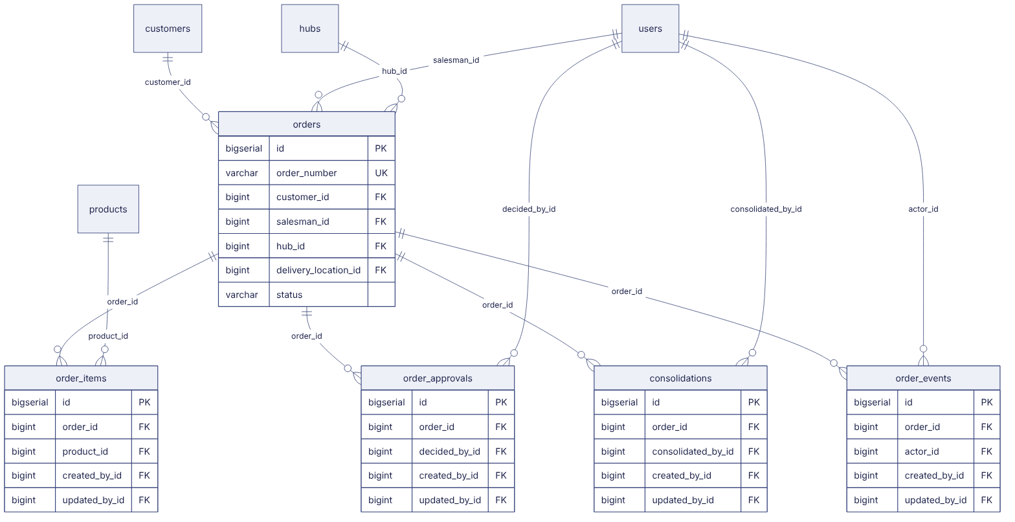

ER diagram — Logistics
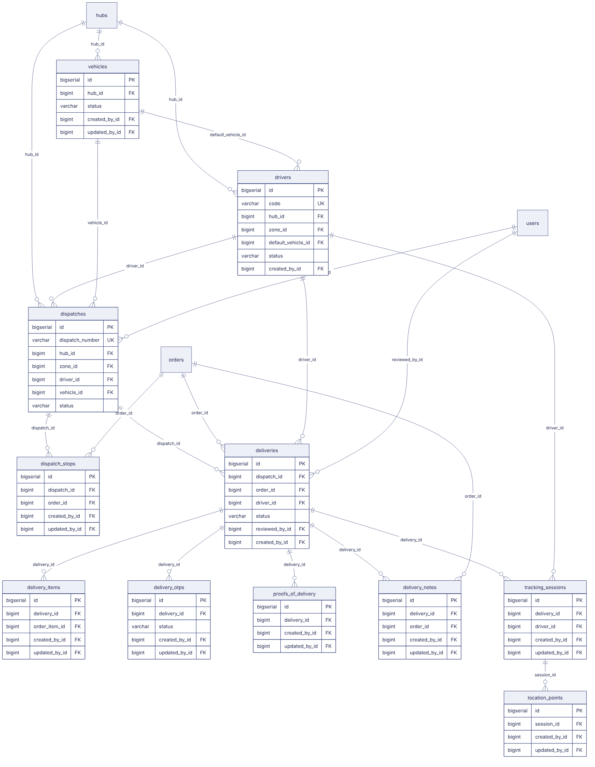

ER diagram — Inventory
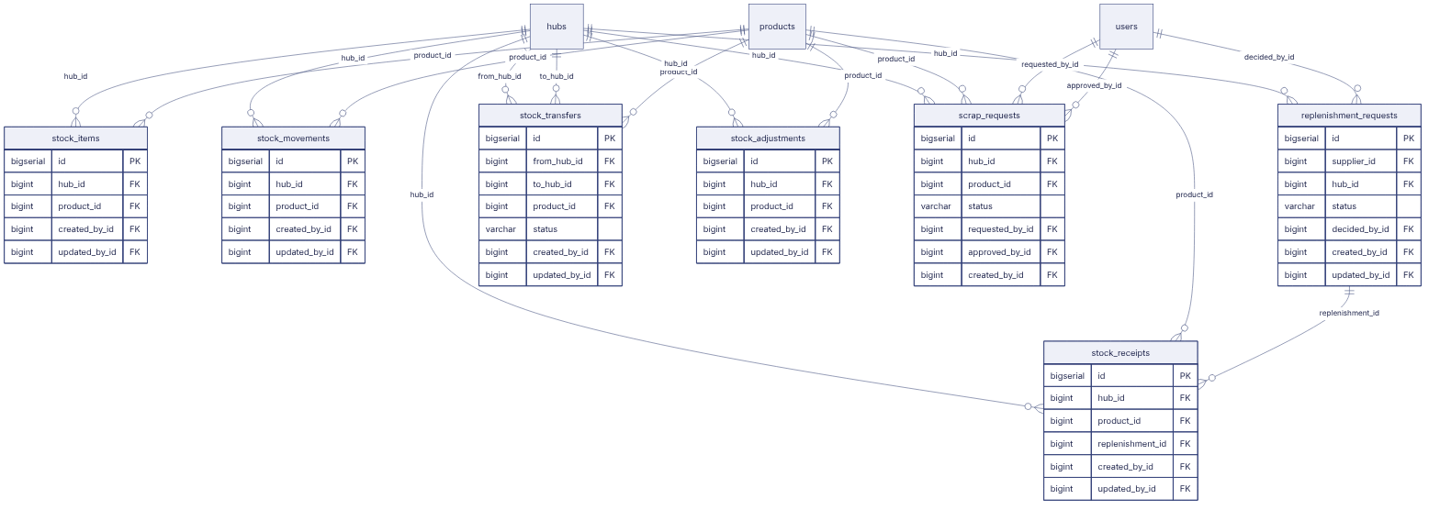

ER diagram — Documents and billing
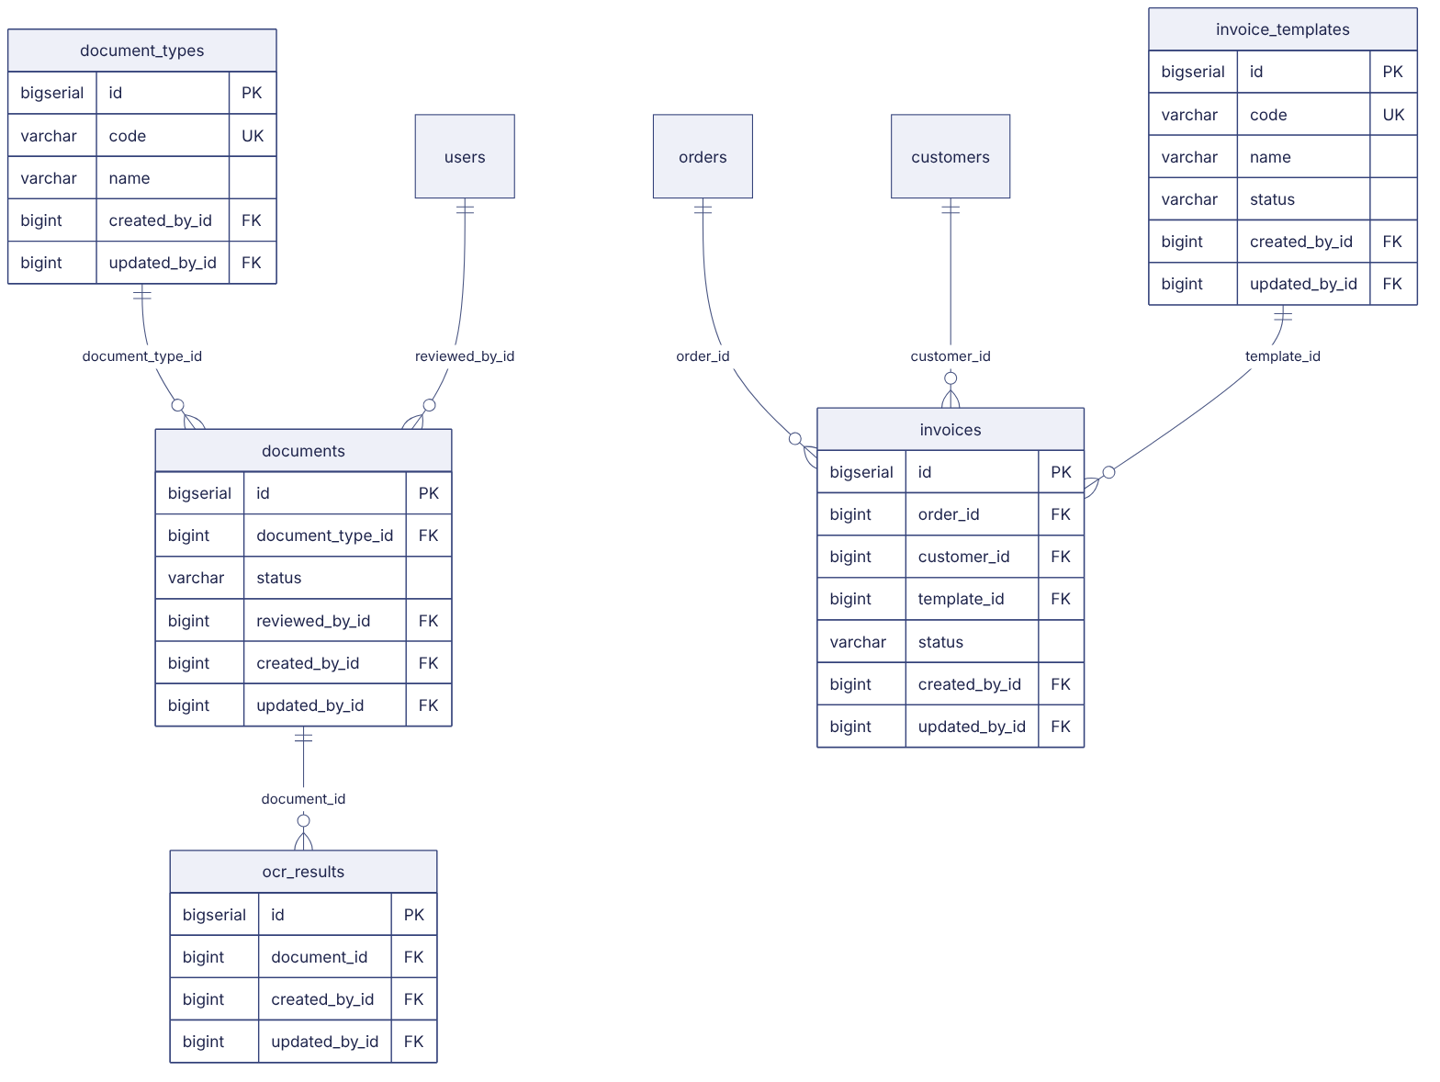

ER diagram — Communication and platform
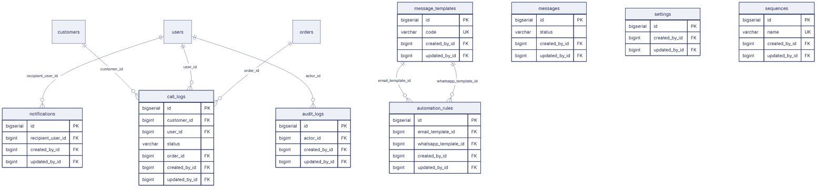

Column definitions
All columns with type, keys and constraints are in BM-DAT-003 (Data Dictionary (Proposed Production Schema)). Summary of keys per table:
Table | Primary key | Foreign keys | Unique | Indexed
users | id | home_hub_id→hubs, customer_id→customers, driver_id→drivers, supplier_id→suppliers | username, email | phone
roles | id | — | code | —
permissions | id | — | key | —
role_permissions | id | role_id→roles, permission_id→permissions | — | —
user_roles | id | user_id→users, role_id→roles | — | —
company | id | — | — | —
hubs | id | — | code, name | —
zones | id | hub_id→hubs | code | —
zone_postal_codes | id | zone_id→zones | — | postal_code
customers | id | hub_id→hubs, zone_id→zones, sales_rep_id→users | code, sap_customer_no | —
customer_locations | id | customer_id→customers | — | —
product_categories | id | — | name | —
products | id | category_id→product_categories | code, sku, barcode, sap_material_no | —
suppliers | id | — | — | —
orders | id | customer_id→customers, salesman_id→users, hub_id→hubs, delivery_location_id→customer_locations | order_number | requested_delivery_date, status
order_items | id | order_id→orders, product_id→products | — | —
order_approvals | id | order_id→orders, decided_by_id→users | — | —
consolidations | id | order_id→orders, consolidated_by_id→users | order_id | —
order_events | id | order_id→orders, actor_id→users | — | —
drivers | id | hub_id→hubs, zone_id→zones, default_vehicle_id→vehicles | code, mobile, employee_no, licence_no | —
vehicles | id | hub_id→hubs | registration_no | —
dispatches | id | hub_id→hubs, zone_id→zones, driver_id→drivers, vehicle_id→vehicles, confirmed_by_id→users | dispatch_number | dispatch_date, status
dispatch_stops | id | dispatch_id→dispatches, order_id→orders | — | —
deliveries | id | dispatch_id→dispatches, order_id→orders, driver_id→drivers, reviewed_by_id→users | delivery_number | status
delivery_items | id | delivery_id→deliveries, order_item_id→order_items | — | —
delivery_otps | id | delivery_id→deliveries | — | —
proofs_of_delivery | id | delivery_id→deliveries | delivery_id | —
delivery_notes | id | delivery_id→deliveries, order_id→orders | note_number, delivery_id | —
tracking_sessions | id | delivery_id→deliveries, driver_id→drivers | — | —
location_points | id | session_id→tracking_sessions | — | recorded_at
stock_items | id | hub_id→hubs, product_id→products | — | —
stock_movements | id | hub_id→hubs, product_id→products | — | occurred_at
stock_receipts | id | hub_id→hubs, product_id→products, replenishment_id→replenishment_requests | receipt_number | —
stock_transfers | id | from_hub_id→hubs, to_hub_id→hubs, product_id→products | transfer_number | —
stock_adjustments | id | hub_id→hubs, product_id→products | adjustment_number | —
scrap_requests | id | hub_id→hubs, product_id→products, requested_by_id→users, approved_by_id→users | request_number | —
replenishment_requests | id | supplier_id→suppliers, hub_id→hubs, decided_by_id→users | request_number | —
document_types | id | — | code | —
documents | id | document_type_id→document_types, reviewed_by_id→users | — | entity_id, expiry_date
ocr_results | id | document_id→documents | — | —
invoice_templates | id | — | code | —
invoices | id | order_id→orders, customer_id→customers, template_id→invoice_templates | invoice_number | —
notifications | id | recipient_user_id→users | — | recipient_role
message_templates | id | — | code | —
messages | id | — | — | —
automation_rules | id | email_template_id→message_templates, whatsapp_template_id→message_templates | event | —
call_logs | id | customer_id→customers, user_id→users, order_id→orders | — | —
settings | id | — | — | —
sequences | id | — | name | —
audit_logs | id | actor_id→users | — | action, occurred_at

Constraints and indexes
Constraint | Definition
Status checks | orders.status IN (DRAFT, SUBMITTED, RETURNED, REJECTED, APPROVED, CONSOLIDATED, READY_FOR_DISPATCH, DISPATCHED, OUT_FOR_DELIVERY, PARTIALLY_DELIVERED, DELIVERED, DELIVERY_FAILED, RETURNED_TO_HUB); similar for dispatches, deliveries, OTPs, scrap, documents, invoices
One active invoice per order | Partial unique index invoices(order_id) WHERE status = 'ISSUED'
One open scrap per hub+product+source | Partial unique index on scrap_requests where status in (DRAFT, PENDING_APPROVAL, APPROVED)
One stock row per hub+product | Unique (hub_id, product_id) on stock_items
Unique stop | Unique (dispatch_id, order_id) and (dispatch_id, sequence) on dispatch_stops
One active dispatch per order | Partial unique on dispatch_stops(order_id) joined to non-cancelled dispatch (enforced in service + trigger)
Zone name per hub | Unique (hub_id, name) on zones
Non-negative stock | CHECK total_qty >= 0 unless product allows negative (service-level)
Scrap approver ≠ requester | CHECK approved_by_id <> requested_by_id
Frequent queries | Indexes on orders(status, requested_delivery_date), orders(salesman_id, status), deliveries(driver_id, status), dispatches(dispatch_date, status), stock_movements(hub_id, product_id, occurred_at), documents(expiry_date), audit_logs(occurred_at)

Status fields
Exact values: BM-GLO-003 (Quick Reference Card). They are identical to the prototype so that the frontend status metadata can be reused.

Audit fields and soft delete
Audit columns on every table; audit_logs is append-only (no UPDATE / DELETE grants for the application role). Soft delete on: users, roles, hubs, zones, customers, customer_locations, products, suppliers, documents, templates, call logs. Business transactions (orders, dispatches, deliveries, movements, invoices) are never deleted; drafts may be hard-deleted by their owner.

Data retention and migration
See BM-DAT-005 (Data Retention Policy (Draft)) and BM-DAT-004 (Data Migration Strategy).

Revision history
Version | Date | Author | Description
1.0 | 2026-11-12 | Documentation team | Initial draft prepared from analysis of the bellomassi-premium-ui source code and existing project documents.

