Security Architecture
Bellomassi Order-to-Delivery Management Platform
BM-SEC-002 · Version 1.0 · Draft — for client review
2026-11-12

Document control
Field | Value
Document title | Security Architecture
Document ID | BM-SEC-002
Version | 1.0
Status | Draft — for client review
Category | Security and Compliance
Related module(s) | All modules
Document owner | Security Architect
Prepared by | Project documentation team (AI-assisted draft prepared from source-code analysis)
Reviewed by | Pending — not yet reviewed
Approval | Not approved — awaiting client review (no approval has been given)
Created date | 2026-11-12
Last updated date | 2026-11-12
Status labels used in this document: VERIFIED (confirmed in the current source code or existing documents) · PROTOTYPE (works in the React/LocalStorage prototype with mock or simulated behaviour) · PROPOSED (recommended production design, not built) · PENDING CONFIRMATION (needs a client decision) · NOT IMPLEMENTED · NOT VERIFIED.

Purpose
Describe the layered security architecture of the production platform, including API security, encryption and monitoring.

Scope
PROPOSED production controls; prototype status for comparison.

Definitions
Other terms: see BM-GLO-001 (Project Glossary).

References
- BM-SEC-001 (Security Requirements Document)
- BM-ARC-001 (High-Level Design (HLD))
- BM-INF-010 (Infrastructure Security, Scalability and Cloud Migration Plan)

1. Layers
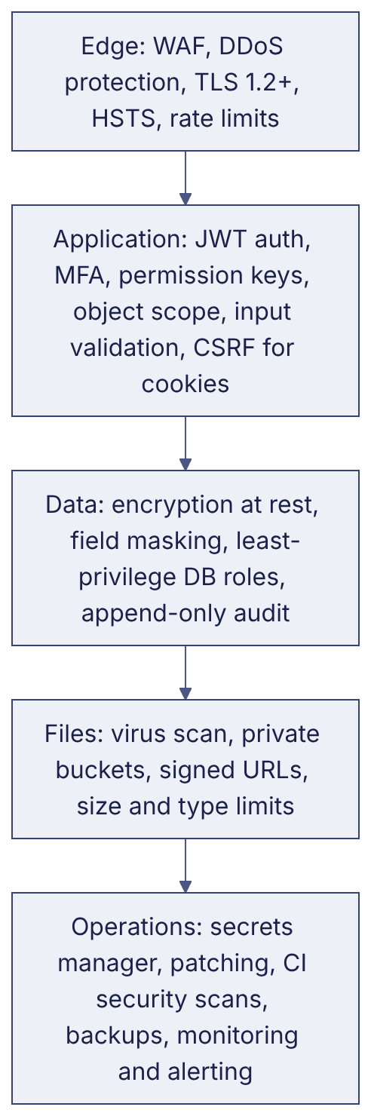

2. API security — PROPOSED
Control | Design
Authentication | Bearer JWT (15 min), refresh rotation, revocation list in Redis
Authorisation | DRF permission class per view mapped to permission keys; queryset scoped by role data scope
Input validation | Serializers with the prototype’s rules; reject unknown fields
Output filtering | Never return password hashes, OTP values, secrets; mask phone / tax IDs for roles that do not need them
Rate limiting | Login 5/min/IP, OTP verify 5 per OTP, regenerate 3/10 min, general 600/min/user
CORS | Allow-list of web origins only
Idempotency | Keys on state-changing workflow endpoints
Error handling | No stack traces; correlation ID in responses
Webhooks | HMAC signature + timestamp tolerance

3. Encryption
Data | In transit | At rest
API / WebSocket | TLS 1.2+ | —
PostgreSQL | TLS between app and DB | Storage encryption (provider KMS / LUKS on-premises)
Object storage | TLS | Server-side encryption (KMS)
Backups | TLS | Encrypted with separate key
Secrets | TLS | Secrets manager (KMS)
Mobile app | TLS with certificate validation | Tokens in Keychain / Keystore

4. Monitoring
Security events (failed logins, lockouts, permission changes, role grants, exports, OTP lock-outs, webhook failures) forwarded to the central log platform with alerts — see BM-SEC-008 (Audit Logging and Security Monitoring Policy).

5. Prototype comparison
None of these controls exist in the prototype except the permission model, lockout / idle-timeout logic and the audit log — all running client-side (PROTOTYPE).

Revision history
Version | Date | Author | Description
1.0 | 2026-11-12 | Documentation team | Initial draft prepared from analysis of the bellomassi-premium-ui source code and existing project documents.

