UI/UX Design Document
Bellomassi Order-to-Delivery Management Platform
BM-UX-001 · Version 1.0 · Draft — for client review
2026-11-12

Document control
Field | Value
Document title | UI/UX Design Document
Document ID | BM-UX-001
Version | 1.0
Status | Draft — for client review
Category | UI/UX and Design
Related module(s) | All modules
Document owner | UX Designer
Prepared by | Project documentation team (AI-assisted draft prepared from source-code analysis)
Reviewed by | Pending — not yet reviewed
Approval | Not approved — awaiting client review (no approval has been given)
Created date | 2026-11-12
Last updated date | 2026-11-12
Status labels used in this document: VERIFIED (confirmed in the current source code or existing documents) · PROTOTYPE (works in the React/LocalStorage prototype with mock or simulated behaviour) · PROPOSED (recommended production design, not built) · PENDING CONFIRMATION (needs a client decision) · NOT IMPLEMENTED · NOT VERIFIED.

Purpose
Describe the user experience of the Bellomassi platform — users, principles, layouts and key journeys — as built in the prototype and as proposed for production.

Scope
Office web app, Driver app and Customer app. Current UI is VERIFIED from the prototype; production changes are PROPOSED.

Definitions
Other terms: see BM-GLO-001 (Project Glossary).

References
- Project doc: UI design system and dashboard filter
- src/styles/index.css, src/components/common, src/components/layout
- BM-UX-002 (Design System and Style Guide)
- BM-UX-003 (Information Architecture, Navigation and Sitemap)
- BM-UX-004 (Screen Inventory)
- BM-UX-005 (Screen Specifications)
- BM-UX-006 (Prototype Screenshot Gallery)
- BM-UX-007 (Mobile UX — Driver App and Customer App)
- BM-UX-008 (Accessibility and Responsive Design Guidelines)
- BM-UX-009 (UI Content, Messages and Status Display Standards)

1. Users and their main jobs
User | Device | Main jobs | Landing screen
Salesman | Laptop / tablet | Capture and submit orders, follow up returns | Dashboard
Sales Manager | Laptop | Approve, return or reject orders; watch credit | Dashboard → Order Approval
Customer Service | Desktop | Verify and consolidate approved orders | Dashboard → Consolidation
Dispatcher | Desktop (large screen) | Plan by zone, assign driver and vehicle, confirm dispatch, monitor, review exceptions | Dashboard
Driver | Phone | See today’s stops, navigate, arrive, OTP, POD, delivery note | Driver Today
Customer | Phone | Order from catalogue, track, view delivery notes and invoices | Customer Home
Finance | Desktop | Invoices, credit position | Dashboard
Admin / Super Admin | Desktop | Users, roles, settings, master data, audit | Dashboard
Warehouse / Inventory / QA | Desktop / tablet | Stock, scrap, inspections, documents | Role dashboard

2. Design principles (VERIFIED in the prototype)
- One record, one status — every order and delivery shows its status badge and timeline.
- Role-first — the menu, dashboard and landing page change by role; users see only what they can act on.
- Queues over searches — work screens are queues (pending approval, ready for dispatch, exceptions).
- Explain the blocker — checks (credit, stock, documents) are shown before the action, with the reason.
- Honest prototype — demo markers (DEMO PROTOTYPE, DEMO GPS, demo mode for email / WhatsApp) show what is simulated.
- Mobile for the field — driver and customer apps are thumb-friendly single-column layouts with bottom navigation.

3. Layouts
Layout | Structure | Screenshot
Office (AppLayout) | Collapsible grouped sidebar, header with breadcrumbs, global search, theme, notifications, profile | UX-DASH-SA
Driver (DriverLayout) | Navy header, cards, bottom navigation (Today, Deliveries, Route, Completed, Profile) | UX-DRV-DASH
Customer (CustomerLayout) | Header, cards, bottom navigation (Home, Catalog, Cart, Orders, Account) | UX-CUS-DASH
Sign-in | Split screen (office) / mobile card (driver, customer) with demo account selector | UX-LOGIN
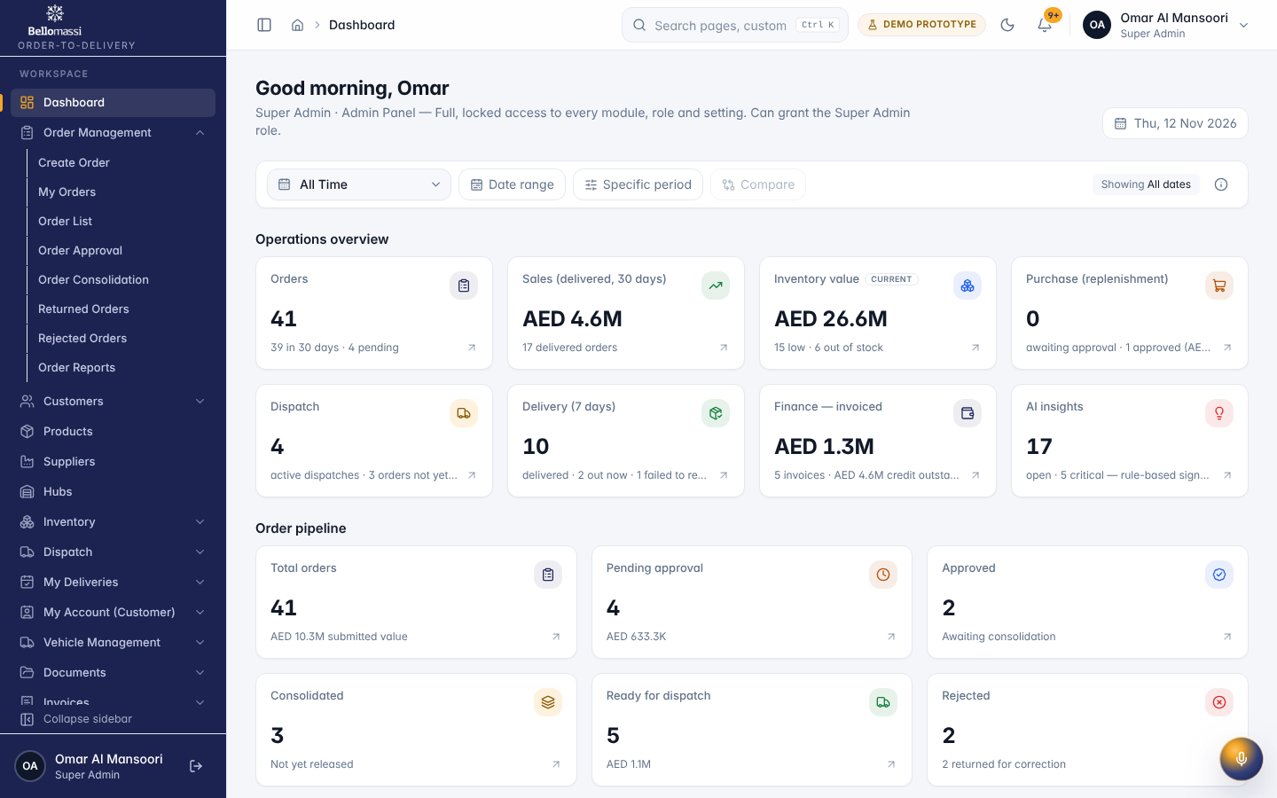

4. Key journeys
Journey | Screens (in order) | Spec
Create and submit order | Create Order → Preview → Submit → My Orders | UX-ORDER-CREATE, UX-MY-ORDERS
Approve order | Order Approval queue → Approval detail (6 checks) → Approve / Return / Reject | UX-APPROVAL, UX-APPROVAL-DETAIL
Consolidate | Consolidation queue → verify → Ready for dispatch | UX-CONSOLIDATION
Plan and dispatch | Ready Orders → Planning (zones) → Create dispatch → Confirm | UX-READY, UX-PLANNING, UX-DISPATCH-CREATE
Deliver | Driver Today → Delivery → Navigate → Arrive → OTP → POD → Delivery note | UX-DRV-DELIVERY, UX-DRV-ROUTE
Track | Delivery Tracking / Live Tracking; customer tracking | UX-TRACKING, UX-LIVE
Review exception | Delivery detail → return stock / re-queue | UX-DELIVERY-REVIEW
Customer order | Catalog → Cart → Submit → Orders → Track | UX-CUS-CATALOG, UX-CUS-CART
All screen specifications are in BM-UX-005 (Screen Specifications); the full screen list in BM-UX-004 (Screen Inventory).

5. Known UX gaps
ID | Gap | Label
UXG-01 | Zone planning is a list / filter view, not the drag-and-drop board described in the SOW | PARTIAL — PENDING CONFIRMATION
UXG-02 | Live tracking uses DEMO GPS, not real device positions | PROTOTYPE
UXG-03 | Driver app is a responsive web app, not a native React Native app (no background GPS, push notifications or offline mode) | NOT IMPLEMENTED (native)
UXG-04 | Address and phone formats are India-style (pincode, +91) while the company profile is Dubai / AED | PENDING CONFIRMATION
UXG-05 | No usability testing with real users has been carried out | NOT VERIFIED
UXG-06 | Arabic / RTL support not present | NOT IMPLEMENTED

Revision history
Version | Date | Author | Description
1.0 | 2026-11-12 | Documentation team | Initial draft prepared from analysis of the bellomassi-premium-ui source code and existing project documents.

