Screen Specifications
Bellomassi Order-to-Delivery Management Platform
BM-UX-005 · Version 1.0 · Draft — for client review
2026-11-12

Document control
Field | Value
Document title | Screen Specifications
Document ID | BM-UX-005
Version | 1.0
Status | Draft — for client review
Category | UI/UX and Design
Related module(s) | All modules
Document owner | UX Designer
Prepared by | Project documentation team (AI-assisted draft prepared from source-code analysis)
Reviewed by | Pending — not yet reviewed
Approval | Not approved — awaiting client review (no approval has been given)
Created date | 2026-11-12
Last updated date | 2026-11-12
Status labels used in this document: VERIFIED (confirmed in the current source code or existing documents) · PROTOTYPE (works in the React/LocalStorage prototype with mock or simulated behaviour) · PROPOSED (recommended production design, not built) · PENDING CONFIRMATION (needs a client decision) · NOT IMPLEMENTED · NOT VERIFIED.

Purpose
Specify the key screens: purpose, users, access, layout content, fields, actions and states, each with a real screenshot.

Scope
73 key screens captured from the running prototype (build of 2026-11-12, demo seed data). Remaining screens are listed in BM-UX-004.

Definitions
Other terms: see BM-GLO-001 (Project Glossary).

References
- Screenshots captured with Playwright from vite preview of the prototype
- src/config/navigation.js
- BM-UX-004 (Screen Inventory)
- BM-UX-006 (Prototype Screenshot Gallery)
- BM-FRD-ORD (Functional Requirements — Salesman Order Management)
- BM-SEC-005 (RBAC and Access Control Matrix)

Contents

  - How to read this document
- UX-DASH-SA — Dashboard
- UX-USERS — User Management
- UX-ROLES — Role Management
- UX-PERMS — Permission Matrix
- UX-AUDIT — Audit Log
- UX-SETTINGS — Application Settings
- UX-COMPANY — Company
- UX-CUSTOMERS — Customer List
- UX-CUSTOMER-DETAIL — Customer Details
- UX-CREDIT — Customer Credit
- UX-PRODUCTS — Products
- UX-HUBS — Hubs
- UX-SUPPLIERS — Suppliers
- UX-ORDERS — Order List
- UX-ORDER-DETAIL — Order Details
- UX-REPORTS — Reports Center
- UX-INVENTORY — Inventory Dashboard
- UX-STOCK — Stock Overview
- UX-MOVEMENTS — Stock Movements
- UX-SCRAP — Scrap Requests
- UX-WAREHOUSE — Warehouse Dashboard
- UX-QUALITY — QA & Cold Chain
- UX-VMS — VMS Dashboard
- UX-VMS-EXPIRY — Document Expiry
- UX-DOCUMENTS — Document Repository
- UX-OCR — OCR Queue
- UX-INVOICES — Invoices
- UX-INVOICE-TPL — Invoice Templates
- UX-EMAIL — Email
- UX-WHATSAPP — WhatsApp
- UX-CALLS — Call History
- UX-AI — AI Overview
- UX-FORECAST — Forecasting
- UX-NOTIFICATIONS — Notification Center
- UX-DASH-SE — Dashboard
- UX-ORDER-CREATE — Create Order
- UX-MY-ORDERS — My Orders
- UX-DASH-SM — Dashboard
- UX-APPROVAL — Order Approval
- UX-APPROVAL-DETAIL — Review Order
- UX-DASH-CS — Dashboard
- UX-CONSOLIDATION — Order Consolidation
- UX-DASH-DP — Dashboard
- UX-READY — Ready for Dispatch
- UX-PLANNING — Dispatch Planning
- UX-DISPATCH-LIST — Dispatch Dashboard
- UX-DISPATCH-DETAIL — Dispatch Details
- UX-DISPATCH-CREATE — New Dispatch
- UX-ZONES — Dispatch Zones
- UX-DRIVERS — Drivers
- UX-VEHICLES — Vehicles
- UX-TRACKING — Delivery Tracking
- UX-LIVE — Live Tracking (Demo GPS)
- UX-DELIVERY-REVIEW — Delivery Details
- UX-DN — Delivery Note
- UX-DELIVERY-HISTORY — Delivery History
- UX-DASH-FI — Dashboard
- UX-INVOICE-DASH — Invoice Dashboard
- UX-DRV-DASH — Today
- UX-DRV-DELIVERIES — My Deliveries
- UX-DRV-DELIVERY — Delivery
- UX-DRV-ROUTE — Route
- UX-DRV-COMPLETED — Completed
- UX-DRV-NOTES — My Delivery Notes
- UX-DRV-PROFILE — Driver Profile
- UX-CUS-DASH — Home
- UX-CUS-CATALOG — Catalog
- UX-CUS-CART — Cart
- UX-CUS-ORDERS — My Orders
- UX-CUS-ORDER — Order
- UX-CUS-NOTES — Delivery Notes
- UX-CUS-INVOICES — Invoices
- UX-CUS-PROFILE — Profile

1. How to read this document
Content lists (headings, fields, buttons, table columns) were read from the rendered screen at capture time, so they reflect the prototype as built (VERIFIED for the demo data shown). Field names followed by * are mandatory in the form. The screenshots show demo data only. Behaviour behind buttons is specified in the FRDs (BM-SYS-003 (Functional Requirements Document (Consolidated))).
Common states for every list screen: loading, empty state with call to action, filtered-empty, error boundary. Common states for forms: validation messages under fields, disabled submit while saving, toast on success / error.

UX-DASH-SA — Dashboard
Item | Value
Screen ID | SCR-001
Route | /dashboard (captured: /dashboard)
Application | Public (no sign-in)
Permission | (signed in)
Captured as role | superadmin
Roles with access | all signed-in roles
Purpose | Role-specific overview of orders, approvals, dispatch and deliveries.
Page heading | Good morning, Omar
Sections | Operations overview; Order pipeline; Order trend; Order status distribution; Delivery performance; Pending tasks; Recent orders; Quick actions; Recent activity; Low stock alerts
Fields / filters | Period
Table columns | ORDER; Salesman; STATUS; VALUE; Updated
Actions | Date range; Specific period; Compare; Which dates are filtered; All TimeAll dates; View all
Screen type | dashboard
Layout | Office layout: sidebar, header (breadcrumbs, search, notifications, profile), page header, content cards
Components | Period filter, KPI cards, charts (Recharts), queue tables, quick links
Validation | Period filter: valid date range
Responsive behaviour | Sidebar fixed ≥ 1024 px, drawer below; grids collapse to one column; tables scroll horizontally inside the card
Empty state | EmptyState with explanation and call to action
Loading state | Spinner / skeleton while data is read (prototype reads are near-instant from LocalStorage)
Error state | ErrorBoundary page; action refusals as error toast
Success state | Data displayed with counts
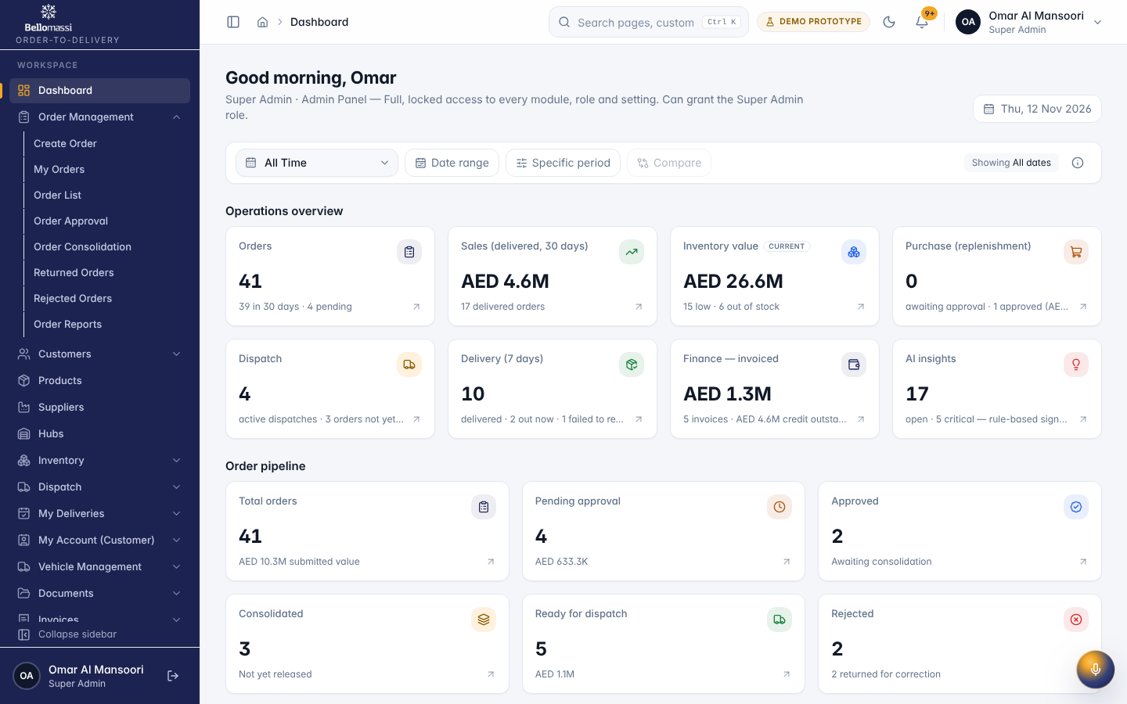

UX-USERS — User Management
Item | Value
Screen ID | SCR-144
Route | /admin/users (captured: /admin/users)
Application | Office web app
Permission | users.view
Captured as role | superadmin
Roles with access | SUPER_ADMIN, ADMIN
Purpose | Users, their roles, hubs and status — create, edit, activate, reset demo passwords and export.
Page heading | User Management
Fields / filters | Role; Status; Department; Hub
Table columns | ID; USER; Phone; ROLE; DEPARTMENT; HUB; STATUS; CREATED; ACTIONS
Actions | Export CSV; ID; USER; ROLE; DEPARTMENT; HUB; STATUS; CREATED; Row actions; Previous page; 1; 2; Next page
Screen type | list
Layout | Office layout: sidebar, header (breadcrumbs, search, notifications, profile), page header, content cards
Components | PageHeader, FilterToolbar, DataTable (sort, paging), Badge, RowActions, EmptyState
Validation | Filter inputs only
Responsive behaviour | Sidebar fixed ≥ 1024 px, drawer below; grids collapse to one column; tables scroll horizontally inside the card
Empty state | EmptyState with explanation and call to action
Loading state | Spinner / skeleton while data is read (prototype reads are near-instant from LocalStorage)
Error state | ErrorBoundary page; action refusals as error toast
Success state | Data displayed with counts
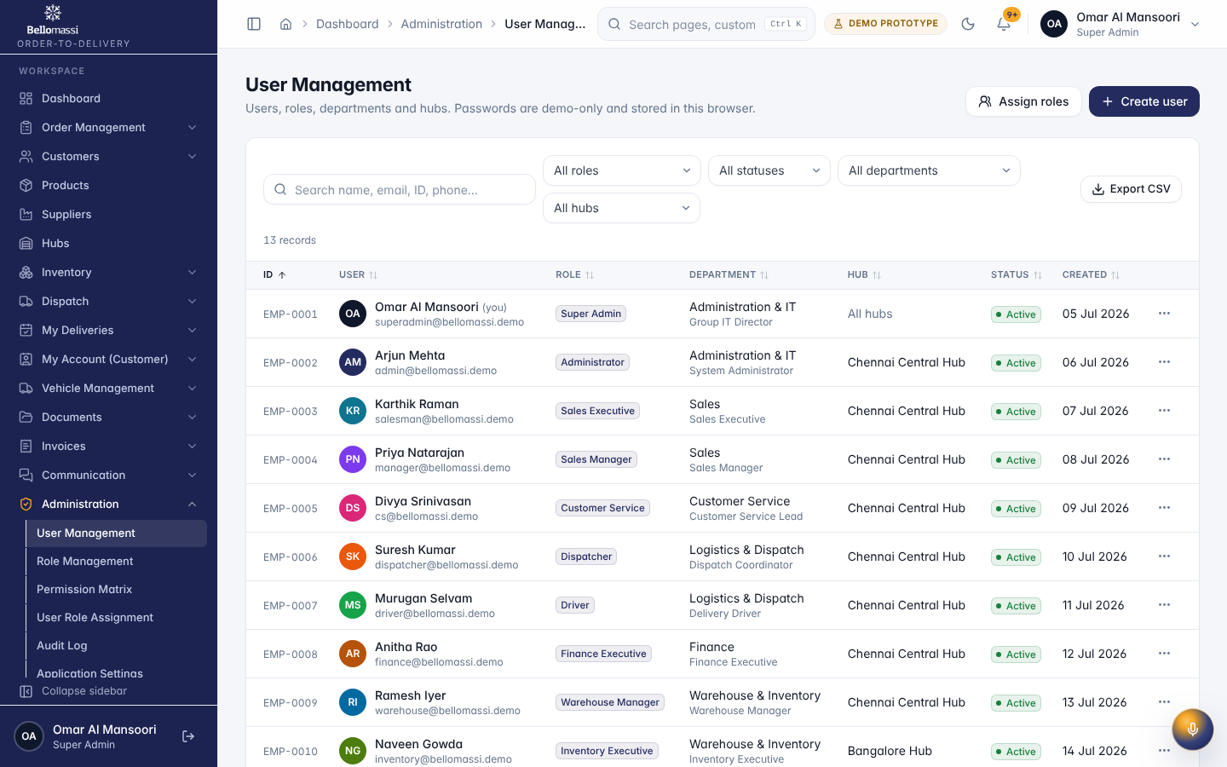

UX-ROLES — Role Management
Item | Value
Screen ID | SCR-145
Route | /admin/roles (captured: /admin/roles)
Application | Office web app
Permission | roles.view
Captured as role | superadmin
Roles with access | SUPER_ADMIN, ADMIN
Purpose | System and custom roles — create, edit, duplicate and delete, with module, page and action permissions.
Page heading | Role Management
Fields / filters | Type; Status
Table columns | ROLE; TYPE; DATA SCOPE; USERS; PERMISSIONS; STATUS; UPDATED; ACTIONS
Actions | Export CSV; ROLE; USERS; PERMISSIONS; STATUS; UPDATED; Row actions; Previous page; 1; 2; Next page
Screen type | list
Layout | Office layout: sidebar, header (breadcrumbs, search, notifications, profile), page header, content cards
Components | PageHeader, FilterToolbar, DataTable (sort, paging), Badge, RowActions, EmptyState
Validation | Filter inputs only
Responsive behaviour | Sidebar fixed ≥ 1024 px, drawer below; grids collapse to one column; tables scroll horizontally inside the card
Empty state | EmptyState with explanation and call to action
Loading state | Spinner / skeleton while data is read (prototype reads are near-instant from LocalStorage)
Error state | ErrorBoundary page; action refusals as error toast
Success state | Data displayed with counts
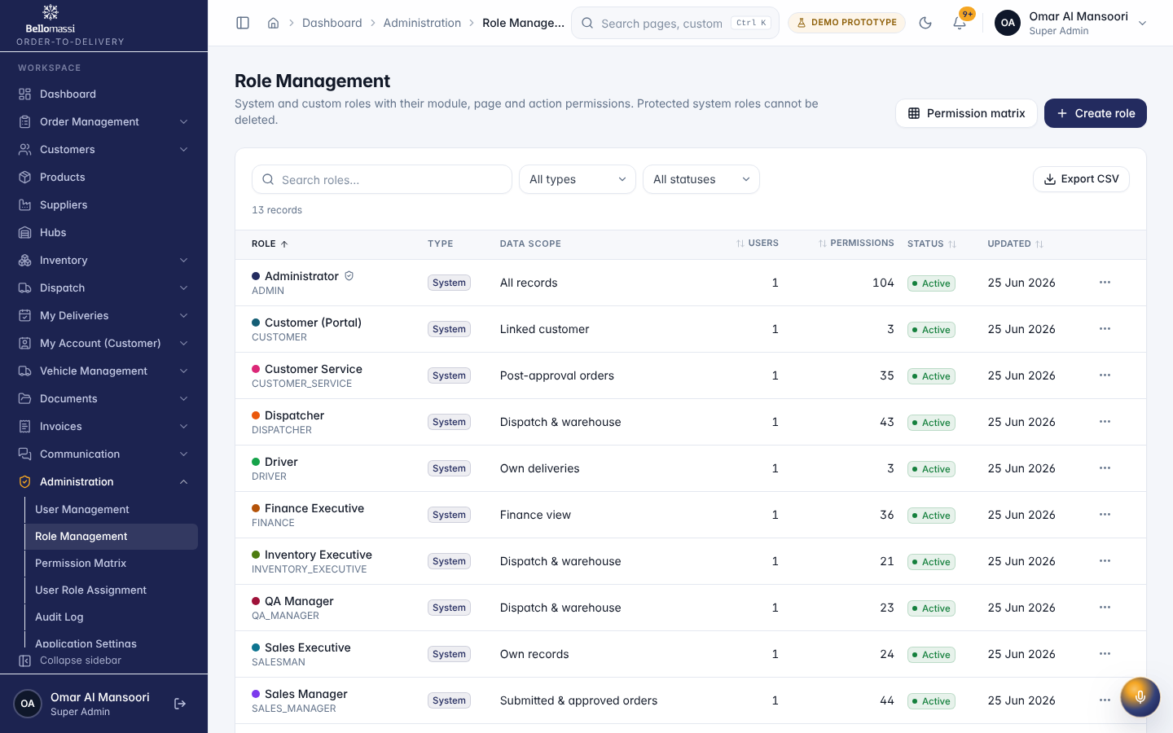

UX-PERMS — Permission Matrix
Item | Value
Screen ID | SCR-146
Route | /admin/permissions (captured: /admin/permissions)
Application | Office web app
Permission | roles.view
Captured as role | superadmin
Roles with access | SUPER_ADMIN, ADMIN
Purpose | Every role against every module and action in one grid.
Page heading | Permission Matrix
Sections | Overview; Sales Manager — module × action permissions
Fields / filters | Role
Table columns | Module; Super Admin; Administrator; Sales Executive; Sales Manager; Customer Service; Dispatcher; Driver; Finance Executive; Warehouse Manager; Inventory Executive; QA Manager; Customer (Portal); Supplier (Portal); Dashboard; Customers; Products; Suppliers; Procurement; Inventory
Actions | Export CSV; Super Admin; Administrator; Sales Executive; Sales Manager; Customer Service; Dispatcher; Driver; Finance Executive; Warehouse Manager; Inventory Executive; QA Manager; Customer (Portal); Supplier (Portal); Select all; Clear all; Dashboard; Customers; Products; Suppliers; Procurement; Inventory; Warehouse; Sales; Orders
Screen type | list
Layout | Office layout: sidebar, header (breadcrumbs, search, notifications, profile), page header, content cards
Components | PageHeader, FilterToolbar, DataTable (sort, paging), Badge, RowActions, EmptyState
Validation | Filter inputs only
Responsive behaviour | Sidebar fixed ≥ 1024 px, drawer below; grids collapse to one column; tables scroll horizontally inside the card
Empty state | EmptyState with explanation and call to action
Loading state | Spinner / skeleton while data is read (prototype reads are near-instant from LocalStorage)
Error state | ErrorBoundary page; action refusals as error toast
Success state | Data displayed with counts
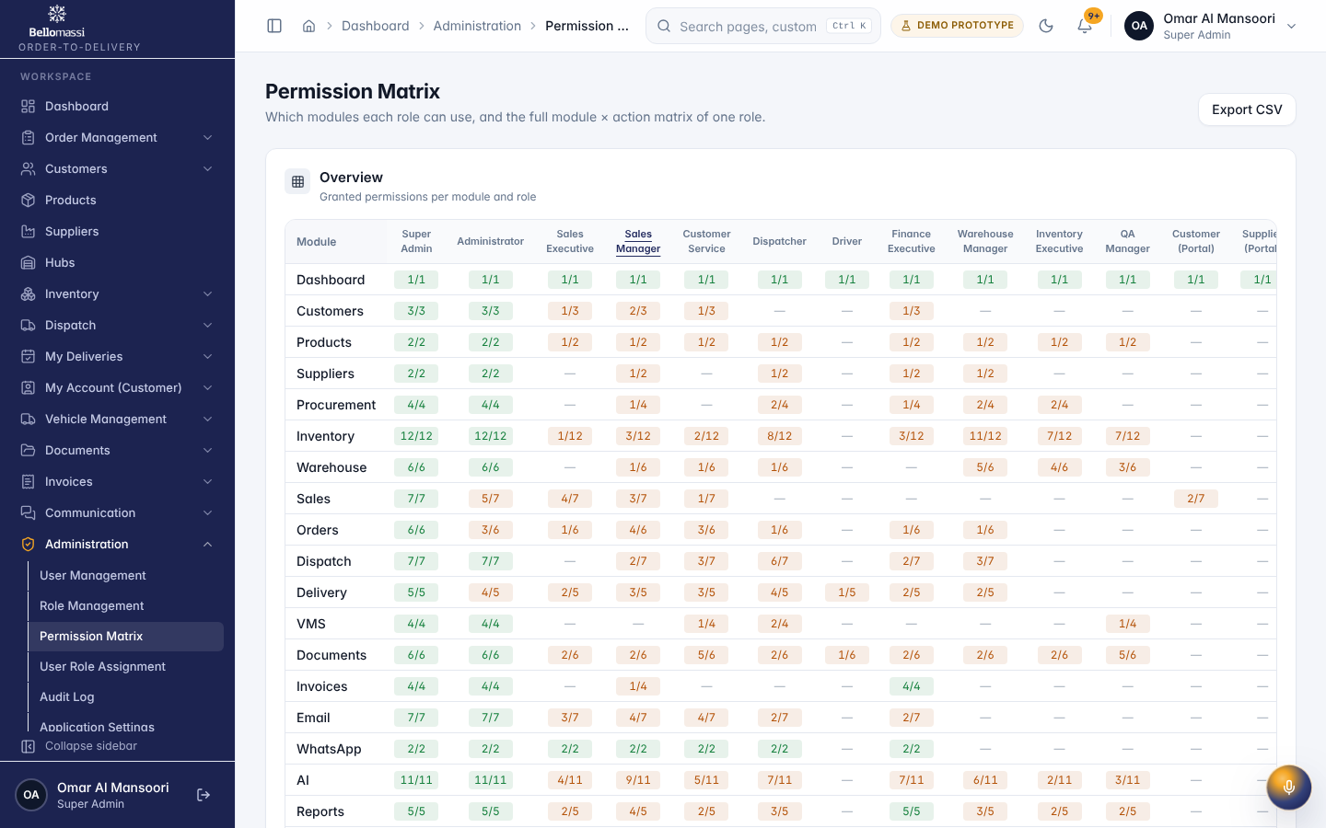

UX-AUDIT — Audit Log
Item | Value
Screen ID | SCR-148
Route | /admin/audit-logs (captured: /admin/audit-logs)
Application | Office web app
Permission | audit.view
Captured as role | superadmin
Roles with access | SUPER_ADMIN, ADMIN
Purpose | Who did what and when — logins, creates, edits, deletes, approvals, rejections, status and settings changes.
Page heading | Audit Log
Fields / filters | User; Action; Module; From; To
Table columns | TIMESTAMP; USER; ACTION; MODULE; ENTITY; DESCRIPTION; CHANGES
Actions | Export CSV; TIMESTAMP; USER; ACTION; MODULE
Screen type | list
Layout | Office layout: sidebar, header (breadcrumbs, search, notifications, profile), page header, content cards
Components | PageHeader, FilterToolbar, DataTable (sort, paging), Badge, RowActions, EmptyState
Validation | Filter inputs only
Responsive behaviour | Sidebar fixed ≥ 1024 px, drawer below; grids collapse to one column; tables scroll horizontally inside the card
Empty state | EmptyState with explanation and call to action
Loading state | Spinner / skeleton while data is read (prototype reads are near-instant from LocalStorage)
Error state | ErrorBoundary page; action refusals as error toast
Success state | Data displayed with counts
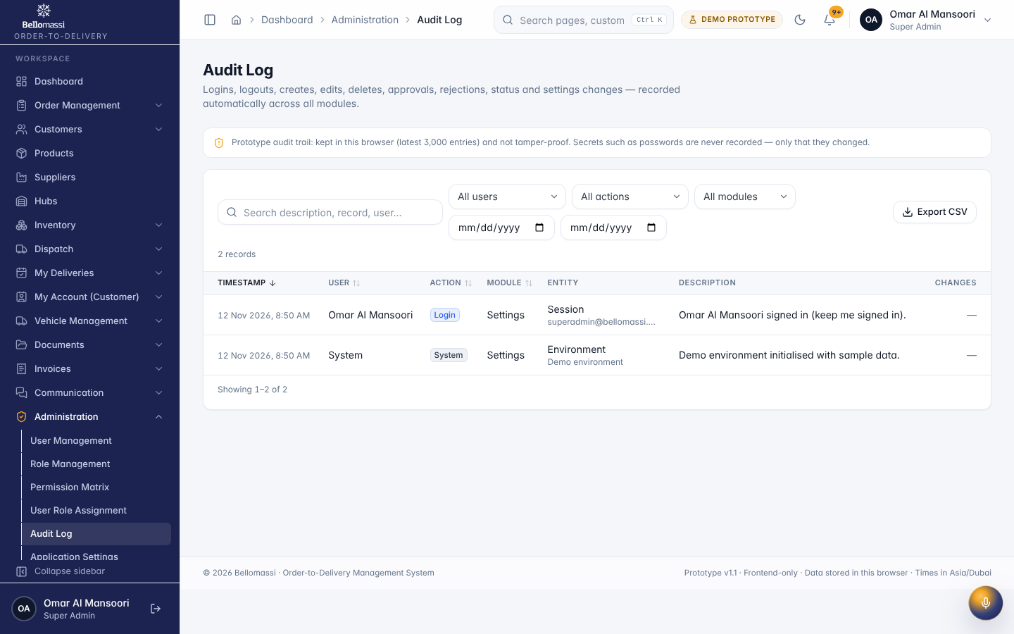

UX-SETTINGS — Application Settings
Item | Value
Screen ID | SCR-149
Route | /admin/settings (captured: /admin/settings)
Application | Office web app
Permission | settings.view
Captured as role | superadmin
Roles with access | SUPER_ADMIN, ADMIN
Purpose | General, localization, currency, numbering, notifications, security, approval, inventory, warehouse, cold chain, integration and AI settings.
Page heading | Application Settings
Sections | General; Preview
Fields / filters | Application name; Support email; Rows per page (administration lists); Show the DEMO PROTOTYPE badge in the header
Tabs | General; Company; Localization; Currency; Numbering; Notifications; Security; Approval Settings; Inventory Settings; Warehouse Settings; Cold Chain Settings; Integration Settings; AI Settings
Actions | General; Company; Localization; Currency; Numbering; Notifications; Security; Approval Settings; Inventory Settings; Warehouse Settings; Cold Chain Settings; Integration Settings; AI Settings; Reset section; Discard; Save general
Screen type | detail
Layout | Office layout: sidebar, header (breadcrumbs, search, notifications, profile), page header, content cards
Components | PageHeader with status Badge, InfoList, Tabs / Cards, Timeline, action Buttons, ConfirmDialog
Validation | Action pre-conditions checked by the service (status, permission, data scope); refusal message shown
Responsive behaviour | Sidebar fixed ≥ 1024 px, drawer below; grids collapse to one column; tables scroll horizontally inside the card
Empty state | Not found / access denied message for missing record
Loading state | Spinner / skeleton while data is read (prototype reads are near-instant from LocalStorage)
Error state | ErrorBoundary page; action refusals as error toast
Success state | Success toast after actions; badges and timeline update immediately
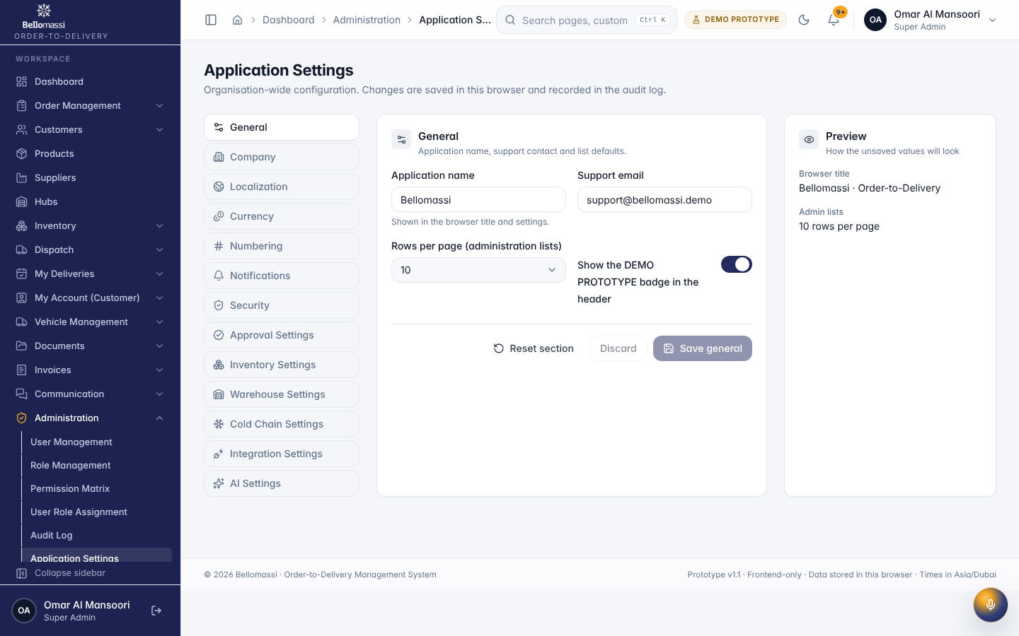

UX-COMPANY — Company
Item | Value
Screen ID | SCR-156
Route | /admin/organization/company (captured: /admin/organization/company)
Application | Office web app
Permission | organization.view
Captured as role | superadmin
Roles with access | SUPER_ADMIN, ADMIN
Purpose | Company name, logo, address, country, currency and tax registration number.
Page heading | Company
Sections | Identity; Address & contact; Country, currency & timezone; Tax & registration
Fields / filters | Company name*; Registered legal name*; Tagline; Address line 1*; Address line 2 / PO Box; City*; Emirate / region; Postal code; Phone; Email; Website; Country*; Base currency*; Timezone*; Tax number label; Tax registration number*; Trade licence number
Actions | Upload; Discard; Save company
Screen type | detail
Layout | Office layout: sidebar, header (breadcrumbs, search, notifications, profile), page header, content cards
Components | PageHeader with status Badge, InfoList, Tabs / Cards, Timeline, action Buttons, ConfirmDialog
Validation | Action pre-conditions checked by the service (status, permission, data scope); refusal message shown
Responsive behaviour | Sidebar fixed ≥ 1024 px, drawer below; grids collapse to one column; tables scroll horizontally inside the card
Empty state | Not found / access denied message for missing record
Loading state | Spinner / skeleton while data is read (prototype reads are near-instant from LocalStorage)
Error state | ErrorBoundary page; action refusals as error toast
Success state | Success toast after actions; badges and timeline update immediately
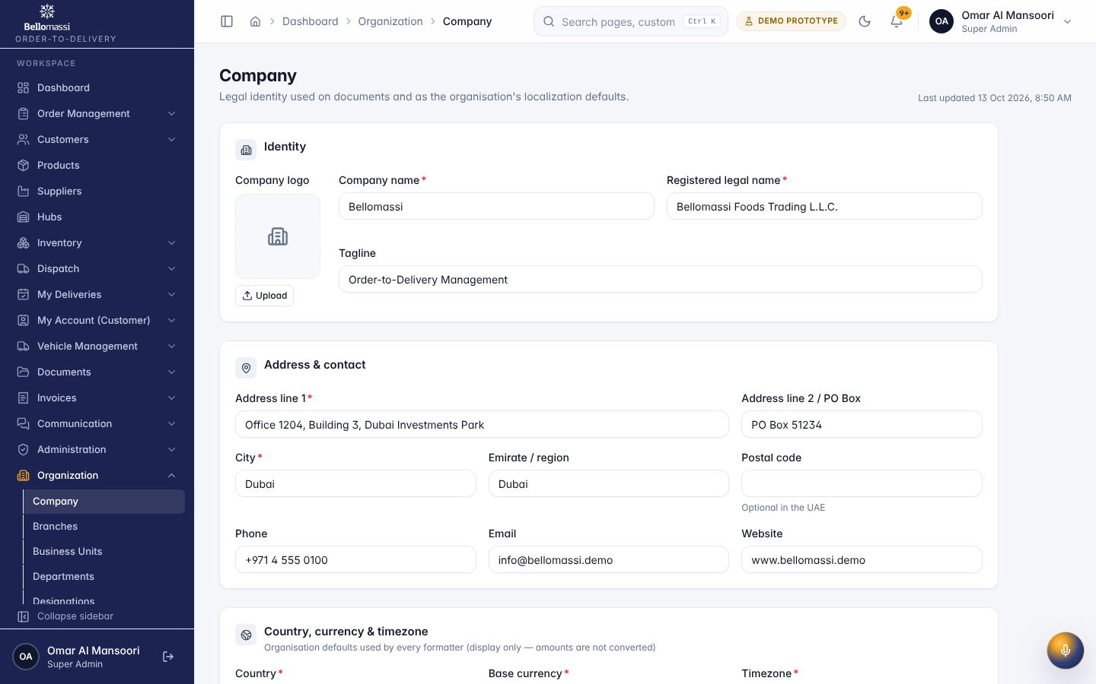

UX-CUSTOMERS — Customer List
Item | Value
Screen ID | SCR-014
Route | /customers (captured: /customers)
Application | Office web app
Permission | customers.view
Captured as role | superadmin
Roles with access | SUPER_ADMIN, ADMIN, SALESMAN, SALES_MANAGER, CUSTOMER_SERVICE
Purpose | Customer accounts with contacts, addresses, credit configuration and VIP passes.
Page heading | Customers
Fields / filters | Customer type; Status; VIP; Credit; Credit status; Assigned salesman
Table columns | CUSTOMER; TYPE; CITY; SALESMAN; CREDIT; STATUS; ACTIONS
Actions | Export CSV; CUSTOMER; TYPE; CITY; SALESMAN; CREDIT; STATUS; Actions for ABC Enterprises; Actions for Annapoorna Caterers; Actions for Charminar Foods; Actions for Chennai Industrial Supplies; Actions for Coastal Seafood Traders; Actions for Deccan Retail Mart; Actions for Global Distributors; Actions for Green Leaf Restaurants; Actions for Kaveri Supermarket; Actions for Kochi Hotel Supplies; Previous page; 1; 2; Next page
Screen type | list
Layout | Office layout: sidebar, header (breadcrumbs, search, notifications, profile), page header, content cards
Components | PageHeader, FilterToolbar, DataTable (sort, paging), Badge, RowActions, EmptyState
Validation | Filter inputs only
Responsive behaviour | Designed for 360–430 px; single column; bottom navigation
Empty state | EmptyState with explanation and call to action
Loading state | Spinner / skeleton while data is read (prototype reads are near-instant from LocalStorage)
Error state | ErrorBoundary page; action refusals as error toast
Success state | Data displayed with counts
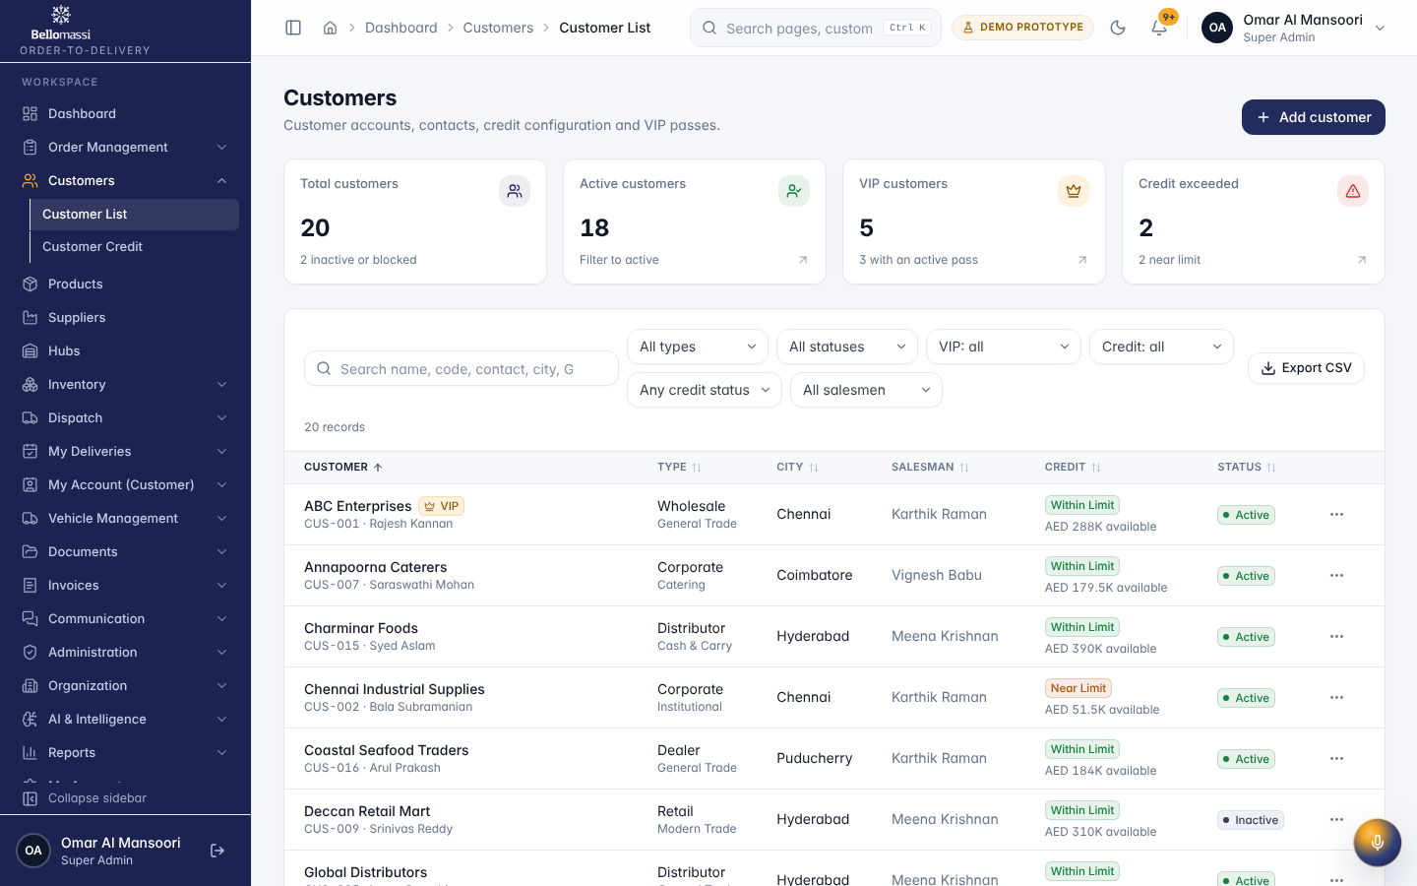

UX-CUSTOMER-DETAIL — Customer Details
Item | Value
Screen ID | SCR-017
Route | /customers/:id (captured: /customers/c-001)
Application | Office web app
Permission | customers.view
Captured as role | superadmin
Roles with access | SUPER_ADMIN, ADMIN, SALESMAN, SALES_MANAGER, CUSTOMER_SERVICE
Purpose | ABC Enterprises
Page heading | ABC Enterprises
Sections | Business information; Credit configuration; VIP; Order history; Activity timeline; Credit history
Table columns | ORDER; DATE; ITEMS; VALUE; STATUS
Actions | Back; Delete; Previous page; 1; 2; Next page
Screen type | list
Layout | Office layout: sidebar, header (breadcrumbs, search, notifications, profile), page header, content cards
Components | PageHeader, FilterToolbar, DataTable (sort, paging), Badge, RowActions, EmptyState
Validation | Filter inputs only
Responsive behaviour | Designed for 360–430 px; single column; bottom navigation
Empty state | EmptyState with explanation and call to action
Loading state | Spinner / skeleton while data is read (prototype reads are near-instant from LocalStorage)
Error state | ErrorBoundary page; action refusals as error toast
Success state | Data displayed with counts
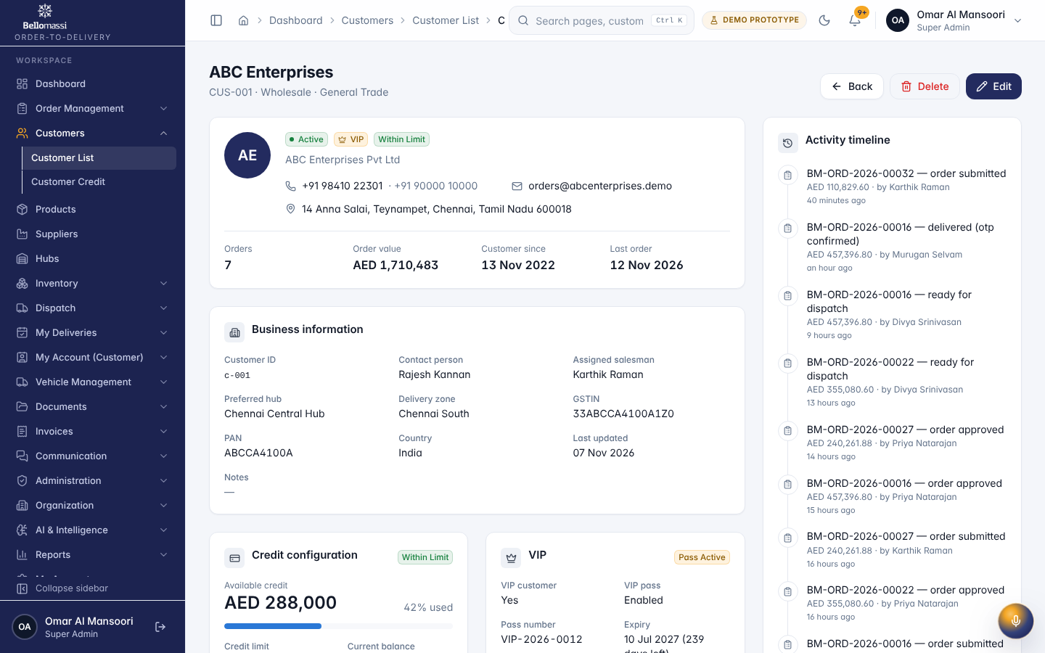

UX-CREDIT — Customer Credit
Item | Value
Screen ID | SCR-015
Route | /customers/credit (captured: /customers/credit)
Application | Office web app
Permission | customers.credit.view
Captured as role | superadmin
Roles with access | SUPER_ADMIN, ADMIN, SALES_MANAGER, FINANCE
Purpose | Credit limits, balances, available credit and credit status.
Page heading | Customer credit
Fields / filters | Credit status; Customer status; Salesman
Table columns | CUSTOMER; LIMIT; BALANCE; AVAILABLE; UTILISATION; DAYS; STATUS
Actions | Export CSV; CUSTOMER; LIMIT; BALANCE; AVAILABLE; UTILISATION; DAYS; STATUS; Previous page; 1; 2; Next page
Screen type | list
Layout | Office layout: sidebar, header (breadcrumbs, search, notifications, profile), page header, content cards
Components | PageHeader, FilterToolbar, DataTable (sort, paging), Badge, RowActions, EmptyState
Validation | Filter inputs only
Responsive behaviour | Sidebar fixed ≥ 1024 px, drawer below; grids collapse to one column; tables scroll horizontally inside the card
Empty state | EmptyState with explanation and call to action
Loading state | Spinner / skeleton while data is read (prototype reads are near-instant from LocalStorage)
Error state | ErrorBoundary page; action refusals as error toast
Success state | Data displayed with counts
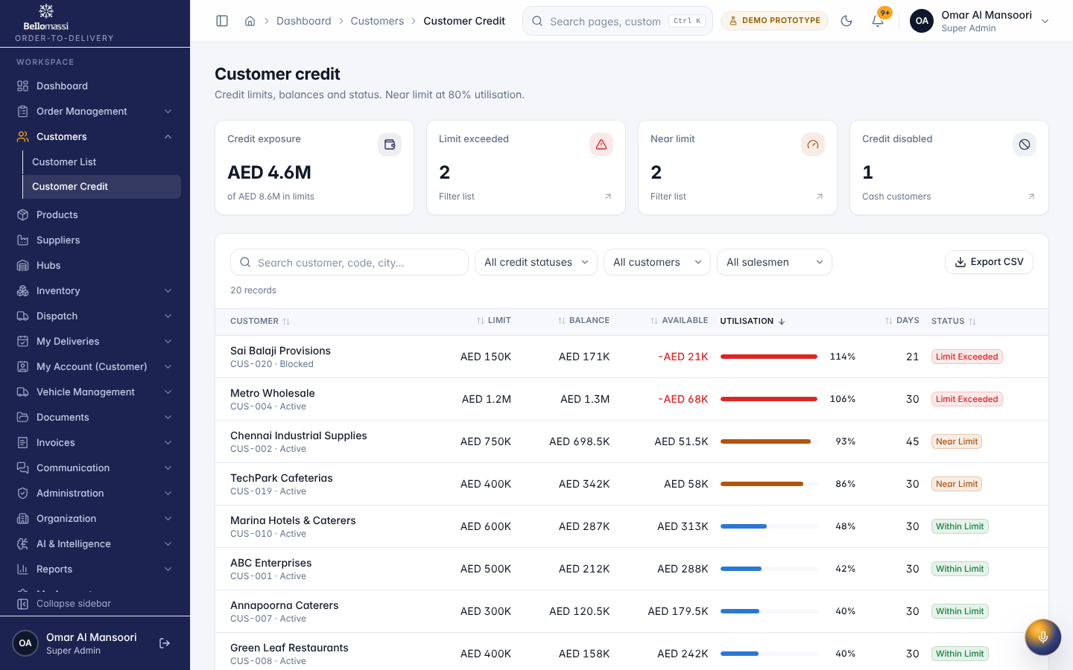

UX-PRODUCTS — Products
Item | Value
Screen ID | SCR-019
Route | /products (captured: /products)
Application | Office web app
Permission | products.view
Captured as role | superadmin
Roles with access | SUPER_ADMIN, ADMIN, SALESMAN, SALES_MANAGER, CUSTOMER_SERVICE, DISPATCHER, FINANCE, WAREHOUSE_MANAGER, INVENTORY_EXECUTIVE, QA_MANAGER
Purpose | Product catalogue with pricing, units and inventory rules.
Page heading | Products
Fields / filters | Category; Status; Inventory tracking
Table columns | PRODUCT; CATEGORY; UNIT; PRICE; AVAILABLE; STATUS; ACTIONS
Actions | Export CSV; PRODUCT; CATEGORY; UNIT; PRICE; AVAILABLE; STATUS; Actions for Aloo Tikki; Actions for Basa Fish Fillet; Actions for Cheddar Cheese Slices; Actions for Chicken Breast Boneless; Actions for Chicken Nuggets; Actions for Chicken Seekh Kebab; Actions for Chicken Wings; Actions for Doorstep Handling Charge; Actions for Fish Fingers; Actions for Food-Grade Nitrile Gloves; Previous page; 1; 2; 3; Next page
Screen type | list
Layout | Office layout: sidebar, header (breadcrumbs, search, notifications, profile), page header, content cards
Components | PageHeader, FilterToolbar, DataTable (sort, paging), Badge, RowActions, EmptyState
Validation | Filter inputs only
Responsive behaviour | Sidebar fixed ≥ 1024 px, drawer below; grids collapse to one column; tables scroll horizontally inside the card
Empty state | EmptyState with explanation and call to action
Loading state | Spinner / skeleton while data is read (prototype reads are near-instant from LocalStorage)
Error state | ErrorBoundary page; action refusals as error toast
Success state | Data displayed with counts
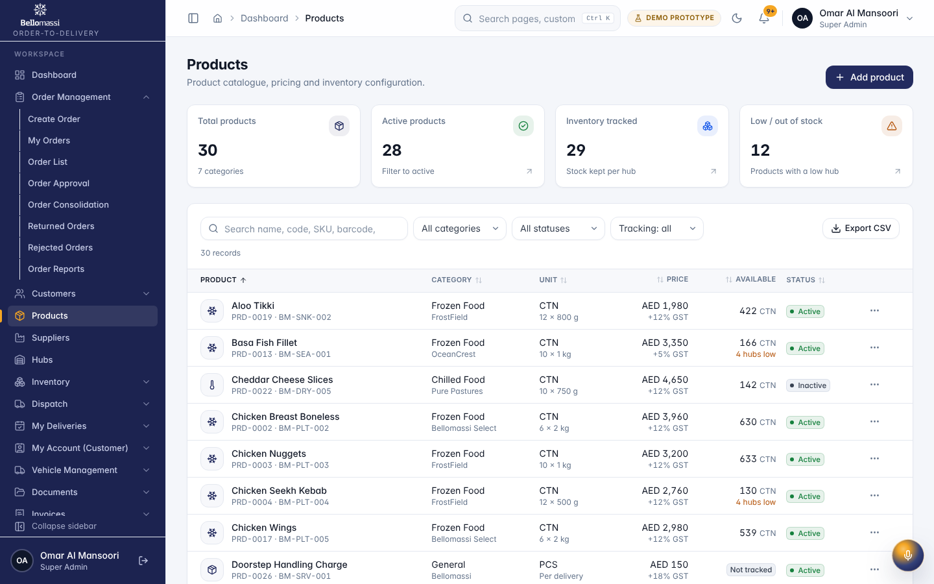

UX-HUBS — Hubs
Item | Value
Screen ID | SCR-021
Route | /hubs (captured: /hubs)
Application | Office web app
Permission | hubs.view
Captured as role | superadmin
Roles with access | SUPER_ADMIN, ADMIN, SALES_MANAGER, CUSTOMER_SERVICE, DISPATCHER, WAREHOUSE_MANAGER, INVENTORY_EXECUTIVE, QA_MANAGER
Purpose | Hubs and warehouses with managers, locations and stock valuation.
Page heading | Hubs
Fields / filters | Hub type; Status
Table columns | HUB; LOCATION; MANAGER; PRODUCTS; STOCK VALUE; LOW / OUT; STATUS; ACTIONS
Actions | Export CSV; HUB; LOCATION; MANAGER; PRODUCTS; STOCK VALUE; LOW / OUT; STATUS; Actions for Bangalore Hub; Actions for Chennai Central Hub; Actions for Coimbatore Hub; Actions for Hyderabad Hub; Actions for Madurai Hub; Actions for Trichy Branch Hub
Screen type | list
Layout | Office layout: sidebar, header (breadcrumbs, search, notifications, profile), page header, content cards
Components | PageHeader, FilterToolbar, DataTable (sort, paging), Badge, RowActions, EmptyState
Validation | Filter inputs only
Responsive behaviour | Sidebar fixed ≥ 1024 px, drawer below; grids collapse to one column; tables scroll horizontally inside the card
Empty state | EmptyState with explanation and call to action
Loading state | Spinner / skeleton while data is read (prototype reads are near-instant from LocalStorage)
Error state | ErrorBoundary page; action refusals as error toast
Success state | Data displayed with counts
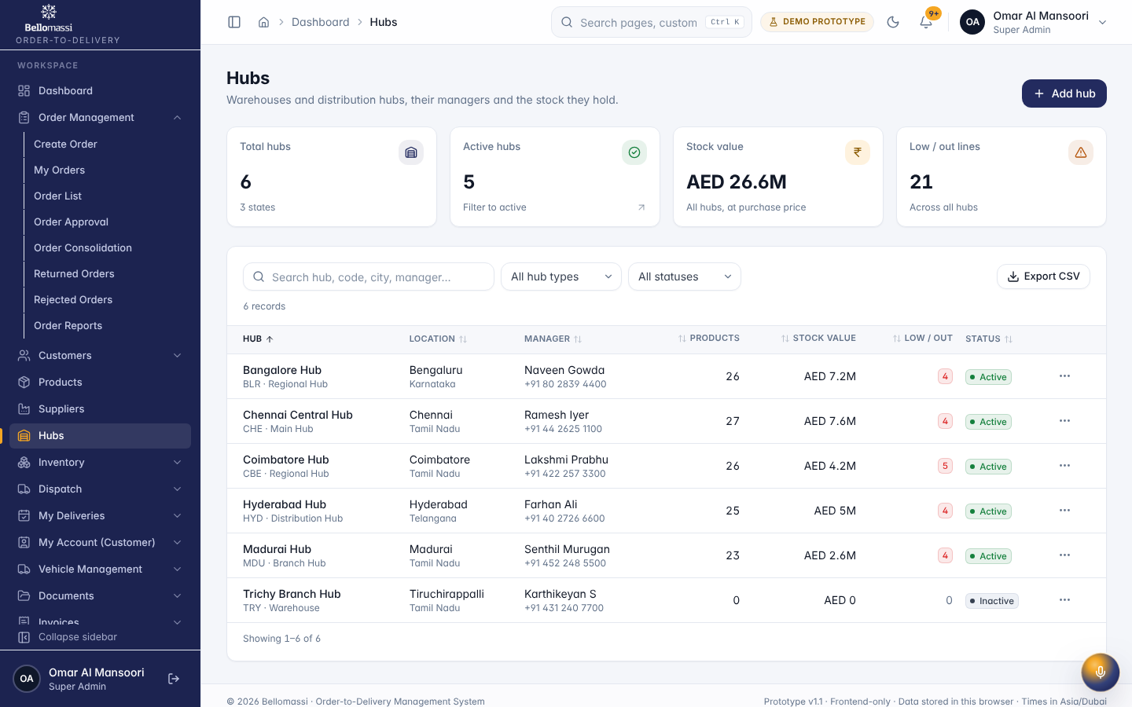

UX-SUPPLIERS — Suppliers
Item | Value
Screen ID | SCR-020
Route | /suppliers (captured: /suppliers)
Application | Office web app
Permission | suppliers.view
Captured as role | superadmin
Roles with access | SUPER_ADMIN, ADMIN, SALES_MANAGER, DISPATCHER, FINANCE, WAREHOUSE_MANAGER
Purpose | Supplier directory with lead times, minimum order values and replenishment history.
Page heading | Suppliers
Table columns | SUPPLIER; CATEGORIES; LEAD TIME; MIN ORDER; OPEN REQUESTS; REQUESTED VALUE; PORTAL USERS; EDIT
Actions | Export CSV; SUPPLIER; LEAD TIME; MIN ORDER; OPEN REQUESTS; REQUESTED VALUE; Edit
Screen type | list
Layout | Office layout: sidebar, header (breadcrumbs, search, notifications, profile), page header, content cards
Components | PageHeader, FilterToolbar, DataTable (sort, paging), Badge, RowActions, EmptyState
Validation | Filter inputs only
Responsive behaviour | Sidebar fixed ≥ 1024 px, drawer below; grids collapse to one column; tables scroll horizontally inside the card
Empty state | EmptyState with explanation and call to action
Loading state | Spinner / skeleton while data is read (prototype reads are near-instant from LocalStorage)
Error state | ErrorBoundary page; action refusals as error toast
Success state | Data displayed with counts
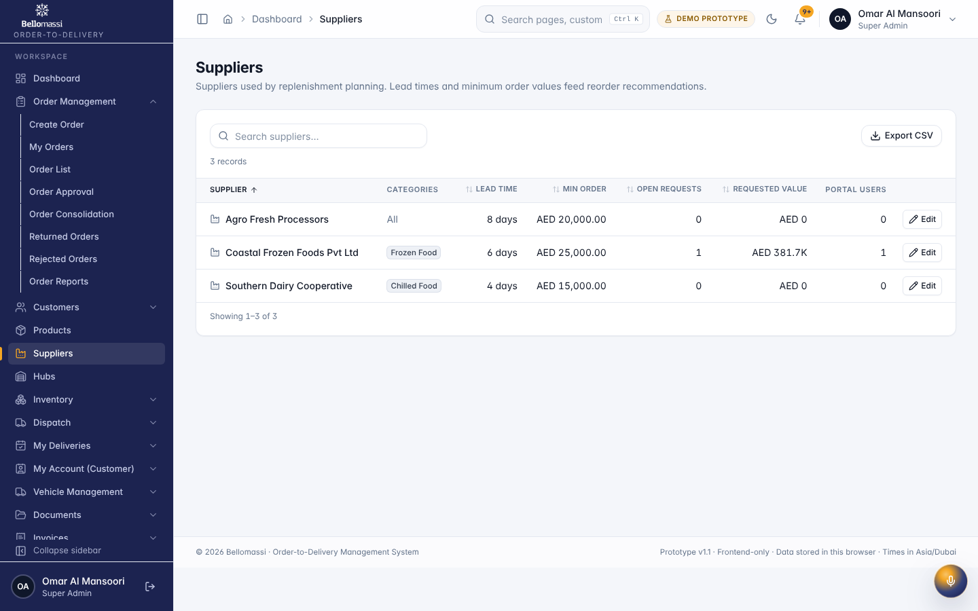

UX-ORDERS — Order List
Item | Value
Screen ID | SCR-004
Route | /orders (captured: /orders)
Application | Office web app
Permission | orders.view
Captured as role | superadmin
Roles with access | SUPER_ADMIN, ADMIN, SALESMAN, SALES_MANAGER, CUSTOMER_SERVICE, DISPATCHER, FINANCE, WAREHOUSE_MANAGER
Purpose | Every order with its live status, full history, search, filters and export.
Page heading | Orders
Fields / filters | Order status; Approval status; Customer; Salesman; Hub; Priority; From order date; To order date
Table columns | ORDER; CUSTOMER; SALESMAN; HUB; QTY; TOTAL; STATUS; APPROVAL; PRIORITY; DELIVERY; CREATED; ACTIONS
Actions | Export CSV; ORDER; CUSTOMER; SALESMAN; HUB; QTY; TOTAL; STATUS; APPROVAL; PRIORITY; DELIVERY; CREATED; Actions for BM-ORD-2026-00031; Actions for draft order; Actions for BM-ORD-2026-00034; Actions for BM-ORD-2026-00032; Actions for BM-ORD-2026-00033; Actions for BM-ORD-2026-00029; Actions for BM-ORD-2026-00030; Actions for BM-ORD-2026-00038; Actions for BM-ORD-2026-00035; Actions for BM-ORD-2026-00027; Actions for BM-ORD-2026-00017; Previous page; 1
Screen type | list
Layout | Office layout: sidebar, header (breadcrumbs, search, notifications, profile), page header, content cards
Components | PageHeader, FilterToolbar, DataTable (sort, paging), Badge, RowActions, EmptyState
Validation | Filter inputs only
Responsive behaviour | Sidebar fixed ≥ 1024 px, drawer below; grids collapse to one column; tables scroll horizontally inside the card
Empty state | EmptyState with explanation and call to action
Loading state | Spinner / skeleton while data is read (prototype reads are near-instant from LocalStorage)
Error state | ErrorBoundary page; action refusals as error toast
Success state | Data displayed with counts
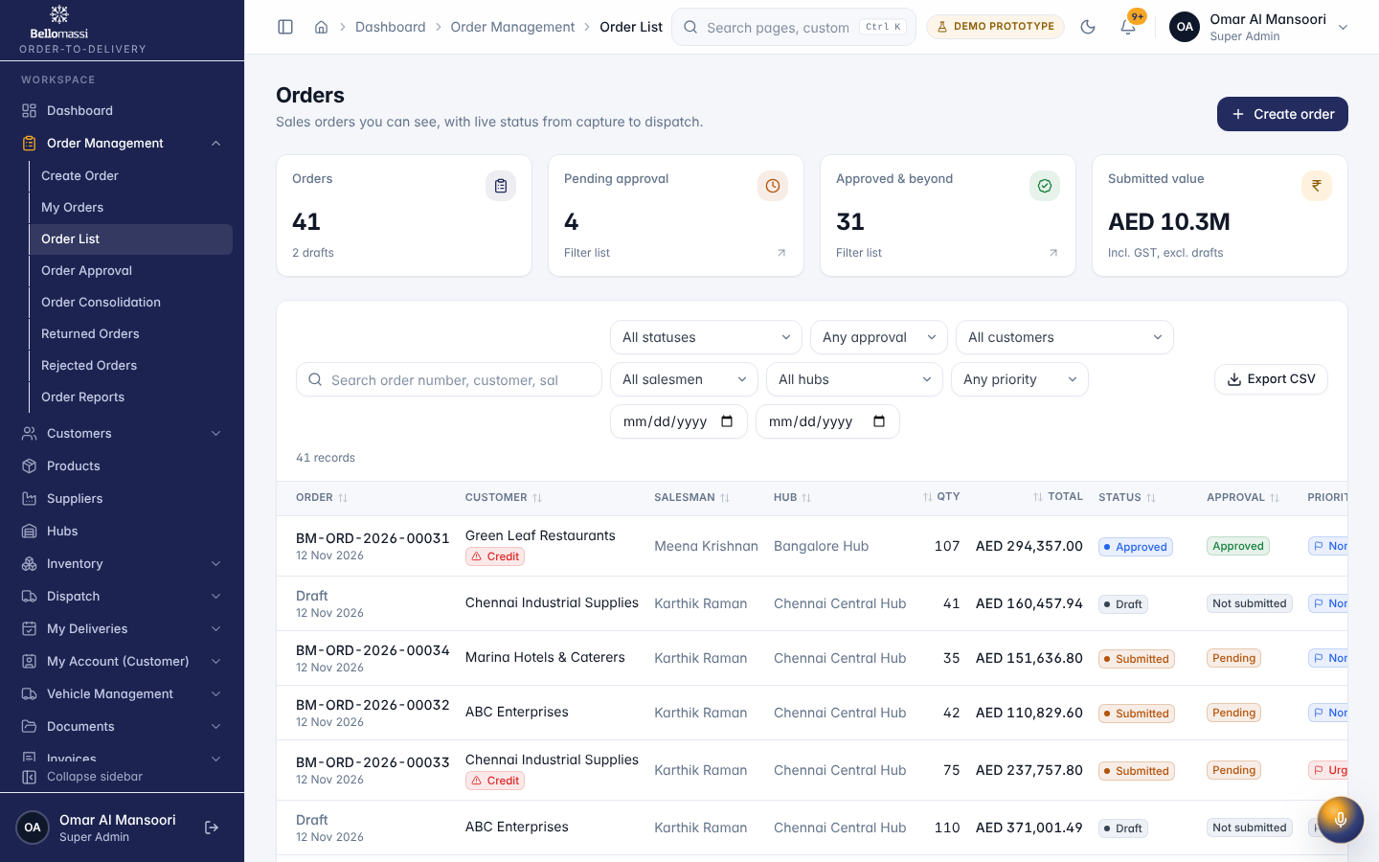

UX-ORDER-DETAIL — Order Details
Item | Value
Screen ID | SCR-013
Route | /orders/:id (captured: /orders/ord-0001)
Application | Office web app
Permission | orders.view
Captured as role | superadmin
Roles with access | SUPER_ADMIN, ADMIN, SALESMAN, SALES_MANAGER, CUSTOMER_SERVICE, DISPATCHER, FINANCE, WAREHOUSE_MANAGER
Purpose | BM-ORD-2026-00001
Page heading | BM-ORD-2026-00001
Sections | Products; Delivery; Order details; Approval; Consolidation; Dispatch & delivery; Customer & credit; Salesman; Fulfilment hub
Table columns | PRODUCT; QTY; UNIT PRICE; DISC.; GST; LINE TOTAL
Tabs | Overview; Timeline (8); Approval history (1); Consolidation
Actions | Back; Duplicate; Overview; Timeline (8); Approval history (1); Consolidation
Screen type | list
Layout | Office layout: sidebar, header (breadcrumbs, search, notifications, profile), page header, content cards
Components | PageHeader, FilterToolbar, DataTable (sort, paging), Badge, RowActions, EmptyState
Validation | Filter inputs only
Responsive behaviour | Sidebar fixed ≥ 1024 px, drawer below; grids collapse to one column; tables scroll horizontally inside the card
Empty state | EmptyState with explanation and call to action
Loading state | Spinner / skeleton while data is read (prototype reads are near-instant from LocalStorage)
Error state | ErrorBoundary page; action refusals as error toast
Success state | Data displayed with counts
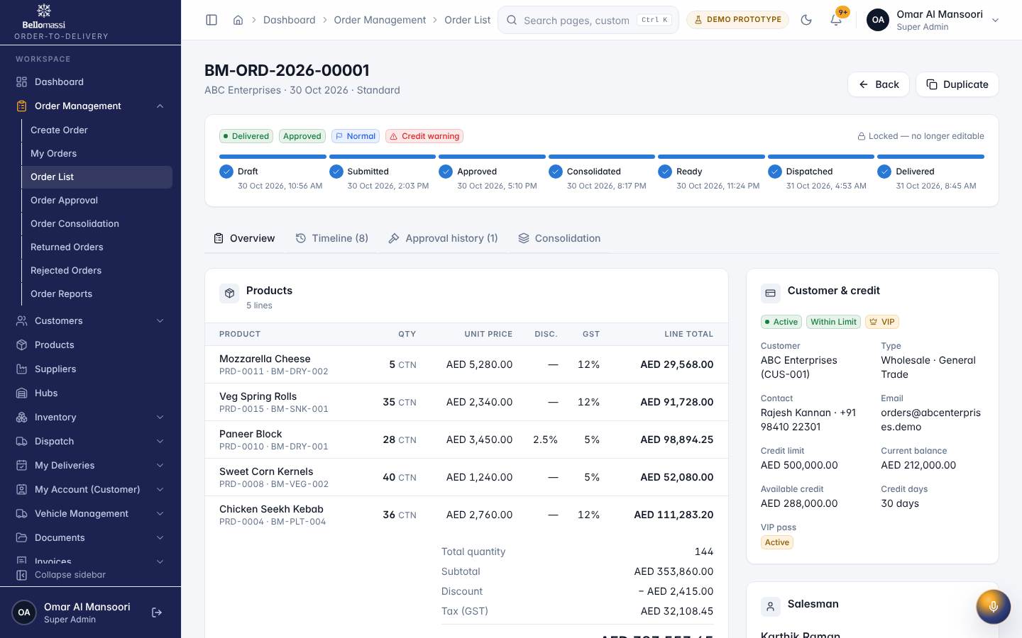

UX-REPORTS — Reports Center
Item | Value
Screen ID | SCR-185
Route | /reports/center (captured: /reports/center)
Application | Office web app
Permission | reports.center
Captured as role | superadmin
Roles with access | SUPER_ADMIN, ADMIN, SALESMAN, SALES_MANAGER, CUSTOMER_SERVICE, DISPATCHER, FINANCE, WAREHOUSE_MANAGER, INVENTORY_EXECUTIVE, QA_MANAGER
Purpose | Every report in one place — sales, inventory, procurement, delivery, finance, customers, suppliers, fleet, calls, scrap and AI — with filters, charts and CSV.
Page heading | Reports Center
Sections | Favourites; Recently viewed; Popular; Sales Order Register; Sales Order Summary; Sales by Customer; Sales by Salesman; Sales by Product; Sales by Category; Sales by Month; Sales Order Status; Pending Approval; Rejected Orders; Credit Limit Exceptions; Order Conversion; Customer Sales Analysis; VIP Orders; Stock Overview
Fields / filters | Category
Actions | 118 All reports; 14 Sales; 18 Inventory; 10 Procurement; 19 Dispatch & Delivery; 14 Finance; 8 Customer; 5 Supplier; 9 Fleet; 7 Communication; 7 Scrap; 7 AI; Favourites only; Add Sales Order Register to favourites; Add Sales Order Summary to favourites; Add Sales by Customer to favourites; Add Sales by Salesman to favourites; Add Sales by Product to favourites; Add Sales by Category to favourites; Add Sales by Month to favourites; Add Sales Order Status to favourites; Add Pending Approval to favourites; Add Rejected Orders to favourites; Add Credit Limit Exceptions to favourites; Add Order Conversion to favourites
Screen type | detail
Layout | Office layout: sidebar, header (breadcrumbs, search, notifications, profile), page header, content cards
Components | PageHeader with status Badge, InfoList, Tabs / Cards, Timeline, action Buttons, ConfirmDialog
Validation | Action pre-conditions checked by the service (status, permission, data scope); refusal message shown
Responsive behaviour | Sidebar fixed ≥ 1024 px, drawer below; grids collapse to one column; tables scroll horizontally inside the card
Empty state | Not found / access denied message for missing record
Loading state | Spinner / skeleton while data is read (prototype reads are near-instant from LocalStorage)
Error state | ErrorBoundary page; action refusals as error toast
Success state | Success toast after actions; badges and timeline update immediately
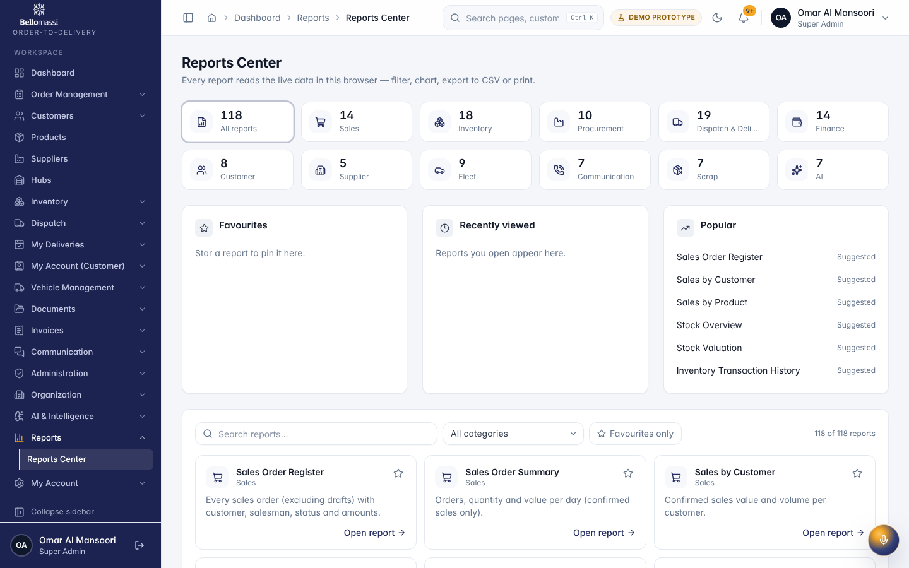

UX-INVENTORY — Inventory Dashboard
Item | Value
Screen ID | SCR-022
Route | /inventory (captured: /inventory)
Application | Office web app
Permission | inventory.dashboard
Captured as role | superadmin
Roles with access | SUPER_ADMIN, ADMIN, DISPATCHER, FINANCE, WAREHOUSE_MANAGER, INVENTORY_EXECUTIVE
Purpose | Stock quantity, value, low-stock alerts and recent movements across all hubs.
Page heading | Inventory
Sections | Stock by hub; Inventory by category; Low stock overview; Low stock products; Hub stock summary; Recent stock movements
Table columns | PRODUCT; AVAILABLE; REORDER AT; STATUS; HUB; PRODUCTS; ON HAND; DAMAGED; VALUE; LOW / OUT; DATE; TYPE; QTY; REFERENCE; BY
Screen type | dashboard
Layout | Office layout: sidebar, header (breadcrumbs, search, notifications, profile), page header, content cards
Components | Period filter, KPI cards, charts (Recharts), queue tables, quick links
Validation | Period filter: valid date range
Responsive behaviour | Sidebar fixed ≥ 1024 px, drawer below; grids collapse to one column; tables scroll horizontally inside the card
Empty state | EmptyState with explanation and call to action
Loading state | Spinner / skeleton while data is read (prototype reads are near-instant from LocalStorage)
Error state | ErrorBoundary page; action refusals as error toast
Success state | Data displayed with counts
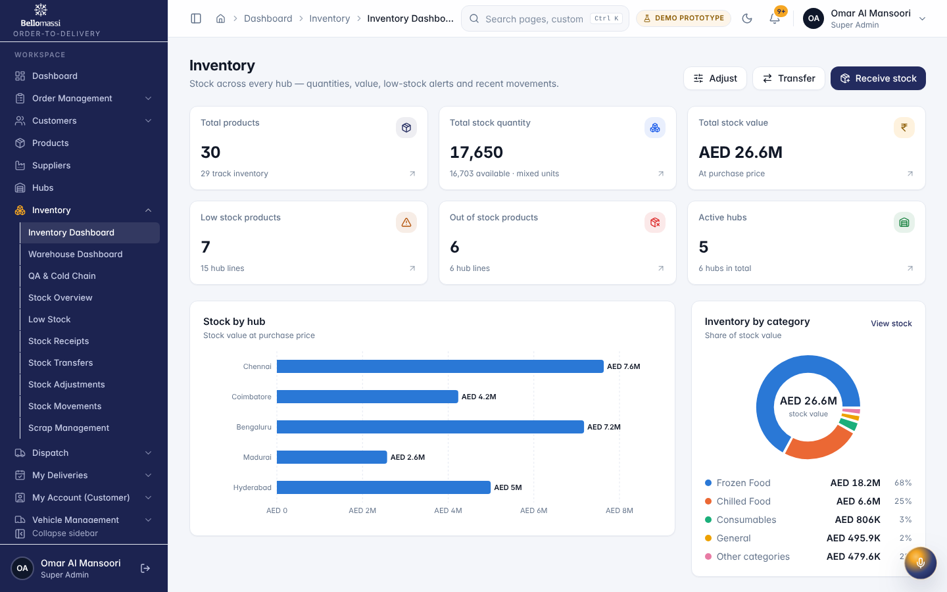

UX-STOCK — Stock Overview
Item | Value
Screen ID | SCR-025
Route | /inventory/stock (captured: /inventory/stock)
Application | Office web app
Permission | inventory.stock.view
Captured as role | superadmin
Roles with access | SUPER_ADMIN, ADMIN, SALESMAN, SALES_MANAGER, CUSTOMER_SERVICE, DISPATCHER, FINANCE, WAREHOUSE_MANAGER, INVENTORY_EXECUTIVE, QA_MANAGER
Purpose | Hub-wise stock: total, reserved, damaged and available quantities.
Page heading | Stock overview
Fields / filters | Product; Hub; Category; Stock status
Table columns | CODE; PRODUCT; HUB; TOTAL; RESERVED; DAMAGED; AVAILABLE; REORDER; STATUS; UPDATED
Actions | By hub line; By product; Export CSV; CODE; PRODUCT; HUB; TOTAL; RESERVED; DAMAGED; AVAILABLE; REORDER; STATUS; UPDATED; Previous page; 1; 2; 11; Next page
Screen type | list
Layout | Office layout: sidebar, header (breadcrumbs, search, notifications, profile), page header, content cards
Components | PageHeader, FilterToolbar, DataTable (sort, paging), Badge, RowActions, EmptyState
Validation | Filter inputs only
Responsive behaviour | Sidebar fixed ≥ 1024 px, drawer below; grids collapse to one column; tables scroll horizontally inside the card
Empty state | EmptyState with explanation and call to action
Loading state | Spinner / skeleton while data is read (prototype reads are near-instant from LocalStorage)
Error state | ErrorBoundary page; action refusals as error toast
Success state | Data displayed with counts
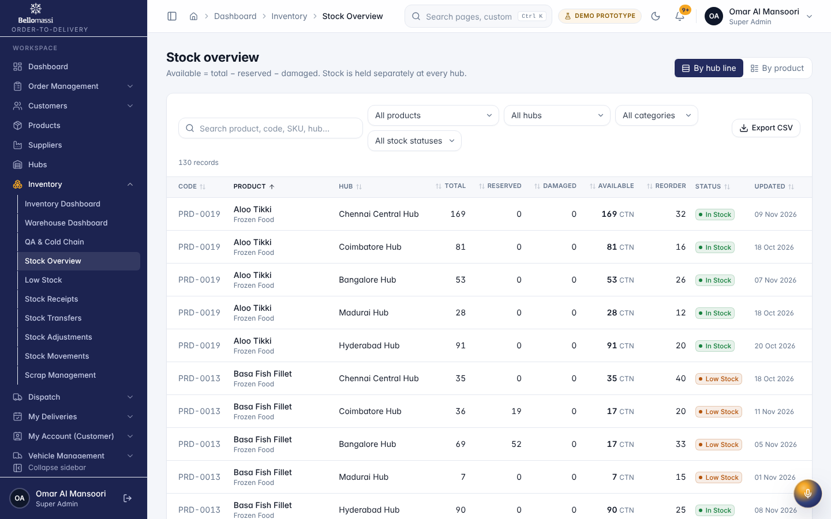

UX-MOVEMENTS — Stock Movements
Item | Value
Screen ID | SCR-030
Route | /inventory/movements (captured: /inventory/movements)
Application | Office web app
Permission | inventory.movements.view
Captured as role | superadmin
Roles with access | SUPER_ADMIN, ADMIN, DISPATCHER, WAREHOUSE_MANAGER, INVENTORY_EXECUTIVE, QA_MANAGER
Purpose | The read-only stock ledger with every movement.
Page heading | Stock movements
Fields / filters | Movement type; Hub; Product; From date; To date
Table columns | DATE; PRODUCT; HUB; TYPE; QTY; AVAILABLE; REFERENCE; BY
Actions | Export CSV; DATE; PRODUCT; HUB; TYPE; QTY; REFERENCE; Previous page; 1; 2; 5; Next page
Screen type | list
Layout | Office layout: sidebar, header (breadcrumbs, search, notifications, profile), page header, content cards
Components | PageHeader, FilterToolbar, DataTable (sort, paging), Badge, RowActions, EmptyState
Validation | Filter inputs only
Responsive behaviour | Sidebar fixed ≥ 1024 px, drawer below; grids collapse to one column; tables scroll horizontally inside the card
Empty state | EmptyState with explanation and call to action
Loading state | Spinner / skeleton while data is read (prototype reads are near-instant from LocalStorage)
Error state | ErrorBoundary page; action refusals as error toast
Success state | Data displayed with counts
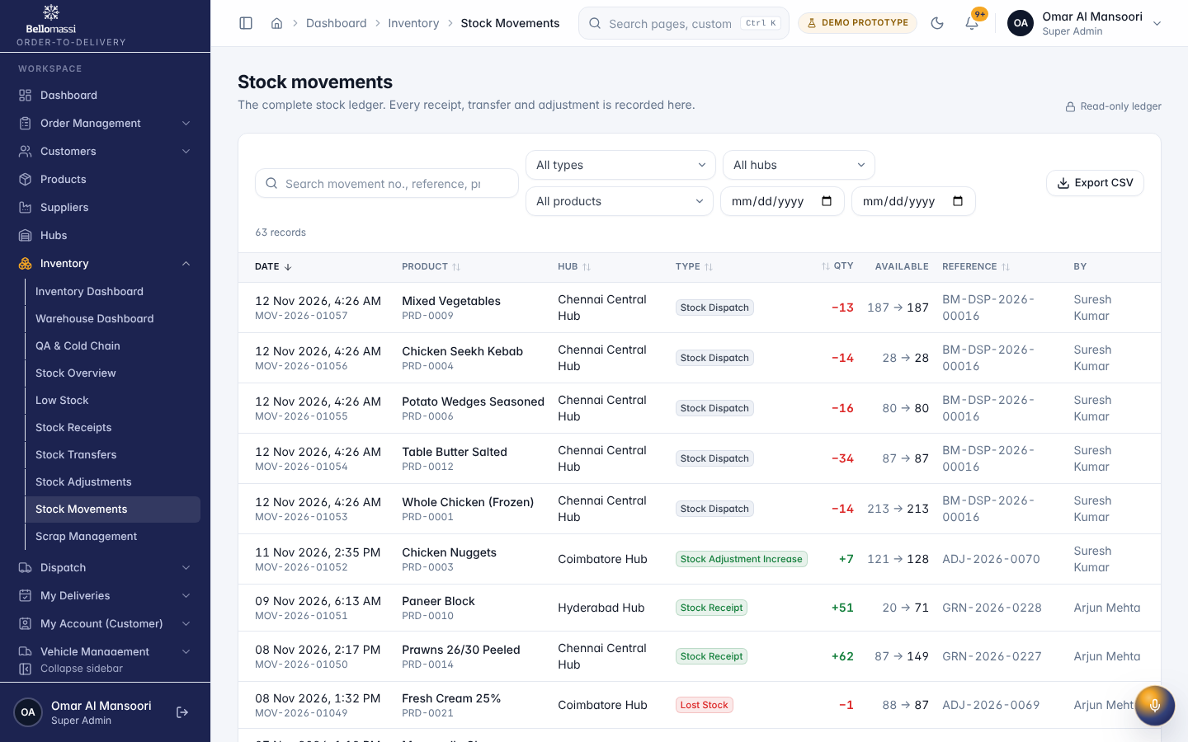

UX-SCRAP — Scrap Requests
Item | Value
Screen ID | SCR-032
Route | /inventory/scrap/requests (captured: /inventory/scrap/requests)
Application | Office web app
Permission | inventory.scrap.view
Captured as role | superadmin
Roles with access | SUPER_ADMIN, ADMIN, DISPATCHER, WAREHOUSE_MANAGER, INVENTORY_EXECUTIVE, QA_MANAGER
Purpose | Scrap Requests
Page heading | Scrap Requests
Fields / filters | Status; Approval; Reason; Hub; Warehouse; Product; Requested by; From date; To date
Table columns | SCRAP NO.; DATE; PRODUCT; HUB; QTY; VALUE; REASON; REQUESTED BY; STATUS; ACTIONS
Actions | Print; Export CSV; SCRAP NO.; DATE; PRODUCT; HUB; QTY; VALUE; REASON; REQUESTED BY; STATUS; Actions for SCR-2026-0012; Actions for SCR-2026-0011; Actions for SCR-2026-0010; Actions for SCR-2026-0009; Actions for SCR-2026-0008; Actions for SCR-2026-0007; Actions for SCR-2026-0006; Actions for SCR-2026-0005; Actions for SCR-2026-0004; Actions for SCR-2026-0003; Actions for SCR-2026-0002; Actions for SCR-2026-0001
Screen type | list
Layout | Office layout: sidebar, header (breadcrumbs, search, notifications, profile), page header, content cards
Components | PageHeader, FilterToolbar, DataTable (sort, paging), Badge, RowActions, EmptyState
Validation | Filter inputs only
Responsive behaviour | Sidebar fixed ≥ 1024 px, drawer below; grids collapse to one column; tables scroll horizontally inside the card
Empty state | EmptyState with explanation and call to action
Loading state | Spinner / skeleton while data is read (prototype reads are near-instant from LocalStorage)
Error state | ErrorBoundary page; action refusals as error toast
Success state | Data displayed with counts
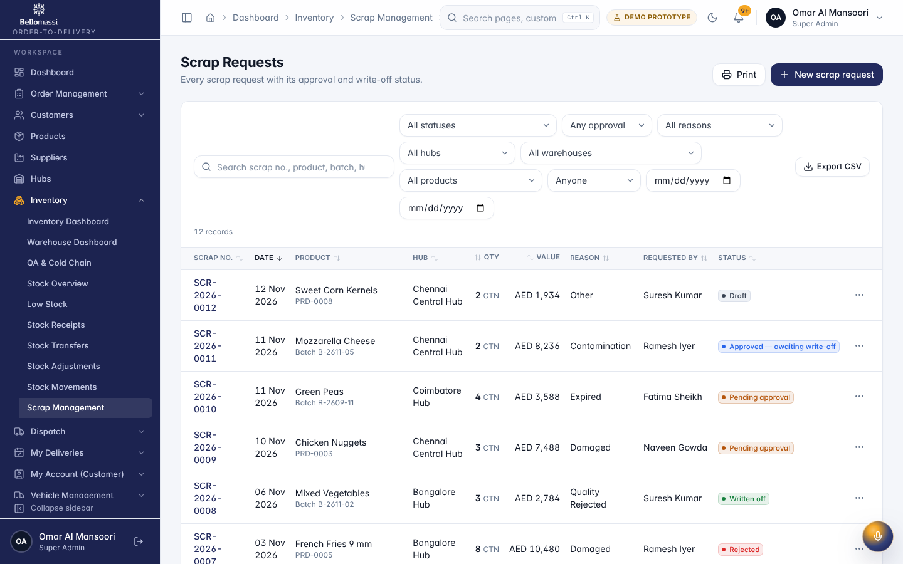

UX-WAREHOUSE — Warehouse Dashboard
Item | Value
Screen ID | SCR-023
Route | /warehouse (captured: /warehouse)
Application | Office web app
Permission | warehouse.dashboard
Captured as role | superadmin
Roles with access | SUPER_ADMIN, ADMIN, WAREHOUSE_MANAGER, INVENTORY_EXECUTIVE, QA_MANAGER
Purpose | Receiving, stock, picking readiness, expiry and inventory alerts per hub.
Page heading | Warehouse Dashboard
Sections | Inventory alerts; Quick actions; Receiving; Picking & loading; Expiry
Fields / filters | Hub
Table columns | PRODUCT; HUB; AVAILABLE; REORDER AT; STATUS; RECEIPT; QTY; DATE; ORDER; CUSTOMER; UNITS; OWNER; DOCUMENT; EXPIRY; STATE
Screen type | dashboard
Layout | Office layout: sidebar, header (breadcrumbs, search, notifications, profile), page header, content cards
Components | Period filter, KPI cards, charts (Recharts), queue tables, quick links
Validation | Period filter: valid date range
Responsive behaviour | Sidebar fixed ≥ 1024 px, drawer below; grids collapse to one column; tables scroll horizontally inside the card
Empty state | EmptyState with explanation and call to action
Loading state | Spinner / skeleton while data is read (prototype reads are near-instant from LocalStorage)
Error state | ErrorBoundary page; action refusals as error toast
Success state | Data displayed with counts
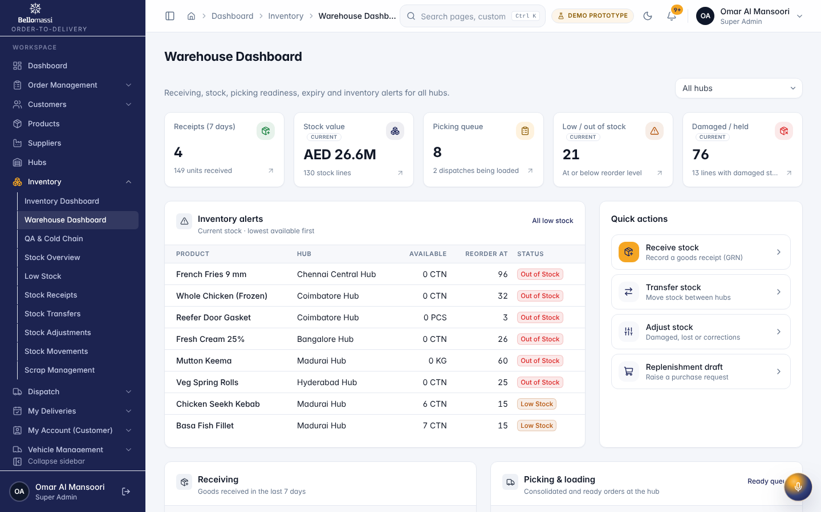

UX-QUALITY — QA & Cold Chain
Item | Value
Screen ID | SCR-024
Route | /quality (captured: /quality)
Application | Office web app
Permission | warehouse.qa.view
Captured as role | superadmin
Roles with access | SUPER_ADMIN, ADMIN, WAREHOUSE_MANAGER, QA_MANAGER
Purpose | Inspection queue, quarantined stock, document expiry and cold-chain ranges.
Page heading | QA & Cold Chain
Sections | Inspection queue; Quick actions; Quarantine; Expiry; Cold chain & temperature alerts
Table columns | DOCUMENT; TYPE; LINKED TO; UPLOADED; PRODUCT; HUB; DAMAGED; OWNER; EXPIRY; STATE
Screen type | dashboard
Layout | Office layout: sidebar, header (breadcrumbs, search, notifications, profile), page header, content cards
Components | Period filter, KPI cards, charts (Recharts), queue tables, quick links
Validation | Period filter: valid date range
Responsive behaviour | Sidebar fixed ≥ 1024 px, drawer below; grids collapse to one column; tables scroll horizontally inside the card
Empty state | EmptyState with explanation and call to action
Loading state | Spinner / skeleton while data is read (prototype reads are near-instant from LocalStorage)
Error state | ErrorBoundary page; action refusals as error toast
Success state | Data displayed with counts
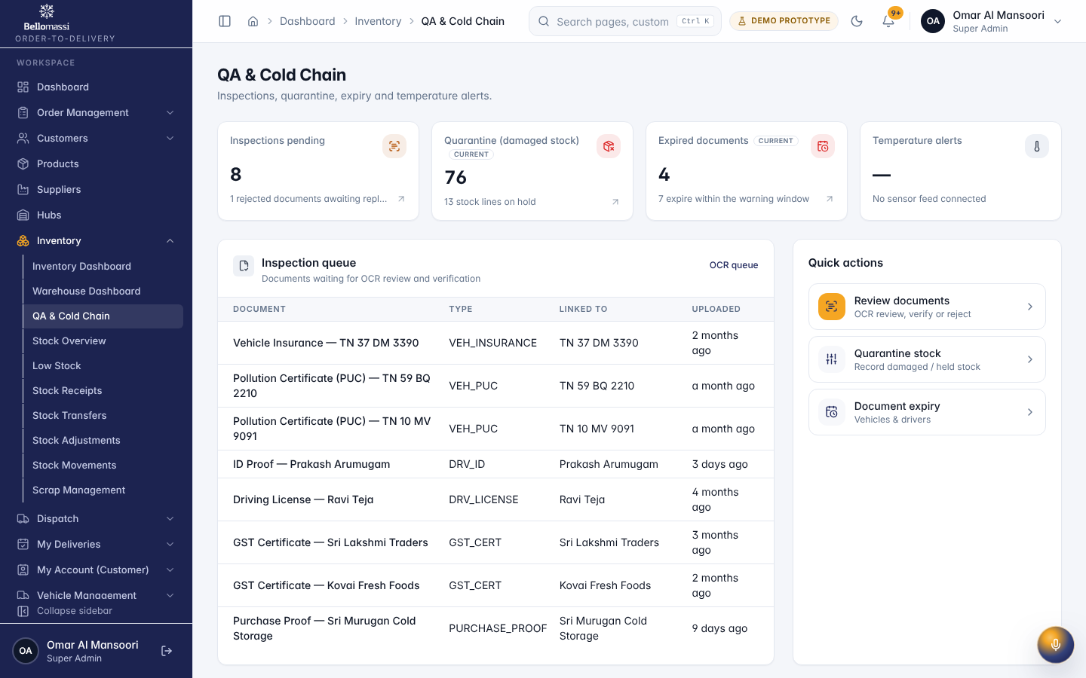

UX-VMS — VMS Dashboard
Item | Value
Screen ID | SCR-087
Route | /vms (captured: /vms)
Application | Office web app
Permission | vms.view
Captured as role | superadmin
Roles with access | SUPER_ADMIN, ADMIN, DISPATCHER, QA_MANAGER
Purpose | Fleet status, compliance and document expiry.
Page heading | Vehicle Management
Sections | Vehicle status; Vehicle type; Hub-wise vehicles; Vehicle document expiry; Driver document expiry; Expiry alerts; Document verification; Vehicle availability; Recent vehicle activity
Screen type | dashboard
Layout | Office layout: sidebar, header (breadcrumbs, search, notifications, profile), page header, content cards
Components | Period filter, KPI cards, charts (Recharts), queue tables, quick links
Validation | Period filter: valid date range
Responsive behaviour | Sidebar fixed ≥ 1024 px, drawer below; grids collapse to one column; tables scroll horizontally inside the card
Empty state | EmptyState with explanation and call to action
Loading state | Spinner / skeleton while data is read (prototype reads are near-instant from LocalStorage)
Error state | ErrorBoundary page; action refusals as error toast
Success state | Data displayed with counts
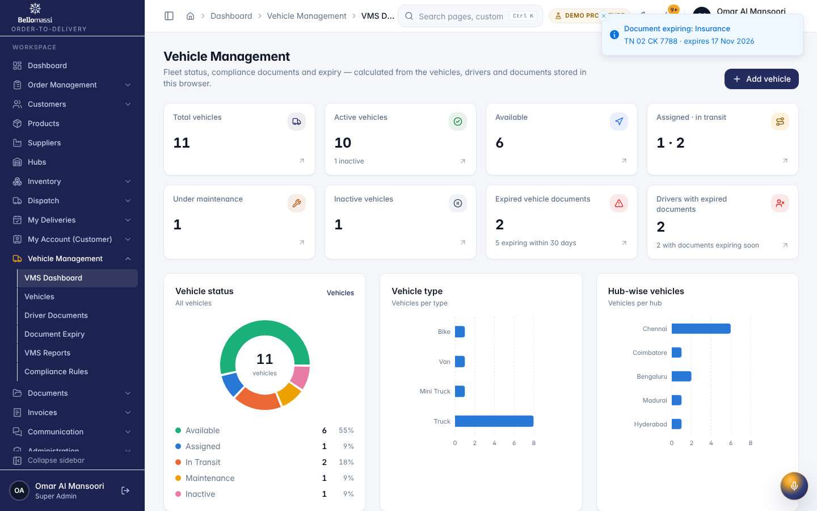

UX-VMS-EXPIRY — Document Expiry
Item | Value
Screen ID | SCR-090
Route | /vms/document-expiry (captured: /vms/document-expiry)
Application | Office web app
Permission | vms.view
Captured as role | superadmin
Roles with access | SUPER_ADMIN, ADMIN, DISPATCHER, QA_MANAGER
Purpose | Expired and expiring vehicle and driver documents.
Page heading | Document expiry
Fields / filters | Expiry state; Hub; Required
Table columns | VEHICLE; DOCUMENT; EXPIRY DATE; STATE
Tabs | Vehicle documents; Driver documents
Actions | Send expiry alerts; Vehicle documents; Driver documents; Export CSV; Previous page; 1; 2; 4; Next page
Screen type | list
Layout | Office layout: sidebar, header (breadcrumbs, search, notifications, profile), page header, content cards
Components | PageHeader, FilterToolbar, DataTable (sort, paging), Badge, RowActions, EmptyState
Validation | Filter inputs only
Responsive behaviour | Sidebar fixed ≥ 1024 px, drawer below; grids collapse to one column; tables scroll horizontally inside the card
Empty state | EmptyState with explanation and call to action
Loading state | Spinner / skeleton while data is read (prototype reads are near-instant from LocalStorage)
Error state | ErrorBoundary page; action refusals as error toast
Success state | Data displayed with counts
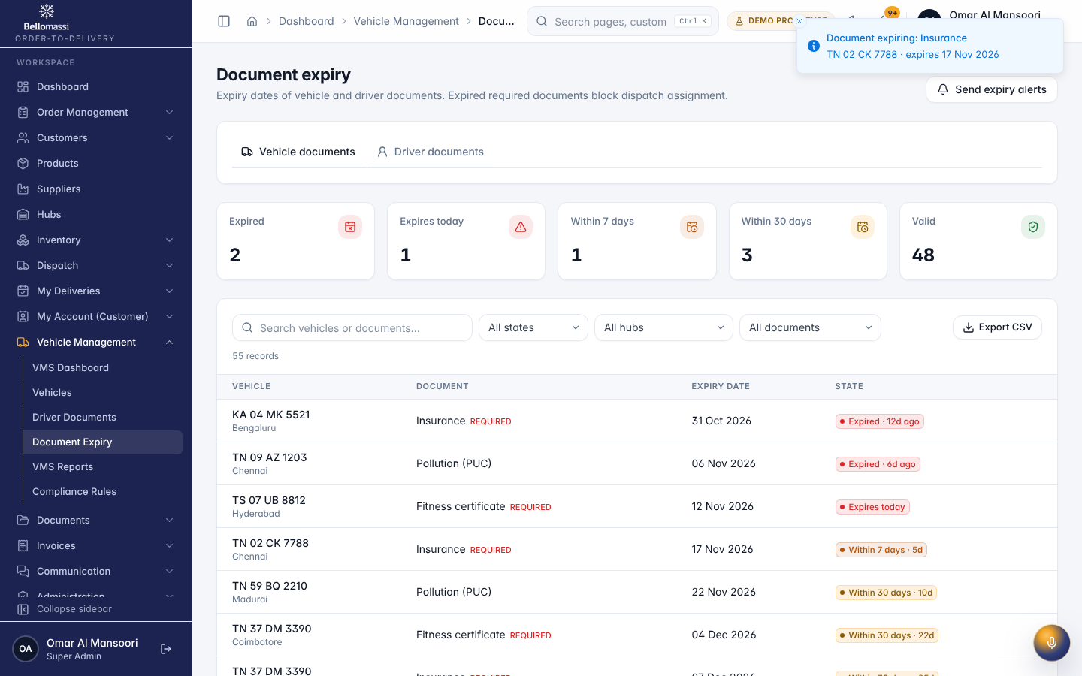

UX-DOCUMENTS — Document Repository
Item | Value
Screen ID | SCR-098
Route | /documents (captured: /documents)
Application | Office web app
Permission | documents.view
Captured as role | superadmin
Roles with access | SUPER_ADMIN, ADMIN, SALESMAN, SALES_MANAGER, CUSTOMER_SERVICE, DISPATCHER, FINANCE, WAREHOUSE_MANAGER, INVENTORY_EXECUTIVE, QA_MANAGER
Purpose | All proofs and documents with OCR review and verification.
Page heading | Document repository
Fields / filters | Document type; Entity; Status; Expiry; Uploaded from; Uploaded to
Table columns | DOCUMENT; RELATED TO; EXPIRY; OCR; STATUS; UPLOADED
Tabs | All; OCR queue; Verified; Rejected
Actions | All; OCR queue; Verified; Rejected; Export CSV; Actions for ID Proof — Prakash Arumugam; Actions for Purchase Proof — Sri Murugan Cold Storage; Actions for Delivery Proof — BM-DN-2026-00004; Actions for Delivery Proof — BM-DN-2026-00003; Actions for Delivery Proof — BM-DN-2026-00002; Actions for Delivery Proof — BM-DN-2026-00001; Actions for Pollution Certificate (PUC) — TN 22 BK 0077; Actions for Pollution Certificate (PUC) — TN 01 RX 3344; Actions for Pollution Certificate (PUC) — TN 10 MV 9091; Actions for Pollution Certificate (PUC) — KA 01 HN 6604; Actions for Pollution Certificate (PUC) — TN 59 BQ 2210; Actions for Pollution Certificate (PUC) — TS 07 UB 8812; Previous page; 1; 2; 6; Next page
Screen type | list
Layout | Office layout: sidebar, header (breadcrumbs, search, notifications, profile), page header, content cards
Components | PageHeader, FilterToolbar, DataTable (sort, paging), Badge, RowActions, EmptyState
Validation | Filter inputs only
Responsive behaviour | Sidebar fixed ≥ 1024 px, drawer below; grids collapse to one column; tables scroll horizontally inside the card
Empty state | EmptyState with explanation and call to action
Loading state | Spinner / skeleton while data is read (prototype reads are near-instant from LocalStorage)
Error state | ErrorBoundary page; action refusals as error toast
Success state | Data displayed with counts
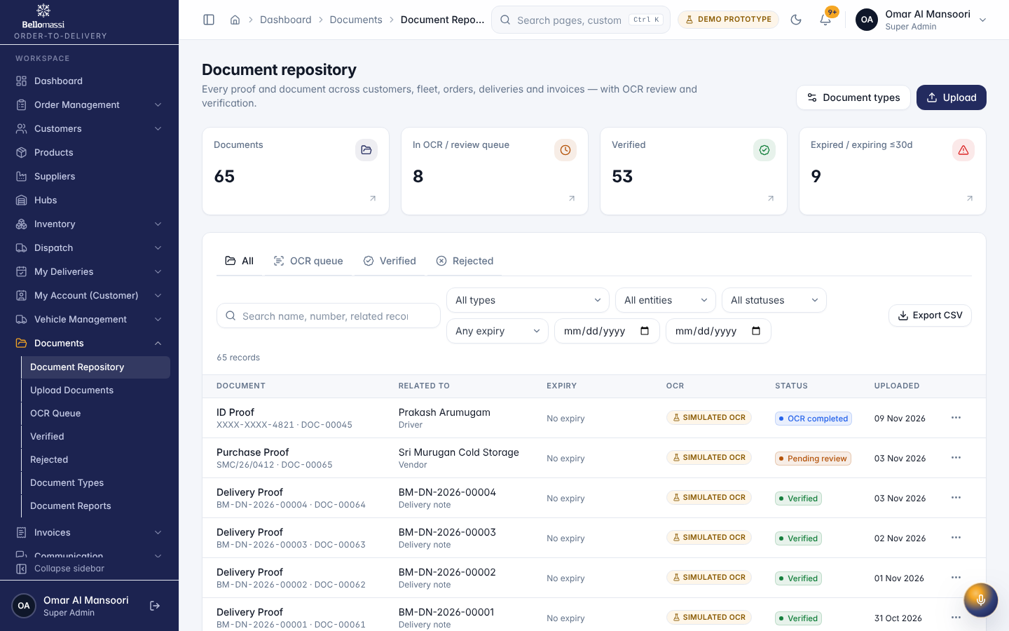

UX-OCR — OCR Queue
Item | Value
Screen ID | SCR-100
Route | /documents/ocr-queue (captured: /documents/ocr-queue)
Application | Office web app
Permission | documents.view
Captured as role | superadmin
Roles with access | SUPER_ADMIN, ADMIN, SALESMAN, SALES_MANAGER, CUSTOMER_SERVICE, DISPATCHER, FINANCE, WAREHOUSE_MANAGER, INVENTORY_EXECUTIVE, QA_MANAGER
Purpose | Documents waiting for OCR or review.
Page heading | OCR queue
Fields / filters | Document type; Entity; Expiry; Uploaded from; Uploaded to
Table columns | DOCUMENT; RELATED TO; EXPIRY; OCR; STATUS; UPLOADED
Tabs | All; OCR queue; Verified; Rejected
Actions | All; OCR queue; Verified; Rejected; Export CSV; Actions for ID Proof — Prakash Arumugam; Actions for Purchase Proof — Sri Murugan Cold Storage; Actions for Pollution Certificate (PUC) — TN 10 MV 9091; Actions for Pollution Certificate (PUC) — TN 59 BQ 2210; Actions for GST Certificate — Kovai Fresh Foods; Actions for Vehicle Insurance — TN 37 DM 3390; Actions for GST Certificate — Sri Lakshmi Traders; Actions for Driving License — Ravi Teja
Screen type | list
Layout | Office layout: sidebar, header (breadcrumbs, search, notifications, profile), page header, content cards
Components | PageHeader, FilterToolbar, DataTable (sort, paging), Badge, RowActions, EmptyState
Validation | Filter inputs only
Responsive behaviour | Sidebar fixed ≥ 1024 px, drawer below; grids collapse to one column; tables scroll horizontally inside the card
Empty state | EmptyState with explanation and call to action
Loading state | Spinner / skeleton while data is read (prototype reads are near-instant from LocalStorage)
Error state | ErrorBoundary page; action refusals as error toast
Success state | Data displayed with counts
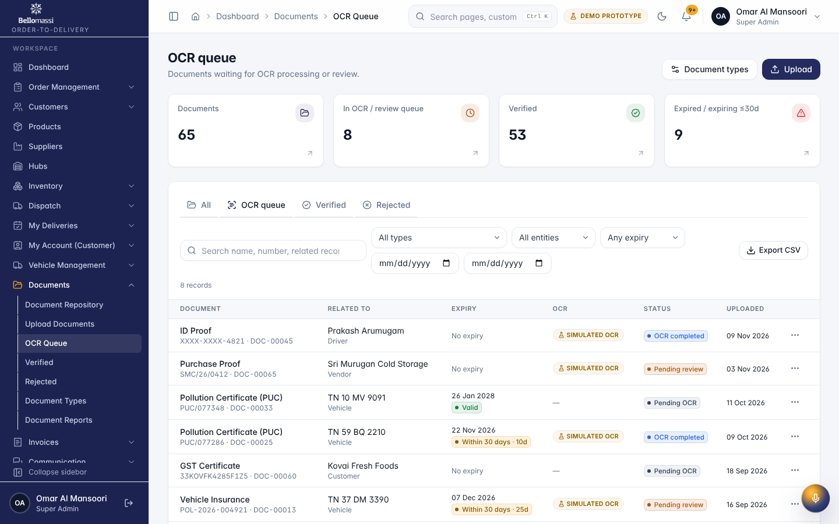

UX-INVOICES — Invoices
Item | Value
Screen ID | SCR-110
Route | /invoices (captured: /invoices)
Application | Office web app
Permission | invoices.view
Captured as role | superadmin
Roles with access | SUPER_ADMIN, ADMIN, SALES_MANAGER, FINANCE
Purpose | Issued and cancelled invoices.
Page heading | Invoices
Fields / filters | Status; Customer; Hub; From; To
Table columns | INVOICE; CUSTOMER; ORDER; DELIVERY NOTE; TOTAL; STATUS
Actions | Export CSV
Screen type | list
Layout | Office layout: sidebar, header (breadcrumbs, search, notifications, profile), page header, content cards
Components | PageHeader, FilterToolbar, DataTable (sort, paging), Badge, RowActions, EmptyState
Validation | Filter inputs only
Responsive behaviour | Sidebar fixed ≥ 1024 px, drawer below; grids collapse to one column; tables scroll horizontally inside the card
Empty state | EmptyState with explanation and call to action
Loading state | Spinner / skeleton while data is read (prototype reads are near-instant from LocalStorage)
Error state | ErrorBoundary page; action refusals as error toast
Success state | Data displayed with counts
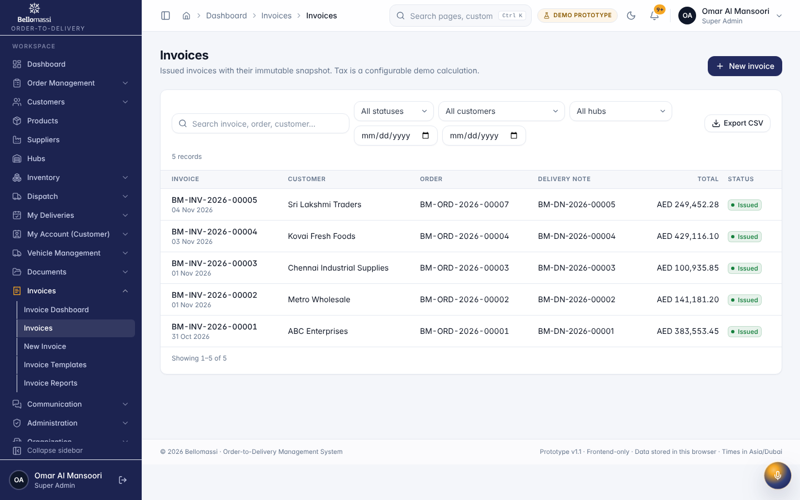

UX-INVOICE-TPL — Invoice Templates
Item | Value
Screen ID | SCR-112
Route | /invoices/templates (captured: /invoices/templates)
Application | Office web app
Permission | invoices.templates
Captured as role | superadmin
Roles with access | SUPER_ADMIN, ADMIN, FINANCE
Purpose | Template builder and invoice numbering.
Page heading | Invoice templates
Sections | Invoice numbering
Fields / filters | Prefix; Year; Starting number; Digits; Include year
Table columns | TEMPLATE; PAGE; COLOURS; USED BY; STATUS
Actions | Actions for Standard invoice; Actions for Compact (no SKU / description); Actions for Landscape — banner header; Save numbering
Screen type | list
Layout | Office layout: sidebar, header (breadcrumbs, search, notifications, profile), page header, content cards
Components | PageHeader, FilterToolbar, DataTable (sort, paging), Badge, RowActions, EmptyState
Validation | Filter inputs only
Responsive behaviour | Sidebar fixed ≥ 1024 px, drawer below; grids collapse to one column; tables scroll horizontally inside the card
Empty state | EmptyState with explanation and call to action
Loading state | Spinner / skeleton while data is read (prototype reads are near-instant from LocalStorage)
Error state | ErrorBoundary page; action refusals as error toast
Success state | Data displayed with counts
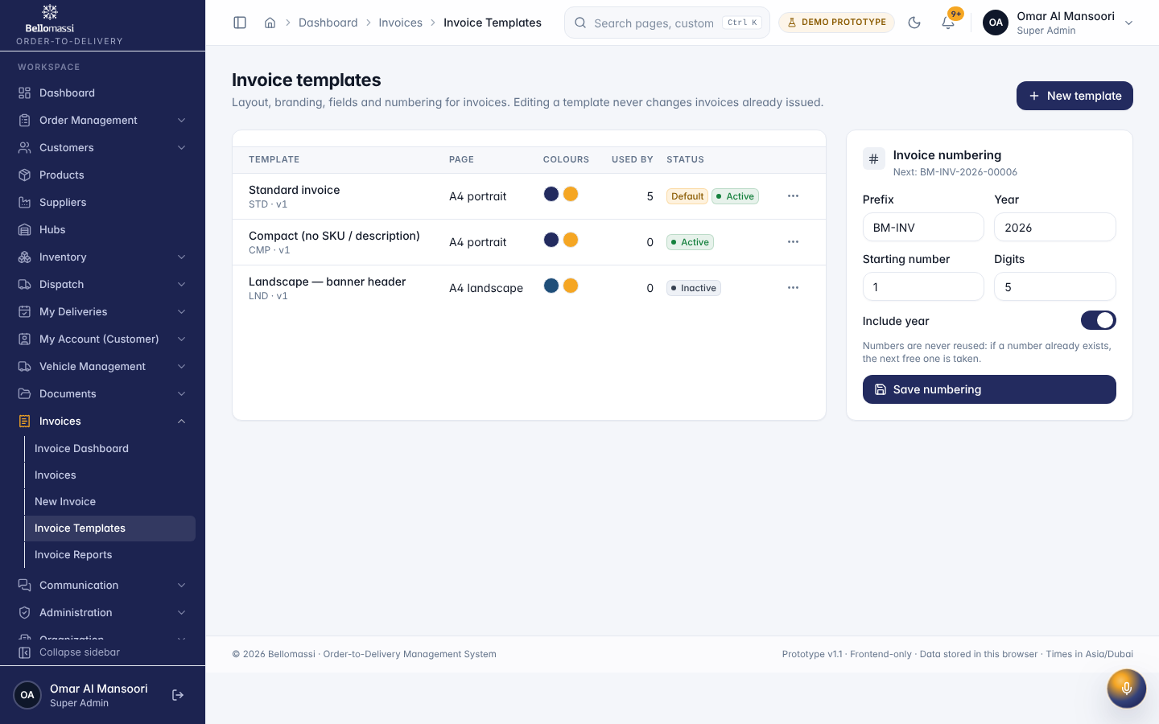

UX-EMAIL — Email
Item | Value
Screen ID | SCR-120
Route | /communication/email (captured: /communication/email)
Application | Office web app
Permission | communication.view
Captured as role | superadmin
Roles with access | SUPER_ADMIN, ADMIN, SALESMAN, SALES_MANAGER, CUSTOMER_SERVICE, DISPATCHER, FINANCE
Purpose | SMTP sending and IMAP inbox through the backend gateway.
Page heading | Email
Sections | Connection; Recent email
Tabs | Overview; Inbox; Sent; Drafts; History; Templates
Actions | Overview; Inbox; Sent; Drafts; History; Templates
Screen type | detail
Layout | Office layout: sidebar, header (breadcrumbs, search, notifications, profile), page header, content cards
Components | PageHeader with status Badge, InfoList, Tabs / Cards, Timeline, action Buttons, ConfirmDialog
Validation | Action pre-conditions checked by the service (status, permission, data scope); refusal message shown
Responsive behaviour | Sidebar fixed ≥ 1024 px, drawer below; grids collapse to one column; tables scroll horizontally inside the card
Empty state | Not found / access denied message for missing record
Loading state | Spinner / skeleton while data is read (prototype reads are near-instant from LocalStorage)
Error state | ErrorBoundary page; action refusals as error toast
Success state | Success toast after actions; badges and timeline update immediately
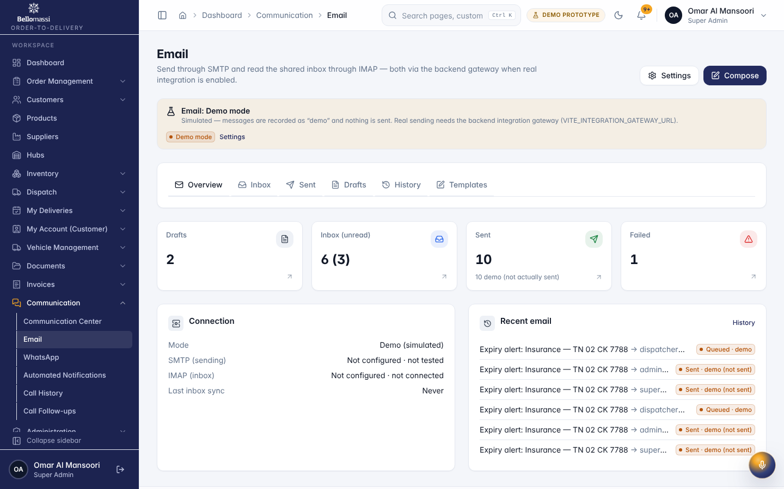

UX-WHATSAPP — WhatsApp
Item | Value
Screen ID | SCR-121
Route | /communication/whatsapp (captured: /communication/whatsapp)
Application | Office web app
Permission | whatsapp.view
Captured as role | superadmin
Roles with access | SUPER_ADMIN, ADMIN, SALESMAN, SALES_MANAGER, CUSTOMER_SERVICE, DISPATCHER, FINANCE
Purpose | WhatsApp through OpenWA, with a clearly labelled demo mode.
Page heading | WhatsApp (OpenWA)
Sections | Session; Recent messages
Tabs | Overview; Compose; History; Templates
Actions | Overview; Compose; History; Templates; Disconnect session; Refresh status; Test connection
Screen type | detail
Layout | Office layout: sidebar, header (breadcrumbs, search, notifications, profile), page header, content cards
Components | PageHeader with status Badge, InfoList, Tabs / Cards, Timeline, action Buttons, ConfirmDialog
Validation | Action pre-conditions checked by the service (status, permission, data scope); refusal message shown
Responsive behaviour | Sidebar fixed ≥ 1024 px, drawer below; grids collapse to one column; tables scroll horizontally inside the card
Empty state | Not found / access denied message for missing record
Loading state | Spinner / skeleton while data is read (prototype reads are near-instant from LocalStorage)
Error state | ErrorBoundary page; action refusals as error toast
Success state | Success toast after actions; badges and timeline update immediately
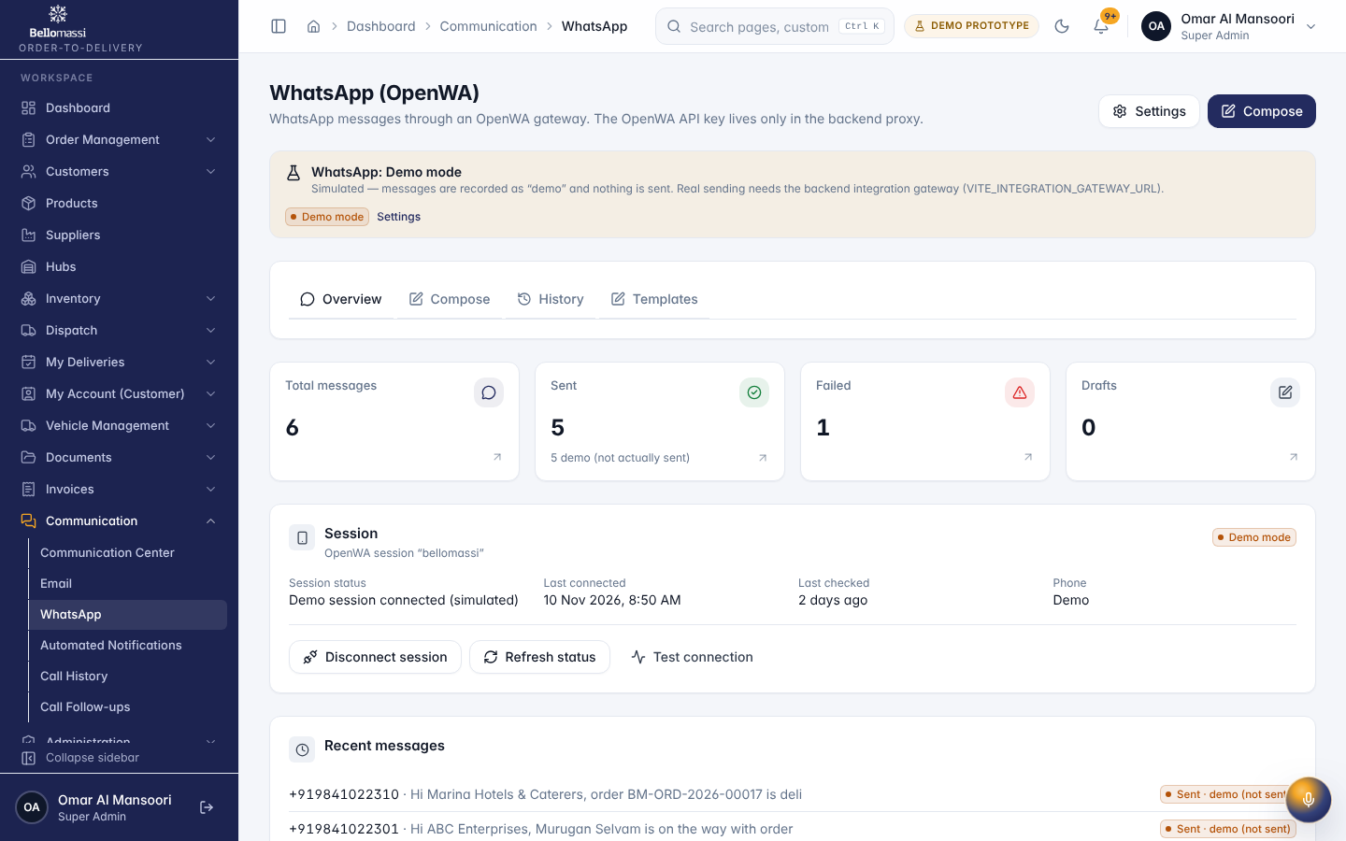

UX-CALLS — Call History
Item | Value
Screen ID | SCR-123
Route | /communication/calls (captured: /communication/calls)
Application | Office web app
Permission | communication.calls
Captured as role | superadmin
Roles with access | SUPER_ADMIN, ADMIN, SALESMAN, SALES_MANAGER, CUSTOMER_SERVICE
Purpose | Customer call log (manually recorded — no telephony connected) linked to customers, salesmen and the orders they produced.
Page heading | Call History
Sections | Calls by day; Outcome distribution; Calls and orders by salesman; Calls by customer
Screen type | detail
Layout | Office layout: sidebar, header (breadcrumbs, search, notifications, profile), page header, content cards
Components | PageHeader with status Badge, InfoList, Tabs / Cards, Timeline, action Buttons, ConfirmDialog
Validation | Action pre-conditions checked by the service (status, permission, data scope); refusal message shown
Responsive behaviour | Sidebar fixed ≥ 1024 px, drawer below; grids collapse to one column; tables scroll horizontally inside the card
Empty state | Not found / access denied message for missing record
Loading state | Spinner / skeleton while data is read (prototype reads are near-instant from LocalStorage)
Error state | ErrorBoundary page; action refusals as error toast
Success state | Success toast after actions; badges and timeline update immediately
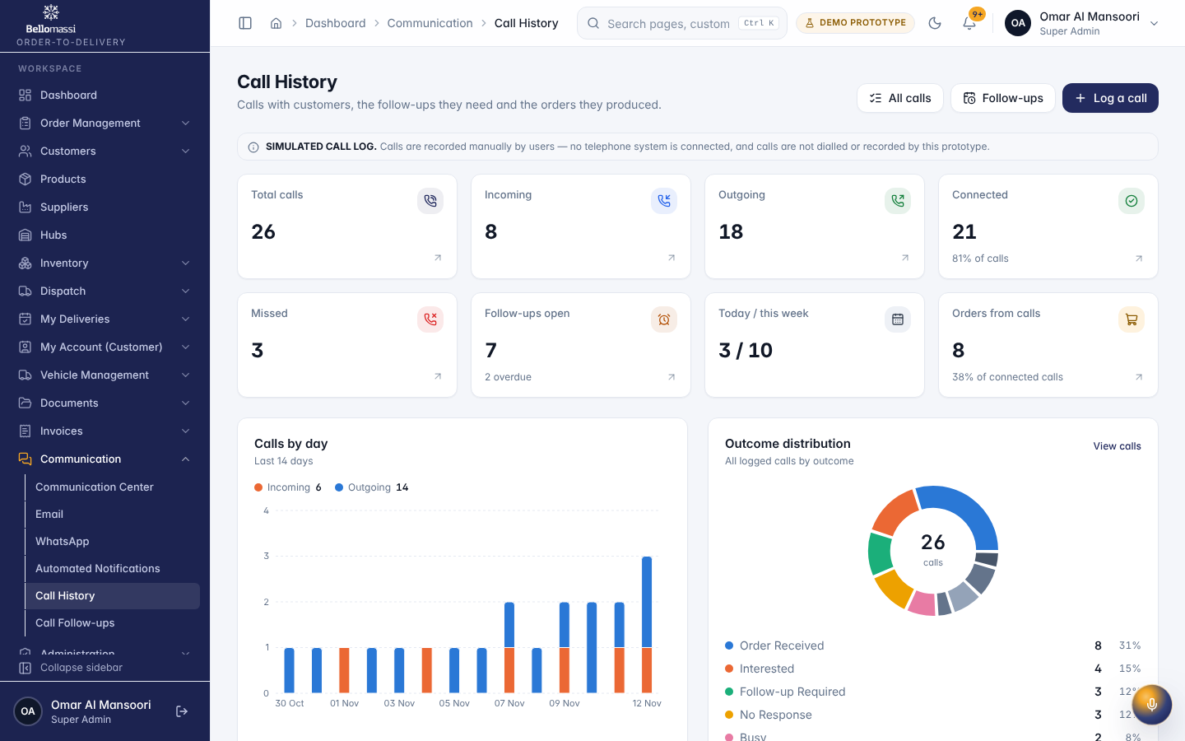

UX-AI — AI Overview
Item | Value
Screen ID | SCR-163
Route | /ai (captured: /ai)
Application | Office web app
Permission | ai.assistant.view
Captured as role | superadmin
Roles with access | SUPER_ADMIN, ADMIN, SALESMAN, SALES_MANAGER, CUSTOMER_SERVICE, DISPATCHER, FINANCE, WAREHOUSE_MANAGER, INVENTORY_EXECUTIVE, QA_MANAGER
Purpose | AI insights, recommendations, provider status and recent AI activity.
Page heading | AI & Intelligence
Sections | Business insights; French Fries 9 mm at Chennai Central Hub may run out now; Whole Chicken (Frozen) at Coimbatore Hub may run out now; Reefer Door Gasket at Coimbatore Hub may run out now; Fresh Cream 25% at Bangalore Hub may run out now; AI recommendations; Recent AI activity; AI provider; Try asking
Fields / filters | Question
Table columns | PRODUCT; RISK; RECOMMENDED; WHY
Actions | Ask; Mark reviewed; Resolve
Screen type | dashboard
Layout | Office layout: sidebar, header (breadcrumbs, search, notifications, profile), page header, content cards
Components | Period filter, KPI cards, charts (Recharts), queue tables, quick links
Validation | Period filter: valid date range
Responsive behaviour | Sidebar fixed ≥ 1024 px, drawer below; grids collapse to one column; tables scroll horizontally inside the card
Empty state | EmptyState with explanation and call to action
Loading state | Spinner / skeleton while data is read (prototype reads are near-instant from LocalStorage)
Error state | ErrorBoundary page; action refusals as error toast
Success state | Data displayed with counts
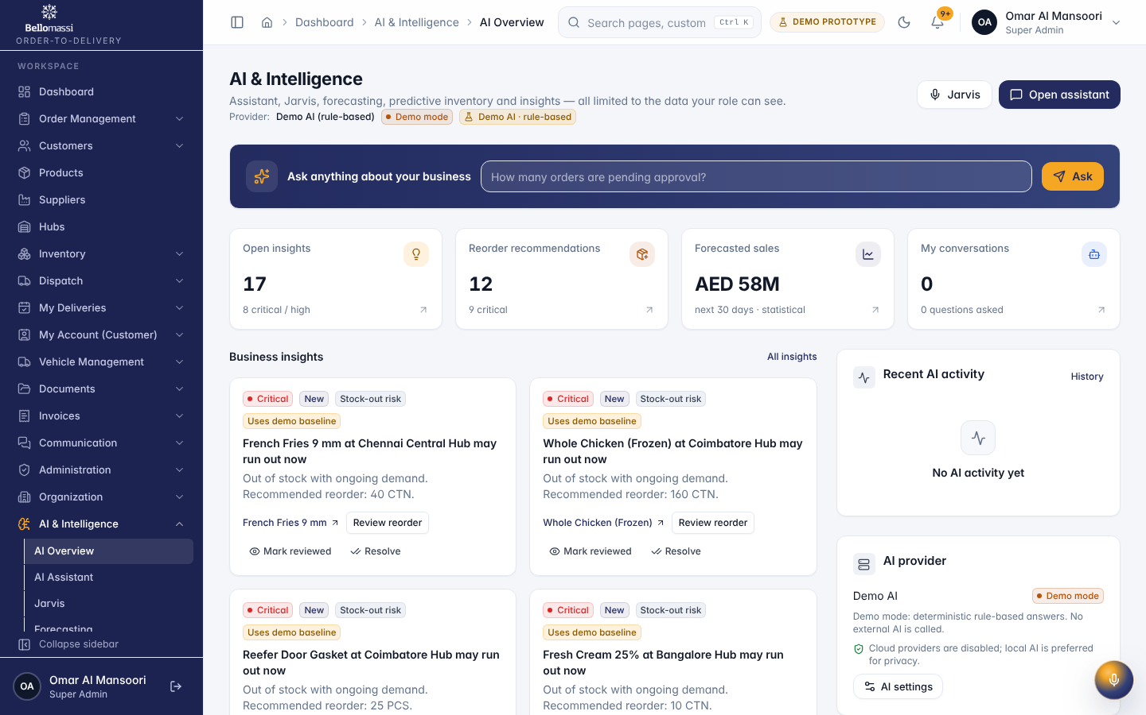

UX-FORECAST — Forecasting
Item | Value
Screen ID | SCR-166
Route | /ai/forecasting (captured: /ai/forecasting)
Application | Office web app
Permission | forecasting.view
Captured as role | superadmin
Roles with access | SUPER_ADMIN, ADMIN, SALES_MANAGER, DISPATCHER, FINANCE, WAREHOUSE_MANAGER
Purpose | Sales, order and demand forecasts with backtest accuracy.
Page heading | Forecasting
Sections | Daily revenue — next 30 days; Quick forecast; Model & data; Actual vs predicted; Recent forecasts
Fields / filters | Forecast; Period
Table columns | FORECAST; TARGET; MODEL; FORECAST TOTAL; ACCURACY; STATUS
Actions | 7 d; 14 d; 30 d; 60 d; 90 d; Generate
Screen type | list
Layout | Office layout: sidebar, header (breadcrumbs, search, notifications, profile), page header, content cards
Components | PageHeader, FilterToolbar, DataTable (sort, paging), Badge, RowActions, EmptyState
Validation | Filter inputs only
Responsive behaviour | Sidebar fixed ≥ 1024 px, drawer below; grids collapse to one column; tables scroll horizontally inside the card
Empty state | EmptyState with explanation and call to action
Loading state | Spinner / skeleton while data is read (prototype reads are near-instant from LocalStorage)
Error state | ErrorBoundary page; action refusals as error toast
Success state | Data displayed with counts
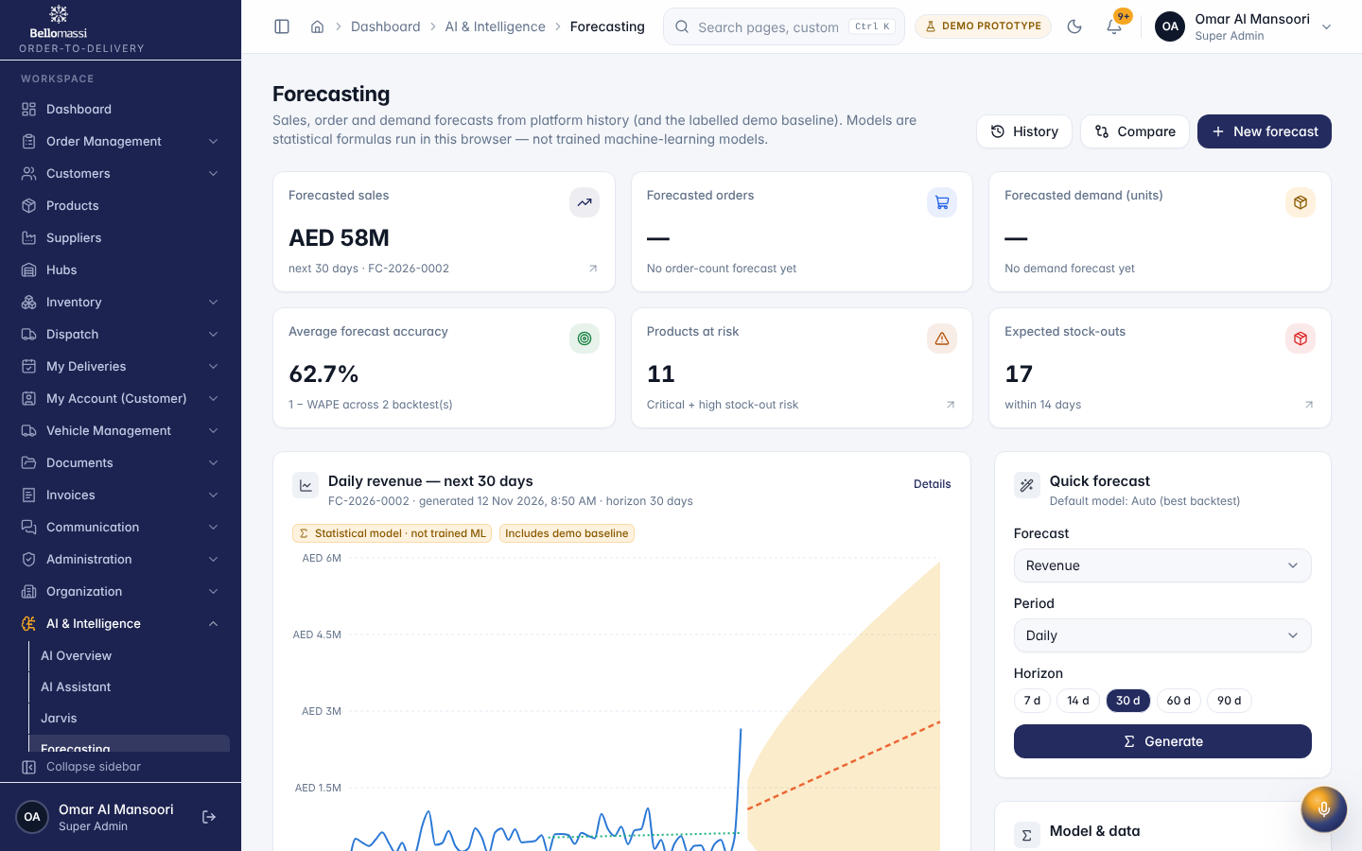

UX-NOTIFICATIONS — Notification Center
Item | Value
Screen ID | SCR-188
Route | /notifications (captured: /notifications)
Application | Public (no sign-in)
Permission | (signed in)
Captured as role | superadmin
Roles with access | all signed-in roles
Purpose | All notifications with categories, filters, read status, history and preferences.
Page heading | Notification Center
Sections | Categories
Fields / filters | Category; Type; Read state
Tabs | Inbox (13); History; Preferences
Actions | Mark all read; Inbox (13); History; Preferences; Open; Mark “Document expiring: Insurance” as read; Archive “Document expiring: Insurance”; Mark “Welcome to Bellomassi” as read; Archive “Welcome to Bellomassi”; Mark “Demo environment initialised” as read; Archive “Demo environment initialised”; Mark “Sample order data loaded” as read; Archive “Sample order data loaded”; Mark “Dispatch & delivery is live” as read; Archive “Dispatch & delivery is live”; Mark “21 stock lines need replenishment” as read; Archive “21 stock lines need replenishment”; Mark “Pending order approval” as read; Archive “Pending order approval”; Mark “Low stock alert” as read; Archive “Low stock alert”; Mark “Delivery failed” as read; Archive “Delivery failed”; Mark “Vehicle document expiry” as read; Archive “Vehicle document expiry”
Screen type | list
Layout | Office layout: sidebar, header (breadcrumbs, search, notifications, profile), page header, content cards
Components | PageHeader, FilterToolbar, DataTable (sort, paging), Badge, RowActions, EmptyState
Validation | Filter inputs only
Responsive behaviour | Sidebar fixed ≥ 1024 px, drawer below; grids collapse to one column; tables scroll horizontally inside the card
Empty state | EmptyState with explanation and call to action
Loading state | Spinner / skeleton while data is read (prototype reads are near-instant from LocalStorage)
Error state | ErrorBoundary page; action refusals as error toast
Success state | Data displayed with counts
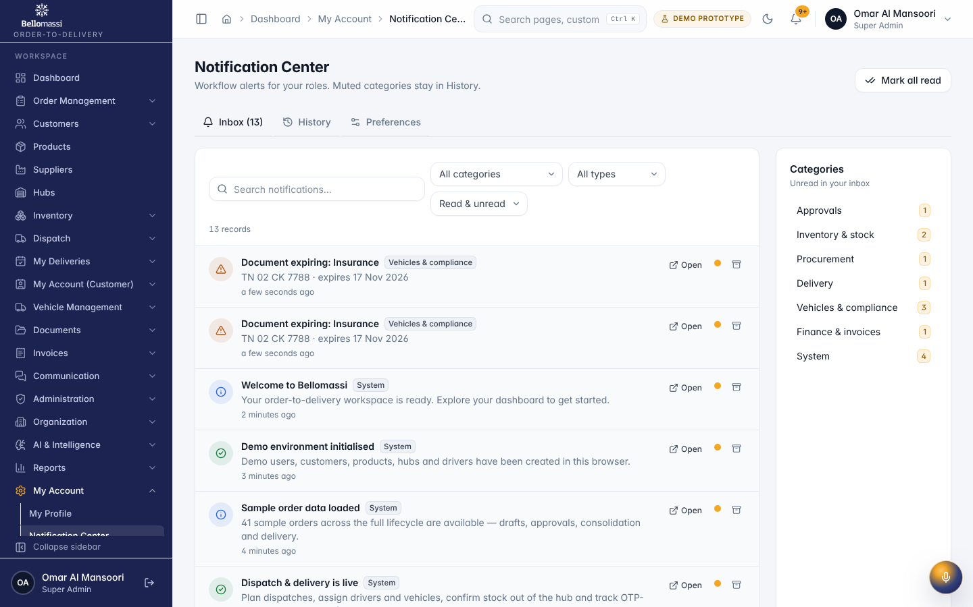

UX-DASH-SE — Dashboard
Item | Value
Screen ID | SCR-001
Route | /dashboard (captured: /dashboard)
Application | Public (no sign-in)
Permission | (signed in)
Captured as role | salesman
Roles with access | all signed-in roles
Purpose | Role-specific overview of orders, approvals, dispatch and deliveries.
Page heading | Good morning, Karthik
Sections | Got an order by call, email or WhatsApp?; My recent orders; Needs your action; Quick actions; My order trend
Fields / filters | Period
Table columns | ORDER; STATUS; VALUE; Updated
Actions | Date range; Specific period; Compare; Which dates are filtered; All TimeAll dates; View all
Screen type | dashboard
Layout | Office layout: sidebar, header (breadcrumbs, search, notifications, profile), page header, content cards
Components | Period filter, KPI cards, charts (Recharts), queue tables, quick links
Validation | Period filter: valid date range
Responsive behaviour | Sidebar fixed ≥ 1024 px, drawer below; grids collapse to one column; tables scroll horizontally inside the card
Empty state | EmptyState with explanation and call to action
Loading state | Spinner / skeleton while data is read (prototype reads are near-instant from LocalStorage)
Error state | ErrorBoundary page; action refusals as error toast
Success state | Data displayed with counts
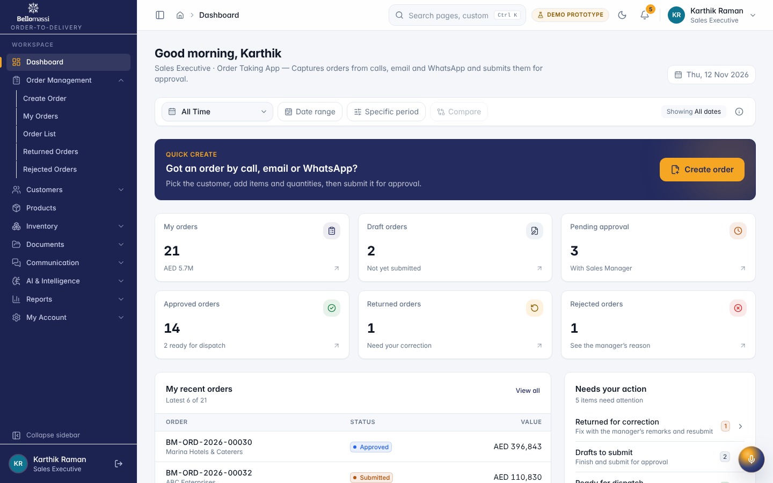

UX-ORDER-CREATE — Create Order
Item | Value
Screen ID | SCR-002
Route | /orders/create (captured: /orders/create)
Application | Office web app
Permission | orders.create
Captured as role | salesman
Roles with access | SUPER_ADMIN, ADMIN, SALESMAN
Purpose | Capture orders received by call, email or WhatsApp — customer first, then items and quantities, then submit for approval.
Page heading | New sales order
Sections | Order information; Delivery information; Products; Notes; Customer; Order summary
Fields / filters | Order number; Order date*; Order source; Order type*; Priority*; Payment terms*; Customer*; Assigned salesman; Fulfilment hub*; Customer reference; Delivery address*; City*; State*; Pincode*; Requested delivery date*; Delivery instructions; Internal notes
Actions | Submit for approval; Save draft; Preview
Screen type | form
Layout | Office layout: sidebar, header (breadcrumbs, search, notifications, profile), page header, content cards
Components | PageHeader, FormSection, Input / Select / Textarea / Checkbox, Button (primary / secondary), ConfirmDialog, toasts
Validation | Mandatory fields marked *; inline messages under fields; service-level validation re-checked on save (see FRD business rules)
Responsive behaviour | Sidebar fixed ≥ 1024 px, drawer below; grids collapse to one column; tables scroll horizontally inside the card
Empty state | Blank form with defaults
Loading state | Spinner / skeleton while data is read (prototype reads are near-instant from LocalStorage)
Error state | Field errors + error toast; ErrorBoundary for unexpected errors
Success state | Success toast and navigation to the record / landing page
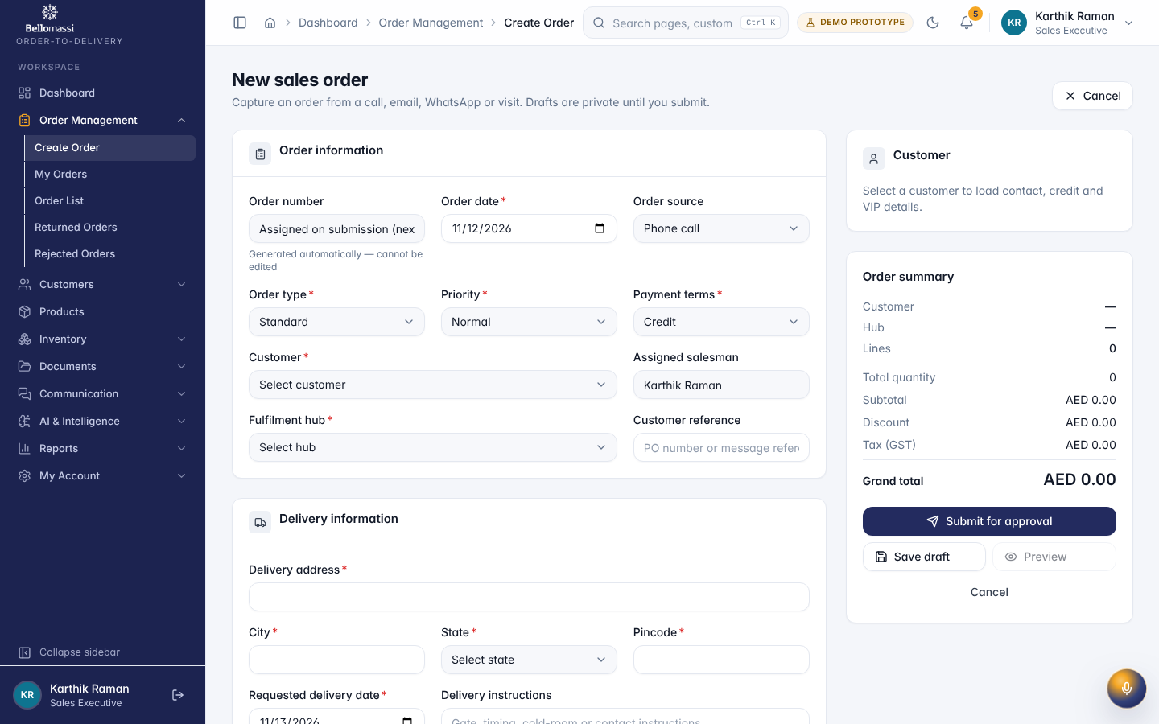

UX-MY-ORDERS — My Orders
Item | Value
Screen ID | SCR-003
Route | /orders/my-orders (captured: /orders/my-orders)
Application | Office web app
Permission | orders.mine
Captured as role | salesman
Roles with access | SUPER_ADMIN, ADMIN, SALESMAN
Purpose | Your drafts and submitted orders with their approval and consolidation status.
Page heading | My orders
Fields / filters | Order status; Approval status; Customer; Hub; Priority; From order date; To order date
Table columns | ORDER; CUSTOMER; SALESMAN; HUB; QTY; TOTAL; STATUS; APPROVAL; PRIORITY; DELIVERY; CREATED; ACTIONS
Actions | Export CSV; ORDER; CUSTOMER; SALESMAN; HUB; QTY; TOTAL; STATUS; APPROVAL; PRIORITY; DELIVERY; CREATED; Actions for draft order; Actions for BM-ORD-2026-00034; Actions for BM-ORD-2026-00032; Actions for BM-ORD-2026-00033; Actions for BM-ORD-2026-00030; Actions for BM-ORD-2026-00038; Actions for BM-ORD-2026-00027; Actions for BM-ORD-2026-00017; Actions for BM-ORD-2026-00022; Actions for BM-ORD-2026-00024; Actions for BM-ORD-2026-00016; Previous page; 1
Screen type | list
Layout | Office layout: sidebar, header (breadcrumbs, search, notifications, profile), page header, content cards
Components | PageHeader, FilterToolbar, DataTable (sort, paging), Badge, RowActions, EmptyState
Validation | Filter inputs only
Responsive behaviour | Sidebar fixed ≥ 1024 px, drawer below; grids collapse to one column; tables scroll horizontally inside the card
Empty state | EmptyState with explanation and call to action
Loading state | Spinner / skeleton while data is read (prototype reads are near-instant from LocalStorage)
Error state | ErrorBoundary page; action refusals as error toast
Success state | Data displayed with counts
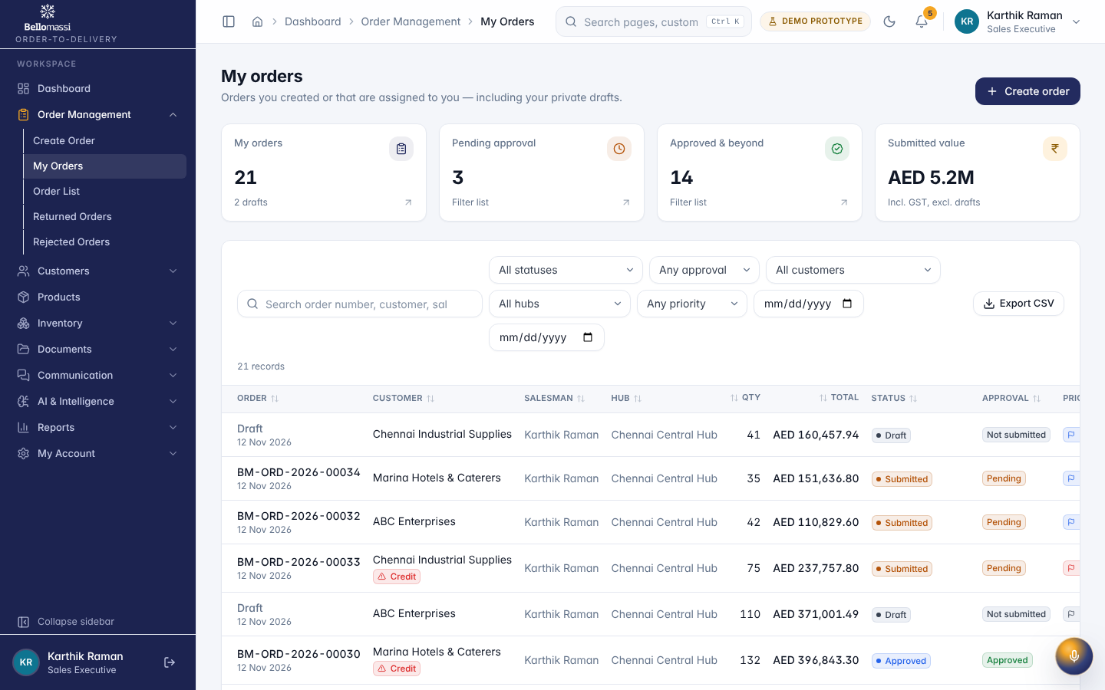

UX-DASH-SM — Dashboard
Item | Value
Screen ID | SCR-001
Route | /dashboard (captured: /dashboard)
Application | Public (no sign-in)
Permission | (signed in)
Captured as role | manager
Roles with access | all signed-in roles
Purpose | Role-specific overview of orders, approvals, dispatch and deliveries.
Page heading | Good morning, Priya
Sections | Recent pending orders; Approval trend; Sales targets; Customers CURRENT; Customer credit overview; Recent orders
Fields / filters | Period
Table columns | CUSTOMER; LIMIT; OUTSTANDING; UTILISATION; ORDER; Salesman; STATUS; VALUE; Updated
Actions | Date range; Specific period; Compare; Which dates are filtered; All TimeAll dates; Set targets; Open credit module; View all
Screen type | dashboard
Layout | Office layout: sidebar, header (breadcrumbs, search, notifications, profile), page header, content cards
Components | Period filter, KPI cards, charts (Recharts), queue tables, quick links
Validation | Period filter: valid date range
Responsive behaviour | Sidebar fixed ≥ 1024 px, drawer below; grids collapse to one column; tables scroll horizontally inside the card
Empty state | EmptyState with explanation and call to action
Loading state | Spinner / skeleton while data is read (prototype reads are near-instant from LocalStorage)
Error state | ErrorBoundary page; action refusals as error toast
Success state | Data displayed with counts
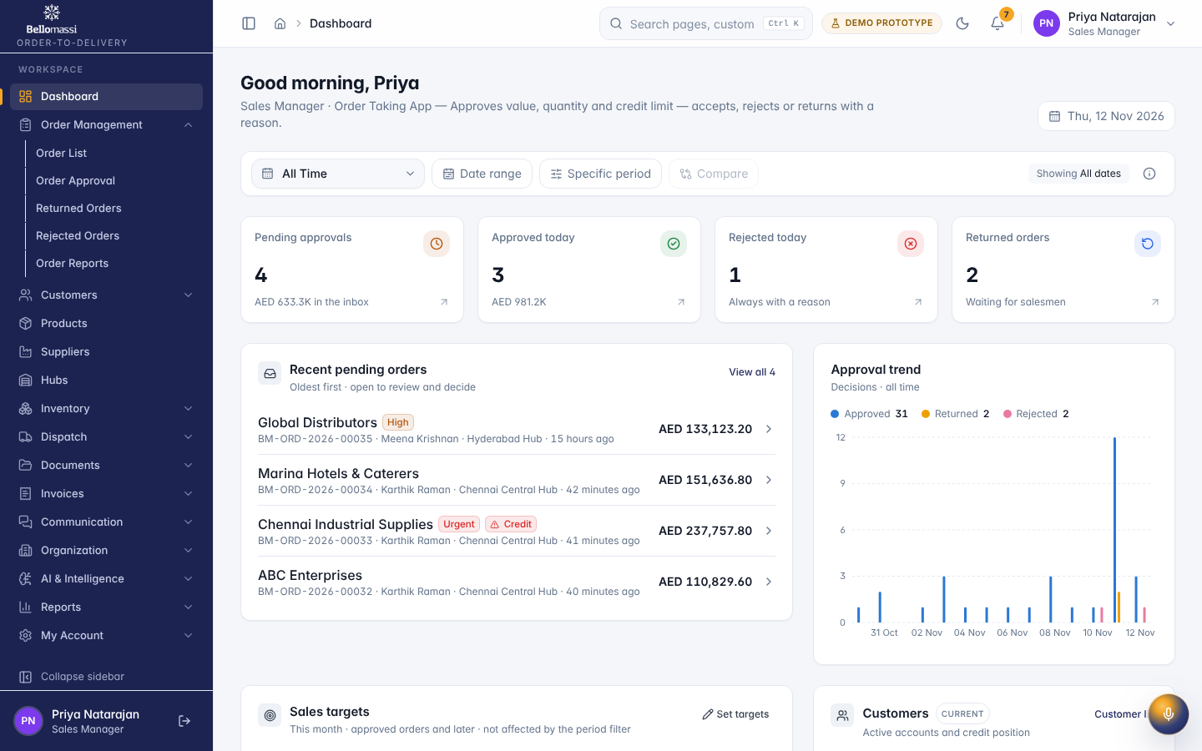

UX-APPROVAL — Order Approval
Item | Value
Screen ID | SCR-005
Route | /orders/approval (captured: /orders/approval)
Application | Office web app
Permission | orders.approval.view
Captured as role | manager
Roles with access | SUPER_ADMIN, ADMIN, SALES_MANAGER
Purpose | Approval inbox for the Sales Manager — approve, return for correction or reject with a mandatory reason, including the credit-limit decision.
Page heading | Order approval
Fields / filters | Warnings; Salesman; Hub; Priority
Table columns | ORDER; CUSTOMER; SALESMAN; HUB; QTY; TOTAL; CREDIT; STOCK; PRIORITY; DELIVERY; SUBMITTED; ACTIONS
Tabs | Pending (4); Decision history (35)
Actions | Pending (4); Decision history (35); Export CSV; ORDER; CUSTOMER; SALESMAN; HUB; QTY; TOTAL; CREDIT; STOCK; PRIORITY; DELIVERY; SUBMITTED; Decide BM-ORD-2026-00035; Decide BM-ORD-2026-00034; Decide BM-ORD-2026-00033; Decide BM-ORD-2026-00032
Screen type | list
Layout | Office layout: sidebar, header (breadcrumbs, search, notifications, profile), page header, content cards
Components | PageHeader, FilterToolbar, DataTable (sort, paging), Badge, RowActions, EmptyState
Validation | Filter inputs only
Responsive behaviour | Sidebar fixed ≥ 1024 px, drawer below; grids collapse to one column; tables scroll horizontally inside the card
Empty state | EmptyState with explanation and call to action
Loading state | Spinner / skeleton while data is read (prototype reads are near-instant from LocalStorage)
Error state | ErrorBoundary page; action refusals as error toast
Success state | Data displayed with counts
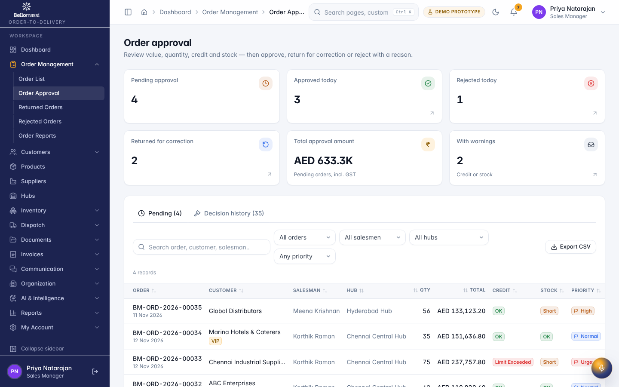

UX-APPROVAL-DETAIL — Review Order
Item | Value
Screen ID | SCR-011
Route | /orders/approval/:id (captured: /orders/approval/ord-0001)
Application | Office web app
Permission | orders.approval.view
Captured as role | manager
Roles with access | SUPER_ADMIN, ADMIN, SALES_MANAGER
Purpose | Review BM-ORD-2026-00001
Page heading | Review BM-ORD-2026-00001
Sections | Order header; Product details; Delivery information; History; Approval checks; Customer information
Table columns | PRODUCT; QTY; UNIT PRICE; DISC.; GST; HUB STOCK NOW; LINE TOTAL
Screen type | list
Layout | Office layout: sidebar, header (breadcrumbs, search, notifications, profile), page header, content cards
Components | PageHeader, FilterToolbar, DataTable (sort, paging), Badge, RowActions, EmptyState
Validation | Filter inputs only
Responsive behaviour | Sidebar fixed ≥ 1024 px, drawer below; grids collapse to one column; tables scroll horizontally inside the card
Empty state | EmptyState with explanation and call to action
Loading state | Spinner / skeleton while data is read (prototype reads are near-instant from LocalStorage)
Error state | ErrorBoundary page; action refusals as error toast
Success state | Data displayed with counts
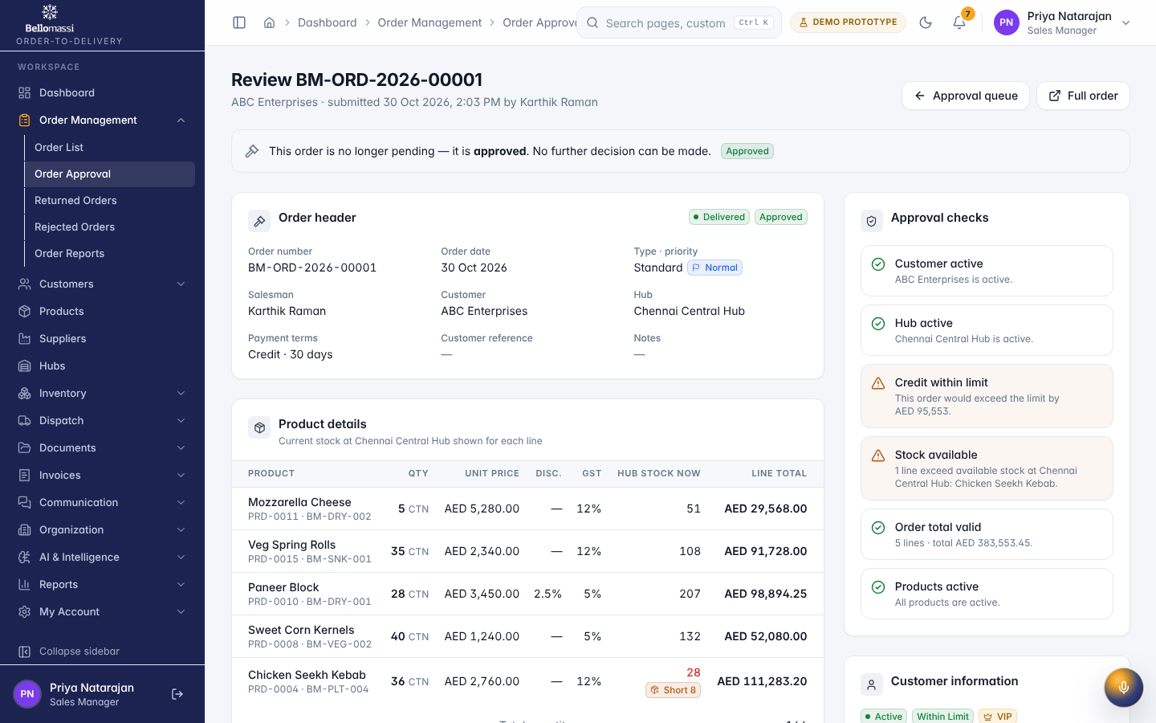

UX-DASH-CS — Dashboard
Item | Value
Screen ID | SCR-001
Route | /dashboard (captured: /dashboard)
Application | Public (no sign-in)
Permission | (signed in)
Captured as role | cs
Roles with access | all signed-in roles
Purpose | Role-specific overview of orders, approvals, dispatch and deliveries.
Page heading | Good morning, Divya
Sections | Consolidation queue; Queue by salesman; Order status distribution; Recent approved orders
Fields / filters | Period
Table columns | SALESMAN; ORDERS; VALUE; ORDER; Salesman; STATUS; Updated
Actions | Date range; Specific period; Compare; Which dates are filtered; All TimeAll dates; View all
Screen type | dashboard
Layout | Office layout: sidebar, header (breadcrumbs, search, notifications, profile), page header, content cards
Components | Period filter, KPI cards, charts (Recharts), queue tables, quick links
Validation | Period filter: valid date range
Responsive behaviour | Sidebar fixed ≥ 1024 px, drawer below; grids collapse to one column; tables scroll horizontally inside the card
Empty state | EmptyState with explanation and call to action
Loading state | Spinner / skeleton while data is read (prototype reads are near-instant from LocalStorage)
Error state | ErrorBoundary page; action refusals as error toast
Success state | Data displayed with counts
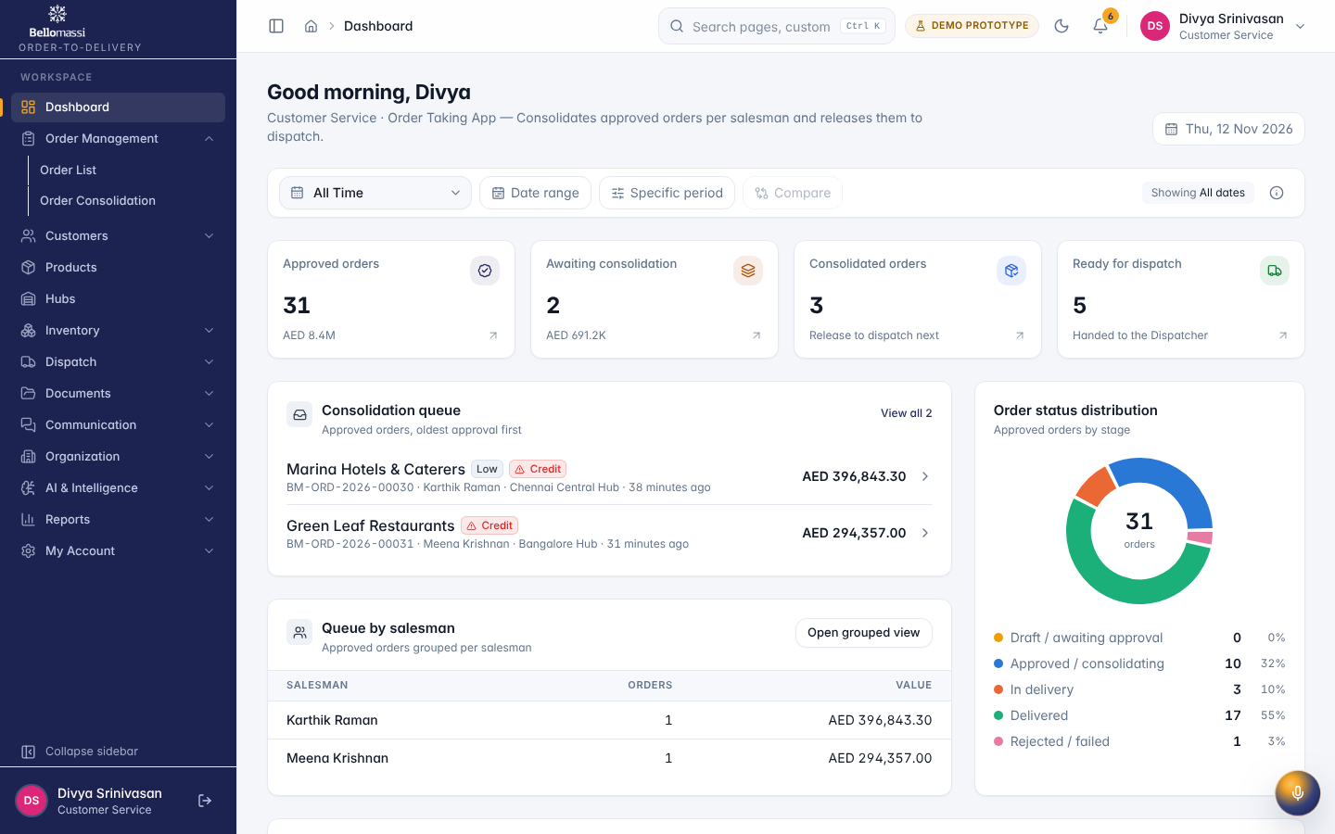

UX-CONSOLIDATION — Order Consolidation
Item | Value
Screen ID | SCR-006
Route | /orders/consolidation (captured: /orders/consolidation)
Application | Office web app
Permission | orders.consolidation.view
Captured as role | cs
Roles with access | SUPER_ADMIN, ADMIN, CUSTOMER_SERVICE
Purpose | Approved orders grouped per salesman, verified, consolidated and released to the Dispatcher.
Page heading | Order consolidation
Fields / filters | Salesman; Hub
Table columns | ORDER; CUSTOMER; SALESMAN; HUB; PRODUCTS; QTY; TOTAL; APPROVED; CONSOLIDATION; ACTIONS
Tabs | Awaiting (2); Consolidated (3); Ready (5); History
Actions | Awaiting (2); Consolidated (3); Ready (5); History; List; By salesman; Export CSV; ORDER; CUSTOMER; SALESMAN; HUB; PRODUCTS; QTY; TOTAL; APPROVED; Actions for BM-ORD-2026-00030; Actions for BM-ORD-2026-00031
Screen type | list
Layout | Office layout: sidebar, header (breadcrumbs, search, notifications, profile), page header, content cards
Components | PageHeader, FilterToolbar, DataTable (sort, paging), Badge, RowActions, EmptyState
Validation | Filter inputs only
Responsive behaviour | Sidebar fixed ≥ 1024 px, drawer below; grids collapse to one column; tables scroll horizontally inside the card
Empty state | EmptyState with explanation and call to action
Loading state | Spinner / skeleton while data is read (prototype reads are near-instant from LocalStorage)
Error state | ErrorBoundary page; action refusals as error toast
Success state | Data displayed with counts
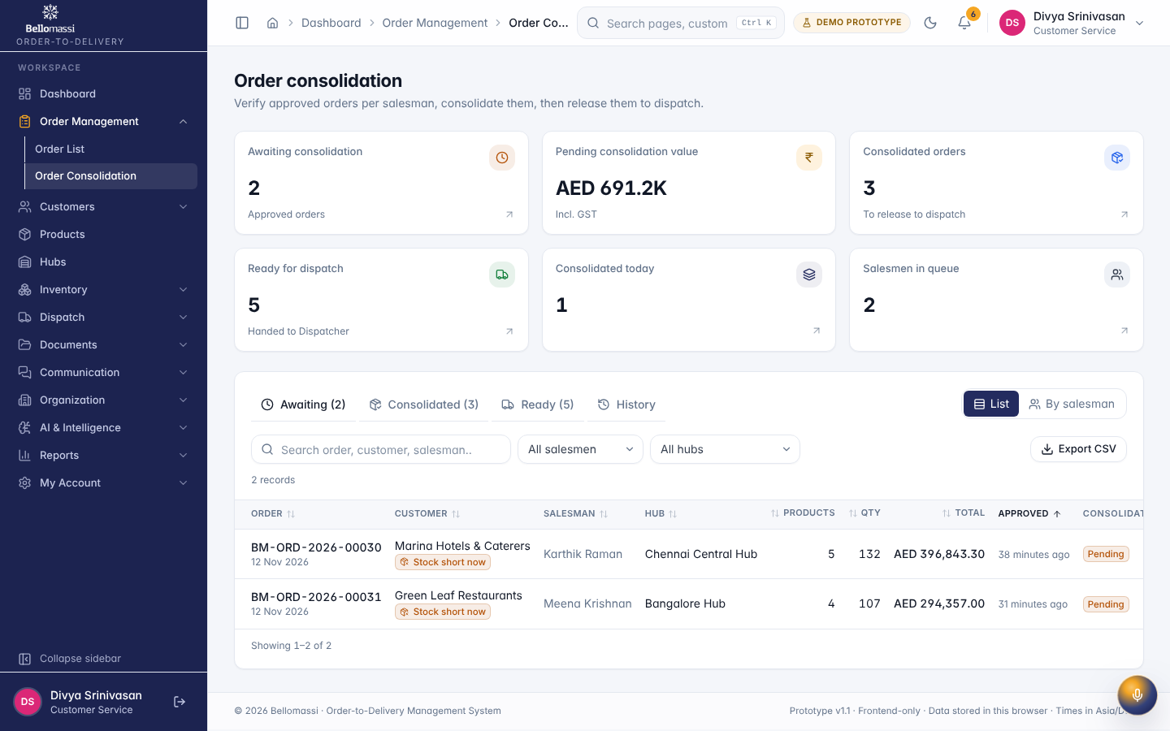

UX-DASH-DP — Dashboard
Item | Value
Screen ID | SCR-001
Route | /dashboard (captured: /dashboard)
Application | Public (no sign-in)
Permission | (signed in)
Captured as role | dispatcher
Roles with access | all signed-in roles
Purpose | Role-specific overview of orders, approvals, dispatch and deliveries.
Page heading | Good morning, Suresh
Sections | Dispatch trend; Delivery completion trend; Delivery status distribution; Driver performance; Zone delivery performance; Recent dispatches; In-transit deliveries; Failed / partial — review; Pending assignments; Recent delivery notes; Quick actions
Fields / filters | Period
Actions | Date range; Specific period; Compare; Which dates are filtered; All TimeAll dates
Screen type | dashboard
Layout | Office layout: sidebar, header (breadcrumbs, search, notifications, profile), page header, content cards
Components | Period filter, KPI cards, charts (Recharts), queue tables, quick links
Validation | Period filter: valid date range
Responsive behaviour | Sidebar fixed ≥ 1024 px, drawer below; grids collapse to one column; tables scroll horizontally inside the card
Empty state | EmptyState with explanation and call to action
Loading state | Spinner / skeleton while data is read (prototype reads are near-instant from LocalStorage)
Error state | ErrorBoundary page; action refusals as error toast
Success state | Data displayed with counts
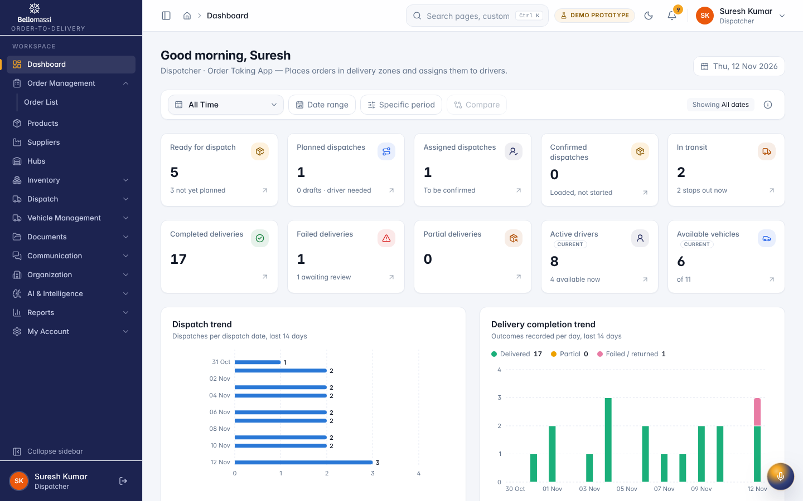

UX-READY — Ready for Dispatch
Item | Value
Screen ID | SCR-042
Route | /dispatch/ready-orders (captured: /dispatch/ready-orders)
Application | Office web app
Permission | dispatch.ready.view
Captured as role | dispatcher
Roles with access | SUPER_ADMIN, ADMIN, CUSTOMER_SERVICE, DISPATCHER, WAREHOUSE_MANAGER
Purpose | Orders released by Customer Service, waiting to be planned into a dispatch.
Page heading | Ready for dispatch
Fields / filters | Customer; Hub; Zone; Priority; Dispatch status; Requested from; Requested to
Table columns | ORDER; CUSTOMER; HUB / ZONE; Delivery address; QTY; AMOUNT; REQUESTED; PRIORITY; DISPATCH STATUS; ACTIONS
Actions | Create dispatch; Export CSV; ORDER; CUSTOMER; HUB / ZONE; QTY; AMOUNT; REQUESTED; PRIORITY; Actions for BM-ORD-2026-00022; Actions for BM-ORD-2026-00026; Actions for BM-ORD-2026-00024; Actions for BM-ORD-2026-00023; Actions for BM-ORD-2026-00025
Screen type | list
Layout | Office layout: sidebar, header (breadcrumbs, search, notifications, profile), page header, content cards
Components | PageHeader, FilterToolbar, DataTable (sort, paging), Badge, RowActions, EmptyState
Validation | Filter inputs only
Responsive behaviour | Sidebar fixed ≥ 1024 px, drawer below; grids collapse to one column; tables scroll horizontally inside the card
Empty state | EmptyState with explanation and call to action
Loading state | Spinner / skeleton while data is read (prototype reads are near-instant from LocalStorage)
Error state | ErrorBoundary page; action refusals as error toast
Success state | Data displayed with counts
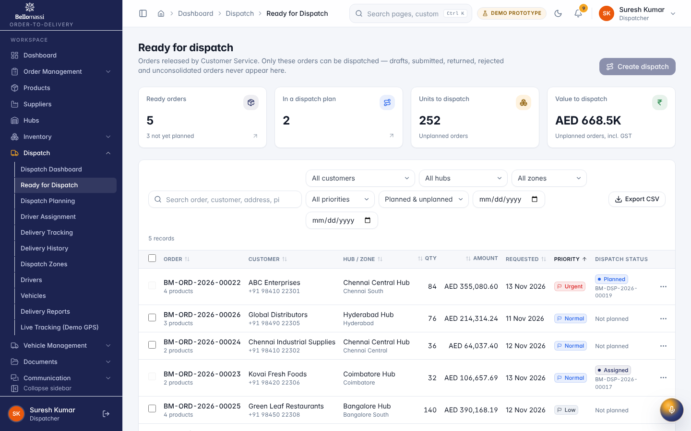

UX-PLANNING — Dispatch Planning
Item | Value
Screen ID | SCR-043
Route | /dispatch/planning (captured: /dispatch/planning)
Application | Office web app
Permission | dispatch.view
Captured as role | dispatcher
Roles with access | SUPER_ADMIN, ADMIN, SALES_MANAGER, CUSTOMER_SERVICE, DISPATCHER, FINANCE, WAREHOUSE_MANAGER
Purpose | Plan multi-order dispatches by hub and zone, set the delivery sequence and confirm loading.
Page heading | Dispatch planning
Sections | Ready orders by zone
Fields / filters | Hub; Zone; Driver; From date; To date
Tabs | Board; All dispatches
Actions | Plan this zone; Board; All dispatches; Export CSV
Screen type | detail
Layout | Office layout: sidebar, header (breadcrumbs, search, notifications, profile), page header, content cards
Components | PageHeader with status Badge, InfoList, Tabs / Cards, Timeline, action Buttons, ConfirmDialog
Validation | Action pre-conditions checked by the service (status, permission, data scope); refusal message shown
Responsive behaviour | Sidebar fixed ≥ 1024 px, drawer below; grids collapse to one column; tables scroll horizontally inside the card
Empty state | Not found / access denied message for missing record
Loading state | Spinner / skeleton while data is read (prototype reads are near-instant from LocalStorage)
Error state | ErrorBoundary page; action refusals as error toast
Success state | Success toast after actions; badges and timeline update immediately
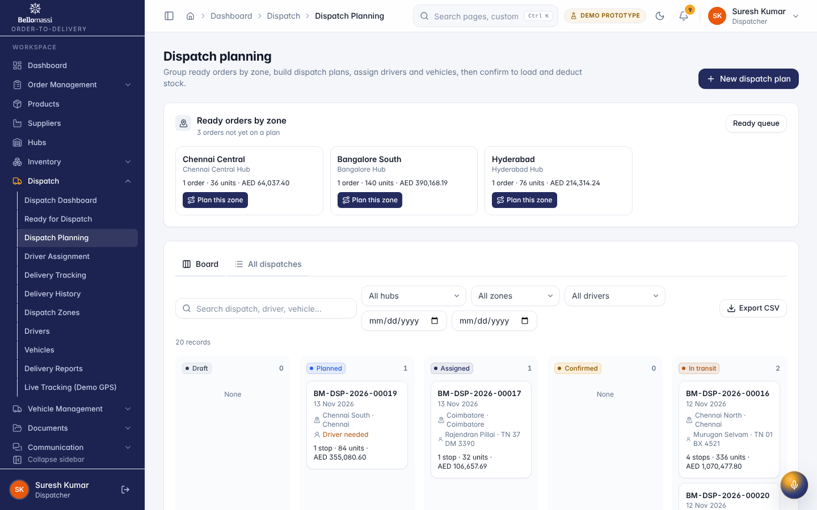

UX-DISPATCH-LIST — Dispatch Dashboard
Item | Value
Screen ID | SCR-041
Route | /dispatch (captured: /dispatch)
Application | Office web app
Permission | dispatch.view
Captured as role | dispatcher
Roles with access | SUPER_ADMIN, ADMIN, SALES_MANAGER, CUSTOMER_SERVICE, DISPATCHER, FINANCE, WAREHOUSE_MANAGER
Purpose | Ready orders, dispatch plans, drivers on the road and delivery outcomes.
Page heading | Dispatch & delivery
Sections | Dispatch trend; Delivery completion trend; Delivery status distribution; Driver performance; Zone delivery performance; Recent dispatches; In-transit deliveries; Failed / partial — review; Pending assignments; Recent delivery notes; Quick actions
Screen type | list
Layout | Office layout: sidebar, header (breadcrumbs, search, notifications, profile), page header, content cards
Components | PageHeader, FilterToolbar, DataTable (sort, paging), Badge, RowActions, EmptyState
Validation | Filter inputs only
Responsive behaviour | Sidebar fixed ≥ 1024 px, drawer below; grids collapse to one column; tables scroll horizontally inside the card
Empty state | EmptyState with explanation and call to action
Loading state | Spinner / skeleton while data is read (prototype reads are near-instant from LocalStorage)
Error state | ErrorBoundary page; action refusals as error toast
Success state | Data displayed with counts
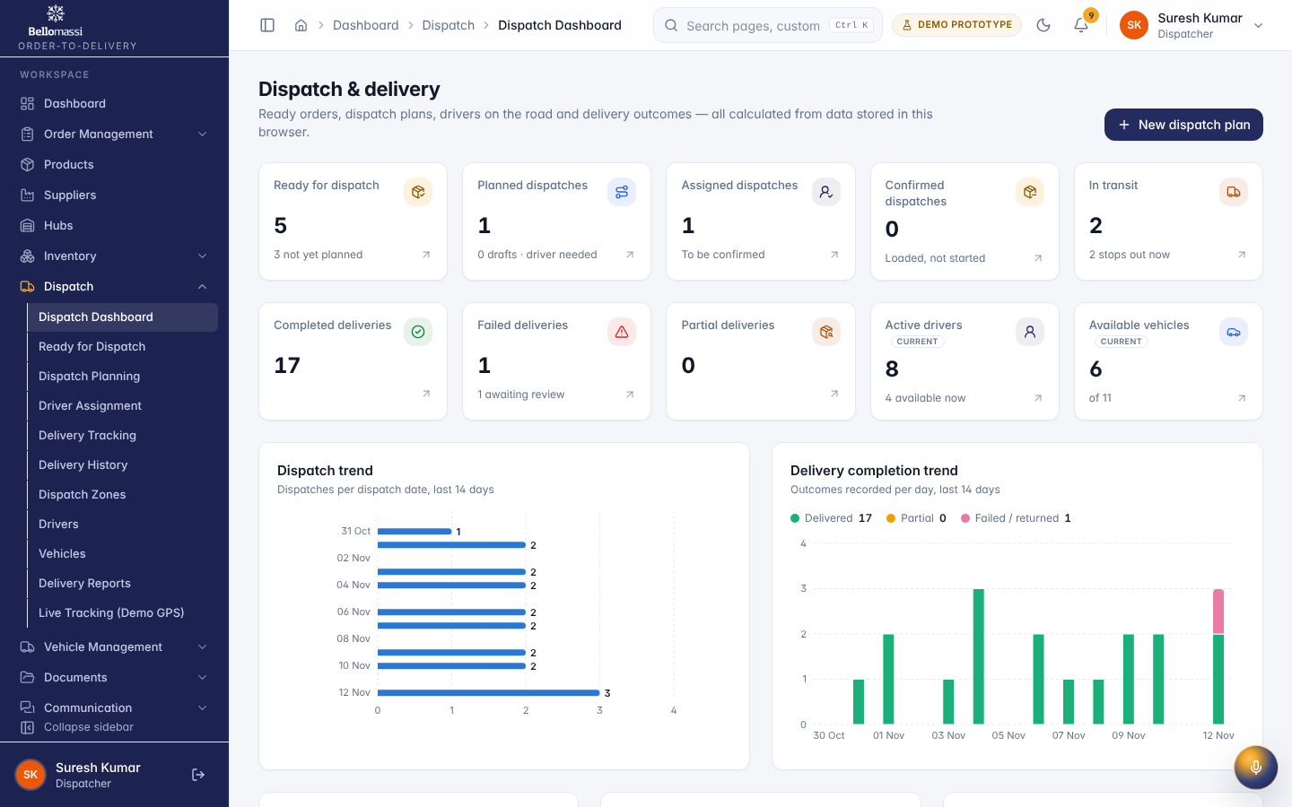

UX-DISPATCH-DETAIL — Dispatch Details
Item | Value
Screen ID | SCR-063
Route | /dispatch/:id (captured: /dispatch/dsp-0001)
Application | Office web app
Permission | dispatch.view
Captured as role | dispatcher
Roles with access | SUPER_ADMIN, ADMIN, SALES_MANAGER, CUSTOMER_SERVICE, DISPATCHER, FINANCE, WAREHOUSE_MANAGER
Purpose | BM-DSP-2026-00001
Page heading | BM-DSP-2026-00001
Sections | Dispatch
Tabs | Stops (1); Stock; Timeline (10)
Actions | Stops (1); Stock; Timeline (10); Open
Screen type | detail
Layout | Office layout: sidebar, header (breadcrumbs, search, notifications, profile), page header, content cards
Components | PageHeader with status Badge, InfoList, Tabs / Cards, Timeline, action Buttons, ConfirmDialog
Validation | Action pre-conditions checked by the service (status, permission, data scope); refusal message shown
Responsive behaviour | Sidebar fixed ≥ 1024 px, drawer below; grids collapse to one column; tables scroll horizontally inside the card
Empty state | Not found / access denied message for missing record
Loading state | Spinner / skeleton while data is read (prototype reads are near-instant from LocalStorage)
Error state | ErrorBoundary page; action refusals as error toast
Success state | Success toast after actions; badges and timeline update immediately
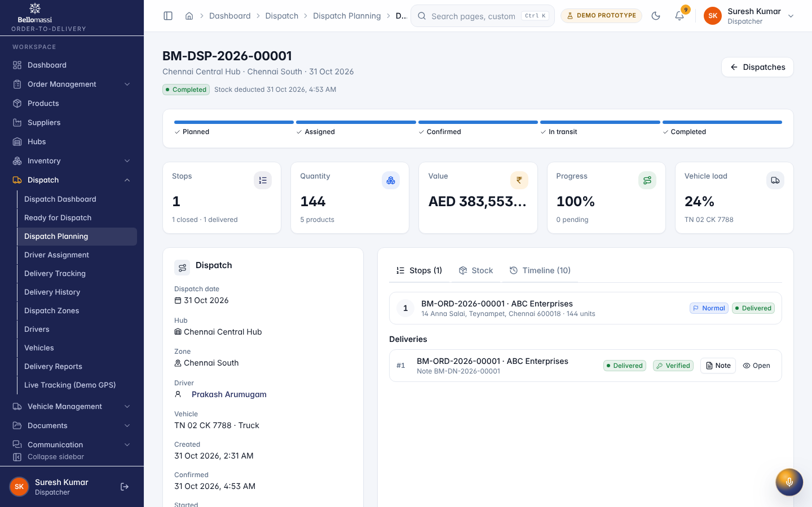

UX-DISPATCH-CREATE — New Dispatch
Item | Value
Screen ID | SCR-051
Route | /dispatch/create (captured: /dispatch/create)
Application | Office web app
Permission | dispatch.manage
Captured as role | dispatcher
Roles with access | SUPER_ADMIN, ADMIN, DISPATCHER
Purpose | New dispatch plan
Page heading | New dispatch plan
Sections | 1 · Hub, date & zone; 2 · Ready orders; 3 · Delivery sequence; 4 · Load summary; 5 · Driver & vehicle
Fields / filters | Dispatching hub*; Dispatch date*; Delivery zone*; Dispatch notes
Actions | Save draft; Create plan
Screen type | form
Layout | Office layout: sidebar, header (breadcrumbs, search, notifications, profile), page header, content cards
Components | PageHeader, FormSection, Input / Select / Textarea / Checkbox, Button (primary / secondary), ConfirmDialog, toasts
Validation | Mandatory fields marked *; inline messages under fields; service-level validation re-checked on save (see FRD business rules)
Responsive behaviour | Sidebar fixed ≥ 1024 px, drawer below; grids collapse to one column; tables scroll horizontally inside the card
Empty state | Blank form with defaults
Loading state | Spinner / skeleton while data is read (prototype reads are near-instant from LocalStorage)
Error state | Field errors + error toast; ErrorBoundary for unexpected errors
Success state | Success toast and navigation to the record / landing page
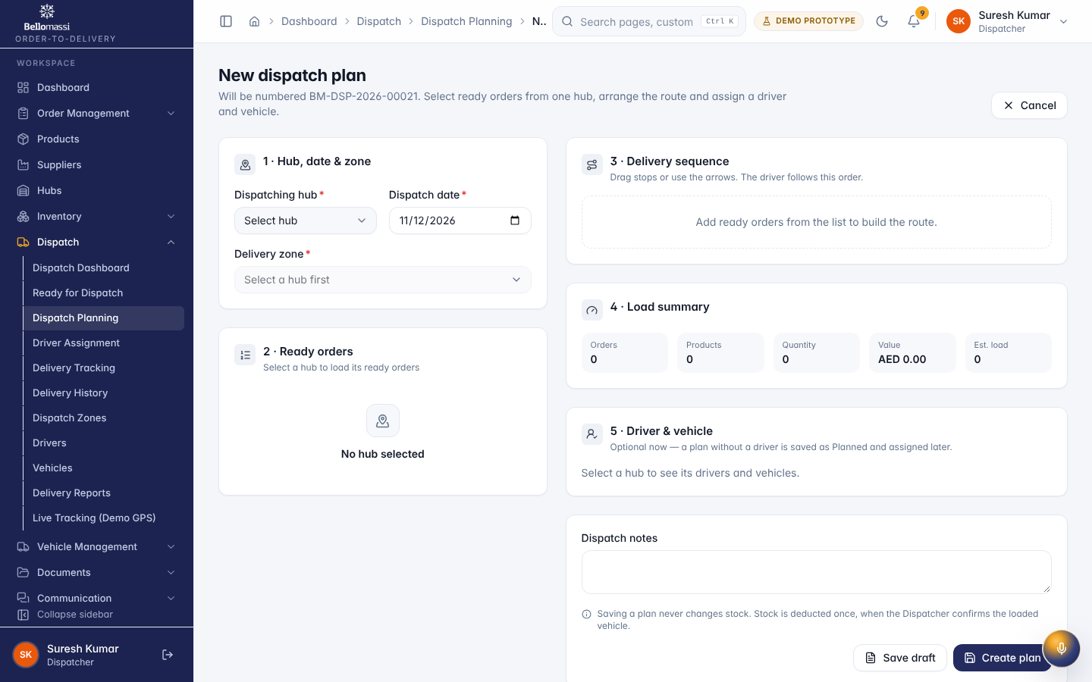

UX-ZONES — Dispatch Zones
Item | Value
Screen ID | SCR-047
Route | /dispatch/zones (captured: /dispatch/zones)
Application | Office web app
Permission | fleet.view
Captured as role | dispatcher
Roles with access | SUPER_ADMIN, ADMIN, DISPATCHER
Purpose | Delivery zones per hub with their pincodes.
Page heading | Dispatch zones
Fields / filters | Hub; Status; City
Table columns | ZONE; HUB; CITY; MANAGER; PINCODES; ACTIVE DISPATCHES; STATUS; ACTIONS
Actions | Export CSV; ZONE; HUB; CITY; MANAGER; PINCODES; ACTIVE DISPATCHES; STATUS; Actions for Bangalore North; Actions for Bangalore South; Actions for Chennai Central; Actions for Chennai North; Actions for Chennai South; Actions for Coimbatore; Actions for Hyderabad; Actions for Madurai
Screen type | list
Layout | Office layout: sidebar, header (breadcrumbs, search, notifications, profile), page header, content cards
Components | PageHeader, FilterToolbar, DataTable (sort, paging), Badge, RowActions, EmptyState
Validation | Filter inputs only
Responsive behaviour | Sidebar fixed ≥ 1024 px, drawer below; grids collapse to one column; tables scroll horizontally inside the card
Empty state | EmptyState with explanation and call to action
Loading state | Spinner / skeleton while data is read (prototype reads are near-instant from LocalStorage)
Error state | ErrorBoundary page; action refusals as error toast
Success state | Data displayed with counts
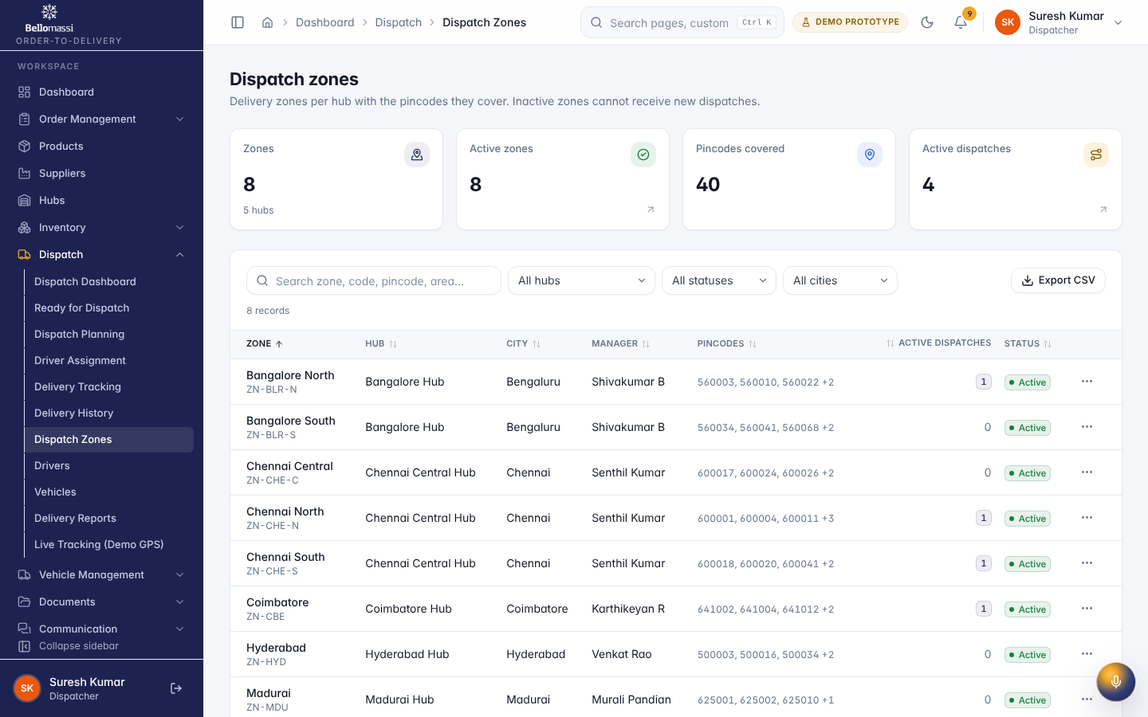

UX-DRIVERS — Drivers
Item | Value
Screen ID | SCR-048
Route | /dispatch/drivers (captured: /dispatch/drivers)
Application | Office web app
Permission | fleet.view
Captured as role | dispatcher
Roles with access | SUPER_ADMIN, ADMIN, DISPATCHER
Purpose | Driver records, licences, availability and delivery performance.
Page heading | Drivers
Fields / filters | Hub; Zone; Availability; Licence
Table columns | DRIVER; HUB / ZONE; VEHICLE; LICENCE; AVAILABILITY; CURRENT DISPATCH; STATUS; ACTIONS
Actions | Export CSV; DRIVER; HUB / ZONE; LICENCE; AVAILABILITY; STATUS; Actions for Dinesh Kumar; Actions for Manjunath Gowda; Actions for Murugan Selvam; Actions for Pandiyan Raj; Actions for Prakash Arumugam; Actions for Rajendran Pillai; Actions for Ravi Teja; Actions for Syed Ameer
Screen type | list
Layout | Office layout: sidebar, header (breadcrumbs, search, notifications, profile), page header, content cards
Components | PageHeader, FilterToolbar, DataTable (sort, paging), Badge, RowActions, EmptyState
Validation | Filter inputs only
Responsive behaviour | Sidebar fixed ≥ 1024 px, drawer below; grids collapse to one column; tables scroll horizontally inside the card
Empty state | EmptyState with explanation and call to action
Loading state | Spinner / skeleton while data is read (prototype reads are near-instant from LocalStorage)
Error state | ErrorBoundary page; action refusals as error toast
Success state | Data displayed with counts
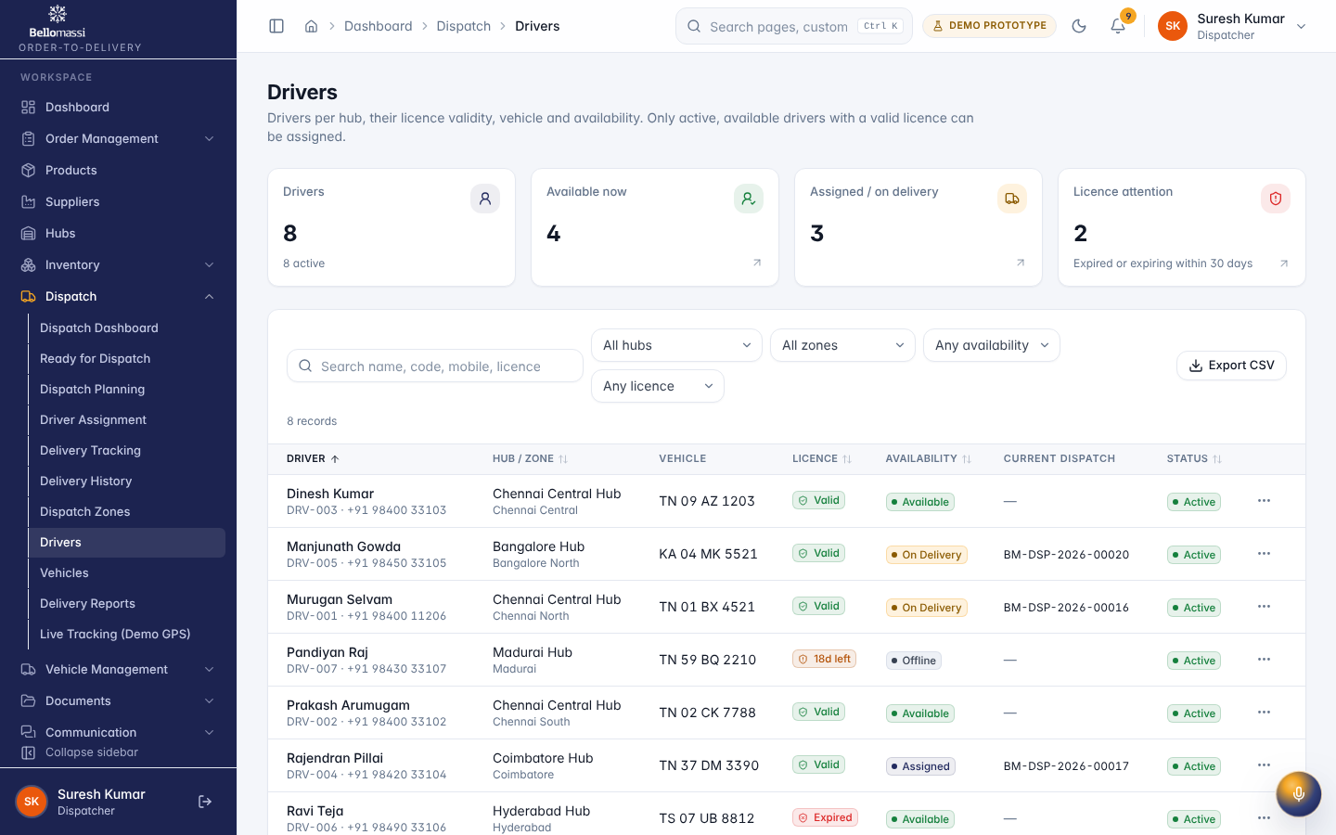

UX-VEHICLES — Vehicles
Item | Value
Screen ID | SCR-049
Route | /dispatch/vehicles (captured: /dispatch/vehicles)
Application | Office web app
Permission | fleet.view
Captured as role | dispatcher
Roles with access | SUPER_ADMIN, ADMIN, DISPATCHER
Purpose | Delivery vehicles, capacity and status.
Page heading | Vehicles
Fields / filters | Hub; Status; Type
Table columns | VEHICLE; HUB; CAPACITY; REGULAR DRIVER; CURRENT DISPATCH; STATUS; ACTIONS
Actions | Export CSV; VEHICLE; HUB; CAPACITY; STATUS; Actions for KA 01 HN 6604; Actions for KA 04 MK 5521; Actions for TN 01 BX 4521; Actions for TN 01 RX 3344; Actions for TN 02 CK 7788; Actions for TN 09 AZ 1203; Actions for TN 10 MV 9091; Actions for TN 22 BK 0077; Actions for TN 37 DM 3390; Actions for TN 59 BQ 2210; Previous page; 1; 2; Next page
Screen type | list
Layout | Office layout: sidebar, header (breadcrumbs, search, notifications, profile), page header, content cards
Components | PageHeader, FilterToolbar, DataTable (sort, paging), Badge, RowActions, EmptyState
Validation | Filter inputs only
Responsive behaviour | Sidebar fixed ≥ 1024 px, drawer below; grids collapse to one column; tables scroll horizontally inside the card
Empty state | EmptyState with explanation and call to action
Loading state | Spinner / skeleton while data is read (prototype reads are near-instant from LocalStorage)
Error state | ErrorBoundary page; action refusals as error toast
Success state | Data displayed with counts
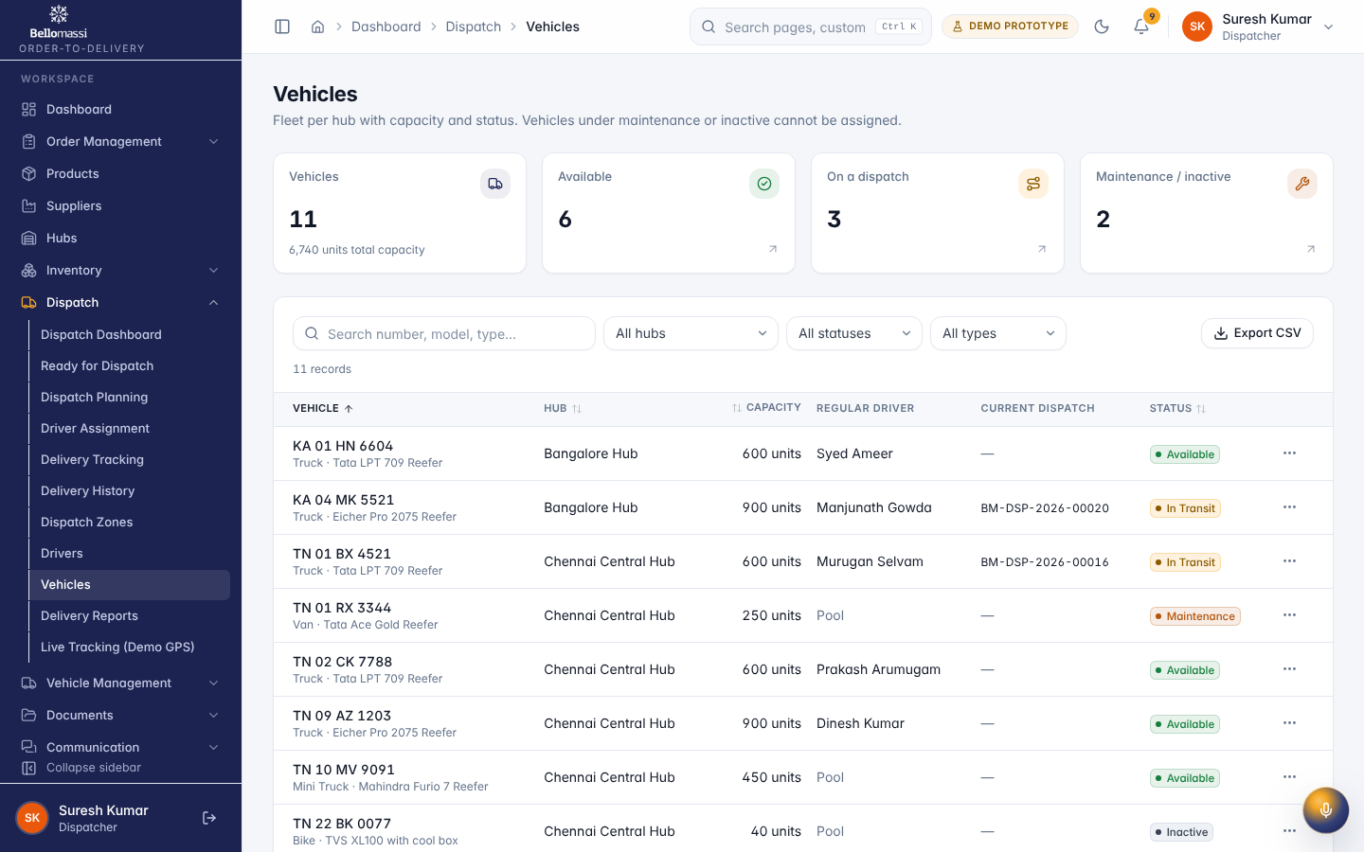

UX-TRACKING — Delivery Tracking
Item | Value
Screen ID | SCR-045
Route | /dispatch/delivery-tracking (captured: /dispatch/delivery-tracking)
Application | Office web app
Permission | dispatch.tracking
Captured as role | dispatcher
Roles with access | SUPER_ADMIN, ADMIN, SALES_MANAGER, CUSTOMER_SERVICE, DISPATCHER
Purpose | Live status of every delivery stop: out for delivery, delivered, partial or failed.
Page heading | Delivery tracking
Fields / filters | From date; To date; Hub; Zone; Driver; Dispatch status; Delivery status; Customer; Order number
Table columns | ORDER / CUSTOMER; DISPATCH; DRIVER / VEHICLE; Hub / zone; DATE; DELIVERY; PROGRESS; OTP; Note; UPDATED; ACTIONS
Actions | Export CSV; ORDER / CUSTOMER; DISPATCH; DRIVER / VEHICLE; DATE; DELIVERY; UPDATED; Actions for BM-ORD-2026-00020; Actions for BM-ORD-2026-00018; Actions for BM-ORD-2026-00016; Actions for BM-ORD-2026-00017; Actions for BM-ORD-2026-00019; Actions for BM-ORD-2026-00021; Actions for BM-ORD-2026-00015; Actions for BM-ORD-2026-00014; Actions for BM-ORD-2026-00012; Actions for BM-ORD-2026-00013; Actions for BM-ORD-2026-00011; Actions for BM-ORD-2026-00010; Previous page; 1; 2; Next page
Screen type | list
Layout | Office layout: sidebar, header (breadcrumbs, search, notifications, profile), page header, content cards
Components | PageHeader, FilterToolbar, DataTable (sort, paging), Badge, RowActions, EmptyState
Validation | Filter inputs only
Responsive behaviour | Sidebar fixed ≥ 1024 px, drawer below; grids collapse to one column; tables scroll horizontally inside the card
Empty state | EmptyState with explanation and call to action
Loading state | Spinner / skeleton while data is read (prototype reads are near-instant from LocalStorage)
Error state | ErrorBoundary page; action refusals as error toast
Success state | Data displayed with counts
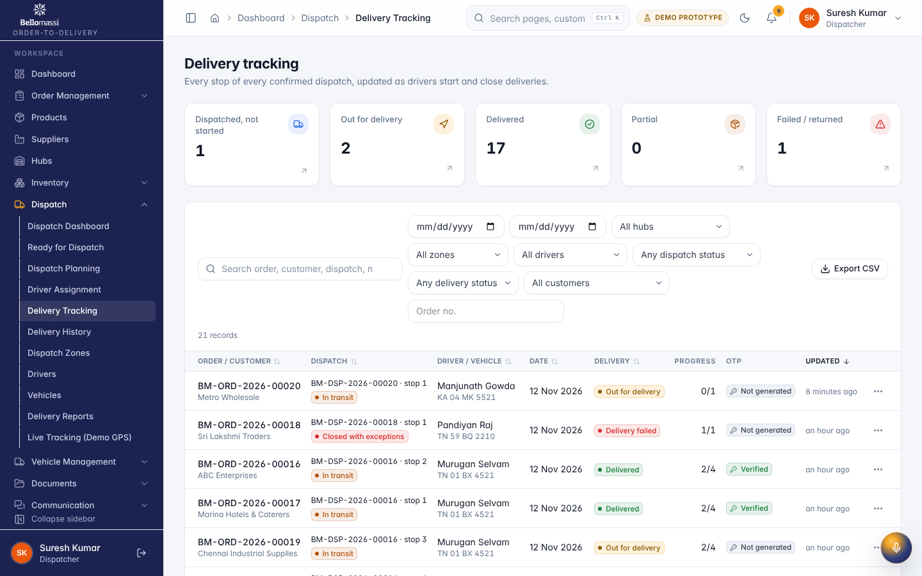

UX-LIVE — Live Tracking (Demo GPS)
Item | Value
Screen ID | SCR-054
Route | /dispatch/live-tracking (captured: /dispatch/live-tracking)
Application | Office web app
Permission | tracking.fleet
Captured as role | dispatcher
Roles with access | SUPER_ADMIN, ADMIN, DISPATCHER
Purpose | Drivers on the road with simulated DEMO GPS positions, ETAs and VIP late-arrival warnings.
Page heading | Live Tracking
Sections | VIP timing warnings; Routes; BM-DSP-2026-00016 · Murugan Selvam
Fields / filters | Hub
Screen type | detail
Layout | Office layout: sidebar, header (breadcrumbs, search, notifications, profile), page header, content cards
Components | PageHeader with status Badge, InfoList, Tabs / Cards, Timeline, action Buttons, ConfirmDialog
Validation | Action pre-conditions checked by the service (status, permission, data scope); refusal message shown
Responsive behaviour | Sidebar fixed ≥ 1024 px, drawer below; grids collapse to one column; tables scroll horizontally inside the card
Empty state | Not found / access denied message for missing record
Loading state | Spinner / skeleton while data is read (prototype reads are near-instant from LocalStorage)
Error state | ErrorBoundary page; action refusals as error toast
Success state | Success toast after actions; badges and timeline update immediately
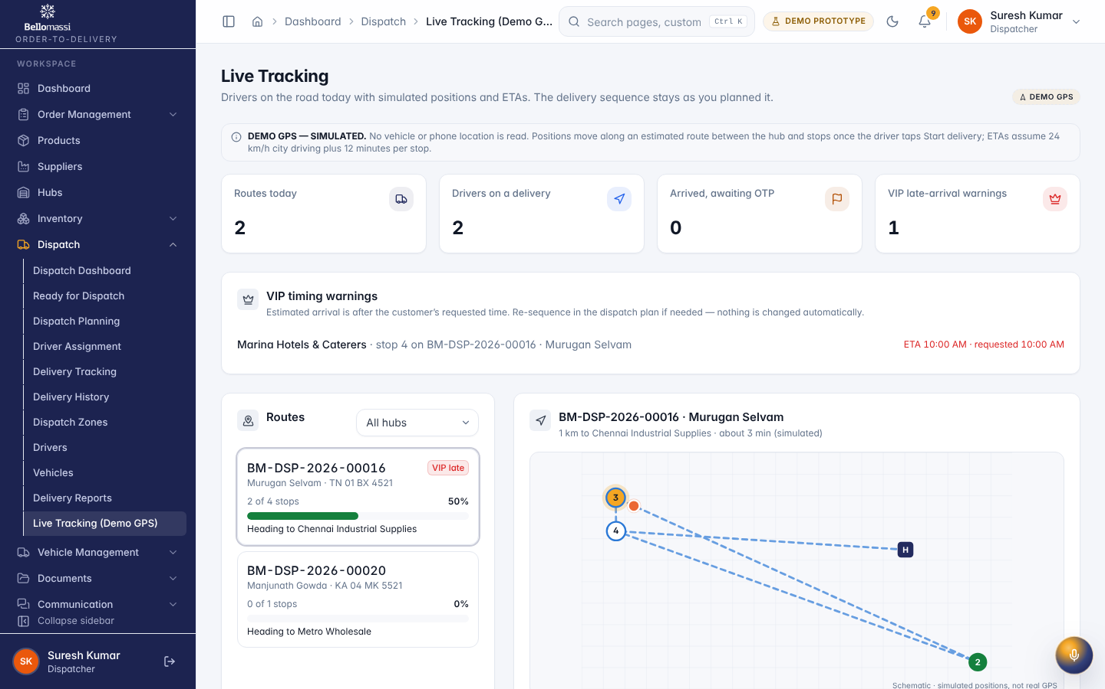

UX-DELIVERY-REVIEW — Delivery Details
Item | Value
Screen ID | SCR-060
Route | /dispatch/deliveries/:id (captured: /dispatch/deliveries/dlv-0001)
Application | Office web app
Permission | deliveries.view
Captured as role | dispatcher
Roles with access | SUPER_ADMIN, ADMIN, SALESMAN, SALES_MANAGER, CUSTOMER_SERVICE, DISPATCHER, FINANCE, WAREHOUSE_MANAGER
Purpose | BM-ORD-2026-00001 · stop 1
Page heading | BM-ORD-2026-00001 · stop 1
Sections | Customer & address; Driver; Delivery OTP
Table columns | PRODUCT; ORDERED; DISPATCHED; DELIVERED; REMAINING; DAMAGED
Tabs | Items; Timeline (3)
Actions | Items; Timeline (3)
Screen type | list
Layout | Office layout: sidebar, header (breadcrumbs, search, notifications, profile), page header, content cards
Components | PageHeader, FilterToolbar, DataTable (sort, paging), Badge, RowActions, EmptyState
Validation | Filter inputs only
Responsive behaviour | Sidebar fixed ≥ 1024 px, drawer below; grids collapse to one column; tables scroll horizontally inside the card
Empty state | EmptyState with explanation and call to action
Loading state | Spinner / skeleton while data is read (prototype reads are near-instant from LocalStorage)
Error state | ErrorBoundary page; action refusals as error toast
Success state | Data displayed with counts
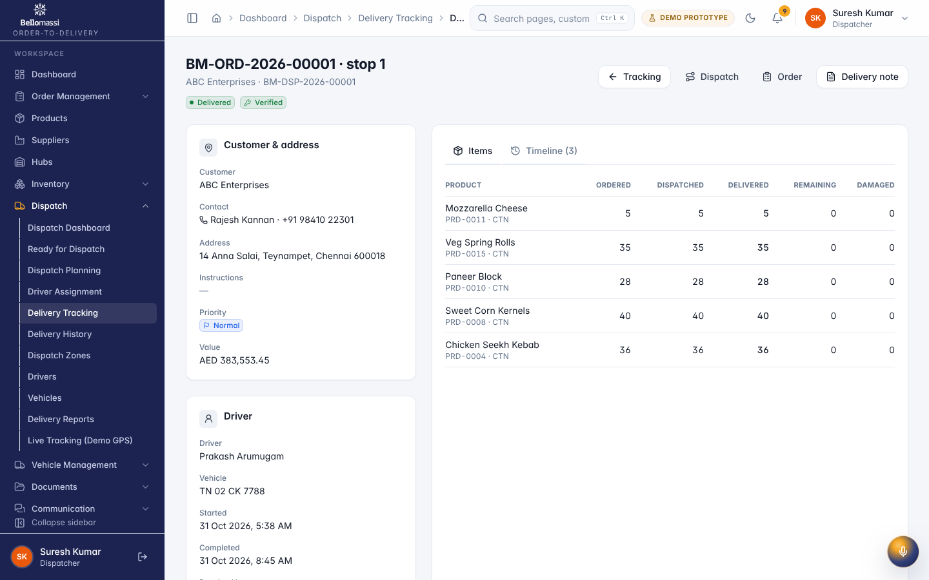

UX-DN — Delivery Note
Item | Value
Screen ID | SCR-061
Route | /dispatch/delivery-notes/:id (captured: /dispatch/delivery-notes/dn-0001)
Application | Office web app
Permission | deliveryNotes.view
Captured as role | dispatcher
Roles with access | SUPER_ADMIN, ADMIN, SALESMAN, SALES_MANAGER, CUSTOMER_SERVICE, DISPATCHER, FINANCE, WAREHOUSE_MANAGER
Purpose | Delivery Note
Page heading | —
Table columns | #; PRODUCT; ORDERED; DISPATCHED; DELIVERED; REMAINING; DAMAGED
Actions | Download PDF; Print
Screen type | list
Layout | Office layout: sidebar, header (breadcrumbs, search, notifications, profile), page header, content cards
Components | PageHeader, FilterToolbar, DataTable (sort, paging), Badge, RowActions, EmptyState
Validation | Filter inputs only
Responsive behaviour | Sidebar fixed ≥ 1024 px, drawer below; grids collapse to one column; tables scroll horizontally inside the card
Empty state | EmptyState with explanation and call to action
Loading state | Spinner / skeleton while data is read (prototype reads are near-instant from LocalStorage)
Error state | ErrorBoundary page; action refusals as error toast
Success state | Data displayed with counts
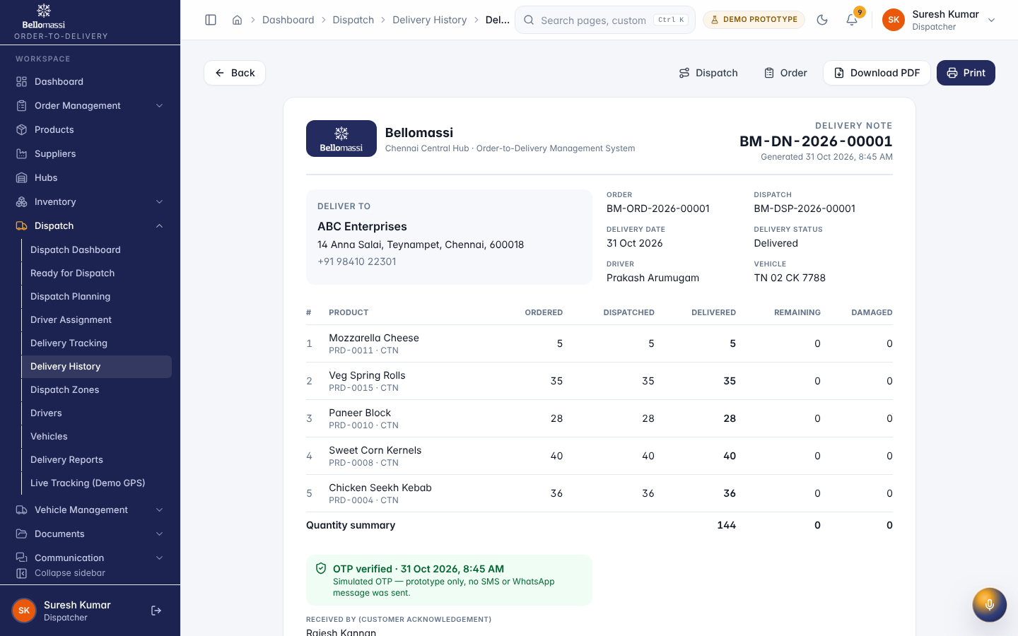

UX-DELIVERY-HISTORY — Delivery History
Item | Value
Screen ID | SCR-046
Route | /dispatch/delivery-history (captured: /dispatch/delivery-history)
Application | Office web app
Permission | dispatch.history
Captured as role | dispatcher
Roles with access | SUPER_ADMIN, ADMIN, SALES_MANAGER, CUSTOMER_SERVICE, DISPATCHER, FINANCE, WAREHOUSE_MANAGER
Purpose | Closed deliveries, delivery notes and failed / partial deliveries awaiting review.
Page heading | Delivery history
Fields / filters | From; To; Hub; Driver; Status
Table columns | ORDER / CUSTOMER; DISPATCH · DRIVER; DELIVERED / DISPATCHED; OUTCOME; CLOSED; STATUS
Tabs | Closed deliveries (18); Needs review (1); Delivery notes (17)
Actions | Closed deliveries (18); Needs review (1); Delivery notes (17); Export CSV; ORDER / CUSTOMER; DISPATCH · DRIVER; CLOSED; STATUS; Previous page; 1; 2; Next page
Screen type | list
Layout | Office layout: sidebar, header (breadcrumbs, search, notifications, profile), page header, content cards
Components | PageHeader, FilterToolbar, DataTable (sort, paging), Badge, RowActions, EmptyState
Validation | Filter inputs only
Responsive behaviour | Sidebar fixed ≥ 1024 px, drawer below; grids collapse to one column; tables scroll horizontally inside the card
Empty state | EmptyState with explanation and call to action
Loading state | Spinner / skeleton while data is read (prototype reads are near-instant from LocalStorage)
Error state | ErrorBoundary page; action refusals as error toast
Success state | Data displayed with counts
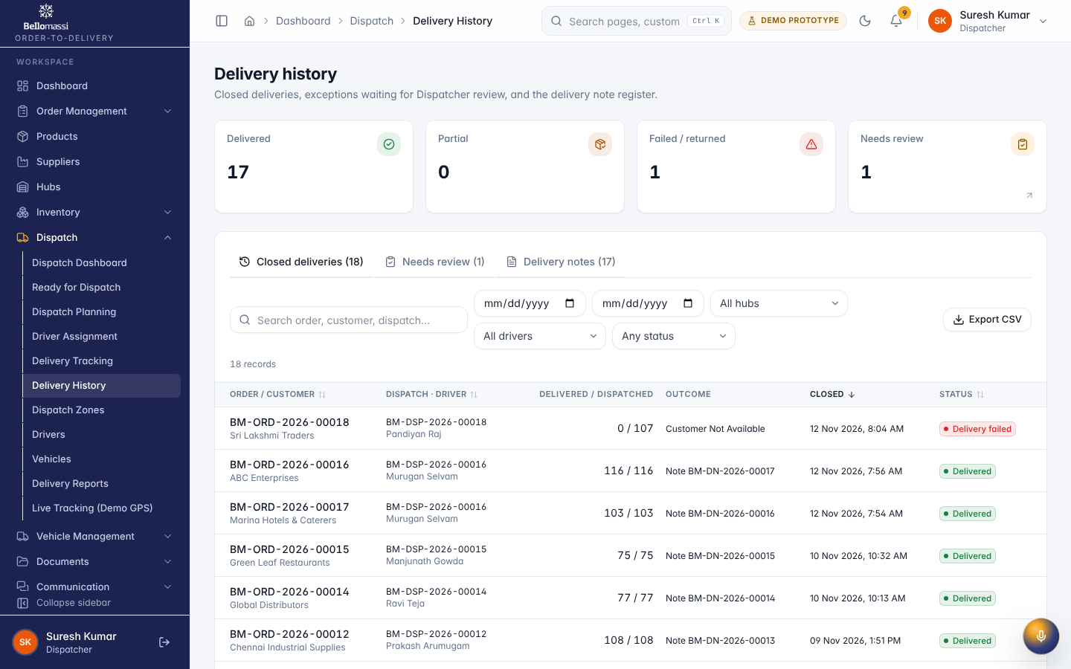

UX-DASH-FI — Dashboard
Item | Value
Screen ID | SCR-001
Route | /dashboard (captured: /dashboard)
Application | Public (no sign-in)
Permission | (signed in)
Captured as role | finance
Roles with access | all signed-in roles
Purpose | Role-specific overview of orders, approvals, dispatch and deliveries.
Page heading | Good morning, Anitha
Sections | Invoices; Collections; Order value overview; Customer credit overview; Credit utilisation; Credit limits; Order reports
Fields / filters | Period
Table columns | CUSTOMER; LIMIT; OUTSTANDING; UTILISATION
Actions | Date range; Specific period; Compare; Which dates are filtered; All TimeAll dates; Open credit module
Screen type | dashboard
Layout | Office layout: sidebar, header (breadcrumbs, search, notifications, profile), page header, content cards
Components | Period filter, KPI cards, charts (Recharts), queue tables, quick links
Validation | Period filter: valid date range
Responsive behaviour | Sidebar fixed ≥ 1024 px, drawer below; grids collapse to one column; tables scroll horizontally inside the card
Empty state | EmptyState with explanation and call to action
Loading state | Spinner / skeleton while data is read (prototype reads are near-instant from LocalStorage)
Error state | ErrorBoundary page; action refusals as error toast
Success state | Data displayed with counts
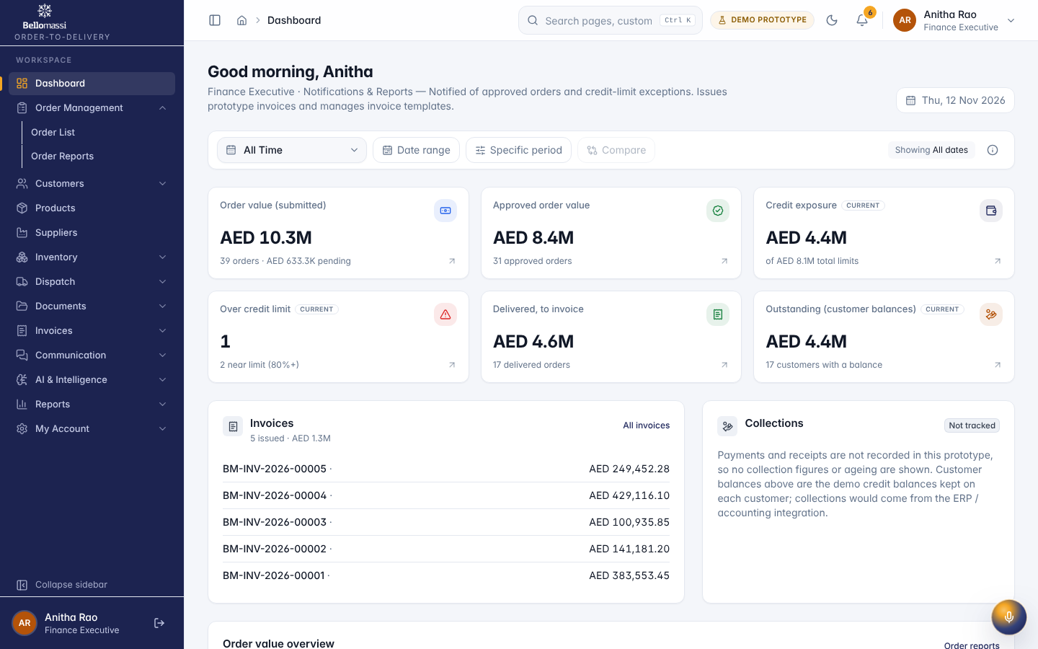

UX-INVOICE-DASH — Invoice Dashboard
Item | Value
Screen ID | SCR-109
Route | /invoices/dashboard (captured: /invoices/dashboard)
Application | Office web app
Permission | invoices.view
Captured as role | finance
Roles with access | SUPER_ADMIN, ADMIN, SALES_MANAGER, FINANCE
Purpose | Invoiced value and delivered orders still to invoice.
Page heading | Invoice dashboard
Sections | Invoiced value by month; Top customers; Delivered orders waiting for an invoice
Screen type | dashboard
Layout | Office layout: sidebar, header (breadcrumbs, search, notifications, profile), page header, content cards
Components | Period filter, KPI cards, charts (Recharts), queue tables, quick links
Validation | Period filter: valid date range
Responsive behaviour | Sidebar fixed ≥ 1024 px, drawer below; grids collapse to one column; tables scroll horizontally inside the card
Empty state | EmptyState with explanation and call to action
Loading state | Spinner / skeleton while data is read (prototype reads are near-instant from LocalStorage)
Error state | ErrorBoundary page; action refusals as error toast
Success state | Data displayed with counts
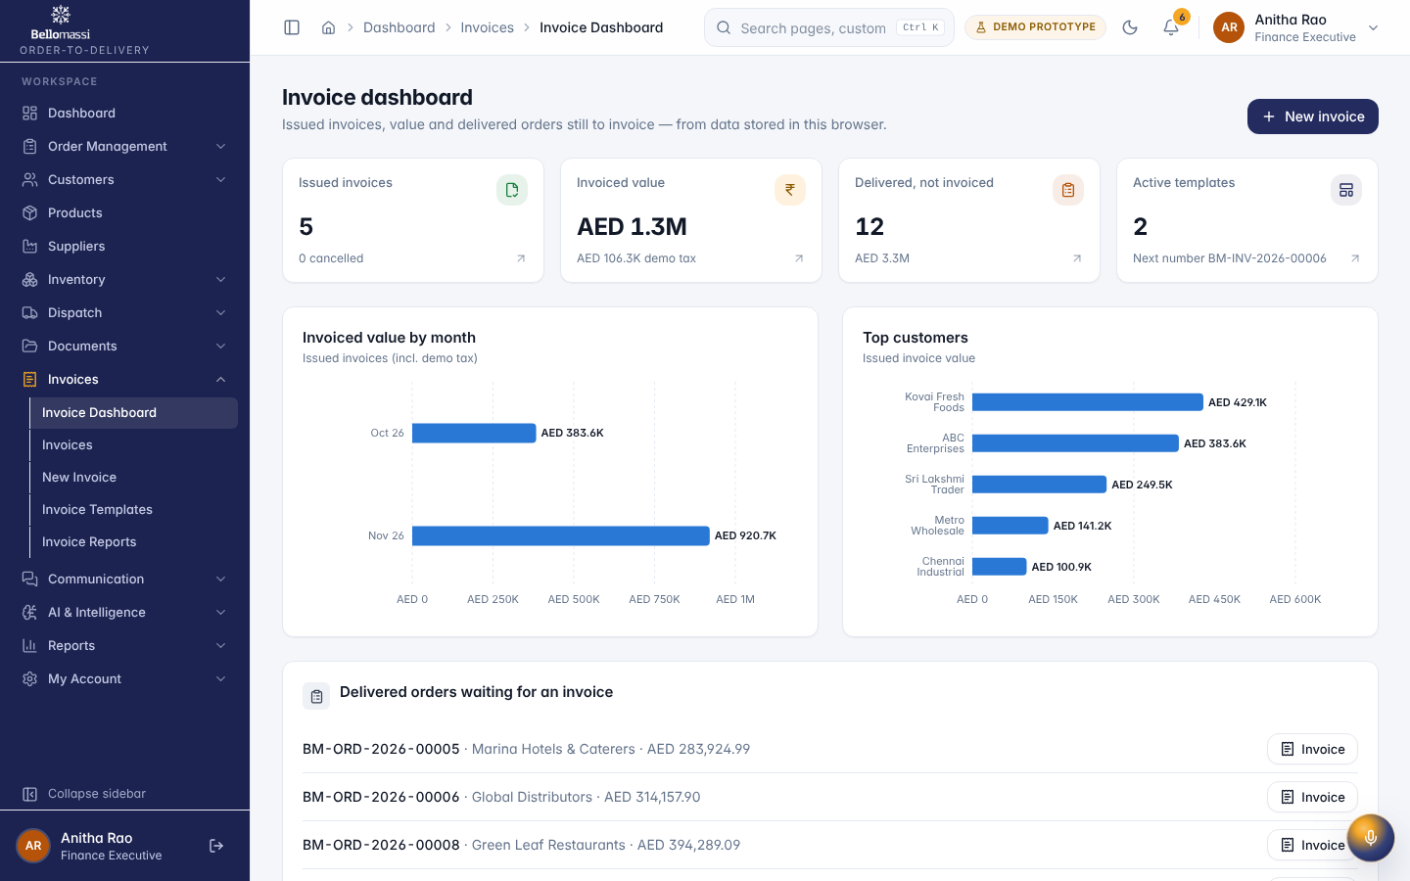

UX-DRV-DASH — Today
Item | Value
Screen ID | SCR-064
Route | /driver/dashboard (captured: /driver/dashboard)
Application | Driver app (mobile)
Permission | driver.app
Captured as role | driver
Roles with access | SUPER_ADMIN, DRIVER
Purpose | Today’s dispatch, progress and next delivery.
Page heading | Hello, Murugan
Sections | My performance; Active delivery; Route summary; Delivery sequence; Tomorrow’s plan; Notifications
Fields / filters | Period
Actions | Date range; Specific period; Compare; Which dates are filtered; Today 12-Nov-2026
Screen type | dashboard
Layout | Driver layout: navy header with demo badge and notifications, single-column cards, bottom navigation
Components | Period filter, KPI cards, charts (Recharts), queue tables, quick links
Validation | Period filter: valid date range
Responsive behaviour | Designed for 360–430 px; single column; bottom navigation
Empty state | EmptyState with explanation and call to action
Loading state | Spinner / skeleton while data is read (prototype reads are near-instant from LocalStorage)
Error state | ErrorBoundary page; action refusals as error toast
Success state | Data displayed with counts
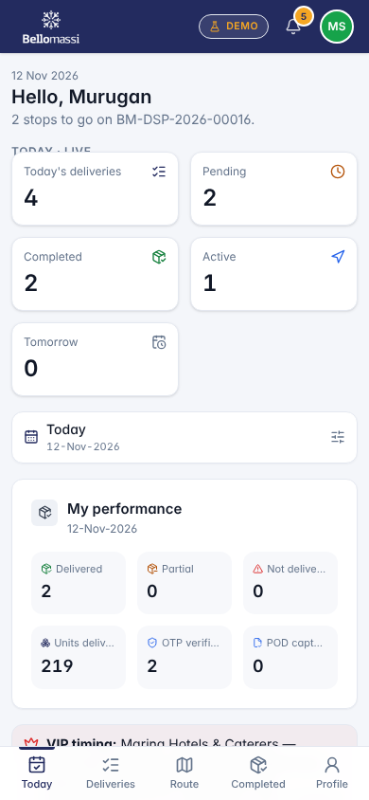

UX-DRV-DELIVERIES — My Deliveries
Item | Value
Screen ID | SCR-065
Route | /driver/deliveries (captured: /driver/deliveries)
Application | Driver app (mobile)
Permission | driver.app
Captured as role | driver
Roles with access | SUPER_ADMIN, DRIVER
Purpose | Your delivery stops in sequence, upcoming dispatches and history.
Page heading | My deliveries
Tabs | Current route; Upcoming; History
Actions | Current route; Upcoming; History
Screen type | detail
Layout | Driver layout: navy header with demo badge and notifications, single-column cards, bottom navigation
Components | PageHeader with status Badge, InfoList, Tabs / Cards, Timeline, action Buttons, ConfirmDialog
Validation | Action pre-conditions checked by the service (status, permission, data scope); refusal message shown
Responsive behaviour | Designed for 360–430 px; single column; bottom navigation
Empty state | Not found / access denied message for missing record
Loading state | Spinner / skeleton while data is read (prototype reads are near-instant from LocalStorage)
Error state | ErrorBoundary page; action refusals as error toast
Success state | Success toast after actions; badges and timeline update immediately
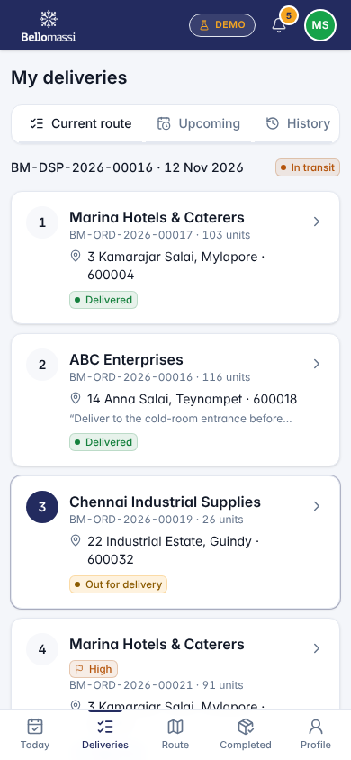

UX-DRV-DELIVERY — Delivery
Item | Value
Screen ID | SCR-073
Route | /driver/deliveries/:id (captured: /driver/deliveries/dlv-0016)
Application | Driver app (mobile)
Permission | driver.app
Captured as role | driver
Roles with access | SUPER_ADMIN, DRIVER
Purpose | Marina Hotels & Caterers
Page heading | Marina Hotels & Caterers
Sections | Deliver to; Items
Screen type | detail
Layout | Driver layout: navy header with demo badge and notifications, single-column cards, bottom navigation
Components | PageHeader with status Badge, InfoList, Tabs / Cards, Timeline, action Buttons, ConfirmDialog
Validation | Action pre-conditions checked by the service (status, permission, data scope); refusal message shown
Responsive behaviour | Designed for 360–430 px; single column; bottom navigation
Empty state | Not found / access denied message for missing record
Loading state | Spinner / skeleton while data is read (prototype reads are near-instant from LocalStorage)
Error state | ErrorBoundary page; action refusals as error toast
Success state | Success toast after actions; badges and timeline update immediately
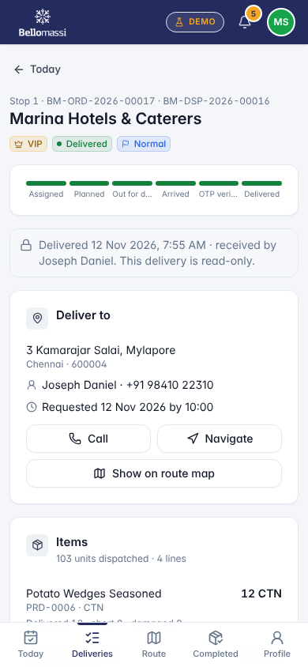

UX-DRV-ROUTE — Route
Item | Value
Screen ID | SCR-066
Route | /driver/route (captured: /driver/route)
Application | Driver app (mobile)
Permission | driver.app
Captured as role | driver
Roles with access | SUPER_ADMIN, DRIVER
Purpose | Your stops on a DEMO GPS route map with ETAs.
Page heading | Route
Sections | Stops in sequence
Screen type | detail
Layout | Driver layout: navy header with demo badge and notifications, single-column cards, bottom navigation
Components | PageHeader with status Badge, InfoList, Tabs / Cards, Timeline, action Buttons, ConfirmDialog
Validation | Action pre-conditions checked by the service (status, permission, data scope); refusal message shown
Responsive behaviour | Designed for 360–430 px; single column; bottom navigation
Empty state | Not found / access denied message for missing record
Loading state | Spinner / skeleton while data is read (prototype reads are near-instant from LocalStorage)
Error state | ErrorBoundary page; action refusals as error toast
Success state | Success toast after actions; badges and timeline update immediately
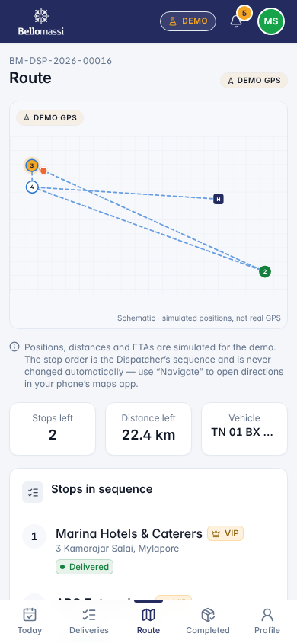

UX-DRV-COMPLETED — Completed
Item | Value
Screen ID | SCR-067
Route | /driver/completed (captured: /driver/completed)
Application | Driver app (mobile)
Permission | driver.app
Captured as role | driver
Roles with access | SUPER_ADMIN, DRIVER
Purpose | Deliveries you completed today with OTP and POD status.
Page heading | Completed today
Screen type | detail
Layout | Driver layout: navy header with demo badge and notifications, single-column cards, bottom navigation
Components | PageHeader with status Badge, InfoList, Tabs / Cards, Timeline, action Buttons, ConfirmDialog
Validation | Action pre-conditions checked by the service (status, permission, data scope); refusal message shown
Responsive behaviour | Designed for 360–430 px; single column; bottom navigation
Empty state | Not found / access denied message for missing record
Loading state | Spinner / skeleton while data is read (prototype reads are near-instant from LocalStorage)
Error state | ErrorBoundary page; action refusals as error toast
Success state | Success toast after actions; badges and timeline update immediately
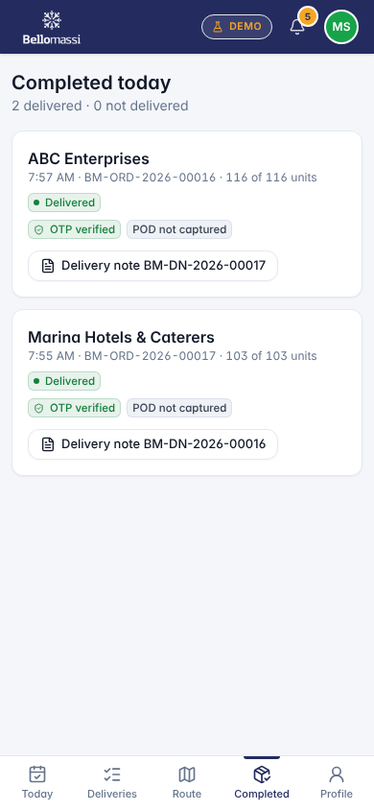

UX-DRV-NOTES — My Delivery Notes
Item | Value
Screen ID | SCR-068
Route | /driver/delivery-notes (captured: /driver/delivery-notes)
Application | Driver app (mobile)
Permission | driver.app
Captured as role | driver
Roles with access | SUPER_ADMIN, DRIVER
Purpose | Delivery notes for your deliveries.
Page heading | Delivery notes
Screen type | detail
Layout | Driver layout: navy header with demo badge and notifications, single-column cards, bottom navigation
Components | PageHeader with status Badge, InfoList, Tabs / Cards, Timeline, action Buttons, ConfirmDialog
Validation | Action pre-conditions checked by the service (status, permission, data scope); refusal message shown
Responsive behaviour | Designed for 360–430 px; single column; bottom navigation
Empty state | Not found / access denied message for missing record
Loading state | Spinner / skeleton while data is read (prototype reads are near-instant from LocalStorage)
Error state | ErrorBoundary page; action refusals as error toast
Success state | Success toast after actions; badges and timeline update immediately
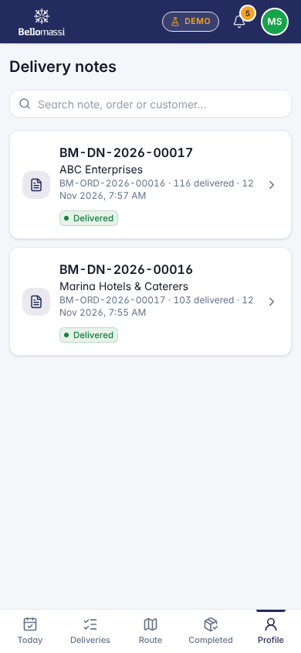

UX-DRV-PROFILE — Driver Profile
Item | Value
Screen ID | SCR-069
Route | /driver/profile (captured: /driver/profile)
Application | Driver app (mobile)
Permission | driver.app
Captured as role | driver
Roles with access | SUPER_ADMIN, DRIVER
Purpose | Your driver details, licence and performance.
Page heading | Murugan Selvam
Sections | Today; Details
Actions | Sign out
Screen type | detail
Layout | Driver layout: navy header with demo badge and notifications, single-column cards, bottom navigation
Components | PageHeader with status Badge, InfoList, Tabs / Cards, Timeline, action Buttons, ConfirmDialog
Validation | Action pre-conditions checked by the service (status, permission, data scope); refusal message shown
Responsive behaviour | Designed for 360–430 px; single column; bottom navigation
Empty state | Not found / access denied message for missing record
Loading state | Spinner / skeleton while data is read (prototype reads are near-instant from LocalStorage)
Error state | ErrorBoundary page; action refusals as error toast
Success state | Success toast after actions; badges and timeline update immediately
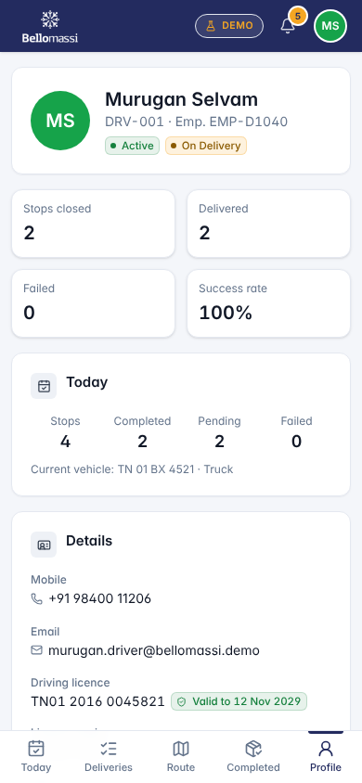

UX-CUS-DASH — Home
Item | Value
Screen ID | SCR-075
Route | /customer/dashboard (captured: /customer/dashboard)
Application | Customer app (mobile)
Permission | customer.app
Captured as role | customer
Roles with access | SUPER_ADMIN, CUSTOMER
Purpose | Your orders, deliveries and documents.
Page heading | Welcome, Joseph
Sections | Your order is on the vehicle; Recent orders; Recent delivery notes; Notifications
Fields / filters | Period
Actions | Date range; Specific period; Compare; Which dates are filtered; All Time All dates
Screen type | dashboard
Layout | Customer layout: header, single-column cards, bottom navigation
Components | Period filter, KPI cards, charts (Recharts), queue tables, quick links
Validation | Period filter: valid date range
Responsive behaviour | Designed for 360–430 px; single column; bottom navigation
Empty state | EmptyState with explanation and call to action
Loading state | Spinner / skeleton while data is read (prototype reads are near-instant from LocalStorage)
Error state | ErrorBoundary page; action refusals as error toast
Success state | Data displayed with counts
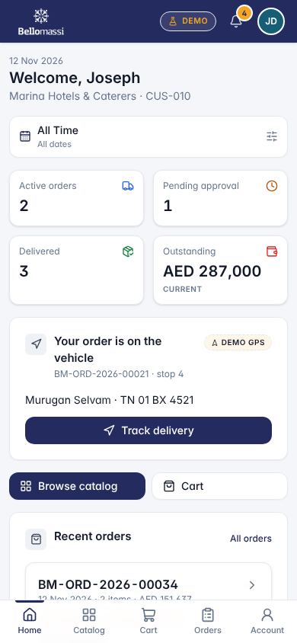

UX-CUS-CATALOG — Catalog
Item | Value
Screen ID | SCR-076
Route | /customer/catalog (captured: /customer/catalog)
Application | Customer app (mobile)
Permission | customer.app
Captured as role | customer
Roles with access | SUPER_ADMIN, CUSTOMER
Purpose | Browse products and add them to your cart.
Page heading | Catalog
Actions | All; Chilled Food; Consumables; Electrical; Frozen Food; General; Spare Parts; Decrease quantity; Increase quantity; Add; Chicken Nuggets BM-PLT-003 · 10 × 1 kg AED 3,200 / CTN; Chicken Seekh Kebab BM-PLT-004 · 12 × 500 g AED 2,760 / CTN; French Fries 9 mm BM-PTO-001 · 4 × 2.5 kg AED 1,680 / CTN; Green Peas BM-VEG-001 · 10 × 1 kg AED 1,150 / CTN; Sweet Corn Kernels BM-VEG-002 · 10 × 1 kg AED 1,240 / CTN; Mixed Vegetables BM-VEG-003 · 10 × 1 kg AED 1,190 / CTN; Paneer Block BM-DRY-001 · 10 × 1 kg AED 3,450 / CTN; Mozzarella Cheese BM-DRY-002 · 6 × 2 kg AED 5,280 / CTN; Table Butter Salted BM-DRY-003 · 20 × 500 g AED 4,900 / CTN; Basa Fish Fillet BM-SEA-001 · 10 × 1 kg AED 3,350 / CTN; Prawns 26/30 Peeled BM-SEA-002 · 10 × 1 kg AED 6,900 / CTN; Veg Spring Rolls BM-SNK-001 · 12 × 600 g AED 2,340 / CTN; Mutton Keema BM-MTN-001 · Bulk AED 720 / KG; Chicken Wings BM-PLT-005 · 6 × 2 kg AED 2,980 / CTN; Fish Fingers BM-SEA-003 · 10 × 1 kg AED 2,650 / CTN
Screen type | detail
Layout | Customer layout: header, single-column cards, bottom navigation
Components | PageHeader with status Badge, InfoList, Tabs / Cards, Timeline, action Buttons, ConfirmDialog
Validation | Action pre-conditions checked by the service (status, permission, data scope); refusal message shown
Responsive behaviour | Designed for 360–430 px; single column; bottom navigation
Empty state | Not found / access denied message for missing record
Loading state | Spinner / skeleton while data is read (prototype reads are near-instant from LocalStorage)
Error state | ErrorBoundary page; action refusals as error toast
Success state | Success toast after actions; badges and timeline update immediately
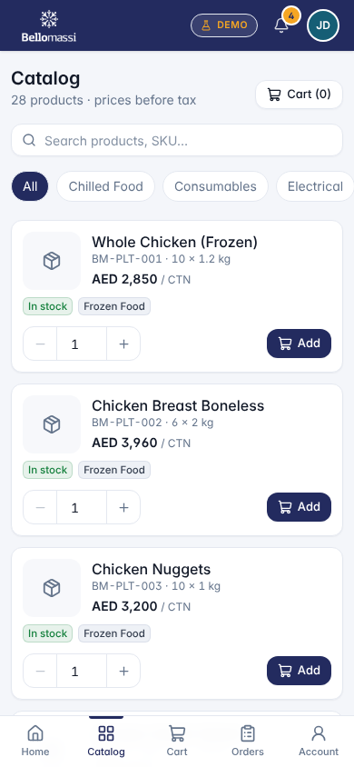

UX-CUS-CART — Cart
Item | Value
Screen ID | SCR-077
Route | /customer/cart (captured: /customer/cart)
Application | Customer app (mobile)
Permission | customer.order
Captured as role | customer
Roles with access | SUPER_ADMIN, CUSTOMER
Purpose | Review your cart and place an order.
Page heading | —
Screen type | detail
Layout | Customer layout: header, single-column cards, bottom navigation
Components | PageHeader with status Badge, InfoList, Tabs / Cards, Timeline, action Buttons, ConfirmDialog
Validation | Action pre-conditions checked by the service (status, permission, data scope); refusal message shown
Responsive behaviour | Designed for 360–430 px; single column; bottom navigation
Empty state | Not found / access denied message for missing record
Loading state | Spinner / skeleton while data is read (prototype reads are near-instant from LocalStorage)
Error state | ErrorBoundary page; action refusals as error toast
Success state | Success toast after actions; badges and timeline update immediately
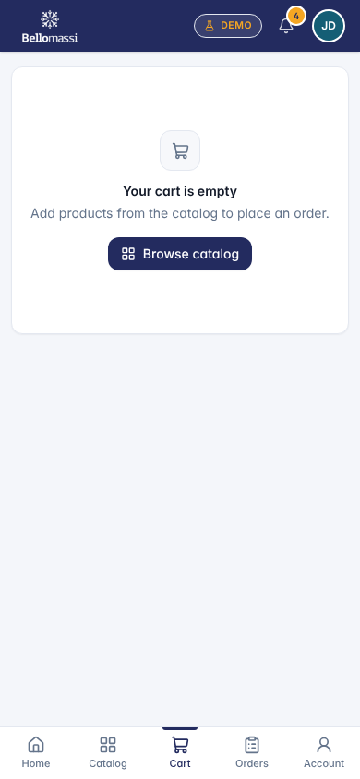

UX-CUS-ORDERS — My Orders
Item | Value
Screen ID | SCR-078
Route | /customer/orders (captured: /customer/orders)
Application | Customer app (mobile)
Permission | customer.app
Captured as role | customer
Roles with access | SUPER_ADMIN, CUSTOMER
Purpose | Your orders with approval and delivery status.
Page heading | My orders
Actions | All (7); Pending (1); In progress (2); Delivered (3); Issues (1)
Screen type | detail
Layout | Customer layout: header, single-column cards, bottom navigation
Components | PageHeader with status Badge, InfoList, Tabs / Cards, Timeline, action Buttons, ConfirmDialog
Validation | Action pre-conditions checked by the service (status, permission, data scope); refusal message shown
Responsive behaviour | Designed for 360–430 px; single column; bottom navigation
Empty state | Not found / access denied message for missing record
Loading state | Spinner / skeleton while data is read (prototype reads are near-instant from LocalStorage)
Error state | ErrorBoundary page; action refusals as error toast
Success state | Success toast after actions; badges and timeline update immediately
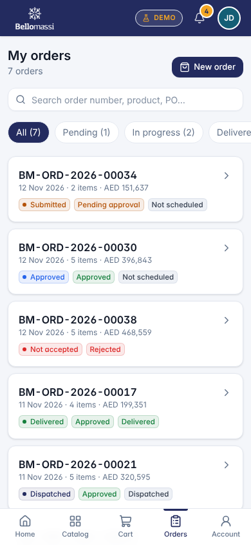

UX-CUS-ORDER — Order
Item | Value
Screen ID | SCR-079
Route | /customer/orders/:id (captured: /customer/orders/ord-0005)
Application | Customer app (mobile)
Permission | customer.app
Captured as role | customer
Roles with access | SUPER_ADMIN, CUSTOMER
Purpose | BM-ORD-2026-00005
Page heading | BM-ORD-2026-00005
Sections | Progress; Order; Items; Delivery address; History
Actions | Reorder
Screen type | detail
Layout | Customer layout: header, single-column cards, bottom navigation
Components | PageHeader with status Badge, InfoList, Tabs / Cards, Timeline, action Buttons, ConfirmDialog
Validation | Action pre-conditions checked by the service (status, permission, data scope); refusal message shown
Responsive behaviour | Designed for 360–430 px; single column; bottom navigation
Empty state | Not found / access denied message for missing record
Loading state | Spinner / skeleton while data is read (prototype reads are near-instant from LocalStorage)
Error state | ErrorBoundary page; action refusals as error toast
Success state | Success toast after actions; badges and timeline update immediately
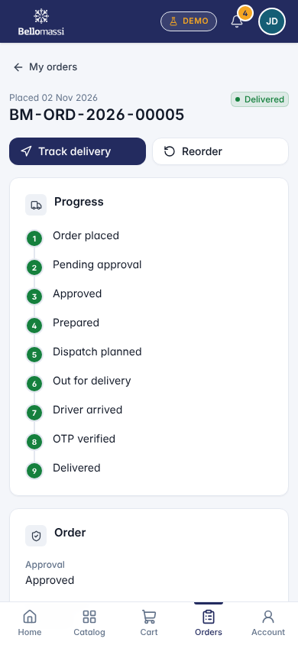

UX-CUS-NOTES — Delivery Notes
Item | Value
Screen ID | SCR-081
Route | /customer/delivery-notes (captured: /customer/delivery-notes)
Application | Customer app (mobile)
Permission | customer.app
Captured as role | customer
Roles with access | SUPER_ADMIN, CUSTOMER
Purpose | Delivery notes for your delivered orders.
Page heading | Delivery notes
Screen type | detail
Layout | Customer layout: header, single-column cards, bottom navigation
Components | PageHeader with status Badge, InfoList, Tabs / Cards, Timeline, action Buttons, ConfirmDialog
Validation | Action pre-conditions checked by the service (status, permission, data scope); refusal message shown
Responsive behaviour | Designed for 360–430 px; single column; bottom navigation
Empty state | Not found / access denied message for missing record
Loading state | Spinner / skeleton while data is read (prototype reads are near-instant from LocalStorage)
Error state | ErrorBoundary page; action refusals as error toast
Success state | Success toast after actions; badges and timeline update immediately
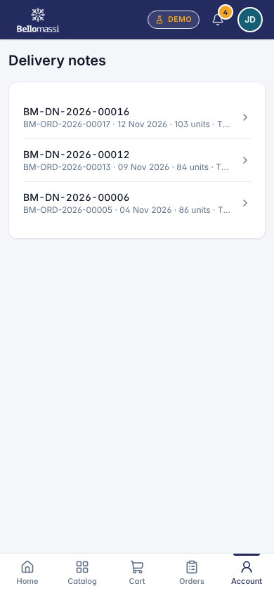

UX-CUS-INVOICES — Invoices
Item | Value
Screen ID | SCR-083
Route | /customer/invoices (captured: /customer/invoices)
Application | Customer app (mobile)
Permission | customer.app
Captured as role | customer
Roles with access | SUPER_ADMIN, CUSTOMER
Purpose | Your invoices.
Page heading | Invoices
Screen type | detail
Layout | Customer layout: header, single-column cards, bottom navigation
Components | PageHeader with status Badge, InfoList, Tabs / Cards, Timeline, action Buttons, ConfirmDialog
Validation | Action pre-conditions checked by the service (status, permission, data scope); refusal message shown
Responsive behaviour | Designed for 360–430 px; single column; bottom navigation
Empty state | Not found / access denied message for missing record
Loading state | Spinner / skeleton while data is read (prototype reads are near-instant from LocalStorage)
Error state | ErrorBoundary page; action refusals as error toast
Success state | Success toast after actions; badges and timeline update immediately
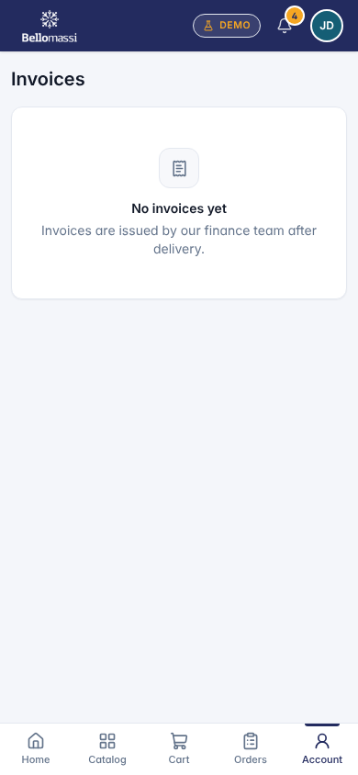

UX-CUS-PROFILE — Profile
Item | Value
Screen ID | SCR-086
Route | /customer/profile (captured: /customer/profile)
Application | Customer app (mobile)
Permission | customer.app
Captured as role | customer
Roles with access | SUPER_ADMIN, CUSTOMER
Purpose | Your company details, addresses and credit.
Page heading | Joseph Daniel
Sections | Company; Addresses; Credit
Actions | Sign out
Screen type | detail
Layout | Customer layout: header, single-column cards, bottom navigation
Components | PageHeader with status Badge, InfoList, Tabs / Cards, Timeline, action Buttons, ConfirmDialog
Validation | Action pre-conditions checked by the service (status, permission, data scope); refusal message shown
Responsive behaviour | Designed for 360–430 px; single column; bottom navigation
Empty state | Not found / access denied message for missing record
Loading state | Spinner / skeleton while data is read (prototype reads are near-instant from LocalStorage)
Error state | ErrorBoundary page; action refusals as error toast
Success state | Success toast after actions; badges and timeline update immediately
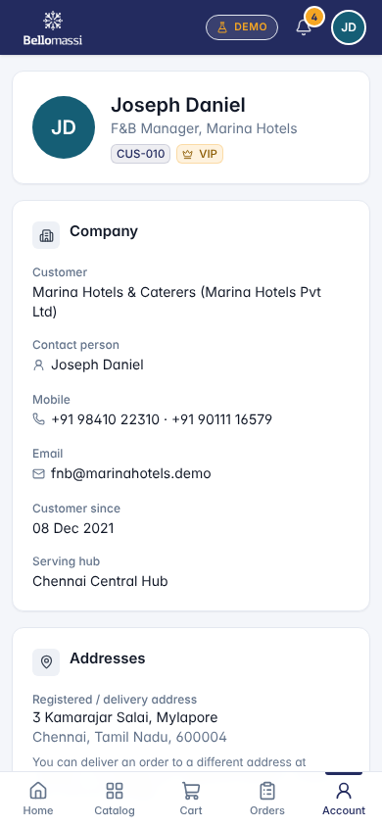

Revision history
Version | Date | Author | Description
1.0 | 2026-11-12 | Documentation team | Initial draft prepared from analysis of the bellomassi-premium-ui source code and existing project documents.

