Mobile UX — Driver App and Customer App
Bellomassi Order-to-Delivery Management Platform
BM-UX-007 · Version 1.0 · Draft — for client review
2026-11-12

Document control
Field | Value
Document title | Mobile UX — Driver App and Customer App
Document ID | BM-UX-007
Version | 1.0
Status | Draft — for client review
Category | UI/UX and Design
Related module(s) | All modules
Document owner | UX Designer
Prepared by | Project documentation team (AI-assisted draft prepared from source-code analysis)
Reviewed by | Pending — not yet reviewed
Approval | Not approved — awaiting client review (no approval has been given)
Created date | 2026-11-12
Last updated date | 2026-11-12
Status labels used in this document: VERIFIED (confirmed in the current source code or existing documents) · PROTOTYPE (works in the React/LocalStorage prototype with mock or simulated behaviour) · PROPOSED (recommended production design, not built) · PENDING CONFIRMATION (needs a client decision) · NOT IMPLEMENTED · NOT VERIFIED.

Purpose
Describe the mobile experience of the driver and customer apps and the changes proposed for the native driver app.

Scope
Prototype mobile web screens (VERIFIED, 390 px viewport); native React Native driver app (PROPOSED).

Definitions
Other terms: see BM-GLO-001 (Project Glossary).

References
- BM-UX-005 (Screen Specifications)
- BM-MAN-001 (Driver App User Manual)
- BM-MAN-002 (Customer App User Manual)
- BM-FRD-DRV (Functional Requirements — Driver Application)
- BM-FRD-CAP (Functional Requirements — Customer Application)

1. Driver app — prototype (VERIFIED)
Screen | Content | Screenshot
Sign-in | Mobile number or email + password; demo account hint | UX-DRV-LOGIN
Today | Greeting, dispatch number, today’s counts (deliveries, pending, completed, active, tomorrow), performance | UX-DRV-DASH
Deliveries | Stop list in sequence with status | UX-DRV-DELIVERIES
Delivery detail | Customer, address, items, actions: navigate, arrive, verify OTP, confirm | UX-DRV-DELIVERY
Route | Ordered stops on a map (DEMO GPS) | UX-DRV-ROUTE
Completed / Delivery notes / Profile | History, notes, profile and documents | UX-DRV-COMPLETED, UX-DRV-NOTES, UX-DRV-PROFILE
The confirmation screen (/driver/deliveries/:id/confirm) opens only after the driver has arrived and the OTP flow has started; opening it directly redirects back to the delivery (VERIFIED during capture).
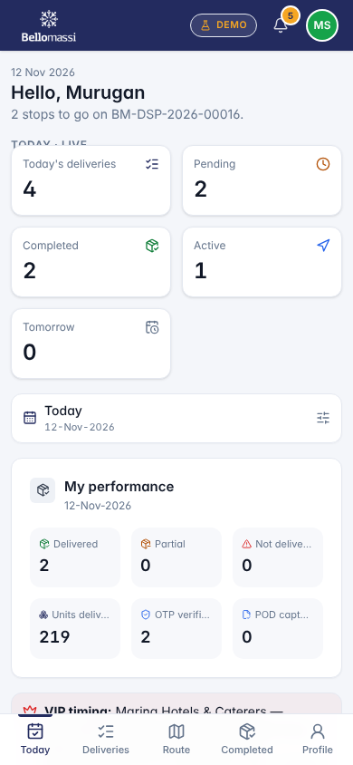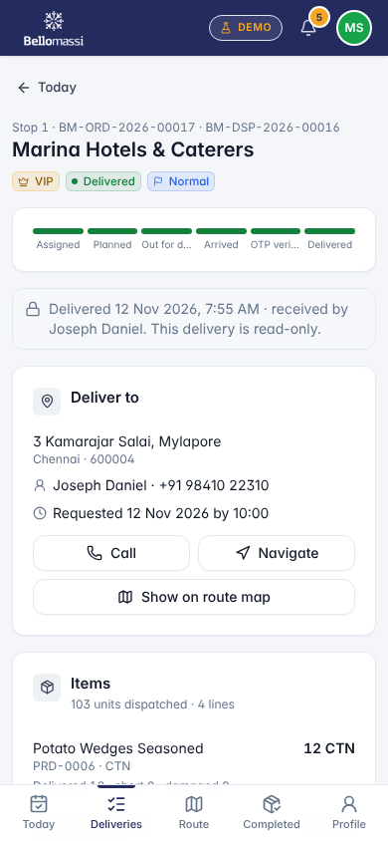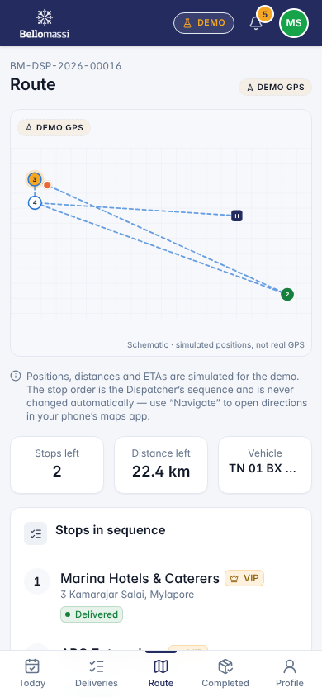

2. Customer app — prototype (VERIFIED; scope PENDING CONFIRMATION — extension X-01)
Screen | Content | Screenshot
Home | Active / pending / delivered orders, outstanding, “your order is on the vehicle” card with Track delivery | UX-CUS-DASH
Catalog / Cart | Product browse, quantities, submit order (goes to Sales Manager approval) | UX-CUS-CATALOG, UX-CUS-CART
Orders / Order detail | Order list and status timeline | UX-CUS-ORDERS, UX-CUS-ORDER
Delivery notes / Invoices / Profile | Documents of the linked customer only | UX-CUS-NOTES, UX-CUS-INVOICES, UX-CUS-PROFILE

3. Mobile UX rules (prototype and production)
- Single column, cards, minimum 44 px touch targets, primary action at the bottom within thumb reach.
- Bottom navigation with 5 items; current item highlighted.
- Large OTP input (6 digits, numeric keyboard); clear error after wrong attempt with attempts remaining.
- Show connection / GPS state; never hide that GPS is simulated (DEMO GPS badge).
- Signature pad and photo capture full-width.

4. Native driver app — PROPOSED
Need | Proposal
Background GPS while a delivery is active | Native location service with foreground notification
Offline | Local queue of POD / status updates, sync when online
Push notifications | New dispatch, changes, messages
Camera / signature | Native camera, compressed upload
Navigation | Hand-off to Google Maps / Waze
Battery | Adaptive interval (10–15 s moving, longer when stationary)

Revision history
Version | Date | Author | Description
1.0 | 2026-11-12 | Documentation team | Initial draft prepared from analysis of the bellomassi-premium-ui source code and existing project documents.

