Defect Management Process and Bug Report Template
Bellomassi Order-to-Delivery Management Platform
BM-QA-004 · Version 1.0 · Draft — for client review
2026-11-12

Document control
Field | Value
Document title | Defect Management Process and Bug Report Template
Document ID | BM-QA-004
Version | 1.0
Status | Draft — for client review
Category | Testing and Quality Assurance
Related module(s) | All modules
Document owner | QA Lead
Prepared by | Project documentation team (AI-assisted draft prepared from source-code analysis)
Reviewed by | Pending — not yet reviewed
Approval | Not approved — awaiting client review (no approval has been given)
Created date | 2026-11-12
Last updated date | 2026-11-12
Status labels used in this document: VERIFIED (confirmed in the current source code or existing documents) · PROTOTYPE (works in the React/LocalStorage prototype with mock or simulated behaviour) · PROPOSED (recommended production design, not built) · PENDING CONFIRMATION (needs a client decision) · NOT IMPLEMENTED · NOT VERIFIED.

Purpose
Define how defects are reported, classified, fixed, verified and closed, with a standard bug report template.

Scope
All test phases and post-go-live support (PROPOSED).

Definitions
Other terms: see BM-GLO-001 (Project Glossary).

References
- BM-QA-001 (Test Strategy)
- BM-QA-005 (Test Execution Report (Template))

1. Severity
Severity | Definition | Example
Critical | System unusable, data loss / corruption, security breach, no workaround | Dispatch confirm deducts stock twice
High | Major function fails, workaround difficult | OTP cannot be verified
Medium | Function partly fails, workaround exists | Report filter wrong
Low | Cosmetic / text | Label misspelt

2. Priority
P1 fix immediately · P2 fix in current cycle · P3 fix in next release · P4 backlog.

3. Workflow
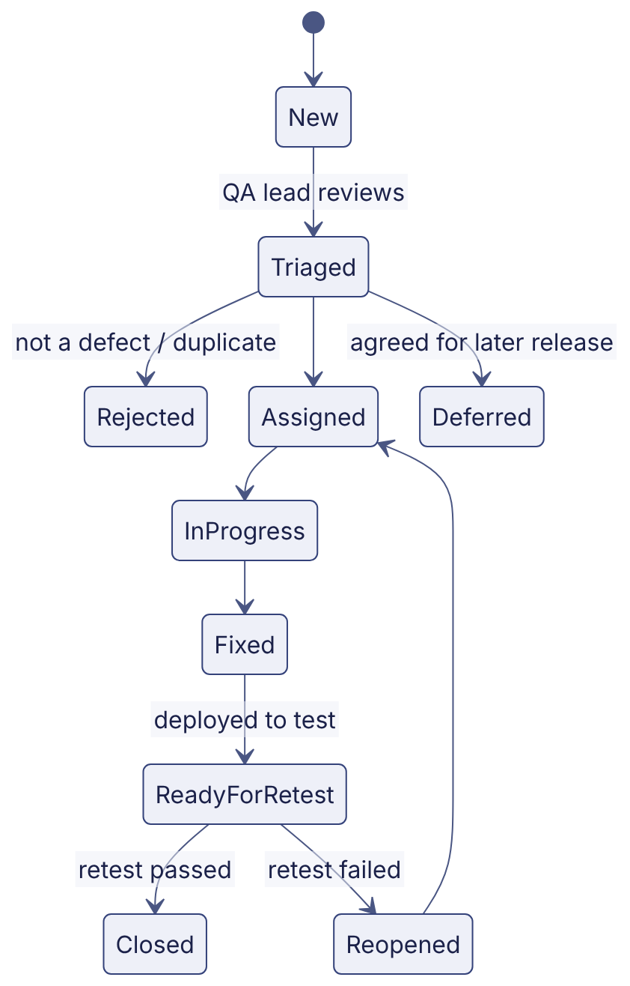

4. Bug report template
Field | Content
Defect ID | BUG-#### (tool generated)
Title | Short description: what fails where
Module / screen | e.g. Dispatch — Confirm dispatch (/dispatch/:id)
Environment / build | Test / staging, build version
Role used | e.g. Dispatcher
Preconditions / data | Order number, dispatch number
Steps to reproduce | Numbered
Expected result | From test case / FRD
Actual result | What happened
Evidence | Screenshot, video, log, request id
Severity / priority | As above
Related test case / requirement | TC-…, FR-…
Reported by / date
Assigned to
Fix version / resolution
Retest result / date

5. Tooling
Jira, Azure Boards or GitHub Issues (client choice — PENDING CONFIRMATION). Daily triage during test cycles.

Revision history
Version | Date | Author | Description
1.0 | 2026-11-12 | Documentation team | Initial draft prepared from analysis of the bellomassi-premium-ui source code and existing project documents.

