Driver App User Manual
Bellomassi Order-to-Delivery Management Platform
BM-MAN-001 · Version 1.0 · Draft — for client review
2026-11-12

Document control
Field | Value
Document title | Driver App User Manual
Document ID | BM-MAN-001
Version | 1.0
Status | Draft — for client review
Category | User Manuals
Related module(s) | All modules
Document owner | Training Lead
Prepared by | Project documentation team (AI-assisted draft prepared from source-code analysis)
Reviewed by | Pending — not yet reviewed
Approval | Not approved — awaiting client review (no approval has been given)
Created date | 2026-11-12
Last updated date | 2026-11-12
Status labels used in this document: VERIFIED (confirmed in the current source code or existing documents) · PROTOTYPE (works in the React/LocalStorage prototype with mock or simulated behaviour) · PROPOSED (recommended production design, not built) · PENDING CONFIRMATION (needs a client decision) · NOT IMPLEMENTED · NOT VERIFIED.

Purpose
Step-by-step guide for drivers to deliver their stops with OTP and proof of delivery.

Scope
Driver app of the prototype (mobile web, VERIFIED with real screenshots captured 2026-11-12). GPS and OTP messages are simulated (PROTOTYPE). The native app is PROPOSED and may look different.

Definitions
Other terms: see BM-GLO-001 (Project Glossary).

References
- Workflow documentation chapter 08 — Driver workflow (existing document, reused)
- BM-MAN-107 (Role User Manual — Driver)
- BM-UX-007 (Mobile UX — Driver App and Customer App)
- BM-WF-08 (WF-08 — Dispatch Workflow)
- BM-FRD-DRV (Functional Requirements — Driver Application)
- BM-FRD-OTP (Functional Requirements — Delivery OTP)
- BM-FRD-POD (Functional Requirements — Proof of Delivery)

Contents

  - Before you start

  - Sign in

  - Today screen

  - Deliver a stop

  - OTP rules

  - When you cannot deliver

  - Quantity rules

  - After delivery

  - What you cannot do

  - Prototype limitations

1. Before you start
- You need a driver account linked to your driver record. Your Administrator gives you the address of the app, your user name (mobile number, email or user name) and a first password.
- Keep your phone charged and mobile data on.
- The Dispatcher must confirm your dispatch (vehicle loaded) before you can start. A dispatch dated tomorrow shows under Tomorrow’s plan with Start disabled.

2. Sign in
- Open the driver app and enter your mobile number, email or user name and your password.
- Tap Sign in. You land on Today.
- Wrong password 5 times locks the account for 15 minutes; ask your Administrator to unlock it.
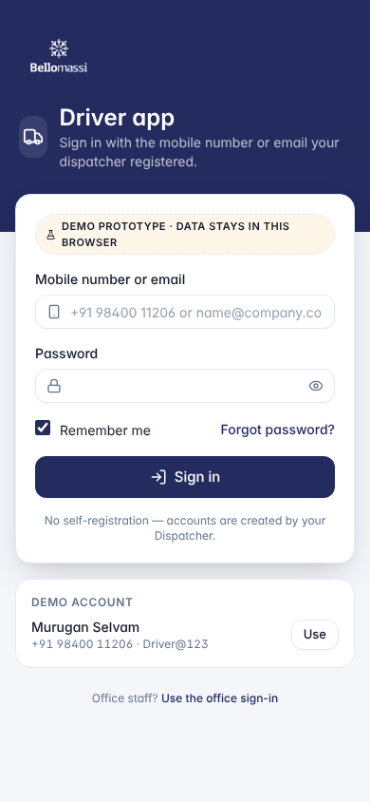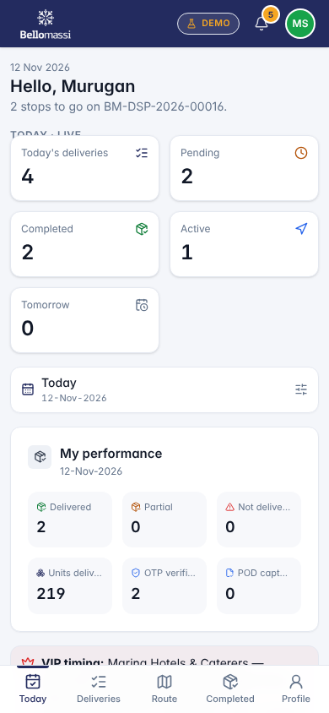

3. Today screen
Shows your dispatch number, number of stops, pending / completed / active counts, tomorrow’s stops, the next stop and your performance. The bottom bar has Today, Deliveries, Route, Completed, Profile.

4. Deliver a stop
Stops must be delivered in the sequence set by the Dispatcher. Only one stop can be out for delivery at a time.
Step | What you do | What the system does
1 | Open the next stop from Today or Deliveries | Shows customer, address, items, map (DEMO GPS)
2 | Tap Start delivery and confirm | Stop becomes Out for delivery; customer and Dispatcher are notified
3 | Use Navigate to open your maps app, or Call the customer | —
4 | At the customer, tap Reach location → I have arrived | Arrival time recorded; a 6-digit OTP is issued to the customer (shown in the customer app — no SMS in the prototype)
5 | Tap Enter OTP & complete | Opens the confirmation form
6 | Enter delivered and damaged quantities per product, name of receiver, remarks; optional rejected quantity and reason, signature, photo, customer remarks | Remaining quantities are calculated
7 | Ask the customer for the OTP, type it, tap Verify OTP & complete delivery | Stop becomes Delivered or Partially delivered; delivery note generated
8 | Go to the next stop | When all stops are closed the dispatch is completed
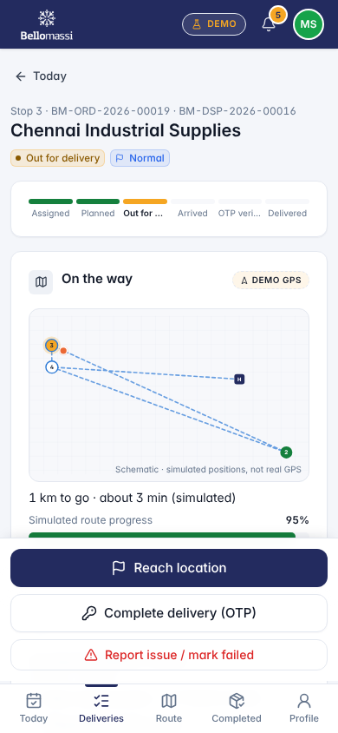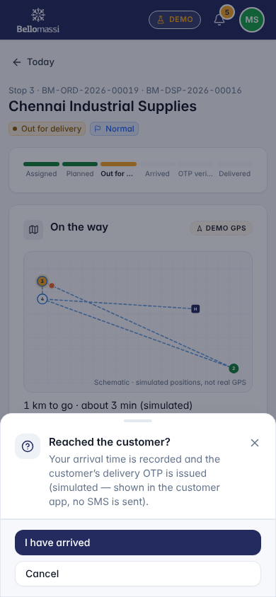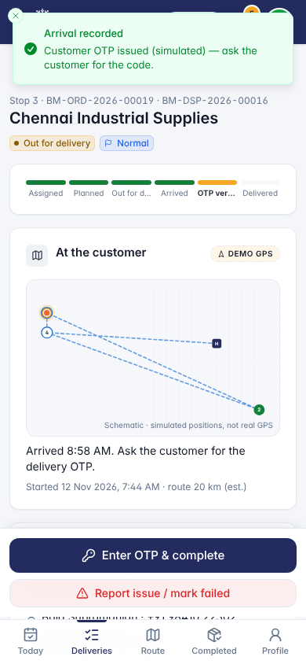
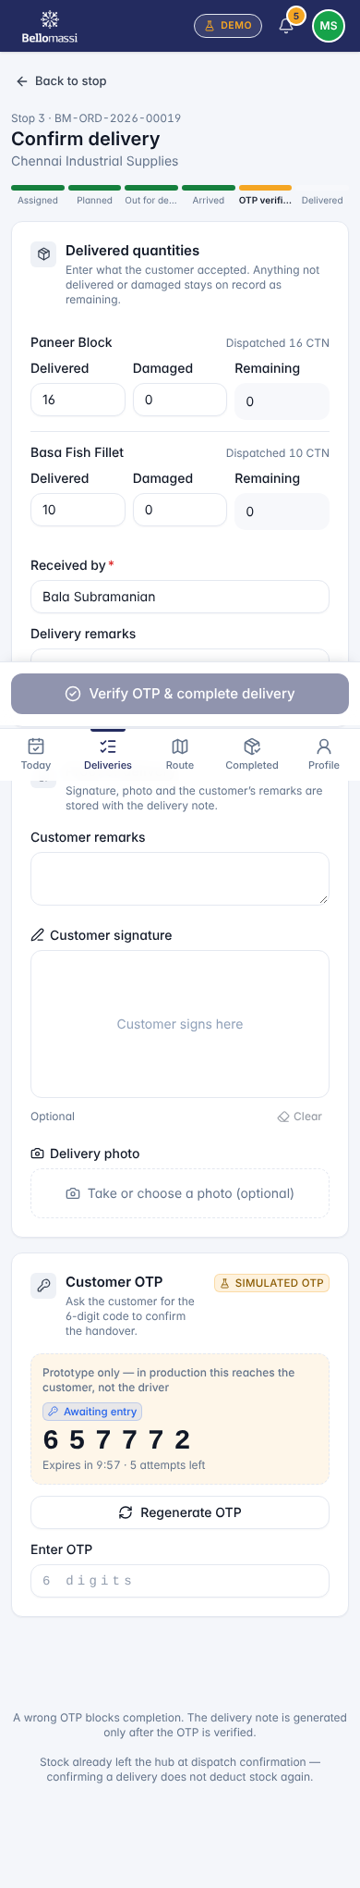

5. OTP rules
Rule | Value
Length | 6 digits
Valid for | 10 minutes (default setting)
Wrong attempts | 5 → code locked; a new code must be generated
Without the correct OTP | The delivery cannot be completed

6. When you cannot deliver
Tap Report issue / mark failed and choose a reason: Customer Not Available, Customer Refused, Customer Requested Reschedule, Incorrect Address, Damaged Goods, Partial Delivery or Other. Add remarks. The Dispatcher reviews the stop and decides to return the stock or re-plan it.

7. Quantity rules
- Delivered quantity is required, whole units, not more than dispatched.
- Damaged / rejected cannot exceed what was not delivered.
- Receiver name is required. Photo and signature each max 350 KB.

8. After delivery
- Completed lists closed stops with OTP and POD status.
- Delivery notes shows the generated notes (BM-DN-…), which you can show to the customer.
- Profile shows your details, today’s statistics and Sign out.
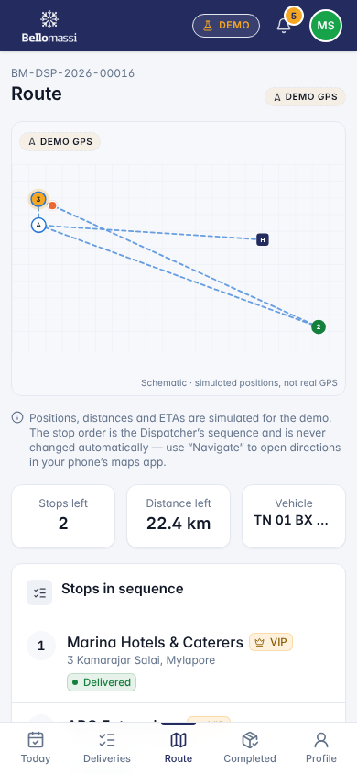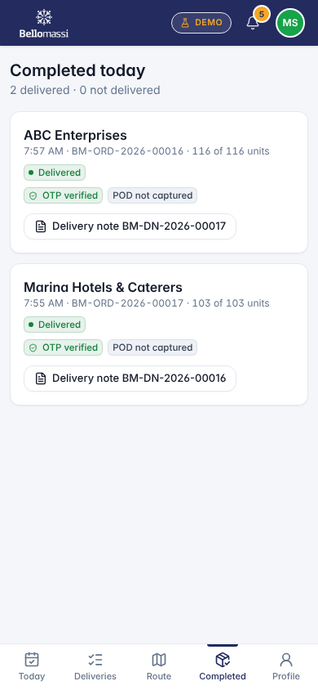

9. What you cannot do
See or change another driver’s stops; change the stop order; start a future-dated dispatch; complete without the OTP; reopen a closed stop; use office screens.

10. Prototype limitations
Positions on the map are simulated (“DEMO GPS”); the OTP is not sent by SMS / WhatsApp; data is kept only in the phone’s browser; no offline mode or push notifications. These are planned for the production app (BM-UX-007 (Mobile UX — Driver App and Customer App)).

Revision history
Version | Date | Author | Description
1.0 | 2026-11-12 | Documentation team | Initial draft prepared from analysis of the bellomassi-premium-ui source code and existing project documents.

