Customer App User Manual
Bellomassi Order-to-Delivery Management Platform
BM-MAN-002 · Version 1.0 · Draft — for client review
2026-11-12

Document control
Field | Value
Document title | Customer App User Manual
Document ID | BM-MAN-002
Version | 1.0
Status | Draft — for client review
Category | User Manuals
Related module(s) | All modules
Document owner | Training Lead
Prepared by | Project documentation team (AI-assisted draft prepared from source-code analysis)
Reviewed by | Pending — not yet reviewed
Approval | Not approved — awaiting client review (no approval has been given)
Created date | 2026-11-12
Last updated date | 2026-11-12
Status labels used in this document: VERIFIED (confirmed in the current source code or existing documents) · PROTOTYPE (works in the React/LocalStorage prototype with mock or simulated behaviour) · PROPOSED (recommended production design, not built) · PENDING CONFIRMATION (needs a client decision) · NOT IMPLEMENTED · NOT VERIFIED.

Purpose
Guide for customer staff to order products, follow orders, track deliveries, share the OTP and get delivery notes and invoices.

Scope
Customer app of the prototype (VERIFIED with real screenshots captured 2026-11-12). The customer app is an extension beyond the SOW (X-01) — production scope PENDING CONFIRMATION.

Definitions
Other terms: see BM-GLO-001 (Project Glossary).

References
- Workflow documentation chapter 09 — Customer workflow (existing document, reused)
- BM-MAN-112 (Role User Manual — Customer (portal / customer app))
- BM-UX-007 (Mobile UX — Driver App and Customer App)
- BM-WF-09 (WF-09 — Driver Assignment Workflow)
- BM-FRD-CAP (Functional Requirements — Customer Application)

Contents

  - Sign in

  - Home

  - Place an order

  - Follow your order

  - Track the delivery and share the OTP

  - Delivery notes, invoices, payments and profile

  - What you cannot do

  - Prototype limitations

1. Sign in
Open the customer app and sign in with the mobile number, email or user name given by Bellomassi. Your login is linked to one customer account; you see only that account’s data.
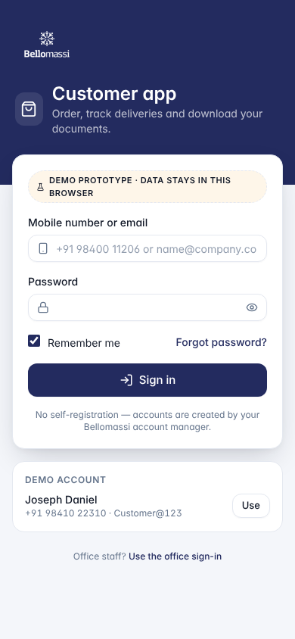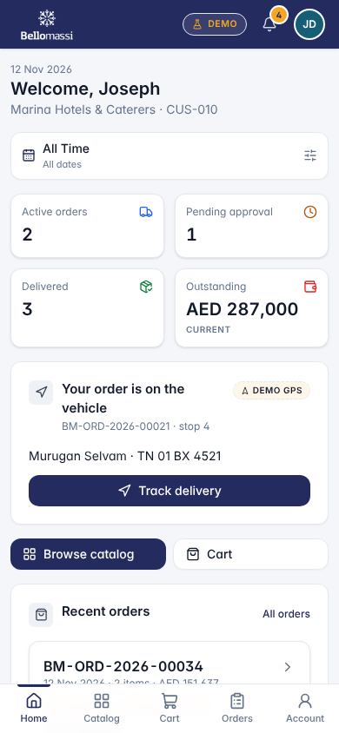

2. Home
Active orders, pending approval, delivered, outstanding balance, a card for any delivery on its way (Track delivery), recent orders, delivery notes and notifications. Bottom bar: Home, Catalog, Cart, Orders, Account.

3. Place an order
- Catalog → search by name, code, SKU or brand, or choose a category.
- Set the quantity and tap Add. Availability is shown (limited stock does not stop ordering).
- Cart → change quantities or remove lines; check subtotal, discount, tax and total.
- Choose the delivery address (registered or another), requested date (tomorrow up to 60 days), optional time, PO / reference and remarks.
- Tap Place order and confirm. The order goes to the Sales Manager for approval (status Pending approval). A credit warning may appear; the order can still be placed and the Sales Manager decides.
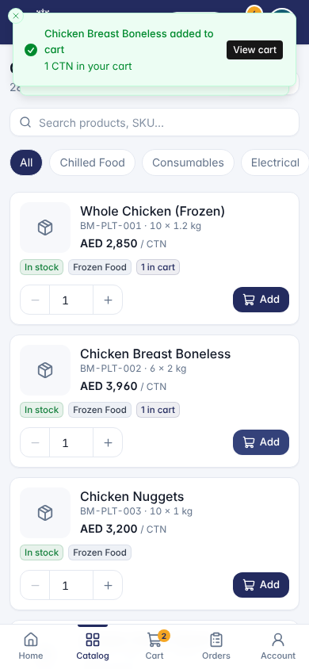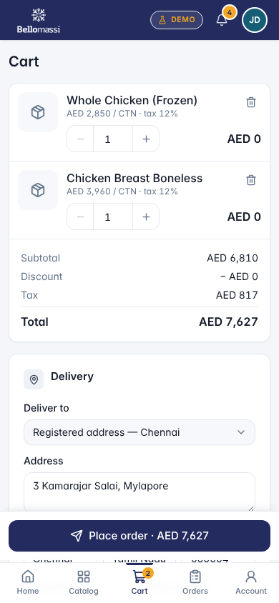
Known issue (prototype): in the cart, the amount shown on each product line is “AED 0” although subtotal, tax and total are correct (see known issues list BM-HND-010 (Known Issues Register)).

4. Follow your order
Orders lists your orders with filters; open one to see a 9-step tracker: Order placed → Pending approval → Approved → Prepared → Dispatch planned → Out for delivery → Driver arrived → OTP verified → Delivered. Reorder copies a past order into the cart.

5. Track the delivery and share the OTP
- When the driver is on the way, open Track delivery — driver, vehicle and a map (DEMO GPS in the prototype).
- When the driver arrives, the OTP appears in large digits with its expiry time.
- Read the OTP to the driver only when you have checked the goods. Never share it before the driver is with you.
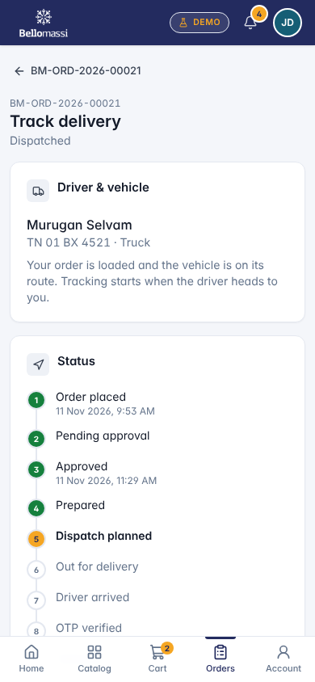

6. Delivery notes, invoices, payments and profile
- Delivery notes: notes with quantities, signature and remarks; printable.
- Invoices: issued invoices; printable.
- Payments: not available in the prototype (shows an explanation and the balance).
- Account / Profile: your details and Sign out.

7. What you cannot do
Cancel or change an order after placing it (contact your sales representative); pay online; see other customers’ data; approve anything.

8. Prototype limitations
No SMS / WhatsApp messages are sent; the OTP is shown only in the app; map positions are simulated; data is stored in the browser.

Revision history
Version | Date | Author | Description
1.0 | 2026-11-12 | Documentation team | Initial draft prepared from analysis of the bellomassi-premium-ui source code and existing project documents.

