Office Web Application User Manual (All Office Roles)
Bellomassi Order-to-Delivery Management Platform
BM-MAN-003 · Version 1.0 · Draft — for client review
2026-11-12

Document control
Field | Value
Document title | Office Web Application User Manual (All Office Roles)
Document ID | BM-MAN-003
Version | 1.0
Status | Draft — for client review
Category | User Manuals
Related module(s) | All modules
Document owner | Training Lead
Prepared by | Project documentation team (AI-assisted draft prepared from source-code analysis)
Reviewed by | Pending — not yet reviewed
Approval | Not approved — awaiting client review (no approval has been given)
Created date | 2026-11-12
Last updated date | 2026-11-12
Status labels used in this document: VERIFIED (confirmed in the current source code or existing documents) · PROTOTYPE (works in the React/LocalStorage prototype with mock or simulated behaviour) · PROPOSED (recommended production design, not built) · PENDING CONFIRMATION (needs a client decision) · NOT IMPLEMENTED · NOT VERIFIED.

Purpose
Common guide to the office web application and the main order-to-delivery procedures; role details are in the role manuals.

Scope
Office web app of the prototype (VERIFIED with real screenshots captured 2026-11-12, demo data).

Definitions
Other terms: see BM-GLO-001 (Project Glossary).

References
- BM-MAN-101 (Role User Manual — Super Admin)
- BM-MAN-102 (Role User Manual — Administrator)
- BM-MAN-103 (Role User Manual — Sales Executive (SALESMAN))
- BM-MAN-104 (Role User Manual — Sales Manager)
- BM-MAN-105 (Role User Manual — Customer Service)
- BM-MAN-106 (Role User Manual — Dispatcher)
- BM-MAN-108 (Role User Manual — Finance Executive)
- BM-MAN-120 (Role Responsibility Matrix)
- BM-UX-005 (Screen Specifications)

1. Signing in and out
- Open the application and sign in with your user name or email and password.
- Tick Remember username / Keep me signed in only on your own computer.
- After 5 wrong passwords the account is locked for 15 minutes (default) — an Administrator can unlock it.
- Inactivity signs you out after 60 minutes (default setting).
- Sign out from the profile menu (top right).
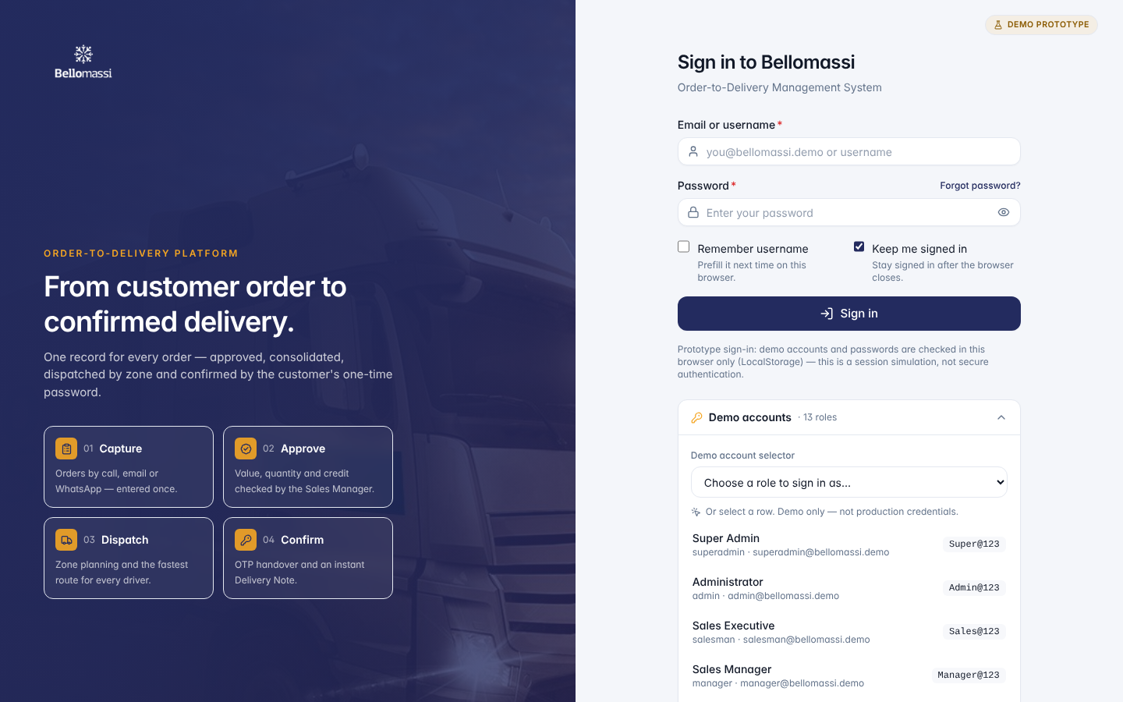

2. Finding your way
Element | Use
Sidebar | Menu groups for your role; collapse with the arrow; on small screens it opens as a drawer
Breadcrumbs | Shows where you are; click to go back
Global search (Ctrl K) | Find pages, customers, orders, deliveries, drivers, vehicles, reports
Bell | Notifications; open the Notification Center for history
Theme | Light / dark mode
Profile menu | My profile, change password, preferences, sign out
Dashboard period filter | All time, date range, specific period, compare with previous period

3. Working with lists and forms
- Lists: search box, filters, sorting by column header, paging, row actions (view, edit, more).
- Forms: fields with * are mandatory; errors appear below the field; Save draft keeps unfinished work; destructive actions ask for confirmation.
- Every important change is written to the audit log.

4. Main procedures

4.1 Create and submit an order (Salesman)
- Orders → Create Order. Choose customer, order type, priority, payment terms, fulfilment hub; delivery address and requested date.
- Add products and quantities; review warnings (stock, credit).
- Preview, then Submit for approval (or Save draft).
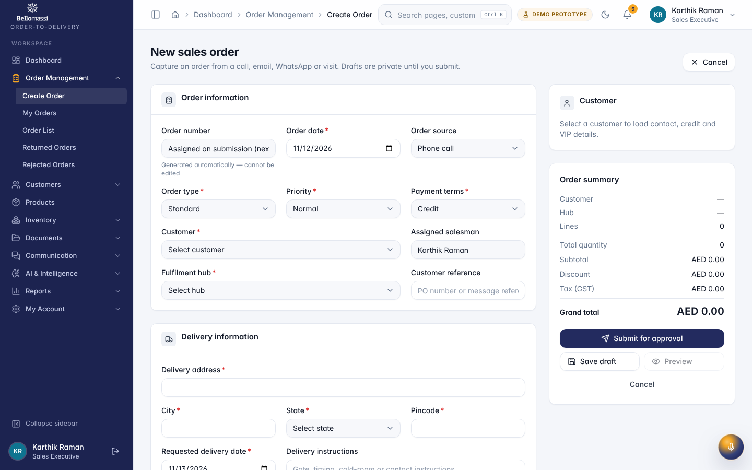

4.2 Approve, return or reject (Sales Manager)
- Order Approval shows submitted orders.
- Open an order; review the 6 automatic checks (including credit).
- Approve, Return for correction (reason required) or Reject (reason required).
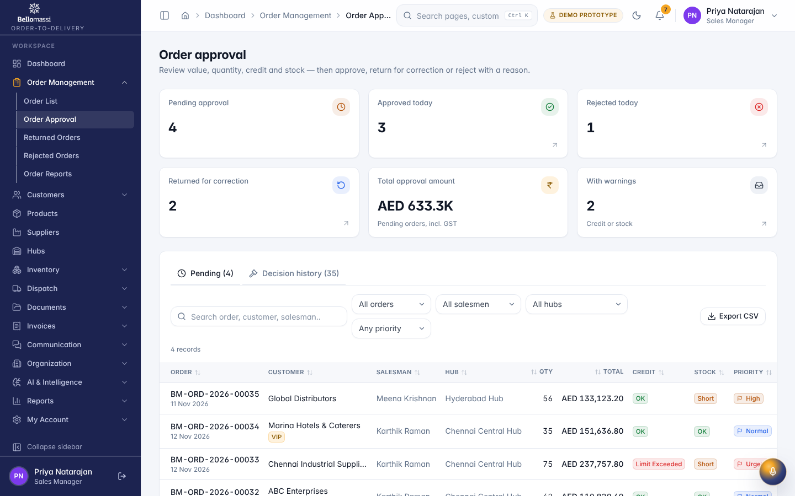

4.3 Consolidate (Customer Service)
Order Consolidation → open approved orders per salesman → verify (5 checks) → consolidate → Ready for dispatch.

4.4 Plan and confirm a dispatch (Dispatcher)
- Ready Orders → select orders (by zone / date).
- New Dispatch: orders, zone, date, stop sequence; assign a compliant driver and vehicle of the same hub.
- Confirm after loading review — stock is deducted at this point and the driver can start.
- Follow progress in Delivery Tracking / Live Tracking (DEMO GPS).
- Review failed / partial deliveries: return stock or re-queue.
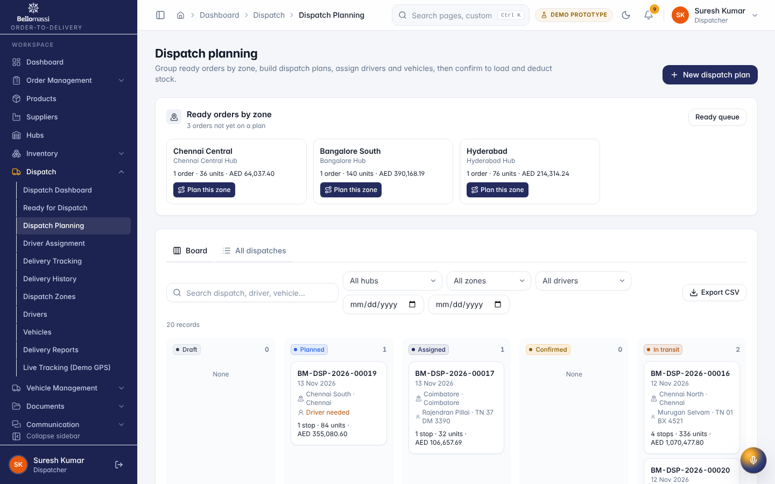

4.5 Delivery notes and invoices
Delivery notes are created automatically for each completed stop (Dispatch → delivery note). Invoices (Finance) are an extension module; whether invoicing is in scope is PENDING CONFIRMATION.

4.6 Reports
Reports Center: 118 reports in 11 categories — search, filter, group, export CSV, print. 24 reports show “No source data” because the prototype does not capture that data.

5. Role manuals
Role | Manual
Super Admin | BM-MAN-101 (Role User Manual — Super Admin)
Administrator | BM-MAN-102 (Role User Manual — Administrator)
Sales Executive | BM-MAN-103 (Role User Manual — Sales Executive (SALESMAN))
Sales Manager | BM-MAN-104 (Role User Manual — Sales Manager)
Customer Service | BM-MAN-105 (Role User Manual — Customer Service)
Dispatcher | BM-MAN-106 (Role User Manual — Dispatcher)
Finance | BM-MAN-108 (Role User Manual — Finance Executive)
Warehouse Manager | BM-MAN-109 (Role User Manual — Warehouse Manager)
Inventory Executive | BM-MAN-110 (Role User Manual — Inventory Executive)
QA Manager | BM-MAN-111 (Role User Manual — QA Manager)
Supplier | BM-MAN-113 (Role User Manual — Supplier (portal))
Management (proposed) | BM-MAN-114 (Role User Manual — Management (Read-only Oversight))

6. Prototype notes
Data is stored in your browser only — another computer does not see your changes. Email, WhatsApp, GPS, OCR and AI functions are simulated and labelled. Do not enter real customer data in the prototype.

Revision history
Version | Date | Author | Description
1.0 | 2026-11-12 | Documentation team | Initial draft prepared from analysis of the bellomassi-premium-ui source code and existing project documents.

