Role User Manual — Super Admin
Bellomassi Order-to-Delivery Management Platform
BM-MAN-101 · Version 1.0 · Draft — for client review
2026-11-12

Document control
Field | Value
Document title | Role User Manual — Super Admin
Document ID | BM-MAN-101
Version | 1.0
Status | Draft — for client review
Category | User Manuals
Related module(s) | All modules
Document owner | Training Lead
Prepared by | Project documentation team (AI-assisted draft prepared from source-code analysis)
Reviewed by | Pending — not yet reviewed
Approval | Not approved — awaiting client review (no approval has been given)
Created date | 2026-11-12
Last updated date | 2026-11-12
Status labels used in this document: VERIFIED (confirmed in the current source code or existing documents) · PROTOTYPE (works in the React/LocalStorage prototype with mock or simulated behaviour) · PROPOSED (recommended production design, not built) · PENDING CONFIRMATION (needs a client decision) · NOT IMPLEMENTED · NOT VERIFIED.

Purpose
Explain to a Super Admin user how to sign in, find their screens and do their daily work in the Bellomassi prototype.

Scope
Role SUPER_ADMIN with its default permissions (VERIFIED from src/config/permissions.js and navigation.js). An Administrator can change permissions, so menus may differ.

Definitions
Other terms: see BM-GLO-001 (Project Glossary).

References
- Workflow documentation chapter 04 (existing document
- reused)
- BM-UX-005 Screen Specifications
- BM-MAN-003 (Office Web Application User Manual (All Office Roles))
- BM-MAN-120 (Role Responsibility Matrix)
- BM-SEC-005 (RBAC and Access Control Matrix)

1. Your role
Owner of the platform: every module, every role and setting. The only role that can grant, change, reset or delete Super Admin accounts.
Topic | Details
Purpose | Owner of the platform: every module, every role and setting. The only role that can grant, change, reset or delete Super Admin accounts.
Login | /login · superadmin / Super@123 (demo account — PROTOTYPE only; production accounts are issued by the Administrator)
Dashboard | /dashboard → AdminDashboard (Operations overview)
Menus | Everything the Administrator sees (4.2). Because Super Admin holds every permission key, the My Deliveries (driver app) and My Account (Customer) groups also appear; those pages show “No driver profile linked” / “No customer account linked” unless the user is linked to a driver or customer record.
KPIs | Total orders, Pending approval, Approved, Rejected, Consolidated, Ready for dispatch, Order pipeline; Operations overview: Sales (delivered, 30 days), Delivery (7 days), Inventory value, Finance — invoiced, Purchase (replenishment), AI insights
CRUD | All master data, users, roles, permissions, settings, organization, templates
Approvals | Orders, scrap, replenishment, documents (all permissions)
Reports | All 118 reports in the Reports Center; every module report
Notifications | Administrative and operational notifications addressed to ADMIN / SUPER_ADMIN
Cannot do | Delete or deactivate their own account; remove their own access to user management
Next responsible user | Administrator (day-to-day administration)
Logout | Header menu › Sign Out → /logout → /login

2. Getting started
- Open the application address given by your Administrator.
- Sign in with your user name (or mobile number / email) and password. After 5 wrong attempts the account is locked for 15 minutes (default security setting; an Administrator can unlock it).
- You land on your dashboard. Use the menu (sidebar on desktop, bottom bar on phone) to move between screens.
- Use the bell icon for notifications and the profile menu to change your password, preferences or to sign out.

3. Your daily work
- Review dashboard
- user and role administration
- audit log
- settings

4. Screens you use
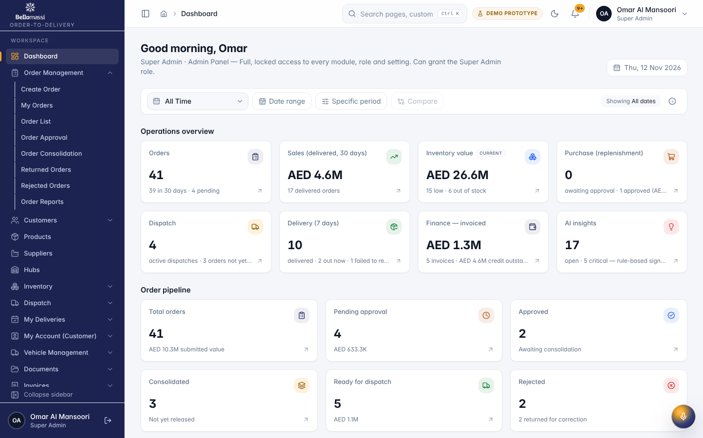
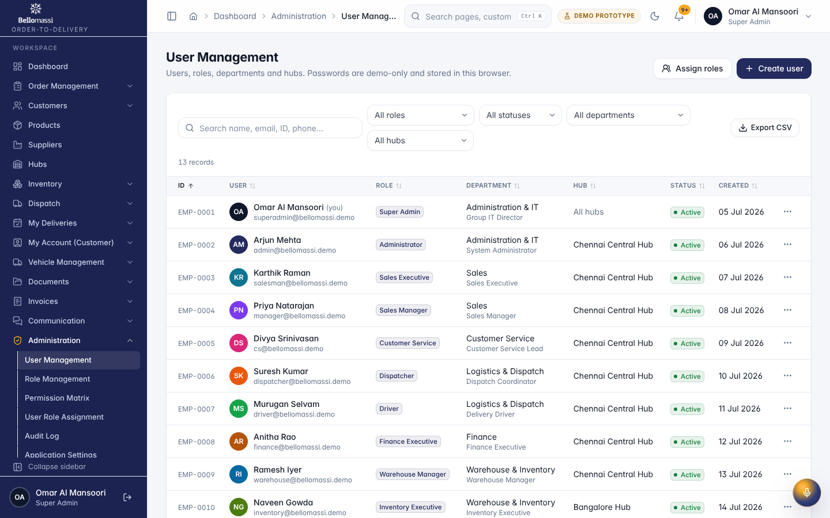
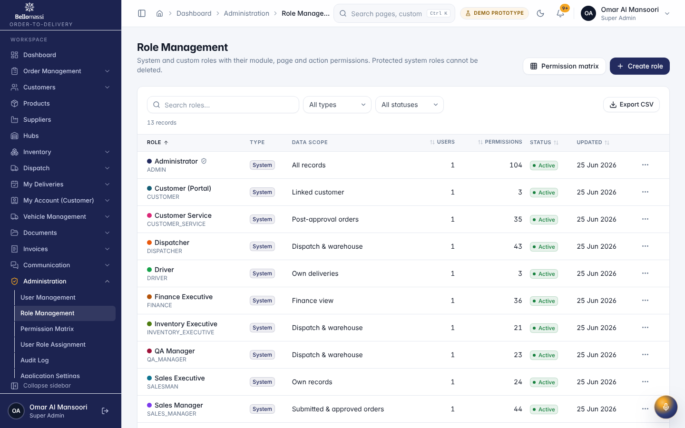
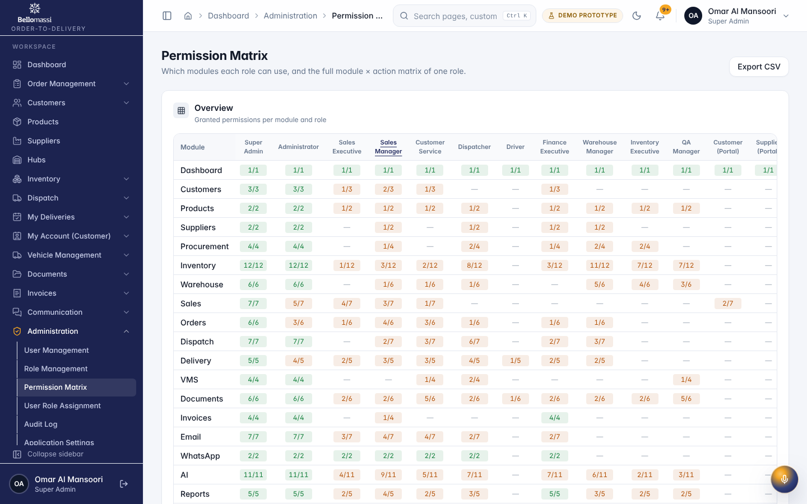
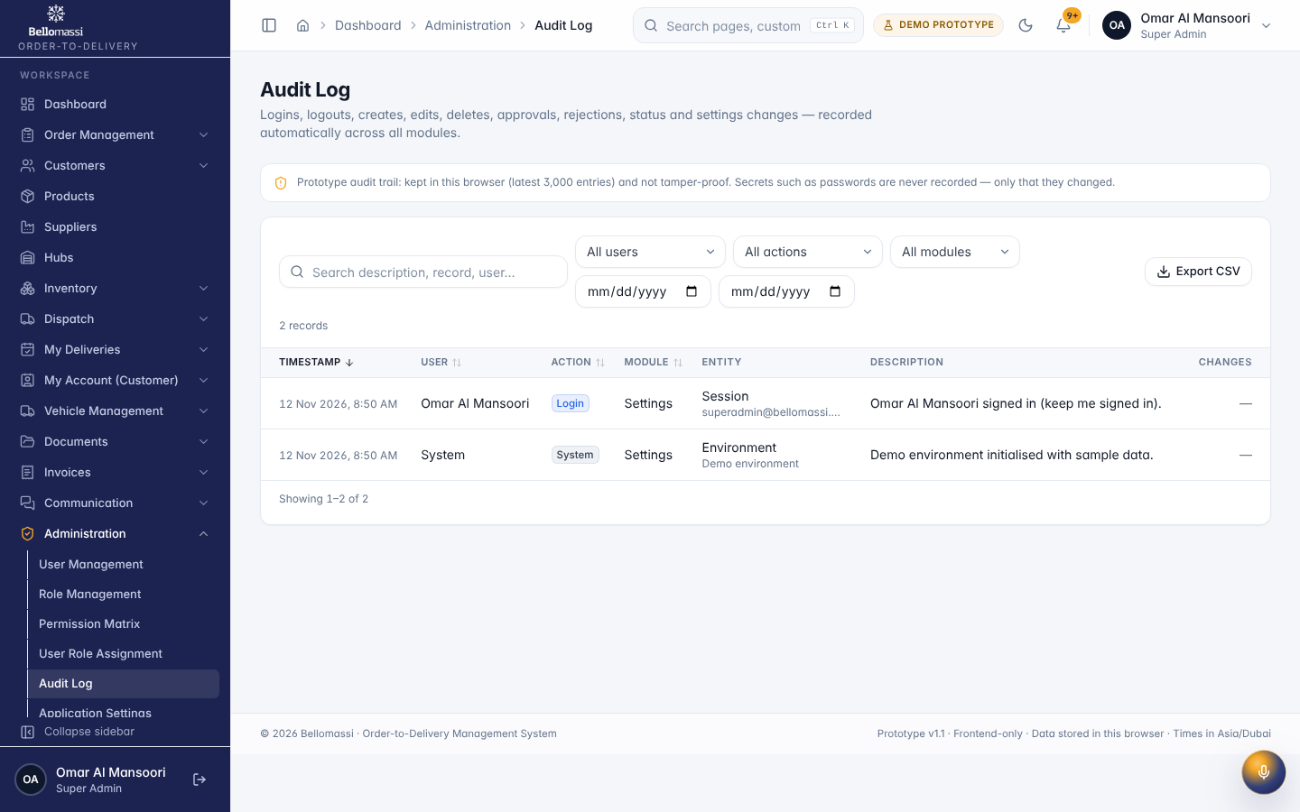

5. Rules to remember
- Delete or deactivate their own account; remove their own access to user management
- Work only with the records in your data scope: as configured.
- After your step the next responsible user is: Administrator (day-to-day administration).

6. Prototype notes
This manual describes the prototype (PROTOTYPE). Data is stored only in your browser; demo markers show simulated features (GPS, OTP messages, email / WhatsApp). Production behaviour may differ — see BM-OVW-015 (Project Status and Implementation Summary).

Revision history
Version | Date | Author | Description
1.0 | 2026-11-12 | Documentation team | Initial draft prepared from analysis of the bellomassi-premium-ui source code and existing project documents.

