Role User Manual — Administrator
Bellomassi Order-to-Delivery Management Platform
BM-MAN-102 · Version 1.0 · Draft — for client review
2026-11-12

Document control
Field | Value
Document title | Role User Manual — Administrator
Document ID | BM-MAN-102
Version | 1.0
Status | Draft — for client review
Category | User Manuals
Related module(s) | All modules
Document owner | Training Lead
Prepared by | Project documentation team (AI-assisted draft prepared from source-code analysis)
Reviewed by | Pending — not yet reviewed
Approval | Not approved — awaiting client review (no approval has been given)
Created date | 2026-11-12
Last updated date | 2026-11-12
Status labels used in this document: VERIFIED (confirmed in the current source code or existing documents) · PROTOTYPE (works in the React/LocalStorage prototype with mock or simulated behaviour) · PROPOSED (recommended production design, not built) · PENDING CONFIRMATION (needs a client decision) · NOT IMPLEMENTED · NOT VERIFIED.

Purpose
Explain to a Administrator user how to sign in, find their screens and do their daily work in the Bellomassi prototype.

Scope
Role ADMIN with its default permissions (VERIFIED from src/config/permissions.js and navigation.js). An Administrator can change permissions, so menus may differ.

Definitions
Other terms: see BM-GLO-001 (Project Glossary).

References
- Workflow documentation chapter 04 (existing document
- reused)
- BM-UX-005 Screen Specifications
- BM-MAN-003 (Office Web Application User Manual (All Office Roles))
- BM-MAN-120 (Role Responsibility Matrix)
- BM-SEC-005 (RBAC and Access Control Matrix)

1. Your role
Runs the system day to day: administers users, roles and settings and can perform most business steps (create orders, plan and confirm dispatches, issue invoices, approve scrap and replenishment).
Topic | Details
Purpose | Runs the system day to day: administers users, roles and settings and can perform most business steps (create orders, plan and confirm dispatches, issue invoices, approve scrap and replenishment).
Login | /login · admin / Admin@123 (demo account — PROTOTYPE only; production accounts are issued by the Administrator)
Dashboard | /dashboard → AdminDashboard (same KPIs as Super Admin)
Menus | Order Management: Create Order, My Orders, Order List, Order Approval, Order Consolidation, Returned Orders, Rejected Orders, Order Reports · Customers: Customer List, Customer Credit · Products, Suppliers, Hubs · Inventory: Inventory Dashboard, Warehouse Dashboard, QA & Cold Chain, Stock Overview, Low Stock, Stock Receipts, Stock Transfers, Stock Adjustments, Stock Movements, Scrap Management · Dispatch: Dispatch Dashboard, Ready for Dispatch, Dispatch Planning, Driver Assignment, Delivery Tracking, Delivery History, Dispatch Zones, Drivers, Vehicles, Delivery Reports, Live Tracking (Demo GPS) · Vehicle Management: VMS Dashboard, Vehicles, Driver Documents, Document Expiry, VMS Reports, Compliance Rules · Documents: Document Repository, Upload Documents, OCR Queue, Verified, Rejected, Document Types, Document Reports · Invoices: Invoice Dashboard, Invoices, New Invoice, Invoice Templates, Invoice Reports · Communication: Communication Center, Email, WhatsApp, Automated Notifications, Call History, Call Follow-ups · Administration: User Management, Role Management, Permission Matrix, User Role Assignment, Audit Log, Application Settings · Organization: Company, Branches, Business Units, Departments, Designations, Employee Master, Warehouse Master · AI & Intelligence: AI Overview, AI Assistant, Jarvis, Forecasting, Predictive Inventory, Replenishment, AI Insights, Model Management, AI Settings · Reports: Reports Center
CRUD | Customers, products, suppliers, hubs, zones, drivers, vehicles, document types, invoice templates, email/WhatsApp templates, users, roles, organization records
Approvals | Scrap (scrap.approve), replenishment (procurement.approve / procurement.reject — only Administrator and Super Admin hold these), documents (documents.review, documents.reject). Not order approval or consolidation: the Administrator can open the Order Approval and Consolidation queues but orders.approve, orders.reject and orders.consolidate are not granted by default (Super Admin holds them).
Reports | All report categories
Notifications | Failed deliveries, dispatch confirmations, document expiry, low stock, purchase approvals
Cannot do | Change or delete a Super Admin account; change the Administrator role unless they are Administrator or Super Admin
Next responsible user | Depends on the module (e.g. approved replenishment → Supplier / warehouse goods receipt)
Logout | /logout → /login

2. Getting started
- Open the application address given by your Administrator.
- Sign in with your user name (or mobile number / email) and password. After 5 wrong attempts the account is locked for 15 minutes (default security setting; an Administrator can unlock it).
- You land on your dashboard. Use the menu (sidebar on desktop, bottom bar on phone) to move between screens.
- Use the bell icon for notifications and the profile menu to change your password, preferences or to sign out.

3. Your daily work
- Check dashboard
- approve replenishment drafts
- handle user requests (unlock, reset password)
- review audit log
- adjust settings

4. Screens you use
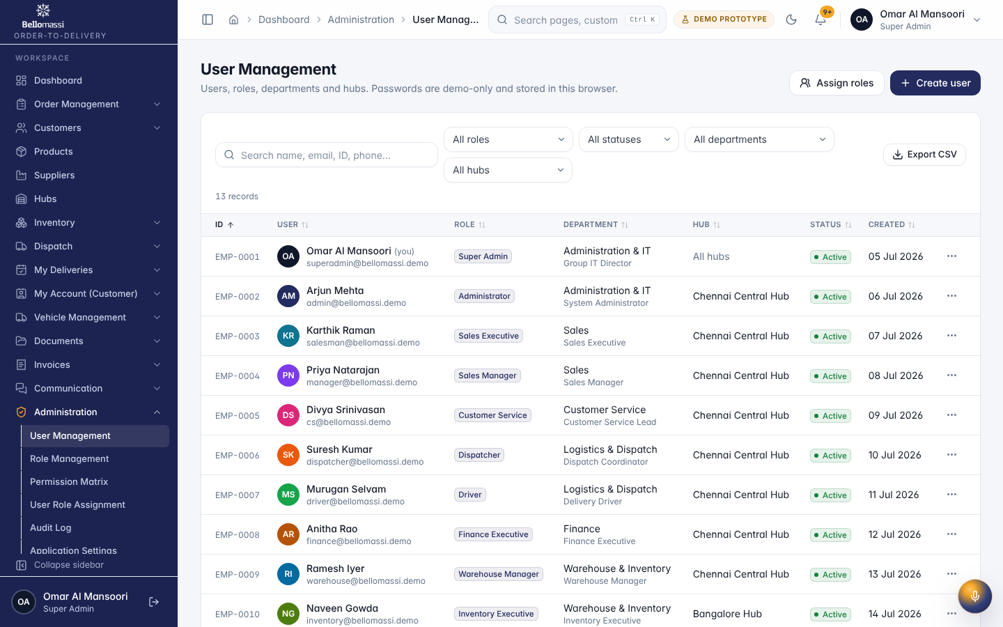
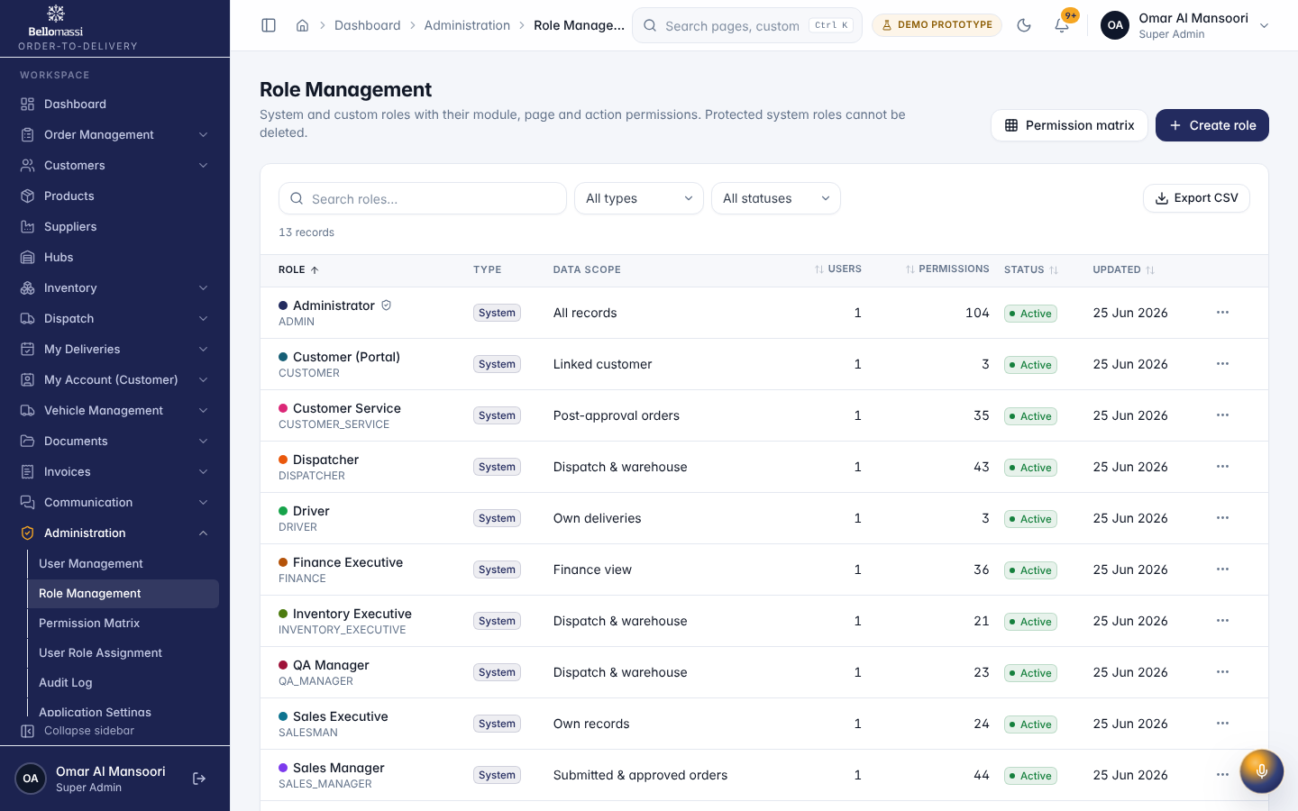
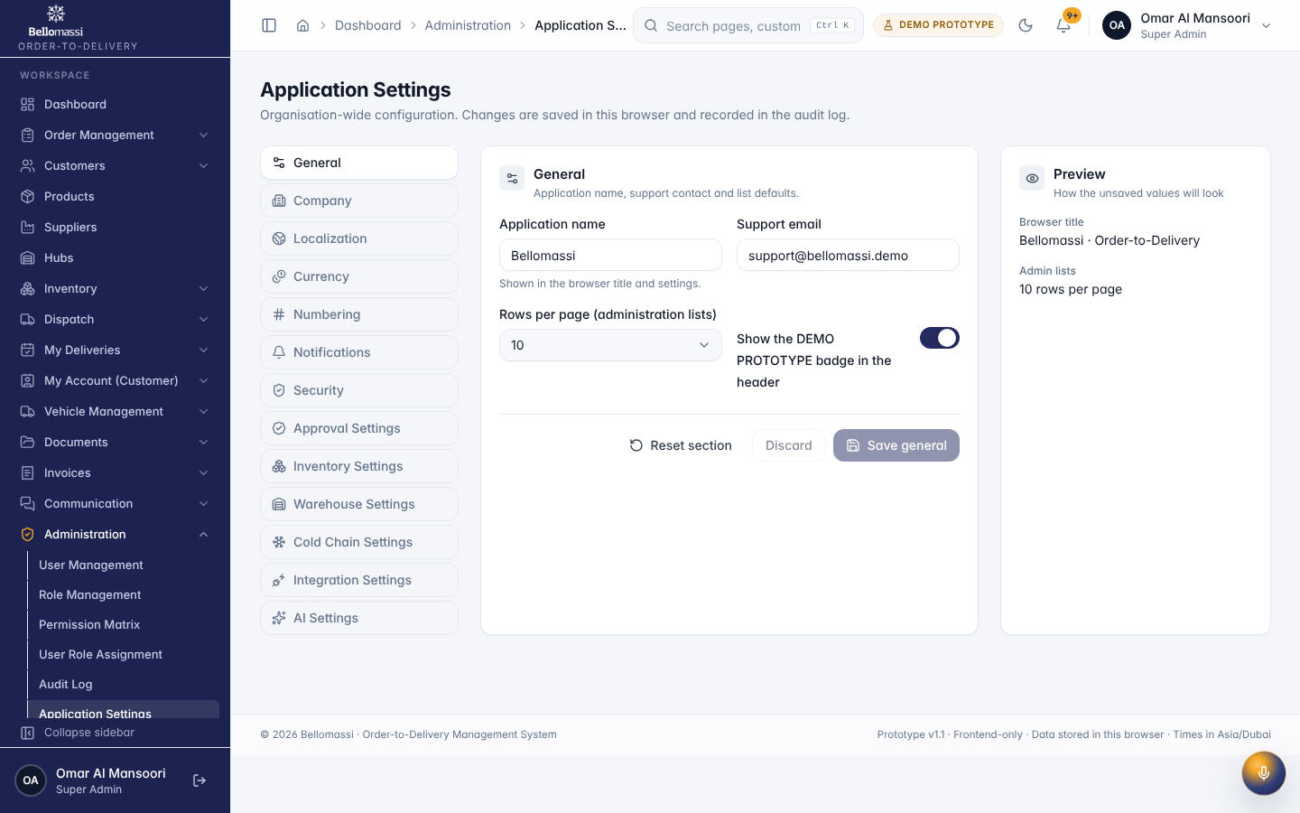
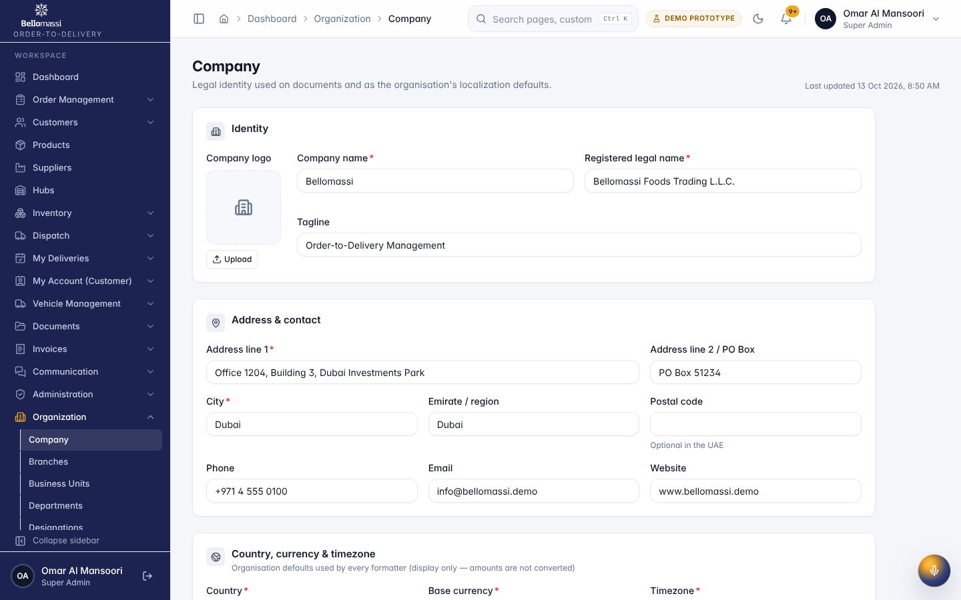
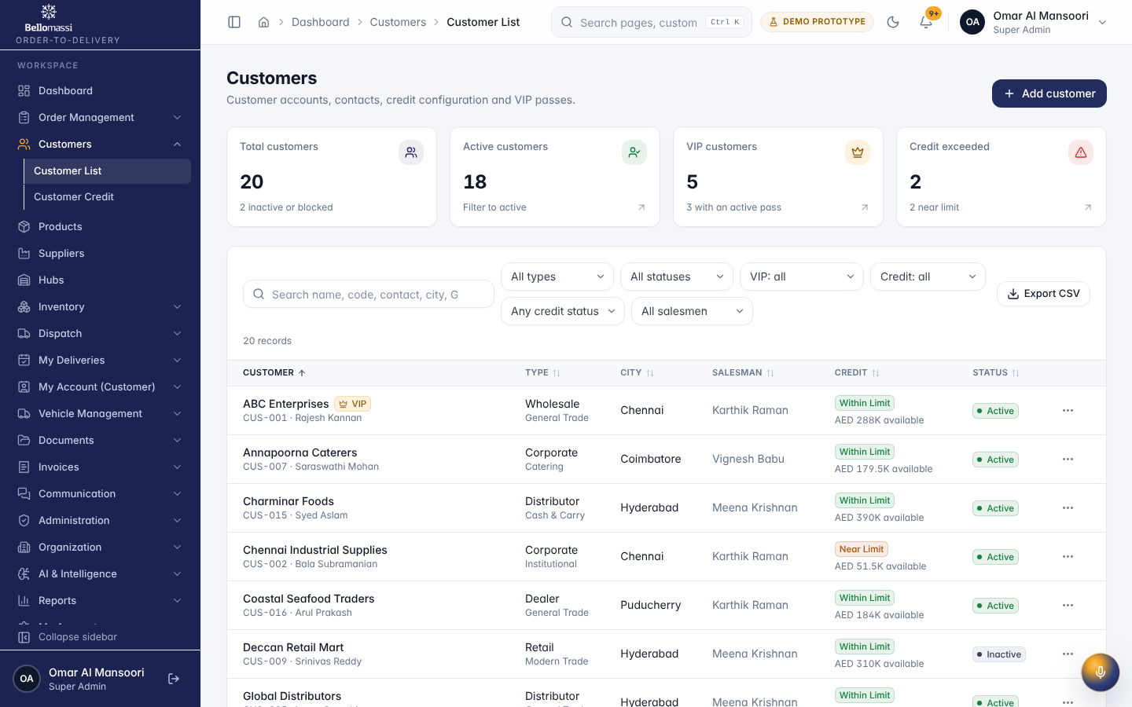
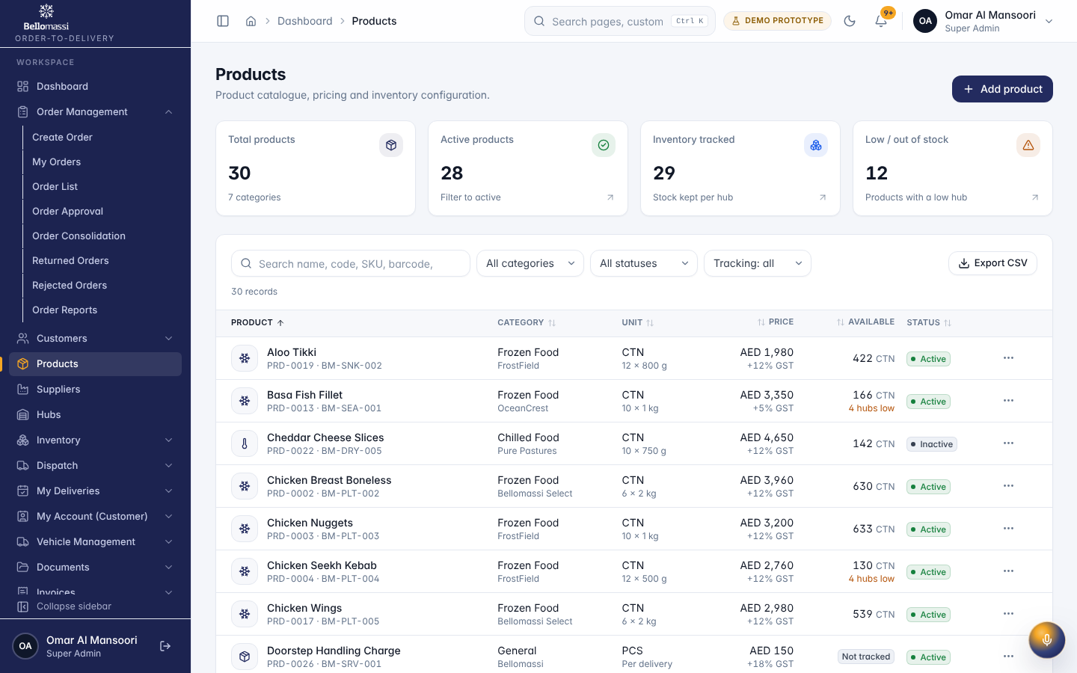

5. Rules to remember
- Change or delete a Super Admin account; change the Administrator role unless they are Administrator or Super Admin
- Work only with the records in your data scope: as configured.
- After your step the next responsible user is: Depends on the module (e.g. approved replenishment → Supplier / warehouse goods receipt).

6. Prototype notes
This manual describes the prototype (PROTOTYPE). Data is stored only in your browser; demo markers show simulated features (GPS, OTP messages, email / WhatsApp). Production behaviour may differ — see BM-OVW-015 (Project Status and Implementation Summary).

Revision history
Version | Date | Author | Description
1.0 | 2026-11-12 | Documentation team | Initial draft prepared from analysis of the bellomassi-premium-ui source code and existing project documents.

