Role User Manual — Sales Executive (SALESMAN)
Bellomassi Order-to-Delivery Management Platform
BM-MAN-103 · Version 1.0 · Draft — for client review
2026-11-12

Document control
Field | Value
Document title | Role User Manual — Sales Executive (SALESMAN)
Document ID | BM-MAN-103
Version | 1.0
Status | Draft — for client review
Category | User Manuals
Related module(s) | All modules
Document owner | Training Lead
Prepared by | Project documentation team (AI-assisted draft prepared from source-code analysis)
Reviewed by | Pending — not yet reviewed
Approval | Not approved — awaiting client review (no approval has been given)
Created date | 2026-11-12
Last updated date | 2026-11-12
Status labels used in this document: VERIFIED (confirmed in the current source code or existing documents) · PROTOTYPE (works in the React/LocalStorage prototype with mock or simulated behaviour) · PROPOSED (recommended production design, not built) · PENDING CONFIRMATION (needs a client decision) · NOT IMPLEMENTED · NOT VERIFIED.

Purpose
Explain to a Sales Executive (SALESMAN) user how to sign in, find their screens and do their daily work in the Bellomassi prototype.

Scope
Role SALESMAN with its default permissions (VERIFIED from src/config/permissions.js and navigation.js). An Administrator can change permissions, so menus may differ.

Definitions
Other terms: see BM-GLO-001 (Project Glossary).

References
- Workflow documentation chapter 04 (existing document
- reused)
- BM-UX-005 Screen Specifications
- BM-MAN-003 (Office Web Application User Manual (All Office Roles))
- BM-MAN-120 (Role Responsibility Matrix)
- BM-SEC-005 (RBAC and Access Control Matrix)

1. Your role
Takes orders for the customers assigned to them and keeps them moving through approval.
Topic | Details
Purpose | Takes orders for the customers assigned to them and keeps them moving through approval.
Login | /login · salesman / Sales@123 (demo account — PROTOTYPE only; production accounts are issued by the Administrator)
Dashboard | SalesmanDashboard: My orders, Draft orders, Pending approval, Approved orders, Returned orders, Rejected orders, Needs your action, My order trend, My recent orders
Menus | Order Management: Create Order, My Orders, Order List, Returned Orders, Rejected Orders · Customers: Customer List · Products · Inventory: Stock Overview · Documents: Repository, Upload, OCR Queue, Verified, Rejected · Communication: Communication Center, Email, WhatsApp, Call History, Call Follow-ups · AI: AI Overview, AI Assistant, Jarvis · Reports Center
Data scope | Own records only (orders where salesmanId or createdBy is the user)
CRUD | Create, edit and delete draft orders; duplicate an order; edit and resubmit returned orders; log, edit and delete own calls; upload documents for own records
Approvals | None (submits for approval)
Reports | Reports Center — only categories their permissions allow (Customer reports via customers.view, Communication reports via communication.calls)
Notifications | Order submitted / approved / returned (with link to edit) / rejected / ready for dispatch
Cannot do | Approve or reject orders; consolidate; dispatch; invoice; see other salesmen’s orders; delete a submitted order (“Only draft orders can be deleted”)
Next responsible user | Sales Manager (approval)
Logout | /logout → /login

2. Getting started
- Open the application address given by your Administrator.
- Sign in with your user name (or mobile number / email) and password. After 5 wrong attempts the account is locked for 15 minutes (default security setting; an Administrator can unlock it).
- You land on your dashboard. Use the menu (sidebar on desktop, bottom bar on phone) to move between screens.
- Use the bell icon for notifications and the profile menu to change your password, preferences or to sign out.

3. Your daily work
- Dashboard “Needs your action”
- fix returned orders
- create today’s orders (or from a call)
- submit
- follow up calls
- check approvals

4. Screens you use
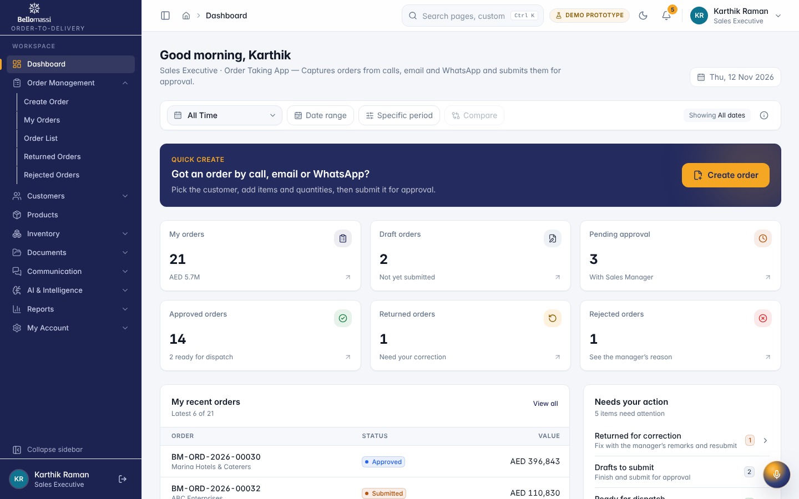
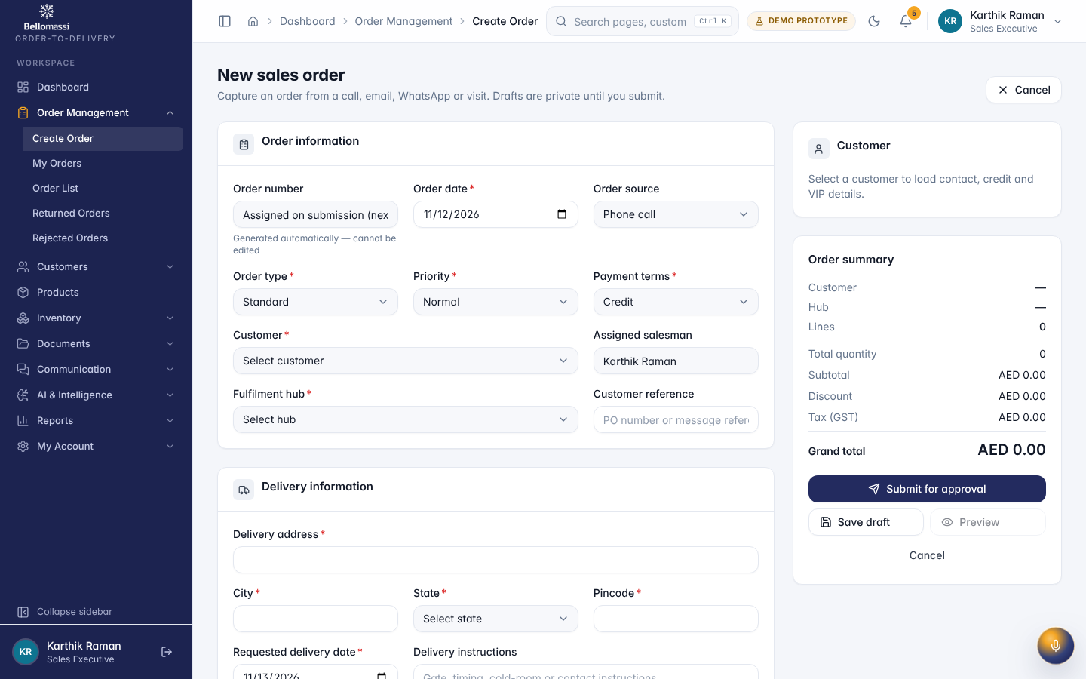
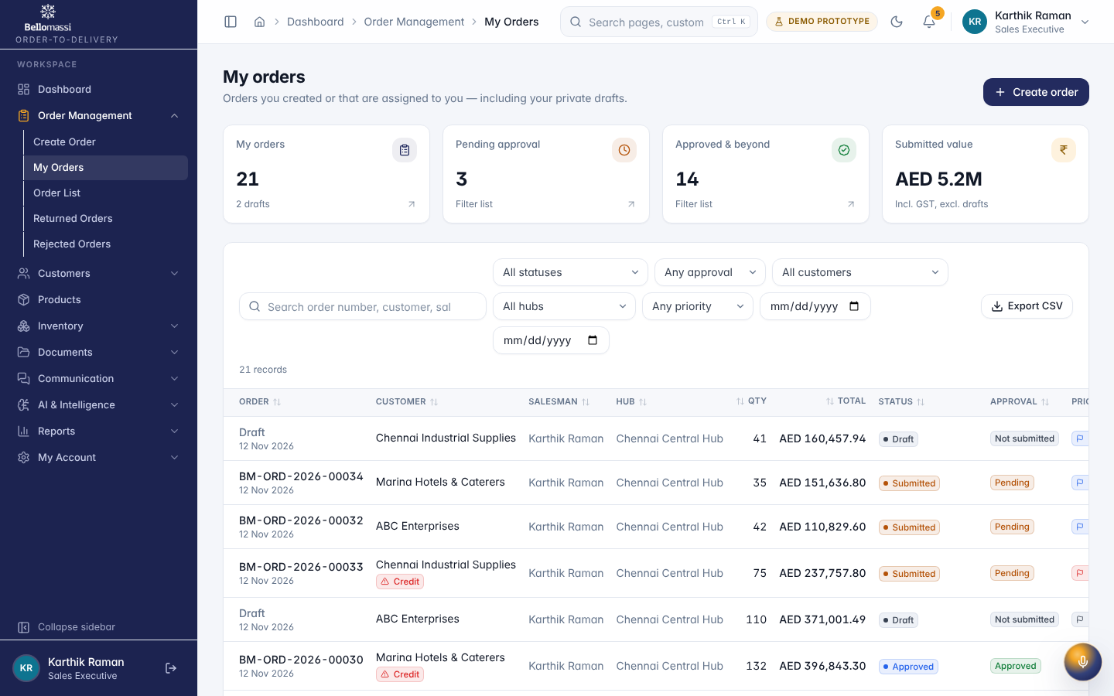
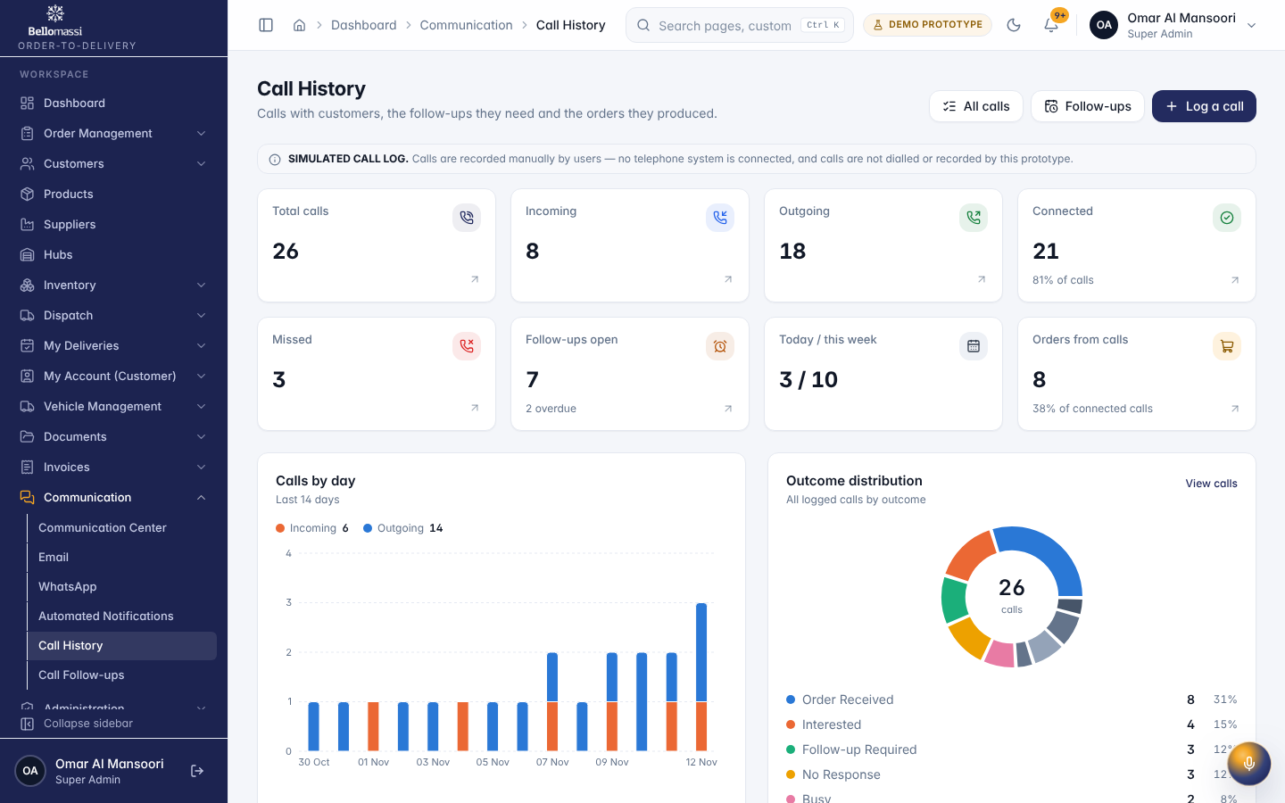

5. Rules to remember
- Approve or reject orders; consolidate; dispatch; invoice; see other salesmen’s orders; delete a submitted order (“Only draft orders can be deleted”)
- Work only with the records in your data scope: Own records only (orders where salesmanId or createdBy is the user).
- After your step the next responsible user is: Sales Manager (approval).

6. Prototype notes
This manual describes the prototype (PROTOTYPE). Data is stored only in your browser; demo markers show simulated features (GPS, OTP messages, email / WhatsApp). Production behaviour may differ — see BM-OVW-015 (Project Status and Implementation Summary).

Revision history
Version | Date | Author | Description
1.0 | 2026-11-12 | Documentation team | Initial draft prepared from analysis of the bellomassi-premium-ui source code and existing project documents.

