Role User Manual — Sales Manager
Bellomassi Order-to-Delivery Management Platform
BM-MAN-104 · Version 1.0 · Draft — for client review
2026-11-12

Document control
Field | Value
Document title | Role User Manual — Sales Manager
Document ID | BM-MAN-104
Version | 1.0
Status | Draft — for client review
Category | User Manuals
Related module(s) | All modules
Document owner | Training Lead
Prepared by | Project documentation team (AI-assisted draft prepared from source-code analysis)
Reviewed by | Pending — not yet reviewed
Approval | Not approved — awaiting client review (no approval has been given)
Created date | 2026-11-12
Last updated date | 2026-11-12
Status labels used in this document: VERIFIED (confirmed in the current source code or existing documents) · PROTOTYPE (works in the React/LocalStorage prototype with mock or simulated behaviour) · PROPOSED (recommended production design, not built) · PENDING CONFIRMATION (needs a client decision) · NOT IMPLEMENTED · NOT VERIFIED.

Purpose
Explain to a Sales Manager user how to sign in, find their screens and do their daily work in the Bellomassi prototype.

Scope
Role SALES_MANAGER with its default permissions (VERIFIED from src/config/permissions.js and navigation.js). An Administrator can change permissions, so menus may differ.

Definitions
Other terms: see BM-GLO-001 (Project Glossary).

References
- Workflow documentation chapter 04 (existing document
- reused)
- BM-UX-005 Screen Specifications
- BM-MAN-003 (Office Web Application User Manual (All Office Roles))
- BM-MAN-120 (Role Responsibility Matrix)
- BM-SEC-005 (RBAC and Access Control Matrix)

1. Your role
Approves, returns or rejects submitted orders after checking credit, stock and data quality; watches sales performance.
Topic | Details
Purpose | Approves, returns or rejects submitted orders after checking credit, stock and data quality; watches sales performance.
Login | /login · manager / Manager@123 (demo account — PROTOTYPE only; production accounts are issued by the Administrator)
Dashboard | SalesManagerDashboard: Pending approvals, Returned orders, Recent pending orders (oldest first), Active accounts and credit position
Menus | Order Management: Order List, Order Approval, Returned Orders, Rejected Orders, Order Reports · Customers: Customer List, Customer Credit · Products, Suppliers, Hubs · Inventory: Stock Overview, Low Stock · Dispatch: Dispatch Dashboard, Dispatch Planning, Delivery Tracking, Delivery History · Documents (5 pages) · Invoices: Invoice Dashboard, Invoices · Communication: Center, Email, WhatsApp, Call History, Call Follow-ups · AI: AI Overview, AI Assistant, Jarvis, Forecasting, Predictive Inventory, Replenishment, AI Insights, Model Management · Reports Center
Data scope | All submitted and later orders (not other users’ drafts)
CRUD | Sales targets (sales.targets.manage); calls; documents upload; forecasts (generate / export)
Approvals | Order approval — Approve (orders.approve), Return for correction and Reject (orders.reject)
Reports | Sales, Inventory, Procurement, Dispatch & Delivery (history), Customer, Supplier, Communication, AI categories
Notifications | “New order for approval”, “Order resubmitted” (with credit / stock warning flags)
Cannot do | Create orders; consolidate; plan or confirm dispatches; issue invoices; manage master data
Next responsible user | Customer Service (approved) or Sales Executive (returned)
Logout | /logout → /login

2. Getting started
- Open the application address given by your Administrator.
- Sign in with your user name (or mobile number / email) and password. After 5 wrong attempts the account is locked for 15 minutes (default security setting; an Administrator can unlock it).
- You land on your dashboard. Use the menu (sidebar on desktop, bottom bar on phone) to move between screens.
- Use the bell icon for notifications and the profile menu to change your password, preferences or to sign out.

3. Your daily work
- Order Approval queue (oldest first)
- open each order
- read approval checks
- approve / return / reject
- check returned orders
- review credit position and reports

4. Screens you use
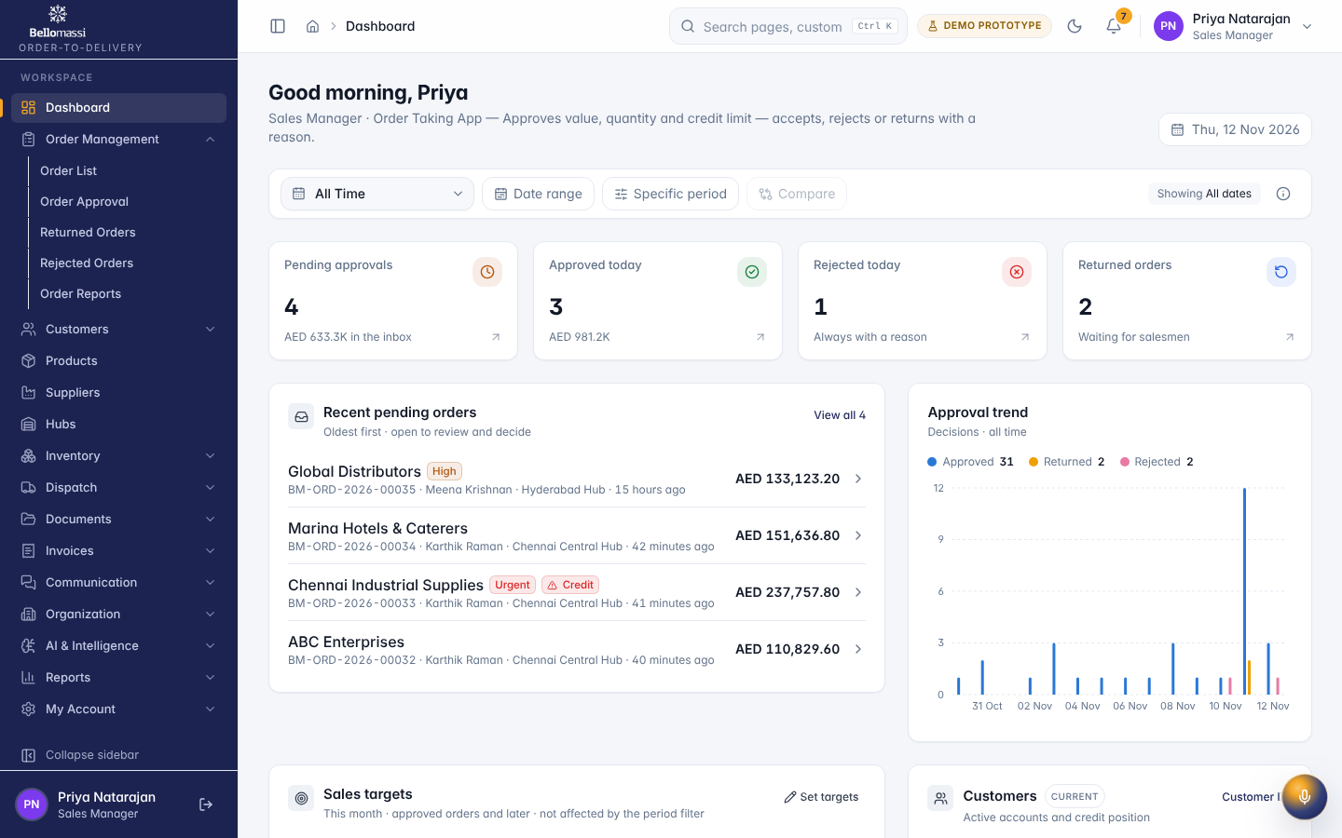
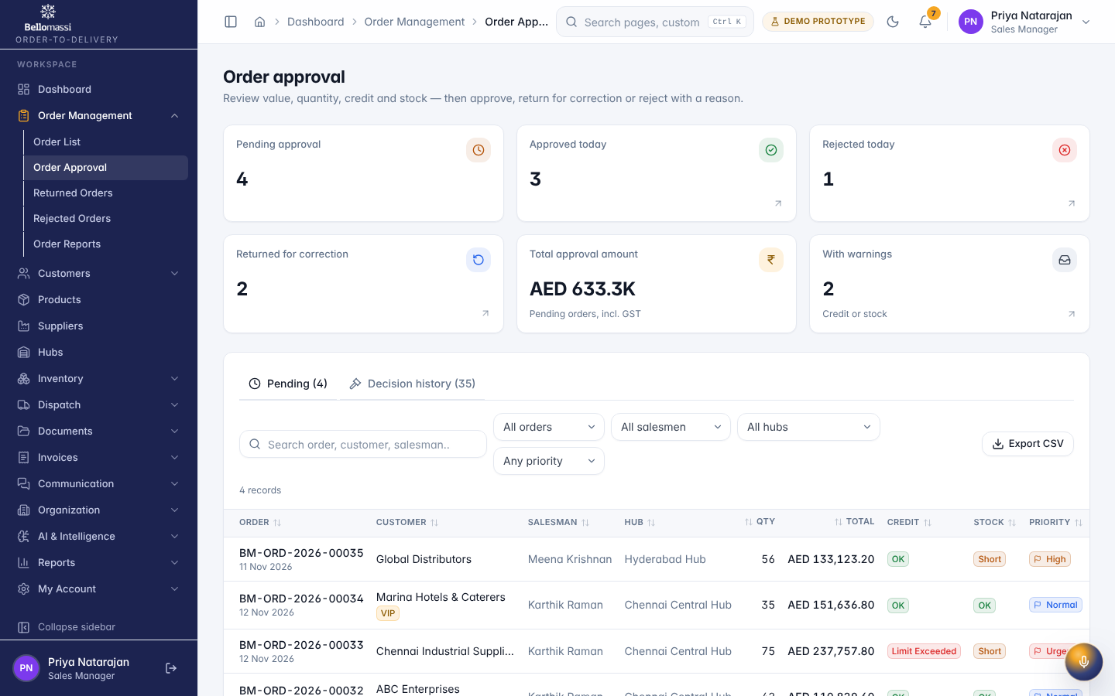
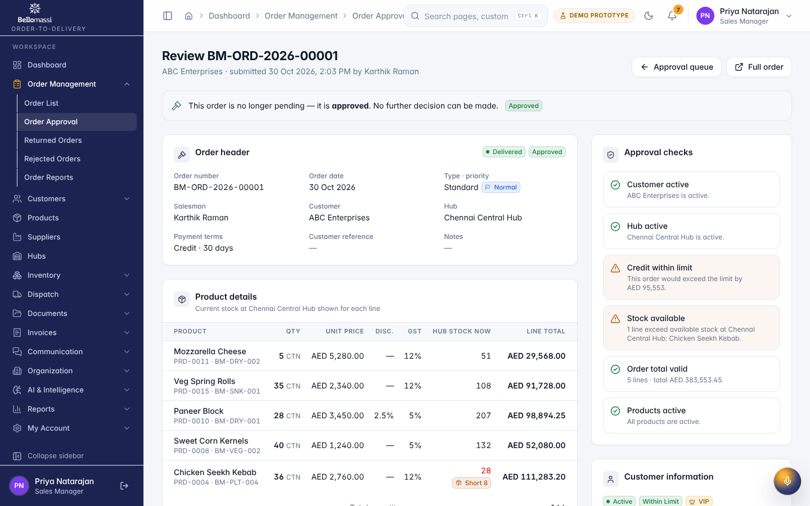
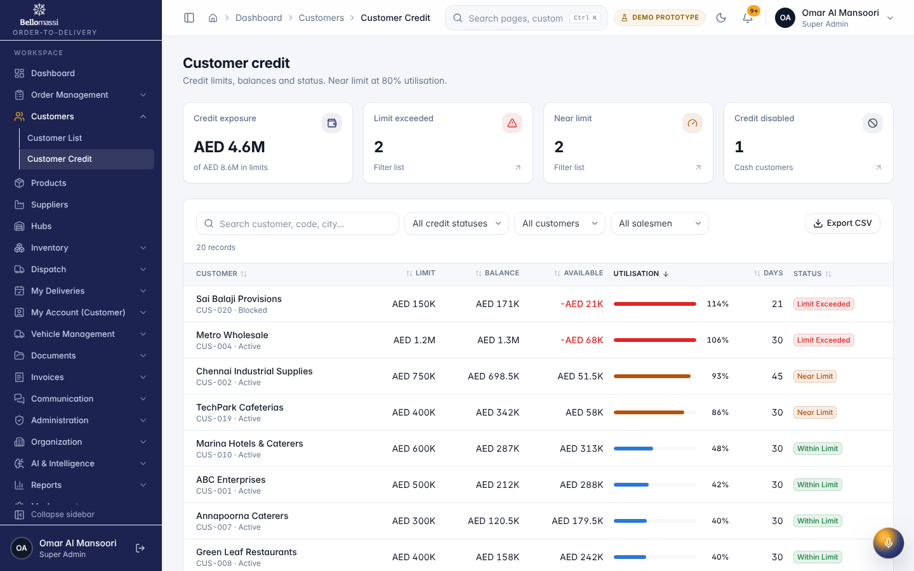

5. Rules to remember
- Create orders; consolidate; plan or confirm dispatches; issue invoices; manage master data
- Work only with the records in your data scope: All submitted and later orders (not other users’ drafts).
- After your step the next responsible user is: Customer Service (approved) or Sales Executive (returned).

6. Prototype notes
This manual describes the prototype (PROTOTYPE). Data is stored only in your browser; demo markers show simulated features (GPS, OTP messages, email / WhatsApp). Production behaviour may differ — see BM-OVW-015 (Project Status and Implementation Summary).

Revision history
Version | Date | Author | Description
1.0 | 2026-11-12 | Documentation team | Initial draft prepared from analysis of the bellomassi-premium-ui source code and existing project documents.

