Role User Manual — Customer Service
Bellomassi Order-to-Delivery Management Platform
BM-MAN-105 · Version 1.0 · Draft — for client review
2026-11-12

Document control
Field | Value
Document title | Role User Manual — Customer Service
Document ID | BM-MAN-105
Version | 1.0
Status | Draft — for client review
Category | User Manuals
Related module(s) | All modules
Document owner | Training Lead
Prepared by | Project documentation team (AI-assisted draft prepared from source-code analysis)
Reviewed by | Pending — not yet reviewed
Approval | Not approved — awaiting client review (no approval has been given)
Created date | 2026-11-12
Last updated date | 2026-11-12
Status labels used in this document: VERIFIED (confirmed in the current source code or existing documents) · PROTOTYPE (works in the React/LocalStorage prototype with mock or simulated behaviour) · PROPOSED (recommended production design, not built) · PENDING CONFIRMATION (needs a client decision) · NOT IMPLEMENTED · NOT VERIFIED.

Purpose
Explain to a Customer Service user how to sign in, find their screens and do their daily work in the Bellomassi prototype.

Scope
Role CUSTOMER_SERVICE with its default permissions (VERIFIED from src/config/permissions.js and navigation.js). An Administrator can change permissions, so menus may differ.

Definitions
Other terms: see BM-GLO-001 (Project Glossary).

References
- Workflow documentation chapter 04 (existing document
- reused)
- BM-UX-005 Screen Specifications
- BM-MAN-003 (Office Web Application User Manual (All Office Roles))
- BM-MAN-120 (Role Responsibility Matrix)
- BM-SEC-005 (RBAC and Access Control Matrix)

1. Your role
Verifies approved orders against the warehouse, consolidates them and releases them to dispatch; reviews documents.
Topic | Details
Purpose | Verifies approved orders against the warehouse, consolidates them and releases them to dispatch; reviews documents.
Login | /login · cs / Cs@123 (demo account — PROTOTYPE only; production accounts are issued by the Administrator)
Dashboard | CustomerServiceDashboard: Approved orders, Awaiting consolidation, Consolidated orders, Ready for dispatch, Approved orders by stage, Queue by salesman, Consolidation queue (oldest approval first), Recent approved orders
Menus | Order Management: Order List, Order Consolidation · Customer List · Products, Hubs · Inventory: Stock Overview, Low Stock · Dispatch: Dispatch Dashboard, Ready for Dispatch, Dispatch Planning, Delivery Tracking, Delivery History · Documents: Repository, Upload, OCR Queue, Verified, Rejected, Document Reports · Communication: Center, Email, WhatsApp, Call History, Call Follow-ups · AI: AI Overview, AI Assistant, Jarvis, AI Insights · Reports Center
Data scope | Orders from approval onwards; all documents
CRUD | Consolidation records; calls; documents (upload, review, reject); VMS document upload
Approvals | Consolidation (5-point verification); document review (verify / reject)
Reports | Customer, Communication, Dispatch & Delivery (where permitted)
Notifications | “Order awaiting consolidation” after each approval
Cannot do | Approve or reject orders; create dispatches; assign drivers; confirm dispatch; issue invoices
Next responsible user | Dispatcher
Logout | /logout → /login

2. Getting started
- Open the application address given by your Administrator.
- Sign in with your user name (or mobile number / email) and password. After 5 wrong attempts the account is locked for 15 minutes (default security setting; an Administrator can unlock it).
- You land on your dashboard. Use the menu (sidebar on desktop, bottom bar on phone) to move between screens.
- Use the bell icon for notifications and the profile menu to change your password, preferences or to sign out.

3. Your daily work
- Consolidation queue
- open order
- tick the 5 checks, review hub stock
- Consolidate
- Mark ready for dispatch
- OCR queue / document review
- customer calls

4. Screens you use
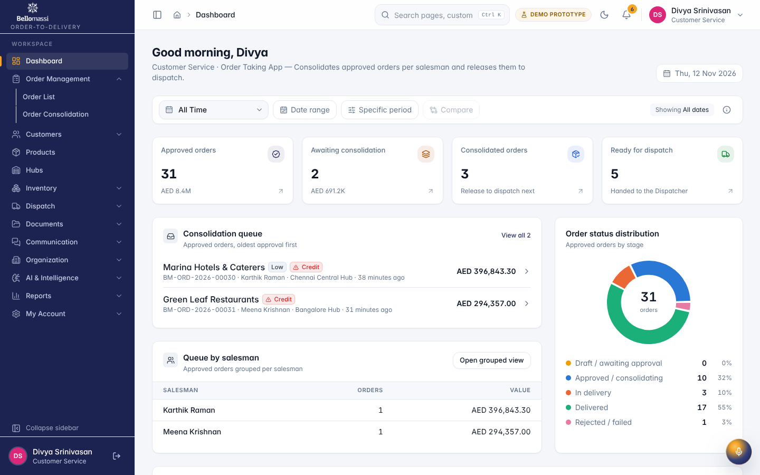
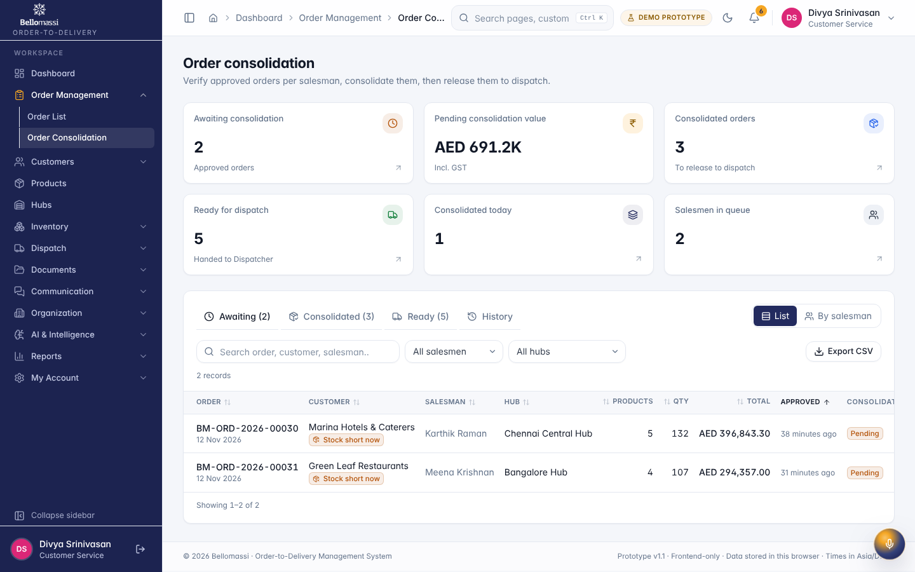

5. Rules to remember
- Approve or reject orders; create dispatches; assign drivers; confirm dispatch; issue invoices
- Work only with the records in your data scope: Orders from approval onwards; all documents.
- After your step the next responsible user is: Dispatcher.

6. Prototype notes
This manual describes the prototype (PROTOTYPE). Data is stored only in your browser; demo markers show simulated features (GPS, OTP messages, email / WhatsApp). Production behaviour may differ — see BM-OVW-015 (Project Status and Implementation Summary).

Revision history
Version | Date | Author | Description
1.0 | 2026-11-12 | Documentation team | Initial draft prepared from analysis of the bellomassi-premium-ui source code and existing project documents.

