Role User Manual — Dispatcher
Bellomassi Order-to-Delivery Management Platform
BM-MAN-106 · Version 1.0 · Draft — for client review
2026-11-12

Document control
Field | Value
Document title | Role User Manual — Dispatcher
Document ID | BM-MAN-106
Version | 1.0
Status | Draft — for client review
Category | User Manuals
Related module(s) | All modules
Document owner | Training Lead
Prepared by | Project documentation team (AI-assisted draft prepared from source-code analysis)
Reviewed by | Pending — not yet reviewed
Approval | Not approved — awaiting client review (no approval has been given)
Created date | 2026-11-12
Last updated date | 2026-11-12
Status labels used in this document: VERIFIED (confirmed in the current source code or existing documents) · PROTOTYPE (works in the React/LocalStorage prototype with mock or simulated behaviour) · PROPOSED (recommended production design, not built) · PENDING CONFIRMATION (needs a client decision) · NOT IMPLEMENTED · NOT VERIFIED.

Purpose
Explain to a Dispatcher user how to sign in, find their screens and do their daily work in the Bellomassi prototype.

Scope
Role DISPATCHER with its default permissions (VERIFIED from src/config/permissions.js and navigation.js). An Administrator can change permissions, so menus may differ.

Definitions
Other terms: see BM-GLO-001 (Project Glossary).

References
- Workflow documentation chapter 04 (existing document
- reused)
- BM-UX-005 Screen Specifications
- BM-MAN-003 (Office Web Application User Manual (All Office Roles))
- BM-MAN-120 (Role Responsibility Matrix)
- BM-SEC-005 (RBAC and Access Control Matrix)

1. Your role
Plans dispatches from ready orders, assigns compliant drivers and vehicles, confirms loading (stock deduction), follows deliveries and resolves exceptions.
Topic | Details
Purpose | Plans dispatches from ready orders, assigns compliant drivers and vehicles, confirms loading (stock deduction), follows deliveries and resolves exceptions.
Login | /login · dispatcher / Dispatch@123 (demo account — PROTOTYPE only; production accounts are issued by the Administrator)
Dashboard | DispatcherDashboard / DispatchOverview: Ready for dispatch, Planned dispatches, Assigned dispatches, Confirmed dispatches, In transit, Completed deliveries, Failed deliveries, Partial deliveries, Active drivers, Available vehicles; charts: Dispatch trend, Delivery completion trend, Delivery status distribution, Driver performance, Zone delivery performance; tables: Recent dispatches, In-transit deliveries
Menus | Order List · Products, Suppliers, Hubs · Inventory: Inventory Dashboard, Stock Overview, Low Stock, Stock Receipts, Stock Transfers, Stock Adjustments, Stock Movements, Scrap Management · Dispatch: all 11 pages including Live Tracking (Demo GPS) · VMS: Dashboard, Vehicles, Driver Documents, Document Expiry, VMS Reports · Documents (5) · Communication: Center, Email, WhatsApp · AI: AI Overview, Assistant, Jarvis, Forecasting, Predictive Inventory, Replenishment, AI Insights, Model Management · Reports Center
Data scope | Orders from consolidation onwards; fleet and hub documents
CRUD | Dispatches (create, edit while DRAFT/PLANNED/ASSIGNED, cancel), delivery sequence; scrap requests (create); replenishment drafts (create); documents upload. Drivers, vehicles and zones are view-only for the Dispatcher (fleet.manage is Administrator only).
Approvals | Confirms dispatch (loading check); reviews failed / partial deliveries; can inspect delivery OTPs (dispatch.otp.inspect)
Reports | Dispatch & Delivery, Fleet, Inventory-related (where permitted), Procurement, AI
Notifications | “Ready for dispatch: …”, “Delivery failed: … Review required”, dispatch confirmations, document expiry
Cannot do | Approve orders; consolidate; issue invoices; create or edit drivers / vehicles / zones; approve scrap or replenishment
Next responsible user | Driver; for exceptions, the Dispatcher again
Logout | /logout → /login

2. Getting started
- Open the application address given by your Administrator.
- Sign in with your user name (or mobile number / email) and password. After 5 wrong attempts the account is locked for 15 minutes (default security setting; an Administrator can unlock it).
- You land on your dashboard. Use the menu (sidebar on desktop, bottom bar on phone) to move between screens.
- Use the bell icon for notifications and the profile menu to change your password, preferences or to sign out.

3. Your daily work
- Ready for Dispatch
- New Dispatch (orders, zone, date, sequence)
- assign driver & vehicle
- confirm (tick review)
- Live Tracking
- review failed / partial stops
- re-queue or return stock

4. Screens you use
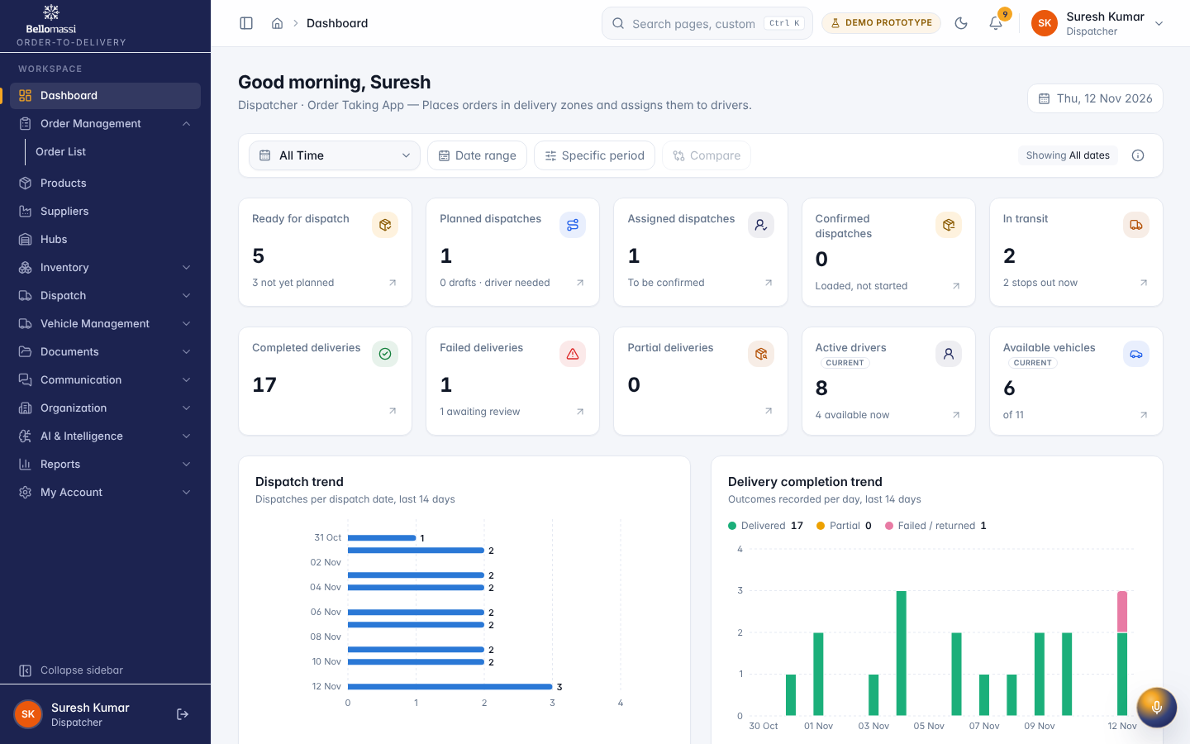
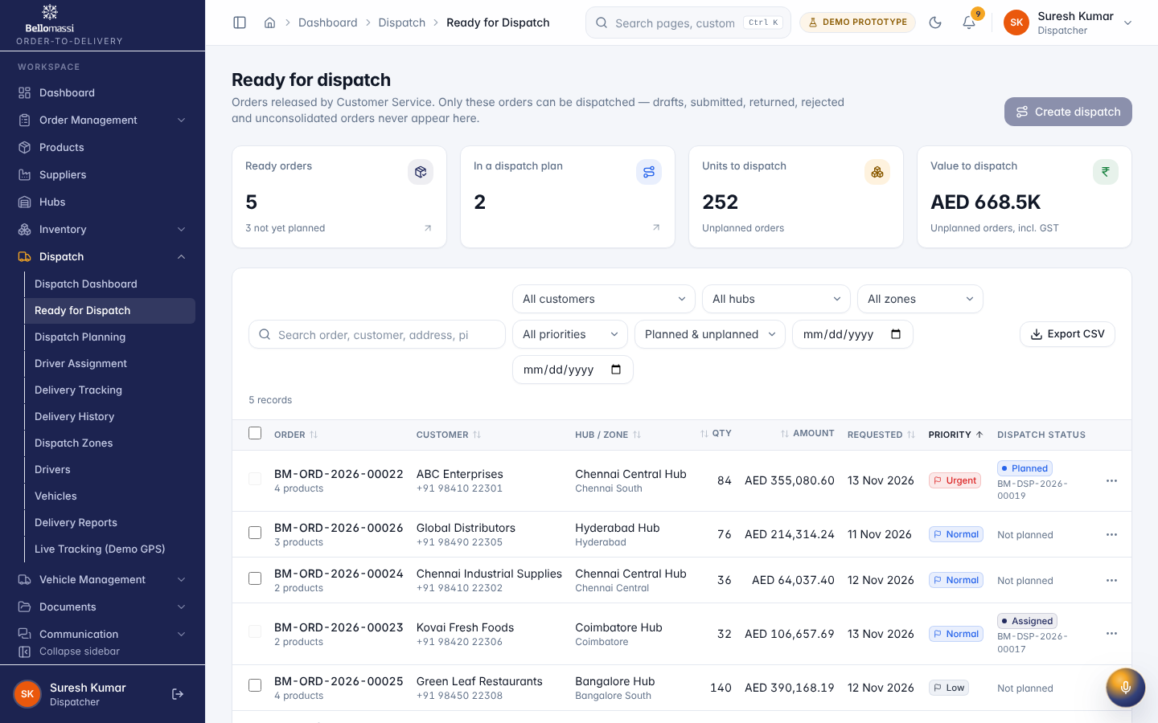
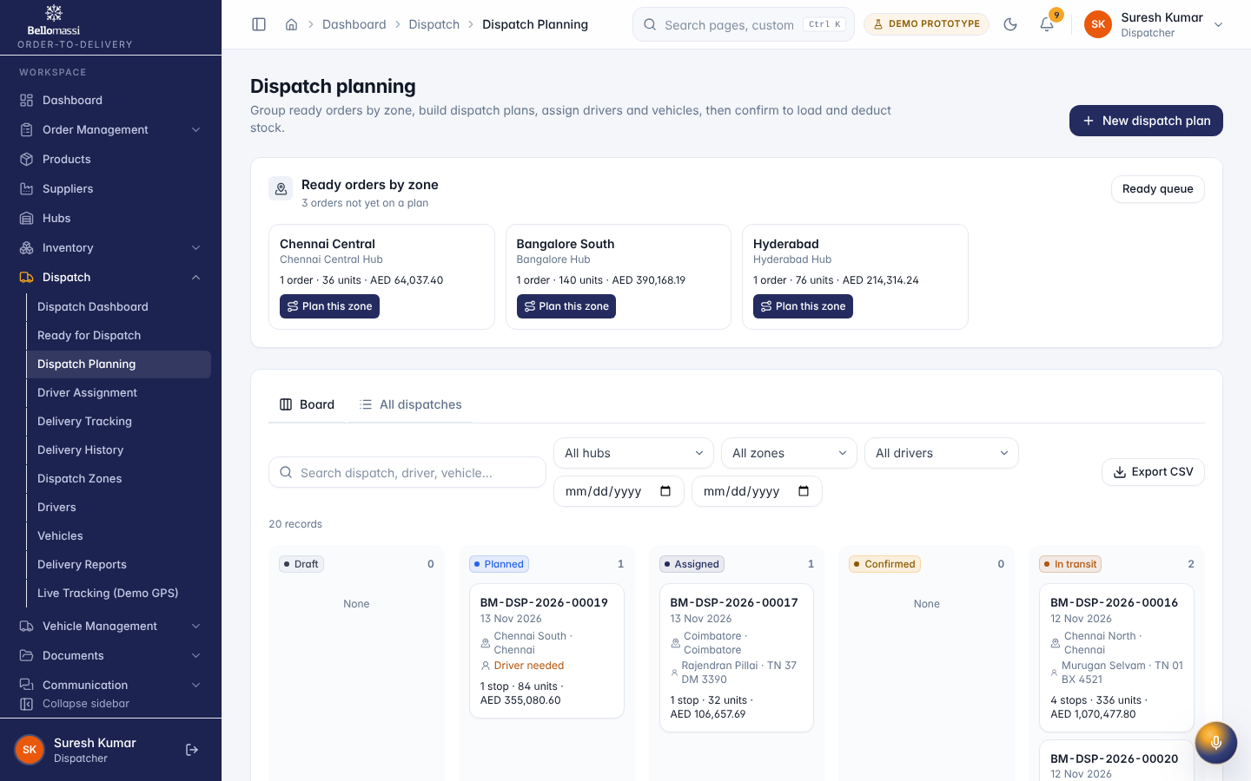
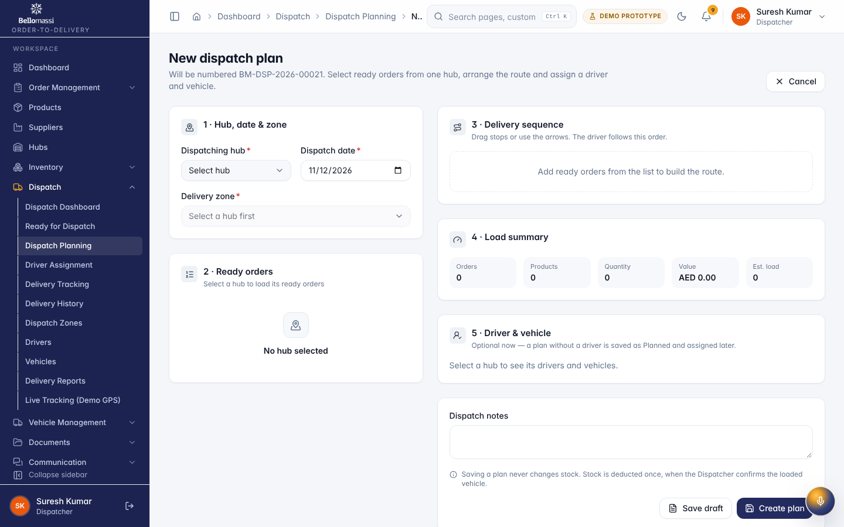
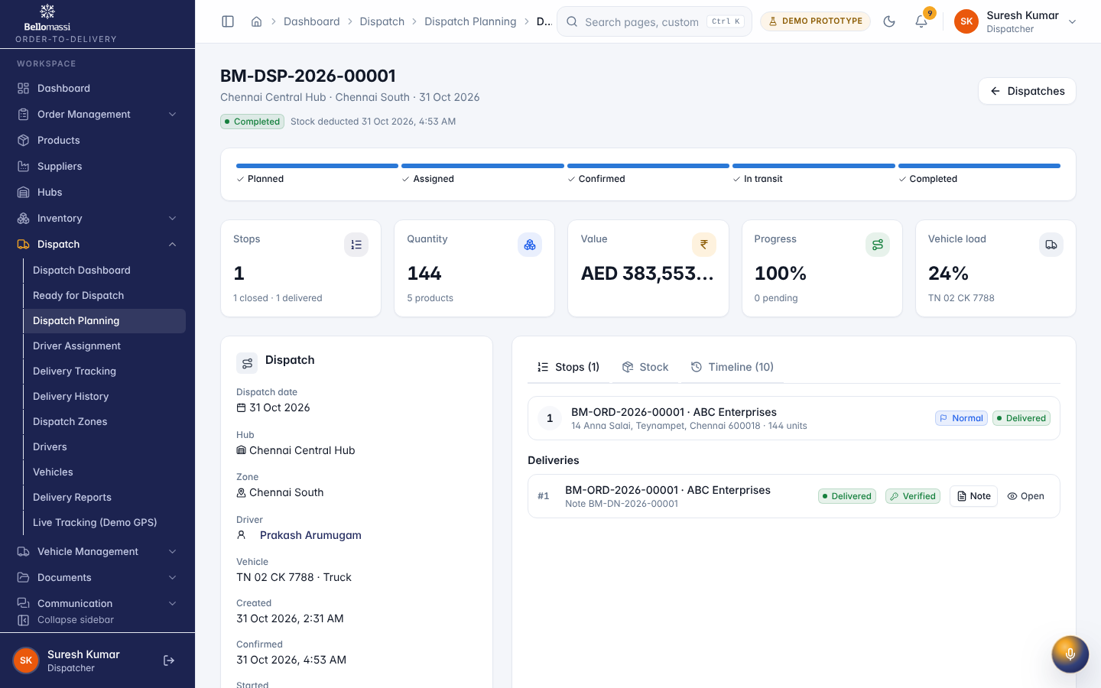
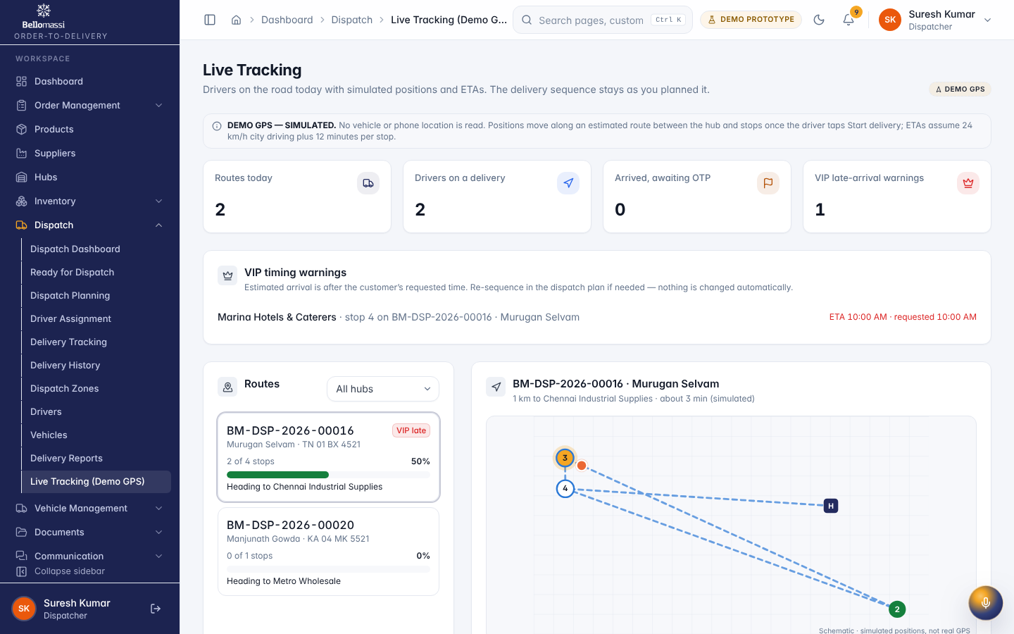
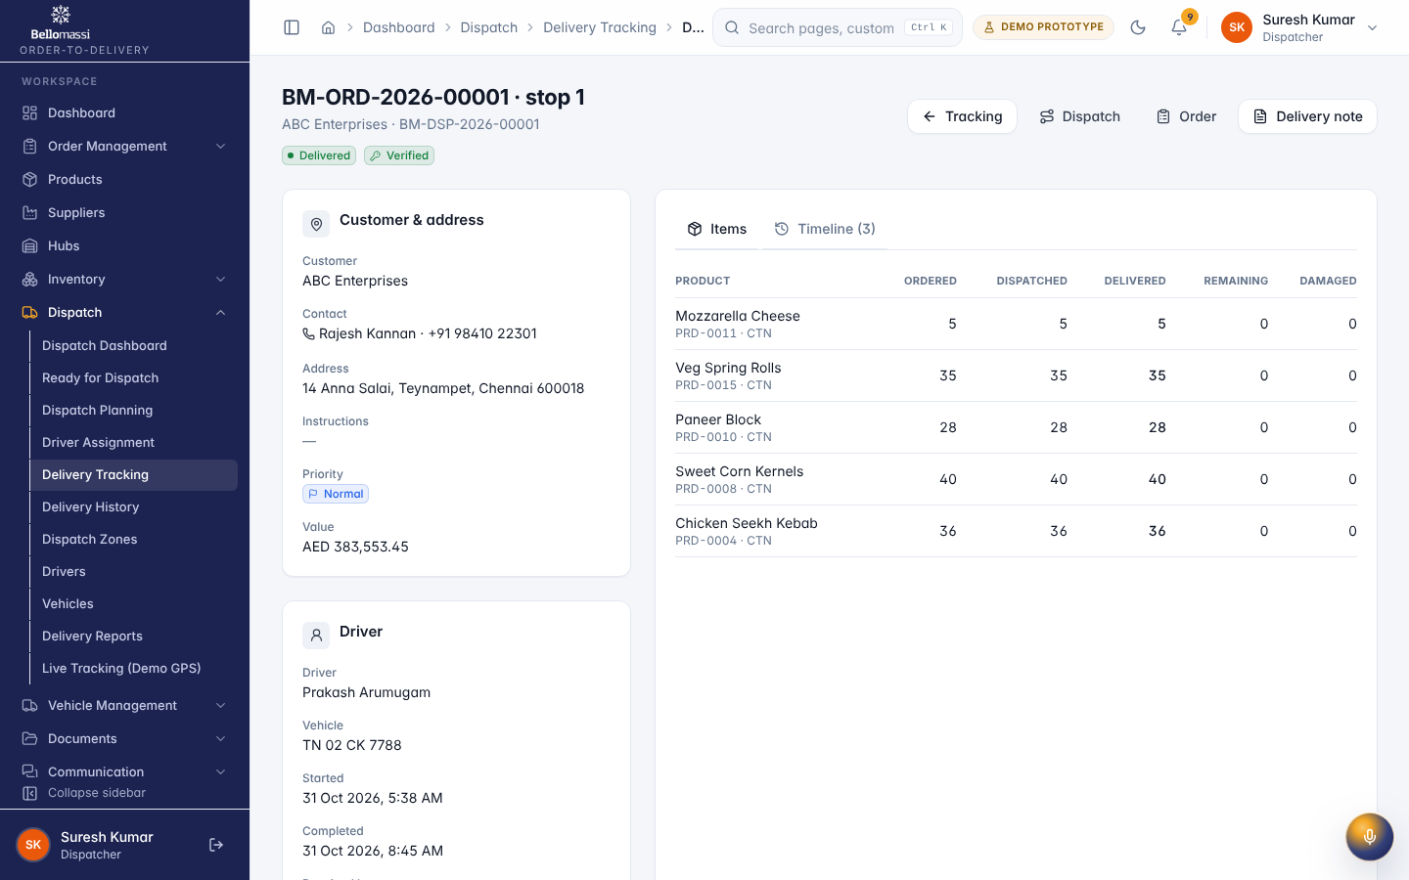

5. Rules to remember
- Approve orders; consolidate; issue invoices; create or edit drivers / vehicles / zones; approve scrap or replenishment
- Work only with the records in your data scope: Orders from consolidation onwards; fleet and hub documents.
- After your step the next responsible user is: Driver; for exceptions, the Dispatcher again.

6. Prototype notes
This manual describes the prototype (PROTOTYPE). Data is stored only in your browser; demo markers show simulated features (GPS, OTP messages, email / WhatsApp). Production behaviour may differ — see BM-OVW-015 (Project Status and Implementation Summary).

Revision history
Version | Date | Author | Description
1.0 | 2026-11-12 | Documentation team | Initial draft prepared from analysis of the bellomassi-premium-ui source code and existing project documents.

