Role User Manual — Driver
Bellomassi Order-to-Delivery Management Platform
BM-MAN-107 · Version 1.0 · Draft — for client review
2026-11-12

Document control
Field | Value
Document title | Role User Manual — Driver
Document ID | BM-MAN-107
Version | 1.0
Status | Draft — for client review
Category | User Manuals
Related module(s) | All modules
Document owner | Training Lead
Prepared by | Project documentation team (AI-assisted draft prepared from source-code analysis)
Reviewed by | Pending — not yet reviewed
Approval | Not approved — awaiting client review (no approval has been given)
Created date | 2026-11-12
Last updated date | 2026-11-12
Status labels used in this document: VERIFIED (confirmed in the current source code or existing documents) · PROTOTYPE (works in the React/LocalStorage prototype with mock or simulated behaviour) · PROPOSED (recommended production design, not built) · PENDING CONFIRMATION (needs a client decision) · NOT IMPLEMENTED · NOT VERIFIED.

Purpose
Explain to a Driver user how to sign in, find their screens and do their daily work in the Bellomassi prototype.

Scope
Role DRIVER with its default permissions (VERIFIED from src/config/permissions.js and navigation.js). An Administrator can change permissions, so menus may differ.

Definitions
Other terms: see BM-GLO-001 (Project Glossary).

References
- Workflow documentation chapter 04 (existing document
- reused)
- BM-UX-005 Screen Specifications
- BM-MAN-003 (Office Web Application User Manual (All Office Roles))
- BM-MAN-120 (Role Responsibility Matrix)
- BM-SEC-005 (RBAC and Access Control Matrix)
- BM-MAN-001 (Driver App User Manual)

1. Your role
Delivers the stops of their confirmed dispatch in sequence and records proof of delivery.
Topic | Details
Purpose | Delivers the stops of their confirmed dispatch in sequence and records proof of delivery.
Login | /driver/login · driver / Driver@123 or mobile +91 98400 11206 (also works on /login) (demo account — PROTOTYPE only; production accounts are issued by the Administrator)
Dashboard | /driver/dashboard (Today) — period filter defaults to Today; Pending / Completed stops, Today / Tomorrow plan (“Published by the Dispatcher”), next stop, driver performance
Menus (bottom bar) | Today, My Deliveries, Route, Completed, My Delivery Notes, Driver Profile, My Documents
Data scope | Own dispatches, deliveries and documents only — another driver’s delivery shows “Access denied”
CRUD | Upload own documents (documents.upload); delivery notes are generated automatically
Approvals | None
Actions | Start delivery → Reach location → Enter OTP & complete (quantities, receiver, photo/signature) → or Report issue / mark failed
Reports | Driver performance on the Today screen only
Notifications | New dispatch assigned, dispatch confirmed (“Start your first delivery when you leave the hub”), sequence updated, removed from dispatch, dispatch cancelled
Cannot do | Start a stop out of sequence, start a future-dated dispatch, start before the Dispatcher confirms, complete without the correct OTP, restart a closed stop, see office modules
Next responsible user | Customer (receives goods), Finance (invoice), Dispatcher (exceptions)
Logout | Driver Profile › Sign Out → /driver/login

2. Getting started
- Open the application address given by your Administrator.
- Sign in with your user name (or mobile number / email) and password. After 5 wrong attempts the account is locked for 15 minutes (default security setting; an Administrator can unlock it).
- You land on your dashboard. Use the menu (sidebar on desktop, bottom bar on phone) to move between screens.
- Use the bell icon for notifications and the profile menu to change your password, preferences or to sign out.

3. Your daily work
The full step-by-step driver procedure is in BM-MAN-001 (Driver App User Manual). In short:
- Start delivery
- Reach location
- Enter OTP & complete (quantities, receiver, photo/signature)
- or Report issue / mark failed

4. Screens you use
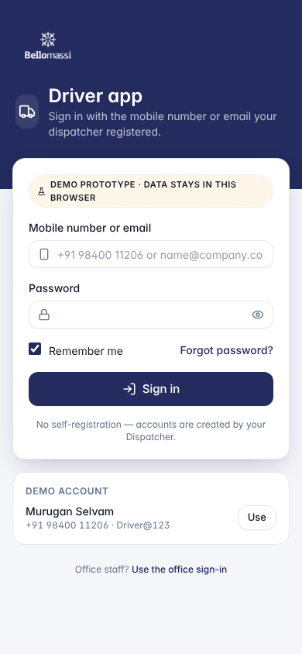
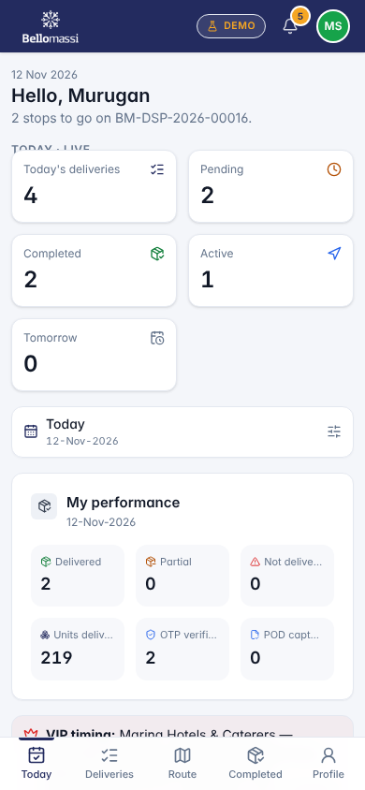
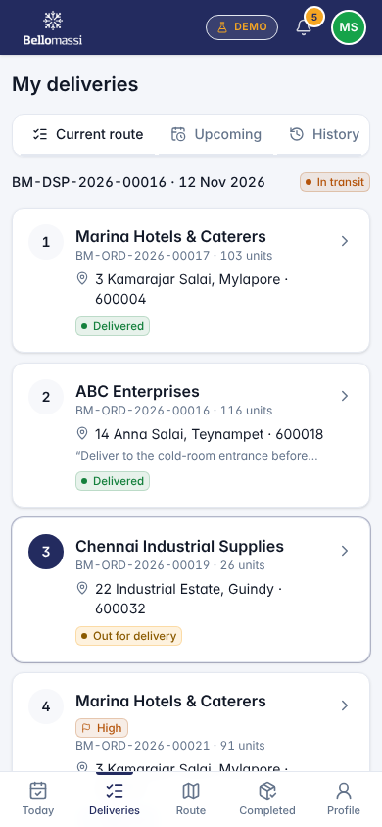
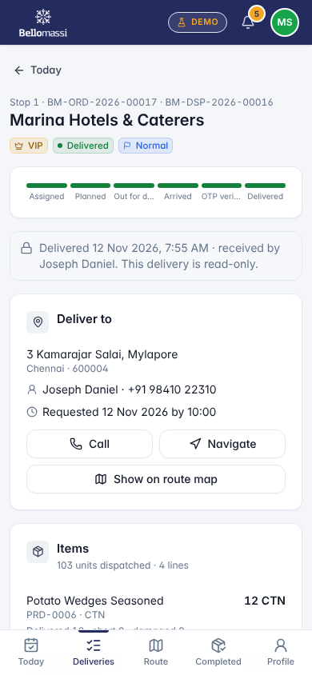
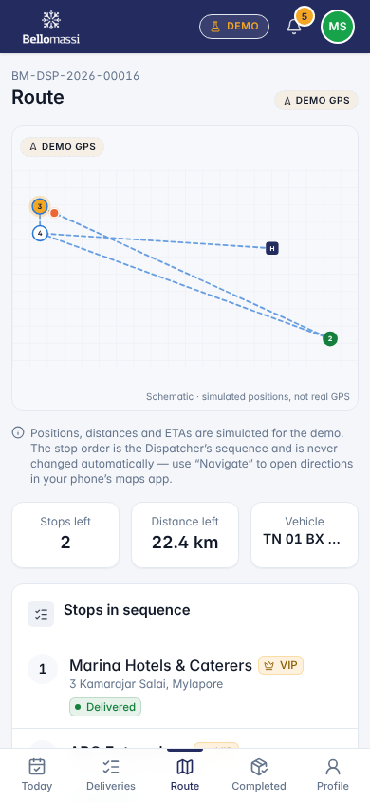
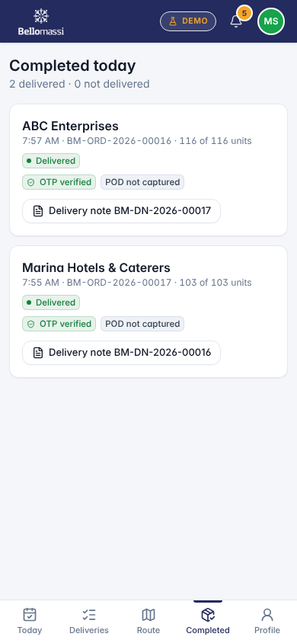

5. Rules to remember
- Start a stop out of sequence, start a future-dated dispatch, start before the Dispatcher confirms, complete without the correct OTP, restart a closed stop, see office modules
- Work only with the records in your data scope: Own dispatches, deliveries and documents only — another driver’s delivery shows “Access denied”.
- After your step the next responsible user is: Customer (receives goods), Finance (invoice), Dispatcher (exceptions).

6. Prototype notes
This manual describes the prototype (PROTOTYPE). Data is stored only in your browser; demo markers show simulated features (GPS, OTP messages, email / WhatsApp). Production behaviour may differ — see BM-OVW-015 (Project Status and Implementation Summary).

Revision history
Version | Date | Author | Description
1.0 | 2026-11-12 | Documentation team | Initial draft prepared from analysis of the bellomassi-premium-ui source code and existing project documents.

