Role User Manual — Finance Executive
Bellomassi Order-to-Delivery Management Platform
BM-MAN-108 · Version 1.0 · Draft — for client review
2026-11-12

Document control
Field | Value
Document title | Role User Manual — Finance Executive
Document ID | BM-MAN-108
Version | 1.0
Status | Draft — for client review
Category | User Manuals
Related module(s) | All modules
Document owner | Training Lead
Prepared by | Project documentation team (AI-assisted draft prepared from source-code analysis)
Reviewed by | Pending — not yet reviewed
Approval | Not approved — awaiting client review (no approval has been given)
Created date | 2026-11-12
Last updated date | 2026-11-12
Status labels used in this document: VERIFIED (confirmed in the current source code or existing documents) · PROTOTYPE (works in the React/LocalStorage prototype with mock or simulated behaviour) · PROPOSED (recommended production design, not built) · PENDING CONFIRMATION (needs a client decision) · NOT IMPLEMENTED · NOT VERIFIED.

Purpose
Explain to a Finance Executive user how to sign in, find their screens and do their daily work in the Bellomassi prototype.

Scope
Role FINANCE with its default permissions (VERIFIED from src/config/permissions.js and navigation.js). An Administrator can change permissions, so menus may differ.

Definitions
Other terms: see BM-GLO-001 (Project Glossary).

References
- Workflow documentation chapter 04 (existing document
- reused)
- BM-UX-005 Screen Specifications
- BM-MAN-003 (Office Web Application User Manual (All Office Roles))
- BM-MAN-120 (Role Responsibility Matrix)
- BM-SEC-005 (RBAC and Access Control Matrix)

1. Your role
Issues and cancels customer invoices, manages invoice templates and numbering, watches credit exposure.
Topic | Details
Purpose | Issues and cancels customer invoices, manages invoice templates and numbering, watches credit exposure.
Login | /login · finance / Finance@123 (demo account — PROTOTYPE only; production accounts are issued by the Administrator)
Dashboard | FinanceDashboard: Order value (submitted), Approved order value, Delivered to invoice, Invoices issued, Collections, Outstanding (customer balances), Credit exposure, Credit utilisation, Over credit limit, Order value overview
Menus | Order List, Order Reports · Customer Credit · Products, Suppliers · Inventory Dashboard, Stock Overview · Dispatch: Dispatch Dashboard, Dispatch Planning, Delivery History, Delivery Reports · Documents (5) · Invoices: Invoice Dashboard, Invoices, New Invoice, Invoice Templates, Invoice Reports · Communication: Center, Email, WhatsApp · AI: AI Overview, Assistant, Jarvis, Forecasting, Predictive Inventory, Replenishment, AI Insights, Model Management · Reports Center
Data scope | All non-draft orders; invoices, customers, vendor documents
CRUD | Invoices (issue, cancel), invoice templates, invoice numbering settings; email invoice (demo)
Approvals | None in the order flow; replenishment approval is not granted to Finance by default
Reports | Finance, Sales, Dispatch & Delivery, Inventory, Procurement, Supplier, AI
Notifications | Invoice generated; purchase approval information
Cannot do | Record payments, credit notes or refunds (Not Implemented); change a customer’s credit balance (Customer master is Administrator only); approve orders
Next responsible user | Customer (receives invoice)
Logout | /logout → /login

2. Getting started
- Open the application address given by your Administrator.
- Sign in with your user name (or mobile number / email) and password. After 5 wrong attempts the account is locked for 15 minutes (default security setting; an Administrator can unlock it).
- You land on your dashboard. Use the menu (sidebar on desktop, bottom bar on phone) to move between screens.
- Use the bell icon for notifications and the profile menu to change your password, preferences or to sign out.

3. Your daily work
- Invoice Dashboard
- New Invoice for delivered / approved orders
- print or email
- review outstanding and credit utilisation
- reports

4. Screens you use
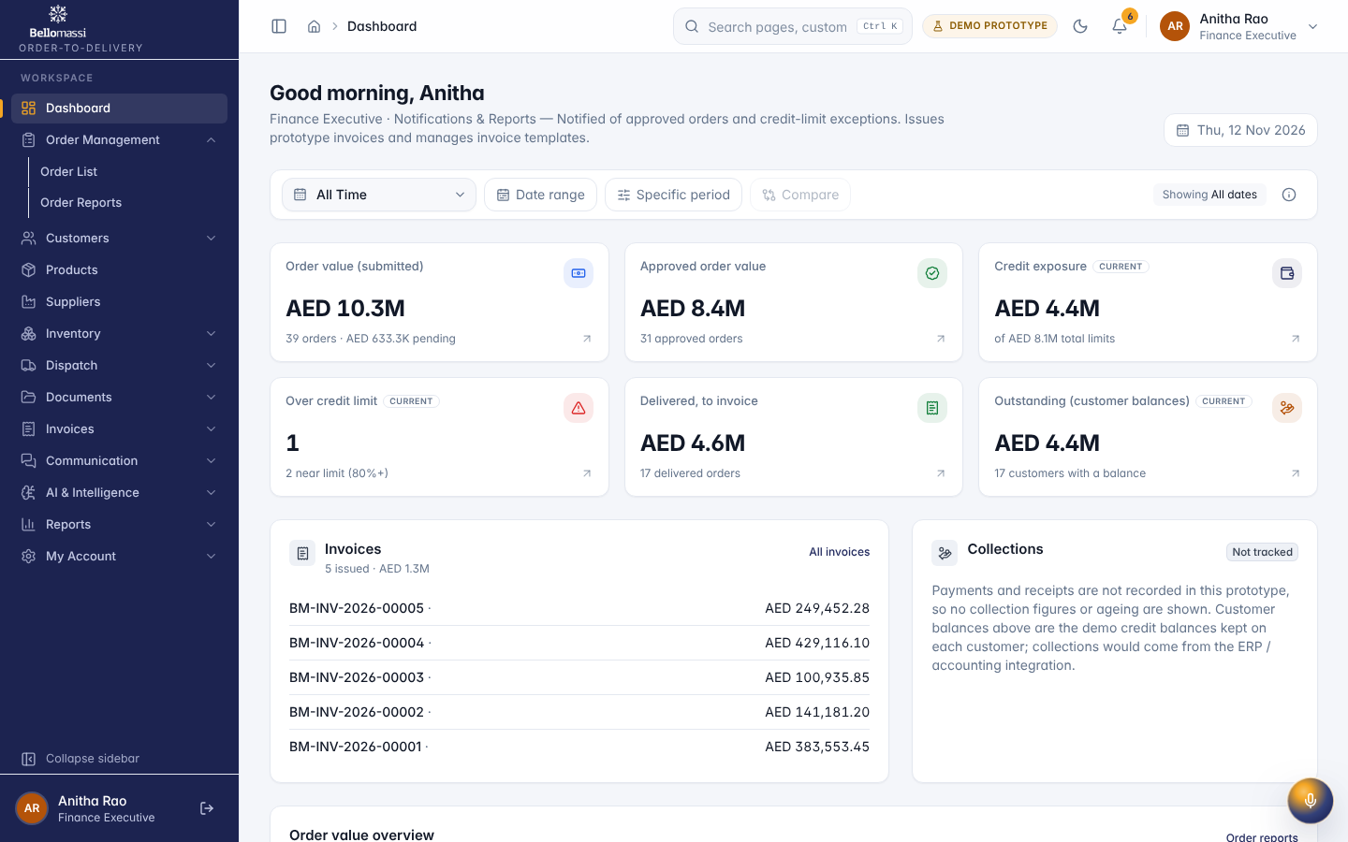
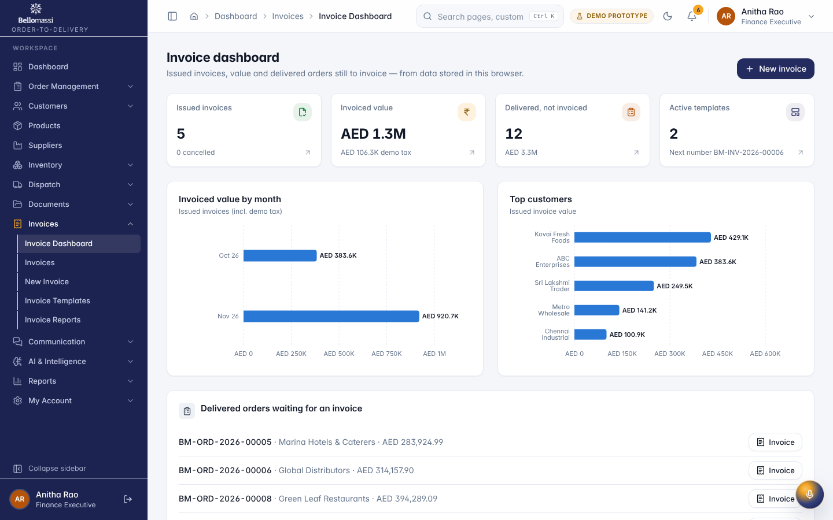
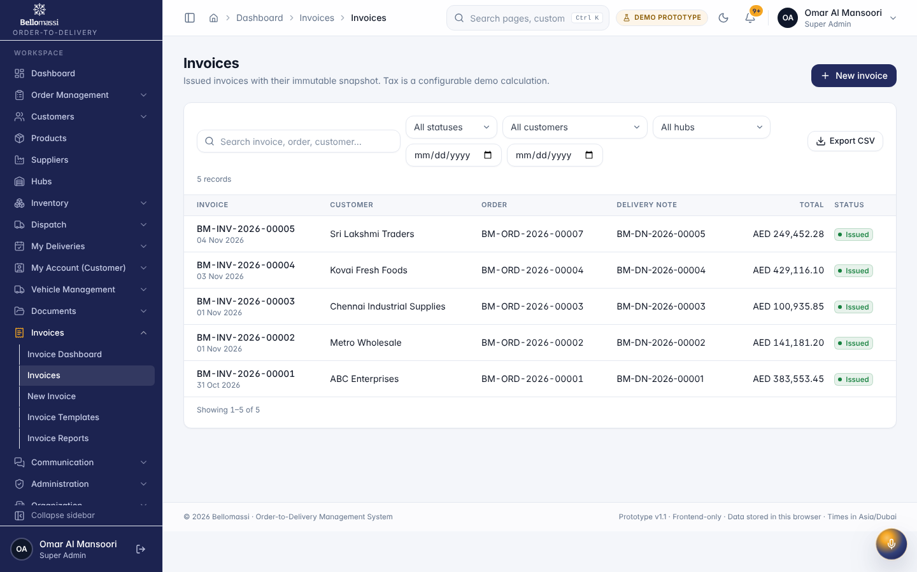

5. Rules to remember
- Record payments, credit notes or refunds (Not Implemented); change a customer’s credit balance (Customer master is Administrator only); approve orders
- Work only with the records in your data scope: All non-draft orders; invoices, customers, vendor documents.
- After your step the next responsible user is: Customer (receives invoice).

6. Prototype notes
This manual describes the prototype (PROTOTYPE). Data is stored only in your browser; demo markers show simulated features (GPS, OTP messages, email / WhatsApp). Production behaviour may differ — see BM-OVW-015 (Project Status and Implementation Summary).

Revision history
Version | Date | Author | Description
1.0 | 2026-11-12 | Documentation team | Initial draft prepared from analysis of the bellomassi-premium-ui source code and existing project documents.

