Role User Manual — Warehouse Manager
Bellomassi Order-to-Delivery Management Platform
BM-MAN-109 · Version 1.0 · Draft — for client review
2026-11-12

Document control
Field | Value
Document title | Role User Manual — Warehouse Manager
Document ID | BM-MAN-109
Version | 1.0
Status | Draft — for client review
Category | User Manuals
Related module(s) | All modules
Document owner | Training Lead
Prepared by | Project documentation team (AI-assisted draft prepared from source-code analysis)
Reviewed by | Pending — not yet reviewed
Approval | Not approved — awaiting client review (no approval has been given)
Created date | 2026-11-12
Last updated date | 2026-11-12
Status labels used in this document: VERIFIED (confirmed in the current source code or existing documents) · PROTOTYPE (works in the React/LocalStorage prototype with mock or simulated behaviour) · PROPOSED (recommended production design, not built) · PENDING CONFIRMATION (needs a client decision) · NOT IMPLEMENTED · NOT VERIFIED.

Purpose
Explain to a Warehouse Manager user how to sign in, find their screens and do their daily work in the Bellomassi prototype.

Scope
Role WAREHOUSE_MANAGER with its default permissions (VERIFIED from src/config/permissions.js and navigation.js). An Administrator can change permissions, so menus may differ.

Definitions
Other terms: see BM-GLO-001 (Project Glossary).

References
- Workflow documentation chapter 04 (existing document
- reused)
- BM-UX-005 Screen Specifications
- BM-MAN-003 (Office Web Application User Manual (All Office Roles))
- BM-MAN-120 (Role Responsibility Matrix)
- BM-SEC-005 (RBAC and Access Control Matrix)

1. Your role
Owns hub stock: receipts, transfers, adjustments, scrap approval, picking & loading view, document expiry.
Topic | Details
Purpose | Owns hub stock: receipts, transfers, adjustments, scrap approval, picking & loading view, document expiry.
Login | /login · warehouse / Warehouse@123 (demo account — PROTOTYPE only; production accounts are issued by the Administrator)
Dashboard | WarehouseDashboard: Stock value, Low / out of stock, Damaged / held, Expiry, Inventory alerts, Picking & loading (consolidated and ready orders at the hub), Current stock (lowest available first), vehicle & driver documents expired or due
Menus | Order List · Products, Suppliers, Hubs · Inventory: all 10 pages incl. Warehouse Dashboard and QA & Cold Chain · Dispatch: Dashboard, Ready for Dispatch, Dispatch Planning, Delivery History · Documents (5) · AI: Overview, Assistant, Jarvis, Forecasting, Predictive Inventory, Replenishment, AI Insights, Model Management · Reports Center
CRUD | Stock receipts, transfers, adjustments, min/max/reorder levels, scrap requests, replenishment drafts
Approvals | Scrap requests (approve / reject / post write-off) — not their own requests
Reports | Inventory, Procurement, Scrap, Dispatch & Delivery history, Supplier, AI
Notifications | Low stock alert, scrap requests pending approval, purchase approval information
Cannot do | Approve orders; dispatch; approve replenishment (Administrator only); manage products or hubs master data
Next responsible user | Dispatcher (stock ready for loading); Administrator (replenishment approval)
Logout | /logout → /login

2. Getting started
- Open the application address given by your Administrator.
- Sign in with your user name (or mobile number / email) and password. After 5 wrong attempts the account is locked for 15 minutes (default security setting; an Administrator can unlock it).
- You land on your dashboard. Use the menu (sidebar on desktop, bottom bar on phone) to move between screens.
- Use the bell icon for notifications and the profile menu to change your password, preferences or to sign out.

3. Your daily work
- Inventory alerts
- receive goods (Stock Receipt, incl. replenishment receipts)
- transfers between hubs
- approve scrap
- check picking list for today’s dispatches

4. Screens you use
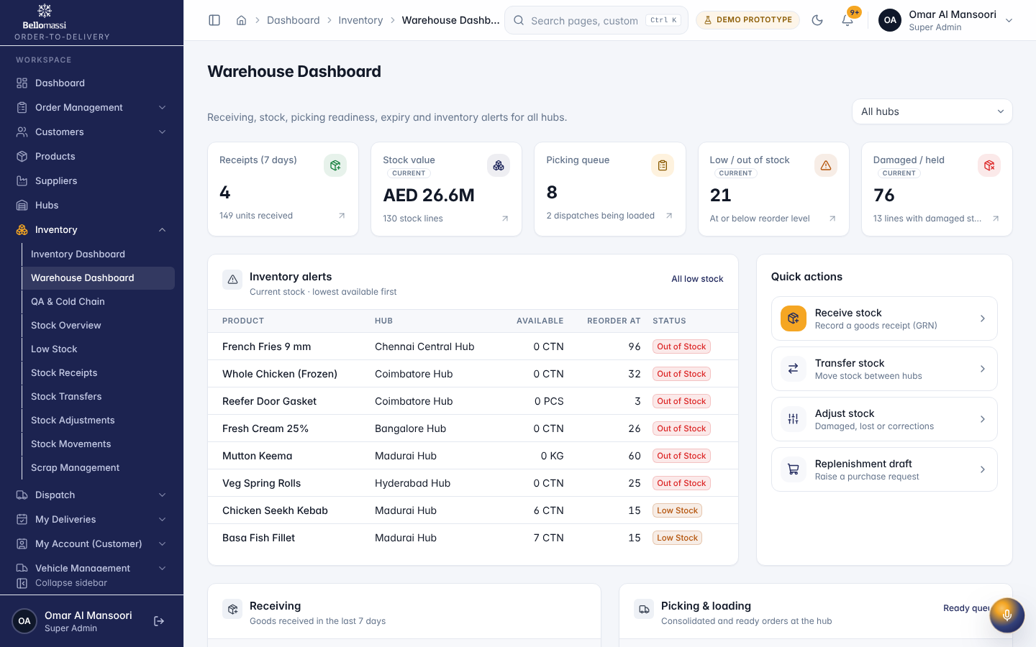
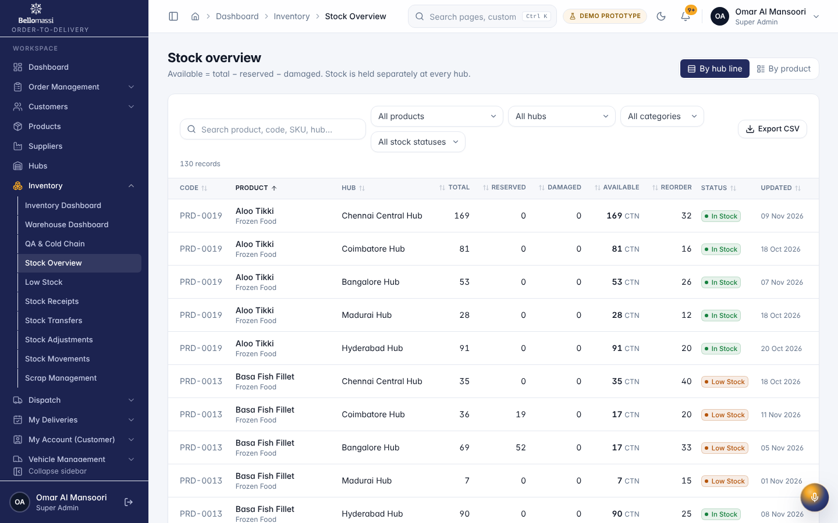
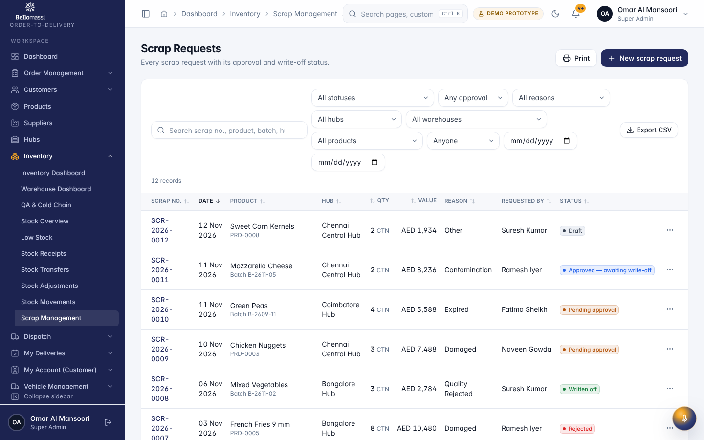

5. Rules to remember
- Approve orders; dispatch; approve replenishment (Administrator only); manage products or hubs master data
- Work only with the records in your data scope: as configured.
- After your step the next responsible user is: Dispatcher (stock ready for loading); Administrator (replenishment approval).

6. Prototype notes
This manual describes the prototype (PROTOTYPE). Data is stored only in your browser; demo markers show simulated features (GPS, OTP messages, email / WhatsApp). Production behaviour may differ — see BM-OVW-015 (Project Status and Implementation Summary).

Revision history
Version | Date | Author | Description
1.0 | 2026-11-12 | Documentation team | Initial draft prepared from analysis of the bellomassi-premium-ui source code and existing project documents.

