System Administration Guide
Bellomassi Order-to-Delivery Management Platform
BM-ADM-001 · Version 1.0 · Draft — for client review
2026-11-12

Document control
Field | Value
Document title | System Administration Guide
Document ID | BM-ADM-001
Version | 1.0
Status | Draft — for client review
Category | Administration and Configuration
Related module(s) | All modules
Document owner | System Administrator
Prepared by | Project documentation team (AI-assisted draft prepared from source-code analysis)
Reviewed by | Pending — not yet reviewed
Approval | Not approved — awaiting client review (no approval has been given)
Created date | 2026-11-12
Last updated date | 2026-11-12
Status labels used in this document: VERIFIED (confirmed in the current source code or existing documents) · PROTOTYPE (works in the React/LocalStorage prototype with mock or simulated behaviour) · PROPOSED (recommended production design, not built) · PENDING CONFIRMATION (needs a client decision) · NOT IMPLEMENTED · NOT VERIFIED.

Purpose
Explain how administrators manage users, roles, permissions, organisation data and audit logs.

Scope
Administration features of the prototype (VERIFIED). Production differences are marked PROPOSED.

Definitions
Other terms: see BM-GLO-001 (Project Glossary).

References
- docs/RBAC_AND_ADMINISTRATION.md (existing document, reused)
- BM-ADM-002 (Application Configuration Reference)
- BM-ADM-003 (Master Data Management Guide)
- BM-ADM-004 (Monitoring and Maintenance Guide)
- BM-MAN-101 (Role User Manual — Super Admin)
- BM-MAN-102 (Role User Manual — Administrator)
- BM-SEC-004 (Authorization and RBAC Design)
- BM-SEC-005 (RBAC and Access Control Matrix)

1. Administrator roles
Role | Can do | Cannot do
Super Admin | Everything, including Super Admin accounts and locked system roles | Delete / deactivate own account
Administrator | Users, roles (non-locked), settings, master data, organisation, templates | Manage Super Admin accounts

2. User management (/admin/users)
Task | Steps
Create user | Users → Create → name, email, user name, phone, role, hub, department / designation; link to driver / customer / supplier record when needed → Save. First password is set and must be changed at first sign-in (setting)
Edit / change role | Open user → Edit → change role or additional roles → Save (audit logged)
Deactivate / activate | Row action → Deactivate (user cannot sign in)
Unlock | Row action → Unlock (after lockout)
Reset password | Row action → Reset password → new temporary password; force change at next sign-in
Role assignment | /admin/role-assignment — bulk view of users per role
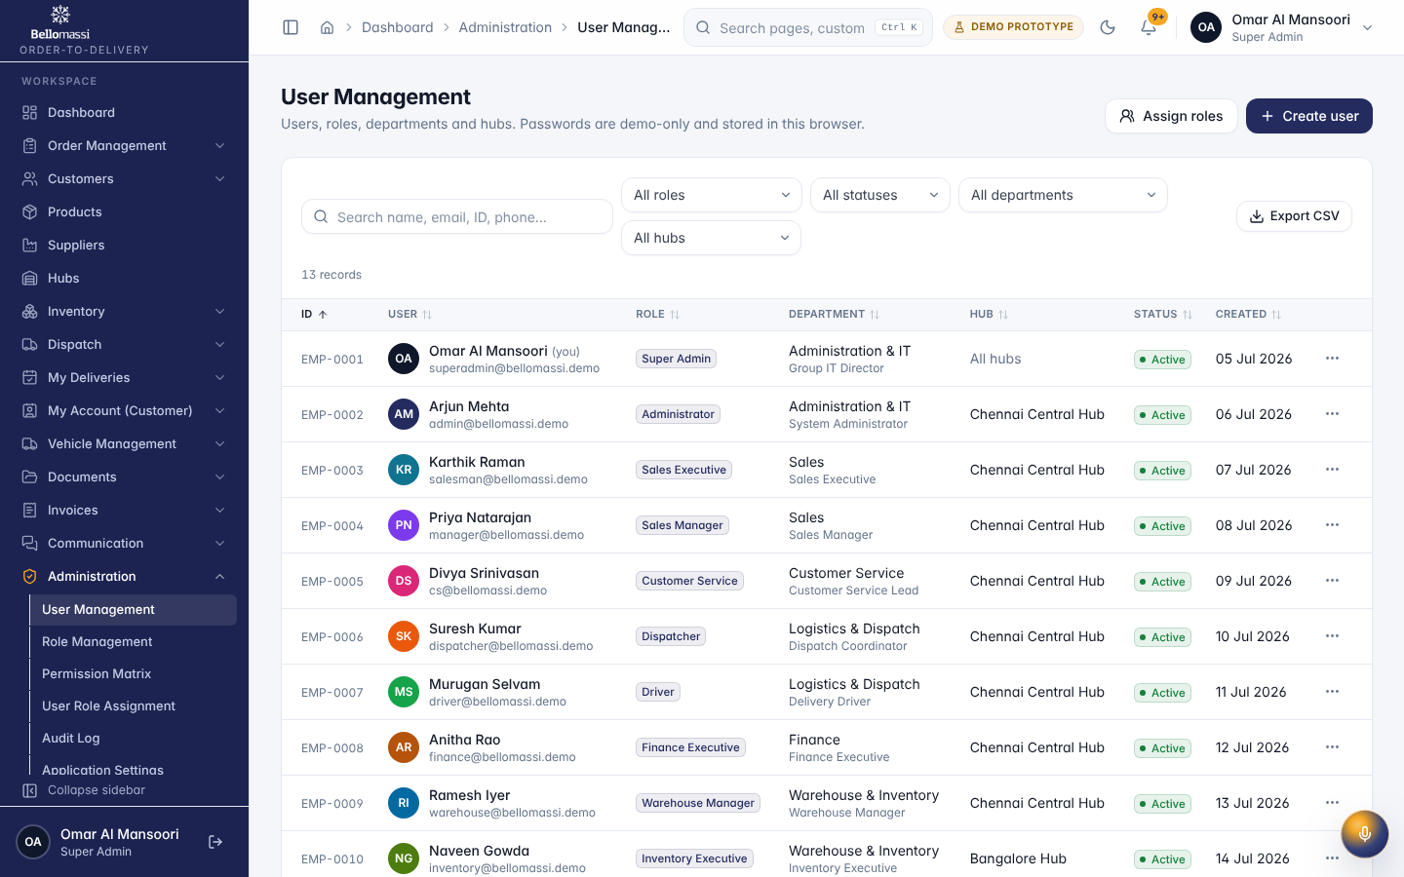

3. Roles and permissions (/admin/roles, /admin/permissions)
- Create role: name, description, data scope, landing page, permission keys (grouped by module).
- Edit role: system roles can be edited except locked keys; Super Admin role is locked.
- Permission matrix: role × permission grid; changes apply at the user’s next page load.
- Custom roles get the workspace launcher dashboard.
Default grants: BM-SEC-005 (RBAC and Access Control Matrix). Production: roles and permissions enforced on the server (PROPOSED, BM-SEC-004 (Authorization and RBAC Design)).

4. Organisation set-up (/admin/organization/*)
Company profile, branches, business units, departments, designations, warehouses and employees. Company profile holds country, base currency, time zone and tax registration — used by formatters and documents.

5. Audit log (/admin/audit-logs)
Every create / update / delete, sign-in, failed sign-in, lockout, permission change and setting change is written with user, time, entity and description. Filter by user, module, action and date; export CSV. In the prototype the log is kept in the browser (VERIFIED); production keeps it in the database with retention (BM-SEC-008 (Audit Logging and Security Monitoring Policy)).

6. Daily / weekly admin checklist
Frequency | Check
Daily | Locked accounts, failed sign-ins, notifications for document expiry
Weekly | Users without sign-in for 30 days; drivers / vehicles with expiring documents (VMS)
Monthly | Role and permission review; leavers deactivated
On change | Settings changes recorded with reason

Revision history
Version | Date | Author | Description
1.0 | 2026-11-12 | Documentation team | Initial draft prepared from analysis of the bellomassi-premium-ui source code and existing project documents.

