Diagram Catalogue and Visual Documentation
Bellomassi Order-to-Delivery Management Platform
BM-DGM-001 · Version 1.0 · Draft — for client review
2026-11-12

Document control
Field | Value
Document title | Diagram Catalogue and Visual Documentation
Document ID | BM-DGM-001
Version | 1.0
Status | Draft — for client review
Category | Diagrams and Visual Documentation
Related module(s) | All modules
Document owner | Solution Architect
Prepared by | Project documentation team (AI-assisted draft prepared from source-code analysis)
Reviewed by | Pending — not yet reviewed
Approval | Not approved — awaiting client review (no approval has been given)
Created date | 2026-11-12
Last updated date | 2026-11-12
Status labels used in this document: VERIFIED (confirmed in the current source code or existing documents) · PROTOTYPE (works in the React/LocalStorage prototype with mock or simulated behaviour) · PROPOSED (recommended production design, not built) · PENDING CONFIRMATION (needs a client decision) · NOT IMPLEMENTED · NOT VERIFIED.

Purpose
Provide all required architecture, process, data and operations diagrams in one place with editable sources.

Scope
23 diagrams (system architecture, business process, workflows, lifecycle, roles, RBAC, ER, data flow, deployment, network, authentication, integration, CI/CD, backup and recovery).

Definitions
Other terms: see BM-GLO-001 (Project Glossary).

References
- BM-ARC-003 (Architecture Diagrams)
- BM-ARC-001 (High-Level Design (HLD))
- BM-WF-00 (Business Workflow Catalogue)

Contents

  - Catalogue

  - Editing
- DGM-01 — Overall System Architecture (prototype and target)
- DGM-02 — Business Process Architecture
- DGM-03 — Order-to-Delivery Flowchart
- DGM-04 — Order Status Lifecycle
- DGM-05 — Approval Workflow
- DGM-06 — Dispatch Workflow
- DGM-07 — Driver Delivery Workflow
- DGM-08 — Customer Order Workflow
- DGM-09 — Role Interaction Diagram
- DGM-10 — RBAC Diagram
- DGM-11 — ER Diagram (overview)
- DGM-12 — Data Flow Diagram
- DGM-13 — Deployment Architecture
- DGM-14 — Network Architecture
- DGM-15 — Authentication Flow (production)
- DGM-16 — Integration Architecture
- DGM-17 — CI/CD Pipeline
- DGM-18 — Backup and Recovery Architecture
- DGM-19 — System Context Diagram
- DGM-20 — Component Diagram (prototype)
- DGM-21 — Driver Delivery Architecture (production)
- DGM-22 — Customer Application Architecture
- DGM-23 — Order Processing Architecture

1. Catalogue
Editable sources are Mermaid (.mmd) files; previews are exported as SVG and PNG in this folder. Diagrams never show a production component as existing: labels state VERIFIED (prototype) or PROPOSED (target).
ID | Diagram | Label | Files | Source
DGM-01 | Overall System Architecture (prototype and target) | VERIFIED (prototype) / PROPOSED (target) | mermaid/DGM-01_Overall_System_Architecture_prototype_and_target.mmd · svg/DGM-01_Overall_System_Architecture_prototype_and_target.svg · png/DGM-01_Overall_System_Architecture_prototype_and_target.png | this catalogue
DGM-02 | Business Process Architecture | VERIFIED | mermaid/DGM-02_Business_Process_Architecture.mmd · svg/DGM-02_Business_Process_Architecture.svg · png/DGM-02_Business_Process_Architecture.png | this catalogue
DGM-03 | Order-to-Delivery Flowchart | VERIFIED | mermaid/DGM-03_Order_to_Delivery_Flowchart.mmd · svg/DGM-03_Order_to_Delivery_Flowchart.svg · png/DGM-03_Order_to_Delivery_Flowchart.png | docs/workflow chapter 06
DGM-04 | Order Status Lifecycle | VERIFIED | mermaid/DGM-04_Order_Status_Lifecycle.mmd · svg/DGM-04_Order_Status_Lifecycle.svg · png/DGM-04_Order_Status_Lifecycle.png | docs/workflow chapter 17
DGM-05 | Approval Workflow | VERIFIED | mermaid/DGM-05_Approval_Workflow.mmd · svg/DGM-05_Approval_Workflow.svg · png/DGM-05_Approval_Workflow.png | docs/workflow chapter 07
DGM-06 | Dispatch Workflow | VERIFIED | mermaid/DGM-06_Dispatch_Workflow.mmd · svg/DGM-06_Dispatch_Workflow.svg · png/DGM-06_Dispatch_Workflow.png | docs/workflow chapter 11
DGM-07 | Driver Delivery Workflow | VERIFIED (GPS / OTP delivery simulated) | mermaid/DGM-07_Driver_Delivery_Workflow.mmd · svg/DGM-07_Driver_Delivery_Workflow.svg · png/DGM-07_Driver_Delivery_Workflow.png | docs/workflow chapter 08
DGM-08 | Customer Order Workflow | VERIFIED (customer app scope PENDING CONFIRMATION) | mermaid/DGM-08_Customer_Order_Workflow.mmd · svg/DGM-08_Customer_Order_Workflow.svg · png/DGM-08_Customer_Order_Workflow.png | docs/workflow chapter 09
DGM-09 | Role Interaction Diagram | VERIFIED | mermaid/DGM-09_Role_Interaction_Diagram.mmd · svg/DGM-09_Role_Interaction_Diagram.svg · png/DGM-09_Role_Interaction_Diagram.png | docs/workflow chapter 04
DGM-10 | RBAC Diagram | VERIFIED (prototype) / PROPOSED (server enforcement) | mermaid/DGM-10_RBAC_Diagram.mmd · svg/DGM-10_RBAC_Diagram.svg · png/DGM-10_RBAC_Diagram.png | this catalogue
DGM-11 | ER Diagram (overview) | PROPOSED | mermaid/DGM-11_ER_Diagram_overview.mmd · svg/DGM-11_ER_Diagram_overview.svg · png/DGM-11_ER_Diagram_overview.png | this catalogue
DGM-12 | Data Flow Diagram | PROPOSED | mermaid/DGM-12_Data_Flow_Diagram.mmd · svg/DGM-12_Data_Flow_Diagram.svg · png/DGM-12_Data_Flow_Diagram.png | this catalogue
DGM-13 | Deployment Architecture | PROPOSED | mermaid/DGM-13_Deployment_Architecture.mmd · svg/DGM-13_Deployment_Architecture.svg · png/DGM-13_Deployment_Architecture.png | this catalogue
DGM-14 | Network Architecture | PROPOSED | mermaid/DGM-14_Network_Architecture.mmd · svg/DGM-14_Network_Architecture.svg · png/DGM-14_Network_Architecture.png | this catalogue
DGM-15 | Authentication Flow (production) | PROPOSED | mermaid/DGM-15_Authentication_Flow_production.mmd · svg/DGM-15_Authentication_Flow_production.svg · png/DGM-15_Authentication_Flow_production.png | this catalogue
DGM-16 | Integration Architecture | PROPOSED | mermaid/DGM-16_Integration_Architecture.mmd · svg/DGM-16_Integration_Architecture.svg · png/DGM-16_Integration_Architecture.png | this catalogue
DGM-17 | CI/CD Pipeline | PROPOSED | mermaid/DGM-17_CI_CD_Pipeline.mmd · svg/DGM-17_CI_CD_Pipeline.svg · png/DGM-17_CI_CD_Pipeline.png | this catalogue
DGM-18 | Backup and Recovery Architecture | PROPOSED | mermaid/DGM-18_Backup_and_Recovery_Architecture.mmd · svg/DGM-18_Backup_and_Recovery_Architecture.svg · png/DGM-18_Backup_and_Recovery_Architecture.png | this catalogue
DGM-19 | System Context Diagram | VERIFIED (actors) / PROPOSED (external systems) | mermaid/DGM-19_System_Context_Diagram.mmd · svg/DGM-19_System_Context_Diagram.svg · png/DGM-19_System_Context_Diagram.png | this catalogue
DGM-20 | Component Diagram (prototype) | VERIFIED | mermaid/DGM-20_Component_Diagram_prototype.mmd · svg/DGM-20_Component_Diagram_prototype.svg · png/DGM-20_Component_Diagram_prototype.png | this catalogue
DGM-21 | Driver Delivery Architecture (production) | PROPOSED | mermaid/DGM-21_Driver_Delivery_Architecture_production.mmd · svg/DGM-21_Driver_Delivery_Architecture_production.svg · png/DGM-21_Driver_Delivery_Architecture_production.png | this catalogue
DGM-22 | Customer Application Architecture | VERIFIED (prototype) / PROPOSED (production) | mermaid/DGM-22_Customer_Application_Architecture.mmd · svg/DGM-22_Customer_Application_Architecture.svg · png/DGM-22_Customer_Application_Architecture.png | this catalogue
DGM-23 | Order Processing Architecture | VERIFIED (logic) / PROPOSED (server) | mermaid/DGM-23_Order_Processing_Architecture.mmd · svg/DGM-23_Order_Processing_Architecture.svg · png/DGM-23_Order_Processing_Architecture.png | this catalogue

2. Editing
Edit the .mmd file and re-render with Mermaid CLI: mmdc -i mermaid/<file>.mmd -o svg/<file>.svg. The workflow diagrams (DGM-03 … DGM-09) are maintained in docs/workflow/ and copied here.

DGM-01 — Overall System Architecture (prototype and target)
Label: VERIFIED (prototype) / PROPOSED (target)
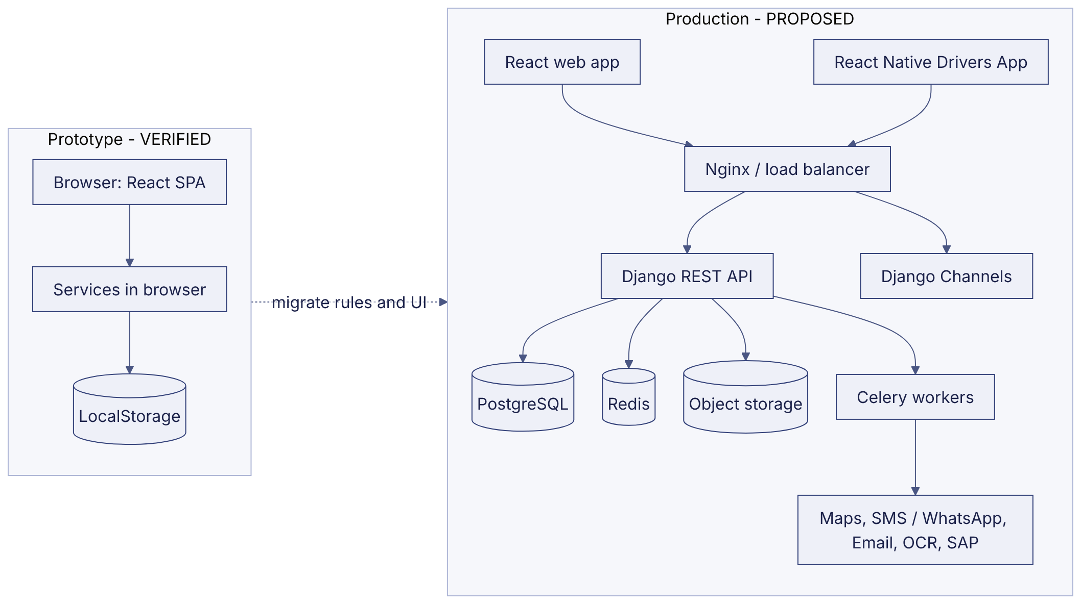

DGM-02 — Business Process Architecture
Label: VERIFIED
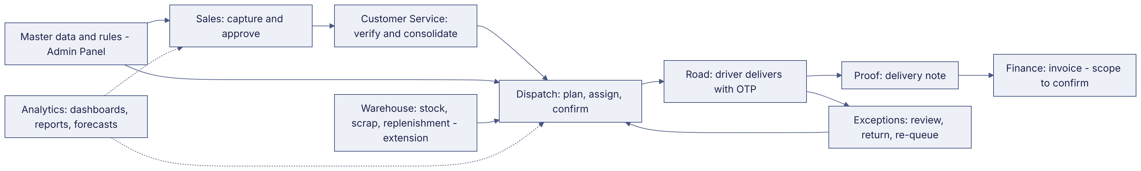

DGM-03 — Order-to-Delivery Flowchart
Label: VERIFIED
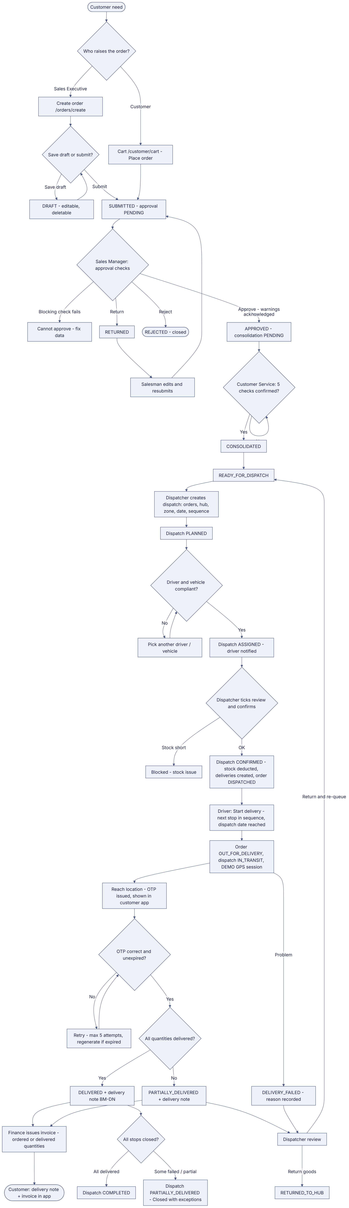

DGM-04 — Order Status Lifecycle
Label: VERIFIED
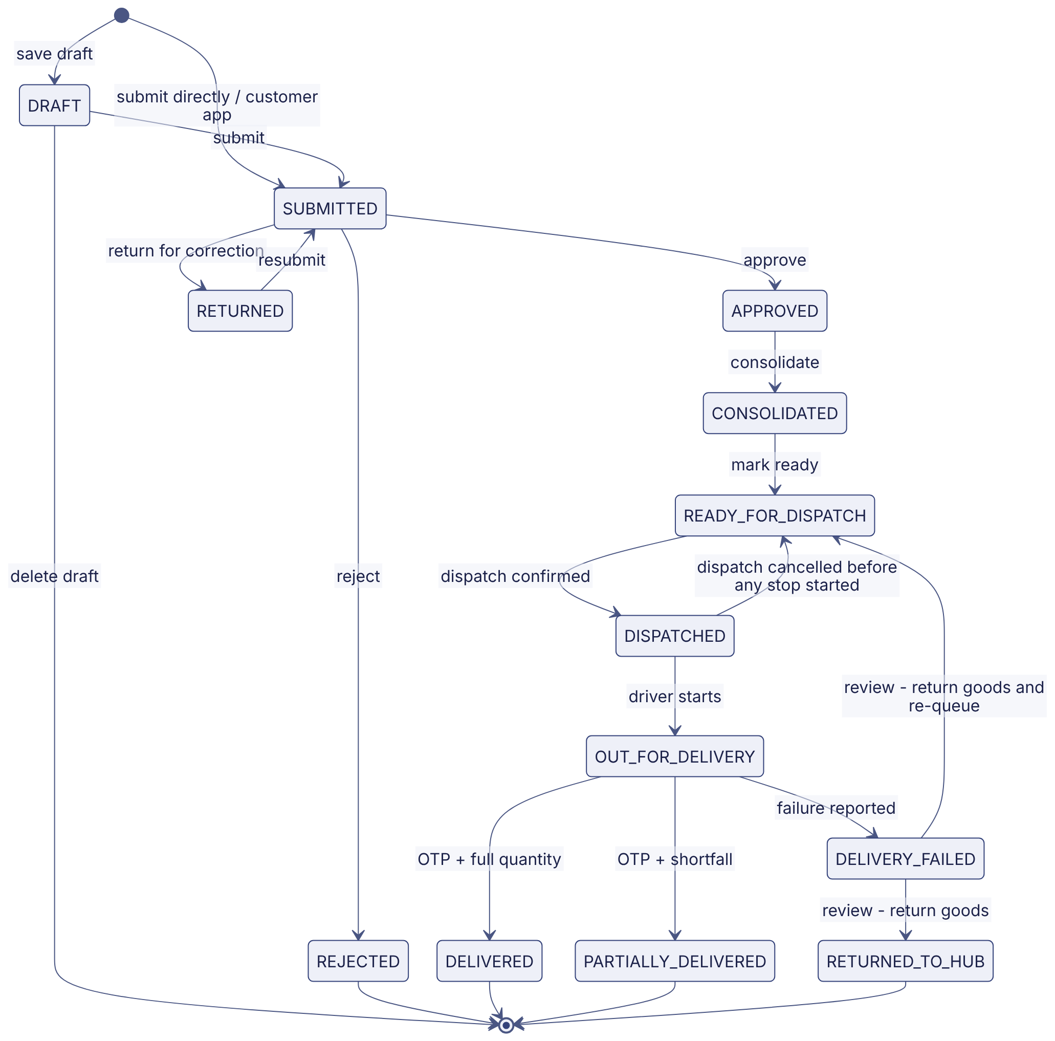

DGM-05 — Approval Workflow
Label: VERIFIED
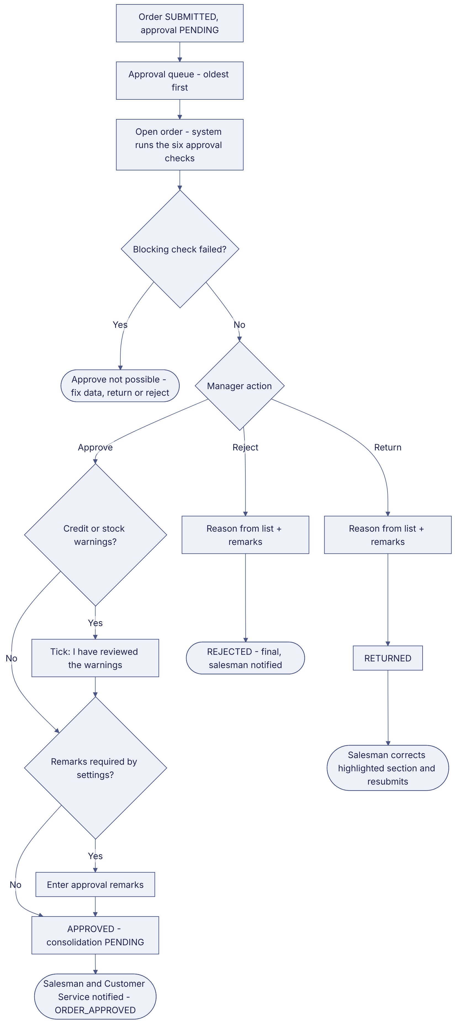

DGM-06 — Dispatch Workflow
Label: VERIFIED
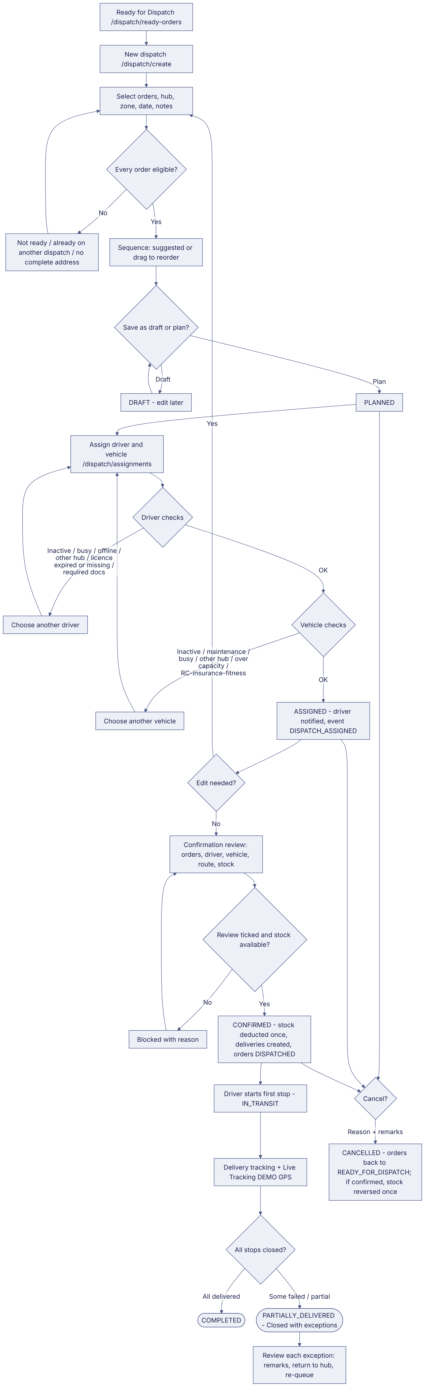

DGM-07 — Driver Delivery Workflow
Label: VERIFIED (GPS / OTP delivery simulated)
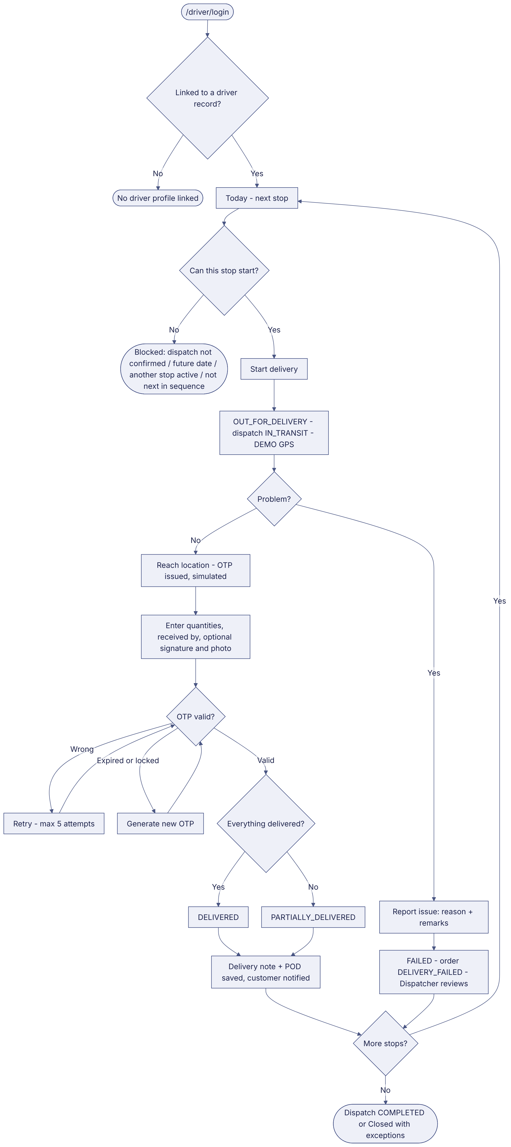

DGM-08 — Customer Order Workflow
Label: VERIFIED (customer app scope PENDING CONFIRMATION)
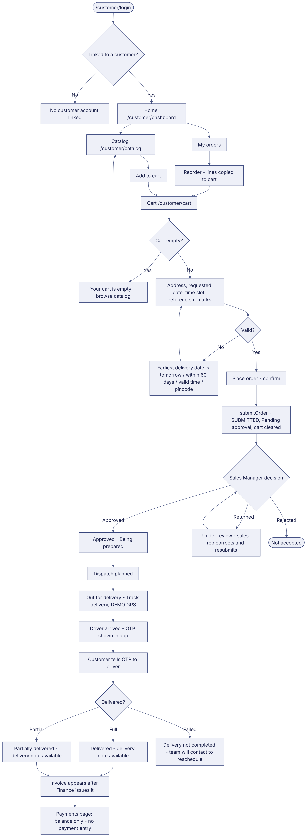

DGM-09 — Role Interaction Diagram
Label: VERIFIED
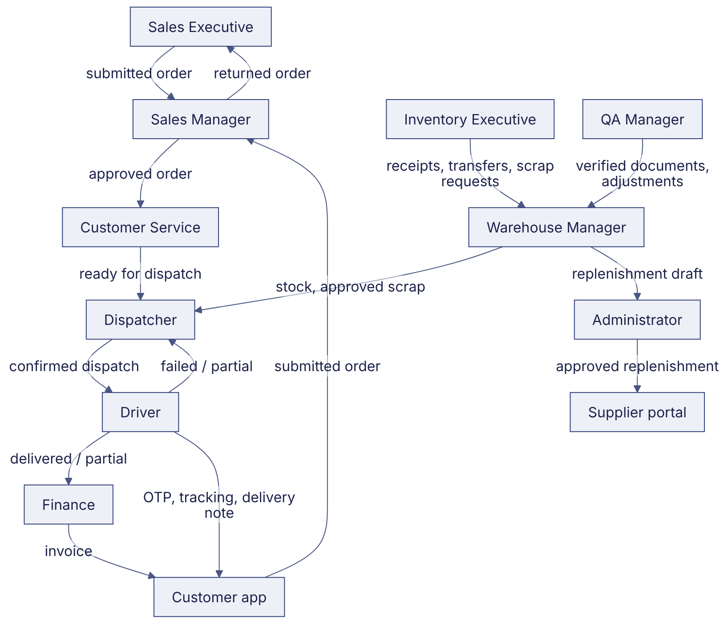

DGM-10 — RBAC Diagram
Label: VERIFIED (prototype) / PROPOSED (server enforcement)
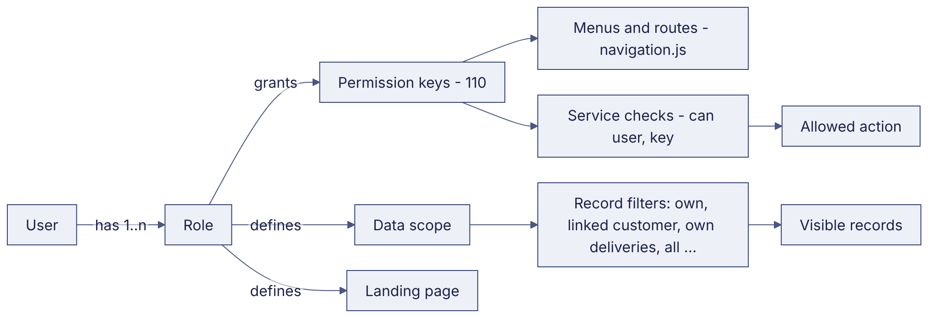

DGM-11 — ER Diagram (overview)
Label: PROPOSED
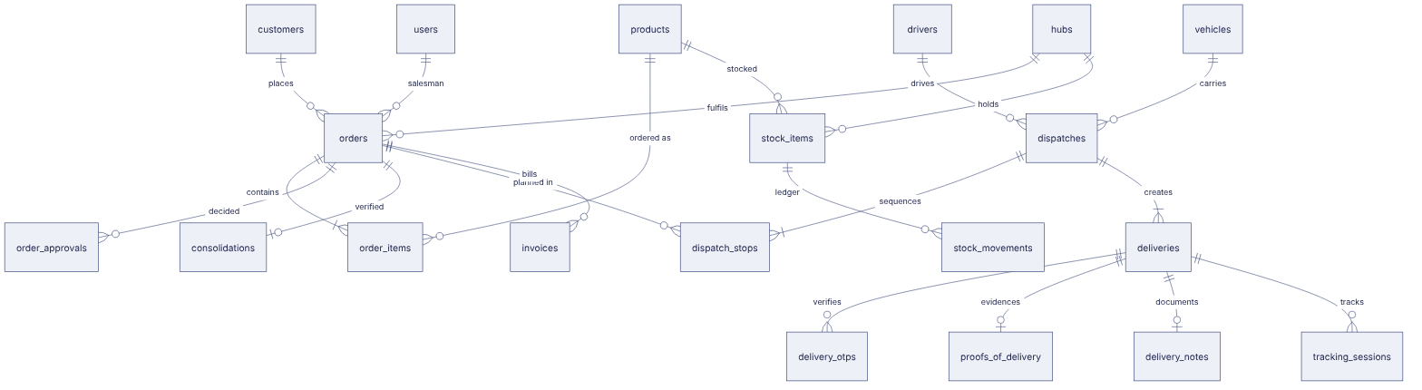

DGM-12 — Data Flow Diagram
Label: PROPOSED
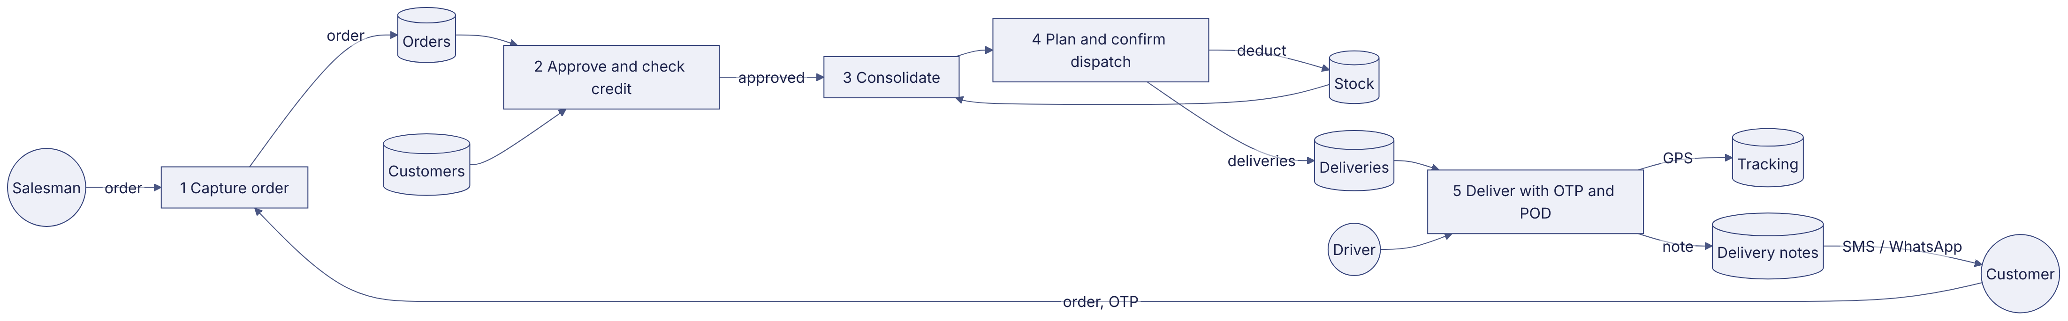

DGM-13 — Deployment Architecture
Label: PROPOSED
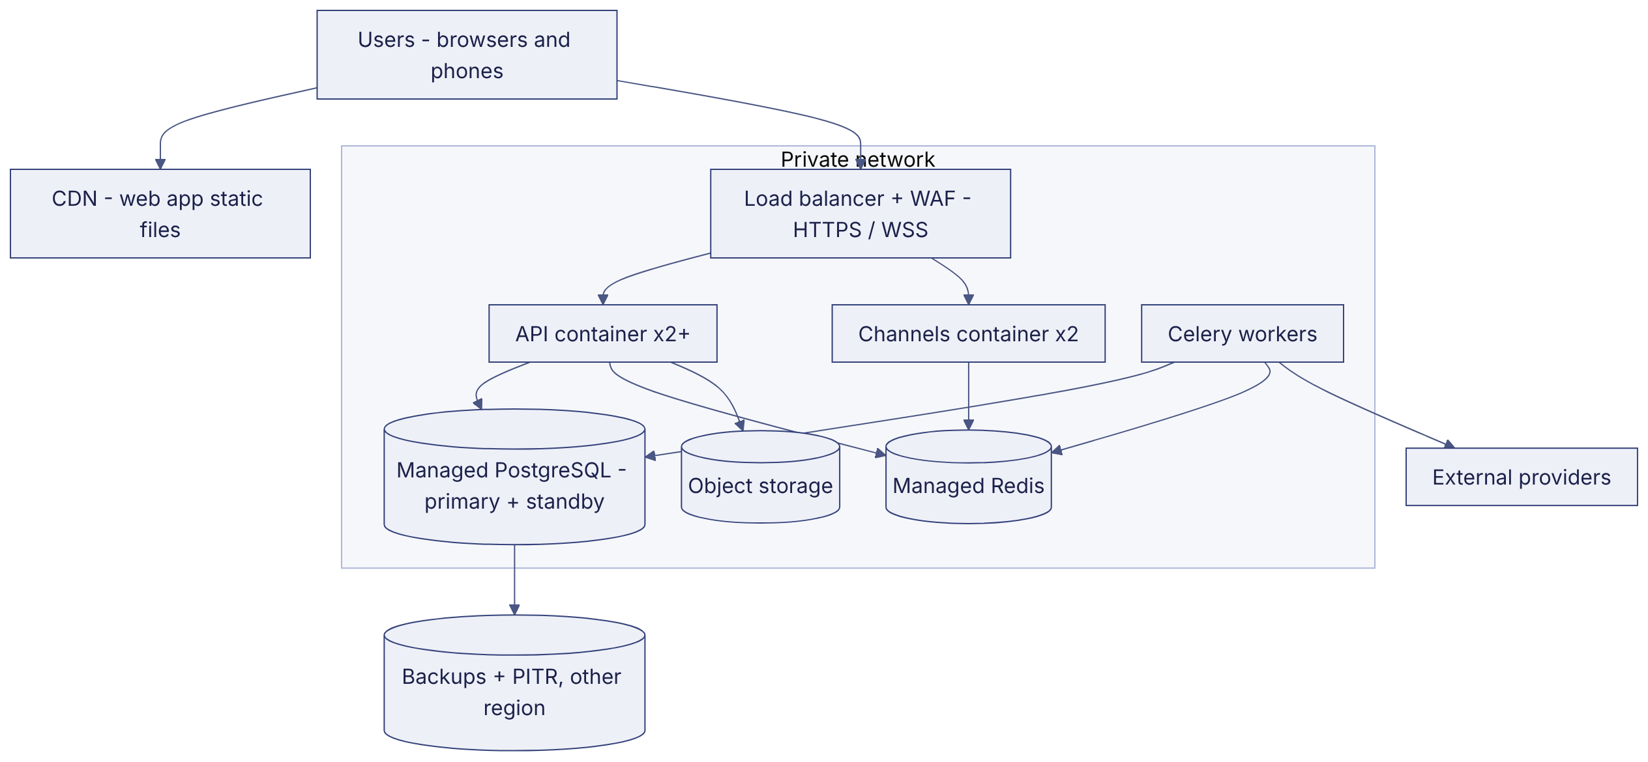

DGM-14 — Network Architecture
Label: PROPOSED
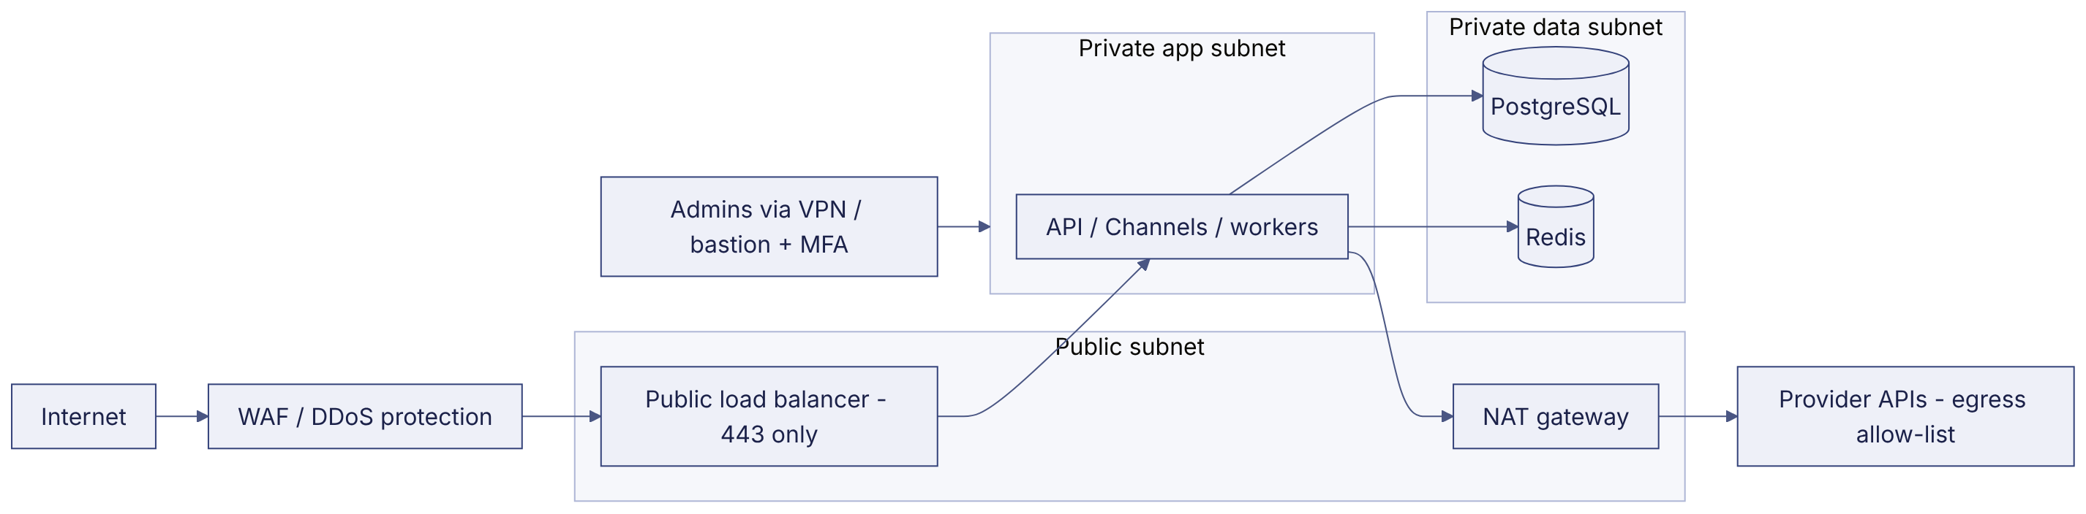

DGM-15 — Authentication Flow (production)
Label: PROPOSED
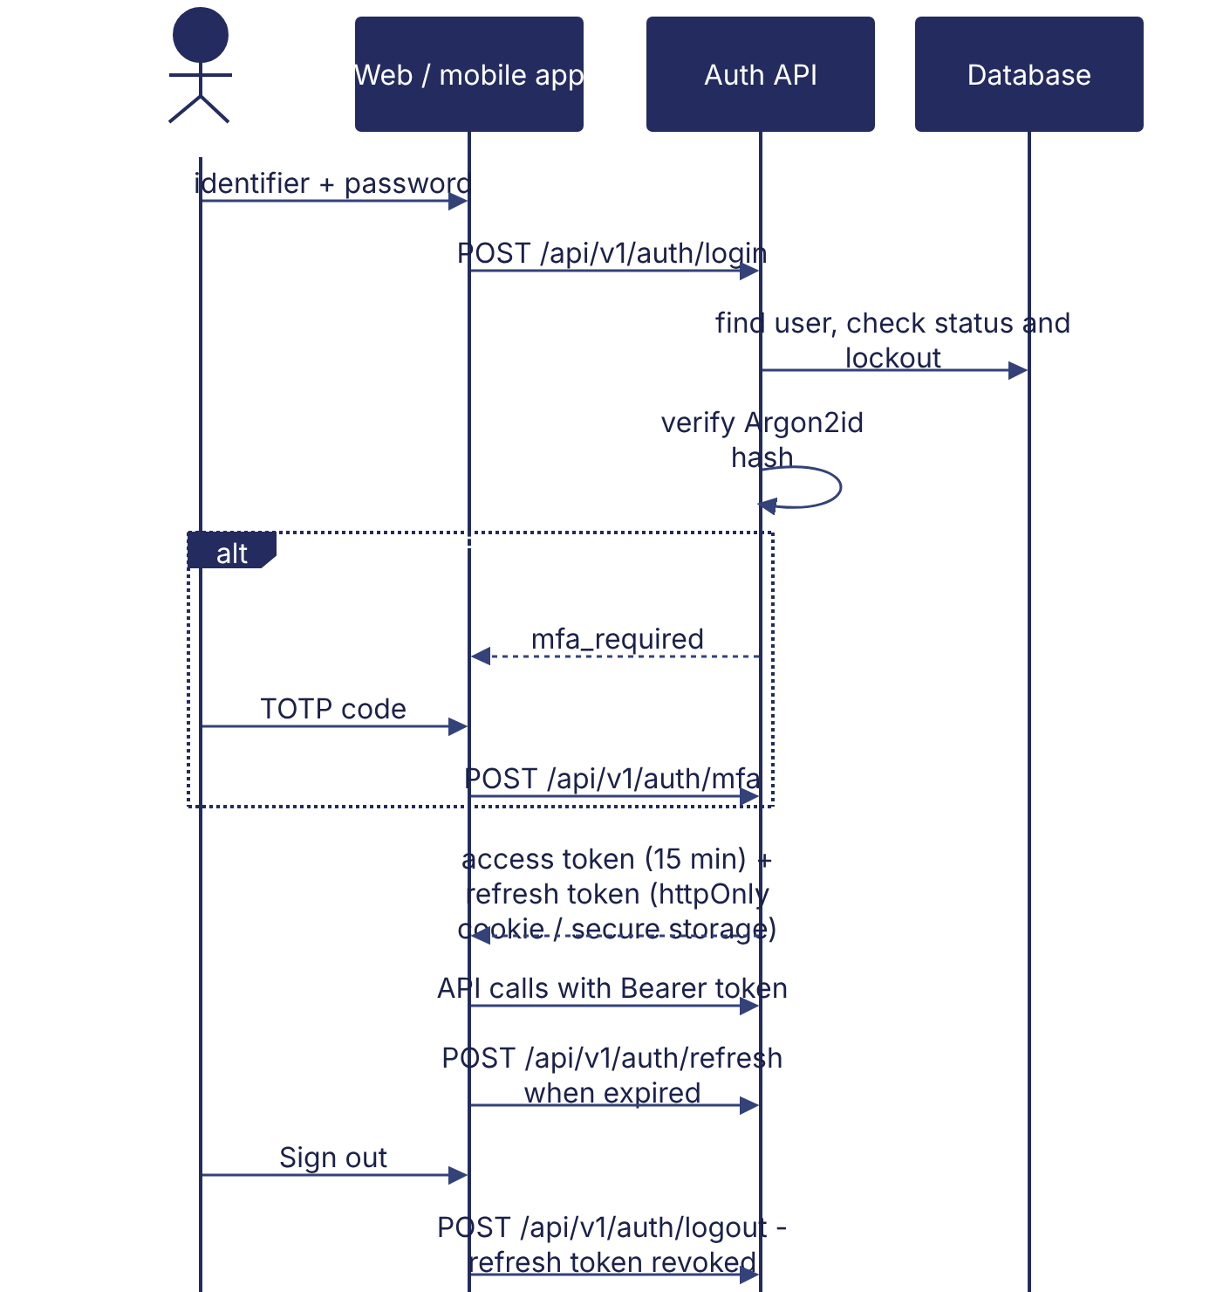

DGM-16 — Integration Architecture
Label: PROPOSED
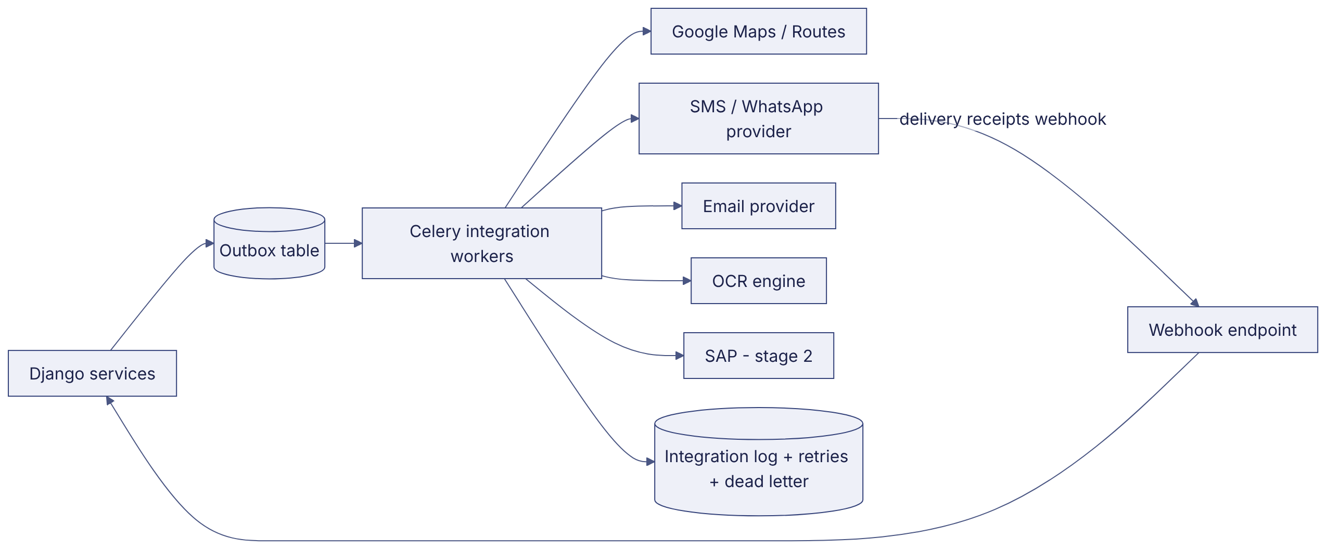

DGM-17 — CI/CD Pipeline
Label: PROPOSED

DGM-18 — Backup and Recovery Architecture
Label: PROPOSED
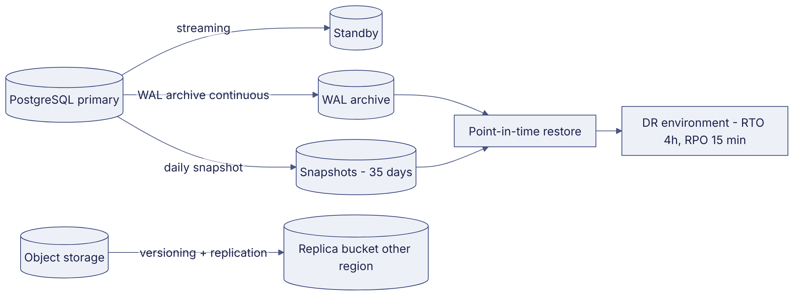

DGM-19 — System Context Diagram
Label: VERIFIED (actors) / PROPOSED (external systems)
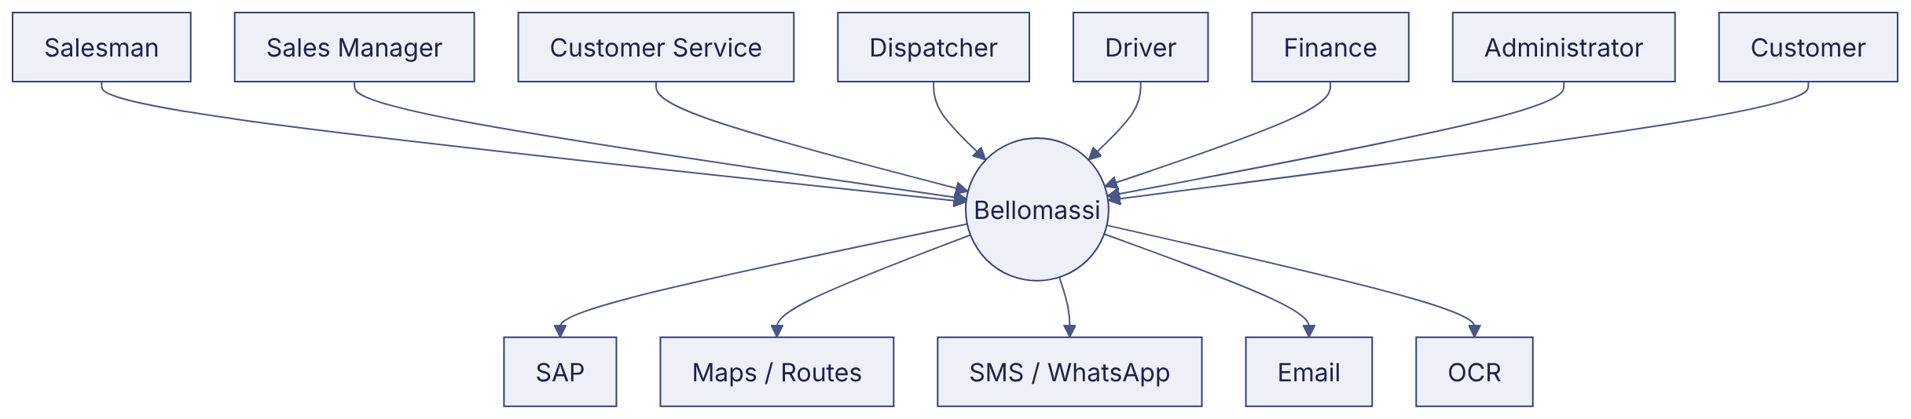

DGM-20 — Component Diagram (prototype)
Label: VERIFIED
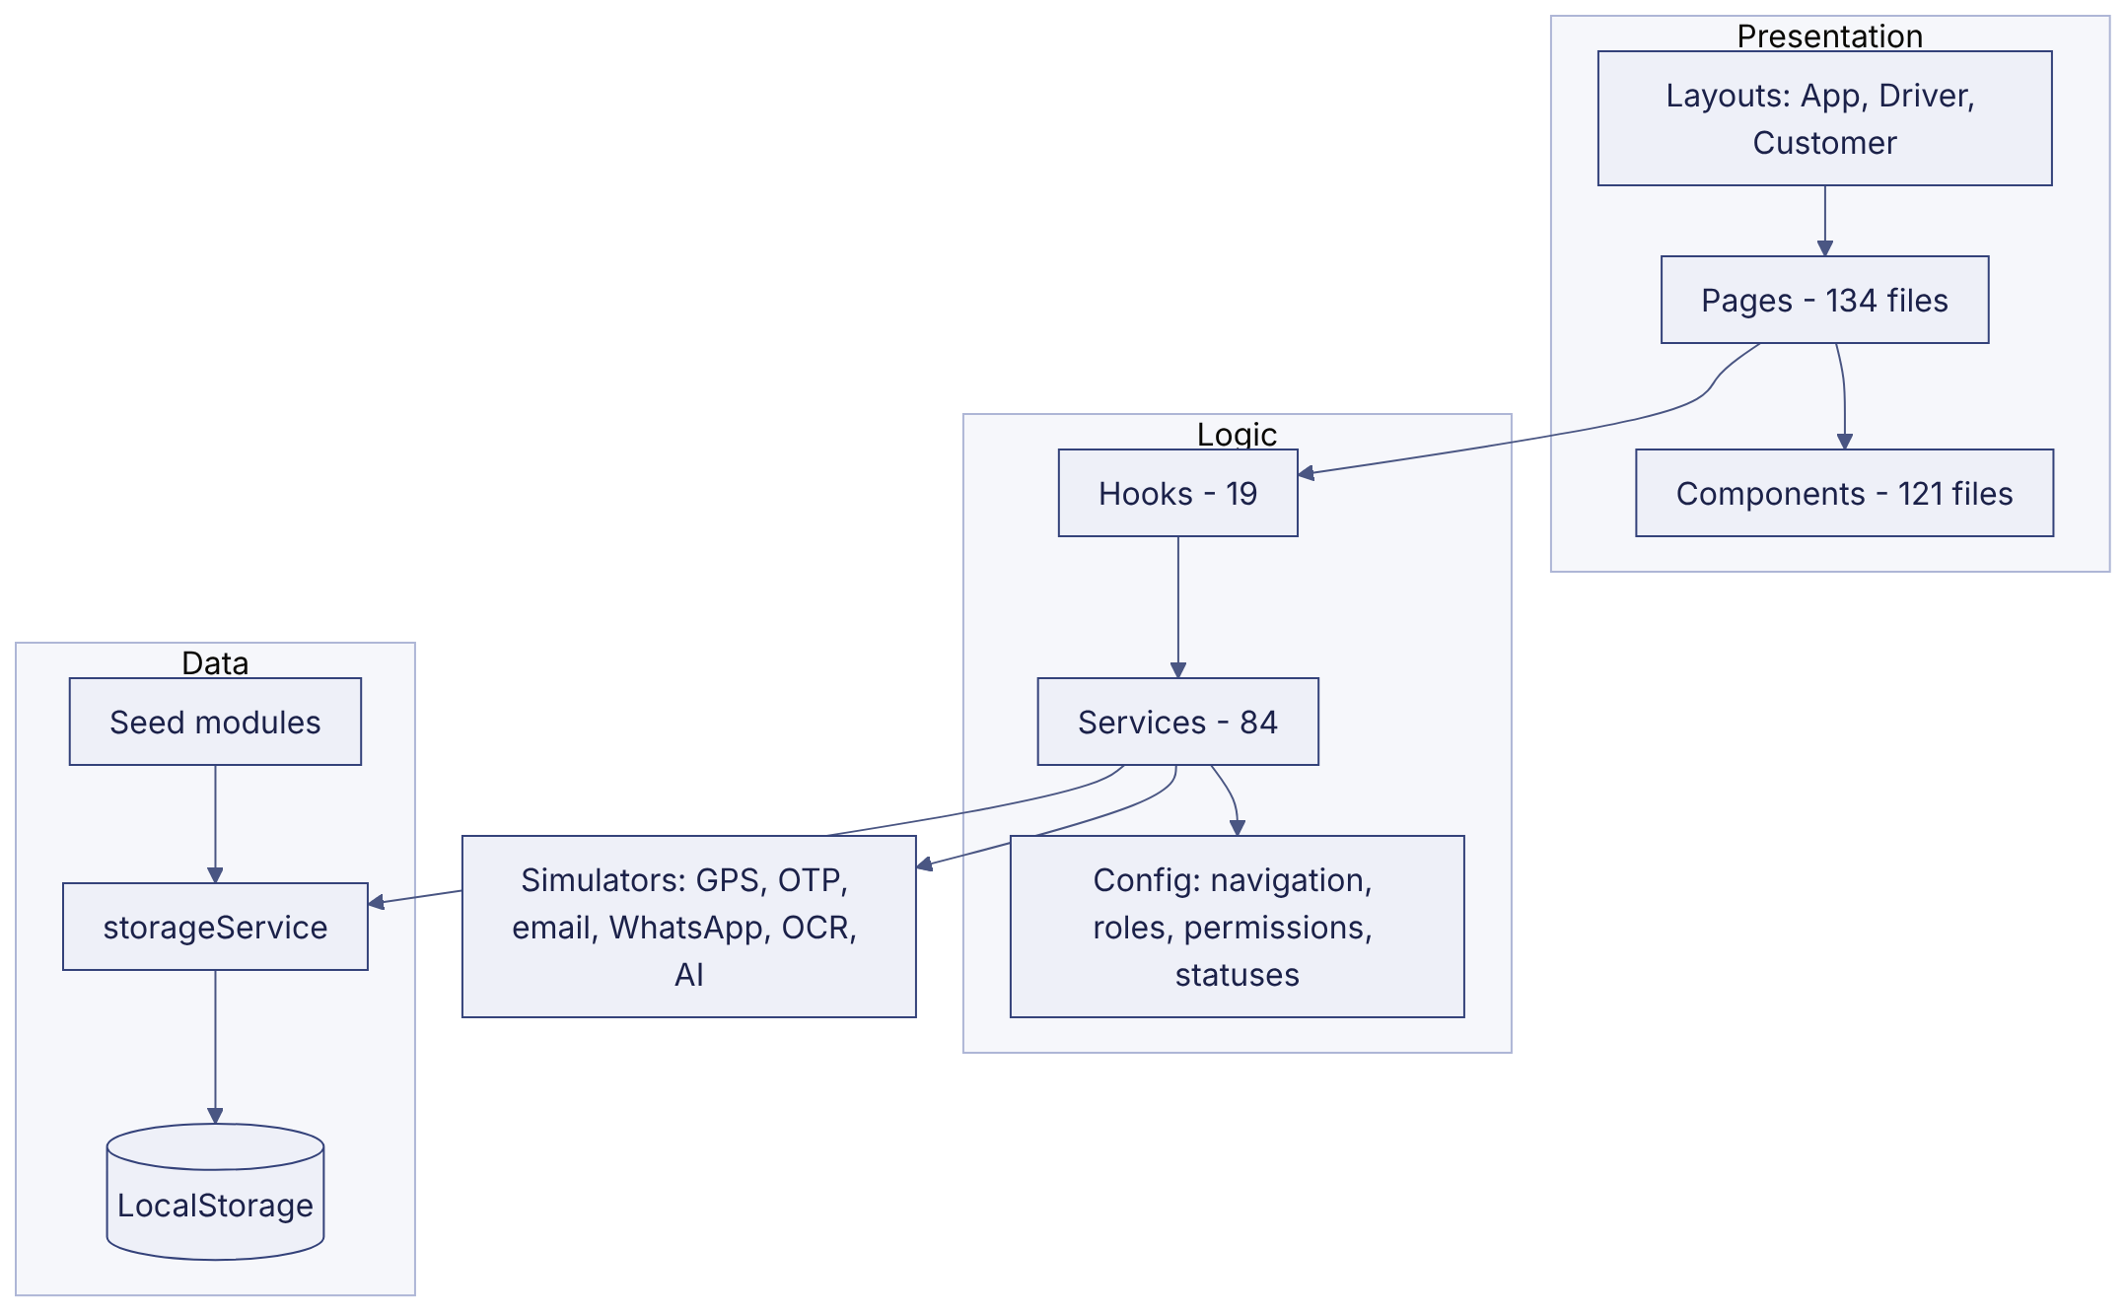

DGM-21 — Driver Delivery Architecture (production)
Label: PROPOSED
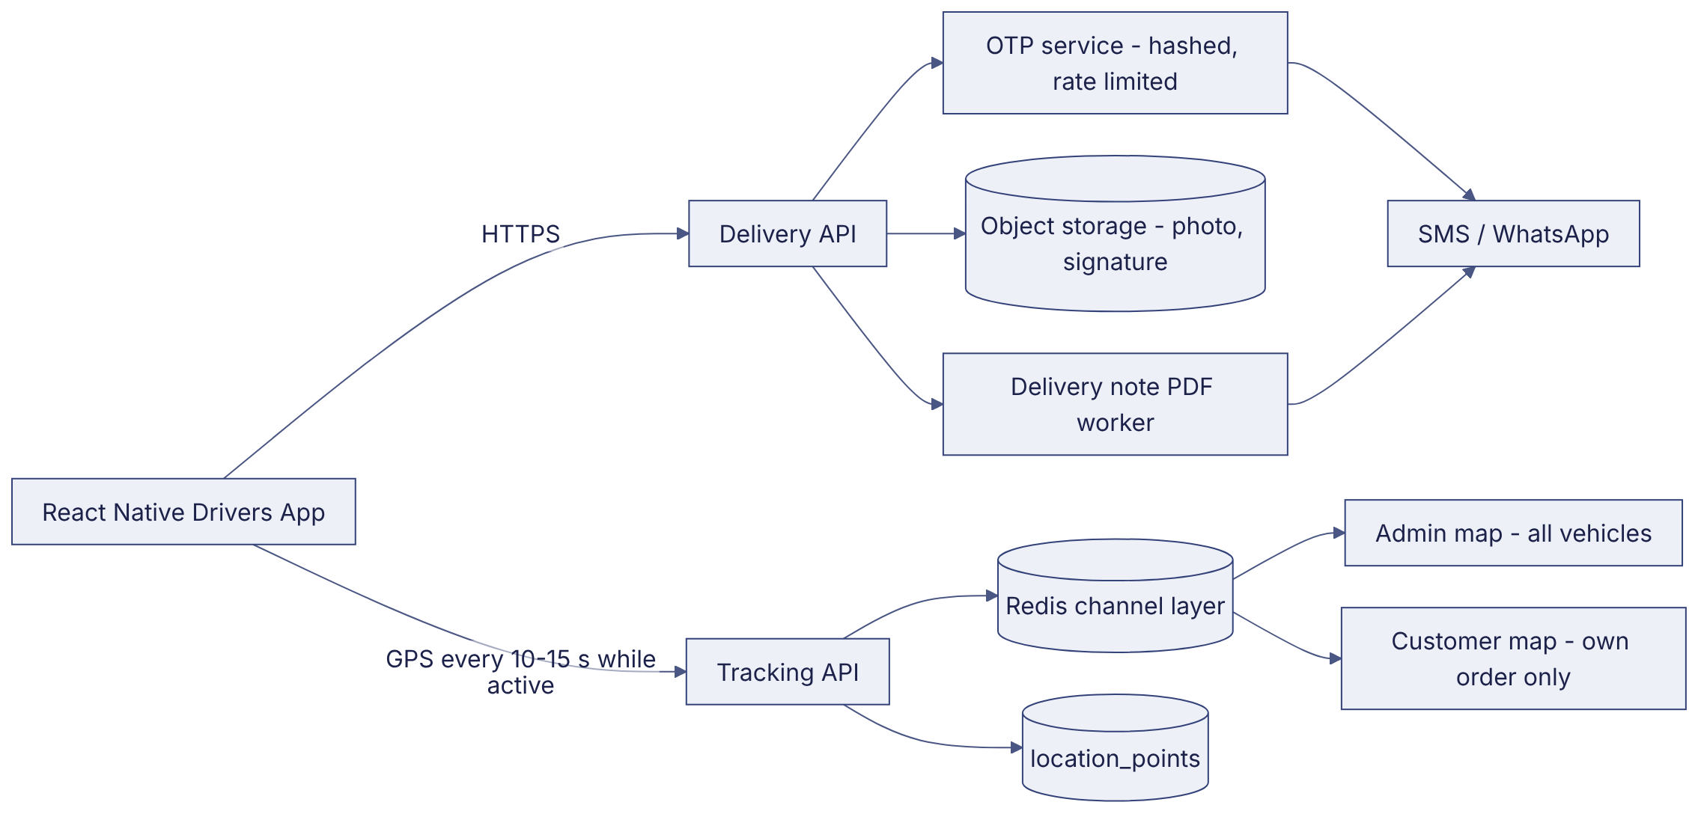

DGM-22 — Customer Application Architecture
Label: VERIFIED (prototype) / PROPOSED (production)
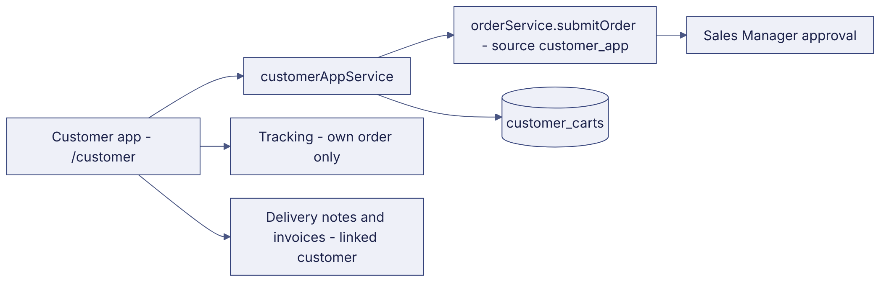

DGM-23 — Order Processing Architecture
Label: VERIFIED (logic) / PROPOSED (server)

Revision history
Version | Date | Author | Description
1.0 | 2026-11-12 | Documentation team | Initial draft prepared from analysis of the bellomassi-premium-ui source code and existing project documents.

