RAG API with Automated DevOps Pipeline

Project Report — Team 8

Table of Contents
- Title
- Problem Statement
- Solution
- Tech Stack
- Screenshots
- Conclusion

1. Title
Project Title: RAG API with Automated DevOps Pipeline
Domain: DevOps
Department: Computer Science and Engineering
Team Members:
S.No | Name | Register No
1 | Abisheck A M | 23BCS007
2 | Abinesh B | 23BCS006
3 | Dharun S | 23BCS034
4 | Jeevan Kumar S | 23BCS064

2. Problem Statement
Software teams today struggle with deploying applications the manual way. Every time a change is made to the code, someone has to manually build the project, run tests, check for errors, create a Docker image, and upload it — all by hand. This is slow, repetitive, and easy to get wrong.
Here are the specific problems we identified:
Manual deployments take too much time. Every release involves the same steps done by hand — building, testing, packaging, and uploading. As the team grows, this becomes a serious bottleneck.
Human errors creep in easily. When people do repetitive tasks manually, they miss steps. A wrong config, a skipped test, or an unreviewed change can break what users see in production.
There is no way to enforce quality automatically. Without automation, there is nothing stopping poorly written or untested code from being deployed. Code quality and security checks depend on individual discipline, not the system.
No visibility after deployment. Once the application is running, teams have no real-time view of how it is performing — how many requests are coming in, how fast it is responding, or if something is going wrong.
AI systems go stale. A RAG (Retrieval-Augmented Generation) system answers questions from documents. If those documents are updated and the AI is not re-trained, users get outdated answers. Doing this by hand is unreliable.

3. Solution
We solved these problems by building a system where everything is automated — from the moment a developer pushes code, all the way to a Docker image being ready to deploy.

An AI-Powered Question Answering System (RAG)
We built a web application where anyone can type a question and get an intelligent answer. The system searches through a set of documents stored in ChromaDB (a vector database) and passes the most relevant content to an AI language model (Groq — llama-3.1-8b-instant), which then generates a clear, grounded answer.
Users do not need to search through documents manually — they just ask a question and get an answer instantly.

A Fully Automated CI/CD Pipeline
We connected the project to GitHub Actions, which watches for any code push to the repository. The moment code is pushed, the pipeline automatically does all of the following without any human involvement:
- Checks the code for formatting and style issues using Ruff
- Runs all unit tests and verifies that at least 80% of the code is covered using pytest
- Scans all installed packages for known security vulnerabilities using pip-audit
- Runs an end-to-end integration test of the live API in mock mode — no GPU needed
- Builds Docker images for both the backend and frontend
- Pushes those images to GitHub Container Registry (GHCR) with proper version tags

One-Command Startup
The entire system — the AI backend, the web frontend, the vector database, and the monitoring tools — starts with a single command:
docker compose up --build
Five containers start automatically in the correct order with health checks. No manual service startup or configuration is needed.

Live Monitoring
Prometheus automatically collects performance metrics from the API every 15 seconds. Grafana turns those metrics into live dashboards showing query counts, response times, and system health — with no manual setup required.

4. Tech Stack
Below are all the tools and technologies we used and why we chose each one.
What It Does | Tool Used | Why We Used It
Backend API | FastAPI (Python 3.11) | Fast, modern Python framework with automatic API documentation
Reverse Proxy | Nginx (Alpine) | Routes web traffic to the right service and serves the frontend
Vector Database | ChromaDB | Stores document embeddings and retrieves the most relevant ones
AI / Language Model | Groq (llama-3.1-8b-instant) | Cloud LLM API for fast, accurate answer generation
Containerization | Docker + Docker Compose | Packages each service in isolation and runs them all together
CI/CD Automation | GitHub Actions | Runs the full pipeline automatically on every code push
Metrics Collection | Prometheus | Continuously scrapes the API for performance data
Monitoring Dashboard | Grafana (v10.4.3) | Displays live charts and dashboards from Prometheus data
Code Quality | Ruff | Lints and formats Python code — fast and strict
Testing | pytest + pytest-cov | Runs tests and measures how much code is actually tested
Security Scanning | pip-audit | Checks all Python packages against known vulnerability databases
Image Storage | GHCR | Stores the built Docker images and makes them available to deploy

Knowledge Base Documents
The RAG system answers questions based on these documents stored in the docs/ folder:
File | What It Contains
Devops.txt | Core DevOps concepts and how RAG fits in
k8s.txt | Kubernetes architecture and key concepts
nextwork.txt | NextWork platform information
CI_AND_TESTING.md | CI/CD pipelines and automated testing practices

5. Screenshots

GitHub Actions — CI/CD Pipeline Success
The pipeline ran successfully on a push to the main branch. All jobs — path-filter, lint, unit-tests, security, integration, and build — completed with green status. Total run time was 2 minutes 38 seconds.
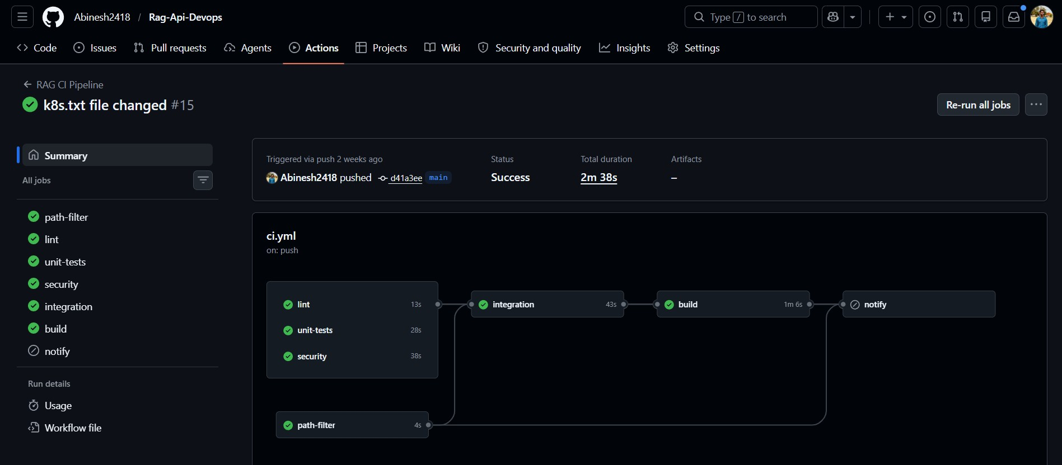
GitHub Actions CI/CD Pipeline - All jobs passing

Docker Containers — All Services Running
All five containers started successfully via Docker Desktop. The backend (port 8000), frontend (port 3000), Grafana (port 3001), and Prometheus (port 9090) are all running and healthy. The logs confirm the backend is responding to HTTP requests with 200 OK.
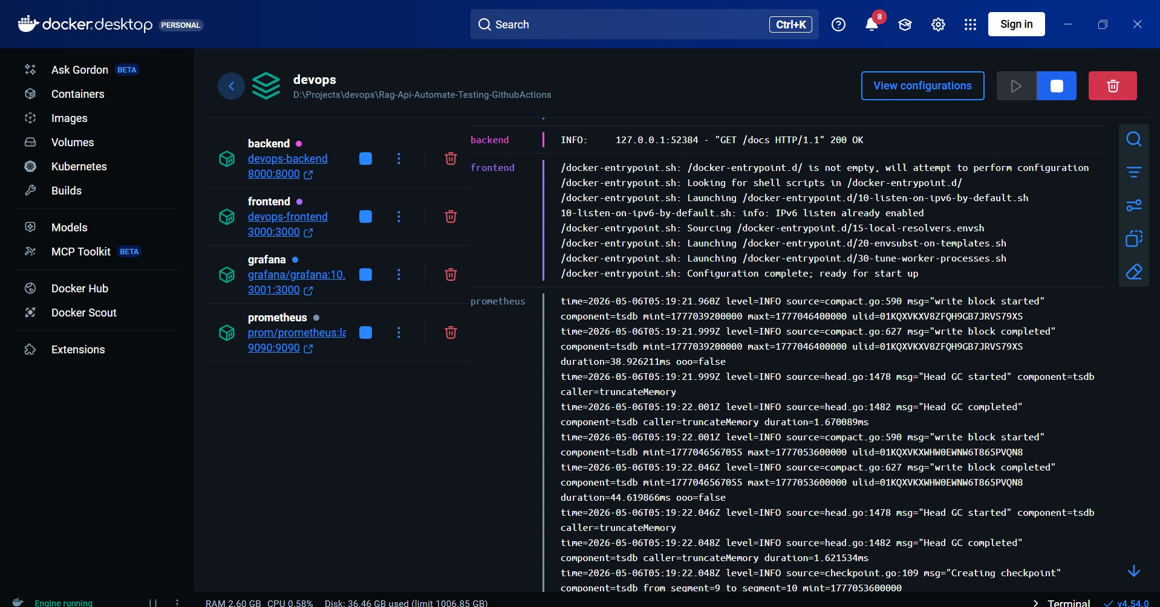
Docker Desktop - All containers running

Docker Container Logs — Live HTTP Traffic
The container logs show real-time HTTP traffic flowing through the system. The backend is receiving GET requests to /docs and /metrics, and Grafana is reporting its usage stats — confirming all services are communicating correctly over the Docker network.
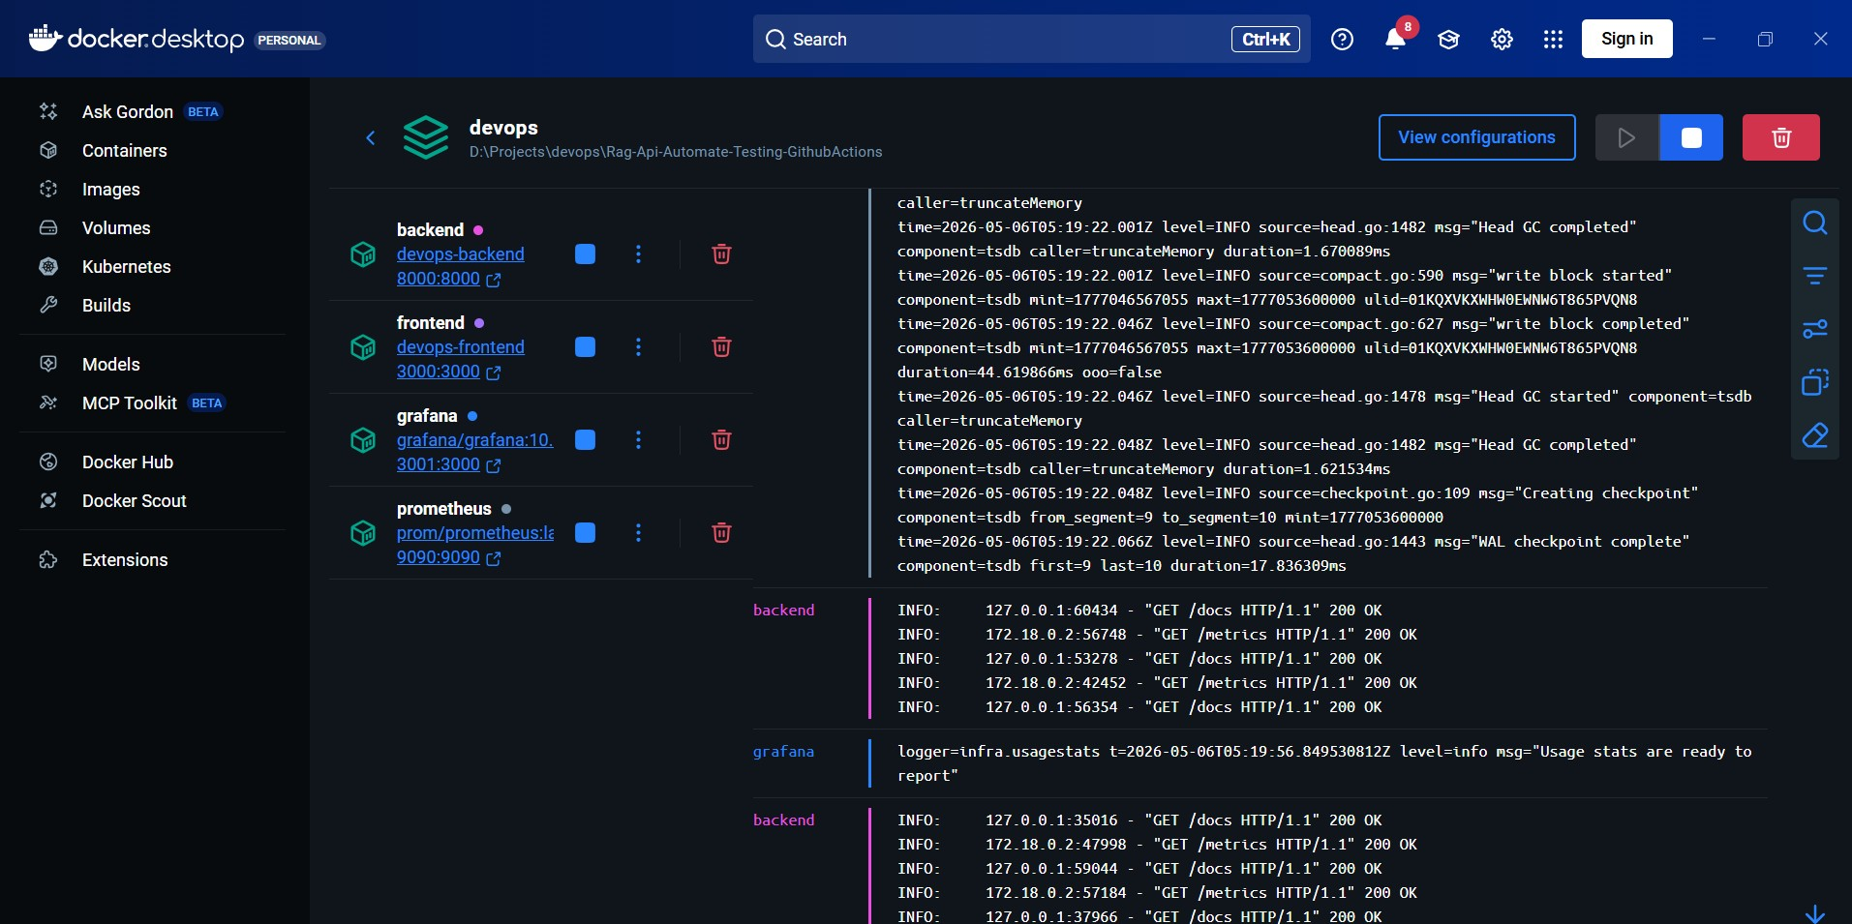
Docker containers - live request logs

Frontend Web Interface — RAG Query in Action
The web dashboard at localhost:3000 shows the RAG system in action. The query “what is docker?” was asked and the AI returned a clear, accurate answer in 0.29 seconds. The stats at the bottom show: 1 total query, 0.29s last response time, and API status as Up.
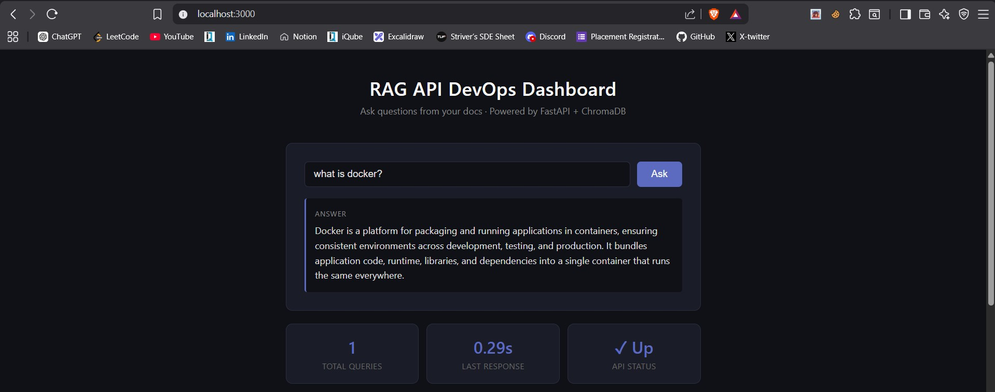
Frontend UI - RAG query answered

Grafana Dashboard — Live API Monitoring
The Grafana dashboard (RAG API Monitoring) shows real-time metrics collected from the backend. The panels display API requests per second, query response time (p95 latency), total queries processed (2), and average query duration (560 ms).
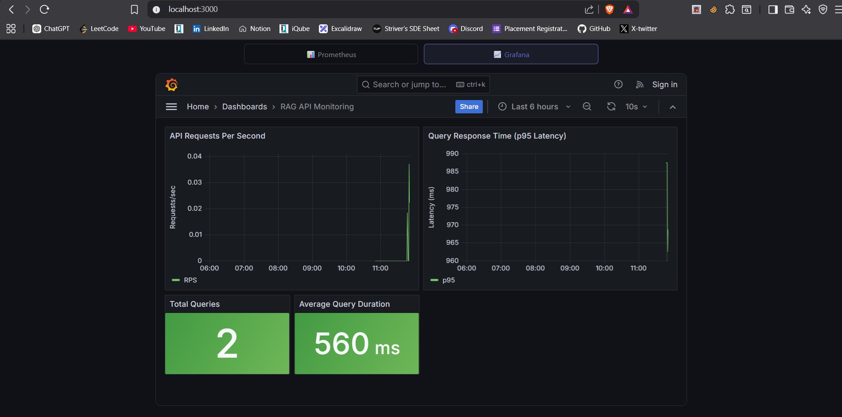
Grafana dashboard - live metrics

Prometheus — Metrics Graph
The Prometheus metrics explorer shows the rag_queries_total metric reaching a value of 3, scraped from backend:8000 under the job fastapi-backend. This confirms that Prometheus is successfully collecting data from the running API.
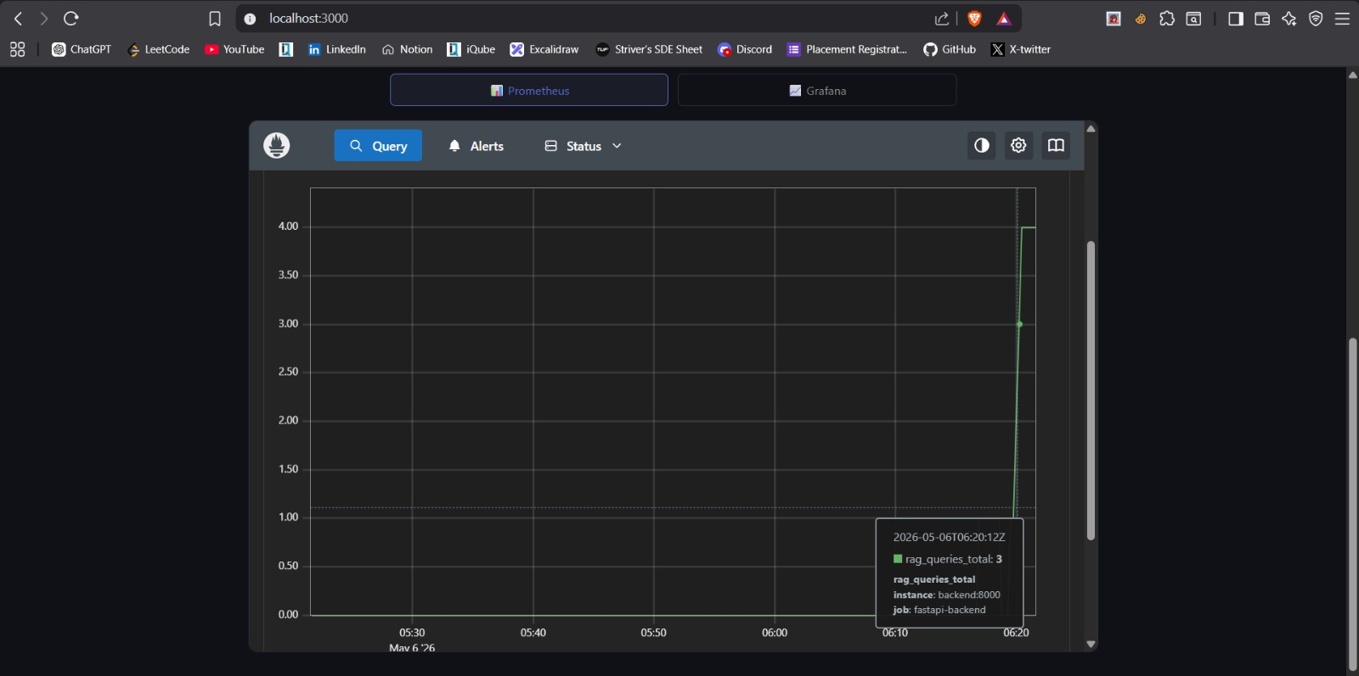
Prometheus - rag_queries_total metric graph

FastAPI — API Documentation (Swagger UI)
The FastAPI Swagger documentation at localhost:8000/docs shows all available API endpoints under the updated project name RAG-API-AUTOMATE-TESTING-GITHUBACTIONS. The endpoints include /dashboard, /api/docker-status, /api/pipeline-status, /api/deployments, /api/auto-triggers, /metrics, and POST /query.
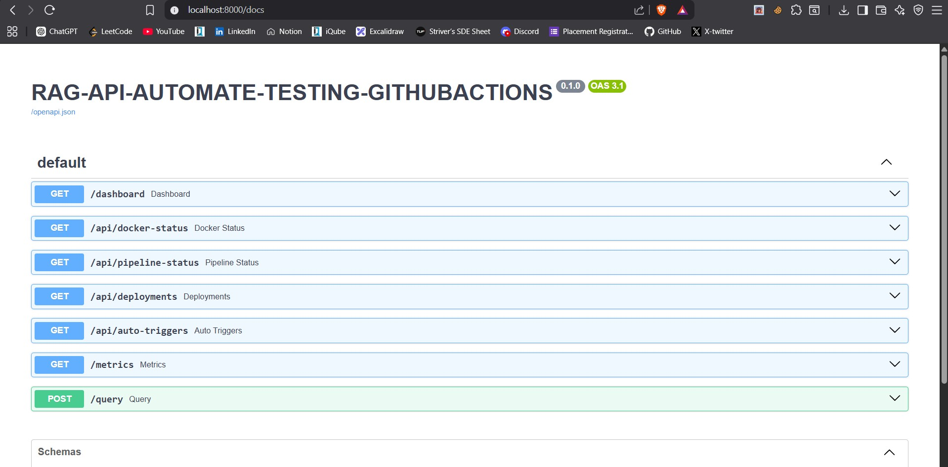
FastAPI Swagger docs - all endpoints listed

6. Conclusion
This project started from a simple observation — too much of what developers do day to day is repetitive, manual, and easy to get wrong. We set out to automate it, and we did.
By combining GitHub Actions, Docker, Prometheus, Grafana, and a RAG AI system, we built a pipeline where a developer writes code, pushes it, and the system handles everything else. Code quality is checked, tests are run, security is scanned, an image is built, and monitoring is live — all automatically, in under a few minutes.

What We Achieved
- A working RAG question-answering system that searches documents and generates answers using Groq LLM
- A fully automated CI/CD pipeline with six stages: path-filter, lint, unit-tests, security, integration, and Docker build — completing in 2m 38s
- A five-container Docker stack that starts with one command and includes live monitoring from day one
- Test coverage enforced at a minimum of 80% and security checked on every single commit
- Docker images automatically pushed to GHCR with version tags for full traceability
- Real-time Grafana dashboards showing query rates, p95 latency, and average response time (560ms)
- Prometheus successfully scraping live metrics from the backend every 15 seconds

What We Learned
- How to write GitHub Actions workflows with multiple stages and conditional execution
- Why AI systems need a mock mode to be testable in CI without expensive cloud infrastructure
- How Docker containers on a private network communicate with each other using service names
- How Prometheus and Grafana work together to provide monitoring without any manual setup
- That good DevOps systems enforce standards automatically — they do not rely on people to remember

Future Plans
What We Would Add Next | Why It Matters
Kubernetes | Auto-scaling, self-healing, and zero-downtime updates
Full auto-deployment | Containers deployed to the server automatically after a successful build
Multiple LLM support | Switch between Groq, Ollama, or OpenAI using a config file
GitOps with ArgoCD | Infrastructure managed entirely through Git
Live document ingestion | Add documents to the knowledge base without restarting the system
Alert routing | Grafana alerts sent to Slack or email when something goes wrong

