**Wireframe Documentation**

**Stores Sales Prediction**

|  |  |
| --- | --- |
| **Written by** | **Abinesh B** |
| **Documented Version** | **1.0** |
| **Last Revised Date** | **13 December 2024** |

**Overview:**

The interface consists of two main sections:

1. **Input Section** – Users provide data through input fields like item weight, item MRP, outlet size, outlet type, etc.
2. **Visualization and Output Section** – Displays the predicted sales value and two visualizations related to MRP vs Item Outlet Sales and Outlet Size vs Average Item Sales.

**1. Input Section:**

**Position:**

* The input fields (Item Weight, Item MRP, Outlet Size, etc.) are positioned at the top of the screen, aligned in a column layout.
* They are grouped together for better readability and to encourage the user to input their details in a structured manner.

**Behavior:**

* The fields are interactive, and the user can select values for each field.
  + The "Item Weight" is a numeric input that can be increased or decreased.
  + The "Item MRP" is another numeric input with a range slider.
  + "Outlet Size," "Outlet Type," and "Outlet Location" are dropdown or radio button inputs.
* The "Predict" button activates the prediction process.

**Purpose:**

* The input section allows users to provide essential data points to generate sales predictions based on the provided details.

**Workflow:**

1. The user selects or inputs data in all fields.
2. Once all fields are filled, the user presses the "Predict" button.
3. The system takes the input, processes it through the trained model, and returns the predicted sales value.
4. The output prediction is displayed at the bottom of the input section.

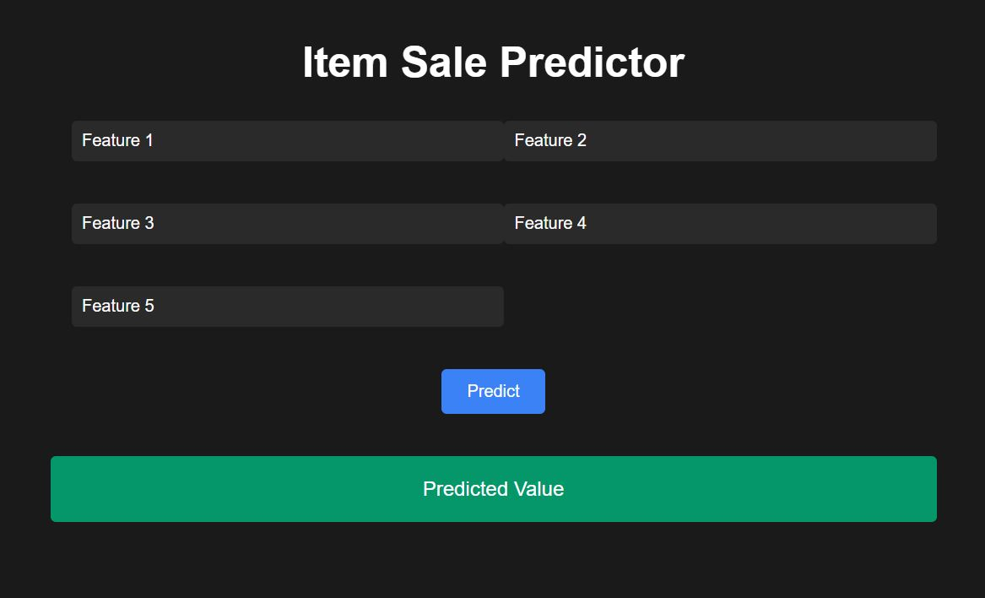

2. **Visualization and Output Section:**

**Position:**

* The **Visualization and Output Section** is positioned below the user input fields and above any potential additional content or footer.
* This section is designed to ensure that the user interface (UI) remains clear and focused, displaying the results in an easily accessible and readable area.
* The visualizations are presented in a vertical layout:
  1. **MRP vs Item Outlet Sales**: A graph that demonstrates how the MRP (Maximum Retail Price) correlates with sales figures for each outlet.
  2. **Outlet Size vs Average Item Sales**: A graph showcasing how sales figures vary with different outlet sizes, which could be a crucial factor in understanding sales performance.
* This arrangement ensures that there is enough space for both graphs, preventing any overlap or excessive crowding of elements.

**Behavior:**

* **Real-Time Dynamic Updates**: The visualizations are responsive and immediately adjust based on the user’s input values and the corresponding sales prediction.
* **Update Upon Prediction**: After the user clicks the "Predict" button, the system runs the prediction algorithm and updates both graphs simultaneously.
* **Interactive Legends**: Each chart includes a legend, likely indicating categories such as "Outlet Size" for the second chart. The legend helps to understand the chart's data points and can be toggled or adjusted as needed. It may also show how different input variables like outlet type affect the predictions.
* **Responsive Design**: The visualizations adjust based on the screen size, ensuring that the user experience remains consistent whether on desktop, tablet, or mobile devices.

**Purpose:**

* **Data-Driven Insights**: The visualizations help users understand the relationship between specific input features (like MRP and Outlet Size) and the resulting sales predictions. By visualizing these trends, users can make better decisions regarding pricing and outlet management.
  + **MRP vs Item Outlet Sales**: This graph reveals how pricing affects item sales. It provides insight into whether higher prices are associated with higher sales or if the correlation is weaker, enabling users to refine their pricing strategies.
  + **Outlet Size vs Average Item Sales**: This chart highlights how different outlet sizes impact average sales, helping businesses understand if larger outlets tend to sell more items on average, or if size has less of an effect on sales than other variables.
* **User Engagement**: By showing these visualizations, users can more easily grasp complex patterns in the data. The visual feedback also encourages deeper analysis and interaction with the tool.

**Workflow:**

1. **User Input**: First, the user enters the relevant input data (item weight, MRP, outlet size, etc.).
2. **Prediction Trigger**: When the user presses the “Predict” button, the system uses the input data to generate sales predictions.
3. **Visualization Generation**:
   * Upon receiving the prediction, the system processes the data and generates the two visualizations:
     + **MRP vs Item Outlet Sales**: Displays the relationship between the price of the item and its sales across outlets.
     + **Outlet Size vs Average Item Sales**: Illustrates how the average sales vary by outlet size, helping users understand the impact of outlet characteristics on sales.
4. **Visualization Update**: If the user modifies the input values and presses "Predict" again, both visualizations will automatically update to reflect the new data, ensuring real-time insights.

