**PHASE 3: DEVELOPMENT**

**LOADING AND PREPROCESSING OF DATASET:**

To measure energy consumption using AI, you'll need to follow a specific approach for data loading and preprocessing tailored to energy consumption data. Here's a step-by-step guide:

**1. Collect Energy Consumption Data:**

Obtain relevant energy consumption data from various sources such as sensors, utility companies, or IoT devices. Ensure the data includes features like time, location, and energy usage values.

**2. Import Necessary Libraries:**

python

import pandas as pd

**3. Load the Dataset:**

Load the energy consumption data into a DataFrame using Pandas.

python

df = pd.read_csv('energy_consumption_data.csv')

# Replace with your dataset file path

**4. Explore and Understand the Data:**

Gain insights into the dataset's structure, features, and any missing or erroneous values. This step helps in deciding on the preprocessing steps.

**5. Preprocess the Data:**

Perform preprocessing steps based on the characteristics of your energy consumption data. This may include:

- Handling missing or erroneous values (e.g., imputation, removal).

- Resampling or aggregating the data to a desired time granularity.

- Normalizing or scaling the energy consumption values.

**6. Feature Engineering:**

Depending on your goals, engineer relevant features from the dataset that can enhance AI model performance. This might include adding weather data, holidays, or any other contextual features.

**7. Create Training Data:**

Format the data into suitable input-output pairs for training. For energy consumption prediction, you might use a time series forecasting approach.

**8. Tokenization (Optional):**

If you plan to use natural language processing (NLP) techniques for analyzing related textual data (e.g., maintenance logs, weather reports), tokenization and preprocessing of that data may be necessary.

Once your data is properly preprocessed and organized, you can proceed to build and train AI models for energy consumption prediction or analysis based on your specific objectives. Feel free to ask if you need further guidance on any of these steps!

**IMPORTANCE:**

Loading and preprocessing datasets are crucial steps in building an AI-based system to measure energy consumption accurately and effectively. Here's why these steps are important:

**1. Data Quality and Consistency:**

Proper loading and preprocessing ensure that the data is consistent, accurate, and of high quality. Cleaning and handling missing or erroneous values contribute to reliable analysis and models.

**2. Data Understanding:**

Exploring and understanding the dataset through preprocessing helps identify patterns, trends, and characteristics of energy consumption. This understanding is essential for developing effective AI models.

**3. Feature Engineering:**

Preprocessing enables feature engineering, where you can create new relevant features from the raw data. Properly engineered features can enhance the performance and predictive power of AI models for energy consumption.

**4. Handling Missing Data:**

Dealing with missing data appropriately prevents biased analysis and misleading insights. Imputation or removal of missing values can lead to more accurate predictions and analyses.

**5. Normalization and Scaling:**

Normalizing or scaling the data helps in bringing all features to a similar scale, preventing certain features from dominating the learning process. This is crucial for various AI algorithms, including neural networks.

**6. Time Granularity and Aggregation:**

Resampling or aggregating the data to a desired time granularity is essential for aligning the data with the analysis or prediction goals. It helps in better understanding energy consumption patterns over specific intervals.

**7. Optimized Model Training:**

Well-preprocessed data ensures that AI models are trained optimally. Clean and appropriately structured data enables models to learn meaningful patterns, resulting in more accurate predictions of energy consumption.

**8. Efficient Training and Inference:**

Properly preprocessed data can lead to faster model training and more efficient model inference, which is essential for real-time or near real-time applications in energy consumption monitoring.

**CONCLUSION:**

In summary, loading and preprocessing datasets in the context of energy consumption are fundamental steps that directly impact the quality, accuracy, and efficiency of AI-based systems aiming to measure and predict energy consumption. These steps lay the foundation for successful model development and deployment in the domain of energy management.

**DATASET:**

**PJM Hourly Energy Consumption Data:**

PJM Interconnection LLC (PJM) is a regional transmission organization (RTO) in the United States. It is part of the Eastern Interconnection grid operating an electric transmission system serving all or parts of Delaware, Illinois, Indiana, Kentucky, Maryland, Michigan, New Jersey, North Carolina, Ohio, Pennsylvania, Tennessee, Virginia, West Virginia, and the District of Columbia.

The hourly power consumption data comes from PJM's website and are in megawatts (MW).

The regions have changed over the years so data may only appear for certain dates per region.

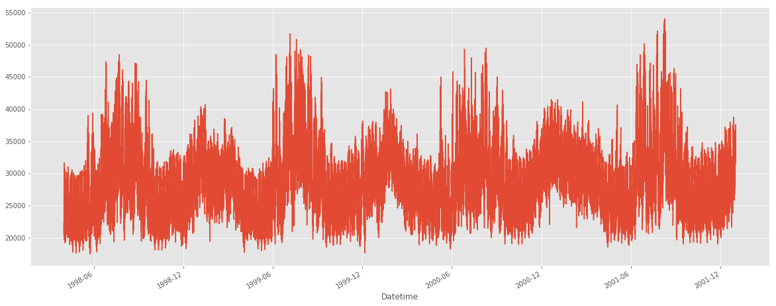

**Split the last year into a test set- can you build a model to predict energy consumption?**

To build a model to predict energy consumption using the hourly power consumption data from PJM for the last year, we'll need to follow these steps:

1. Data Preparation:

a. Split the data into training and test sets.

b. Preprocess the data, handling missing values and any necessary feature engineering.

2. Model Selection:

Choose an appropriate model for predicting energy consumption, such as a time series model like ARIMA, LSTM, or a regression-based model.

3. Model Training:

Train the selected model using the training set.

4. Model Evaluation:

Evaluate the model's performance using the test set.

5. Predict Energy Consumption:

Use the trained model to predict energy consumption for future dates.

Since the hourly power consumption data is in megawatts (MW), time series models like ARIMA or LSTM could be suitable for predicting energy consumption.