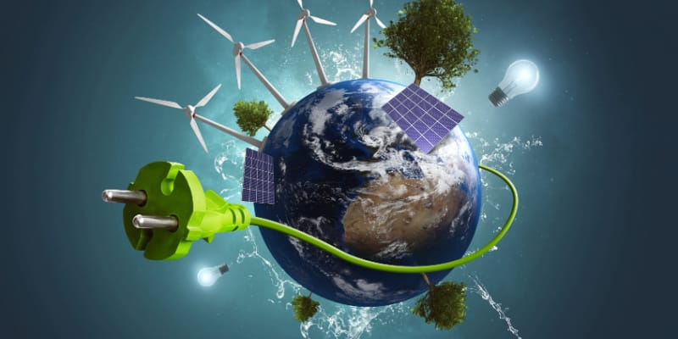

Measure

Energy

Consumption

Phase 2 submission

# Introduction:

Energy consumption refers to ALL the energy used to perform an action, manufacture something or simply inhabit a building. AI algorithms can optimize energy consumption by dynamically adjusting HVAC operations based on real-time data and predictive analytics.In oder to implement this ,the following innovative ideas are to be carried;

Implementation steps:

1.Define the Objectives:

Clearly define the objectives of energy consumption measurement. What type of energy (e.g., electricity, gas) is to be measured? What is the purpose (e.g., energy optimization, cost reduction, sustainability, compliance)?

2.Data Sources Selection:

Identify and gather data sources, including but not limited to:

Energy meters: Smart meters, sub-meters, utility meters.

IoT sensors: Temperature sensors, occupancy sensors, light sensors.

Historical energy data and Weather data.

Building management systems (BMS).

Equipment or appliance-level data (if available).

3.Data Collection:

Integrate data collection methods that automate the retrieval of data from the chosen sources. Ensure data is in a structured and consistent format.

4.Data Preprocessing:

Clean and preprocess the collected data. This may involve:

Removing outliers.

Filling in missing data.

Normalizing or scaling data.

Time series alignment.

5.Feature Engineering:

Create relevant features for the AI model, such as weather datatime of day, day of the week, and equipment-specific features.

6.Machine Learning Model Selection:

Choose a suitable machine learning algorithm for our specific use case. Common choices include linear regression, decision trees, random forests, neural networks, and time series forecasting models like ARIMA or LSTM.

7.Training the Model:

Train the machine learning model using historical data. Split the data into training and validation sets and use appropriate metrics to assess the model's performance.

8.Model Optimization:

Optimize the model by tuning hyperparameters and experimenting with different algorithms to improve its accuracy and generalization.

9.Real-time Data Processing:

Implement real-time data processing to continually ingest and preprocess new data as it becomes available.

10.Deployment:

Deploy the trained AI model to an environment where it can process real-time or historical data, such as a cloud-based platform or on-premises server.

11.Integration:

Ensure seamless integration with existing systems, like building automation systems, energy management software, or IoT platforms.

12.Alerting and Notification:

Implement alerting and notification systems to inform stakeholders when anomalies or energy consumption trends deviate from the expected norms.

13.Data Visualization:

Develop a user interface or dashboard that allows users to visualize energy consumption data and insights generated by the AI model.

14.Feedback Loop:

Establish a feedback loop to continually improve the AI model by incorporating new data and feedback from users.

15.Validation and Verification:

Verify the accuracy and reliability of the AI model's predictions through testing and validation against ground truth data.

16.Regulatory Compliance:

Ensure that our AI-based energy measurement system complies with relevant regulations and standards in your region or industry.

17.Maintenance and Updates:

Regularly update and maintain the AI model to account for changing data patterns and to improve its predictive accuracy.

18.Training and User Adoption:

Train users and stakeholders on how to effectively use the AI-based system to optimize energy consumption and meet energy goals.

19.Security and Data Privacy:

Implement security measures to protect data and ensure compliance with data privacy regulations.

20.Scalability:

Plan for the scalability of the system to accommodate additional data sources, new facilities, or increased energy measurement demands.

Conclusion:

From the above key points,we can say that measuring the energy consumption using the AI is far better and even it is more efficient.By the Combination of artificial intelligence and various machine learning techniques a well improved measure energy consumption is achieved.

