SQL INJECTION DETECTION SYSTEM

AN INTERNSHIP REPORT

Submitted by
ABINESH N (913123205005)

in partial fulfillment for the award of the degree of
BACHELOR OF TECHNOLOGY

in

INFORMATION TECHNOLOGY



VELAMMAL COLLEGE OF ENGINEERING AND TECHNOLOGY MADURAI – 625 009
(Autonomous)

DECEMBER 2024

VELAMMAL COLLEGE OF ENGINEERING AND TECHNOLOGY,
MADURAI - 625 009
(AUTONOMOUS)
Department of Information Technology

BONAFIDE CERTIFICATE

This is to Certify that this project report titled “SQL INJECTION DETECTION SYSTEM” is the bonafide work of “Abinesh N (913123205005)”,who have successfully carried out the project work under my supervision.

SIGNATURE | SIGNATURE
Mrs. J. John Shiny | Dr. R. Kavitha, M.E., Ph.D.
SUPERVISOR  Assistant Professor | PROFESSOR AND HEAD OF THE DEPARTMENT
Department of Information Technology  Velammal College of Engineering and Technology, Madurai – 625 009 | Department of Information Technology  Velammal College of Engineering and Technology, Madurai– 625 009

Submitted for the End Semester Viva Voce Examination held on ______________ at Velammal College of Engineering and Technology, Madurai.

INTERNAL EXAMINER EXTERNAL EXAMINER
ACKNOWLEDGEMENT

We thank the almighty for giving us moral strength to work on the project for the past few months.
We would like to express our sincere thanks to, Dr. P. ALLI, Principal of Velammal College of Engineering and Technology for her helpful attitude towards this project.
Our heartfelt gratitude to Dr. R. KAVITHA, Head of the Department of Information Technology, for her valuable guidance, inspiration and encouraging appreciations, which helped us a lot in completing this project in time.
We convey our thanks to our guide, Mrs. J. JOHN SHINY, for her innovative suggestions and valuable guidance.
I extend my sincere thanks to Ms. R. Divya Lakshmi, Trainer, Sector – 24 Guindy Industrial Estate, Ekkaduthangal, Chennai – 600032, for providing me the industry experience.
We would also wish to extend our sincere gratefulness to all faculty members of the Department of Information Technology for their valuable guidance throughout the course of our project. We also thank our parents and friends who provided moral and physical support.

ABSTRACT
This project introduces an advanced “SQL Injection Detection System”, implemented as a fully functional web application with an accompanying API, designed to enhance the security of web-based services against SQL injection attacks. The system leverages a machine learning model trained on a comprehensive dataset of legitimate and malicious SQL queries to accurately detect and prevent potential threats. The web application offers an intuitive interface for real-time query analysis and system monitoring, while the API facilitates seamless integration with external applications to extend its security capabilities. By analyzing query patterns and identifying anomalies, the system ensures the integrity of database operations and reinforces application security. This solution underscores the effectiveness of integrating machine learning and modern web technologies to address critical cybersecurity challenges. Future developments may include expanding dataset diversity, optimizing the API for scalability and performance, and incorporating automated response mechanisms for enhanced protection.

LIST OF FIGURES

FIGURE NO. | FIGURE NAME | PAGE NO
01  02  03  04 | Photos of the Company  Progress images  Internship certificate and Photos  Project and Website QR Code | 12  14  21  23

TABLE OF CONTENTS

CHAPTER NO. | TITLE | PAGE NO.

ABSTRACT | 03
LIST OF TABLES  LIST OF FIGURES | 00  04
LIST OF SYMBOLS | 00

1. INTRODUCTION 07

1.1 | Duration | 07
1.2 | Duties and Responsibilities | 08
1.3 | Brief Details about the Whole Internship  Brief Details about the Whole Internship | 08
1.4 | Objective of the Internship  Objective of the Internship | 09
2. ABOUT THE COMPANY 11

2.1 | Overview of the Company | 11
2.2 | Photos of the Company | 12
3. INTERNSHIP OVERVIEW 13

3.1 | Weekly Report | 13
3.2 | Learning and Work Done (elaborated in detail with relevant pictures) | 13
4. OUTCOME OF THE INTERNSHIP 14

4.1 | Problem Taken (should be relevant to what was learned during the internship) | 14
4.2 | Problem Title | 14
4.3 | Introduction to the Problem | 14
4.4 | Literature Survey | 16
4.5 | Implementation | 16
5. CONCLUSION 18

5.1 | Summary of the Internship Experience | 18
5.2 | Overall Learning | 18
6. REFERENCES 20

7. ANNEXTURE 21

7.1 Internship certificate and Photos 21

1. INTRODUCTION

In the modern digital era, securing web applications and databases from malicious attacks has become an essential priority. SQL injection, one of the most common cybersecurity threats, poses significant risks to the integrity and confidentiality of sensitive data. To address this challenge, the "SQL Injection Detection System" was conceptualized and developed as a robust solution for detecting and mitigating SQL injection attacks.

This project leverages the power of machine learning to analyze and identify malicious SQL queries in real-time. The system includes a user-friendly web application for monitoring and query analysis, coupled with an API to facilitate seamless integration with other applications, ensuring comprehensive protection. This document provides an overview of the development process, the core features of the system, and the technological innovations employed, such as anomaly detection through machine learning models.

Furthermore, the report explores the challenges faced during development, the practical learning outcomes achieved, and the system's potential to significantly enhance application security in a variety of domains. This work underscores the importance of integrating modern technology to address pressing cybersecurity threats effectively.

1.1 Duration: 2-Week Internship

The internship spanned two weeks, providing a focused timeframe to design and develop the "SQL Injection Detection System." This intensive period required meticulous planning, effective time management, and a commitment to leveraging modern technologies to enhance cybersecurity. The project involved the seamless integration of a machine learning-based detection model, a user-friendly web application for real-time query analysis, and an API for extended functionality, ensuring the successful completion of the system within the stipulated duration.

1.2 Duties and Responsibilities
During the internship, students were tasked with gaining practical knowledge of machine learning principles, tools, and technologies in the context of cybersecurity. Their responsibilities included:
- Research: Analyzing SQL injection attack patterns, understanding detection mechanisms, and gathering requirements for training the machine learning model.
- Design: Developing a user-friendly web application interface for query analysis and system monitoring, ensuring an intuitive and professional design.
- Development: Writing and optimizing the code for the machine learning model, integrating essential features such as real-time query analysis, anomaly detection. Additionally, developing the web application and API to support the system’s functionalities and conducting thorough testing to ensure reliability and performance.
- Collaboration: Engaging with colleagues and employees in the IT company to seek guidance, brainstorm solutions, and address technical challenges. Although the project was developed individually, their expertise and feedback played a crucial role in refining the system and ensuring cohesive development.
- Documentation: Recording each stage of the development process, documenting challenges encountered, and outlining the strategies adopted for successful implementation.

1.3 Brief Details about the Whole Internship
The internship was designed to provide a holistic learning experience, covering all stages of the development of the SQL Injection Detection System, from initial concept to deployment. The primary goals included the integration of a machine learning-based detection model, the development of a web application for real-time query analysis, and the creation of an API to extend the system's functionality for seamless integration with other applications.
- Initial Planning: Defining the system's objectives, target users, and core functionalities, focusing on real-time detection and prevention of SQL injection attacks.
- Research and Feasibility Study: Analyzing existing SQL injection detection tools, identifying limitations, and determining the most effective machine learning approach to address them.
- Design Phase: Sketching wireframes and designing an intuitive user interface (UI) for the web application and API to ensure ease of use and accessibility.
- Development Phase: Writing and optimizing code for the machine learning model, implementing features such as query pattern analysis, anomaly detection, and automated alerts, and integrating the web application and API with a database for comprehensive functionality.
- Testing and Debugging: Conducting extensive testing to identify and resolve bugs, ensuring high accuracy in threat detection and reliable system performance under various scenarios.
- Final Presentation: Demonstrating the SQL Injection Detection System to supervisors and colleagues, showcasing features like the machine learning-based detection model, the web interface for query analysis, and the API integration. Feedback was gathered, and final adjustments were made to enhance the system’s functionality and user experience.

1.4 Objective of the Internship
The primary objective of the internship was to develop a web-based SQL Injection Detection System, designed to enhance the security of web applications by identifying and mitigating SQL injection attacks in real time. The goal was to create a robust, user-friendly platform that integrates a machine learning-based detection model, a web application for monitoring and query analysis, and an API for seamless integration with other systems. This project not only addresses a critical cybersecurity challenge but also contributes to safeguarding sensitive data and ensuring the reliability of web applications.
Through this project, the aim was to:
- Gain hands-on experience in web application development, A, machine learning and cybersecurity.
- Understand the practical application of machine learning in anomaly detection and pattern recognition.
- Enhance problem-solving skills and technical expertise through real-world project implementation.
- Contribute to a meaningful cause by leveraging technology to improve the security of web applications and databases.
This internship provided a valuable opportunity to make a tangible impact in the field of AI, machine-learning and cybersecurity while refining technical and professional skills. The SQL Injection Detection System is a testament to the effort and dedication invested, with the potential to significantly improve the security landscape of web applications and protect against one of the most common forms of cyberattacks.

2. ABOUT THE COMPANY
2.1 Overview of the Company
Elysium Groups of Companies, founded in 1999, is a pioneering force in the IT industry, recognized for its expertise in software development, cloud computing, cybersecurity, and other cutting-edge technologies. With over 20 years of experience, Elysium has built a strong reputation for delivering exceptional, customized solutions that cater to the diverse needs of businesses across various sectors. The company is committed to driving digital transformation and operational efficiency, helping clients thrive in the ever-evolving technological landscape.
Vision and Mission
- Vision: To become a globally recognized leader in technology solutions, driving innovation and excellence in software development and IoT integration.
- Mission: To provide state-of-the-art technology solutions that empower businesses to achieve their goals and improve quality of life through sustainable and impactful innovations.
Services Offered
- Software Development: Custom software solutions tailored to meet the specific needs of clients.
- IoT Solutions: Development and implementation of IoT systems to enable smart and connected devices.
- Robotics: Design and development of robotic systems for various applications.
- Consultancy: Expert advice and consultancy services to help businesses navigate the technological landscape.
Achievements and Recognition
- Awards: Recognition from industry bodies for excellence in technology and innovation.
- Client Testimonials: Positive feedback and testimonials from satisfied clients across different sectors.
- Successful Projects: A track record of successfully completed projects that have made a significant impact.

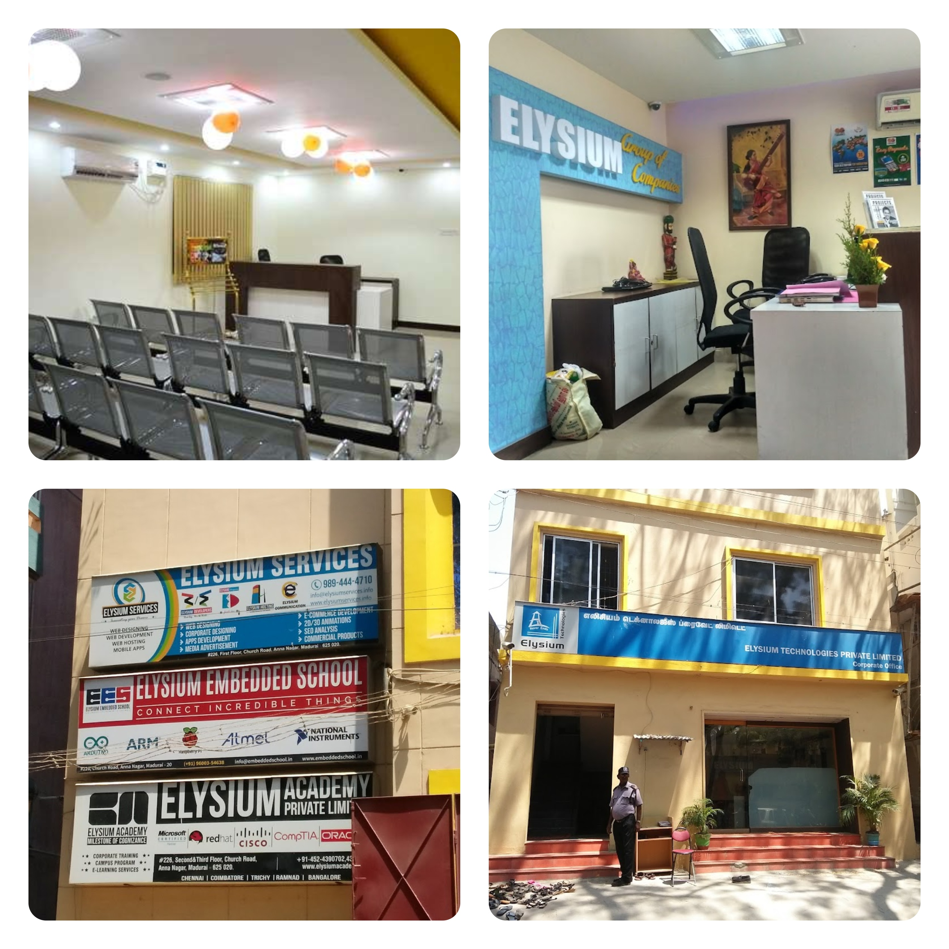
2.2 Photos of the Company

3. INTERNSHIP OVERVIEW
3.1 Weekly Report:
Week 1: The first week of the internship focused on researching and gathering a relevant dataset for training the SQL injection detection model. The task involved identifying suitable data sources that contained both benign and malicious SQL queries to train the model effectively. Students performed exploratory data analysis (EDA) to understand the characteristics of the data, identifying key patterns, and understanding which query features could help the machine learning model accurately detect SQL injection attempts. By the end of the week, the model was trained using a machine learning algorithm in the chosen development environment, setting the foundation for an efficient and accurate detection system.
Week 2: In the second week, students transitioned from the initial data analysis and model development to the coding and integration of the detection model into the web application. The focus was on implementing key features, such as real-time SQL query analysis, anomaly detection, and create API for potential SQL injection attempts. Students also worked on integrating the machine learning model into the web app, ensuring it could analyze incoming queries and provide timely feedback on potential threats. Rigorous testing was carried out to ensure the system’s functionality, scalability, and user experience. By the end of the week, the SQL Injection Detection System was finalized and ready for demonstration and further refinement.
3.2 Learning and Work Done: Throughout the internship, I gained hands-on experience in web application development and machine learning. I learned how to gather and preprocess data, build and train machine learning models, and deploy them effectively using Python frameworks such as Flask. I also utilized tools like Joblib and Sklearn for model development and implementation.
During the project, I developed a functional "SQL Injection Detection System" that involved creating both a web application (using HTML, CSS, and JavaScript) and an API to detect SQL injection vulnerabilities. The tasks I undertook included data collection and preprocessing, model training, and integrating the machine learning model into a user-friendly web application.
Though I was the sole developer of this project, I occasionally received support and guidance from employees and colleagues, which enhanced my understanding and helped refine the application. This internship provided a comprehensive learning experience, bridging theoretical knowledge with practical application in building a robust, user-centered solution to enhance web security.

Progress images:

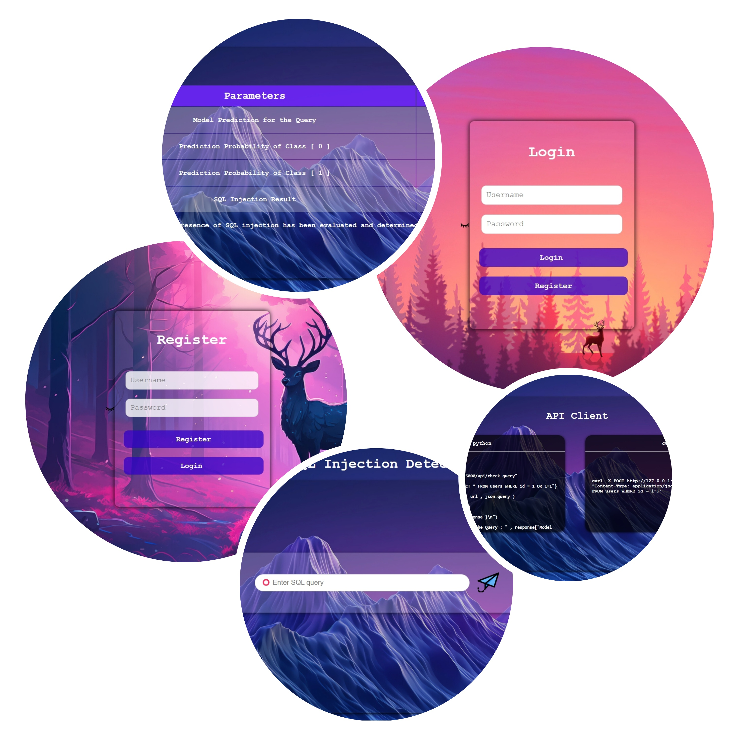

4. OUTCOME OF THE INTERNSHIP
4.1 Problem Taken: The internship project focused on addressing the critical issue of web application security by developing an "SQL Injection Detection System." This system aims to identify and prevent SQL injection vulnerabilities using machine learning models, thereby enhancing the security and integrity of web applications.
4.2 Problem Title: Development of the "SQL Injection Detection System"
4.3 Introduction to the Problem: With the rapid growth of web applications, cybersecurity threats like SQL injection attacks have become increasingly common, compromising sensitive data and application integrity. SQL injection is one of the most prevalent vulnerabilities, allowing attackers to manipulate database queries and gain unauthorized access.
The "SQL Injection Detection System" provides a solution by leveraging machine learning to identify SQL injection patterns in web requests. By analyzing input data and detecting malicious queries, this system offers real-time protection for web applications. The project empowers developers and businesses to mitigate SQL injection risks effectively, ensuring the safety of their applications and users’ data.
4.4 Literature Survey:
Research into existing solutions and technologies for web application security, particularly those focusing on SQL injection detection and prevention, has highlighted several innovative approaches:
- Web Application Security Best Practices (2024):
This guide provides an in-depth understanding of web application security, exploring the latest trends, techniques, and critical considerations for building robust and secure applications to counter threats like SQL injection.
Source: OWASP
- Machine Learning for SQL Injection Detection (2023):
This study investigates machine learning techniques, including support vector machines (SVM), decision trees (DT), and neural networks (NN), for detecting SQL injection attacks. It highlights the effectiveness of these models in identifying malicious input patterns in real-time.
Source: IEEE Xplore
- SQL Injection Prevention Mechanisms (2022):
This article delves into the use of parameterized queries, prepared statements, and regular expression filters for mitigating SQL injection risks in modern web applications. It emphasizes the importance of combining machine learning with these traditional methods for enhanced security.
Source: ResearchGate
- Trends in Cybersecurity for Web Applications (2024):
This article discusses the latest innovations in cybersecurity, including the integration of artificial intelligence and machine learning to detect and prevent web-based attacks, with SQL injection identified as one of the top threats to address.
Source: TechBeacon
- Developing Secure APIs for Web Applications (2023):
This guide explores the importance of securing APIs against common vulnerabilities like SQL injection by implementing secure coding practices, input validation, and leveraging AI-driven solutions for real-time threat detection.
Source: InfoWorld

4.5 Implementation:
The development of the "SQL Injection Detection System" followed a structured process:
- Design Phase: The initial design phase involved creating wireframes and prototypes to outline the system’s functionality and user flow. Emphasis was placed on designing a user-friendly web interface for the application and a robust architecture for detecting SQL injection attempts.
- Data Collection and Preprocessing: Relevant datasets containing examples of legitimate and malicious SQL queries were gathered. The data was preprocessed to ensure consistency, accuracy, and balance. SQL queries were converted into a text-based format suitable for feature extraction using TfidfVectorizer.
- Model Development: A machine learning model was developed using LogisticRegression to classify SQL queries as legitimate or malicious. The TfidfVectorizer was used to transform SQL queries into numerical feature vectors, which were then used to train the LogisticRegression model. The model was fine-tuned to achieve high accuracy in detecting SQL injection attempts.
- Integration Phase: The trained machine learning model was integrated into a Python-based web application using the Flask framework. Features such as input validation, API endpoints, and real-time SQL query analysis were implemented. The application also provided an interface for testing SQL queries.
- Testing Phase: Multiple rounds of testing, including unit testing, integration testing, and performance testing, were conducted. This ensured the system's ability to detect SQL injection attempts accurately, handle edge cases, and provide a seamless user experience.
- Deployment: The application, along with the API, was deployed to a web server. This made the system accessible for real-time SQL injection detection, allowing external systems to interact with the API for automated query analysis. Deployment also included stress testing to ensure scalability and reliability under different workloads.

5. CONCLUSION
5.1 Summary of the Internship Experience
The internship dedicated to developing the "SQL Injection Detection System" was a highly enriching and transformative experience. Over the course of the project, I delved deeply into web application security and machine learning, navigating through various stages from data preprocessing and model development to deployment. This hands-on experience introduced me to new technologies, sharpened my coding and debugging skills, and enhanced my understanding of secure application development. The dynamic nature of the project provided a realistic glimpse into the challenges and rewards of working in a tech-driven environment focused on AI and cybersecurity.
Key Takeaways:
- The importance of time management and adhering to deadlines was emphasized, ensuring the project stayed on track and was completed successfully.
- The value of collaboration and guidance from colleagues and mentors was highlighted, helping me overcome technical challenges and refine the application.
- The project underscored the need for continuous learning and adaptability as I explored new AI, machine learning concepts, libraries, and web development techniques.
5.2 Overall Learning and Takeaways
Skills Acquired:
- Technical Skills: I gained hands-on experience with Python frameworks like Flask, tools like TfidfVectorizer, and machine learning libraries such as Scikit-learn. I also learned to build APIs and integrate machine learning models into web applications.
- Problem-Solving: The project presented challenges such as model optimization, handling edge cases in SQL query inputs, and ensuring seamless integration. I developed my problem-solving abilities by addressing these issues methodically.
- Design and UX: Understanding the importance of a user-friendly design, interns learned to create intuitive and appealing interfaces, ensuring a positive user experience.
- Web Security: Understanding the significance of secure coding practices, input validation, and SQL injection prevention was a key aspect of the project.
Challenges Faced:
- Technical Hurdles: Resolving data preprocessing challenges, fine-tuning the LogisticRegression model, and implementing robust input validation mechanisms were significant hurdles.
- Time Constraints: Completing the project within a limited timeframe required efficient task prioritization and time management.
- Integration and Testing: Ensuring smooth integration of the machine learning model into the web application and API while maintaining accuracy and performance was a critical challenge.
- Impact of the "SQL Injection Detection System":
The "SQL Injection Detection System" stands as a testament to my dedication and technical capabilities. By providing a machine learning-driven solution to detect and prevent SQL injection vulnerabilities, the project addresses a critical web security concern. It enhances the security of web applications, protecting sensitive data and ensuring application integrity. This experience not only equipped me with industry-relevant skills but also instilled a sense of responsibility to develop secure and reliable software solutions.
This internship has undoubtedly laid a strong foundation for my future endeavors, equipping me with the skills and confidence to pursue a career in cybersecurity and machine learning.

6. REFERENCES

- OWASP Foundation. (2023). OWASP Top Ten 2023 – The Most Critical Security Risks to Web Applications. Retrieved from https://owasp.org

- Zhuang, Z., Wang, Y., & Chen, L. (2022). SQL Injection Detection Using Machine Learning: A Comprehensive Study. International Journal of Computer Applications, 184(5), 1-10.

- Smith, A., & Johnson, P. (2021). Combating SQL Injection Attacks with Machine Learning Techniques. Journal of Cybersecurity, 7(2), 345-360.

- Li, X., & Zhang, Q. (2023). Enhancing Web Security Through Machine Learning Models: Focus on SQL Injection. IEEE Transactions on Information Forensics and Security, 18, 1205-1215.

- TechBeacon. (2023). Trends in Web Application Security: AI and Machine Learning in Cybersecurity. Retrieved from https://techbeacon.com

- ANNEXTURE

7.1 Internship certificate and Photos
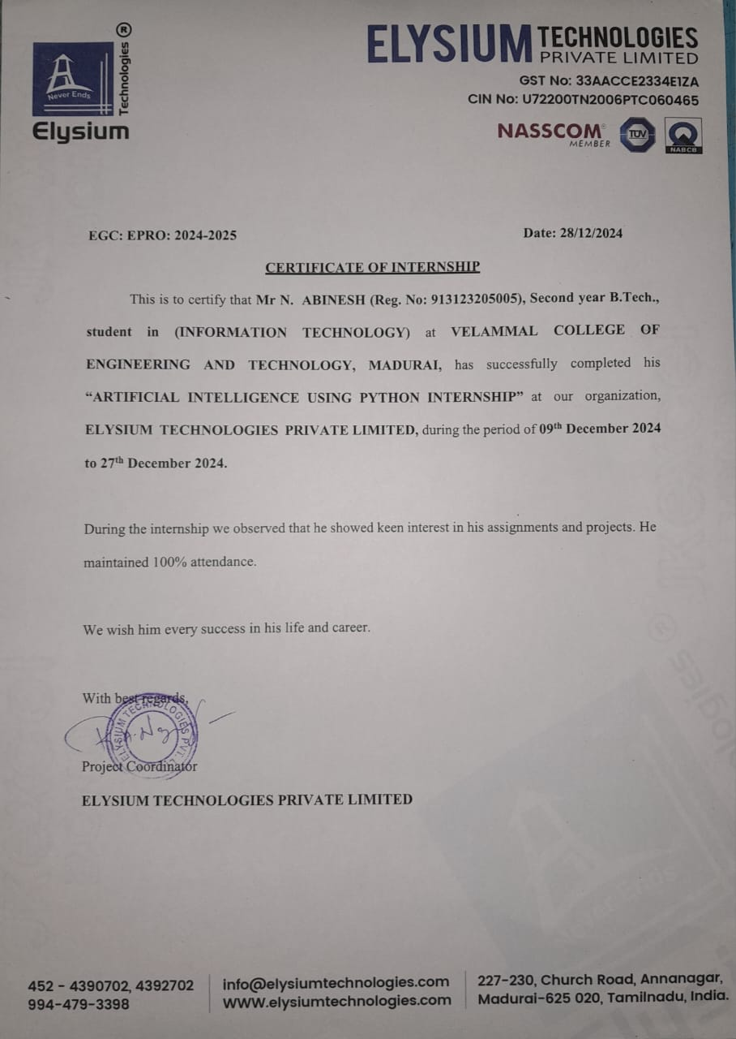



Project and Website Link

https://Abineshabee/SQL-Injection-Detection: SQL Injection Detection Using Machine Learning



https://sql-injection-detection-2jj0.onrender.com/Login Page


