PROJECT NAME : InteriorDesign

Source : src/main/java

package : com.example.interiordesign

BACKEND JAVA PROGRAMS:











Source : src/main/resources

Static

FRONTEND PROGRAM :



Templates



src/test/java

com.example.demo



 THIS ARE ALL PROJECT PROGRAM SOURCE AND TITLE OF THE PROGRAMS.

**InteriorDesignApplication.java:**

**package com.example.interiordesign;**

**import org.springframework.boot.SpringApplication;**

**import org.springframework.boot.autoconfigure.SpringBootApplication;**

**import org.springframework.boot.web.server.WebServerFactoryCustomizer;**

**import org.springframework.boot.web.servlet.server.ConfigurableServletWebServerFactory;**

**import org.springframework.context.annotation.Bean;**

**@SpringBootApplication**

**public class InteriorDesignApplication {**

**public static void main(String[] args) {**

**SpringApplication.run(InteriorDesignApplication.class, args);**

**}**

**@Bean**

**public WebServerFactoryCustomizer<ConfigurableServletWebServerFactory> webServerFactoryCustomizer() {**

**return factory -> factory.setPort(9090); // Set the port to 9090**

**}**

**}**

**Pratical Screenshot InteriorDesignApplication.java :**

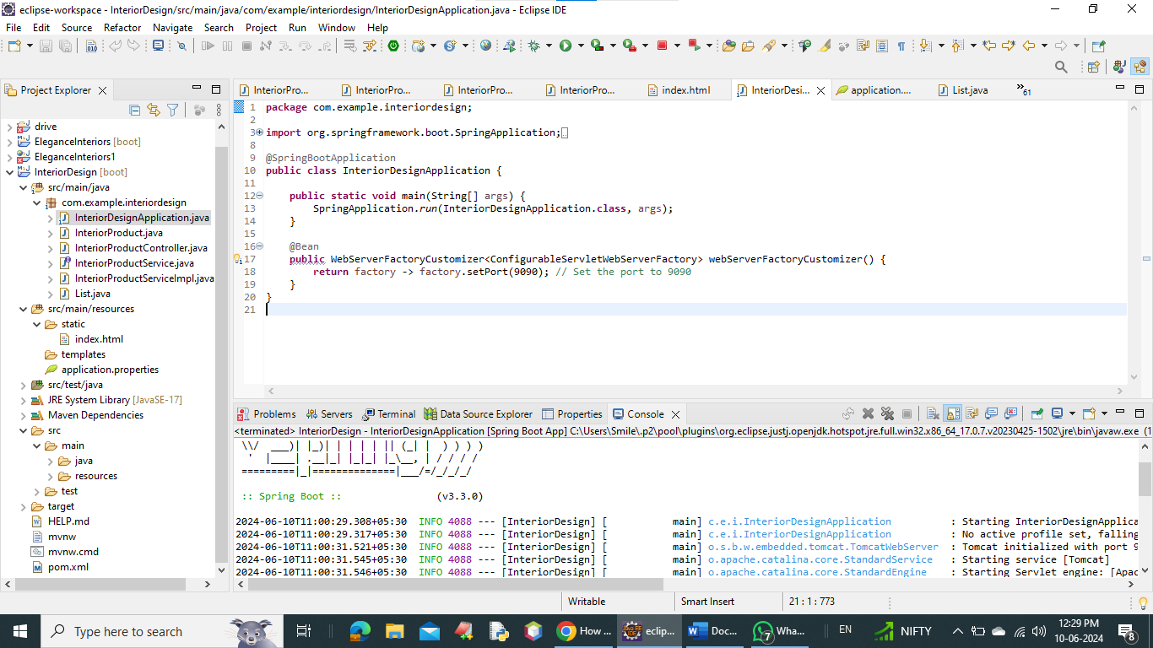

InteriorProduct.java :

**package** com.example.interiordesign;

**public** **class** InteriorProduct {

**private** String name;

**private** String description;

**private** String price;

**public** InteriorProduct() {}

**public** InteriorProduct(String name, String description, String price) {

**this**.name = name;

**this**.description = description;

**this**.price = price;

}

**public** String getName() {

**return** name;

}

**public** **void** setName(String name) {

**this**.name = name;

}

**public** String getDescription() {

**return** description;

}

**public** **void** setDescription(String description) {

**this**.description = description;

}

**public** String getPrice() {

**return** price;

}

**public** **void** setPrice(String price) {

**this**.price = price;

}

}

**Pratical Screenshot**

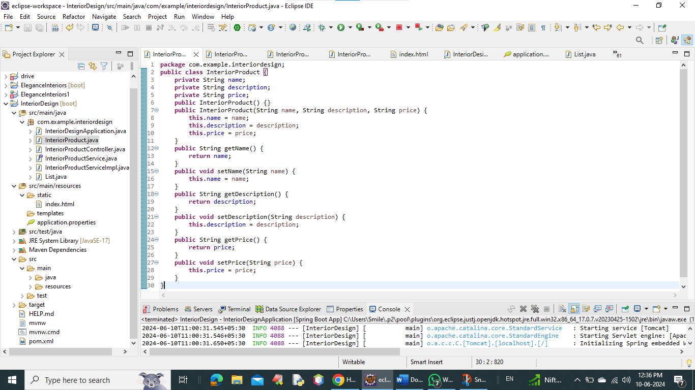

InteriorProductController.java

**package** com.example.interiordesign;

**import** org.springframework.beans.factory.annotation.Autowired;

**import** org.springframework.web.bind.annotation.GetMapping;

**import** org.springframework.web.bind.annotation.RestController;

**import** java.util.List;

@RestController

**public** **class** InteriorProductController {

@Autowired

**private** InteriorProductService productService;

@GetMapping("/products")

**public** List<InteriorProduct> getAllProducts() {

**return** productService.getAllProducts();

}

}

**Pratical Screenshot** InteriorProductController:

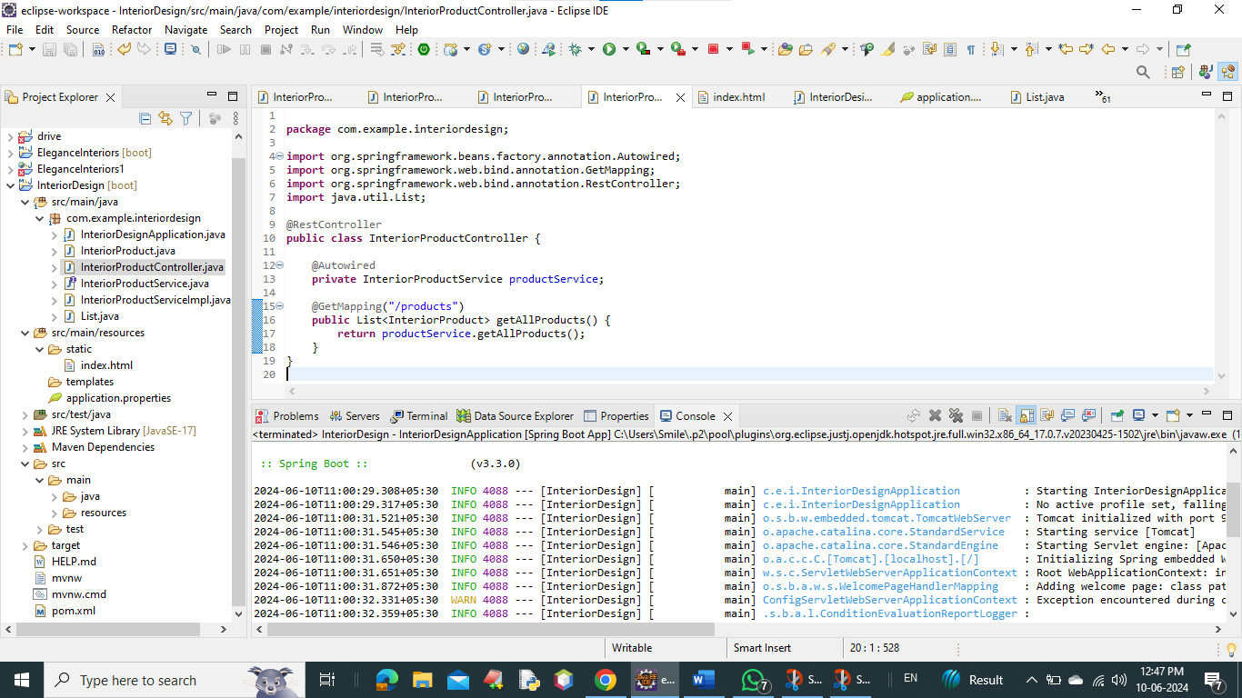

InteriorProductService.java:

**package** com.example.interiordesign;

**import** java.util.List;

**public** **interface** InteriorProductService {

List<InteriorProduct> getAllProducts();

}

**Pratical Screenshot** InteriorProductService:

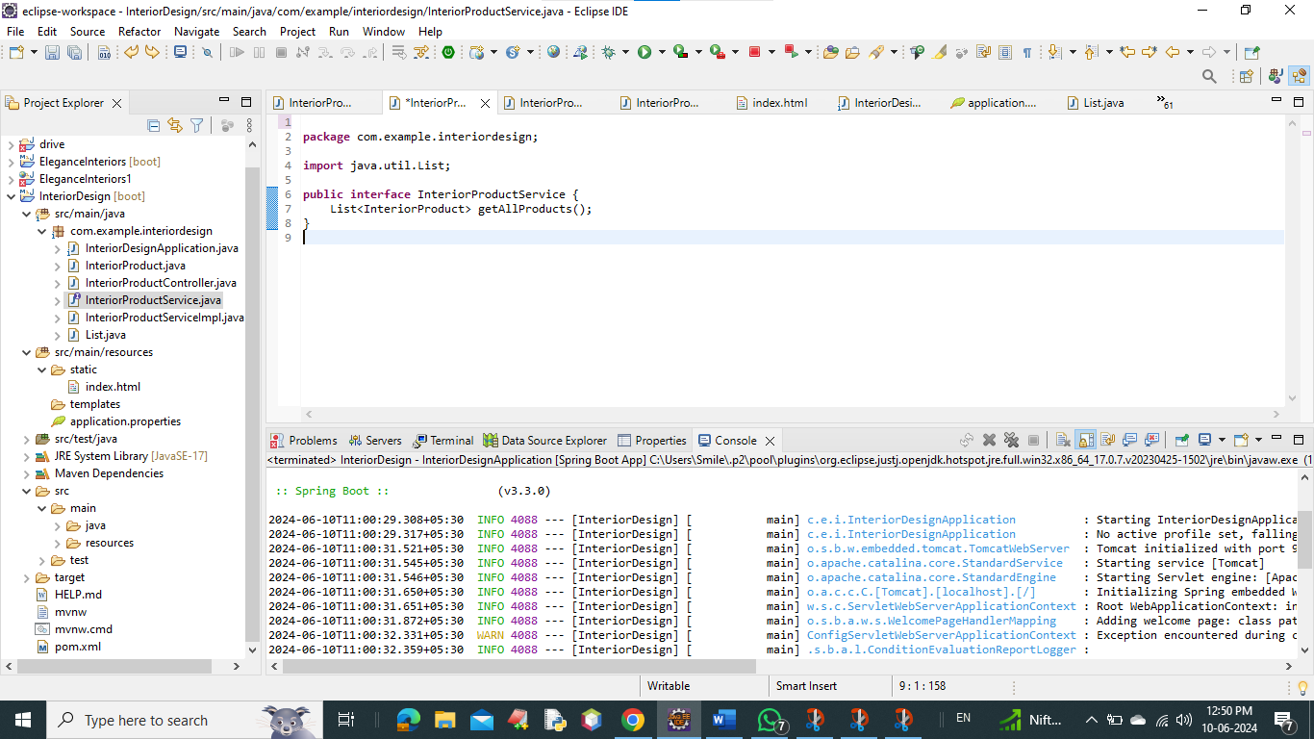

InteriorProductServiceImpl.java :

**package** com.example.interiordesign;

**import** org.springframework.stereotype.Service;

**import** java.util.ArrayList;

**import** java.util.List;

@Service

**public** **class** InteriorProductServiceImpl **implements** InteriorProductService {

@Override

**public** List<InteriorProduct> getAllProducts() {

List<InteriorProduct> products = **new** ArrayList<>();

products.add(**new** InteriorProduct("Corporate Office Painting Works", "Type of Property Covered: Commercial, Location Preference: Tamil Nadu, Type of Services Available: Regular Painting, Wall Mounted: Yes", "Rs 20 / Square Feet"));

products.add(**new** InteriorProduct("Interior Designer Wall Painting", "Service Location: Chennai, Application: Office, home and etc, Finish: Smooth, Thickness: 1-2 mm, Wall Mount: Yes", "Price on Request"));

products.add(**new** InteriorProduct("Modern Office Furniture", "Material: Wood, Style: Modern, Type: Modular, Shape: Rectangular, Country of Origin: Made in India", "Rs 8,000 / Piece"));

products.add(**new** InteriorProduct("Modular Office Cabin Furniture", "Material: Plywood, Color: Any color, Shape: L, Usage/Application: Office and Commercial", "Rs 15,000 / Piece"));

products.add(**new** InteriorProduct("Oval Shape Conference Tables", "Seating Capacity: 8 Seater, Primary Material: Plywood, Storage: Without Storage, Shape: Rectangular", "Rs 36,000 / Piece"));

products.add(**new** InteriorProduct("Office Workstation", "Layout Type: Cluster, Material: Wood, Built Type: Modular, Table Top Thickness: 3-5 mm", "Rs 6,900 / Unit"));

products.add(**new** InteriorProduct("GLD-EX-20-05 Workstation Chair", "Seat Material: Fabric, Color: Black, Warranty: 6 Months, Height Adjustable: Yes", "Rs 2,850 / Piece"));

products.add(**new** InteriorProduct("Office Cubicle Workstation", "Material: Wooden, Seating Capacity: 1 Seater, Deal In: New", "Price on Request"));

**return** products;

}

}

**Pratical Screenshot** InteriorProductServiceImpl : 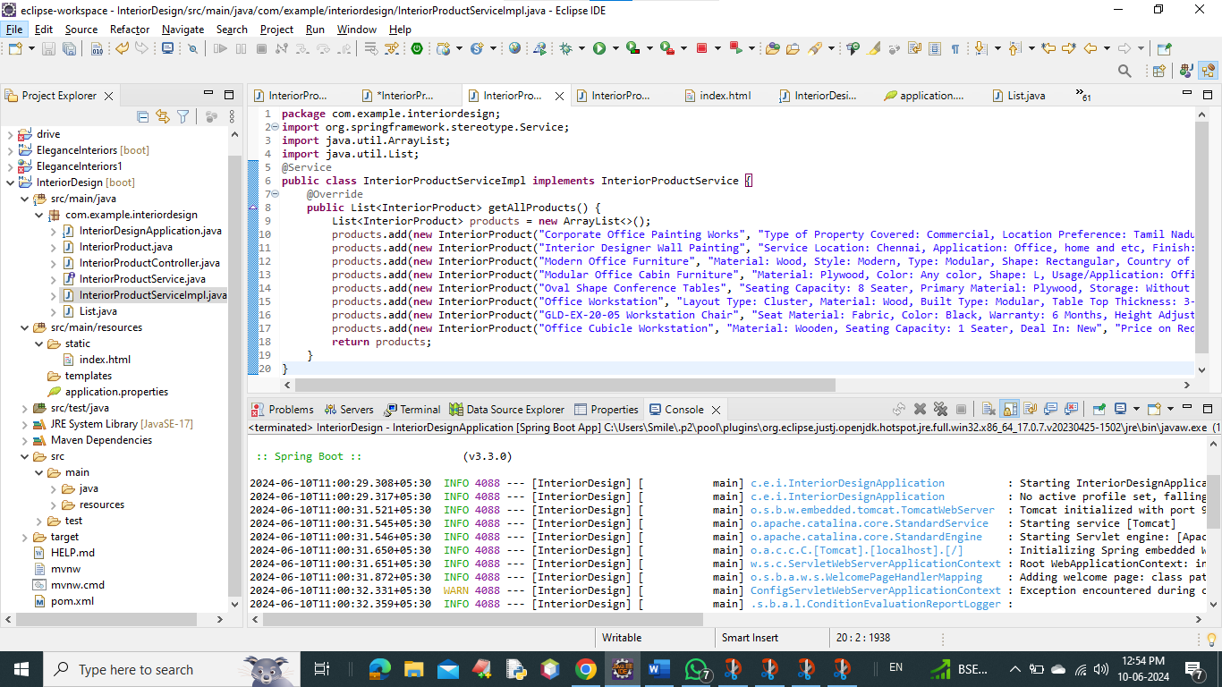

**Frontend program:**

**Index.html :**

<!DOCTYPE html>

<html lang=*"en"*>

<head>

<meta charset=*"UTF-8"*>

<meta name=*"viewport"* content=*"width=device-width, initial-scale=1.0"*>

<title>Interior Design Products and Services</title>

<style>

**body** {

font-family: *Arial, sans-serif*;

background-color: *#f0f0f0*;

color: *#333*;

margin: *0*;

padding: *20px*;

}

**h1** {

color: *#333*;

text-align: *center*;

margin-bottom: *30px*;

}

*.container* {

display: *flex*;

flex-wrap: *wrap*;

justify-content: *space-around*;

}

*.card* {

width: *300px*;

background-color: *#fff*;

border-radius: *8px*;

box-shadow: *0 4px 6px rgba(0, 0, 0, 0.1)*;

margin-bottom: *20px*;

overflow: *hidden*;

transition: *transform 0.3s*;

border: *2px solid #333*; /* Double border */

}

*.card:hover* {

transform: *translateY(-5px)*;

}

*.card-content* {

padding: *20px*;

}

/* Each detail has a different dark color */

*.product-name* { color: *#990000*; } /* Red */

*.product-price* { color: *#003366*; } /* Dark Blue */

*.product-detail* { color: *#006600*; } /* Dark Green */

/* Limit image width */

**img** {

max-width: *100%*;

height: *auto*;

}

</style>

</head>

<body>

<h1>Interior Design Products and Services</h1>

<div class=*"container"* id=*"product-container"*>

<!-- Products will be displayed here -->

</div>

<script>

fetch('/products')

.then(response => response.json())

.then(data => {

**const** container = document.getElementById('product-container');

data.forEach((product, index) => {

**const** card = document.createElement('div');

card.className = 'card';

**const** cardContent = document.createElement('div');

cardContent.className = 'card-content';

**const** name = document.createElement('div');

name.className = 'product-name';

name.innerText = product.name;

**const** price = document.createElement('div');

price.className = 'product-price';

price.innerText = 'Price: ' + product.price;

**const** description = document.createElement('div');

description.className = 'product-detail';

description.innerText = 'Details: ' + product.description;

**const** image = document.createElement('img');

**switch** (index) {

**case** 0:

image.src = 'https://www.nipponpaint.co.in/wp-content/uploads/2019/12/home-interior-wall-design-1024x683.jpg';

image.alt = 'Interior Designer Wall Painting';

**break**;

**case** 1:

image.src = 'https://5.imimg.com/data5/SELLER/Default/2022/8/YU/TQ/NX/7642058/office-painting-work-1000x1000.jpg';

image.alt = 'Corporate Office Painting Works';

**break**;

**case** 2:

image.src = 'https://image.made-in-china.com/2f0j00OMzUCELnbcqf/10-off-Luxury-Foshan-Custom-CEO-Table-Office-Wooden-Table-Executive-Desk-Modern-Office-Furniture.webp';

image.alt = 'Luxury Foshan Custom CEO Table';

**break**;

**case** 3:

image.src = 'https://image.made-in-china.com/202f0j00rBAGgYyFlmbI/Two-Persons-Modular-Office-Cabin-Partition-Table-for-Sale.webp';

image.alt = 'Modular Office Cabin Partition Table';

**break**;

**case** 4:

image.src = 'https://img.archiexpo.com/images_ae/photo-mg/88131-16973467.jpg';

image.alt = 'ArchiExpo Office Furniture';

**break**;

**case** 5:

image.src = 'https://www.tirupatioffice.com/file_upload/product/1600669083-3eb9818155ad351dcf6598d2909b8260-12.jpg';

image.alt = 'Tirupati Office Furniture';

**break**;

**case** 6:

image.src = 'https://www.jiomart.com/images/product/original/rv1eqhsas6/roar-wood-high-back-grey-white-combination-leatherette-office-executive-revolving-chair-product-images-orv1eqhsas6-p594493168-0-202210150350.jpg?im=Resize=(1000,1000)';

image.alt = 'Roar Wood High Back Chair';

**break**;

**case** 7:

image.src = 'https://stancephilippines.com/cdn/shop/products/2-Staff-Cubicle-Office-Workstation_670x543.png?v=1675303690';

image.alt = 'Staff Cubicle Office Workstation';

**break**;

**default**:

**break**;

}

cardContent.appendChild(name);

cardContent.appendChild(price);

cardContent.appendChild(description);

card.appendChild(cardContent);

card.appendChild(image);

container.appendChild(card);

});

});

</script>

</body>

</html>

**Pratical Screenshot Index.html :**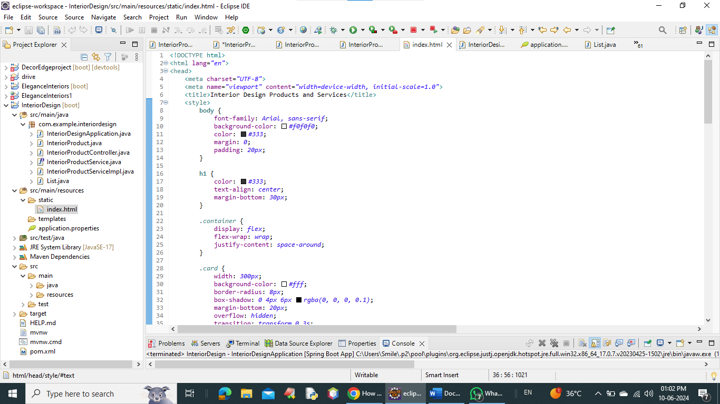

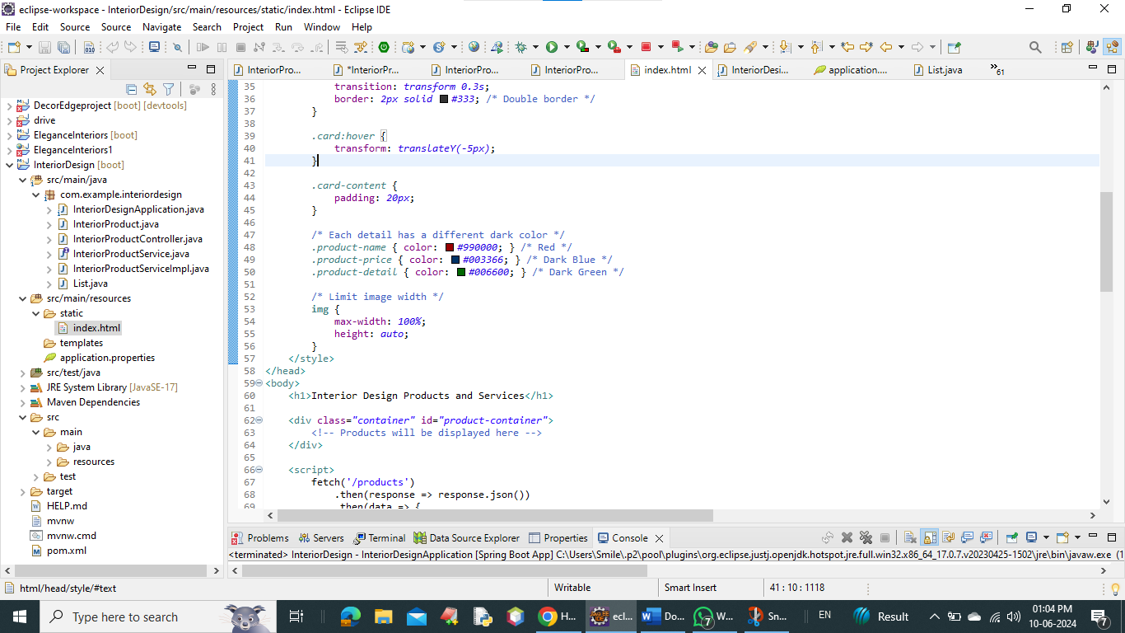

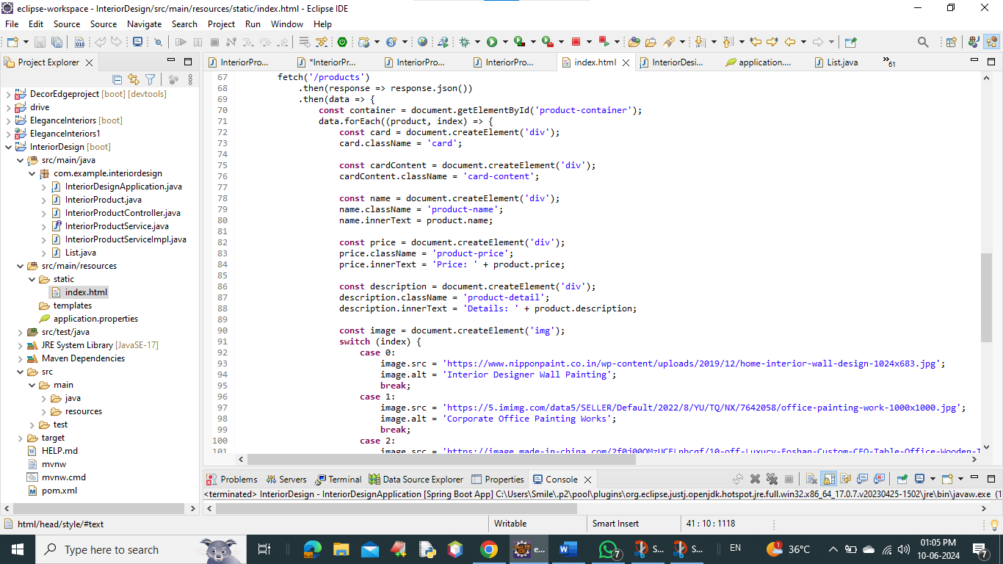

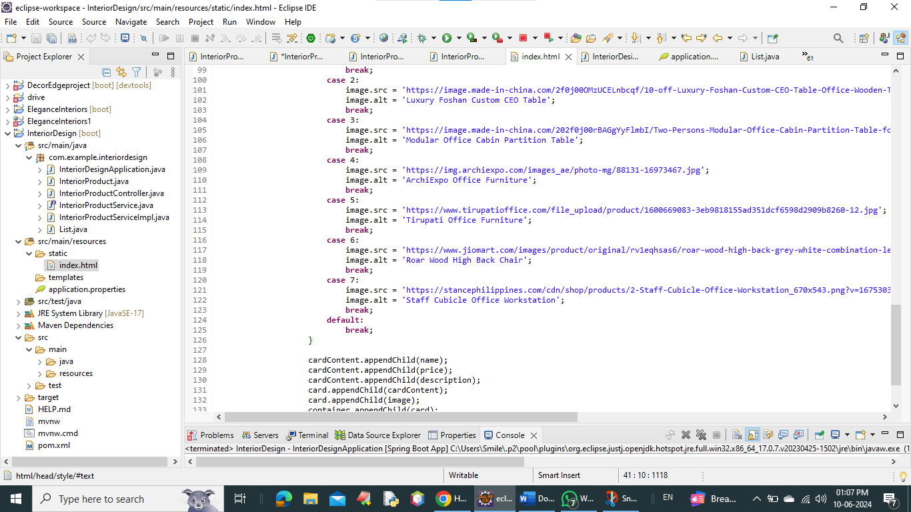

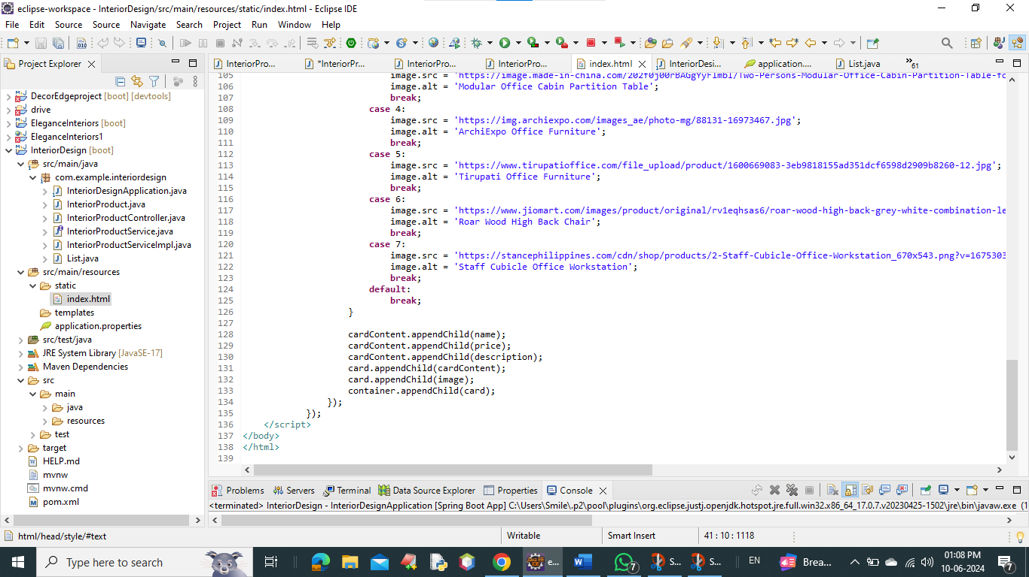

**API Collection for InteriorDesign Project :**

Get All Products :

Method: GET

Endpoint: /products

Description: Retrieves a list of all interior products.

Response:

**[**

**{**

**"name": "Corporate Office Painting Works",**

**"description": "Type of Property Covered: Commercial, Location Preference: Tamil Nadu, Type of Services Available: Regular Painting, Wall Mounted: Yes",**

**"price": "Rs 20 / Square Feet"**

**},**

**{**

**"name": "Interior Designer Wall Painting",**

**"description": "Service Location: Chennai, Application: Office, home and etc, Finish: Smooth, Thickness: 1-2 mm, Wall Mount: Yes",**

**"price": "Price on Request"**

**},**

**{**

**"name": "Modern Office Furniture",**

**"description": "Material: Wood, Style: Modern, Type: Modular, Shape: Rectangular, Country of Origin: Made in India",**

**"price": "Rs 8,000 / Piece"**

**}**

**]**

**The API endpoints are accessed through http://localhost:9090 assuming the application is running locally on port 9090.**

**Web page output in chrome** [**http://localhost:9090**](http://localhost:9090) **:**

