Virtual R Data Analyst Internship
Week 1 Report
Data Cleaning and Preliminary Analysis with R
Dataset: Titanic Passenger Data (Kaggle / R "titanic" package)
Tool: R (RGui), packages dplyr, ggplot2, corrplot
Name: Abinisha P

1. Introduction
This report documents the data cleaning, preprocessing and preliminary analysis carried out in R as part of Week 1 of the Virtual R Data Analyst Internship. The objective was to take a real-world dataset containing missing values and a mix of categorical and numerical variables, prepare it for analysis, and extract initial insights.
The Titanic passenger dataset was chosen because it contains all the complexities the task asks for: missing values in three columns, numerical and categorical variables, skewed distributions with outliers, and a clear outcome variable (Survived) that makes the exploratory findings meaningful. The same cleaned dataset will be reused in the later weeks for visualization and predictive modelling.

2. Dataset Overview
The dataset is the training file of the well-known Kaggle Titanic competition (also distributed in the R package "titanic" as titanic_train). It has 891 passengers (rows) and 12 variables (columns). Each row describes one passenger and whether they survived the sinking.
Variable | Type | Description
PassengerId | Integer | Unique ID of the passenger
Survived | Integer (0/1) | Target variable: 0 = did not survive, 1 = survived
Pclass | Integer (1/2/3) | Ticket class (1 = upper, 2 = middle, 3 = lower)
Name | Text | Passenger name including title (Mr, Mrs, Miss, etc.)
Sex | Categorical | male or female
Age | Numeric | Age in years (some missing)
SibSp | Integer | Number of siblings / spouses aboard
Parch | Integer | Number of parents / children aboard
Ticket | Text | Ticket number
Fare | Numeric | Ticket fare paid
Cabin | Text | Cabin number (mostly missing)
Embarked | Categorical | Port of embarkation: C = Cherbourg, Q = Queenstown, S = Southampton

R code:
library(titanic)
library(dplyr)
library(ggplot2)
library(corrplot)

df <- titanic_train
cat("Rows:", nrow(df), " Columns:", ncol(df), "\n")
head(df)

Output:
Rows: 891 Columns: 12

PassengerId Survived Pclass Name Sex Age SibSp Parch
1 1 0 3 Braund, Mr. Owen Harris male 22 1 0
2 2 1 1 Cumings, Mrs. John ... female 38 1 0
3 3 1 3 Heikkinen, Miss. Laina female 26 0 0
(first rows shown; full output in R console)

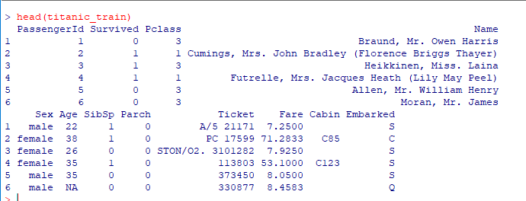

3. Initial Data Inspection
The structure and summary of the raw data were examined first using str() and summary(). This step reveals the data types, ranges and the presence of missing values.
R code:
str(df)
summary(df)

Output:
'data.frame': 891 obs. of 12 variables:
$ PassengerId: int 1 2 3 4 5 6 7 8 9 10 ...
$ Survived : int 0 1 1 1 0 0 0 0 1 1 ...
$ Pclass : int 3 1 3 1 3 3 1 3 3 2 ...
$ Name : chr "Braund, Mr. Owen Harris" ...
$ Sex : chr "male" "female" "female" "female" ...
$ Age : num 22 38 26 35 35 NA 54 2 27 14 ...
$ SibSp : int 1 1 0 1 0 0 0 3 0 1 ...
$ Parch : int 0 0 0 0 0 0 0 1 2 0 ...
$ Ticket : chr "A/5 21171" "PC 17599" ...
$ Fare : num 7.25 71.28 7.92 53.1 8.05 ...
$ Cabin : chr "" "C85" "" "C123" ...
$ Embarked : chr "S" "C" "S" "S" ...

Key observations from the raw data:
- Age has 177 NA values (about 19.9%), with a range from 0.42 to 80 years.
- Cabin contains 687 empty strings, which R does not recognise as NA until converted.
- Embarked contains 2 empty values.
- Fare ranges from 0 to 512.33 with a mean (32.20) far above the median (14.45), which signals a strongly right-skewed distribution with outliers.
- Sex, Embarked, Survived and Pclass are stored as text or integers but are really categorical variables and need proper encoding.

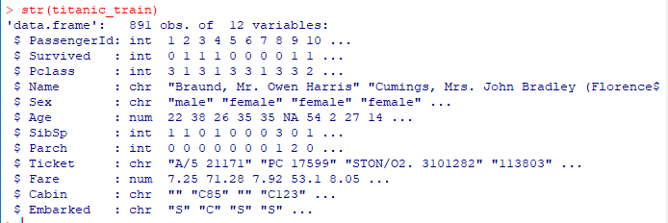

4. Handling Missing Values

4.1 Detecting missing values
Empty strings were first converted to NA so that all missing values are detected consistently. A missing-value report was then created for each variable.
R code:
df[df == ""] <- NA
missing_report <- data.frame(
variable = names(df),
n_missing = colSums(is.na(df)),
pct_missing = round(colSums(is.na(df)) / nrow(df) * 100, 2)
)
print(missing_report[order(-missing_report$pct_missing), ])

Variable | Missing count | Missing %
Cabin | 687 | 77.10
Age | 177 | 19.87
Embarked | 2 | 0.22
All other variables | 0 | 0.00

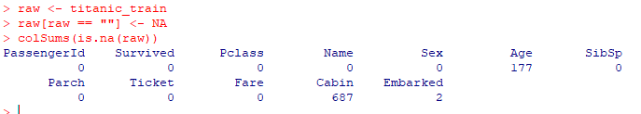
Figure 1: Percentage of missing values by variable

4.2 Treatment strategy
A different strategy was chosen for each variable based on how much data was missing and how important the variable is.
Cabin (77.1% missing): Too much information is missing to impute reliably. Instead of discarding all information, a binary flag HasCabin (1 = cabin recorded, 0 = not recorded) was created and the original column was dropped. Having a recorded cabin is a proxy for higher social class.
Age (19.9% missing): Imputed with the median age of the passenger's group, defined by Pclass and Sex. The median was chosen over the mean because it is robust to outliers, and grouping preserves differences between groups (for example, first-class passengers were older on average than third-class passengers). This is more accurate than a single global median.
Embarked (0.22% missing): Only two values were missing, so they were filled with the mode (most frequent port), which is Southampton (S).
R code:
# Cabin: keep a flag, drop the column
df$HasCabin <- ifelse(is.na(df$Cabin), 0, 1)
df$Cabin <- NULL

# Age: median imputation by Pclass and Sex
df <- df %>%
group_by(Pclass, Sex) %>%
mutate(Age = ifelse(is.na(Age), median(Age, na.rm = TRUE), Age)) %>%
ungroup()

# Embarked: mode imputation
mode_embarked <- names(sort(table(df$Embarked), decreasing = TRUE))[1]
df$Embarked[is.na(df$Embarked)] <- mode_embarked

cat("Missing values remaining:", sum(is.na(df)), "\n")

Output:
Missing values remaining: 0

After treatment the dataset contains no missing values. The mean age changed slightly from 29.70 (observed values only) to 29.11 after imputation, showing the imputation did not distort the distribution much.

5. Feature Engineering and Column Removal
Two useful features were derived and three columns that carry no analytical value were removed.
- Title: extracted from the Name column using a regular expression (Mr, Mrs, Miss, Master). Rare titles such as Dr, Rev, Col, Major, Capt, Sir, Lady and the Countess were grouped into a single "Rare" category, and Mlle / Ms / Mme were merged into Miss / Mrs.
- FamilySize: SibSp + Parch + 1 (the passenger plus their relatives aboard).
- Removed: PassengerId (just an identifier), Name (replaced by Title) and Ticket (681 unique values, no usable pattern).
R code:
df$Title <- gsub("(.*, )|(\\..*)", "", df$Name)
rare <- c("Dr","Rev","Col","Major","Capt","Don","Jonkheer",
"the Countess","Sir","Lady","Dona")
df$Title[df$Title %in% rare] <- "Rare"
df$Title[df$Title %in% c("Mlle","Ms")] <- "Miss"
df$Title[df$Title == "Mme"] <- "Mrs"
df$FamilySize <- df$SibSp + df$Parch + 1
df <- df %>% select(-PassengerId, -Name, -Ticket)

6. Outlier Detection and Treatment
Outliers were detected using the Interquartile Range (IQR) rule: any value below Q1 - 1.5 x IQR or above Q3 + 1.5 x IQR is flagged as an outlier. Boxplots were used to visualise them.
R code:
detect_outliers <- function(x) {
q <- quantile(x, c(0.25, 0.75), na.rm = TRUE)
iqr <- q[2] - q[1]
x < (q[1] - 1.5 * iqr) | x > (q[2] + 1.5 * iqr)
}
cat("Age outliers:", sum(detect_outliers(df$Age)), "\n")
cat("Fare outliers:", sum(detect_outliers(df$Fare)), "\n")

Output:
Age outliers: 33
Fare outliers: 116

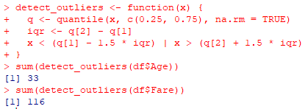
Figure 2: Boxplots of Age and Fare before outlier treatment
Age (33 outliers): These were retained. They correspond to genuine elderly passengers and are plausible real-world values (maximum 80 years), not data errors.
Fare (116 outliers): Fare is heavily right-skewed with a maximum of 512.33, which would dominate any distance-based or regression analysis. The values were capped (winsorized) at the upper IQR fence, which is about 65.63. Capping keeps every passenger in the dataset while limiting the influence of extreme fares.
R code:
q <- quantile(df$Fare, c(0.25, 0.75))
upper <- q[2] + 1.5 * (q[2] - q[1])
df$Fare_capped <- pmin(df$Fare, upper)

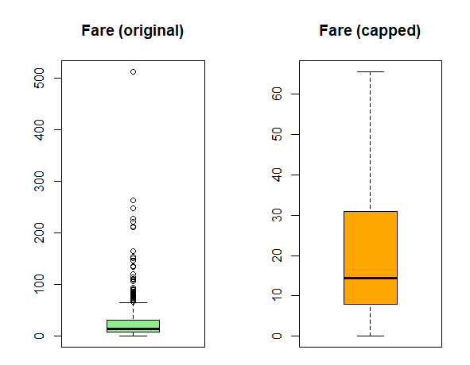
Figure 3: Fare before (original) and after (capped) outlier treatment

7. Normalization
Age and Fare are measured on very different scales, which can bias many algorithms. Two common scaling methods were applied: Min-Max normalization (rescales values to the 0 to 1 range) and Z-score standardization (mean 0, standard deviation 1). Min-Max scaling was applied to Age and the capped Fare, and a Z-score version of Age was also created for comparison.
R code:
min_max <- function(x) (x - min(x)) / (max(x) - min(x))
df$Age_scaled <- min_max(df$Age)
df$Fare_scaled <- min_max(df$Fare_capped)
df$Age_z <- as.numeric(scale(df$Age))
summary(df[, c("Age_scaled", "Fare_scaled", "Age_z")])

Output:
Age_scaled Fare_scaled Age_z
Min. :0.0000 Min. :0.0000 Min. :-2.1566
1st Qu.:0.2649 1st Qu.:0.1205 1st Qu.:-0.5722
Median :0.3214 Median :0.2202 Median :-0.2339
Mean :0.3605 Mean :0.3664 Mean : 0.0000
3rd Qu.:0.4471 3rd Qu.:0.4723 3rd Qu.: 0. 5177
Max. :1.0000 Max. :1.0000 Max. : 3.8249

The output confirms that the scaled variables range from 0 to 1 and that the Z-score variable has a mean of exactly 0.

8. Encoding Categorical Variables
Categorical variables were converted into forms suitable for analysis and modelling:
- Survived: converted to a factor with labels No / Yes.
- Pclass: converted to an ordered factor (1 < 2 < 3), since class has a natural order.
- Sex, Embarked, Title: converted to factors.
- Label encoding: Sex_num (male = 1, female = 0).
- One-hot encoding: Embarked and Title were expanded into binary indicator columns (EmbarkedC/Q/S and TitleMiss/Mr/Mrs/Rare) using model.matrix().
R code:
df$Survived <- factor(df$Survived, levels = c(0, 1), labels = c("No", "Yes"))
df$Pclass <- factor(df$Pclass, levels = c(1, 2, 3), ordered = TRUE)
df$Sex <- factor(df$Sex)
df$Embarked <- factor(df$Embarked)
df$Title <- factor(df$Title)

df$Sex_num <- ifelse(df$Sex == "male", 1, 0)
onehot <- model.matrix(~ Embarked + Title - 1, data = df)
df <- cbind(df, onehot)
str(df)

Output:
'data.frame': 891 obs. of 23 variables:
$ Survived : Factor w/ 2 levels "No","Yes": 1 2 2 2 1 1 1 1 2 2 ...
$ Pclass : Ord.factor w/ 3 levels "1"<"2"<"3": 3 1 3 1 3 3 1 3 3 2 ...
$ Sex : Factor w/ 2 levels "female","male": 2 1 1 1 2 2 2 2 1 1 ...
$ Age : num 22 38 26 35 35 25 54 2 27 14 ...
$ SibSp : int 1 1 0 1 0 0 0 3 0 1 ...
$ Parch : int 0 0 0 0 0 0 0 1 2 0 ...
$ Fare : num 7.25 71.28 7.92 53.1 8.05 ...
$ Embarked : Factor w/ 3 levels "C","Q","S": 3 1 3 3 3 2 3 3 3 1 ...
$ HasCabin : num 0 1 0 1 0 0 1 0 0 0 ...
$ Title : Factor w/ 5 levels "Master","Miss",..: 3 4 2 4 3 3 3 1 4 4 ...
$ FamilySize : num 2 2 1 2 1 1 1 5 3 2 ...
$ Fare_capped: num 7.25 65.63 7.92 53.1 8.05 ...
$ Age_scaled : num 0.271 0.472 0.321 0.435 0.435 ...
$ Fare_scaled: num 0.11 1 0.121 0.809 0.123 ...
$ Age_z : num -0.535 0.668 -0.234 0.443 0.443 ...
$ Sex_num : num 1 0 0 0 1 1 1 1 0 0 ...
$ EmbarkedC : num 0 1 0 0 0 0 0 0 0 1 ...
... (EmbarkedQ, EmbarkedS, TitleMiss, TitleMr, TitleMrs, TitleRare)

The cleaned dataset has 891 rows and 23 variables and is fully numeric or factor-typed with no missing values. It was saved as titanic_clean.rds and titanic_clean.csv for use in the later weeks.

9. Exploratory Data Analysis

9.1 Descriptive statistics
R code:
desc <- df %>% summarise(
mean_age = mean(Age), median_age = median(Age), sd_age = sd(Age),
mean_fare = mean(Fare), median_fare = median(Fare), sd_fare = sd(Fare)
)
print(desc)

Statistic | Age | Fare
Mean | 29.11 | 32.20
Median | 26.00 | 14.45
Standard deviation | 13.30 | 49.69

Age is fairly symmetric (mean close to median), while Fare is strongly right-skewed: the mean is more than double the median and the standard deviation is larger than the mean. This confirms the need for the outlier capping applied earlier.

9.2 Survival analysis
R code:
prop.table(table(df$Survived))
round(prop.table(table(df$Sex, df$Survived), 1) * 100, 1)
round(prop.table(table(df$Pclass, df$Survived), 1) * 100, 1)

Output:
No Yes
0.6161616 0.3838384

No Yes
female 25.8 74.2
male 81.1 18.9

No Yes
1 37.0 63.0
2 52.7 47.3
3 75.8 24.2

Group | Did not survive (%) | Survived (%)
Overall | 61.6 | 38.4
Female | 25.8 | 74.2
Male | 81.1 | 18.9
1st class | 37.0 | 63.0
2nd class | 52.7 | 47.3
3rd class | 75.8 | 24.2

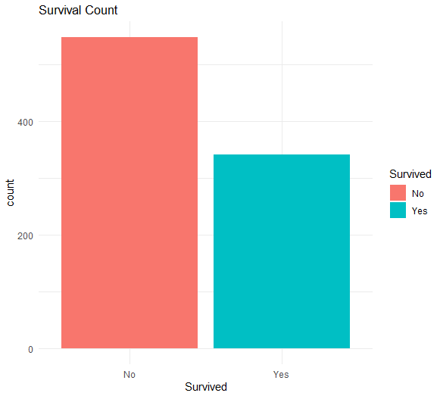
Figure 4: Overall survival count

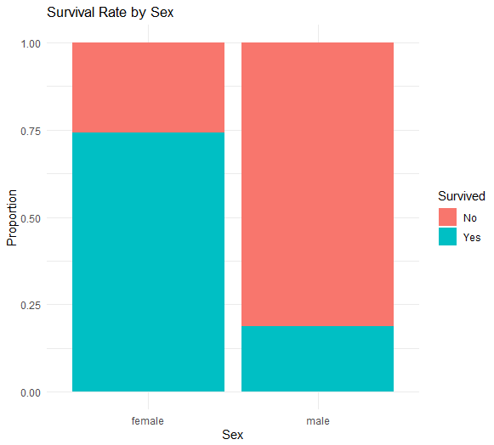
Figure 5: Survival rate by sex
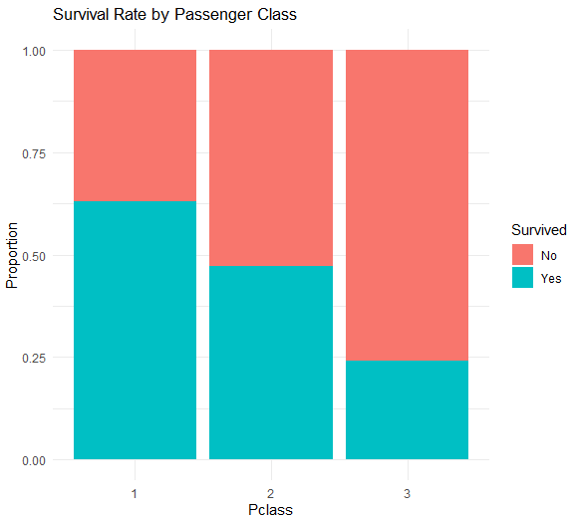
Figure 6: Survival rate by passenger class
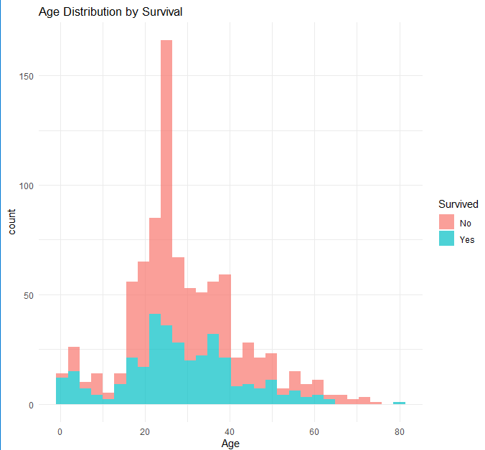
Figure 7: Age distribution by survival

9.3 Correlation analysis
A correlation matrix was computed for the numeric variables (Survived and Pclass were converted to numbers for this purpose).
R code:
num_vars <- df %>%
mutate(Survived_num = as.numeric(Survived) - 1,
Pclass_num = as.numeric(Pclass)) %>%
select(Survived_num, Pclass_num, Age, SibSp, Parch,
Fare_capped, FamilySize, HasCabin, Sex_num)
cor_mat <- cor(num_vars)
print(round(cor_mat, 2))
corrplot(cor_mat, method = "color", type = "upper", addCoef.col = "black")

Variable pair | Correlation | Interpretation
Survived vs Sex (male = 1) | -0.54 | Strongest link: males survived far less
Survived vs Pclass | -0.34 | Lower class (higher number), lower survival
Survived vs Fare (capped) | 0.32 | Higher fare, higher survival
Survived vs HasCabin | 0.32 | Recorded cabin, higher survival
Pclass vs Fare (capped) | -0.72 | Higher class pays higher fares
SibSp vs FamilySize | 0.89 | Highly correlated (FamilySize is built from SibSp)

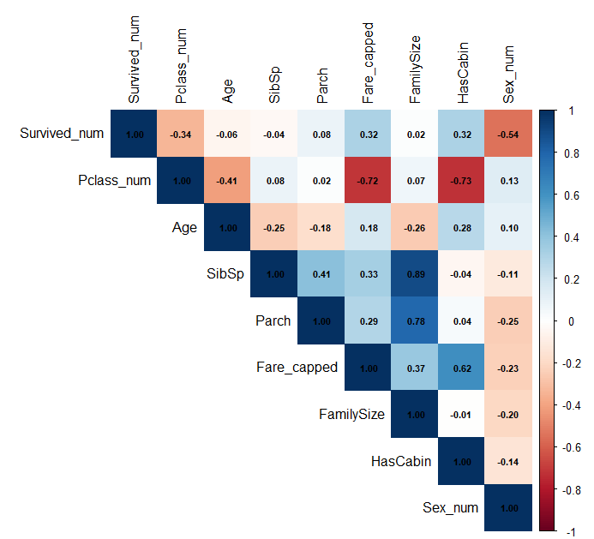
Figure 8: Correlation matrix of numeric variables

9.4 Key initial insights
- Only 38.4% of passengers survived, so the classes are moderately imbalanced.
- Sex is the strongest predictor: 74.2% of women survived compared to 18.9% of men, consistent with the "women and children first" evacuation policy.
- Passenger class matters strongly: survival fell from 63.0% in first class to 24.2% in third class.
- Fare and HasCabin are positively related to survival, but they largely reflect passenger class (Pclass and Fare correlate at -0.72), so they may add little independent information.
- Age has only a weak linear correlation with survival (-0.06), but the age histogram suggests children had better survival odds, which a linear correlation does not fully capture.
- SibSp, Parch and FamilySize are strongly correlated with each other (up to 0.89), so multicollinearity should be considered in future modelling.

10. Conclusion and Next Steps
In Week 1 the raw Titanic dataset was inspected, cleaned and prepared for analysis. Missing values in Cabin, Age and Embarked were handled using strategies suited to each variable, outliers were detected with the IQR rule and treated where appropriate, numeric variables were normalized, and categorical variables were encoded using factor, label and one-hot encoding. Exploratory analysis revealed that sex and passenger class are the dominant factors related to survival.
The cleaned dataset (titanic_clean.rds / titanic_clean.csv) will be used in Week 2 to build richer visualizations and in Week 3 for hypothesis testing and a predictive model of survival.

