Virtual R Data Analyst Internship
Report
Data Visualization and Insight Communication using R
Dataset: Titanic Passenger Data
Tool: R (RGui), packages ggplot2 and dplyr
Name: Abinisha P

1. Introduction
In Week 1 the Titanic passenger data was cleaned and prepared. The goal of Week 2 is to turn that clean data into clear pictures that anyone can understand, including readers with no technical background. Charts make patterns, trends and unusual cases much easier to see than tables of numbers.
This report presents ten visualizations created with the ggplot2 package in R. Each one uses a different chart type (bar chart, histogram, boxplot, scatter plot, line chart and heatmap) and answers a specific question about who survived the Titanic disaster and why. For every chart the report explains why that chart type was chosen, shows the R code, and interprets what the picture tells us.

2. Data Overview
The data used is the cleaned Titanic passenger dataset saved at the end of Week 1 (titanic_clean.rds). It contains 891 passengers. There are no missing values, outliers in Fare were capped, and categorical variables were converted into factors. The key variables used in the charts are described below.
Variable | Type | Meaning
Survived | Factor (No / Yes) | Whether the passenger survived (outcome of interest)
Pclass | Ordered factor (1, 2, 3) | Ticket class: 1st (upper), 2nd (middle), 3rd (lower)
Sex | Factor | female or male
Age | Numeric | Age in years (missing values filled in Week 1)
Fare_capped | Numeric | Ticket price, with extreme values capped at 65.63
FamilySize | Numeric | The passenger plus siblings, spouse, parents and children aboard
Title | Factor | Mr, Mrs, Miss, Master or Rare (from the passenger name)
AgeGroup | Factor (new) | Age bands created for this week: 0-12, 13-18, 19-30, 31-45, 46-60, 60+
Survived_num | Numeric (new) | 1 if survived, 0 if not; its average gives the survival rate

2.1 Setup
R code:
library(dplyr)
library(ggplot2)

setwd("C:/Users/My Laptop/Documents/yuva intern")
df <- readRDS("titanic_clean.rds")
dir.create("plots_week2", showWarnings = FALSE)

df$Survived_num <- ifelse(df$Survived == "Yes", 1, 0)
pal <- c("No" = "#E74C3C", "Yes" = "#2E86C1") # red = died, blue = survived

cat("Rows:", nrow(df), " Columns:", ncol(df), "\n")

Output:
Rows: 891 Columns: 24

A consistent colour scheme was used across the report: red always means the passenger did not survive and blue means the passenger survived. This helps readers understand each new chart quickly. All charts were saved at 300 dpi for high quality.

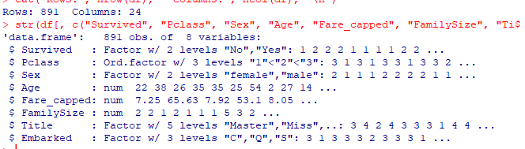

3. Visualizations and Interpretation

3.1 Chart 1: Passengers by Class and Survival (Bar Chart)
Why this chart: A bar chart is the simplest way to compare counts across categories. Placing the "died" and "survived" bars side by side for each class shows both the size of each class and its outcome.
R code:
p1 <- ggplot(df, aes(x = Pclass, fill = Survived)) +
geom_bar(position = "dodge") +
scale_fill_manual(values = pal) +
labs(title = "Passengers by Class and Survival",
x = "Passenger Class", y = "Number of Passengers") +
theme_minimal(base_size = 12)
print(p1)
ggsave("plots_week2/chart1_class_bar.png", p1, width = 7, height = 5, dpi = 300)
print(table(df$Pclass, df$Survived))

Output:
No Yes
1 80 136
2 97 87
3 372 119

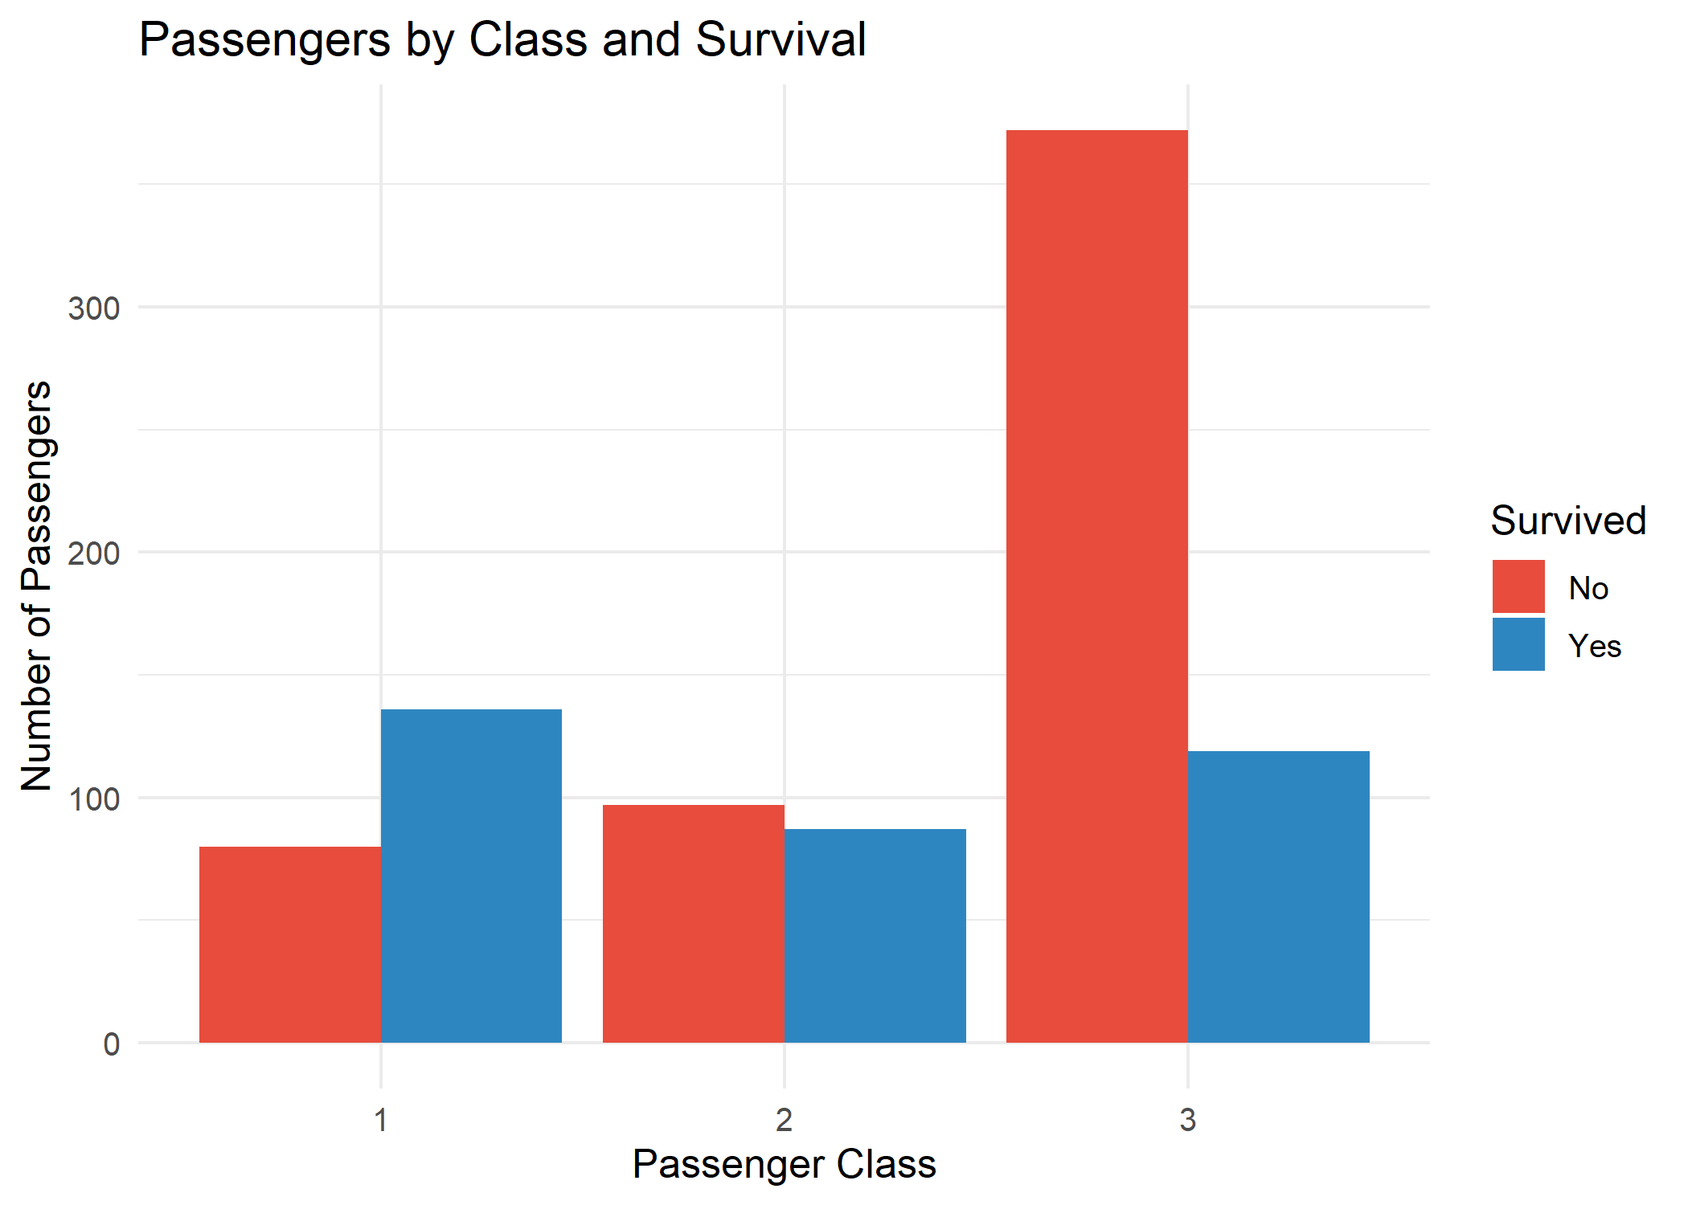
Figure 1: Passengers by class and survival
Interpretation: Third class was by far the largest group with 491 passengers, and 372 of them (about 76%) did not survive. In first class the pattern is reversed: 136 of 216 passengers survived. Second class was close to balanced (97 died, 87 survived).
What this means in plain words: The poorer a passenger's ticket, the lower the chance of survival. Most of the people who died were travelling in third class.

3.2 Chart 2: Survival Rate by Sex and Class (Grouped Bar Chart)
Why this chart: Counts alone can mislead when groups have different sizes, so this chart uses percentages. Grouping bars by sex inside each class shows whether the effect of sex changes with class.
R code:
rate_sc <- df %>% group_by(Pclass, Sex) %>%
summarise(rate = mean(Survived_num) * 100, n = n(), .groups = "drop")
p2 <- ggplot(rate_sc, aes(x = Pclass, y = rate, fill = Sex)) +
geom_col(position = "dodge") +
geom_text(aes(label = paste0(round(rate, 1), "%")),
position = position_dodge(width = 0.9), vjust = -0.4, size = 3.5) +
scale_fill_manual(values = c("female" = "#C0392B", "male" = "#2874A6")) +
ylim(0, 105) +
labs(title = "Survival Rate by Sex and Class",
x = "Passenger Class", y = "Survival Rate (%)") +
theme_minimal(base_size = 12)
print(p2)
print(rate_sc)

Output:
Pclass Sex rate n
1 1 female 96.8 94
2 1 male 36.9 122
3 2 female 92.1 76
4 2 male 15.7 108
5 3 female 50 144
6 3 male 13.5 347

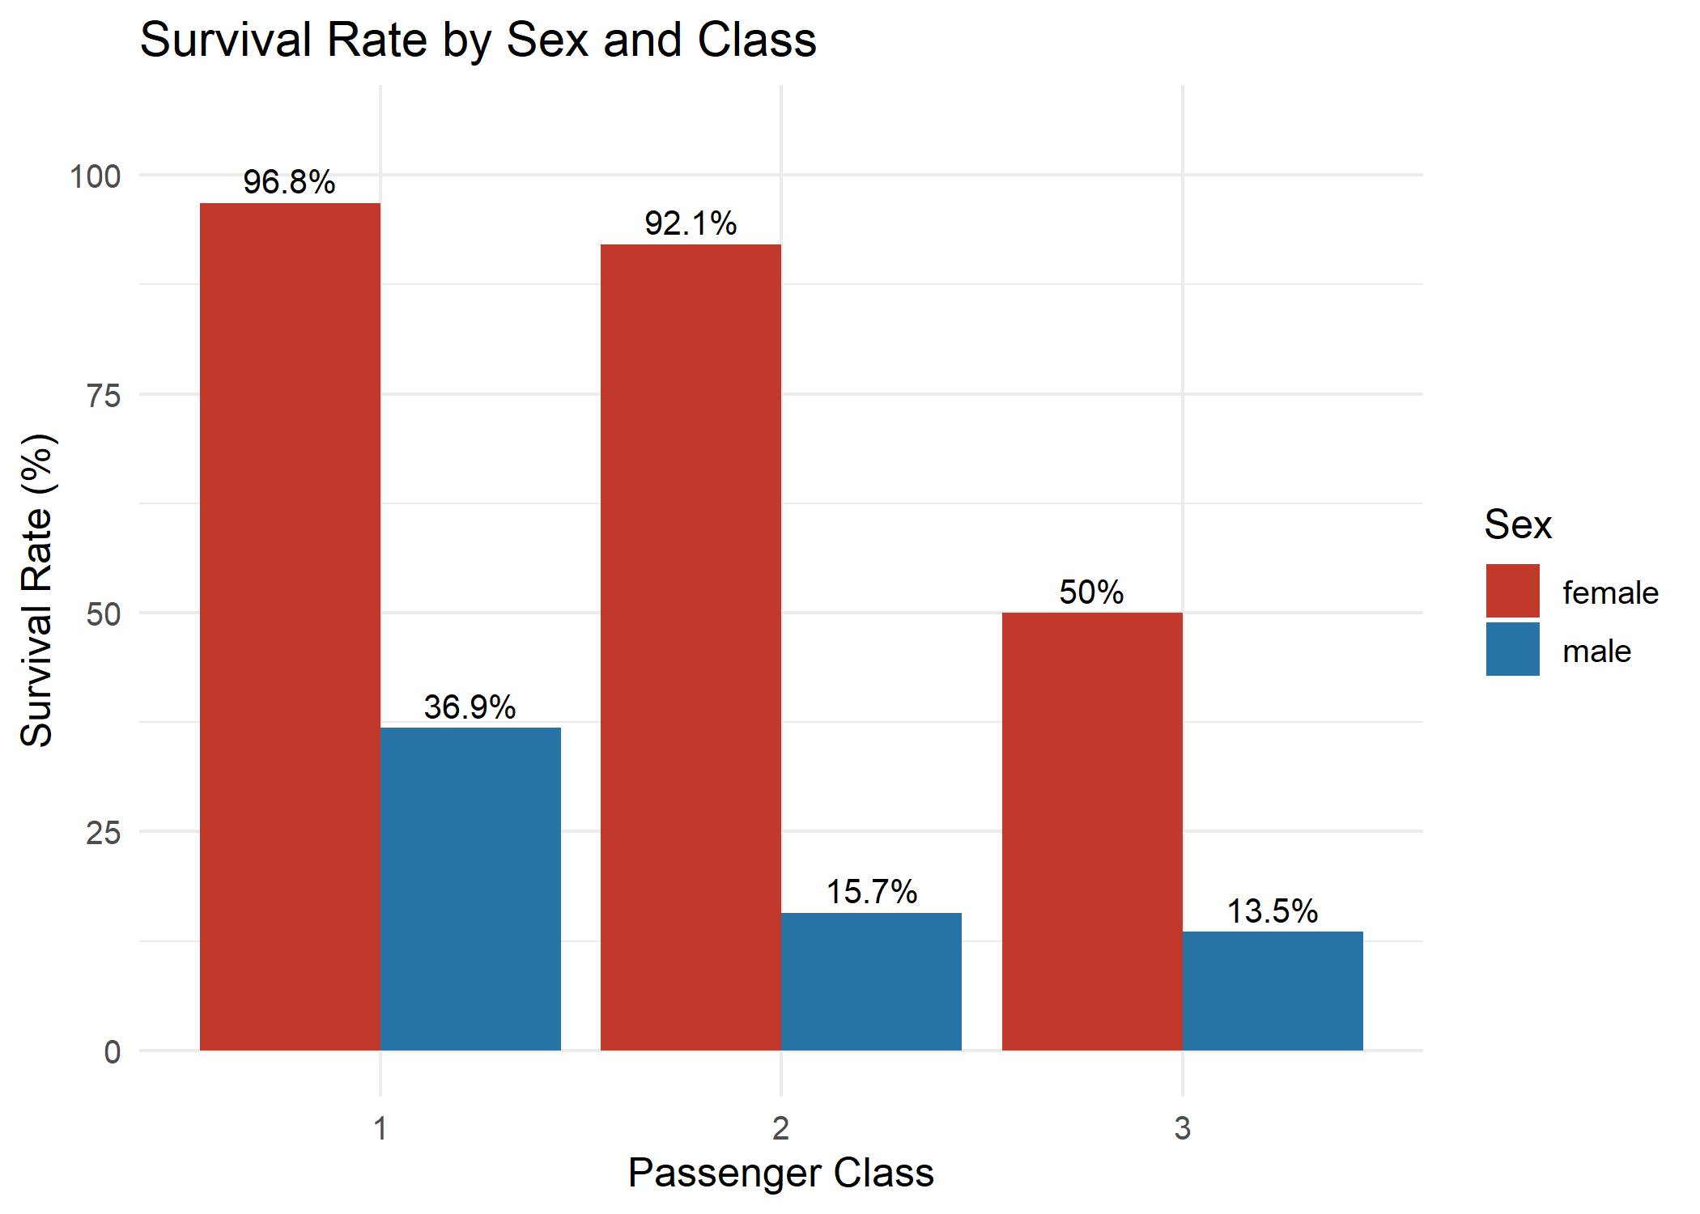
Figure 2: Survival rate by sex within each passenger class
Interpretation: Women survived at much higher rates than men in every class. Almost all first-class women (96.8%) and second-class women (92.1%) survived, but only half of third-class women did (50%). Men fared poorly everywhere, especially in second class (15.7%) and third class (13.5%), while first-class men did better (36.9%).
What this means in plain words: Being female gave a big advantage, which matches the "women and children first" rule. Class mattered most for women: a third-class woman had a far lower chance than a first-class woman.

3.3 Chart 3: Age Distribution by Survival (Histogram)
Why this chart: A histogram shows how a numeric variable is spread out. Splitting it into two panels, one for passengers who died and one for those who survived, makes it easy to compare the shapes.
R code:
p3 <- ggplot(df, aes(x = Age, fill = Survived)) +
geom_histogram(bins = 25, color = "white") +
facet_wrap(~ Survived, labeller = labeller(Survived =
c(No = "Did not survive", Yes = "Survived"))) +
scale_fill_manual(values = pal) +
labs(title = "Age Distribution of Passengers by Survival",
x = "Age (years)", y = "Number of Passengers") +
theme_minimal(base_size = 12) + theme(legend.position = "none")
print(p3)

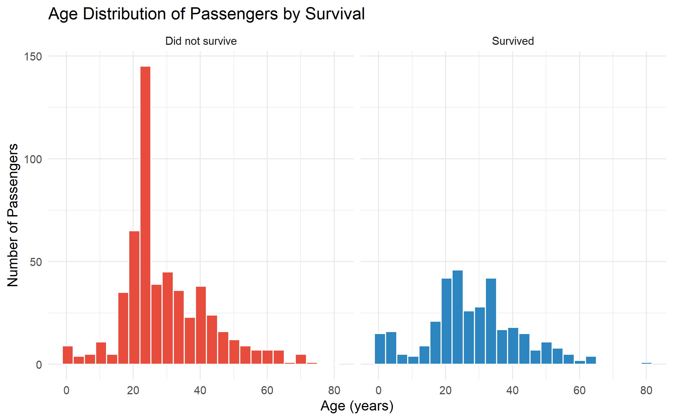
Figure 3: Age distribution of passengers by survival
Interpretation: In both panels most passengers were young adults, so the tallest bars are in the 20 to 35 age range. This age range has a much taller bar for passengers who did not survive. The very tall bar around age 24 is partly caused by filling missing ages with group medians in Week 1. Very young children appear more often in the survived panel than their numbers would suggest, which is explored further in Chart 7.
What this means in plain words: Most people on board were young adults, and that group suffered the most deaths. Small children had better chances.

3.4 Chart 4: Distribution of Ticket Fares (Histogram)
Why this chart: Fare was the most skewed variable in Week 1. A histogram of the capped fares shows how prices are distributed after the outlier treatment.
R code:
p4 <- ggplot(df, aes(x = Fare_capped)) +
geom_histogram(bins = 30, fill = "#27AE60", color = "white") +
labs(title = "Distribution of Ticket Fares (after outlier capping)",
x = "Fare (capped)", y = "Number of Passengers") +
theme_minimal(base_size = 12)
print(p4)

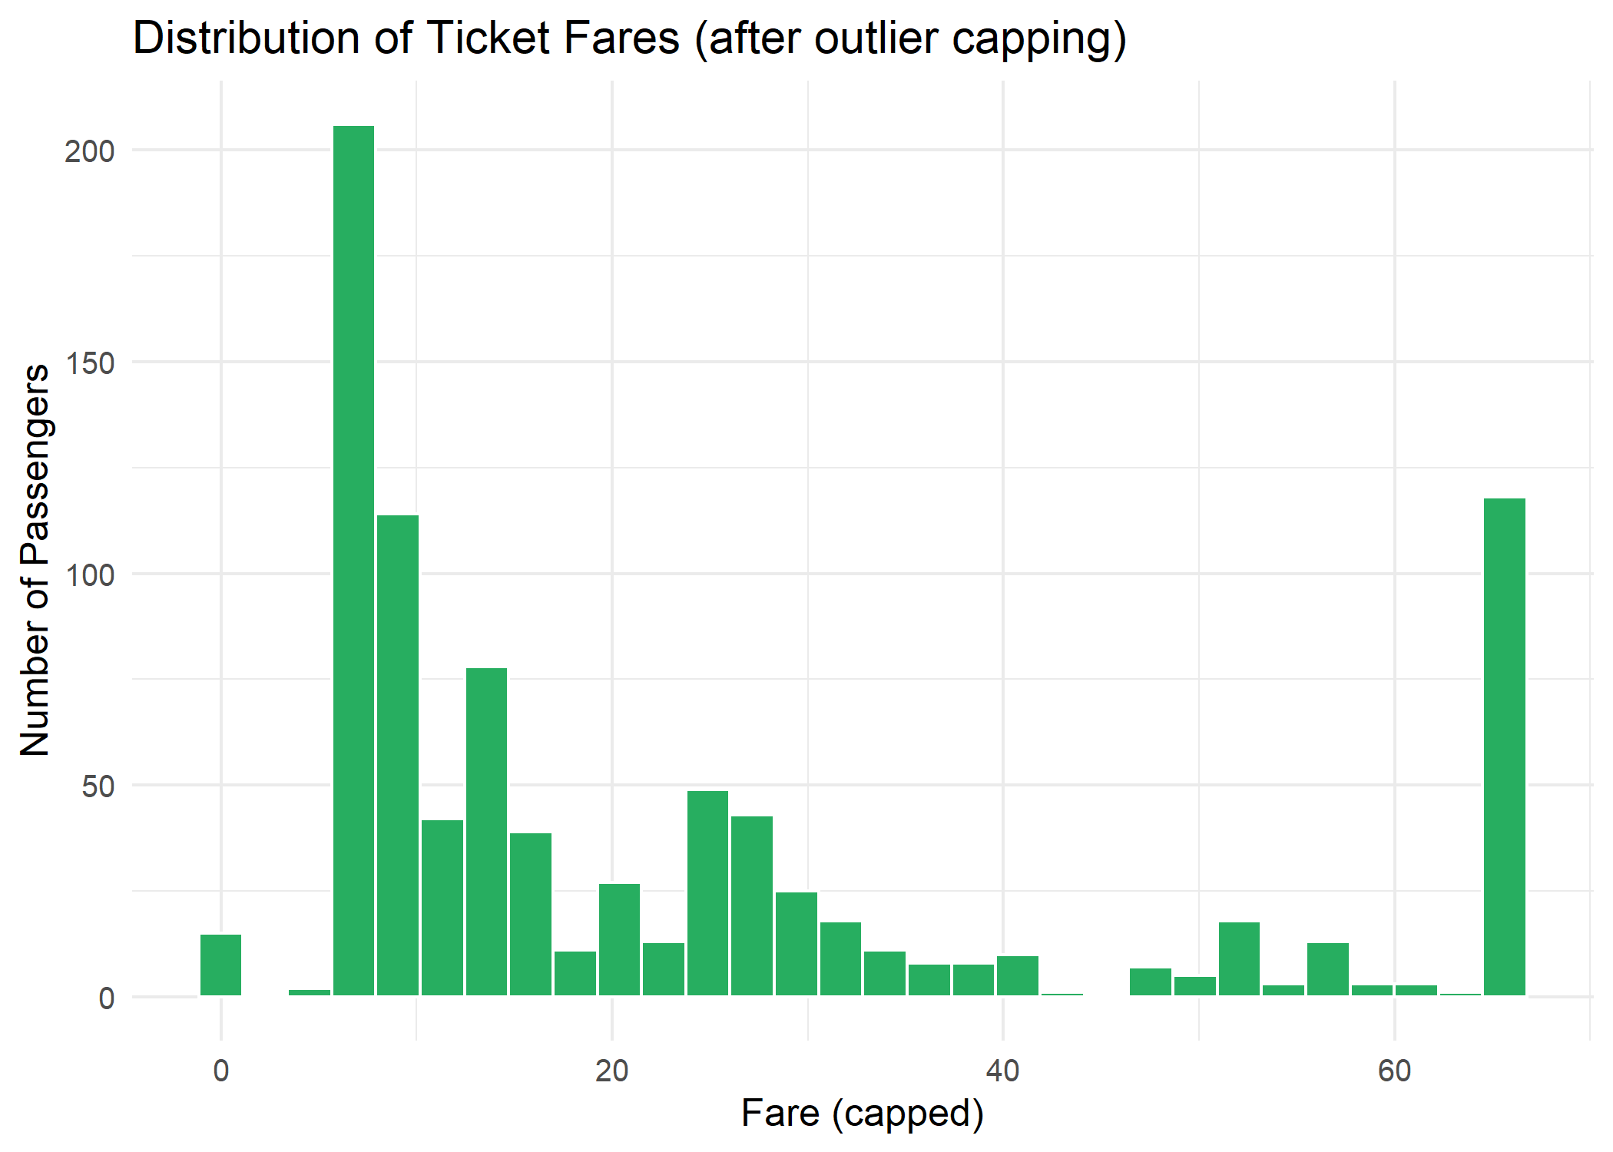
Figure 4: Distribution of ticket fares after outlier capping
Interpretation: The distribution is strongly right-skewed: most passengers paid low fares (the median fare is 14.45 and three quarters paid 31 or less), while a smaller group paid much more. The tall bar at the far right is the effect of capping, where all fares above 65.63 were set to that limit.
What this means in plain words: Most tickets were cheap and a few were very expensive. The chart shows why the very high fares had to be capped before analysis.

3.5 Chart 5: Age Distribution by Passenger Class (Boxplot)
Why this chart: A boxplot summarises a distribution with its median, middle 50% and unusual values, and is ideal for comparing several groups side by side.
R code:
p5 <- ggplot(df, aes(x = Pclass, y = Age, fill = Pclass)) +
geom_boxplot(alpha = 0.8) +
scale_fill_brewer(palette = "Set2") +
labs(title = "Age Distribution by Passenger Class",
x = "Passenger Class", y = "Age (years)") +
theme_minimal(base_size = 12) + theme(legend.position = "none")
print(p5)
print(df %>% group_by(Pclass) %>%
summarise(median_age = median(Age), mean_age = round(mean(Age), 1)))

Output:
Pclass median_age mean_age
1 1 38 38.3
2 2 30 29.9
3 3 25 24.8

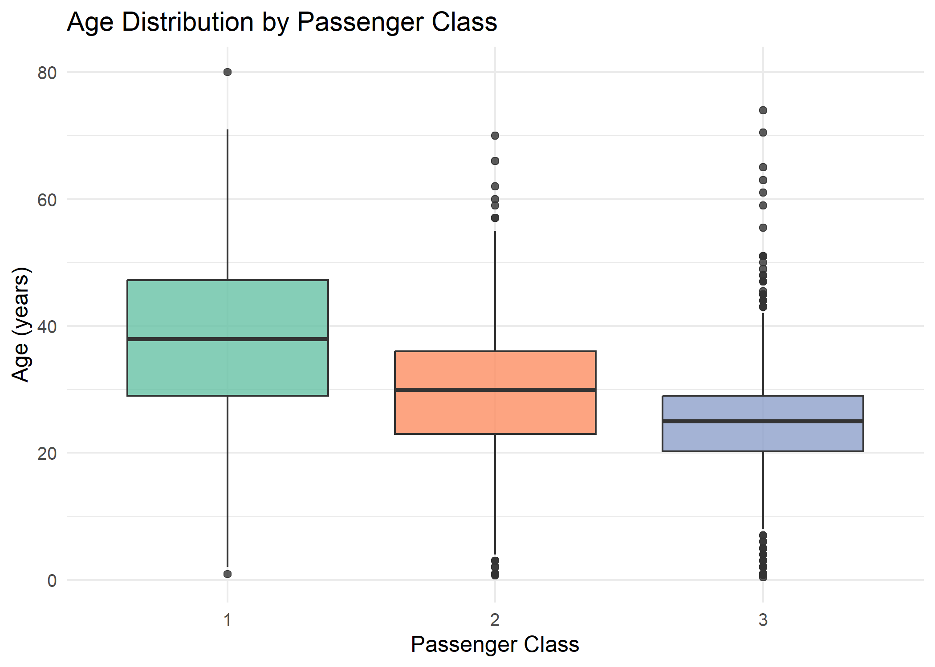
Figure 5: Age distribution by passenger class
Interpretation: Age falls steadily with class. The median age is 38 in first class, 30 in second class and 25 in third class. Third class also contains the most young passengers.
What this means in plain words: First-class passengers were older on average, while third class was a younger group. This links back to Chart 1: many young third-class passengers were among those who did not survive.

3.6 Chart 6: Age vs Fare by Class and Survival (Scatter Plot)
Why this chart: A scatter plot shows the relationship between two numeric variables. Splitting by class and colouring by survival adds two extra dimensions to one view.
R code:
p6 <- ggplot(df, aes(x = Age, y = Fare_capped, color = Survived)) +
geom_point(alpha = 0.6, size = 1.8) +
facet_wrap(~ Pclass, labeller = labeller(Pclass =
c("1" = "1st Class", "2" = "2nd Class", "3" = "3rd Class"))) +
scale_color_manual(values = pal) +
labs(title = "Age vs Fare by Class and Survival",
x = "Age (years)", y = "Fare (capped)") +
theme_minimal(base_size = 12)
print(p6)

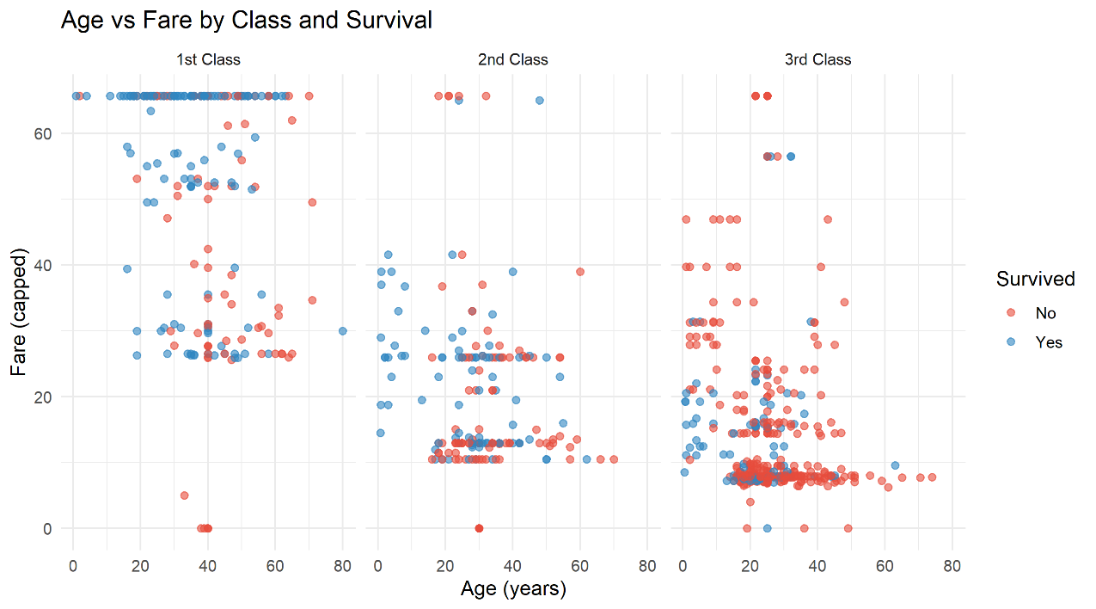
Figure 6: Age versus fare by class and survival
Interpretation: Within each class there is no strong link between age and fare, but the classes differ clearly in price: first-class fares spread widely up to the 65.63 cap, while second and third-class fares are mostly below about 30, with only a few higher values. The red points (did not survive) dominate the third-class panel, while blue points (survived) are far more common in the first-class panel.
What this means in plain words: Fare mostly reflects the class a passenger travelled in rather than their age. The colours again show that survival followed class.

3.7 Chart 7: Survival Rate by Age Group (Line Chart)
Why this chart: A line chart is best for showing change across an ordered scale. Age groups are ordered from youngest to oldest, so the line shows how survival changes with age.
R code:
df$AgeGroup <- cut(df$Age, breaks = c(0, 12, 18, 30, 45, 60, Inf),
labels = c("0-12", "13-18", "19-30", "31-45", "46-60", "60+"))
age_rate <- df %>% group_by(AgeGroup) %>%
summarise(rate = mean(Survived_num) * 100, n = n(), .groups = "drop")
p7 <- ggplot(age_rate, aes(x = AgeGroup, y = rate, group = 1)) +
geom_line(color = "#2E86C1", linewidth = 1.2) +
geom_point(size = 3.5, color = "#1B4F72") +
geom_text(aes(label = paste0(round(rate, 1), "%")), vjust = -1, size = 3.5) +
ylim(0, 80) +
labs(title = "Survival Rate by Age Group",
x = "Age Group", y = "Survival Rate (%)") +
theme_minimal(base_size = 12)
print(p7)
print(age_rate)

Output:
AgeGroup rate n
1 0-12 58.0 69
2 13-18 42.9 70
3 19-30 32.1 417
4 31-45 43.1 232
5 46-60 40.7 81
6 60+ 22.7 22

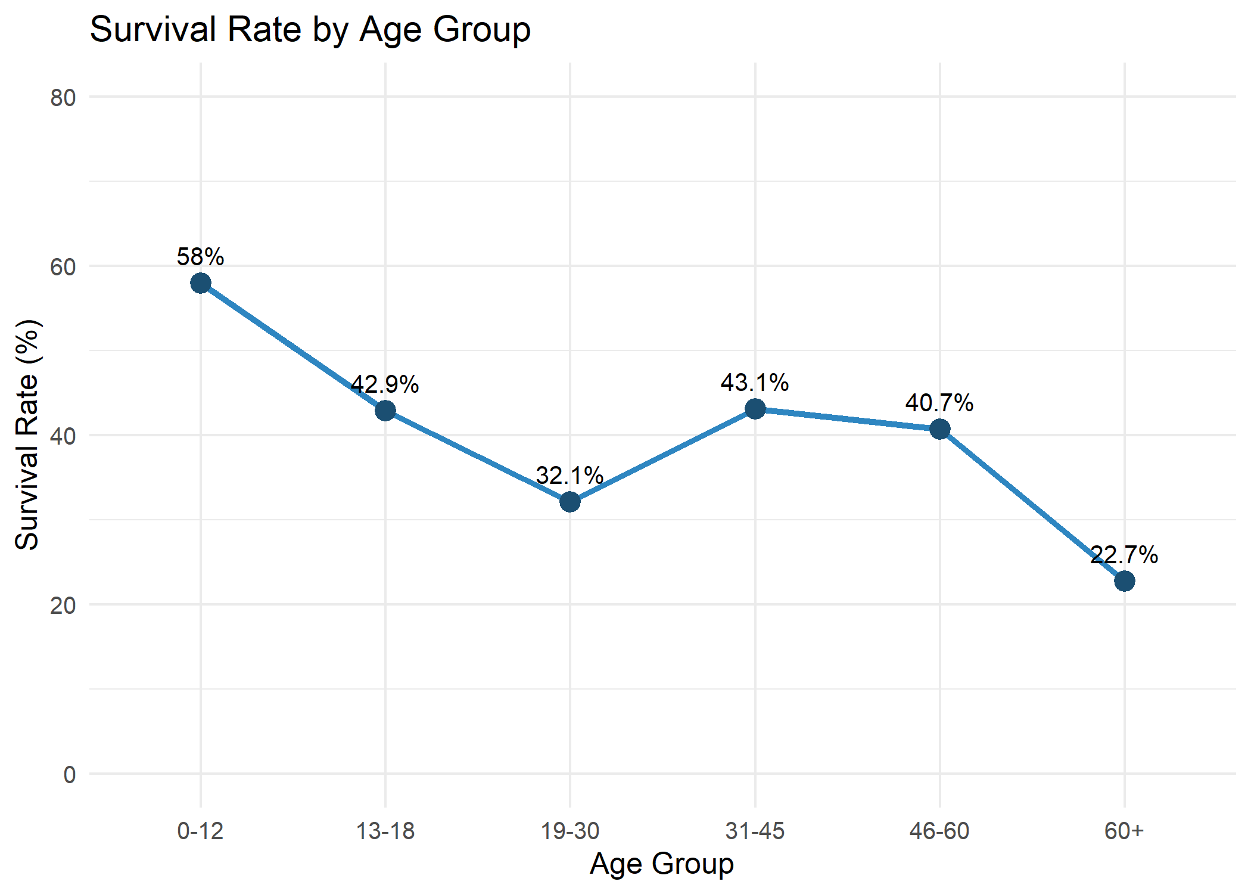
Figure 7: Survival rate by age group
Interpretation: Children aged 0 to 12 had the highest survival rate (58.0%). The rate then drops to its lowest among young adults aged 19 to 30 (32.1%), rises again for ages 31 to 45 (43.1%) and falls to 22.7% for passengers over 60. The 19 to 30 group is also the largest (417 passengers). The 60+ group has only 22 people, so its rate should be treated with caution.
What this means in plain words: Young children were given priority, and older passengers had the lowest chance. Young adults, the biggest group on the ship, mostly did not survive.

3.8 Chart 8: Survival Rate by Family Size (Line Chart)
Why this chart: Family size is an ordered number, so a line chart shows the trend. The size of each point shows how many passengers are behind it, which helps readers judge how reliable each point is.
R code:
fam_rate <- df %>% group_by(FamilySize) %>%
summarise(rate = mean(Survived_num) * 100, n = n(), .groups = "drop")
p8 <- ggplot(fam_rate, aes(x = FamilySize, y = rate)) +
geom_line(color = "#8E44AD", linewidth = 1.2) +
geom_point(aes(size = n), color = "#5B2C6F") +
scale_x_continuous(breaks = 1:11) +
labs(title = "Survival Rate by Family Size",
x = "Family Size (passenger + relatives aboard)",
y = "Survival Rate (%)", size = "Passengers") +
theme_minimal(base_size = 12)
print(p8)
print(fam_rate)

Output:
FamilySize rate n
1 1 30.4 537
2 2 55.3 161
3 3 57.8 102
4 4 72.4 29
5 5 20 15
6 6 13.6 22
7 7 33.3 12
8 8 0 6
9 11 0 7

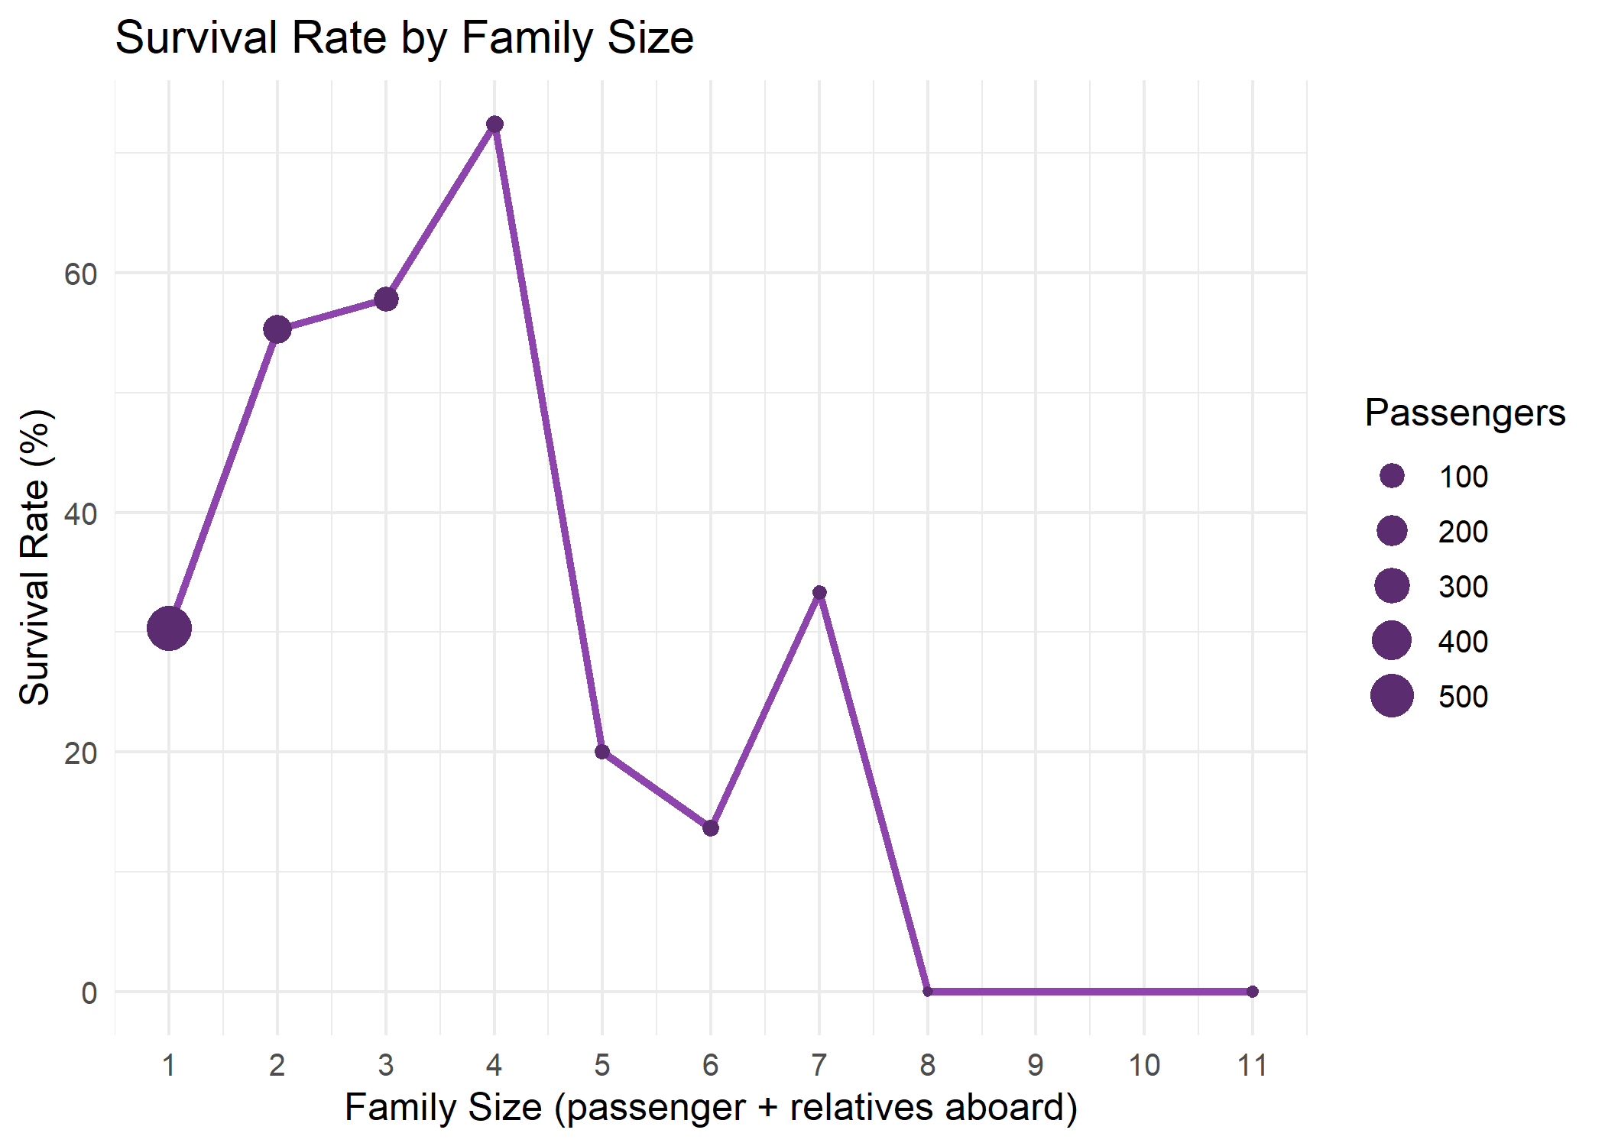
Figure 8: Survival rate by family size
Interpretation: Passengers travelling alone (family size 1) survived at only 30.4%. Survival rises for small families, reaching 55.3% for two people, 57.8% for three and 72.4% for four. For families of five or more, survival falls sharply (20% for five and 13.6% for six), and none of the 13 passengers in families of eight or eleven survived. The line has a gap because no passengers had a family size of 9 or 10.
What this means in plain words: Travelling with a small family helped, probably because relatives could stay together and help each other. Very large families and solo travellers did worse. Some groups are small (for example only 6 and 7 passengers), so these exact numbers are less reliable.

3.9 Chart 9: Survival Rate by Passenger Title (Bar Chart)
Why this chart: The title combines sex, age and marital status in one variable. A sorted horizontal bar chart makes it easy to rank the groups from lowest to highest survival.
R code:
title_rate <- df %>% group_by(Title) %>%
summarise(rate = mean(Survived_num) * 100, n = n(), .groups = "drop")
p9 <- ggplot(title_rate, aes(x = reorder(Title, rate), y = rate, fill = Title)) +
geom_col() +
geom_text(aes(label = paste0(round(rate, 1), "%")), hjust = -0.1, size = 3.5) +
coord_flip() + ylim(0, 100) +
scale_fill_brewer(palette = "Set2") +
labs(title = "Survival Rate by Passenger Title", x = "Title", y = "Survival Rate (%)") +
theme_minimal(base_size = 12) + theme(legend.position = "none")
print(p9)
print(title_rate)

Output:
Title rate n
1 Master 57.5 40
2 Miss 70.3 185
3 Mr 15.7 517
4 Mrs 79.4 126
5 Rare 34.8 23

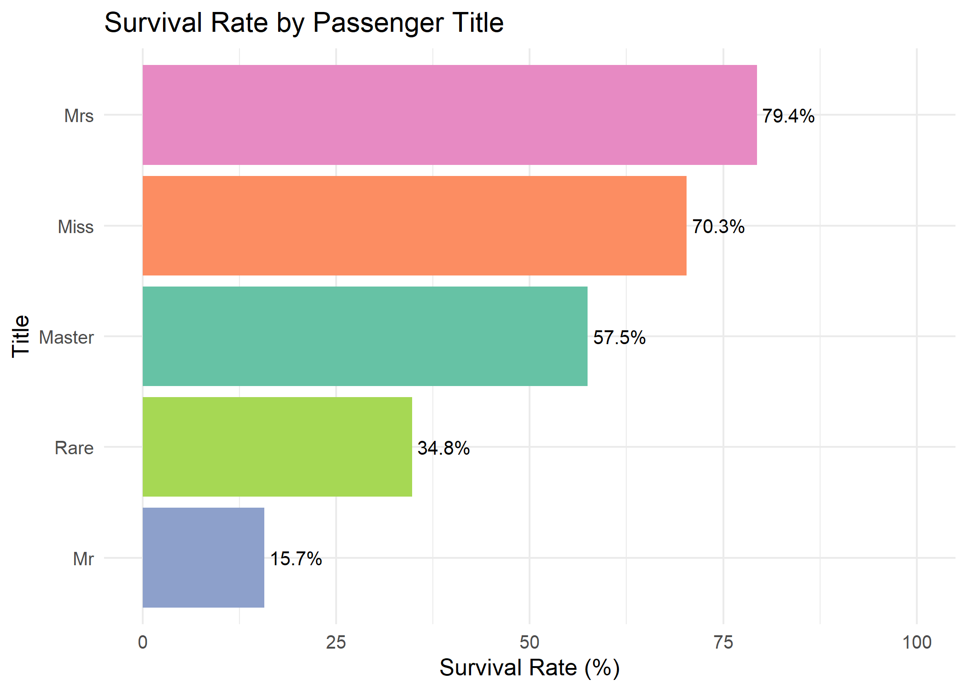
Figure 9: Survival rate by passenger title
Interpretation: Women with the title Mrs (79.4%) and Miss (70.3%) had the best survival rates. Boys with the title Master survived at 57.5%, while adult men with the title Mr, the largest group with 517 passengers, survived at only 15.7%. The Rare group (for example doctors and clergy) sat in between at 34.8%, but contains only 23 people.
What this means in plain words: Women and boys were rescued first, and adult men were the group least likely to survive. This single chart confirms the patterns seen in the sex and age charts.

3.10 Chart 10: Survival Rate by Age Group and Class (Heatmap)
Why this chart: A heatmap shows two categories at once using colour. Here it combines age group and class, so the reader can spot at a glance which combinations had the best and worst survival.
R code:
heat <- df %>% group_by(AgeGroup, Pclass) %>%
summarise(rate = mean(Survived_num) * 100, n = n(), .groups = "drop")
p10 <- ggplot(heat, aes(x = Pclass, y = AgeGroup, fill = rate)) +
geom_tile(color = "white") +
geom_text(aes(label = paste0(round(rate), "%")), size = 4) +
scale_fill_gradient(low = "#FADBD8", high = "#1F618D", name = "Survival %") +
labs(title = "Survival Rate by Age Group and Class",
x = "Passenger Class", y = "Age Group") +
theme_minimal(base_size = 12)
print(p10)

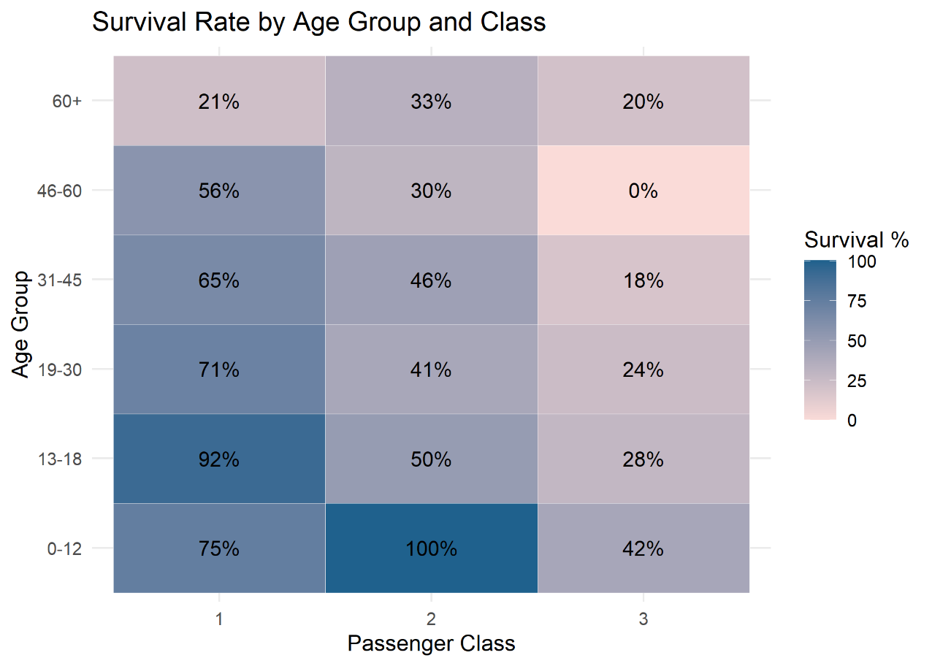
Figure 10: Survival rate by age group and passenger class (heatmap)
Interpretation: Darker blue tiles mean higher survival and pale pink tiles mean lower survival. Reading across the columns, survival generally becomes lower as we move from first class to third class within the same age group, and reading down the rows, children tend to have higher survival than older age groups. Class and age therefore both influence survival, and the combination of young age and a better class gives the best chances.
The highest rates appear for girls and boys aged 0 to 18 in first class (92% for ages 13 to 18) and for children aged 0 to 12 in second class (100%, but this group is small). The lowest is 0% for passengers aged 46 to 60 in third class.
What this means in plain words: Both ticket class and age matter. The best odds belonged to young passengers in better classes and the worst to older passengers in third class.

4. Summary of Key Insights
Question | Chart used | Main finding
Did class affect survival? | Charts 1, 6, 10 | 3rd class: 372 of 491 died; 1st class: 136 of 216 survived
Did sex affect survival? | Charts 2, 9 | Women 96.8% (1st), 92.1% (2nd), 50% (3rd); men 13.5% to 36.9%
Did age affect survival? | Charts 3, 7, 10 | Children 0-12: 58.0%; adults 19-30: 32.1%; over 60: 22.7%
Did family size matter? | Chart 8 | Alone 30.4%; family of 4 72.4%; large families do poorly
How are fares and ages spread? | Charts 4, 5 | Fares are right-skewed; median age 38, 30 and 25 by class

5. Limitations and Next Steps
- Some groups are very small (60+ age group, Rare titles, large families), so their percentages can change a lot with only a few passengers.
- Charts show associations, not proof of cause. For example, class, sex and age are connected to each other, so their effects overlap.
- Age was partly estimated in Week 1 (about 20% of values were filled in with group medians), which may smooth out some age patterns.
- In Week 3 these findings will be tested with statistical hypothesis tests and used to build a predictive model of survival.

6. Conclusion
Ten visualizations were created in R using ggplot2 to communicate the key patterns in the Titanic data to a non-technical audience. Together they show that survival was not random: it depended strongly on sex, passenger class, age and family size. Women, children and first-class passengers had the best chances, while adult men and third-class passengers had the worst. Using a consistent colour scheme, clear titles and plain-language explanations makes these insights easy to understand and remember. The same cleaned dataset and these findings will carry forward into the statistical analysis and predictive modelling in Week 3.

