**DAY 01**

I have concentrated on choosing an image processing project that makes use of convolutional neural networks (CNN) on the first day of my online internship.

**Image processing**

The modification and analysis of digital pictures fall under the umbrella of this important discipline. It may be used for a wide variety of things, including object identification and autonomous cars as well as medical imaging.

**Convolutional Neural Networks for Image Processing**

CNNs have demonstrated considerable potential in image processing jobs. They are particularly suited for applications like image classification, object identification, and image segmentation because they can automatically learn hierarchical representations from pictures.

*CNN Architectures*

* LeNet
* AlexNet
* VGGNet
* GoogLeNet
* MobileNet
* ResNet
* DenseNet

**Project: COVID 19 DETECTION USING VGGNet**

VGGNet is a CNN architecture known for its simplicity and uniformity. It achieved excellent performance in the ILSVRC 2014 competition. It uses small 3x3 filters and stacking of layers to improve learning capacity. VGG16 and VGG19 are variations with different depths. For COVID-19 detection, VGGNet can be used as a feature extractor by leveraging pre-trained weights from ImageNet. By fine-tuning the network and adding additional layers, it can be adapted for COVID-19 detection using specific medical imaging datasets. Performance depends on data quality, size, and other factors.

***Reference***

<https://www.kaggle.com/datasets/pranavraikokte/covid19-image-dataset>

**COVID 19 DETECTION USING VGGNet with Accuracy of 98%**

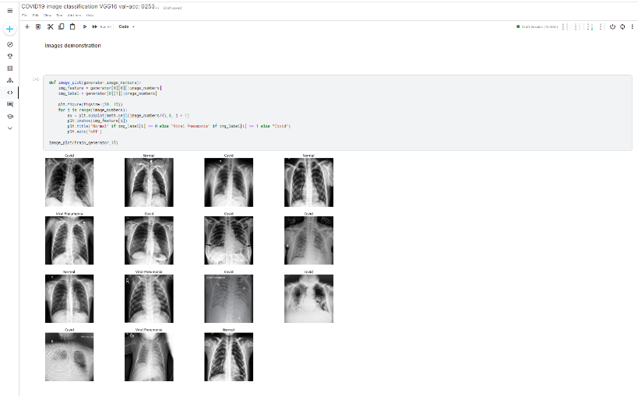https://www.kaggle.com/code/abiniveshm/covid19-image-classification-vgg16-val-acc-0253f3/edit

