**DAY 03**

**Dataset**

Examination dataset have been shared with three folders namely train, validation, validation2 and a Jupyter notebook. The shared dataset is a multi-class dataset. Each folder of Examination dataset has five more folders namely normal, cheat, phone, paperseeing, paperexchange.

Train set: train

Test set: validation

Validation set: validation2

*Google Drive*

<https://drive.google.com/drive/folders/1Zc0bVs66paccr6-yCYT8yI9lgqajFwBv?usp=sharing>

**Google Colab**

Anomaly Detection

## [1. Imports](https://colab.research.google.com/drive/1re6r8c5DXnHsqSlWQQcBUVscZd-tFAae#im)

## [2. HyperParameters](https://colab.research.google.com/drive/1re6r8c5DXnHsqSlWQQcBUVscZd-tFAae#hp)

## [3. Data Loading and Preprocessing](https://colab.research.google.com/drive/1re6r8c5DXnHsqSlWQQcBUVscZd-tFAae#data)

## [4. DenseNet121 Feature Extractor](https://colab.research.google.com/drive/1re6r8c5DXnHsqSlWQQcBUVscZd-tFAae#model)

## [5. Training](https://colab.research.google.com/drive/1re6r8c5DXnHsqSlWQQcBUVscZd-tFAae#train)

## [6. Mutliclass AUC Curve](https://colab.research.google.com/drive/1re6r8c5DXnHsqSlWQQcBUVscZd-tFAae#auc)

IMPORTING LIBRARIES

import pandas as pd

import numpy as np

import matplotlib.pyplot as plt

import seaborn as sns

import plotly.express as px

import os

import tensorflow as tf

from tensorflow.keras.preprocessing.image import ImageDataGenerator

from sklearn.preprocessing import LabelBinarizer

from sklearn.metrics import roc_curve, auc, roc_auc_score

# from IPython.display import clear_output

import warnings

warnings.filterwarnings('ignore')

HYPERPARAMETRERS AND DIRECTORIES

train_dir = "D:/VIT/RESEARCH/dataset/ECDatatry1/train"

test_dir = "D:/VIT/RESEARCH/dataset/ECDatatry1/validation"

SEED = 12

IMG_HEIGHT = 64

IMG_WIDTH = 64

BATCH_SIZE = 64      #Was 46

EPOCHS = 1

LR =  0.001

NUM_CLASSES = 14

CLASS_LABELS = ['cheat','normal','peperexchange','paperseeing','phone']

DATA LOADING AND PRE-PROCESSING

preprocess_fun = tf.keras.applications.resnet50.preprocess_input

train_datagen = ImageDataGenerator(

                                   horizontal_flip=True,

                                   width_shift_range=0.1,

                                   height_shift_range=0.05,

                                   rescale = 1./255,

                                   validation_split=0.2, # set validation split, Added

                                   preprocessing_function=preprocess_fun

                                  )

test_datagen = ImageDataGenerator(rescale = 1./255,

                                  preprocessing_function=preprocess_fun

                                 )

train_generator = train_datagen.flow_from_directory(directory = train_dir,

                                                    target_size = (IMG_HEIGHT ,IMG_WIDTH),

                                                    batch_size = BATCH_SIZE,

                                                    shuffle  = True ,

                                                    color_mode = "rgb",

                                                    class_mode = "categorical",

                                                     subset='training',    #Added

                                                    seed = SEED

                                                   )

validation_generator = train_datagen.flow_from_directory(train_dir, # same directory as training data

                                                    target_size = (IMG_HEIGHT ,IMG_WIDTH),

                                                    batch_size = BATCH_SIZE,

                                                    shuffle  = True ,

                                                    color_mode = "rgb",

                                                    class_mode = "categorical",

                                                    subset='validation', # set as validation data,  #Added

                                                    seed = SEED

                                                   )

test_generator = test_datagen.flow_from_directory(directory = test_dir,

                                                   target_size = (IMG_HEIGHT ,IMG_WIDTH),

                                                    batch_size = BATCH_SIZE,

                                                    shuffle  = False ,

                                                    color_mode = "rgb",

                                                    class_mode = "categorical",

                                                    seed = SEED

                                                  )

Resnet50 Transfer Learning

from tensorflow.keras.callbacks import EarlyStopping

earlystop= tf.keras.callbacks.EarlyStopping(

           monitor="val_loss",

           min_delta=0.1,

           patience=3,

           verbose=0,

           mode="min",

           start_from_epoch =20,

from tensorflow.keras.callbacks import ModelCheckpoint

filepath="weights-improvementResnet50-{epoch:02d}-{val_accuracy:.2f}.hdf5"

checkpoint = ModelCheckpoint(filepath, monitor='val_accuracy', verbose=1, save_best_only=True, mode='max')

callbacks_list = [checkpoint]

def feature_extractor(inputs):

    feature_extractor = tf.keras.applications.ResNet50(input_shape=(IMG_HEIGHT,IMG_WIDTH, 3),

                                               include_top=False,

                                               weights="imagenet")(inputs)

    return feature_extractor

def classifier(inputs):

    x = tf.keras.layers.GlobalAveragePooling2D()(inputs)

    x = tf.keras.layers.Dense(256, activation="relu")(x)

    x = tf.keras.layers.Dropout(0.3)(x)

    x = tf.keras.layers.Dense(1024, activation="relu")(x)

    x = tf.keras.layers.Dropout(0.5)(x)

    x = tf.keras.layers.Dense(512, activation="relu")(x)

    x = tf.keras.layers.Dropout(0.4) (x)

    x = tf.keras.layers.Dense(5, activation="softmax", name="classification")(x)

    return x

def final_model(inputs):

    densenet_feature_extractor = feature_extractor(inputs)

    classification_output = classifier(densenet_feature_extractor)

    return classification_output

def define_compile_model():

    inputs = tf.keras.layers.Input(shape=(IMG_HEIGHT ,IMG_WIDTH,3))

    classification_output = final_model(inputs)

    model = tf.keras.Model(inputs=inputs, outputs = classification_output)

    model.compile(optimizer=tf.keras.optimizers.SGD(LR),

                loss='categorical_crossentropy',

                metrics = ['accuracy'])

    return model

model = define_compile_model()

# clear_output()

model.summary()

history = model.fit(x = train_generator,validation_data=validation_generator,epochs = 100,callbacks=callbacks_list)

#history = model.fit(x = train_generator,validation_split=0.2,epochs = EPOCHS)

y_test = test_generator.classes

print (y_test)

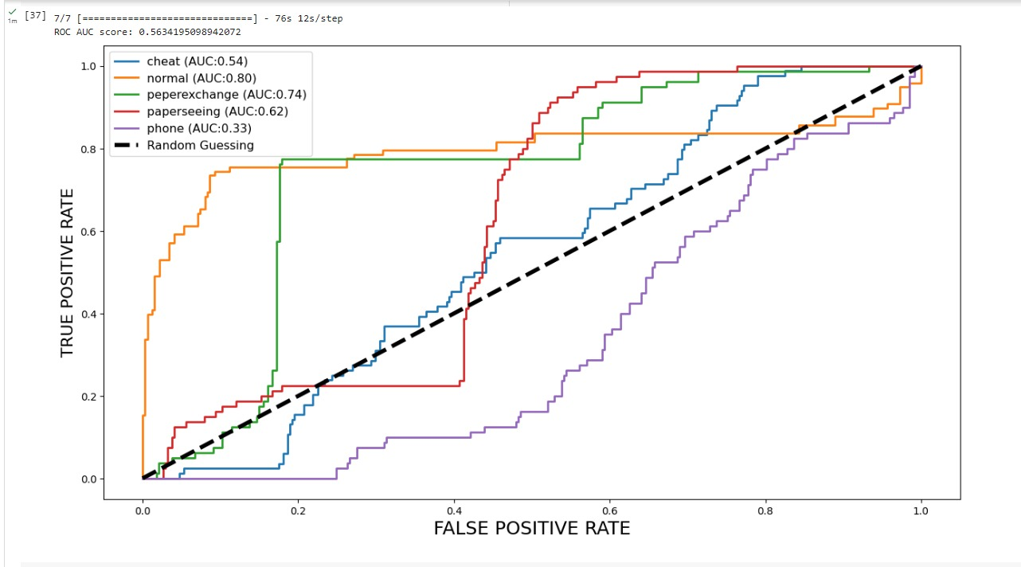Multiclass AUC Curve

Loss and Accuracy

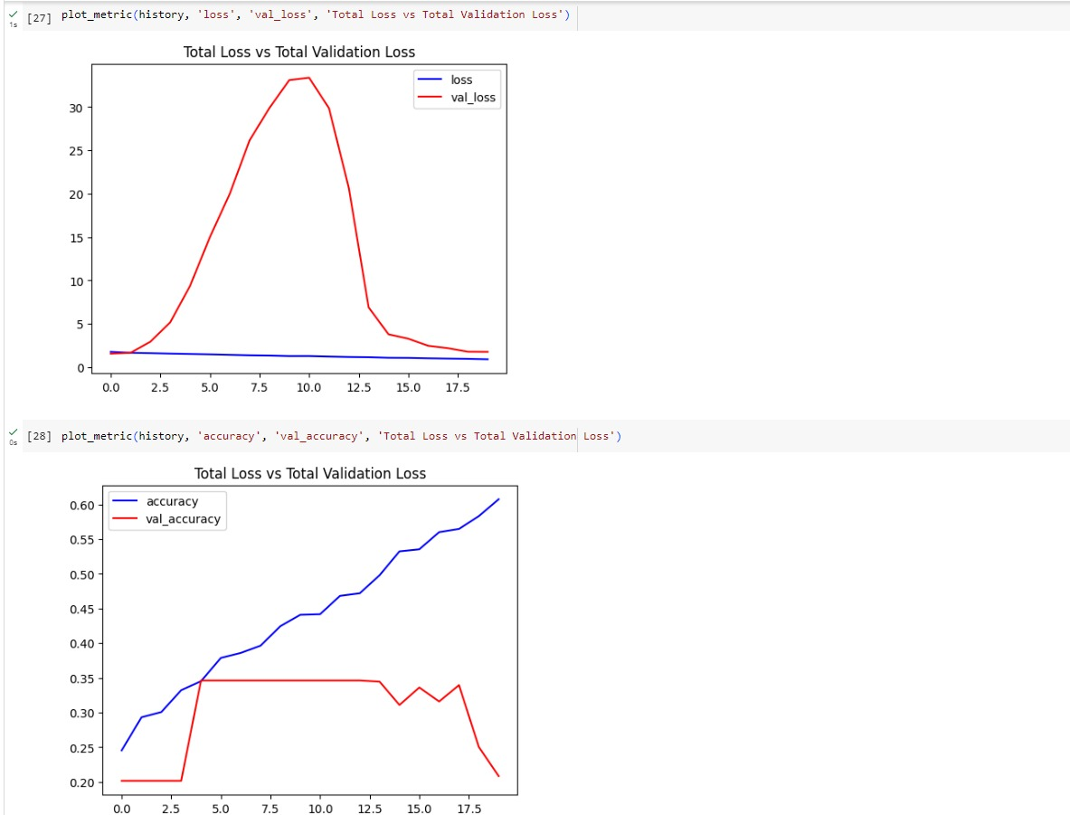

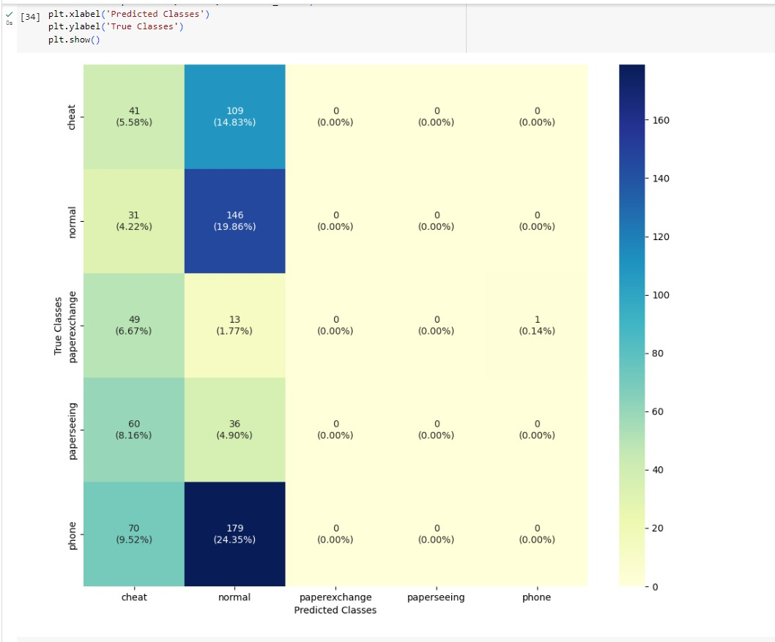Confusion Matrix