**DAY 05**

**23.06.2023**

**Dataset**

Architectural Design dataset (multi-class dataset) have been shared with ten s namely altar, apse, bell-tower, column, dome(inner), dome(outer), flying buttress, gargoyle, stained-glass, vault.

Train set : train

Test set : test

**Convolutional Neural Network**

A convolutional neural network (CNN), is a network architecture for deep learning which learns directly from the data.

*CNN Architecture*

* VGG
* Xception
* ResNet
* InceptionV3
* InceptionResNet
* MobileNet
* DenseNet
* NasNet
* EfficientNet
* ConvNEXT

*Reference*

<https://towardsdatascience.com/top-10-pre-trained-models-for-image-embedding-every-data-scientist-should-know-88da0ef541cd>

<https://www.tensorflow.org/api_docs/python/tf/keras/applications/densenet/DenseNet169>

**DenseNet121**

DenseNet is a CNN model developed to improve accuracy caused by the vanishing gradient in high-level neural networks due to the long distance between input and output layers and the information vanishes before reaching the destination.

***Architecture:***

A DenseNet architecture has 3 dense blocks. The layers between two adjacent blocks are referred to as transition layers and change feature-map sizes via convolution and pooling. 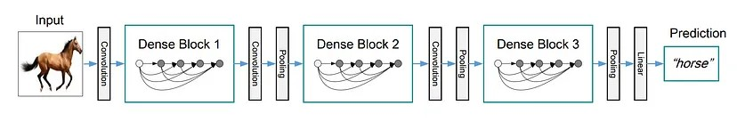

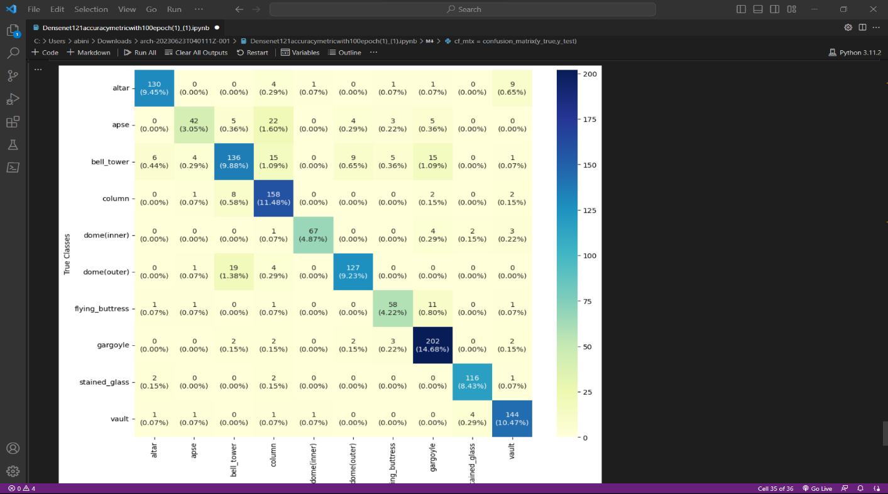***Confusion Matrix:***

**Epoch :** 100

**Batch size :** 64

**LR :** 0.1

**Accuracy :** 0.857558

**Precision :** 0.869083

**Recall :** 0.840506

**F1 score** : 0.848991

**VGGNET 16**

The VGG-16/19 networks were introduced at the ILSVRC 2014 conference since it is one of the most popular pre-trained models. It was developed by the Visual Graphics Group at the University of Oxford. There are two variations of the VGG model: 16 and 19 layers network, VGG-19 (19-layer network) being an improvement of the VGG-16 (16-layer network) model.

***Architecture:***

The VGG network is simple and sequential in nature and uses a lot of filters. At each stage, small (3*3) filters are used to reduce the number of parameters.

The VGG-16 network has the following:

Convolutional Layers = 13

Pooling Layers = 5

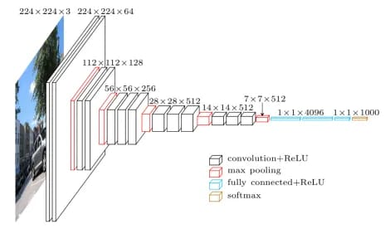Fully Connected Dense Layers = 3

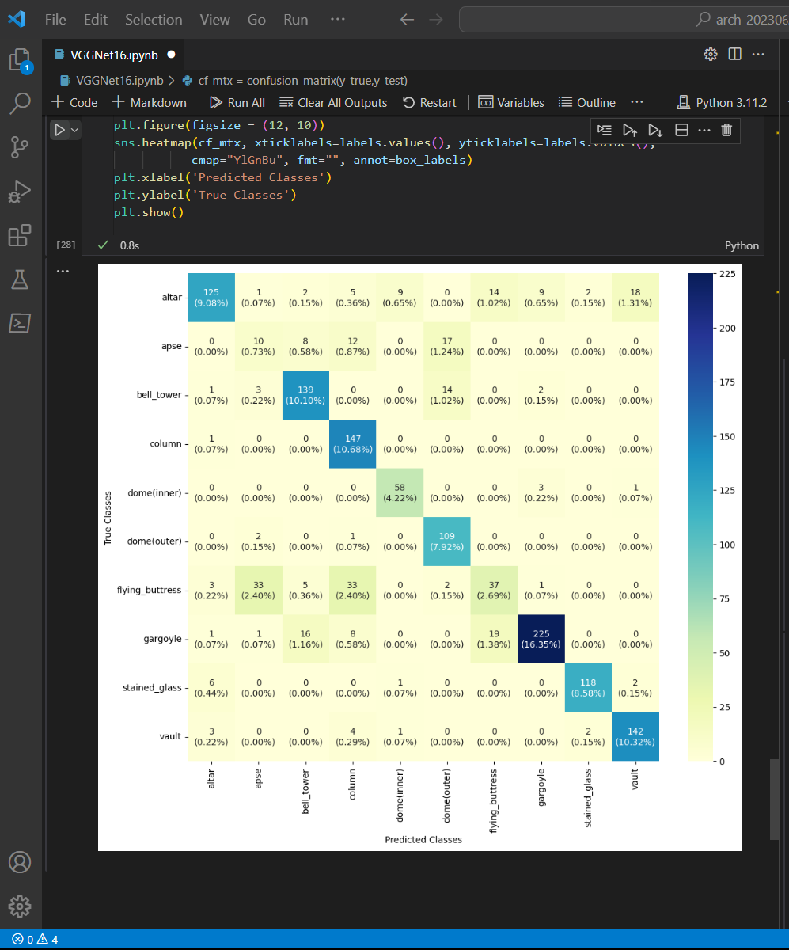***Confusion Matrix***

**Epoch :** 100

**Batch size :** 64

**LR :** 0.1

**Accuracy :** 0.806686

**Precision :** 0.752314

**Recall :** 0.768584

**F1 score** : 0.758584