**DAY 06**

**24.06.2023**

**Dataset**

Architectural Design dataset (multi-class dataset) have been shared with ten s namely altar, apse, bell-tower, column, dome(inner), dome(outer), flying buttress, gargoyle, stained-glass, vault.

Train set : train

Test set : test

**Convolutional Neural Network**

A convolutional neural network (CNN), is a network architecture for deep learning which learns directly from the data.

*CNN Architecture*

* VGG
* Xception
* ResNet
* InceptionV3
* InceptionResNet
* MobileNet
* DenseNet
* NasNet
* EfficientNet
* ConvNEXT

*Reference*

<https://towardsdatascience.com/top-10-pre-trained-models-for-image-embedding-every-data-scientist-should-know-88da0ef541cd>

<https://www.tensorflow.org/api_docs/python/tf/keras/applications/densenet/DenseNet169>

* Concepts of classes, modules and functions are been glanced with their uses.
* Resnet Architecture being implemented.

**ResNet15:**

The previous CNN architectures were not designed to scale to many convolutional layers. It resulted in a vanishing gradient problem and limited performance upon adding new layers to the existing architecture. ResNets architecture offers to skip connections to solve the vanishing gradient problem.

***Architecture:***

This ResNet model uses a 34-layer network architecture inspired by the VGG-19 model to which the shortcut connections are added. These shortcut connections then convert the architecture into a residual network.

There are several versions of ResNet architecture:

* ResNet50
* ResNet50V2
* ResNet101
* ResNet101V2
* ResNet152
* 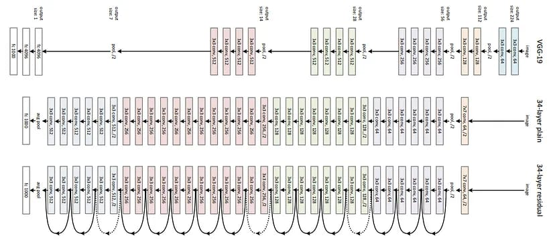ResNet152V2

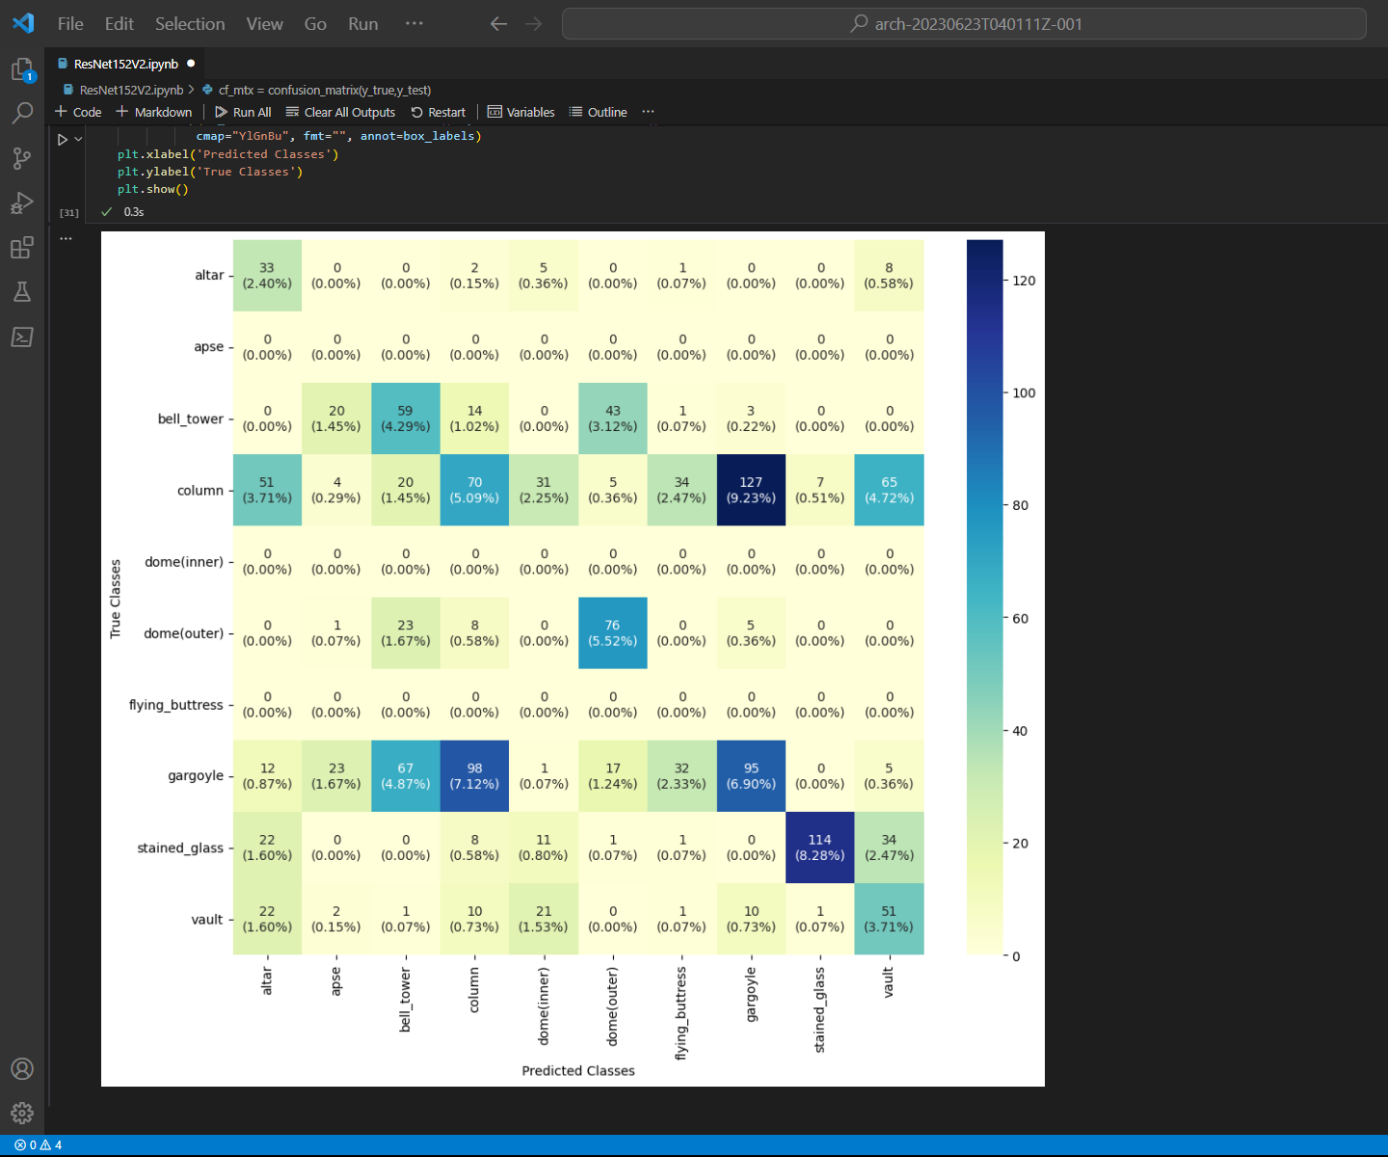***Confusion Matrix:***

**Epoch :** 100

**Batch size :** 64

**LR :** 0.1

**Accuracy :** 0.361919

**Precision :** 0.309446

**Recall :** 0.323341

**F1 score** : 0.296246