1. Theme restaurant

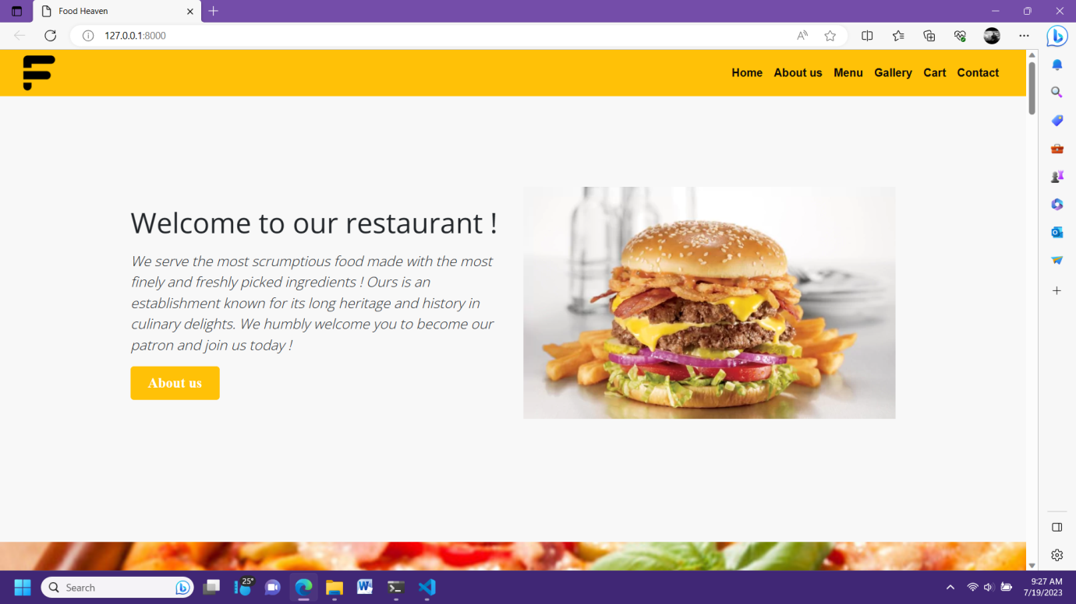

Heading: F

Features:

…………………………………………………………………………………………..

………………………………………………………………………………………….

………………………………………………………………………………………………