**Phase 4: Development Part 2**

**In this part you will continue building your project.**

* **Continue building the data warehouse by implementing ETL processes and enabling data exploration.**
* **Implement ETL processes to extract, transform, and load data into the data warehouse.**
* **Enable data architects to explore and analyze data within Db2 Warehouse using SQL queries and analysis techniques.**

**To continue building your data warehouse project and implement ETL processes, as well as enable data exploration using SQL queries and analysis techniques in Db2 Warehouse, follow these steps:**

**1.Data Extraction (E) :** Start by extracting data from various source systems. This could include databases, flat files, APIs, and more. Make sure to consider the following during this step:

Choose appropriate extraction methods and tools that match your data sources. For example, you might use SQL queries to extract data from relational databases, or Python scripts to fetch data from APIs.

Schedule regular data extraction jobs to keep your data warehouse up-to-date with the latest information.

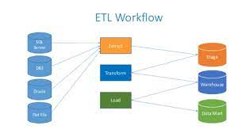

**2.Data Transformation (T):** After extracting the data, you'll need to transform it to fit the data warehouse's schema and quality standards. This typically involves:

* Data cleansing: Identify and handle missing, inconsistent, or erroneous data.
* Data integration: Merge and consolidate data from different sources.
* Data enrichment: Add relevant metadata, such as timestamps or geographical information.
* Data aggregation: Summarize or roll up data for better analytics.

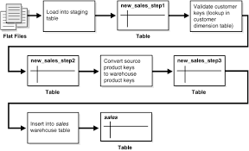

**3.Data Loading (L):** Load the transformed data into your Db2 Warehouse. Depending on the volume and frequency of your data, you can choose one of these loading methods:

* Batch loading: Load data periodically, such as daily or hourly, using ETL tools like IBM DataStage or custom scripts.
* Real-time loading: Implement a streaming architecture to ingest data as it arrives for near real-time analytics.

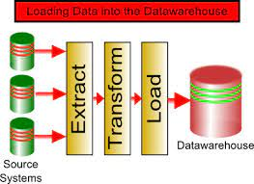

**4. Data Exploration:** To enable data architects to explore and analyze data within Db2 Warehouse using SQL queries and analysis techniques, you should:

* Create a user-friendly and well-documented data dictionary that explains the data warehouse's schema, including table names, column descriptions, data types, and relationships.
* Grant appropriate permissions and access rights to data architects so that they can write SQL queries and analyze data effectively.
* Train your data architects on Db2 Warehouse and SQL best practices for efficient querying and reporting

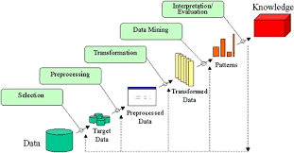

**5.Data Analysis Techniques:** Data architects should be familiar with various SQL techniques for data analysis, such as:

* Aggregation functions: SUM, AVG, COUNT, etc.
* Window functions: RANK, LEAD, LAG, etc., for time-series and ranking analysis.
* JOIN operations to combine data from different tables.
* Subqueries for complex filtering and segmentation.
* Creating views and materialized views for commonly used analysis.
* Using stored procedures to automate routine analysis tasks.

**6.Visualization and Reporting:** Provide tools or integrations for data architects to visualize and report on their findings. Tools like Tableau, Power BI, or open-source solutions like Jupyter notebooks can be helpful for this purpose.

**7.Performance Optimization:** Regularly monitor the performance of your Db2 Warehouse to ensure that queries run efficiently. Consider indexing, query optimization, and hardware scaling as needed.

**8.Security and Compliance:** Ensure that data access and handling comply with security and compliance regulations, such as GDPR or HIPAA, depending on the data you're handling.

**9. Documentation:** Document your ETL processes, data transformation rules, and data exploration techniques to facilitate collaboration and troubleshooting.

**10. Testing and Validation:** Implement a rigorous testing process to validate the accuracy and consistency of the data in your data warehouse. Automated tests can help catch issues early.

**11. Monitoring and Maintenance:** Implement a monitoring system to track ETL job success, performance, and data quality. Regularly perform maintenance tasks like data archiving and purging to keep the data warehouse efficient.

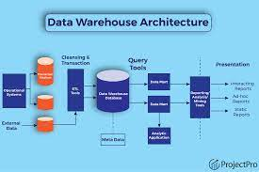

**12. Scalability:**  Plan for future scalability by considering the growth of your data and user base. Ensure that your ETL processes and infrastructure can handle increased demands.