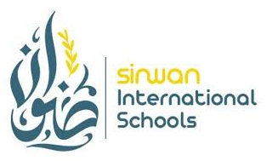

CERTIFICATE OF EXPERIENCE
SINWAN INTERNATIONAL SCHOOLS
This is to certify that
BELLO ABDUL RAHEEM
has served at Sinwan International Schools as a Science Teacher, from
____________________________ to ____________________________
(Start Date) (End Date)
During this period, they demonstrated dedication, subject expertise, and professionalism in teaching Science, and consistently contributed positively to the academic growth of our students and the school community.
We wish them continued success in their future endeavors.
Date of Issue: ____________________ | Principal / Head of School  Sinwan International Schools

