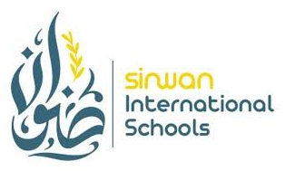
LETTER OF EXPERIENCE
Sinwan International Schools
[School Address]
Date: ____________________
To Whom It May Concern,
This is to certify that Bello Abdul Raheem worked as a Science Teacher at Sinwan International Schools from ____________________ to ____________________. He was responsible for planning and delivering the science curriculum, conducting engaging lessons and practical experiments, and fostering a stimulating and safe learning environment for students.
Throughout his tenure, Mr. Raheem demonstrated strong subject expertise, dedication, and professionalism. He consistently contributed to the academic growth of his students and was well respected by colleagues, students, and parents alike.
We confidently recommend Bello Abdul Raheem for future roles in science education.
Best regards,
____________________________
Principal / Head of School
Sinwan International Schools

