## S11_Coding.docx. Coding, statistics and supplemental graphs for the real-world data confidence interval widths in Figure 4.

## Title of article: Triplication: an important component of the modern scientific method.
## Authors: Jeremy S.C. Clark, Karina Szczypiór-Piasecka, Kamila Rydzewska, Konrad Podsiadło.

## INSTRUCTIONS: (1) choose mypath; (2) Sections 4-7 require four passes: TYPE <- "NOsys" or "SYS", each with grW <- TRUE or FALSE (Welch-Satterthwaite adjustment): choose one combination per run; (3) copy all code into R and run. (Section 3 gives both Welch and non-Welch columns in a single run; k is the number of replicates included in an analysis).

mypath <- "/Users/jsc/Documents/aaJ Clark MACBOOK 2026 PUM/9991 SUBMITTED R3/"
grW <- FALSE ## if TRUE gives Welch-Satterthwaite adjustment.
TYPE <- "SYS" ## "NOsys" (no systematic error inclusion) or "SYS" (systematic error inclusion).

## Sections:
## R Libraries.
## Section 1. Original data: extracted from S8_Table_Plant_Science_CI.xlsx. Table S11.T1.
## Section 2.1. Combining p-values; triple-result joint probability and Fisher's method. Imaginary examples. Table S11.T2.
## Section 2.2. Greenwood statistic normalized: Gw, for imaginary example Table S11.T3.
## Section 2.3. Normalized Greenwood calculations for real-world data. TABLE S11.T4.
## Section 3. Confidence interval widths, actual and expected. TABLE S11.T5.
## Section 4. Generalized additive model (GAM) fits.
## Section 4.1. GAM fits: NOsys results - no Welch-Satterthwaite adjustment.
## Section 4.2. GAM fits: NOsys results - with Welch-Satterthwaite adjustment.
## Section 5.1. GAM fits: SYS results - no Welch-Satterthwaite adjustment.
## Section 5.2. GAM fits: SYS results - with Welch-Satterthwaite adjustment.
## Section 6. NOsys GAM graphs.
## Section 7. SYS GAM graphs.
## Section 8. Do points lie within 25% of the expected decreasing curve ?
## Section 8.1. NOsys data within 25% band. TABLEs S11.T6, S11.T7.
## Section 8.2. SYS data within 25% band. TABLEs S11.T8, S11.T9.
## For coding references see S7_CODING.docx.
##________________________________________________________
## R Libraries:
ipak <- function(pkg){
new.pkg <- pkg[!(pkg %in% installed.packages()[, "Package"])]
if (length(new.pkg))
install.packages(new.pkg, dependencies = TRUE, repos="http://cran.r-project.org")
sapply(pkg, require, character.only = TRUE)
} ## end function
packages <- c("COINr", "dplyr", "tidyr", "mgcv", "ggplot2", "purrr")
ipak(packages) ## References given at end of document.

## Section 1. Original data: extracted from S8_Table_Plant_Science_CI.xlsx, but more details concerning extraction are given in S7 section 12.1.

## TABLE S11.T1 (dataframe original_data). Original data to which columns are added later after analyses.
## column definitions:
## study = study from articles: Tonk_A: from Tonk et al. (2017). Kichigina_B from Kichigina et al. (2017). Carlucci_C from Carlucci et al. (2017). Lawrence_D from Lawrence et al. (2017). Zhang_E from Zhang et al. (2017). Driver_F from Driver et al. (2017). Zhou_G from Zhou et al. (2017). Clark_H from unpublished data from a study preliminary to Clark et al. (1993). For references, see main article.
## level = level as found in original article
## k = order of level as in original article (also number of replicates included in an analysis)
## mean = mean from original article
## SD = standard deviation from original article, if given, or
## SE_ori = standard error from original article, if given
## (NOTE: either SD or SE_ori are used in articles to describe the same type of variance !)
## N = number of samples for that level
original_data <- ("
study level k mean SD SE_ori N
Tonk_A TR1 1 34 8.75 NA 100
Tonk_A TR2 2 52 15.25 NA 100
Tonk_A TR3 3 46 12.5 NA 100
Tonk_A TR4 4 56 25 NA 100
Tonk_A TR5 5 39 10.75 NA 100
Tonk_A TR6 6 49 15.25 NA 100
Tonk_A TR7 7 23.5 4.5 NA 100
Kichigina_B 8473 1 3.9 NA 1.1 5
Kichigina_B 3654 2 2.4 NA 0.35 5
Kichigina_B 2759 3 1.4 NA 0.15 5
Kichigina_B 1903 4 7 NA 1.1 5
Carlucci_C BF144 1 8.2 3.1 NA 10
Carlucci_C BF47 2 10.8 1.1 NA 10
Carlucci_C BF12 3 11.8 1.9 NA 10
Lawrence_D GARDENER 1 6.2 NA 2.1 5
Lawrence_D PHEASANT 2 5.3 NA 3 5
Lawrence_D PRAIRIE 3 14.2 NA 3.9 5
Zhang_E Merlot 1 20 NA 1 10
Zhang_E Syrah 2 23.5 NA 1 10
Zhang_E Concord 3 27.2 NA 1.4 10
Driver_F GPD3-OE1 1 1.8 NA 0.4 3
Driver_F GPD3-OE2 2 2.6 NA 0.6 3
Driver_F GPD3-OE3 3 3 NA 1.3 3
Zhou_G RG2 1 0.8 0.3 NA 3
Zhou_G RG6 2 0.9 0.35 NA 3
Zhou_G RG14 3 0.8 0.5 NA 3
Zhou_G RG20 4 2.1 0.5 NA 3
Clark_H R89/1 1 18.5 0.577 NA 4
Clark_H R89/4 2 19.3 0.5 NA 4
Clark_H R90/6 3 17.8 0.957 NA 4
Clark_H R91/7 4 20 0.816 NA 4
")
mydf2 <- read.table(textConnection(original_data), header=TRUE)
head(mydf2)
mydf2$SE <- mydf2$SD / sqrt(mydf2$N)
mydf2$SE <- dplyr::coalesce(mydf2$SE, mydf2$SE_ori)

## Section 2.1. Combining p-values; triple-result joint probability and Fisher's method. Imaginary examples.
pvaluesA <- c(0.007, 0.5, 0.5)
pvaluesB <- c(0.12, 0.12, 0.12)
pvaluesC <- c(0.049, 0.049, 0.049)
pvaluesD <- c(0.05, 0.05, 0.05)
pvalues <- c(paste0(pvaluesA, collapse = ", "), paste0(pvaluesB, collapse = ", "), paste0(pvaluesC, collapse = ", "), paste0(pvaluesD, collapse = ", "))
description <- c("no coherence", "all non-significant", "(positive) coherence", "(positive) coherence")

## triplejoint = triple-result joint probability assuming (positive) coherence results across replicates (three replicates individually significant), with joint probability under independence with each replicate unbiased. Cut-off is p=1.25$×$10⁻⁴:
triplejointA <- prod(pvaluesA)
triplejointB <- prod(pvaluesB)
triplejointC <- prod(pvaluesC)
triplejointD <- prod(pvaluesD)
triplejoint <- signif(c(triplejointA, triplejointB, triplejointC, triplejointD), 3)
sigtriple <- list();
for (i in 1:length(triplejoint)) {
if (triplejoint[[i]] <= 1.25e-04) {
sigtriple[[i]] <- "significant"
} else {
sigtriple[[i]] <- "not significant"
}
}
sigtriple <- as.vector(unlist(sigtriple))

## Fm_altered = similar to Fisher's method but with 2 degrees of freedom (identical algebraically to triplejoint above):
combinedA <- -2 * sum(log(pvaluesA))
Fm_alteredA <- pchisq(combinedA, df = 2, lower.tail = FALSE)
combinedB <- -2 * sum(log(pvaluesB))
Fm_alteredB <- pchisq(combinedB, df = 2, lower.tail = FALSE)
combinedC <- -2 * sum(log(pvaluesC))
Fm_alteredC <- pchisq(combinedC, df = 2, lower.tail = FALSE)
combinedD <- -2 * sum(log(pvaluesD))
Fm_alteredD <- pchisq(combinedD, df = 2, lower.tail = FALSE)
Fm_altered <- signif(c(Fm_alteredA, Fm_alteredB, Fm_alteredC, Fm_alteredD), 3)

## Fm = Fisher's method with combined p-values (for aggregate null); allowing non-coherent aggregate extremeness to become significant. Cut-off is p=0.05:
combinedA <- -2 * sum(log(pvaluesA))
FmA <- pchisq(combinedA, df = 6, lower.tail = FALSE)
combinedB <- -2 * sum(log(pvaluesB))
FmB <- pchisq(combinedB, df = 6, lower.tail = FALSE)
combinedC <- -2 * sum(log(pvaluesC))
FmC <- pchisq(combinedC, df = 6, lower.tail = FALSE)
combinedD <- -2 * sum(log(pvaluesD))
FmD <- pchisq(combinedD, df = 6, lower.tail = FALSE)
Fm <- signif(c(FmA, FmB, FmC, FmD), 3)
sigFm <- list();
for (i in 1:length(triplejoint)) {
if (triplejoint[[i]] < 0.05) {
sigFm[[i]] <- "significant"
} else {
sigFm[[i]] <- "not significant"
}
}
sigFm <- as.vector(unlist(sigFm))

pvaluedf <- data.frame(pvalues, description, triplejoint, Fm_altered, sigtriple, Fm, sigFm)
colnames(pvaluedf) <- c("pvalues", "Individual significances", "triplejoint_p", "Fm_altered_p", "sigtriple<0.000125", "Fm_p", "sigFm<0.05")
descriptionrow <- c("", "(borderline)", "", "", "", "", "")
pvaluedf2 <- rbind(pvaluedf, descriptionrow)
print(pvaluedf2, row.names=FALSE)

## Table S11.T2 (print(pvaluedf2, row.names=FALSE)). Comparison of three methods of combining the p-value lists.
## column definitions:
## pvalues = imaginary sets of p-values.
## Individual significances = descriptions of individual significances across replicates.
## triplejoint_p = joint probability under independence.
## Fm_altered_p = similar to Fisher's method but with non-standard 2 degrees of freedom (2dp); this is algebraically identical to triplejoint_p.
## sigtriple<0.000125 = joint significance determination of triplejoint_p. This requires positive coherence across replicates (all three p-values <0.05) - necessarily bringing joint p-value below 1.25x10⁻⁴.
## Fm_p = Fisher's method p-value - designed for independent experiments with none individually conclusive or with very weak evidence ignoring the possibility of false positives due to systematic errors (see main article).
## sigFm<0.05 = joint significance determination of Fm_p.
## pvalues Individual significances triplejoint_p Fm_altered_p sigtriple<0.000125 Fm_p sigFm<0.05
## 0.007, 0.5, 0.5 no coherence 0.00175 0.00175 not significant 0.0481 significant
## 0.12, 0.12, 0.12 all non-significant 0.00173 0.00173 not significant 0.0477 significant
## 0.049, 0.049, 0.049 (positive) coherence 0.000118 0.000118 significant 0.006 significant
## 0.05, 0.05, 0.05 (positive) coherence 0.000125 0.000125 significant 0.0063 significant
## (borderline)

## Section 2.2. Greenwood statistic (for cumulative k) normalized: Gw, for imaginary example at lowest "subject" level (which is mostly not relevant for batch replication - analyzed later).
x2 <- c(2, 6.5); y2 <- c(2, 2.4); x3 <- c(2, 6.5, 11); y3 <- c(2, 2.4, 10)
names <- c("x2", "y2", "x3", "y3")
mydata <- c("\"2, 6.5\"", "\"2, 2.4\"", "\"2, 6.5, 11\"", "\"2, 2.4, 10\"")
datalist <- list(c(2, 6.5), c(2, 2.4), c(2, 6.5, 11), c(2, 2.4, 10))
means <- lapply(datalist, mean)
sds <- lapply(datalist, function (x) signif(sd(x), 2))
## Note: t.test is only used to get the 95% confidence interval (CI), not the one-sample t-test !
myCI2 <- lapply(datalist, function (x) signif(t.test(x)$conf.int[1:2], 3))
myCI <- lapply (myCI2, function (x) paste0(x, collapse = ":"))
ranges <- lapply(datalist, function (x) max(x) - min(x))
gaps2 <- lapply(datalist, diff)
gaps <- lapply (gaps2, function (x) paste0(x, collapse = ","))
sqratio <- Map(function(g, r) (g / r)^2, gaps2, ranges)
mygreen <- lapply(sqratio, sum)
myfloor <- lapply(datalist, function (x) 1/(length(x) - 1))
Gw <- list();
for (i in 1:length(mygreen)) {
if ((1 - myfloor[[i]]) != 0) {
Gw[[i]] <- (mygreen[[i]] - myfloor[[i]]) / (1 - myfloor[[i]]) ## normalized so that floor is zero
}
}
Gw <- Map(function(x) if (is.null(x)) NA else x, Gw) ## converts NULL to NA in list - in this case lapply didn't work
mydf <- rbind(mydata, gaps, myfloor, mygreen, Gw, sds, myCI, means)
mydf <- as.data.frame(mydf)
colnames(mydf) <- names
rownames(mydf) <- c("data", "gaps", "floor", "Greenwood", "Normalized Greenwood (Gw)", "sd", "CI", "mean")
mydf["Greenwood", "x2"] <- "1 (NA)"
mydf["Greenwood", "y2"] <- "1 (NA)"
mydf

## TABLE S11.T3 (mydf). Greenwood statistics for imaginary examples with either two (x2 or y2) or three (x3 or y3) values.
## sd(x3) and sd(y3) are identical (to 2 significant figures), but Gws are very different.
## additionally: Greenwood(x2) and Greenwood(y2) are both invalid (NA = not applicable) because the Greenwood statistic is always 1 at n=2, and Gw(x2) and Gw(y2) cannot be calculated because this would require dividing by zero, giving NA.
## rowname definitions:
## data = imaginary data.
## gaps = gaps between datapoints - used in calculation of Greenwood statistic.
## floor = minimum number for Greenwood statistic - maximum is always 1.
## Greenwood = Greenwood statistic, not normalized: minimum (floor) changes with n.
## Gw = Greenwood statistic normalized according to floor: ranges from 0 to 1.
## sd = standard deviation.
## CI = 95% confidence interval for mean (assuming t distribution).
## mean = mean.
## x2 y2 x3 y3
## data "2, 6.5" "2, 2.4" "2, 6.5, 11" "2, 2.4, 10"
## gaps 4.5 0.4 4.5,4.5 0.4,7.6
## floor 1 1 0.5 0.5
## Greenwood 1 (NA) 1 (NA) 0.5 0.905
## Normalized Greenwood (Gw) NA NA 0 0.81
## sd 3.2 0.28 4.5 4.5
## CI -24.3:32.8 -0.341:4.74 -4.68:17.7 -6.4:16
## mean 4.25 2.2 6.5 4.8

## Section 2.3. Normalized Greenwood calculations for real-world data (from Section 1), idealized to show possible effects at the lowest "subject" level (i.e., not analyzing batch replication in this section).
## NOTE: in this section the actual data comes from means which are being treated as individual datapoints - and this section is only for the illustration of the normalized Greenwood statistic (Gw) in reference to what sometimes happens in the treatment of the lowest "subject" level of other studies (studies not shown here). In other words the fact that (in the original studies used here) each mean actually came with its own variance is totally ignored in this section (but not in later sections). The terms ISD and ICI are used to refer to calculated interpoint SDs and CIs (not the actual SDs or CIs from the data), and ISD/ICI only illustrate how the standard deviations (or confidence intervals) would change with increasing k if the datapoints (the means) were treated as individual datapoints (note there are real-world situations (see examples in S5), in which means are actually treated as individual datapoints). The relevant illustration is that the ISDs/ICIs sometimes contrast with Gws - see Discussion.

names <- unique(mydf2$study)
names
xxx <- list(); yyy <- list(); rangeyyy <- list(); gapsyyy <- list(); sqratioy <- list(); greeny <- list(); floor <- list(); Gw <- list(); ISD <- list(); myICI2 <- list(); myICI <- list();
for (i in 1:length(names)) {
xxx[[i]] <- mydf2[which(mydf2$study == names[[i]]), "mean"]
greeny[[i]] <- list(); yyy[[i]] <- list(); rangeyyy[[i]] <- list(); gapsyyy[[i]] <- list();
sqratioy[[i]] <- list(); greeny[[i]] <- list(); floor[[i]] <- list(); Gw[[i]] <- list(); ISD[[i]] <- list(); myICI2[[i]] <- list(); myICI[[i]] <- list();
for (j in 2:length(xxx[[i]])) {
yyy[[i]][[j]] <- xxx[[i]][1:j]
floor[[i]][[j]] <- 1/(length(yyy[[i]][[j]]) - 1)
rangeyyy[[i]][[j]] <- max(yyy[[i]][[j]]) - min(yyy[[i]][[j]])
gapsyyy[[i]][[j]] <- diff(sort(yyy[[i]][[j]]))
sqratioy[[i]][[j]] <- (gapsyyy[[i]][[j]] /rangeyyy[[i]][[j]] )^2
greeny[[i]][[j]] <- sum(sqratioy[[i]][[j]])
ISD[[i]][[j]] <- sd(yyy[[i]][[j]])
myICI2[[i]][[j]] <- signif(t.test(yyy[[i]][[j]])$conf.int[1:2], 3)
myICI[[i]][[j]] <- paste0(myICI2[[i]][[j]], collapse = ":")
Gw[[i]][[j]] <- (greeny[[i]][[j]] - floor[[i]][[j]]) / (1 - floor[[i]][[j]])
if (Gw[[i]][[j]] == "NaN") {
Gw[[i]][[j]] <- NA
} ## from if (length
} ## from for (i in 1
} ## from for (j in 1

## convert NULL to NA in list:
Gw <- sapply(Gw, function(x) unlist(lapply(x, function(x) ifelse(is.null(x), NA, x))))
greeny <- sapply(greeny, function(x) unlist(lapply(x, function(x) ifelse(is.null(x), NA, x))))
Gw <- as.vector(unlist(Gw))
Gw <- round(Gw, 3)
greeny <- as.vector(unlist(greeny))
greeny <- round(greeny, 2)
mydf2$Gw <- Gw
mydf2 <- relocate(mydf2, c("Gw"), .after = mean)
ISD <- sapply(ISD, function(x) unlist(lapply(x, function(x) ifelse(is.null(x), NA, x))))
ISD <- as.vector(unlist(ISD))
ISD <- round(ISD, 3)
mydf2$ISD <- ISD
mydf2 <- relocate(mydf2, c("ISD"), .after = mean)
ICI <- sapply(myICI, function(x) unlist(lapply(x, function(x) ifelse(is.null(x), NA, x))))
ICI <- as.vector(unlist(ICI))
mydf2$ICI <- ICI
mydf2 <- relocate(mydf2, c("ICI"), .after = mean)
mydf2[ , 1:7]

## Note that Lawrence_D and Zhang_E have similar n=3 ISDs but very different Gws (also compare n=4 Zhou_G, Clark_H) similar to the imaginary example in Section 2.2:

## TABLE S11.T4 (mydf2[ , 1:7]). Greenwood statistics for actual data (with means treated as individual datapoints).
## column definitions:
## study = study from section 1.
## level = level as found in original article
## k = order of level as in original article (also number of replicates included in an analysis)
## mean = mean from original article
## ICI = 95% confidence interval of datapoints from 1 to k (means treated as individual datapoints).
## ISD = standard deviation calculated from 1 to k (means treated as individual datapoints).
## Gw = normalized Greenwood statistic calculated from 1 to k ) (means treated as individual datapoints).
## study level k mean ICI ISD Gw
## 1 Tonk_A TR1 1 34.0 <NA> NA NA
## 2 Tonk_A TR2 2 52.0 -71.4:157 12.728 NA
## 3 Tonk_A TR3 3 46.0 21.2:66.8 9.165 0.111
## 4 Tonk_A TR4 4 56.0 31.7:62.3 9.592 0.107
## 5 Tonk_A TR5 5 39.0 34.2:56.6 9.044 0.014
## 6 Tonk_A TR6 6 49.0 37.4:54.6 8.222 0.029
## 7 Tonk_A TR7 7 23.5 32.3:53.3 11.343 0.048
## 8 Kichigina_B 8473 1 3.9 <NA> NA NA
## 9 Kichigina_B 3654 2 2.4 -6.38:12.7 1.061 NA
## 10 Kichigina_B 2759 3 1.4 -0.559:5.69 1.258 0.040
## 11 Kichigina_B 1903 4 7.0 -0.213:7.56 2.443 0.115
## 12 Carlucci_C BF144 1 8.2 <NA> NA NA
## 13 Carlucci_C BF47 2 10.8 -7.02:26 1.838 NA
## 14 Carlucci_C BF12 3 11.8 5.65:14.9 1.858 0.198
## 15 Lawrence_D GARDENER 1 6.2 <NA> NA NA
## 16 Lawrence_D PHEASANT 2 5.3 0.0322:11.5 0.636 NA
## 17 Lawrence_D PRAIRIE 3 14.2 -3.6:20.7 4.899 0.636
## 18 Zhang_E Merlot 1 20.0 <NA> NA NA
## 19 Zhang_E Syrah 2 23.5 -0.486:44 2.475 NA
## 20 Zhang_E Concord 3 27.2 14.6:32.5 3.600 0.001
## 21 Driver_F GPD3-OE1 1 1.8 <NA> NA NA
## 22 Driver_F GPD3-OE2 2 2.6 -2.88:7.28 0.566 NA
## 23 Driver_F GPD3-OE3 3 3.0 0.949:3.98 0.611 0.111
## 24 Zhou_G RG2 1 0.8 <NA> NA NA
## 25 Zhou_G RG6 2 0.9 0.215:1.49 0.071 NA
## 26 Zhou_G RG14 3 0.8 0.69:0.977 0.058 1.000
## 27 Zhou_G RG20 4 2.1 0.139:2.16 0.635 0.787
## 28 Clark_H R89/1 1 18.5 <NA> NA NA
## 29 Clark_H R89/4 2 19.3 13.8:24 0.566 NA
## 30 Clark_H R90/6 3 17.8 16.7:20.4 0.751 0.004
## 31 Clark_H R91/7 4 20.0 17.4:20.4 0.956 0.002

## Section 3. Confidence interval widths, actual and expected.
## From now on, the data is being treated as given in the original data, i.e., with batch replication where each level has its own mean and variance.
## SEp is pooled standard error (SE): relationship with standard deviation (SD) is given by Ruxton (2006): SEp=sp/sqrt(n * k) where sp is pooled SD. SE is NOT sp/sqrt(n/k) = sp * sqrt(k/n), which would be for analyzing differences.
## Functions (in green) identical to those in S7_CODING.docx.

## NOsys
## means = original means from data
## ss = either original SDs or original SEs from data (depending on s_method)
## s_method = method to use either SDs or SEs from original data
## ns = list of sample sizes from original data (usually all the same number)
## alpha = significance p-value cut-off
## Welch = Welch-Satterthwaite adjustment

global_mean_CI_nosys <- function(means, ss, s_method = c("sd", "SE"), ns, alpha = 0.05, Welch = FALSE) {
s_method <- match.arg(s_method)
k <- length(means)
total_n <- sum(ns)
weights <- ns / total_n
global_mean <- sum(weights * means)
if (s_method == "sd") {
sds <- ss
var_total <- sum((sds^2 / ns) * (weights^2))
var_i <- (weights^2 * sds^2) / ns
} else if (s_method == "SE") {
SE <- ss
var_total <- sum((weights^2) * (SE^2))
var_i <- (weights^2 * SE^2)
}
SE_total <- sqrt(var_total)
if (Welch == TRUE) {
df_num <- var_total^2
df_den <- sum(var_i^2 / (ns - 1)) ## Welch–Satterthwaite df correction - differing variances
df <- df_num / df_den
} else {
df <- sum(ns - 1)
}
t_crit <- qt(p = (1 - alpha/2), df)
CI_lower <- global_mean - t_crit * SE_total
CI_upper <- global_mean + t_crit * SE_total
CIwidth <- 2*t_crit * SE_total
ExpCIwidth <- 2*qt((1-alpha/2), df = sum(ns-1)) / sqrt(sum(ns)) ## sample sizes across k are allowed to differ using sqrt(sum(ns)) rather than sqrt(k)
return(c(CIwidth = CIwidth, ExpCIwidth = ExpCIwidth))
}

mydf2 <- mydf2 %>% mutate(study = factor(study, levels = unique(study)))

##NOsys map_dfr
mydf <- mydf2 %>%
group_split(study) %>%
map_dfr(function(df_study) {
out <- vector("list", nrow(df_study))
for (i in seq_len(nrow(df_study))) {
chunk <- df_study[1:i, ]
resultNoW <- global_mean_CI_nosys(
means = chunk$mean,
ss = chunk$SE,
s_method = "SE",
ns = chunk$N,
Welch = FALSE
)
resultW <- global_mean_CI_nosys(
means = chunk$mean,
ss = chunk$SE,
s_method = "SE",
ns = chunk$N,
Welch = TRUE
)
myresult <- c(CIwidth_NoW = unname(resultNoW["CIwidth"]),
CIwidth_W = unname(resultW["CIwidth"]),
ExpCIwidth = unname(resultNoW["ExpCIwidth"]))
out[[i]] <- cbind(df_study[i, ], t(myresult))
}
bind_rows(out)
})

mydf$CIwidth_NoW
mydf$CIwidth_W
mydf$ExpCIwidth

mydf <- mydf %>%
group_by(study) %>%
mutate(
ref_CI_NoW = CIwidth_NoW[k == 2][1],
ref_CI_W = CIwidth_W[k == 2][1],
relCIwidth_NoW = 100 * CIwidth_NoW / ref_CI_NoW,
relCIwidth_W = 100 * CIwidth_W / ref_CI_W,
refExp_CI = ExpCIwidth[k == 2][1],
relExpCIwidth = 100 * ExpCIwidth / refExp_CI,
adjExpCIwidth_NoW = (ref_CI_NoW / refExp_CI) * ExpCIwidth,
adjExpCIwidth_W = (ref_CI_W / refExp_CI) * ExpCIwidth
) %>%
ungroup()

mydf <- as.data.frame(mydf)

## SYS
global_mean_CI_sys <- function(means, ss, s_method = c("sd", "SE"), ns, alpha = 0.05, sys_method = c("var", "range"), Welch = FALSE) {
sys_method <- match.arg(sys_method)
s_method <- match.arg(s_method)
k <- length(means)
total_n <- sum(ns)
weights <- ns / total_n
global_mean <- sum(weights * means)

if (s_method == "sd") {
sds <- ss
var_sampling <- sum((sds^2 / ns) * (weights^2))
var_i <- (weights^2 * sds^2) / ns
} else if (s_method == "SE") {
SE <- ss
var_sampling <- sum((weights^2) * (SE^2))
var_i <- (weights^2 * SE^2)
}
if (sys_method == "var") {
if (k > 1) {
var_sys <- sum((means - global_mean)^2) / (k*(k - 1)) ## NOTE: this is the standard error of the grand mean estimated from the variance among the means, with Bessel's correction used for actual data
} else {
var_sys <- 0
}
} else if (sys_method == "range") {
delta <- max(means) - min(means)
var_sys <- (delta / 2)^2 / k ## NOTE this range estimate of var_sys is crude, probably needs further adjustments for precision use, and was not used further in this article.
}
var_total <- var_sampling + var_sys
SE_total <- sqrt(var_total)
if (Welch == TRUE) {
df_samp <- var_sampling^2 / sum((var_i^2) / (ns - 1)) ## Welch's adjustment
if (var_sys > 0) { ## Welch–Satterthwaite also adjusts df for t_crit from var_sys:
df <- (var_sampling + var_sys)^2 / ((var_sampling^2 / df_samp) + (var_sys^2 / (k - 1)))
} else {
df <- df_samp
} ## from if (var_sys
} else {
df <- sum(ns - 1) ## no Welch's: equal underlying variances assumed; pooled df. ## This is the same df as used for ExpCIwidth, so t_crit cancels in the ratio.
} ## from if (Welch
t_crit <- qt(1 - alpha / 2, df)
CI_lower <- global_mean - t_crit * SE_total
CI_upper <- global_mean + t_crit * SE_total
CI_sys_width <- 2*t_crit * SE_total
ExpCIwidth <- 2*qt((1-alpha/2), df = sum(ns-1)) / sqrt(sum(ns))
return(c(CI_sys_width = CI_sys_width, ExpCIwidth = ExpCIwidth, var_sampling = var_sampling, var_sys = var_sys))
}
##SYS map_dfr
mydf <- mydf %>%
group_split(study) %>%
map_dfr(function(df_study) {
out <- vector("list", nrow(df_study))
for (i in seq_len(nrow(df_study))) {
chunk <- df_study[1:i, ]
resultNoW <- global_mean_CI_sys(
means = chunk$mean,
ss = chunk$SE,
s_method = "SE", ## or "sd" if needed
ns = chunk$N,
sys_method = "var", ## "var" or "range"
Welch = FALSE
)
resultW <- global_mean_CI_sys(
means = chunk$mean,
ss = chunk$SE,
s_method = "SE",
ns = chunk$N,
sys_method = "var",
Welch = TRUE
)
myresult <- c(CI_sys_width_NoW = unname(resultNoW["CI_sys_width"]),
CI_sys_width_W = unname(resultW["CI_sys_width"]),
var_sampling = unname(resultNoW["var_sampling"]),
var_sys = unname(resultNoW["var_sys"]))
out[[i]] <- cbind(df_study[i, ], t(myresult))
}
bind_rows(out)
})

mydf$CI_sys_width_NoW
mydf$CI_sys_width_W

mydf <- mydf %>%
group_by(study) %>%
mutate(
refCI_sys_NoW = CI_sys_width_NoW[k == 2][1],
refCI_sys_W = CI_sys_width_W[k == 2][1],
relCI_sys_NoW = 100 * CI_sys_width_NoW / refCI_sys_NoW,
relCI_sys_W = 100 * CI_sys_width_W / refCI_sys_W,
adj_sys_ExpCIwidth_NoW = (refCI_sys_NoW / refExp_CI) * ExpCIwidth,
adj_sys_ExpCIwidth_W = (refCI_sys_W / refExp_CI) * ExpCIwidth
) %>%
ungroup()

study_order <- unique(mydf$study)
mydf <- mydf %>% mutate(study = factor(study, levels = study_order))
mydf <- as.data.frame(mydf)
mydf

mydf_display <- mydf %>% select(c(study, N, k, mean, SE, ExpCIwidth, CIwidth_NoW, CIwidth_W, adjExpCIwidth_NoW, adjExpCIwidth_W, CI_sys_width_NoW, CI_sys_width_W, adj_sys_ExpCIwidth_NoW, adj_sys_ExpCIwidth_W))
mydf_display <- signif_df(mydf_display, 4)
colnames(mydf_display) <- gsub("width", "", colnames(mydf_display))
colnames(mydf_display) <- gsub("__", "_", colnames(mydf_display))
mydf_display

## TABLE S11.T5 (mydf_display). 95% confidence interval (CI) widths from actual data, together with adjusted expected CI widths (adjusted relative to ratio between k=2 actual and expected).
## column definitions: "width" has been removed from the colnames in mydf for mydf_display to save space.
## study = study from section 1.
## N = number of samples for that level.
## k = order of level as in original article (also number of replicates included in an analysis).
## mean = mean from original article.
## SE = standard error, either from original article or calculated from original SD.
## ExpCI = expected confidence-interval width = 2*qt((1-alpha/2), df = sum(ns - 1)) / sqrt(sum(ns)) where qt is the quantile function for the Student's t-distribution for critical value (1-alpha/2) and degrees of freedom given by the sample sizes (ns).
## CI_NoW = actual 95% confidence-interval width = 2*t_crit * SE_total where SE_total = sqrt(sum((weights^2) * (SE^2))) or sqrt(sum((weights^2) * (sds^2 / ns))).
## CI_W = CI_NoW with Welch-Satterthwaite adjustment.
## adjExpCI_NoW = (ref_CI_NoW / refExp_CI) * ExpCI = ExpCI (defined above) adjusted by the ratio of CI_NoW at k=2 divided by ExpCI at k=2.
## adjExpCI_W = adjExpCI_NoW with Welch-Satterthwaite adjustment.
## CI_sys_NoW = 2*t_crit * SE_total where SE_total = sqrt(var_sampling + var_sys) and var_sys = sum((means - global_mean)^2) / (k*(k - 1)); and var_sampling = sum((weights^2) * (SE^2)) or var_sampling = sum((weights^2) * (sds^2 / ns)); where weights <- ns / total_n.
## CI_sys_W = CI_sys_NoW with Welch-Satterthwaite adjustment.
## adj_sys_ExpCI_NoW = (refCI_sys_NoW / refExp_CI) * ExpCI = ExpCI (defined above) adjusted by the ratio of CI_sys_NoW at k=2 divided by ExpCI at k=2.
## adj_sys_ExpCI_W = adj_sys_ExpCI_NoW with Welch-Satterthwaite adjustment.
## Note 1: ExpCI is unaffected by the Welch setting, so adjExpCI_NoW/adjExpCI_W and adj_sys_ExpCI_NoW/adj_sys_ExpCI_W differ only through their k=2 anchors; within each study these columns are therefore ExpCI multiplied by a single study-specific constant. This is why they differ at k=1 even though CI_NoW and CI_W are identical there (at k=1 the Welch expression reduces to the pooled df).
## Note 2: the Welch adjustment has little effect on CI_NoW/CI_W (mostly under 1%) but a large effect on CI_sys_NoW/CI_sys_W, because once var_sys greatly exceeds var_sampling the combined Welch degrees of freedom fall towards k-1 and t_crit rises sharply (e.g. Tonk at k=2). Zhou_G is an exception because var_sys is small relative to var_sampling and the Welch df exceeds the pooled df.
## mydf_display
## study N k mean SE ExpCI CI_NoW CI_W adjExpCI_NoW adjExpCI_W CI_sys_NoW CI_sys_W adj_sys_ExpCI_NoW adj_sys_ExpCI_W
## 1 Tonk_A 100 1 34.0 0.8750 0.3968 3.4720 3.4720 4.9340 4.9410 3.4720 3.4720 50.7500 312.8000
## 2 Tonk_A 100 2 52.0 1.5250 0.2789 3.4670 3.4730 3.4670 3.4730 35.6700 219.8000 35.6700 219.8000
## 3 Tonk_A 100 3 46.0 1.2500 0.2272 2.8300 2.8320 2.8250 2.8300 21.0200 44.4100 29.0600 179.1000
## 4 Tonk_A 100 4 56.0 2.5000 0.1966 3.2460 3.2520 2.4440 2.4480 19.1300 30.0000 25.1400 155.0000
## 5 Tonk_A 100 5 39.0 1.0750 0.1757 2.7290 2.7340 2.1850 2.1880 16.1300 22.2900 22.4700 138.5000
## 6 Tonk_A 100 6 49.0 1.5250 0.1604 2.4830 2.4860 1.9940 1.9970 13.4200 17.2100 20.5100 126.4000
## 7 Tonk_A 100 7 23.5 0.4500 0.1484 2.1430 2.1450 1.8450 1.8480 16.9700 20.9900 18.9800 117.0000
## 8 Kichigina_B 5 1 3.9 1.1000 2.4830 6.1080 6.1080 4.5320 5.1160 6.1080 6.1080 7.4320 12.0100
## 9 Kichigina_B 5 2 2.4 0.3500 1.4580 2.6620 3.0050 2.6620 3.0050 4.3650 7.0560 4.3650 7.0560
## 10 Kichigina_B 5 3 1.4 0.1500 1.1250 1.6910 1.9990 2.0540 2.3180 3.5890 5.0630 3.3670 5.4430
## 11 Kichigina_B 5 4 7.0 1.1000 0.9481 1.6980 1.8130 1.7300 1.9530 5.4500 7.4030 2.8370 4.5870
## 12 Carlucci_C 10 1 8.2 0.9803 1.4310 4.4350 4.4350 3.3280 3.4780 4.4350 4.4350 8.9590 30.3200
## 13 Carlucci_C 10 2 10.8 0.3479 0.9396 2.1850 2.2840 2.1850 2.2840 5.8830 19.9100 5.8830 19.9100
## 14 Carlucci_C 10 3 11.8 0.6008 0.7492 1.6430 1.6860 1.7430 1.8210 4.6990 7.9870 4.6910 15.8800
## 15 Lawrence_D 5 1 6.2 2.1000 2.4830 11.6600 11.6600 14.3800 14.6800 11.6600 11.6600 14.8100 14.8600
## 16 Lawrence_D 5 2 5.3 3.0000 1.4580 8.4450 8.6200 8.4450 8.6200 8.6960 8.7250 8.6960 8.7250
## 17 Lawrence_D 5 3 14.2 3.9000 1.1250 7.7710 7.9600 6.5150 6.6500 14.5700 18.9900 6.7080 6.7310
## 18 Zhang_E 10 1 20.0 1.0000 1.4310 4.5240 4.5240 4.5240 4.5240 4.5240 4.5240 12.0800 40.4600
## 19 Zhang_E 10 2 23.5 1.0000 0.9396 2.9710 2.9710 2.9710 2.9710 7.9310 26.5700 7.9310 26.5700
## 20 Zhang_E 10 3 27.2 1.4000 0.7492 2.7220 2.7370 2.3690 2.3690 8.9540 15.9500 6.3240 21.1900
## 21 Driver_F 3 1 1.8 0.4000 4.9680 3.4420 3.4420 4.3880 4.6560 3.4420 3.4420 6.5540 7.8920
## 22 Driver_F 3 2 2.6 0.6000 2.2670 2.0020 2.1250 2.0020 2.1250 2.9900 3.6010 2.9900 3.6010
## 23 Driver_F 3 3 3.0 1.3000 1.6310 2.4250 3.0240 1.4410 1.5290 2.9770 3.0920 2.1520 2.5910
## 24 Zhou_G 3 1 0.8 0.1732 4.9680 1.4900 1.4900 1.6190 1.6350 1.4900 1.4900 1.7300 1.6300
## 25 Zhou_G 3 2 0.9 0.2021 2.2670 0.7389 0.7458 0.7389 0.7458 0.7894 0.7440 0.7894 0.7440
## 26 Zhou_G 3 3 0.8 0.2887 1.6310 0.6405 0.6730 0.5317 0.5367 0.6610 0.6723 0.5680 0.5354
## 27 Zhou_G 3 4 2.1 0.2887 1.3310 0.5619 0.5787 0.4340 0.4380 1.5690 1.9060 0.4636 0.4369
## 28 Clark_H 4 1 18.5 0.2885 3.1820 1.8360 1.8360 1.7180 1.7270 1.8360 1.8360 3.9890 9.8640
## 29 Clark_H 4 2 19.3 0.2500 1.7300 0.9341 0.9387 0.9341 0.9387 2.1690 5.3630 2.1690 5.3630
## 30 Clark_H 4 3 17.8 0.4785 1.3060 0.9231 0.9751 0.7051 0.7086 2.1670 3.0830 1.6370 4.0480
## 31 Clark_H 4 4 20.0 0.4080 1.0890 0.8014 0.8235 0.5881 0.5910 2.2310 2.8640 1.3660 3.3770

## Section 4. Generalized additive model (GAM) fits:
if (grW == TRUE) {
grname <- "_W"
} else {
grname <- "_NoW"
}

## add duplicated columns to mydf - depending on value of grW:
attr(mydf, "grW") <- grW
if (grW == TRUE) {
mydf$CIwidth <- mydf$CIwidth_W
mydf$ref_CI <- mydf$ref_CI_W
mydf$relCIwidth <- mydf$relCIwidth_W
mydf$adjExpCIwidth <- mydf$adjExpCIwidth_W
mydf$CI_sys_width <- mydf$CI_sys_width_W
mydf$refCI_sys <- mydf$refCI_sys_W
mydf$relCI_sys <- mydf$relCI_sys_W
mydf$adj_sys_ExpCIwidth <- mydf$adj_sys_ExpCIwidth_W
} else {
mydf$CIwidth <- mydf$CIwidth_NoW
mydf$ref_CI <- mydf$ref_CI_NoW
mydf$relCIwidth <- mydf$relCIwidth_NoW
mydf$adjExpCIwidth <- mydf$adjExpCIwidth_NoW
mydf$CI_sys_width <- mydf$CI_sys_width_NoW
mydf$refCI_sys <- mydf$refCI_sys_NoW
mydf$relCI_sys <- mydf$relCI_sys_NoW
mydf$adj_sys_ExpCIwidth <- mydf$adj_sys_ExpCIwidth_NoW
}
mydf

namesdf <- mydf %>%
mutate(study = factor(study, levels = study_order)) %>% group_by(study) %>% summarize(.groups = "drop")
namesdf$study <- as.character(namesdf$study)
names <- as.vector(namesdf$study)
names
## [1] "Tonk_A" "Kichigina_B" "Carlucci_C" "Lawrence_D"
## [5] "Zhang_E" "Driver_F" "Zhou_G" "Clark_H"

## NO_SYS: GAM between CIwidth and adjExpCIwidth
df_NOsys <- list(); df_long_NOsys <- list();
for (i in 1:length(names)) {
df_NOsys[[i]] <- mydf %>%
filter(study == names[[i]]) %>%
select(k, CIwidth, adjExpCIwidth)
names(df_NOsys)[i] <- names[[i]]
df_long_NOsys[[i]] <- df_NOsys[[i]] %>%
pivot_longer(cols = c(CIwidth, adjExpCIwidth),
names_to = "line_type", values_to = "CI") %>%
mutate(line_type = factor(line_type, levels = c("adjExpCIwidth", "CIwidth")))
names(df_long_NOsys)[i] <- names[[i]]
}

## SYS: GAM between CI_sys_width and adj_sys_ExpCIwidth
df_SYS <- list(); df_long_SYS <- list();
for (i in 1:length(names)) {
df_SYS[[i]] <- mydf %>%
filter(study == names[[i]]) %>%
select(k, CI_sys_width, adj_sys_ExpCIwidth)
names(df_SYS)[i] <- names[[i]]
df_long_SYS[[i]] <- df_SYS[[i]] %>%
pivot_longer(cols = c(CI_sys_width, adj_sys_ExpCIwidth),
names_to = "line_type", values_to = "CI") %>%
mutate(line_type = factor(line_type, levels = c("adj_sys_ExpCIwidth", "CI_sys_width")))
names(df_long_SYS)[i] <- names[[i]]
}

if (TYPE == "NOsys") {
dfA <- df_NOsys
df_longA <- df_long_NOsys
}
if (TYPE == "SYS") {
dfA <- df_SYS
df_longA <- df_long_SYS
}

if (TYPE == "NOsys") {
NumChunkperStudyNOsys <- rep(1:8, c(2, 1, 1, 1, 1, 1, 1, 1)) ## no. of chunks per 8 studies
df <- dfA[NumChunkperStudyNOsys]
df
df_long <- df_longA[NumChunkperStudyNOsys]
df_long
chunks <- list(c(1:7), c(2:6), c(1:4), c(1:3), c(1:3), c(1:3), c(1:3), c(1:4), c(1:4))
names(chunks) <- names(df)
chunks
}

if (TYPE == "SYS") {
NumChunkperStudySYS <- rep(1:8, c(2, 1, 1, 1, 1, 1, 1, 1)) ## no. of chunks per 8 studies
df <- dfA[NumChunkperStudySYS] ## gives numbers of chunks per study (8 studies)
df
df_long <- df_longA[NumChunkperStudySYS]
df_long
## NOTE - SYS graphs are only appropriate if they include k = 2 onwards ! i.e., without k = 1 (any SYS graphs with k = 1 are only produced for coding convenience and are subsequently removed; the k = 1 entry carries zero systematic-error information).
chunks <- list(c(2:7), c(2:6), c(2:4), c(1:3), c(1:3), c(1:3), c(1:3), c(2:4), c(2:4))
names(chunks) <- names(df)
chunks
}

namechunk <- list();
for (i in 1:length(chunks)) {
namechunk[[i]] <- paste0(chunks[[i]], collapse = "")
}

df_chunk <- Map(function(df, ks) {
df %>% filter(k %in% ks)
}, df_long, chunks)

kk <- 3 ## basis for smoothing spline in generalized additive model.
mod_null <- list(); mod_alt <- list(); myanova <- list(); mysummary <- list(); pp <- list();
for (i in 1:length(df_chunk)) {
## Model with shared smooth across both lines
mod_null[[i]] <- mgcv::gam(CI ~ s(k, k = kk), data = df_chunk[[i]])
## Model with separate smooths by line_type (Zhang_E NOsys needed different model to obtain p-value for _W and _NoW (!) - note the most important tests are the tolerance band tests given later which do not rely on the p-values calculated here):

if ((names(df_chunk)[i] == "Zhang_E") & (TYPE == "NOsys")) {
## no separate line_type term for Zhang_E:
mod_alt[[i]] <- mgcv::gam(CI ~ s(k, by = line_type, k = kk), data = df_chunk[[i]])
} else {
mod_alt[[i]] <- mgcv::gam(CI ~ line_type + s(k, by = line_type, k = kk), data = df_chunk[[i]])
}
mysummary[[i]] <- summary(mod_alt[[i]])
myanova[[i]] <- anova(mod_null[[i]], mod_alt[[i]], test = "F")
names(myanova)[i] <- paste0(names(chunks)[i], "_k", namechunk[[i]], "_", TYPE, grname)
pp[[i]] <- signif(myanova[[i]]$"Pr(>F)"[2], 3)
}

myggplot <- list();
for (i in 1:length(df_chunk)) {
if ((TYPE == "NOsys") || ((TYPE == "SYS") & (chunks[[i]][[1]] != 1))) {
df <- df_chunk[[i]]
myggplot[[i]] <- ggplot(df, aes(x = k, y = CI, color = line_type)) +
geom_point() +
ggtitle(paste0("GAM_", names(myanova)[i], " p = ", pp[[i]])) +
geom_smooth(method = "gam", formula = y ~ s(x, k = 3), se = TRUE) +
theme(axis.title.x = element_text(size = 30), axis.title.y = element_text(size = 30), legend.text = element_text(size = 15), legend.title = element_text(size = 15), plot.title = element_text(size = 20), plot.subtitle = element_text(size = 30), text=element_text(size=21))

ggsave(paste0("GAM_", TYPE, grname, i, ".pdf"), plot = myggplot[[i]], device = "pdf", path = mypath, height = 5 , width = 8)
}
}

if (TYPE == "SYS") {
myanova[4:7] <- NA
}
myanova

## Section 4.1. GAM fits: NOsys results - No Welch-Satterthwaite adjustment.
## myanova
## $Tonk_A_k1234567_NOsys_NoW
## Analysis of Deviance Table
##
## Model 1: CI ~ s(k, k = kk)
## Model 2: CI ~ line_type + s(k, by = line_type, k = kk)
## Resid. Df Resid. Dev Df Deviance F Pr(>F)
## 1 11.2927 2.02998
## 2 9.0026 0.44371 2.2901 1.5863 14.129 0.001376 **
## ---
## Signif. codes: 0 ‘***’ 0.001 ‘**’ 0.01 ‘*’ 0.05 ‘.’ 0.1 ‘ ’ 1
##
## $Tonk_A_k23456_NOsys_NoW
## Analysis of Deviance Table
##
## Model 1: CI ~ s(k, k = kk)
## Model 2: CI ~ line_type + s(k, by = line_type, k = kk)
## Resid. Df Resid. Dev Df Deviance F Pr(>F)
## 1 8.0000 0.74056
## 2 5.3252 0.23636 2.6748 0.5042 4.4424 0.06796 .
## ---
## Signif. codes: 0 ‘***’ 0.001 ‘**’ 0.01 ‘*’ 0.05 ‘.’ 0.1 ‘ ’ 1
##
## $Kichigina_B_k1234_NOsys_NoW
## Analysis of Deviance Table
##
## Model 1: CI ~ s(k, k = kk)
## Model 2: CI ~ line_type + s(k, by = line_type, k = kk)
## Resid. Df Resid. Dev Df Deviance F Pr(>F)
## 1 5.0087 1.48809
## 2 2.0185 0.17265 2.9902 1.3154 5.5046 0.156
##
## $Carlucci_C_k123_NOsys_NoW
## Analysis of Deviance Table
##
## Model 1: CI ~ s(k, k = kk)
## Model 2: CI ~ line_type + s(k, by = line_type, k = kk)
## Resid. Df Resid. Dev Df Deviance F Pr(>F)
## 1 3.18205 0.70610
## 2 0.43364 0.04019 2.7484 0.66591 4.5726 0.5244
##
## $Lawrence_D_k123_NOsys_NoW
## Analysis of Deviance Table
##
## Model 1: CI ~ s(k, k = kk)
## Model 2: CI ~ line_type + s(k, by = line_type, k = kk)
## Resid. Df Resid. Dev Df Deviance F Pr(>F)
## 1 3.17490 5.1064
## 2 0.60347 0.7849 2.5714 4.3214 2.1645 0.5444
##
## $Zhang_E_k123_NOsys_NoW
## Analysis of Deviance Table
##
## Model 1: CI ~ s(k, k = kk)
## Model 2: CI ~ s(k, by = line_type, k = kk)
## Resid. Df Resid. Dev Df Deviance F Pr(>F)
## 1 3.0024 0.063253
## 2 1.0243 0.025118 1.9781 0.038135 0.9293 0.5876
##
## $Driver_F_k123_NOsys_NoW
## Analysis of Deviance Table
##
## Model 1: CI ~ s(k, k = kk)
## Model 2: CI ~ line_type + s(k, by = line_type, k = kk)
## Resid. Df Resid. Dev Df Deviance F Pr(>F)
## 1 3.07514 1.01682
## 2 0.32165 0.18207 2.7535 0.83475 1.3352 0.7137
##
## $Zhou_G_k1234_NOsys_NoW
## Analysis of Deviance Table
##
## Model 1: CI ~ s(k, k = kk)
## Model 2: CI ~ line_type + s(k, by = line_type, k = kk)
## Resid. Df Resid. Dev Df Deviance F Pr(>F)
## 1 5.0019 0.058758
## 2 2.0390 0.040912 2.963 0.017845 0.3351 0.8048
##
## $Clark_H_k1234_NOsys_NoW
## Analysis of Deviance Table
##
## Model 1: CI ~ s(k, k = kk)
## Model 2: CI ~ line_type + s(k, by = line_type, k = kk)
## Resid. Df Resid. Dev Df Deviance F Pr(>F)
## 1 5.0065 0.107395
## 2 2.1116 0.074017 2.8949 0.033378 0.3843 0.7735
##
## Section 4.2. GAM fits: NOsys results - with Welch-Satterthwaite adjustment.
## myanova
## $Tonk_A_k1234567_NOsys_W
## Analysis of Deviance Table
##
## Model 1: CI ~ s(k, k = kk)
## Model 2: CI ~ line_type + s(k, by = line_type, k = kk)
## Resid. Df Resid. Dev Df Deviance F Pr(>F)
## 1 11.2994 2.04634
## 2 9.0026 0.44827 2.2968 1.5981 14.049 0.001397 **
## ---
## Signif. codes: 0 ‘***’ 0.001 ‘**’ 0.01 ‘*’ 0.05 ‘.’ 0.1 ‘ ’ 1
##
## $Tonk_A_k23456_NOsys_W
## Analysis of Deviance Table
##
## Model 1: CI ~ s(k, k = kk)
## Model 2: CI ~ line_type + s(k, by = line_type, k = kk)
## Resid. Df Resid. Dev Df Deviance F Pr(>F)
## 1 8.0000 0.74440
## 2 5.3322 0.23987 2.6678 0.50453 4.3963 0.06917 .
## ---
## Signif. codes: 0 ‘***’ 0.001 ‘**’ 0.01 ‘*’ 0.05 ‘.’ 0.1 ‘ ’ 1
##
## $Kichigina_B_k1234_NOsys_W
## Analysis of Deviance Table
##
## Model 1: CI ~ s(k, k = kk)
## Model 2: CI ~ line_type + s(k, by = line_type, k = kk)
## Resid. Df Resid. Dev Df Deviance F Pr(>F)
## 1 5.0026 0.70172
## 2 2.0099 0.15165 2.9927 0.55007 2.5778 0.2909
##
## $Carlucci_C_k123_NOsys_W
## Analysis of Deviance Table
##
## Model 1: CI ~ s(k, k = kk)
## Model 2: CI ~ line_type + s(k, by = line_type, k = kk)
## Resid. Df Resid. Dev Df Deviance F Pr(>F)
## 1 3.12850 0.52365
## 2 0.47927 0.04972 2.6492 0.47392 2.9705 0.5504
##
## $Lawrence_D_k123_NOsys_W
## Analysis of Deviance Table
##
## Model 1: CI ~ s(k, k = kk)
## Model 2: CI ~ line_type + s(k, by = line_type, k = kk)
## Resid. Df Resid. Dev Df Deviance F Pr(>F)
## 1 3.26711 6.3388
## 2 0.58128 0.6601 2.6858 5.6788 3.0978 0.504
##
## $Zhang_E_k123_NOsys_W
## Analysis of Deviance Table
##
## Model 1: CI ~ s(k, k = kk)
## Model 2: CI ~ s(k, by = line_type, k = kk)
## Resid. Df Resid. Dev Df Deviance F Pr(>F)
## 1 3.0028 0.068845
## 2 1.0284 0.027680 1.9743 0.041165 0.9245 0.588
##
## $Driver_F_k123_NOsys_W
## Analysis of Deviance Table
##
## Model 1: CI ~ s(k, k = kk)
## Model 2: CI ~ line_type + s(k, by = line_type, k = kk)
## Resid. Df Resid. Dev Df Deviance F Pr(>F)
## 1 3.185042 2.12075
## 2 0.017371 0.01209 3.1677 2.1087 10.168 0.9423
##
## $Zhou_G_k1234_NOsys_W
## Analysis of Deviance Table
##
## Model 1: CI ~ s(k, k = kk)
## Model 2: CI ~ line_type + s(k, by = line_type, k = kk)
## Resid. Df Resid. Dev Df Deviance F Pr(>F)
## 1 5.0029 0.070141
## 2 2.0528 0.046650 2.9501 0.023491 0.3959 0.77
##
## $Clark_H_k1234_NOsys_W
## Analysis of Deviance Table
##
## Model 1: CI ~ s(k, k = kk)
## Model 2: CI ~ line_type + s(k, by = line_type, k = kk)
## Resid. Df Resid. Dev Df Deviance F Pr(>F)
## 1 5.0107 0.132636
## 2 2.1737 0.094188 2.8371 0.038448 0.3721 0.7772

## Section 5.1. GAM fits: SYS results (all k123 results deleted as invalid) - No Welch-Satterthwaite adjustment.
## myanova
## $Tonk_A_k234567_SYS_NoW
## Analysis of Deviance Table
##
## Model 1: CI ~ s(k, k = kk)
## Model 2: CI ~ line_type + s(k, by = line_type, k = kk)
## Resid. Df Resid. Dev Df Deviance F Pr(>F)
## 1 9.0227 115.636
## 2 6.0998 25.804 2.923 89.832 7.5736 0.01796 *
## ---
## Signif. codes: 0 ‘***’ 0.001 ‘**’ 0.01 ‘*’ 0.05 ‘.’ 0.1 ‘ ’ 1
##
## $Tonk_A_k23456_SYS_NoW
## Analysis of Deviance Table
##
## Model 1: CI ~ s(k, k = kk)
## Model 2: CI ~ line_type + s(k, by = line_type, k = kk)
## Resid. Df Resid. Dev Df Deviance F Pr(>F)
## 1 7.1613 115.06
## 2 4.4392 24.41 2.7221 90.654 6.5343 0.04386 *
## ---
## Signif. codes: 0 ‘***’ 0.001 ‘**’ 0.01 ‘*’ 0.05 ‘.’ 0.1 ‘ ’ 1
##
## $Kichigina_B_k234_SYS_NoW
## Analysis of Deviance Table
##
## Model 1: CI ~ s(k, k = kk)
## Model 2: CI ~ line_type + s(k, by = line_type, k = kk)
## Resid. Df Resid. Dev Df Deviance F Pr(>F)
## 1 4.00000 4.2423
## 2 0.31395 0.0118 3.686 4.2305 56.25 0.4108
##
## $Carlucci_C_k123_SYS_NoW
## [1] NA
##
## $Lawrence_D_k123_SYS_NoW
## [1] NA
##
## $Zhang_E_k123_SYS_NoW
## [1] NA
##
## $Driver_F_k123_SYS_NoW
## [1] NA
##
## $Zhou_G_k234_SYS_NoW
## Analysis of Deviance Table
##
## Model 1: CI ~ s(k, k = kk)
## Model 2: CI ~ line_type + s(k, by = line_type, k = kk)
## Resid. Df Resid. Dev Df Deviance F Pr(>F)
## 1 4.00000 0.72562
## 2 0.29663 0.00068 3.7034 0.72494 157.76 0.3675
##
## $Clark_H_k234_SYS_NoW
## Analysis of Deviance Table
##
## Model 1: CI ~ s(k, k = kk)
## Model 2: CI ~ line_type + s(k, by = line_type, k = kk)
## Resid. Df Resid. Dev Df Deviance F Pr(>F)
## 1 4.00000 0.52373
## 2 0.34392 0.00027 3.6561 0.52347 335.67 0.2816

## Section 5.2. GAM fits: SYS results (all k123 results deleted as invalid) - with Welch-Satterthwaite adjustment.
## myanova
## $Tonk_A_k234567_SYS_W
## Analysis of Deviance Table
##
## Model 1: CI ~ s(k, k = kk)
## Model 2: CI ~ line_type + s(k, by = line_type, k = kk)
## Resid. Df Resid. Dev Df Deviance F Pr(>F)
## 1 9.3036 39279
## 2 7.0056 5287 2.298 33993 19.796 0.001122 **
## ---
## Signif. codes: 0 ‘***’ 0.001 ‘**’ 0.01 ‘*’ 0.05 ‘.’ 0.1 ‘ ’ 1
##
## $Tonk_A_k23456_SYS_W
## Analysis of Deviance Table
##
## Model 1: CI ~ s(k, k = kk)
## Model 2: CI ~ line_type + s(k, by = line_type, k = kk)
## Resid. Df Resid. Dev Df Deviance F Pr(>F)
## 1 7.5626 34688
## 2 5.0061 3364 2.5565 31324 18.497 0.004217 **
## ---
## Signif. codes: 0 ‘***’ 0.001 ‘**’ 0.01 ‘*’ 0.05 ‘.’ 0.1 ‘ ’ 1
##
## $Kichigina_B_k234_SYS_W
## Analysis of Deviance Table
##
## Model 1: CI ~ s(k, k = kk)
## Model 2: CI ~ line_type + s(k, by = line_type, k = kk)
## Resid. Df Resid. Dev Df Deviance F Pr(>F)
## 1 3.38892 4.8790
## 2 0.31302 0.0307 3.0759 4.8483 29.603 0.4514
##
## $Carlucci_C_k123_SYS_W
## [1] NA
##
## $Lawrence_D_k123_SYS_W
## [1] NA
##
## $Zhang_E_k123_SYS_W
## [1] NA
##
## $Driver_F_k123_SYS_W
## [1] NA
##
## $Zhou_G_k234_SYS_W
## Analysis of Deviance Table
##
## Model 1: CI ~ s(k, k = kk)
## Model 2: CI ~ line_type + s(k, by = line_type, k = kk)
## Resid. Df Resid. Dev Df Deviance F Pr(>F)
## 1 4.00000 1.25484
## 2 0.29132 0.00059 3.7087 1.2542 309.6 0.3383
##
## $Clark_H_k234_SYS_W
## Analysis of Deviance Table
##
## Model 1: CI ~ s(k, k = kk)
## Model 2: CI ~ line_type + s(k, by = line_type, k = kk)
## Resid. Df Resid. Dev Df Deviance F Pr(>F)
## 1 3.10676 0.66227
## 2 0.37289 0.02795 2.7339 0.63432 5.5364 0.5403
##

## Section 6. NOsys GAM graphs:
## Fig S11A.1 Fig S11A.W.1
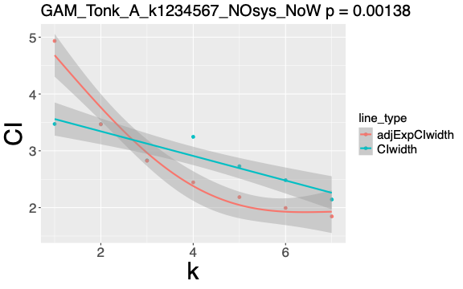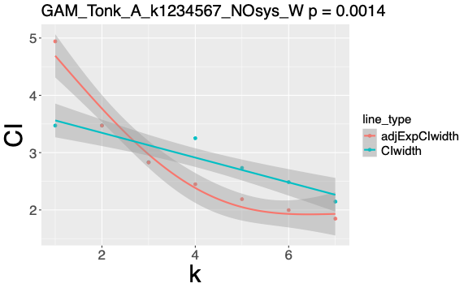
## Fig S11A.2 Fig S11A.W.2
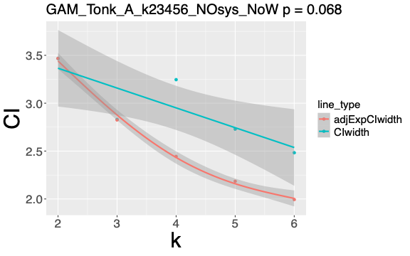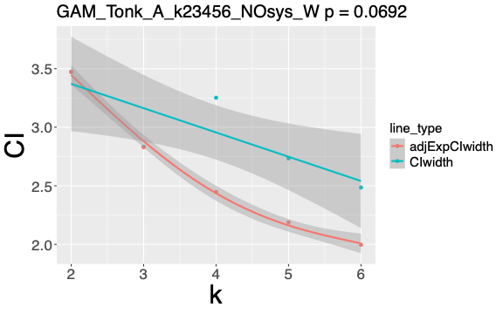
## Fig S11B Fig S11B.W
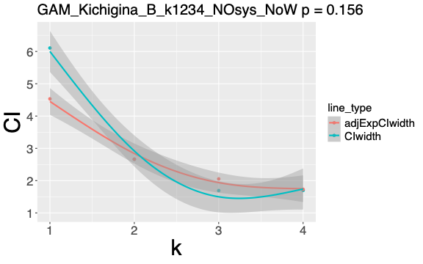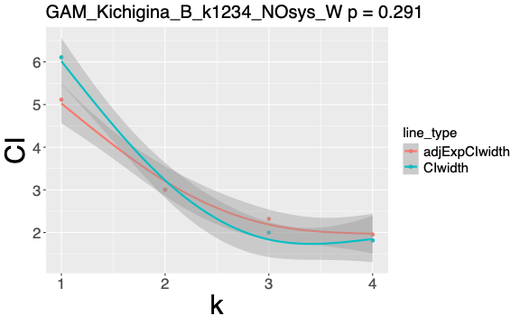

## Fig S11C Fig S11C.W
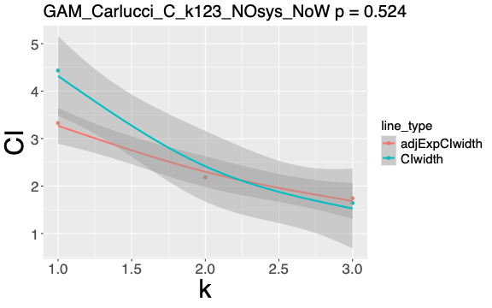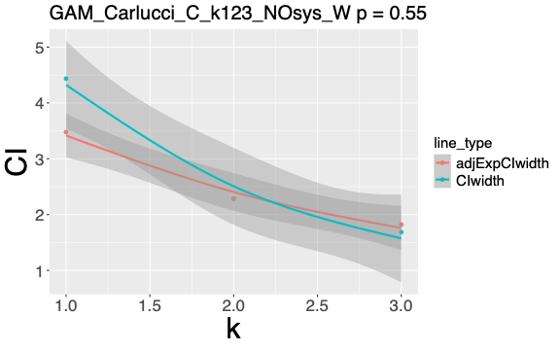
## Fig S11D Fig S11D.W
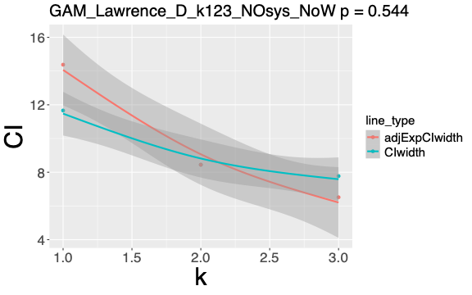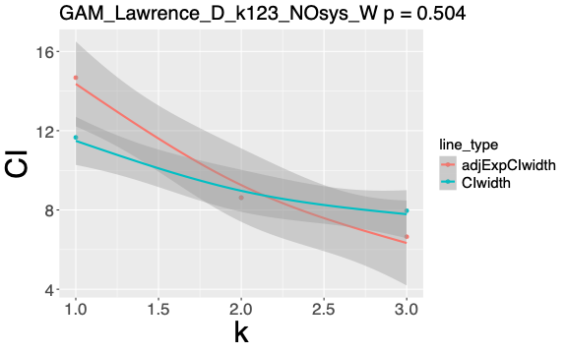
## Fig S11E Fig S11E.W
## (The p-value for Zhang_E was, necessarily, produced by dropping the line_type main-effect term (note the tolerance bands in Section 8 are the main assessment, not the p-value here).
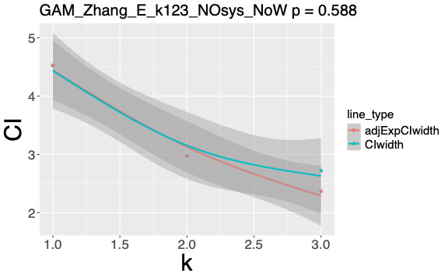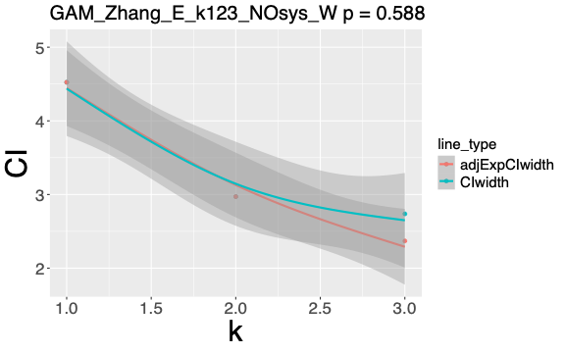
## Fig S11F Fig S11F.W
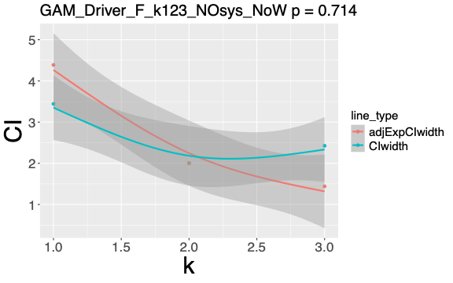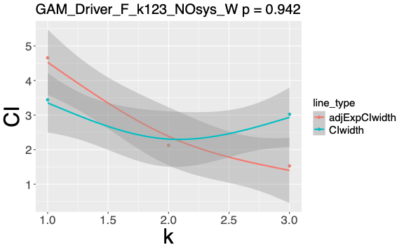
## Fig S11G Fig S11G.W
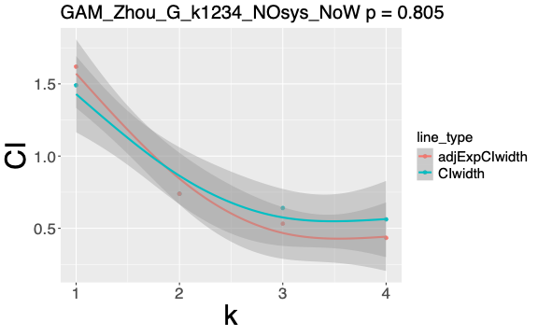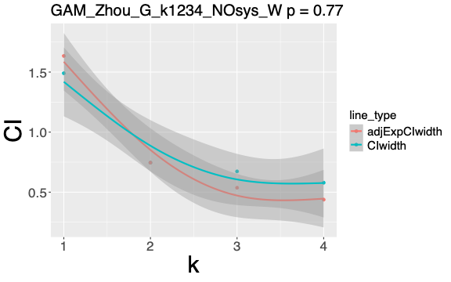
## Fig S11H Fig S11H.W

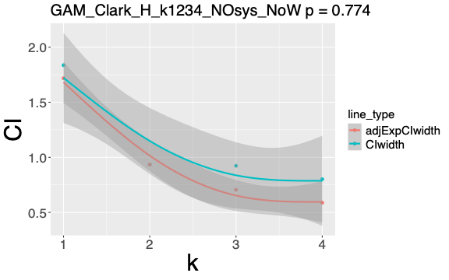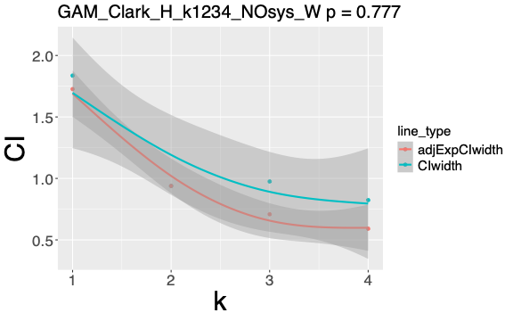
## Section 7. SYS GAM graphs:
## Fig S11AA.1 Fig S11AA.W.1
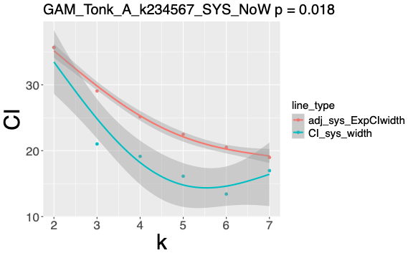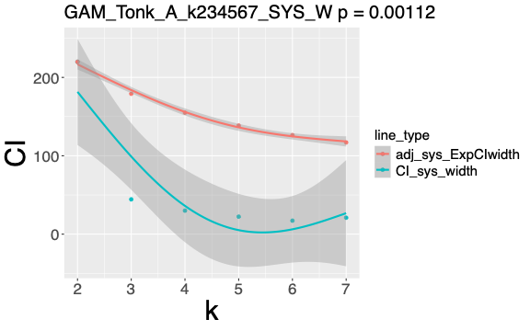
## Fig S11AA.2 Fig S11AA.W.2
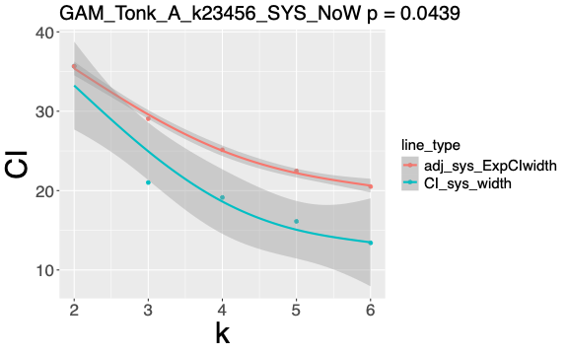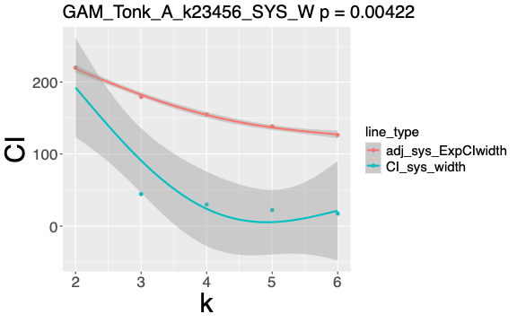
## Fig S11BB Fig S11BB.W
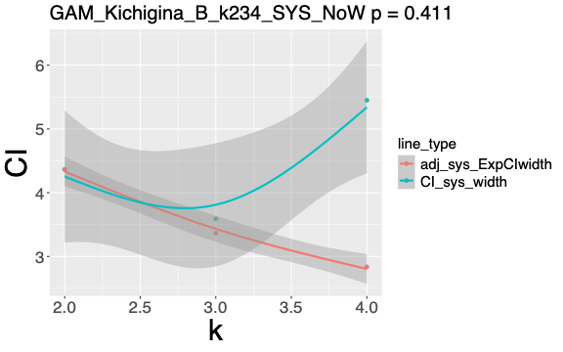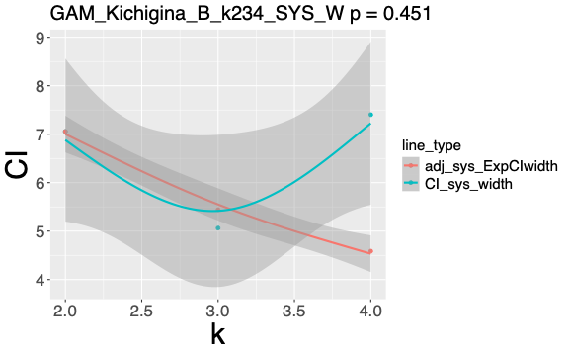
## Fig S11GG Fig S11GG.W
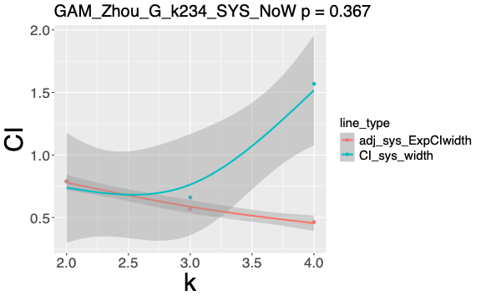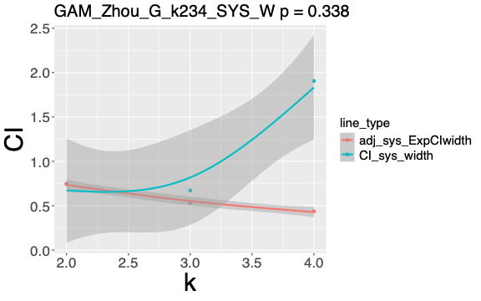
## Fig S11HH
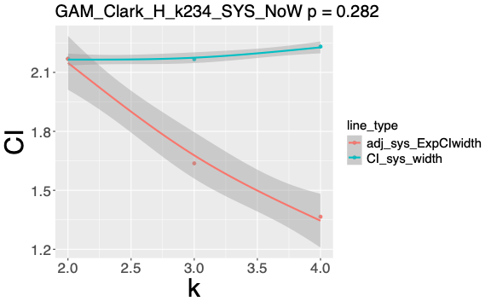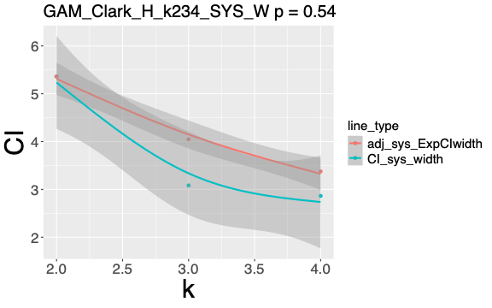
## NOTE: Clark_H is the only study whose SE_total increases with k (var_sys increases while var_sampling stays flat), so the curve is determined almost entirely by t_crit. Under the pooled degrees of freedom (NoW) the actual width is therefore flat but with the Welch adjustment it declines, because the combined degrees of freedom rise from 1.49 at k=2 to 3.93 at k=4 as the systematic term gains k−1 degrees of freedom. The non-Welch panel is perhaps more useful here as the between-mean scatter does not, in fact, shrink with k.

## Section 8. Do points lie within 25% of the expected decreasing curve ?

## Section 8.1. NOsys data with 25% bands. Data from CIdf_list (re-created here from original_data).
myprefix <- c("Tonk", "Kich", "Carl", "Lawr", "Zhan", "Driv", "Zhou", "Clark")
CIdf_list <- list();
for (i in 1:length(names)) {
sub <- mydf[mydf$study == names[[i]], ]
sub <- sub[order(sub$k), ]
mydfband <- data.frame(sub$k,
100 * signif(sub$CIwidth_NoW / sub$ref_CI_NoW, 4),
100 * signif(sub$CIwidth_W / sub$ref_CI_W, 4),
100 * signif(sub$ExpCIwidth / sub$refExp_CI, 4))
colnames(mydfband) <- c("k", paste0(myprefix[i], "_Act_NoW"), paste0(myprefix[i], "_Act_W"), paste0(myprefix[i], "_Exp"))
CIdf_list[[i]] <- mydfband
}
names(CIdf_list) <- myprefix
CIdf_list

## TABLE S11.T6 (re-created here from original_data; identical to S7.T14). (CIdf_list). Actual and expected 95% confidence interval widths, from sampling error alone as ratios of that at k=2, from function global_mean_CI_nosys.
## column definitions (columns match S7 TABLE S7.T14):
## k = number of replicates included for this row's data
## _Act_NoW = actual ratio of confidence interval width (sampling error only) relative to that at k=2. CIwidth = 2*t_crit*SE_total, where SE_total = sqrt(var_total), var_total = sum((weights^2) * (sds^2 / ns)) for studies supplying SDs or sum((weights^2) * (SE^2)) for studies supplying SEs, and weights = ns/total_n. Degrees of freedom for t_crit are pooled, df = sum(ns-1); no Welch's adjustment.
## _Act_W = as _Act_NoW, but with Welch–Satterthwaite adjustment.
## _Exp = expected ratio of confidence interval width (sampling error only) relative to that at k=2. ExpCIwidth = 2*qt((1-alpha/2), df = sum(ns-1)) / sqrt(sum(ns)). This always uses the pooled df and is therefore unaffected by the Welch setting.
## CIdf_list
## $Tonk
## k Tonk_Act_NoW Tonk_Act_W Tonk_Exp
## 1 1 100.10 99.99 142.30
## 2 2 100.00 100.00 100.00
## 3 3 81.63 81.56 81.48
## 4 4 93.62 93.64 70.49
## 5 5 78.71 78.72 63.01
## 6 6 71.61 71.58 57.50
## 7 7 61.79 61.78 53.22
## $Kich
## k Kich_Act_NoW Kich_Act_W Kich_Exp
## 1 1 229.50 203.30 170.30
## 2 2 100.00 100.00 100.00
## 3 3 63.52 66.54 77.15
## 4 4 63.77 60.35 65.00
## $Carl
## k Carl_Act_NoW Carl_Act_W Carl_Exp
## 1 1 203.00 194.20 152.30
## 2 2 100.00 100.00 100.00
## 3 3 75.19 73.81 79.74
## $Lawr
## k Lawr_Act_NoW Lawr_Act_W Lawr_Exp
## 1 1 138.10 135.30 170.30
## 2 2 100.00 100.00 100.00
## 3 3 92.02 92.35 77.15
## $Zhan
## k Zhan_Act_NoW Zhan_Act_W Zhan_Exp
## 1 1 152.30 152.30 152.30
## 2 2 100.00 100.00 100.00
## 3 3 91.62 92.12 79.74
## $Driv
## k Driv_Act_NoW Driv_Act_W Driv_Exp
## 1 1 171.9 162.0 219.20
## 2 2 100.0 100.0 100.00
## 3 3 121.1 142.3 71.96
## $Zhou
## k Zhou_Act_NoW Zhou_Act_W Zhou_Exp
## 1 1 201.70 199.80 219.20
## 2 2 100.00 100.00 100.00
## 3 3 86.68 90.24 71.96
## 4 4 76.04 77.59 58.73
## $Clark
## k Clark_Act_NoW Clark_Act_W Clark_Exp
## 1 1 196.60 195.60 183.90
## 2 2 100.00 100.00 100.00
## 3 3 98.83 103.90 75.48
## 4 4 85.79 87.73 62.96

band_check <- function(k, act_pct_NoW, act_pct_W, exp_pct, kind = c("nosys","sys"),
tau = 1.25, ## ratio band: observed within +/-25% of expected
delta = 25) { ## absolute band: within 25 pp (% of k=2 CI expected width)
kind <- match.arg(kind)
rN <- act_pct_NoW / exp_pct ## observed/expected; r == 1 at k = 2 by construction
rW <- act_pct_W / exp_pct
gapN <- act_pct_NoW - exp_pct ## vertical gap in pp (both are % of the k = 2 CI width)
gapW <- act_pct_W - exp_pct
info <- k >= 3 ## k = 1 unpooled start, k = 2 anchor -> both non-informative
data.frame(k,
actualCI_NoW = round(act_pct_NoW, 1),
actualCI_W = round(act_pct_W, 1),
expCI = round(exp_pct, 1),
## ratio_NoW = round(rN, 3),
## ratio_W = round(rW, 3),
ratiodiff_NoW = round(100 * (rN - 1), 1), ## relative deviation (ratio criterion)
ratiodiff_W = round(100 * (rW - 1), 1),
adddiff_NoW = round(gapN, 1), ## absolute deviation (pp criterion)
adddiff_W = round(gapW, 1),
informative = info,
in_ratioband_NoW = ifelse(info, rN >= 1/tau & rN <= tau, NA), ## within +/-25%
in_ratioband_W = ifelse(info, rW >= 1/tau & rW <= tau, NA),
in_addband_NoW = ifelse(info, abs(gapN) <= delta, NA), ## within 25 pp
in_addband_W = ifelse(info, abs(gapW) <= delta, NA))
}

bandlistNOsys <- list();
for (i in 1:length(CIdf_list)) {
d <- CIdf_list[[i]]
bandlistNOsys[[i]] <- band_check(d[[1]], d[[2]], d[[3]], d[[4]], "nosys")
names(bandlistNOsys)[i] <- myprefix[[i]]
}
print(bandlistNOsys, row.names = FALSE)

## TABLE S11.T7 (bandlistNOsys). NOsys results showing which points lie within 25% expected tolerance bands (either relative at each k or "absolute" = relative to k=2).
## column definitions: (suffixes _W and _NoW are with or without Welch-Satterthwaite adjustment, respectively.)
## k = replicate number: how many of the study's groups (levels) have been accumulated into the running pooled estimate. k=1 is a single, unpooled group; k=2 gives the first two groups pooled; and so on.
## actualCI columns show observed ("actual") CI width at this k (from sampling error alone), as a percentage of the study's observed k=2 CI width (100 x CIwidth(k) / CIwidth(k=2)). This is 100 at k=2 by construction. Lower values (<100) mean the real CI has narrowed as replicates accumulate.
## expCI = expected CI width at each k, on the same scale as actual_CI (100x adjExp(k)/CIwidth(k=2)). This is the idealised 1/sqrt(k) narrowing curve - giving the CI width if adding replicates reduced it purely by sampling theory. This is anchored so it equals the observed value (100) at k=2, i.e., it is also 100 at k=2 by construction.
## ratiodiff columns show multiplicative discrepancy as a percentage: 100 x (ratio−1). This is the quantity the relative band judges (note the band is multiplicative, so the limits are −20% to +25%). Assessed in in_ratioband columns. Where ratio = actual_CI/exp_CI (equivalently: CI(k)/adjExp(k)): this is the multiplicative discrepancy between observed and expected.
## adddiff columns show additive discrepancy: actual_CI minus exp_CI, in percentage points of the k=2 CI expected width. This is the vertical distance between the observed and expected curves on the normalised plot; +25 means the observed curve sits 25 points (a quarter of the k=2 width) above expected. Assessed in in_addband columns.
## informative = whether the position counts towards assessment. TRUE for k≥3; FALSE for k=1 (a single unpooled group) and k=2 (the anchor - both positions forced to 100).
## in_ratioband columns show relative criterion: TRUE if ratio lies within [1/tau, tau] = [0.80, 1.25] (observed within ±25% of expected, multiplicatively), FALSE if outside, NA if non-informative.
## in_addband columns show absolute criterion: TRUE if |gap_pp| ≤ delta = 25 (observed within 25 percentage points = a quarter of the k=2 expected width), FALSE if outside, NA if non-informative.
## print(bandlistNOsys, row.names = FALSE)
## $Tonk
## k actualCI_NoW actualCI_W expCI ratiodiff_NoW ratiodiff_W adddiff_NoW adddiff_W informative in_ratioband_NoW in_ratioband_W in_addband_NoW in_addband_W
## 1 100.1 100.0 142.3 -29.7 -29.7 -42.2 -42.3 FALSE NA NA NA NA
## 2 100.0 100.0 100.0 0.0 0.0 0.0 0.0 FALSE NA NA NA NA
## 3 81.6 81.6 81.5 0.2 0.1 0.2 0.1 TRUE TRUE TRUE TRUE TRUE
## 4 93.6 93.6 70.5 32.8 32.8 23.1 23.2 TRUE FALSE FALSE TRUE TRUE
## 5 78.7 78.7 63.0 24.9 24.9 15.7 15.7 TRUE TRUE TRUE TRUE TRUE
## 6 71.6 71.6 57.5 24.5 24.5 14.1 14.1 TRUE TRUE TRUE TRUE TRUE
## 7 61.8 61.8 53.2 16.1 16.1 8.6 8.6 TRUE TRUE TRUE TRUE TRUE
## $Kich
## k actualCI_NoW actualCI_W expCI ratiodiff_NoW ratiodiff_W adddiff_NoW adddiff_W informative in_ratioband_NoW in_ratioband_W in_addband_NoW in_addband_W
## 1 229.5 203.3 170.3 34.8 19.4 59.2 33.0 FALSE NA NA NA NA
## 2 100.0 100.0 100.0 0.0 0.0 0.0 0.0 FALSE NA NA NA NA
## 3 63.5 66.5 77.1 -17.7 -13.8 -13.6 -10.6 TRUE TRUE TRUE TRUE TRUE
## 4 63.8 60.4 65.0 -1.9 -7.2 -1.2 -4.6 TRUE TRUE TRUE TRUE TRUE
## $Carl
## k actualCI_NoW actualCI_W expCI ratiodiff_NoW ratiodiff_W adddiff_NoW adddiff_W informative in_ratioband_NoW in_ratioband_W in_addband_NoW in_addband_W
## 1 203.0 194.2 152.3 33.3 27.5 50.7 41.9 FALSE NA NA NA NA
## 2 100.0 100.0 100.0 0.0 0.0 0.0 0.0 FALSE NA NA NA NA
## 3 75.2 73.8 79.7 -5.7 -7.4 -4.5 -5.9 TRUE TRUE TRUE TRUE TRUE
## $Lawr
## k actualCI_NoW actualCI_W expCI ratiodiff_NoW ratiodiff_W adddiff_NoW adddiff_W informative in_ratioband_NoW in_ratioband_W in_addband_NoW in_addband_W
## 1 138.1 135.3 170.3 -18.9 -20.6 -32.2 -35.0 FALSE NA NA NA NA
## 2 100.0 100.0 100.0 0.0 0.0 0.0 0.0 FALSE NA NA NA NA
## 3 92.0 92.3 77.1 19.3 19.7 14.9 15.2 TRUE TRUE TRUE TRUE TRUE
## $Zhan
## k actualCI_NoW actualCI_W expCI ratiodiff_NoW ratiodiff_W adddiff_NoW adddiff_W informative in_ratioband_NoW in_ratioband_W in_addband_NoW in_addband_W
## 1 152.3 152.3 152.3 0.0 0.0 0.0 0.0 FALSE NA NA NA NA
## 2 100.0 100.0 100.0 0.0 0.0 0.0 0.0 FALSE NA NA NA NA
## 3 91.6 92.1 79.7 14.9 15.5 11.9 12.4 TRUE TRUE TRUE TRUE TRUE
## $Driv
## k actualCI_NoW actualCI_W expCI ratiodiff_NoW ratiodiff_W adddiff_NoW adddiff_W informative in_ratioband_NoW in_ratioband_W in_addband_NoW in_addband_W
## 1 171.9 162.0 219.2 -21.6 -26.1 -47.3 -57.2 FALSE NA NA NA NA
## 2 100.0 100.0 100.0 0.0 0.0 0.0 0.0 FALSE NA NA NA NA
## 3 121.1 142.3 72.0 68.3 97.7 49.1 70.3 TRUE FALSE FALSE FALSE FALSE
## $Zhou
## k actualCI_NoW actualCI_W expCI ratiodiff_NoW ratiodiff_W adddiff_NoW adddiff_W informative in_ratioband_NoW in_ratioband_W in_addband_NoW in_addband_W
## 1 201.7 199.8 219.2 -8.0 -8.9 -17.5 -19.4 FALSE NA NA NA NA
## 2 100.0 100.0 100.0 0.0 0.0 0.0 0.0 FALSE NA NA NA NA
## 3 86.7 90.2 72.0 20.5 25.4 14.7 18.3 TRUE TRUE FALSE TRUE TRUE
## 4 76.0 77.6 58.7 29.5 32.1 17.3 18.9 TRUE FALSE FALSE TRUE TRUE
## $Clark
## k actualCI_NoW actualCI_W expCI ratiodiff_NoW ratiodiff_W adddiff_NoW adddiff_W informative in_ratioband_NoW in_ratioband_W in_addband_NoW in_addband_W
## 1 196.6 195.6 183.9 6.9 6.4 12.7 11.7 FALSE NA NA NA NA
## 2 100.0 100.0 100.0 0.0 0.0 0.0 0.0 FALSE NA NA NA NA
## 3 98.8 103.9 75.5 30.9 37.7 23.3 28.4 TRUE FALSE FALSE TRUE FALSE
## 4 85.8 87.7 63.0 36.3 39.3 22.8 24.8 TRUE FALSE FALSE TRUE TRUE

## Section 8.2. SYS data with 25% band. (re-created here from original_data).
CIdf_listsys <- list();
for (i in 1:length(names)) {
sub <- mydf[mydf$study == names[[i]], ]
sub <- sub[order(sub$k), ]
mydfbandsys <- data.frame(sub$k,
100 * signif(sub$CI_sys_width_NoW / sub$refCI_sys_NoW, 4),
100 * signif(sub$CI_sys_width_W / sub$refCI_sys_W, 4),
100 * signif(sub$ExpCIwidth / sub$refExp_CI, 4),
100 * signif(sub$CIwidth_NoW / sub$ref_CI_NoW, 4),
100 * signif(sub$CIwidth_W / sub$ref_CI_W, 4))
colnames(mydfbandsys) <- c("k", paste0(myprefix[i], "_Actsysvar_NoW"), paste0(myprefix[i], "_Actsysvar_W"), paste0(myprefix[i], "_Exp"), paste0(myprefix[i], "_Act_NoW"), paste0(myprefix[i], "_Act_W"))
CIdf_listsys[[i]] <- mydfbandsys
}
names(CIdf_listsys) <- myprefix
CIdf_listsys

## TABLE S11.T8 (re-created here from original_data; identical to TABLE S7.T17). (CIdf_listsys). Actual and expected 95% confidence interval widths, from sampling error plus systematic errors (with actual from sampling error alone for comparison), as ratios of that at k=2, from function global_mean_CI_sys.
## column definitions: (suffixes _W and _NoW are with or without Welch-Satterthwaite adjustment, respectively.)
## k = number of replicates included for this row's data
## _Actsysvar columns show confidence interval widths (including systematic and sampling error), relative to that at k=2. CI_sys_width = 2*t_crit * SE_total, where SE_total = sqrt(var_sampling + var_sys).
## _Exp = expected ratio of confidence interval width (sampling error only) relative to that at k=2. ExpCIwidth = 2*qt((1-alpha/2), df = sum(ns-1)) / sqrt(sum(ns)). This always uses the pooled df and is therefore unaffected by the Welch setting.
## _Act columns show actual ratios of confidence interval widths (sampling error only) relative to that at k=2. CIwidth = 2*t_crit * SE_total
## print(CIdf_listsys, row.names = FALSE)
## $Tonk
## k Tonk_Actsysvar_NoW Tonk_Actsysvar_W Tonk_Exp Tonk_Act_NoW Tonk_Act_W
## 1 9.736 1.580 142.30 100.10 99.99
## 2 100.000 100.000 100.00 100.00 100.00
## 3 58.930 20.200 81.48 81.63 81.56
## 4 53.650 13.650 70.49 93.62 93.64
## 5 45.220 10.140 63.01 78.71 78.72
## 6 37.620 7.829 57.50 71.61 71.58
## 7 47.580 9.548 53.22 61.79 61.78
## $Kich
## k Kich_Actsysvar_NoW Kich_Actsysvar_W Kich_Exp Kich_Act_NoW Kich_Act_W
## 1 139.90 86.57 170.30 229.50 203.30
## 2 100.00 100.00 100.00 100.00 100.00
## 3 82.23 71.75 77.15 63.52 66.54
## 4 124.90 104.90 65.00 63.77 60.35
## $Carl
## k Carl_Actsysvar_NoW Carl_Actsysvar_W Carl_Exp Carl_Act_NoW Carl_Act_W
## 1 75.39 22.27 152.30 203.00 194.20
## 2 100.00 100.00 100.00 100.00 100.00
## 3 79.88 40.11 79.74 75.19 73.81
## $Lawr
## k Lawr_Actsysvar_NoW Lawr_Actsysvar_W Lawr_Exp Lawr_Act_NoW Lawr_Act_W
## 1 134.1 133.6 170.30 138.10 135.30
## 2 100.0 100.0 100.00 100.00 100.00
## 3 167.6 217.7 77.15 92.02 92.35
## $Zhan
## k Zhan_Actsysvar_NoW Zhan_Actsysvar_W Zhan_Exp Zhan_Act_NoW Zhan_Act_W
## 1 57.05 17.03 152.30 152.30 152.30
## 2 100.00 100.00 100.00 100.00 100.00
## 3 112.90 60.02 79.74 91.62 92.12
## $Driv
## k Driv_Actsysvar_NoW Driv_Actsysvar_W Driv_Exp Driv_Act_NoW Driv_Act_W
## 1 115.10 95.59 219.20 171.9 162.0
## 2 100.00 100.00 100.00 100.0 100.0
## 3 99.55 85.85 71.96 121.1 142.3
## $Zhou
## k Zhou_Actsysvar_NoW Zhou_Actsysvar_W Zhou_Exp Zhou_Act_NoW Zhou_Act_W
## 1 188.80 200.30 219.20 201.70 199.80
## 2 100.00 100.00 100.00 100.00 100.00
## 3 83.73 90.37 71.96 86.68 90.24
## 4 198.70 256.10 58.73 76.04 77.59
## $Clark
## k Clark_Actsysvar_NoW Clark_Actsysvar_W Clark_Exp Clark_Act_NoW Clark_Act_W
## 1 84.66 34.24 183.90 196.60 195.60
## 2 100.00 100.00 100.00 100.00 100.00
## 3 99.91 57.49 75.48 98.83 103.90
## 4 102.90 53.40 62.96 85.79 87.73

bandlistSYS <- list();
for (i in 1:length(CIdf_listsys)) {
d <- CIdf_listsys[[i]]
bandlistSYS[[i]] <- band_check(d[[1]], d[[2]], d[[3]], d[[4]], "sys")
names(bandlistSYS)[i] <- myprefix[[i]]
}
print(bandlistSYS, row.names = FALSE)

## TABLE S11.T9 (bandlistSYS). SYS results showing which points lie within 25% expected tolerance bands (either relative at each k or "absolute" = relative to k=2).
## column definitions: (suffixes _W and _NoW are with or without Welch-Satterthwaite adjustment, respectively.)
## k = replicate number: how many of the study's groups (levels) have been accumulated into the running pooled estimate. k=1 is a single, unpooled group; k=2 gives the first two groups pooled; and so on.
## actual_CIwidth = observed ("actual") CI width (from systematic plus sampling error) at this k, as a percentage of the study's observed k=2 CI width (100 x CIwidth(k) / CIwidth(k=2)). This is 100 at k=2 by construction. Lower values (<100) mean the real CI has narrowed as replicates accumulate.
## exp_CIwidth = expected CI width at each k, on the same scale as actual_CIwidth (100x adjExp(k)/CIwidth(k=2)). This is the idealised 1/sqrt(k) narrowing curve - giving the CI width if adding replicates reduced it purely by sampling theory. This is anchored so it equals the observed value (100) at k=2, i.e., it is also 100 at k=2 by construction.
## ratio_diff = multiplicative discrepancy as a percentage: 100 x (ratio−1). +30 means the observed CI is 30% wider than expected at that step; −10 means 10% narrower than expected. This is the quantity the relative band judges (note the band is multiplicative, so the limits are −20% to +25%). Assessed in in_ratio_band. Where ratio = actual_CIwidth/exp_CIwidth (equivalently: CIwidth(k)/adjExp(k)): this is the multiplicative discrepancy between observed and expected (exactly 1 at k=2).
## add_diff = additive discrepancy: actual_CIwidth minus exp_CIwidth, in percentage points of the k=2 CI expected width. This is the vertical distance between the observed and expected curves on the normalised plot; +25 means the observed curve sits 25 points (a quarter of the k=2 width) above expected. Assessed in in_add_band.
## informative = whether the position counts towards assessment. TRUE for k≥3; FALSE for k=1 (a single unpooled group; undefined for SYS: var_sys is zero at k=1, so the value shown is the sampling-only width expressed against the systematic k=2 anchor, and carries no systematic-error information) and k=2 (the anchor - both positions forced to 100).
## in_ratio_band = relative criterion: TRUE if ratio lies within [1/tau, tau] = [0.80, 1.25] (observed within ±25% of expected, multiplicatively), FALSE if outside, NA if non-informative.
## in_add_band = absolute criterion: TRUE if |gap_pp| ≤ delta = 25 (observed within 25 percentage points = a quarter of the k=2 expected width), FALSE if outside, NA if non-informative.
## print(bandlistSYS, row.names = FALSE)
## $Tonk
## k actualCI_NoW actualCI_W expCI ratiodiff_NoW ratiodiff_W adddiff_NoW adddiff_W informative in_ratioband_NoW in_ratioband_W in_addband_NoW in_addband_W
## 1 9.7 1.6 142.3 -93.2 -98.9 -132.6 -140.7 FALSE NA NA NA NA
## 2 100.0 100.0 100.0 0.0 0.0 0.0 0.0 FALSE NA NA NA NA
## 3 58.9 20.2 81.5 -27.7 -75.2 -22.5 -61.3 TRUE FALSE FALSE TRUE FALSE
## 4 53.6 13.7 70.5 -23.9 -80.6 -16.8 -56.8 TRUE FALSE FALSE TRUE FALSE
## 5 45.2 10.1 63.0 -28.2 -83.9 -17.8 -52.9 TRUE FALSE FALSE TRUE FALSE
## 6 37.6 7.8 57.5 -34.6 -86.4 -19.9 -49.7 TRUE FALSE FALSE TRUE FALSE
## 7 47.6 9.5 53.2 -10.6 -82.1 -5.6 -43.7 TRUE TRUE FALSE TRUE FALSE
## $Kich
## k actualCI_NoW actualCI_W expCI ratiodiff_NoW ratiodiff_W adddiff_NoW adddiff_W informative in_ratioband_NoW in_ratioband_W in_addband_NoW in_addband_W
## 1 139.9 86.6 170.3 -17.9 -49.2 -30.4 -83.7 FALSE NA NA NA NA
## 2 100.0 100.0 100.0 0.0 0.0 0.0 0.0 FALSE NA NA NA NA
## 3 82.2 71.8 77.1 6.6 -7.0 5.1 -5.4 TRUE TRUE TRUE TRUE TRUE
## 4 124.9 104.9 65.0 92.2 61.4 59.9 39.9 TRUE FALSE FALSE FALSE FALSE
## $Carl
## k actualCI_NoW actualCI_W expCI ratiodiff_NoW ratiodiff_W adddiff_NoW adddiff_W informative in_ratioband_NoW in_ratioband_W in_addband_NoW in_addband_W
## 1 75.4 22.3 152.3 -50.5 -85.4 -76.9 -130.0 FALSE NA NA NA NA
## 2 100.0 100.0 100.0 0.0 0.0 0.0 0.0 FALSE NA NA NA NA
## 3 79.9 40.1 79.7 0.2 -49.7 0.1 -39.6 TRUE TRUE FALSE TRUE FALSE
## $Lawr
## k actualCI_NoW actualCI_W expCI ratiodiff_NoW ratiodiff_W adddiff_NoW adddiff_W informative in_ratioband_NoW in_ratioband_W in_addband_NoW in_addband_W
## 1 134.1 133.6 170.3 -21.3 -21.6 -36.2 -36.7 FALSE NA NA NA NA
## 2 100.0 100.0 100.0 0.0 0.0 0.0 0.0 FALSE NA NA NA NA
## 3 167.6 217.7 77.1 117.2 182.2 90.4 140.6 TRUE FALSE FALSE FALSE FALSE
## $Zhan
## k actualCI_NoW actualCI_W expCI ratiodiff_NoW ratiodiff_W adddiff_NoW adddiff_W informative in_ratioband_NoW in_ratioband_W in_addband_NoW in_addband_W
## 1 57.0 17 152.3 -62.5 -88.8 -95.2 -135.3 FALSE NA NA NA NA
## 2 100.0 100 100.0 0.0 0.0 0.0 0.0 FALSE NA NA NA NA
## 3 112.9 60 79.7 41.6 -24.7 33.2 -19.7 TRUE FALSE FALSE FALSE TRUE
## $Driv
## k actualCI_NoW actualCI_W expCI ratiodiff_NoW ratiodiff_W adddiff_NoW adddiff_W informative in_ratioband_NoW in_ratioband_W in_addband_NoW in_addband_W
## 1 115.1 95.6 219.2 -47.5 -56.4 -104.1 -123.6 FALSE NA NA NA NA
## 2 100.0 100.0 100.0 0.0 0.0 0.0 0.0 FALSE NA NA NA NA
## 3 99.6 85.9 72.0 38.3 19.3 27.6 13.9 TRUE FALSE TRUE FALSE TRUE
## $Zhou
## k actualCI_NoW actualCI_W expCI ratiodiff_NoW ratiodiff_W adddiff_NoW adddiff_W informative in_ratioband_NoW in_ratioband_W in_addband_NoW in_addband_W
## 1 188.8 200.3 219.2 -13.9 -8.6 -30.4 -18.9 FALSE NA NA NA NA
## 2 100.0 100.0 100.0 0.0 0.0 0.0 0.0 FALSE NA NA NA NA
## 3 83.7 90.4 72.0 16.4 25.6 11.8 18.4 TRUE TRUE FALSE TRUE TRUE
## 4 198.7 256.1 58.7 238.3 336.1 140.0 197.4 TRUE FALSE FALSE FALSE FALSE
## $Clark
## k actualCI_NoW actualCI_W expCI ratiodiff_NoW ratiodiff_W adddiff_NoW adddiff_W informative in_ratioband_NoW in_ratioband_W in_addband_NoW in_addband_W
## 1 84.7 34.2 183.9 -54.0 -81.4 -99.2 -149.7 FALSE NA NA NA NA
## 2 100.0 100.0 100.0 0.0 0.0 0.0 0.0 FALSE NA NA NA NA
## 3 99.9 57.5 75.5 32.4 -23.8 24.4 -18.0 TRUE FALSE FALSE TRUE TRUE
## 4 102.9 53.4 63.0 63.4 -15.2 39.9 -9.6 TRUE FALSE TRUE FALSE TRUE

