Date : 25.11.2020

Task-1 :

1. Select department name & location of all the employees working for CLARK.
2. Select all the departmental information for all the managers
3. Display the first maximum salary.
4. Display the second maximum salary.
5. Display the third maximum salary.
6. Display all the managers & clerks who work in Accounts and Marketing departments.

7.Display all the salesmen who are not located at DALLAS.

Answers:

1. select dept.dname,dept.loc from dept,emp where dept.deptno=emp.deptno and emp.ename='CLARK';

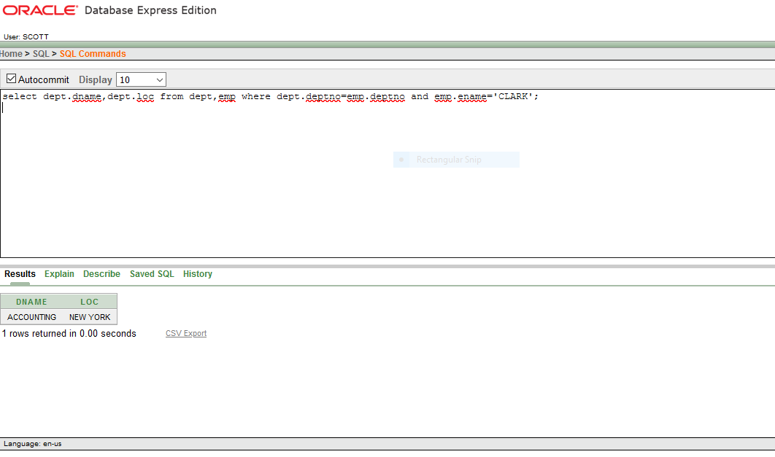

1. select dept.* from dept,emp where emp.deptno=dept.deptno and emp.job='MANAGER';

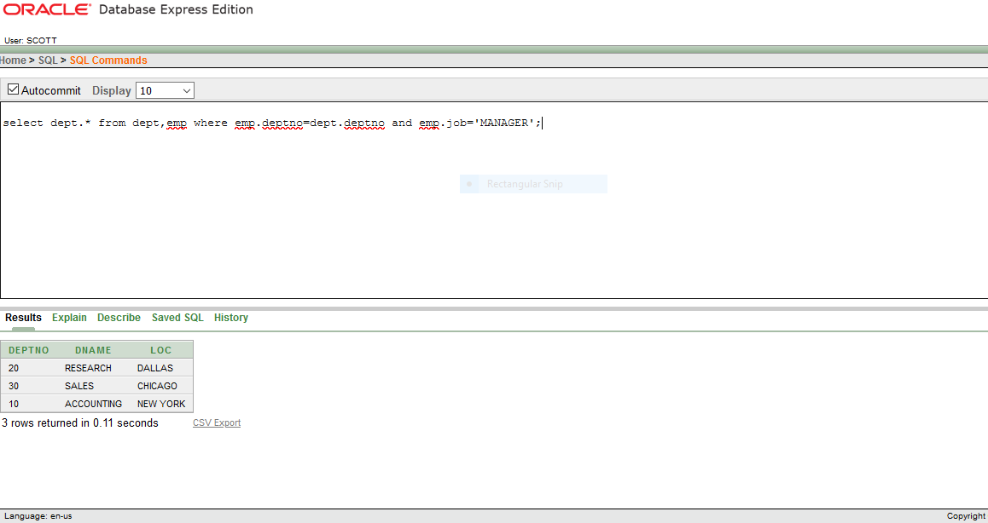

1. SELECT A.SAL

FROM EMP A

WHERE 0 = (SELECT COUNT(DISTINCT(SAL))

FROM EMP B

WHERE A.SAL < B.SAL);

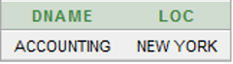

1. SELECT A.SAL

FROM EMP A

WHERE 1 = (SELECT COUNT(DISTINCT(SAL))

FROM EMP B

WHERE A.SAL < B.SAL);



5. : SELECT A.SAL

FROM EMP A

WHERE 2 = (SELECT COUNT(DISTINCT(SAL))

FROM EMP B

WHERE A.SAL < B.SAL);



6 . Select emp.ename,emp.sal from emp,dept where emp.deptno=dept.deptno and emp.job in('MANAGER','CLERK') and dept.dname in ('ACCOUNTING','SALES');

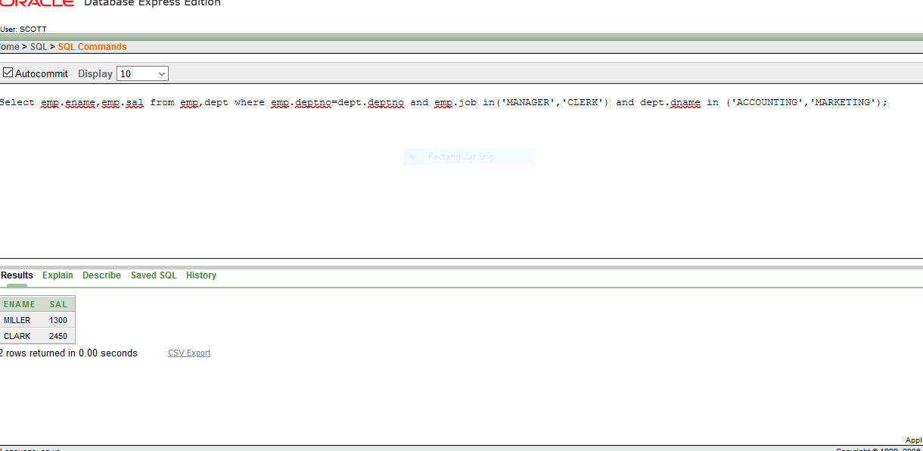

7 . select emp.ename,emp.job from emp,dept where emp.deptno=dept.deptno and emp.job='SALESMAN' and dept.loc<>'DALLAS';

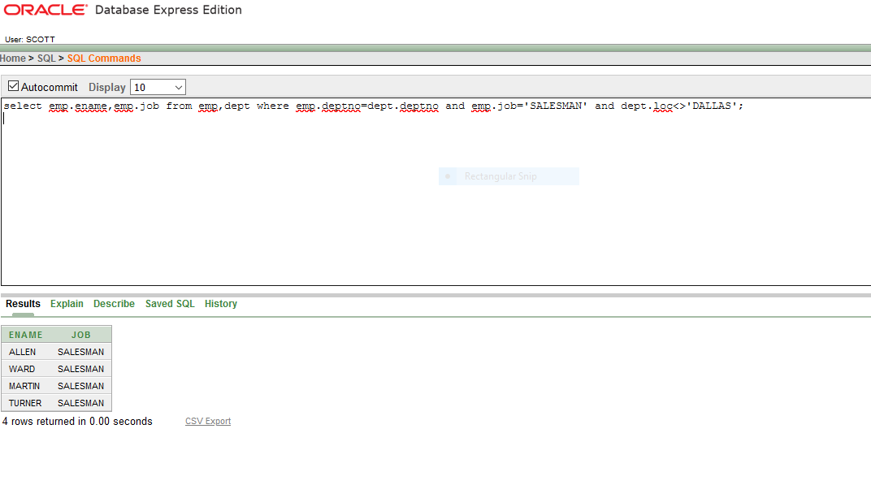

28.11.2020

Questions:

1.Display all the managers & clerks who work in Accounts and Marketing departments

2.Display all the salesmen who are not located at DALLAS

3.Select department name & location of all the employees working for CLARK

4.Display all the departmental information for all the existing employees and if a department has no employees display it as “No employees

5.Get all the matching & non-matching records from both the tables

6.Get all the employees who work in the same departments as of SCOTT

7.Display all the employees who have joined before their managers

8.List all the employees who are earning more than their managers

1. Select emp.ename,emp.sal from emp,dept where emp.deptno=dept.deptno and emp.job in('MANAGER','CLERK') and dept.dname in ('ACCOUNTING','SALES');

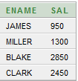

2. select emp.ename,emp.job from emp,dept where emp.deptno=dept.deptno and emp.job='SALESMAN' and dept.loc<>'DALLAS';

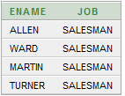

3. SELECT DNAME,LOC FROM DEPT WHERE DEPTNO IN (SELECT DEPTNO FROM EMP WHERE MGR IN (SELECT EMPNO FROM EMP WHERE ENAME='CLARK'));

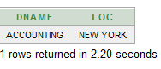

4.SELECT NVL2(ENAME,DNAME,'NO EMPLOYEE'),DNAME  
FROM EMP,DEPT  
WHERE EMP.DEPTNO(+)=DEPT.DEPTNO;

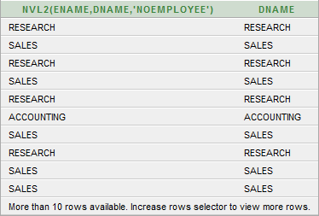

5. SELECT EMP.*,DEPT.* FROM EMP FULL OUTER JOIN DEPT ON EMP.DEPTNO=DEPT.DEPTNO;

SELECT EMP.*,DEPT.* FROM EMP,DEPT WHERE EMP.DEPTNO(+)=DEPT.DEPTNO

UNION

SELECT EMP.*,DEPT.* FROM EMP,DEPT WHERE EMP.DEPTNO=DEPT.DEPTNO(+) ;

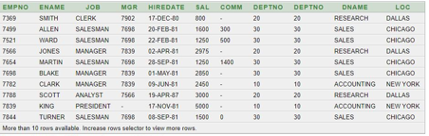

6. : SELECT DISTINCT A.ENAME FROM EMP A, EMP B WHERE A.DEPTNO=(SELECT DEPTNO FROM EMP WHERE ENAME='SCOTT') AND A.ENAME<>'SCOTT';



7.SELECT A.ENAME EMP ,A.HIREDATE EMP_HIREDATE,B.HIREDATE MGR_HIREDATE FROM EMP A,EMP B WHERE A.MGR=B.EMPNO AND A.HIREDATE<B.HIREDATE;

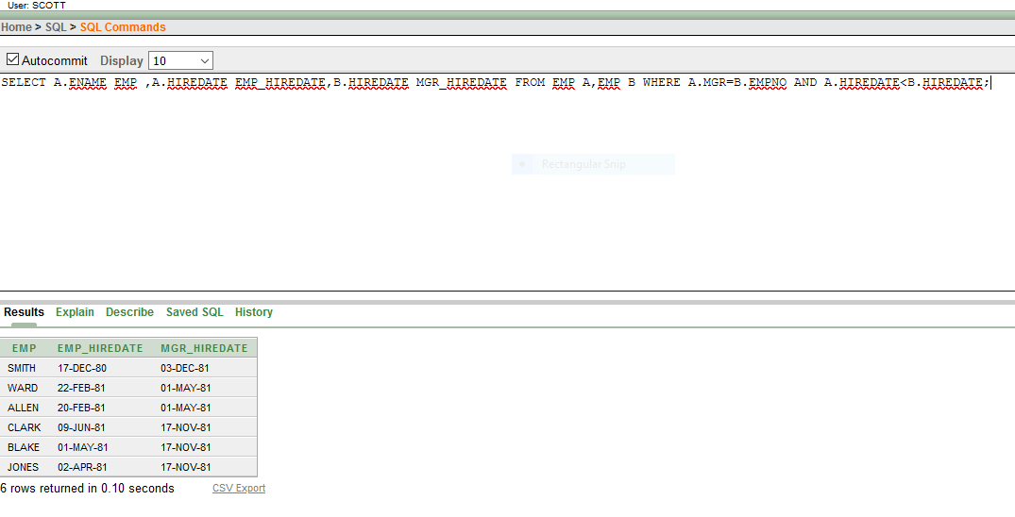

1. SELECT A.ENAME EMPLOYEE,A.SAL EMP_SAL, B.ENAME MANAGER,B.SAL MGR_SAL FROM EMP A,EMP B WHERE A.MGR=B.EMPNO AND A.SAL>B.SAL;

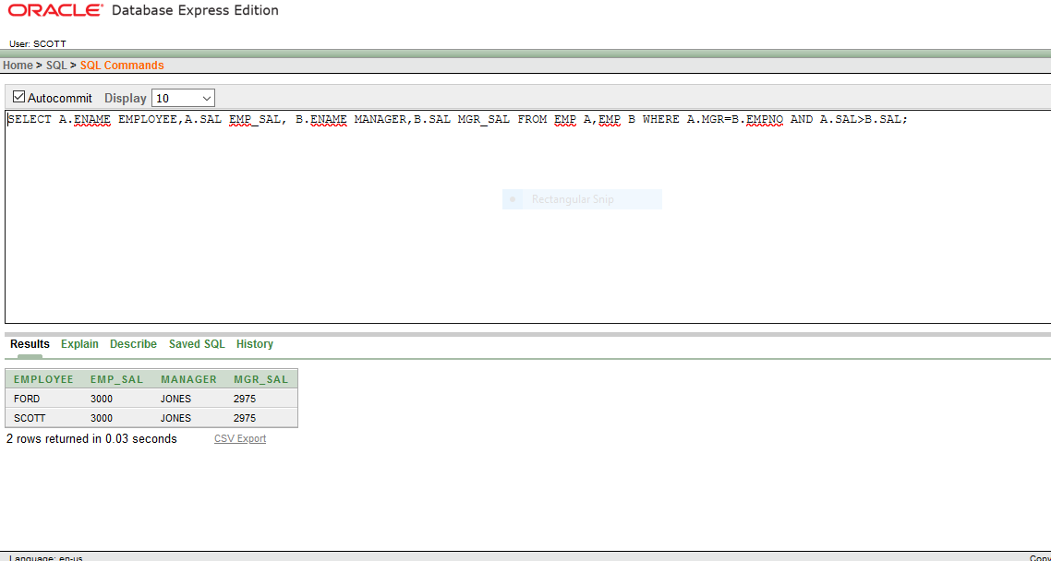

09.12.2020

Task-2 :

1. Create a view called **EMP_VU**based on the employee number, employee name, and department number from the EMP table. Change the heading for the employee name to EMPLOYEE.
2. Display the contents of the **EMP_VU**view. EMPNO                               EMPLOYEE          DEPTNO

|  |  |  |  |
| --- | --- | --- | --- |
| 7839 | KING |  | 10 |
| 7698 | BLAKE |  | 30 |
| 7782 | CLARK |  | 10 |
| 7566 | JONES |  | 20 |
| 7654 | MARTIN |  | 30 |
| 7499 | ALLEN |  | 30 |
| 7844 | TURNER |  | 30 |
| 7900 | JAMES |  | 30 |
| 7521 | WARD |  | 30 |
| 7902 | FORD |  | 20 |
| 7369 | SMITH |  | 20 |
| 7788 | SCOTT |  | 20 |
| 7876 | ADAMS | 20 |  |
| 7934 | MILLER |  | 10 |

1. using your view EMP_VU, enter a query to display all employee names and department numbers.

|  |  |
| --- | --- |
| EMPLOYEE | DEPTNO |
| KING | 10 |
| BLAKE | 30 |
| CLARK | 10 |

1. Create a view named **DEPT20**that contains the employee number, employee name, and department number for all employees in department 20. Label the view column EMPLOYEE_ID, EMPLOYEE, and DEPARTMENT_ID. Do not allow an employee to be reassigned to another department through the view

CREATE VIEW empvu10

AS SELECT empno,ename, job

FROM emp

WHERE deptno = 10;

DESCRIBE empvu10;

select * from empvu10;

CREATE VIEW dept_sum_vu

(name, minsal, maxsal, avgsal)

AS SELECT d.dname, MIN(e.sal), MAX(E.SAL), AVG(e.sal)

FROM emp e, dept d

WHERE e.deptno = d.deptno

GROUP BY d.dname;

select * from dept_sum_vu;

CREATE VIEW emp_vu

AS SELECT empno, ename EMPLOYEE, deptno

FROM emp;

select *from emp_vu;

CREATE or replace view dept20

AS SELECT empno EMPLOYEE_ID, ename EMPLOYEE, deptno DEPARTMENT_ID

FROM emp

WHERE deptno=20;

DESCRIBE dept20;

select *from dept20;

14.12.2020

1. Create a sequence to be used with the primary key column of the DEPARTMENT table. The sequence should start at 60 and have a maximum value of 200. Have your sequence increment by ten numbers. Name the sequence DEPT_ID_SEQ.
2. Write a script to display the following information about your sequences: sequence name, maximum value, increment size, and last number.
3. Create a user **Rahul** with the password ret23erz.
4. Create a new role **Accounts**.
5. Grant system privileges create table, view and sequence to role Accounts.
6. Assign role Accounts to Rahul.
7. Change password of **Rahul** with the new password **rec34tg**

Answers:

1.CREATE SEQUENCE DEPT_ID_SEQ

START WITH 60

INCREMENT BY 10

MAX VALUE 200;

2.SELECT SEQUNCE_NAME,MAX_VALUE,INCREMENT_BY,LAST NUMBER

FROM USER_SEQUNCE;

3.CREATE USER RAHUL

WITH PASSWORD = ‘ ret23erz’;

4.CREATE ROLE Account;

5.GRANT CREATE TABLE,CREATE VIEW,CREATE SEQUENCE TO ACCOUNTS;

6.GRANT ACCOUNTS TO RAHUL;

7.ALTER USER Rahul IDENTIFIED BY rec34tg