

North South University Department of Electrical & Computer Engineering

Project Proposal

Project :Ultrasonic Radar
Course cse323
Section: 9
Submitted To:

Faculty: Mosabber Uddin Ahmed (MUA3)

Email: mosabber.ahmed@northsouth.edu

Members Name | ID
1.Faisal Mahmud Abir | 2132358642
2.Md Shajid Hasan | 2211961642
3.Md.Musaaddek | 2021067642
4.Most Yeanur Akter | 2121800642

Ultrasonic Radar

Objectives :

This project aims to design, develop, and implement a Ultrasonic Radar System Using Arduino Uno. The main objectives include
- Object Detection: Identify the presence of objects within a specified range.
- Distance Measurement: Accurately measure the distance between the radar and the detected objects.
- Obstacle Avoidance: Aid in navigation by detecting obstacles in real-time for applications like robotics or vehicles.
- Angular Scanning: Implement a scanning mechanism to detect objects across a defined angular range, simulating radar functionality..
- Cost Efficiency: Build a reliable and affordable radar system using commonly available components like ultrasonic sensors, microcontrollers, and servos.

.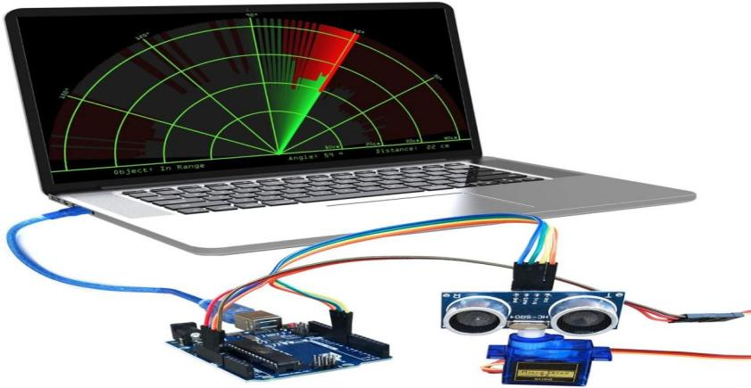
Components:

Hardware:
1. Arduino Uno
2. Sonar Sensor
3.SG90 Micro-servo motor
4.Sonar sensor header
5.Jumper Wire .
Software:
- Arduino IDE
- Processing

Conclusion :
The Ultrasonic Radar Project aims to develop a cost-effective object detection and distance measurement system using Arduino Uno and ultrasonic sensors, providing an affordable alternative to traditional radar systems for applications in robotics, navigation, and security.

