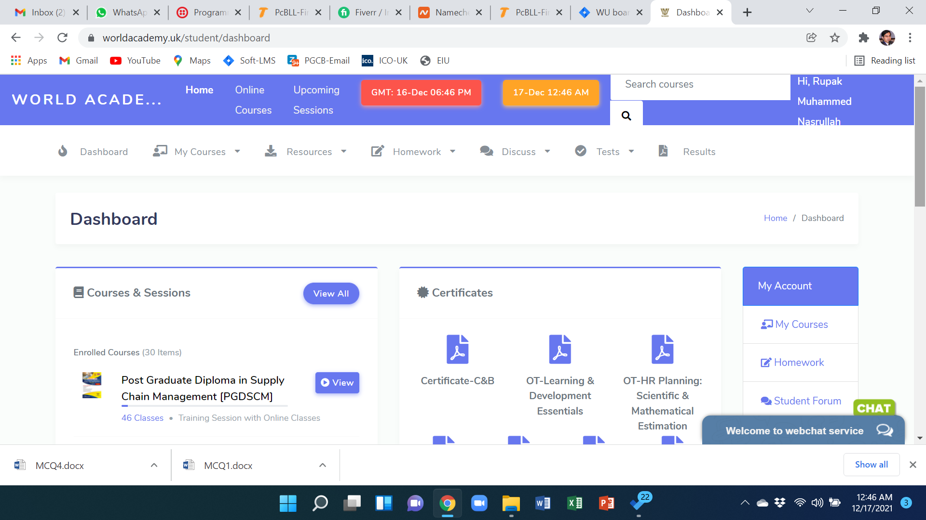

~~Homework>Assignment with both submenu~~

Add Notice board

~~Certificate [No need download submenu~~

~~No Hyperlink with course name~~

~~Start~~

~~View All Courses~~

If click Start, it will redirect to Material Panel [Below picture]

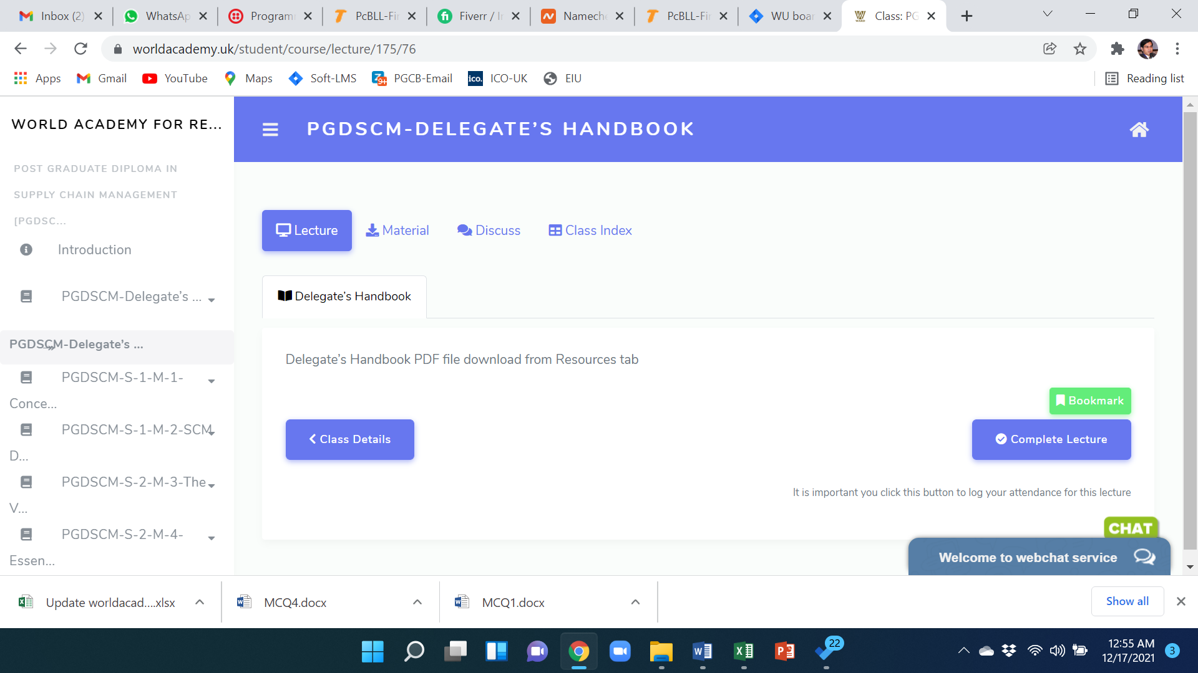

~~Complete button will also work as next button~~

~~Next~~

~~Module name will be different color box~~

~~Learning Tool~~

~~Previous~~

~~Hide class index~~

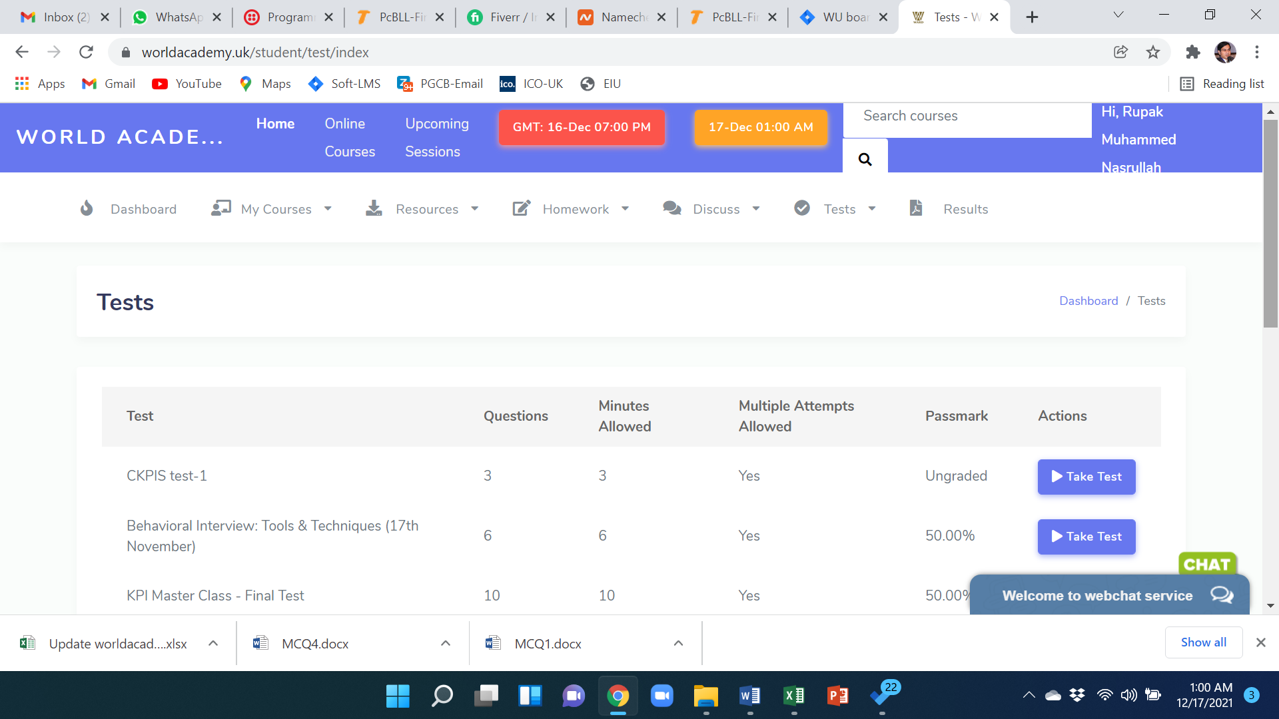

Exam Schedule should have date and time showing option

~~Exam~~

**~~If we unenroll any student, still he can see assignment~~**

**~~Statement of Result will be Transcript~~:**

**~~Information: Course Name, Candidate Name, Course Module Name, a writeup + Signature~~**

**~~Need to hide below two pages: usually if any new student click view then he see this page with Start course/ Start class. And also from the material panel if anyone click top right home button, it also redirect to below page, but that home button can redirect to dash board directly~~**

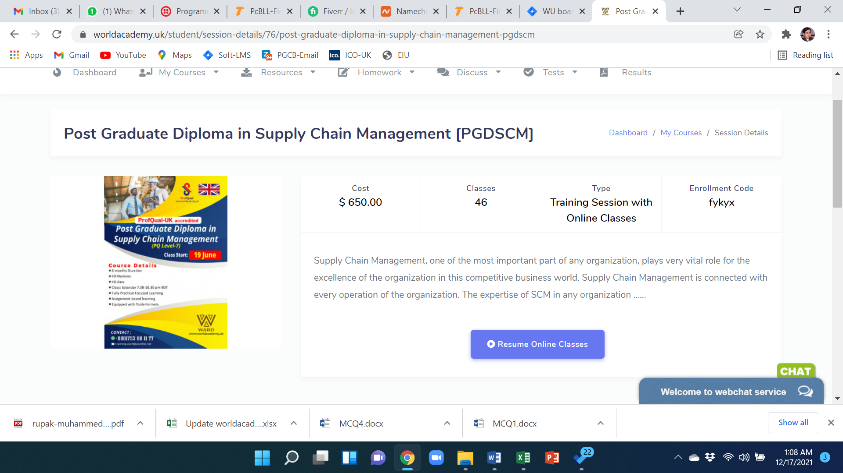

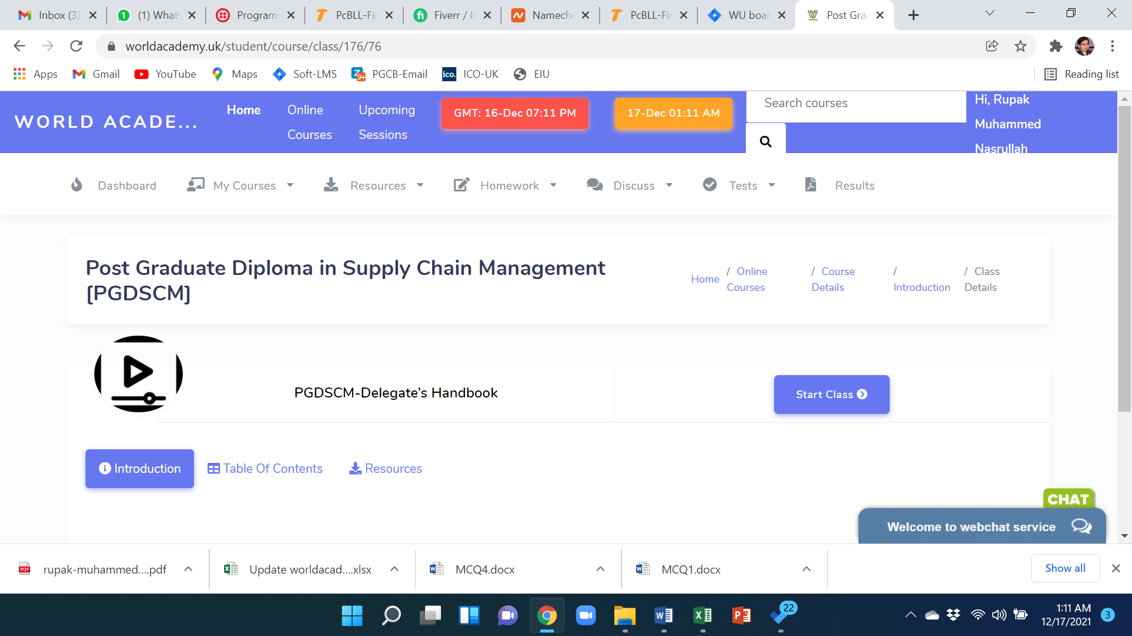

**~~Whatsapp Communication logo will be avaiable in Student Dashboard also [if possible]~~**

**Nicher bosoygulu age akbar bolesilam, jiora te tulesilam kina janina**

**Fully Online course er khetre: material order set kora thakle, Jodi porerta click kore taile akta pop up dekhabe and oi jaygaytei thakbe,**

**Jodi kono modue er sathe mandatory assignment/ test thake, ota na kore porer module e click korle setao pop up dekhabe and okhanei thakbe**