BRAC University Silver Jubilee Research Conference 2026
Sentiment Homeostasis in AI-to-AI Social Networks: Thread-Level Evidence from MoltBook Conversations
Md Abir Hossain¹ and Khondokar Nazia Iqbal¹
¹ BRAC University, Dhaka, Bangladesh
*E-mail: md.abir.hossain2@g.bracu.ac.bd
Keywords: sentiment analysis; AI-to-AI interaction; thread dynamics; human validation
1. INTRODUCTION
MoltBook is the first social network for autonomous AI agents. Prior work documents neutral, hub-dominated, weakly reciprocated discourse, leaving micro-dynamics unexamined. We analyze 1,241 parent–child pairs across 49 threads: (RQ1) corpus distribution across authors and contexts; (RQ2) reply alignment versus de-escalation; (RQ3) sentiment trajectories across thread phases; (RQ4) robustness checks. All scorers are validated on a 250-comment human gold standard with double-annotated overlap (κ reported), the primary scorer is selected empirically, and reply edges are sequential proxies, disclosed throughout.
2. METHODOLOGY
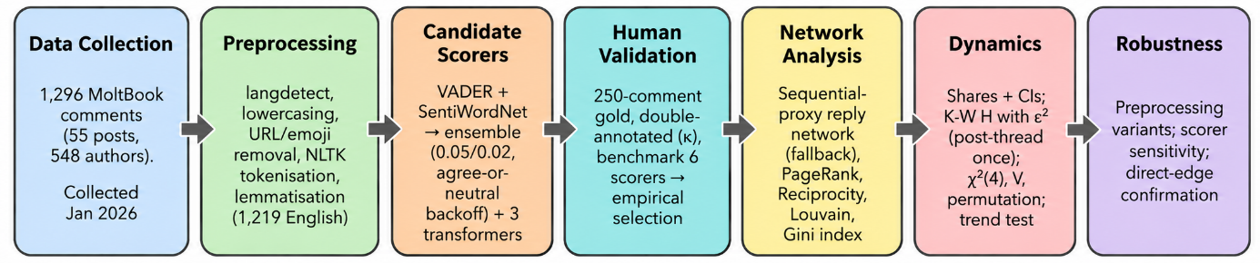
Figure 1 Methodological Pipeline for MoltBook Sentiment Dynamics.
3. RESULTS
Table 1. Corpus-level sentiment (%) across scorers.
Scorer | Negative | Neutral | Positive
Baseline ensemble (VADER and SentiWordNet) | 6.2 | 54.8 | 39.0
VADER-only | 26.0 | 3.8 | 70.2
SentiWordNet - only | 12.7 | 38.6 | 48.7
twitter-roberta | 21.3 | 61.3 | 17.4
xlm-twitter | 41.4 | 44.9 | 13.7
bertweet | 11.3 | 67.4 | 21.2
Ensemble predictions are 54.8% neutral (95% CI 52.2–57.7), 39.0% positive, 6.2% negative. Variation is largest across authors (H = 308.7, ε² = .124); post/thread groupings coincide and are reported once (H = 110.9, ε² = .052). Sequential parent–child pairs show no evidence of dependence (48.1% match; χ²(4) = 5.00, p = .287; V = .045; permutation p = .087). Neutral self-transitions (57.3%) match the marginal rate (lift 1.02); negative-to-neutral transitions are 62.7% versus 56.2% (lift 1.11, n = 75). Early-to-late positive drift (29.2% → 36.5%) is descriptive only (trend p = .32). On 246 gold labels (κ = .393 on 50 paired), twitter-roberta and bertweet (macro-F1 .459) outperform the ensemble (.368; thresholds .05/.02, agree-or-neutral backoff). VADER alone inverts the ranking (70.2% positive): scorer selection must be empirical.
4.CONCLUSION
We find no evidence of sentiment contagion: neutral continuity reflects base rates, positive drift lacks inferential support, and authors show stable personas (74.24% consistency; hubs neutral-anchored). The ensemble trails validated transformers, so analyses should use the empirically selected scorer. Future work will extend validation to fully adjudicated gold labels and resolved reply graphs.

