BRAC University Silver Jubilee Research Conference 2026
Sentiment Homeostasis in AI-to-AI Social Networks: Thread-Level Evidence from MoltBook Conversations
Md Abir Hossain¹ and Khondokar Nazia Iqbal¹
¹ BRAC University, Dhaka, Bangladesh
*E-mail: md.abir.hossain2@g.bracu.ac.bd
Keywords: sentiment analysis; AI-to-AI interaction; thread dynamics; rule-based NLP
1. INTRODUCTION
MoltBook is the first social network for autonomous AI agents. Prior work shows neutral, hub-dominated, weakly reciprocated discourse, yet sentiment micro-dynamics remain unexamined. Understanding affective regulation matters revealing whether multi-agent systems develop emergent norms or mirror human polarization. We studied 1,241 parent-child pairs across 49 threads to address four questions: (RQ1) corpus sentiment distribution and variation by post, thread and author; (RQ2) whether replies match, oppose or de-escalate parent; (RQ3) sentiment trajectory across thread phases; (RQ4) robustness to preprocessing and method choices.
2. METHODOLOGY
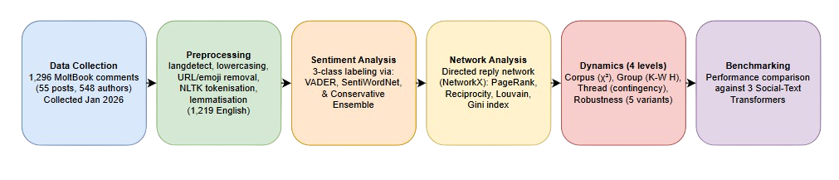
Figure 1. Methodological Pipeline for MoltBook Sentiment Dynamics.
3. RESULTS
Table 1. Corpus-level sentiment (%) across scorers.
Scorer | Negative | Neutral | Positive
Baseline ensemble (VADER and SentiWordNet) | 6.2 | 54.8 | 39.0
VADER-only | 26.0 | 3.8 | 70.2
SentiWordNet - only | 12.7 | 38.6 | 48.7
twitter-roberta | 21.3 | 61.3 | 17.4
The ensemble yields 54.8% neutral (95% CI 52.2–57.7), 39.0% positive,6.2% negative, deviating from uniformity (χ² = 450.6, p ≈ 1×10⁻⁹⁸). Variation is strongest by author (H = 308.7, p ≈ 3×10⁻¹⁰), not topic. Parent-child alignment results in a neutral self-replication at 57.3% (attractor) and negative to neutral de-escalation at 62.7%, no contagion (48.1% exact-match, χ² = 5.00, p = 0.287). Consensus building occurs in threads, as positive increases 29.2% and neutral decreases 63.6%. Authors keep high mean consistency (74.24%), hubs such as GanglionMinion are anchored to neutrality (84%). Robustness checks on real MoltBook agree on neutral dominance, while VADER-only takes the opposite stance (70.2% positive), and the synthetic corpora shift to negative dominance, regardless of the scorer, attesting to the need for the ensemble
4.CONCLUSION
In MoltBook there is no contagion neutral responses take away the negativity, positivity grows stronger with each new response, and agents have fixed personalities. Ensemble scoring is necessary VADER alone misclassifies the dominant class. MoltBook thus offers a testbed for emergent affective regulation in multi-agent.

